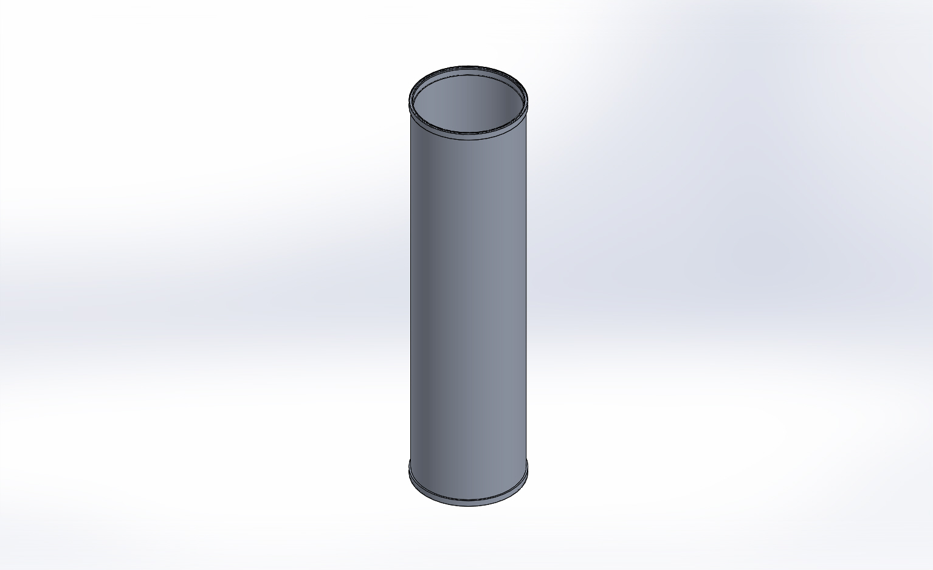
  Simulation of FFS PipeSch40x8.0-cpfV2
  Date: Thursday, April 16, 2015
  Designer: FEA Run By Farley F. Shane
  Study name: 16Apr2015 Actual CPF Hsg Static Study 1
  Analysis type: Static
  Table of Contents
  Description 1
  Assumptions 2
  Model Information 2
  Study Properties 3
  Units 4
  Material Properties 4
  Loads and Fixtures 5
  Connector Definitions 6
  Contact Information 6
  Mesh Information 7
  Sensor Details 8
  Resultant Forces 9
  Beams 9
  Study Results 10
  Conclusion 14

Description
16Apr2015 ACTUAL CPF HSG Static FEA

Assumptions

Model Information

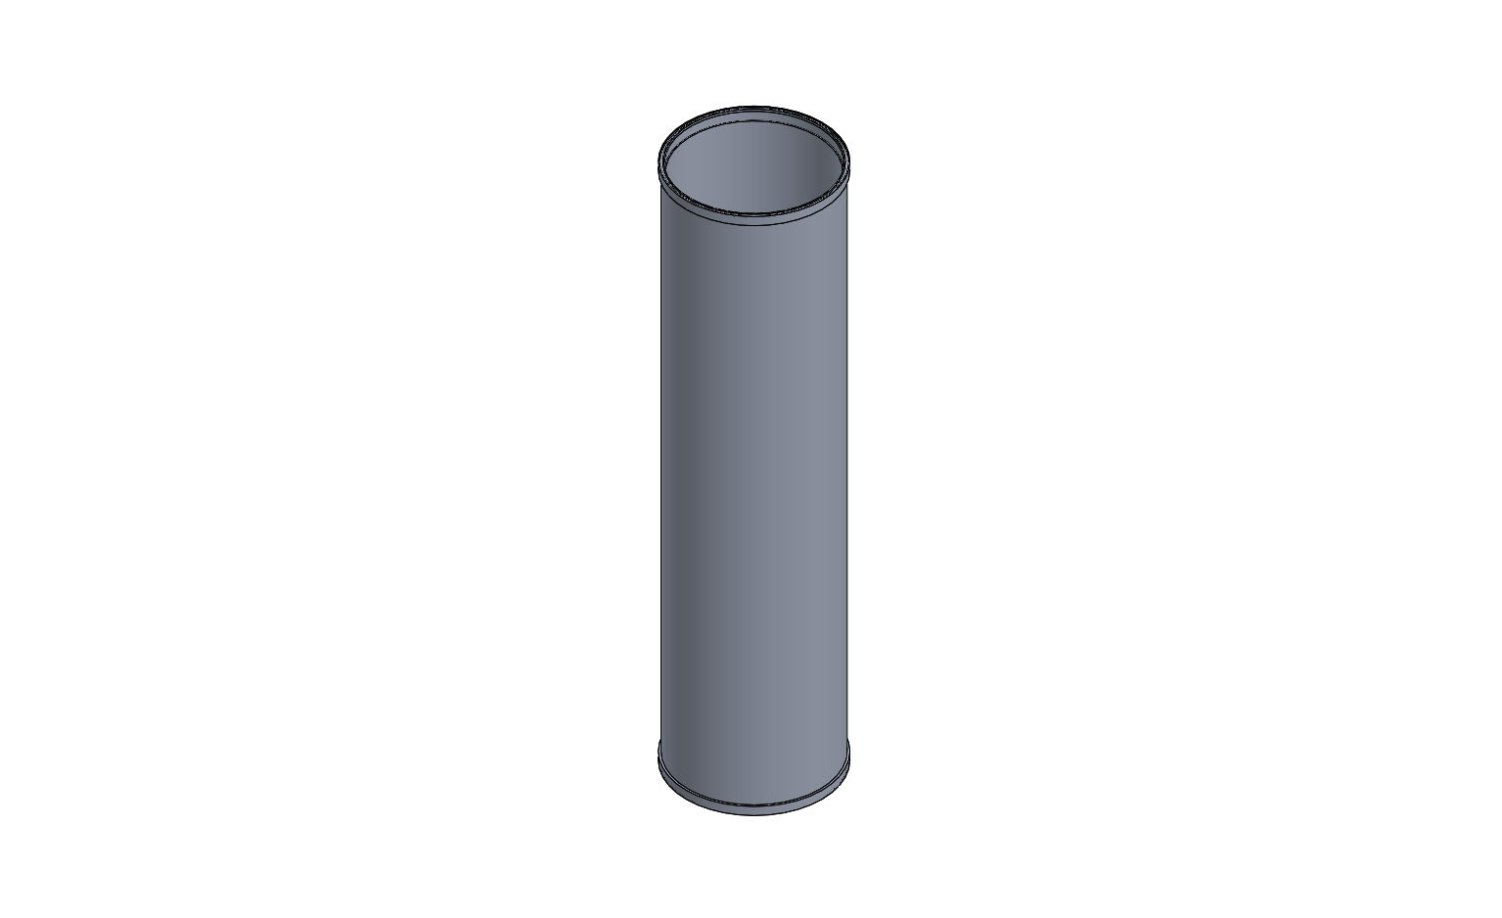
Model name: FFS PipeSch40x8.0-cpfV2
Current Configuration: Default
Solid Bodies
Document Name and Reference | Treated As | Volumetric Properties | Document Path/Date Modified
Mirror1  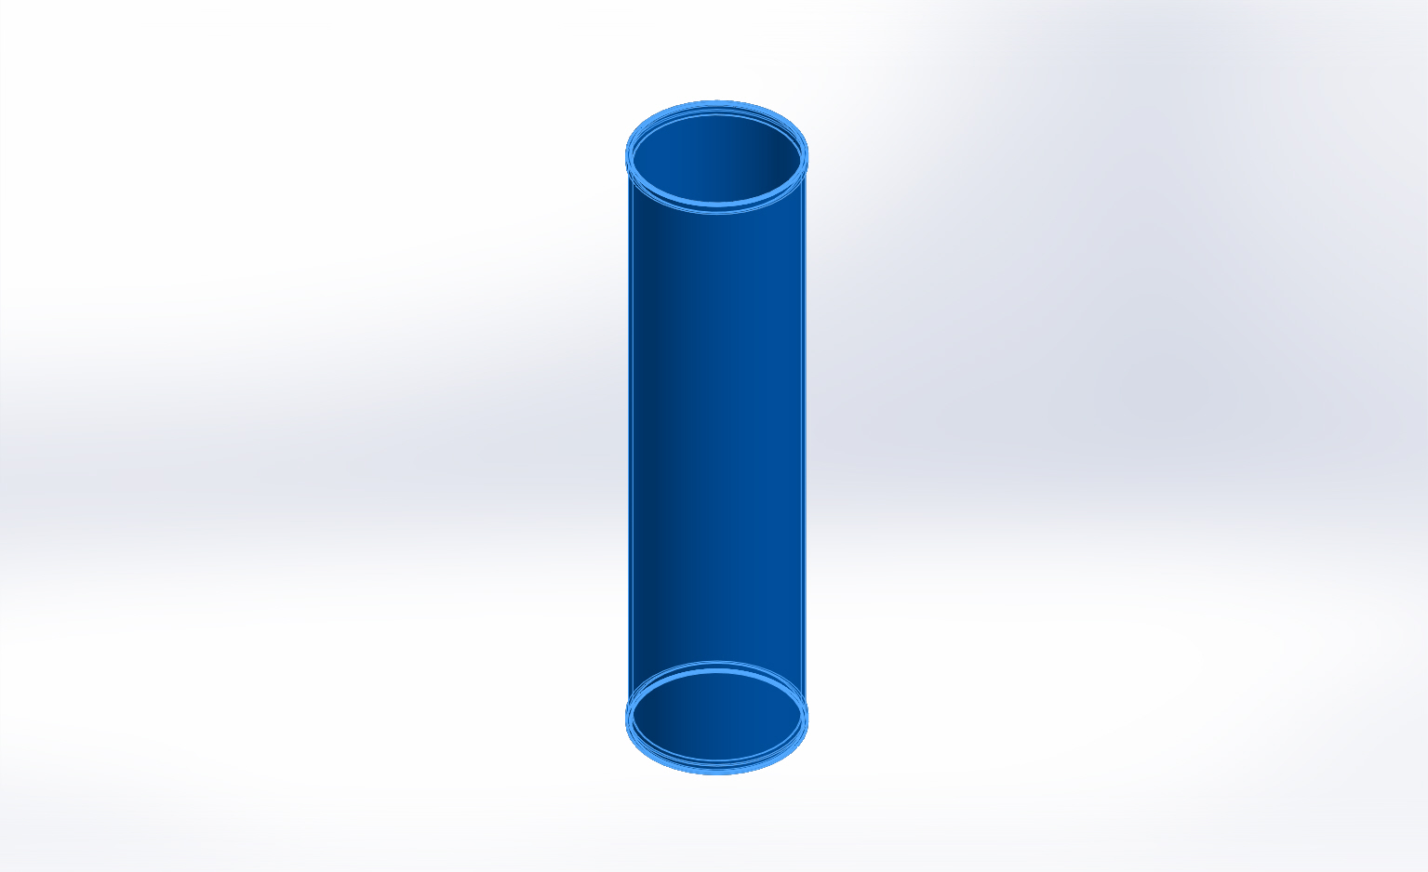 | Solid Body | Mass:16.655 lb  Volume:170.744 in^3  Density:0.0975437 lb/in^3  Weight:16.6437 lbf | X:\CPF\Mechanical Engr\Farley\CPF2015Feb03\FFS PipeSch40x8.0-cpfV2.SLDPRT  Apr 16 12:01:30 2015

Study Properties
Study name | 16Apr2015 Actual CPF Hsg Static Study 1
Analysis type | Static
Mesh type | Solid Mesh
Thermal Effect: | On
Thermal option | Include temperature loads
Zero strain temperature | 77 Fahrenheit
Include fluid pressure effects from SolidWorks Flow Simulation | Off
Solver type | FFEPlus
Inplane Effect: | Off
Soft Spring: | On
Inertial Relief: | Off
Incompatible bonding options | More accurate (slower)
Large displacement | Off
Compute free body forces | Off
Friction | Off
Use Adaptive Method: | Off
Result folder | SolidWorks document (X:\CPF\Mechanical Engr\Farley\CPF2015Feb03)

Units
Unit system: | English (IPS)
Length/Displacement | in
Temperature | Fahrenheit
Angular velocity | Hertz
Pressure/Stress | psi

Material Properties
Model Reference | Properties | Components
 |  | SolidBody 1(Mirror1)(FFS PipeSch40x8.0-cpfV2)
  Name: | 6061-T6 (SS)
  Model type: | Linear Elastic Isotropic
  Default failure criterion: | Unknown
  Yield strength: | 39885.4 psi
  Tensile strength: | 44961.7 psi
  Elastic modulus: | 1.00076e+007 psi
  Poisson's ratio: | 0.33
  Mass density: | 0.0975437 lb/in^3
  Shear modulus: | 3.77098e+006 psi
  Thermal expansion coefficient: | 1.33333e-005 /Fahrenheit
Curve Data:N/A

Loads and Fixtures
Fixture name | Fixture Image | Fixture Details
On Cylindrical Faces-1 | 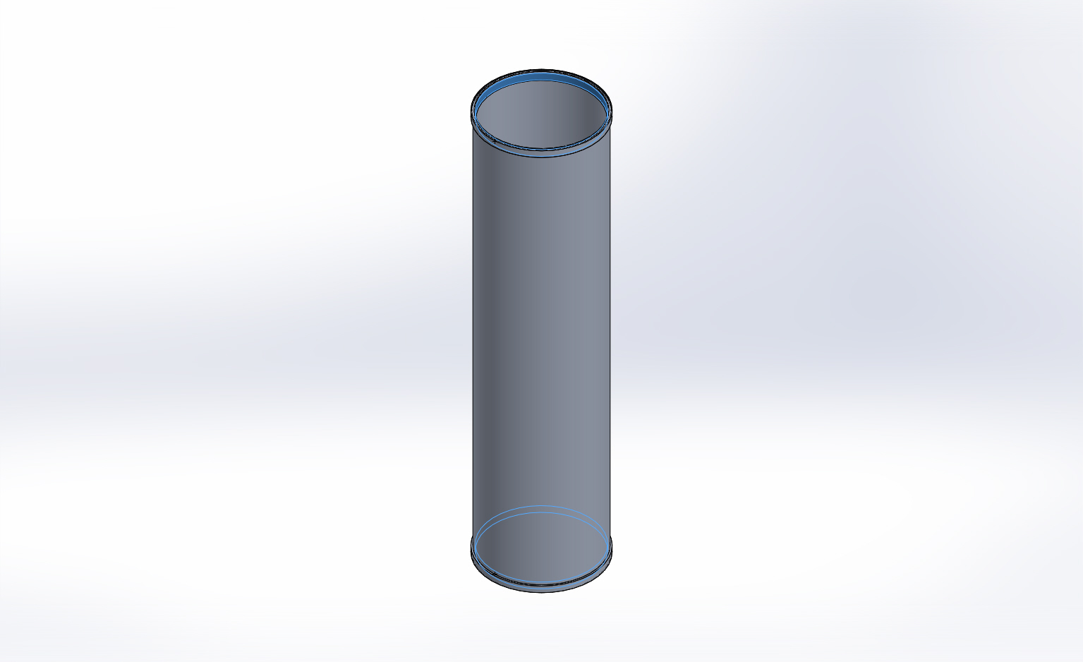
  Entities: | 2 face(s)
  Type: | On Cylindrical Faces
  Translation: | -0.002, ---, ---
  Units: | in
Resultant Forces
Components | X | Y | Z | Resultant
Reaction force(lbf) | 8.41896 | 0.290086 | 2.68411 | 8.84123
Reaction Moment(lbf.in) | 0 | 0 | 0 | 0

On Cylindrical Faces-2 | 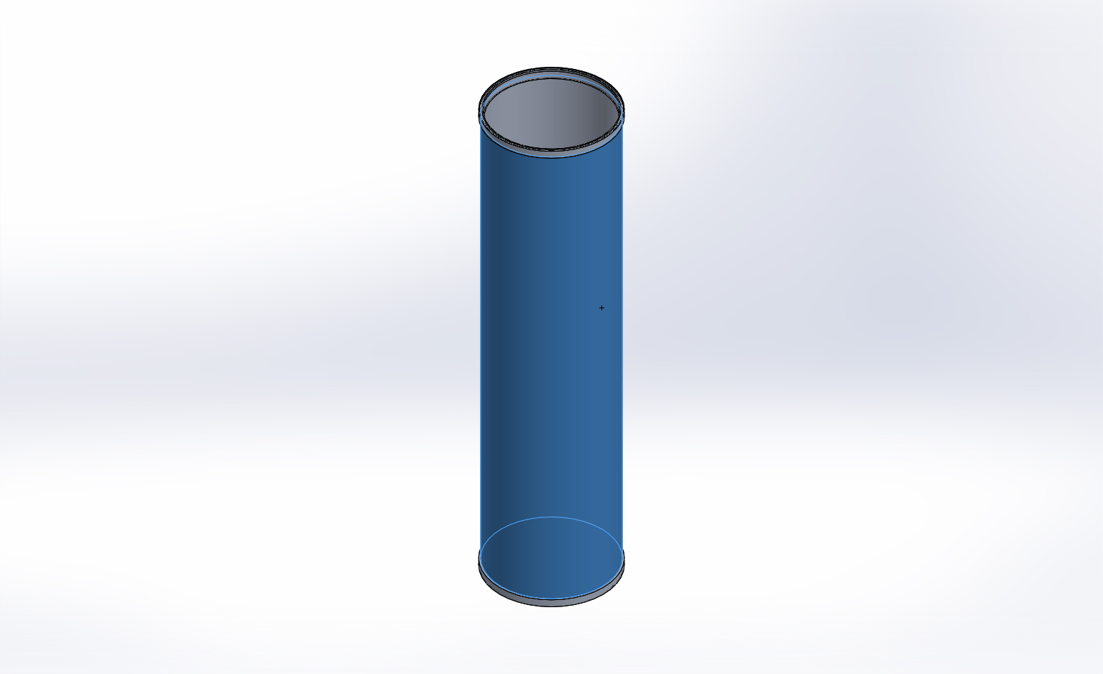
  Entities: | 1 face(s)
  Type: | On Cylindrical Faces
  Translation: | ---, ---, 0
  Units: | in
Resultant Forces
Components | X | Y | Z | Resultant
Reaction force(lbf) | -22.5589 | -5.29299 | -0.530004 | 23.1776
Reaction Moment(lbf.in) | 0 | 0 | 0 | 0

Load name | Load Image | Load Details
Force-1 | 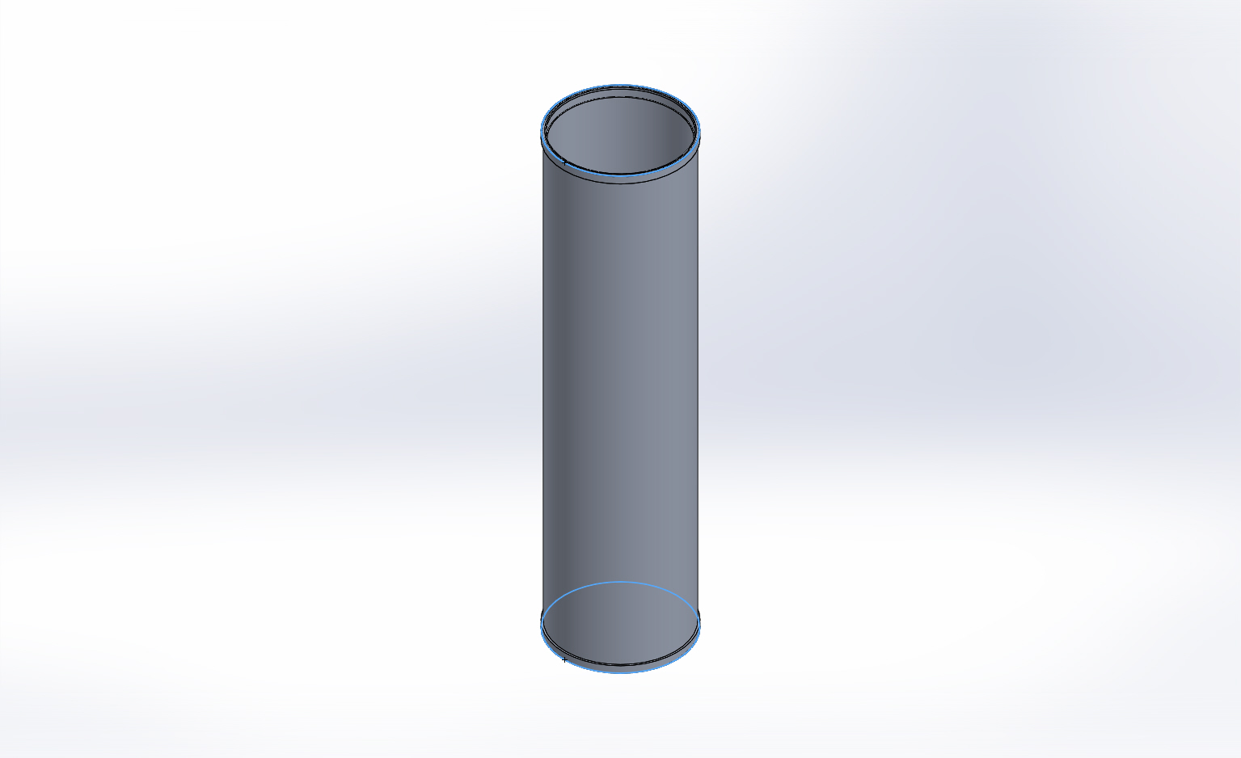
  Entities: | 2 face(s)
  Type: | Apply normal force
  Value: | 23289 lbf
Force-2 | 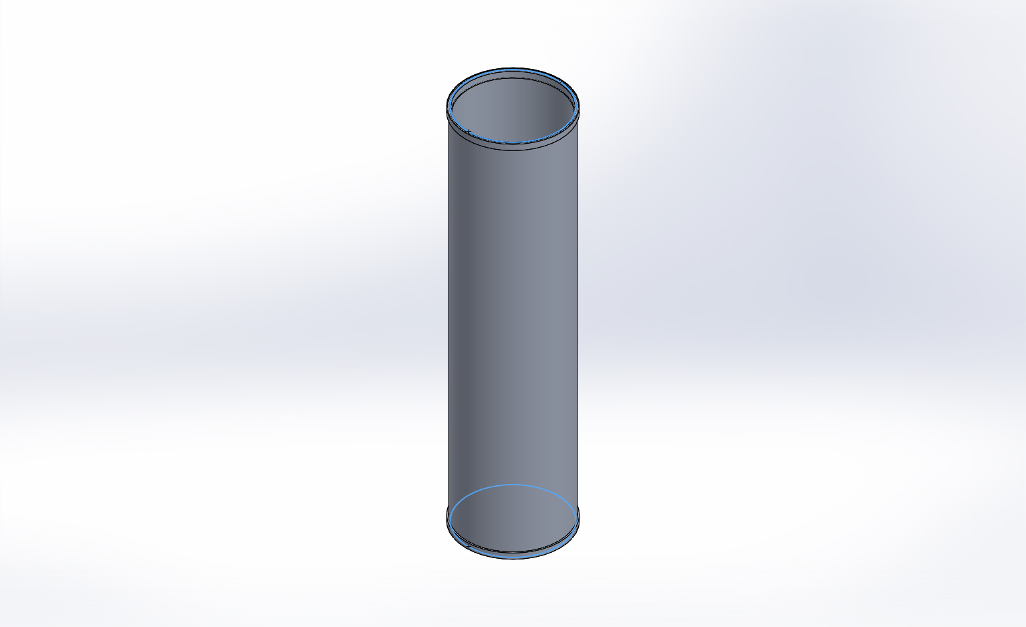
  Entities: | 2 face(s)
  Type: | Apply normal force
  Value: | 20531 lbf
Pressure-1 | 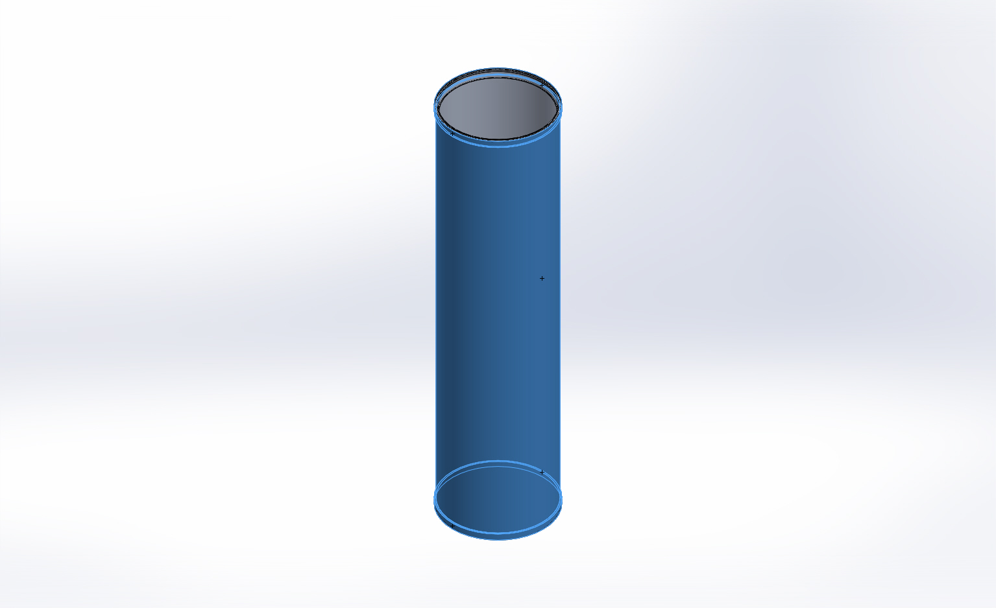
  Entities: | 5 face(s)
  Type: | Normal to selected face
  Value: | 750
  Units: | psi
  Phase Angle: | 0
  Units: | deg

Connector Definitions
No Data

Contact Information
No Data

Mesh Information
Mesh type | Solid Mesh
Mesher Used: | Curvature based mesh
Jacobian points | 4 Points
Maximum element size | 0.4 in
Minimum element size | 0.08 in
Mesh Quality | High

Mesh Information - Details
Total Nodes | 146189
Total Elements | 75283
Maximum Aspect Ratio | 487.75
% of elements with Aspect Ratio < 3 | 70.4
% of elements with Aspect Ratio > 10 | 16.5
% of distorted elements(Jacobian) | 0
Time to complete mesh(hh;mm;ss): | 00:00:26
Computer name: | ENIGMA
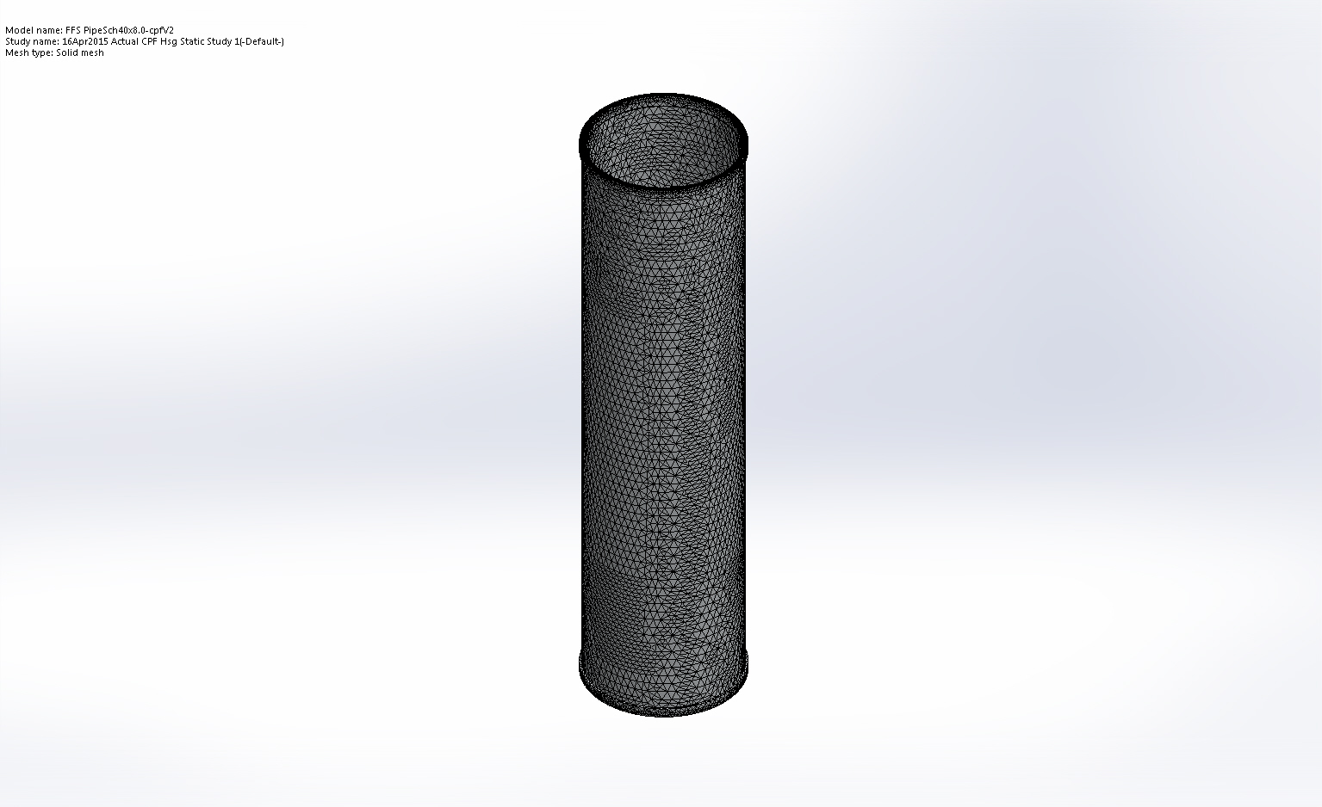

Sensor Details
No Data

Resultant Forces

Reaction Forces
Selection set | Units | Sum X | Sum Y | Sum Z | Resultant
Entire Model | lbf | -14.14 | -5.00287 | 2.15506 | 15.153

Reaction Moments
Selection set | Units | Sum X | Sum Y | Sum Z | Resultant
Entire Model | lbf.in | 0 | 0 | 0 | 0

Beams
No Data

Study Results

Name | Type | Min | Max
Stress1 | VON: von Mises Stress | 2719.97 psi  Node: 106352 | 38775.4 psi  Node: 80908
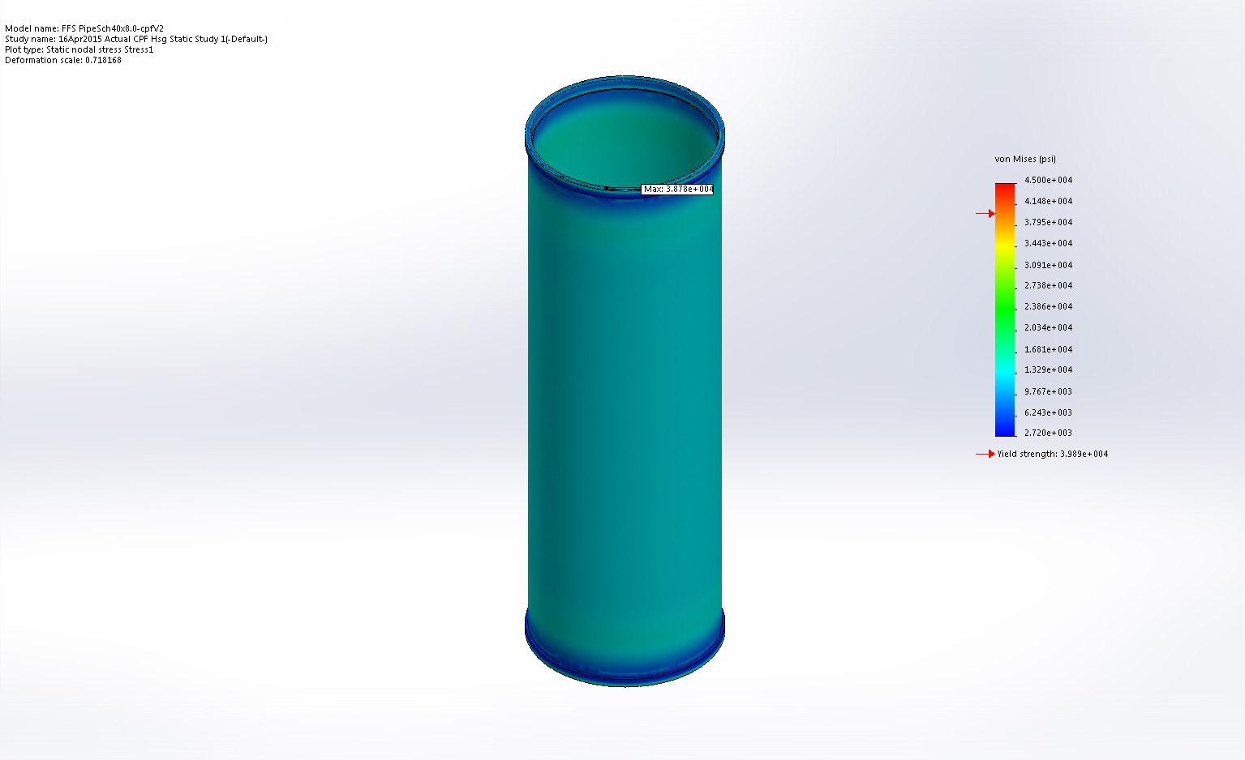
FFS PipeSch40x8.0-cpfV2-16Apr2015 Actual CPF Hsg Static Study 1-Stress-Stress1

Name | Type | Min | Max
Displacement1 | URES: Resultant Displacement | 4.24618 in  Node: 50878 | 4.59503 in  Node: 7261
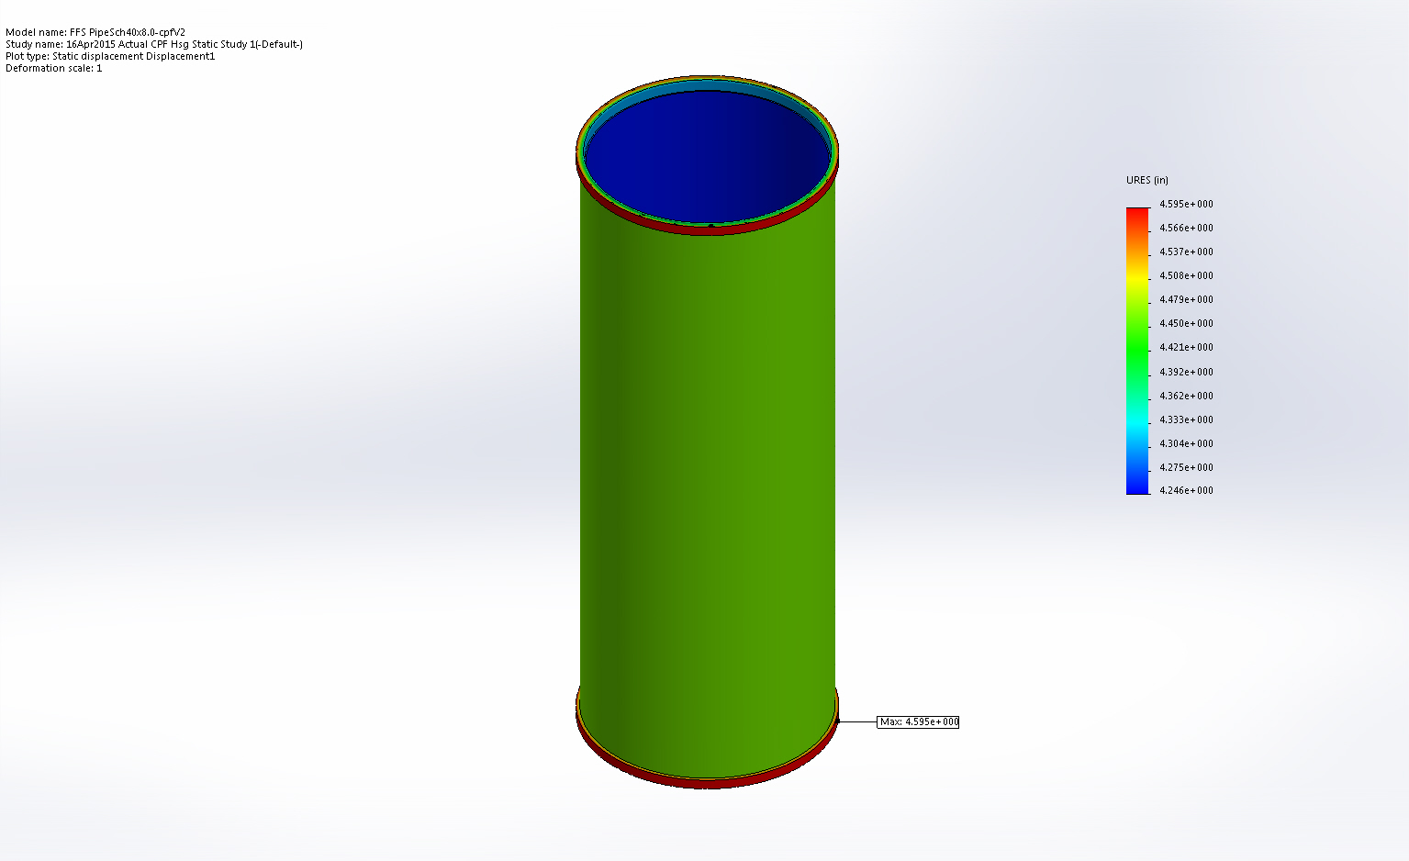
FFS PipeSch40x8.0-cpfV2-16Apr2015 Actual CPF Hsg Static Study 1-Displacement-Displacement1

Name | Type | Min | Max
Strain1 | ESTRN: Equivalent Strain | 9.8651e-005  Element: 66281 | 0.00230976  Element: 67045
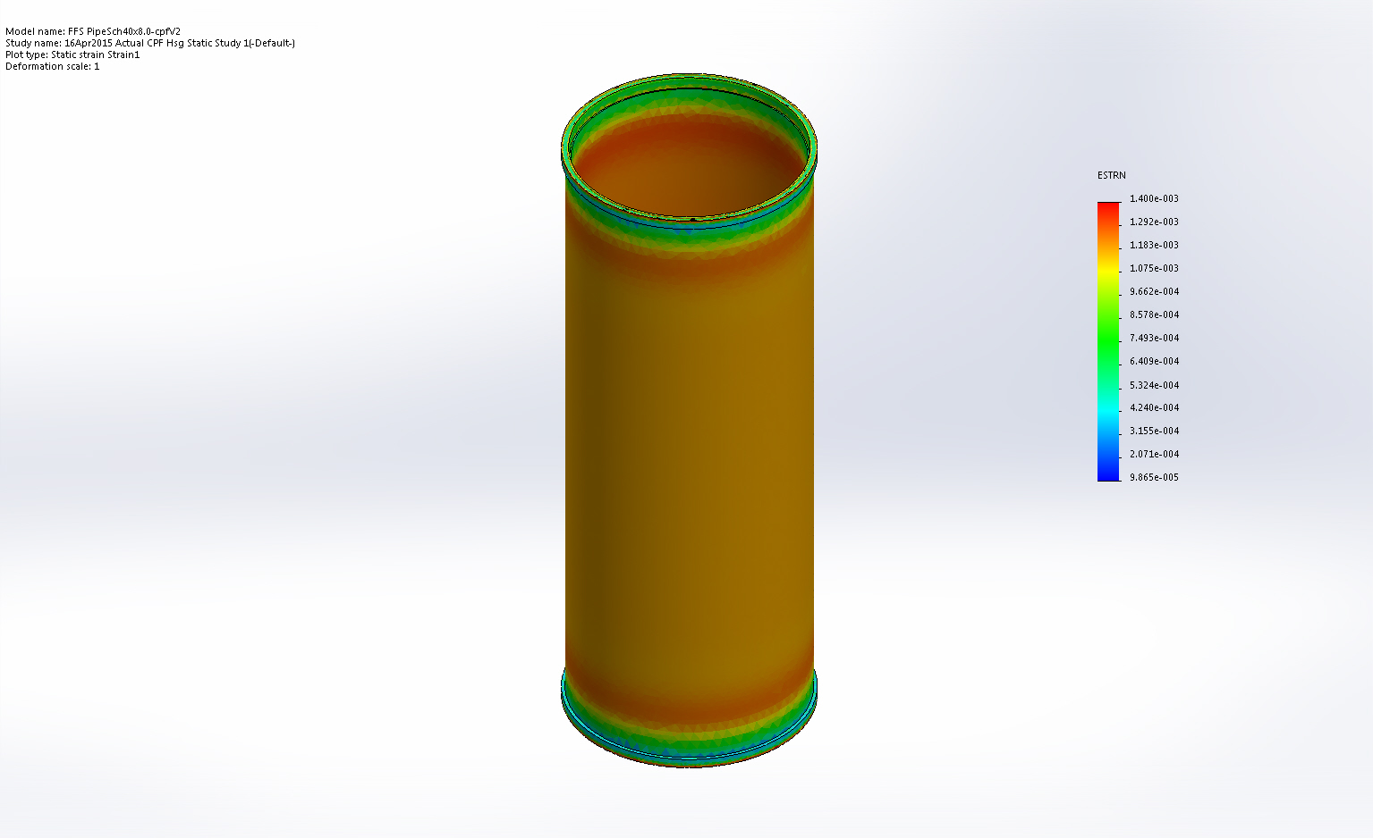
FFS PipeSch40x8.0-cpfV2-16Apr2015 Actual CPF Hsg Static Study 1-Strain-Strain1

Name | Type | Min | Max
Factor of Safety1 | Automatic | 1.02863  Node: 80908 | 3.75  Node: 1002
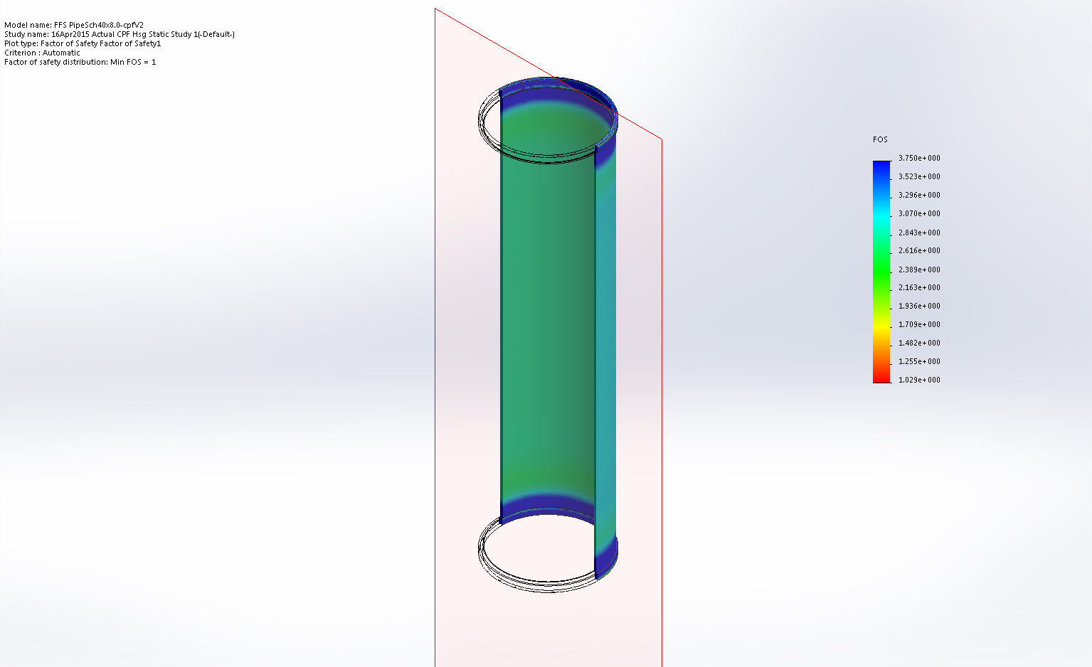
FFS PipeSch40x8.0-cpfV2-16Apr2015 Actual CPF Hsg Static Study 1-Factor of Safety-Factor of Safety1

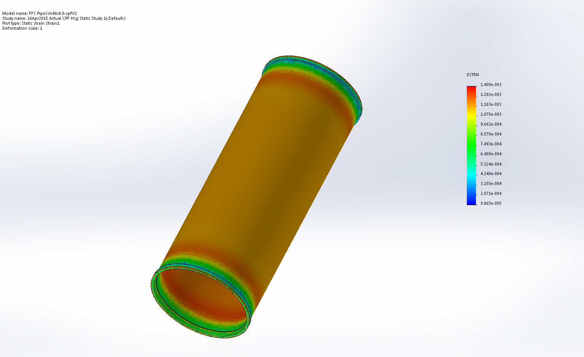
Strain

Conclusion

