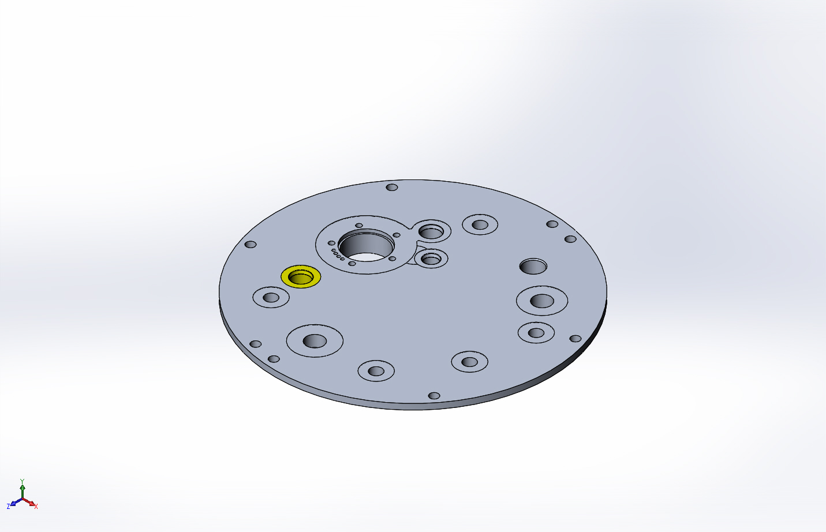
  Simulation of FFS topFlange-cpfV2
  Date: Friday, April 10, 2015
  Designer: FEA done by Farley F. Shane
  Study name: 30Mar2015 Top Flange Cap with Holes Static Study 2
  Analysis type: Static
  Table of Contents
  Description 1
  Assumptions 2
  Model Information 2
  Study Properties 3
  Units 4
  Material Properties 4
  Loads and Fixtures 5
  Connector Definitions 5
  Contact Information 6
  Mesh Information 7
  Sensor Details 9
  Resultant Forces 9
  Beams 10
  Study Results 11
  Conclusion 17

Description
Static Study of CPF Top Flange 09Apr2015

Assumptions

Model Information

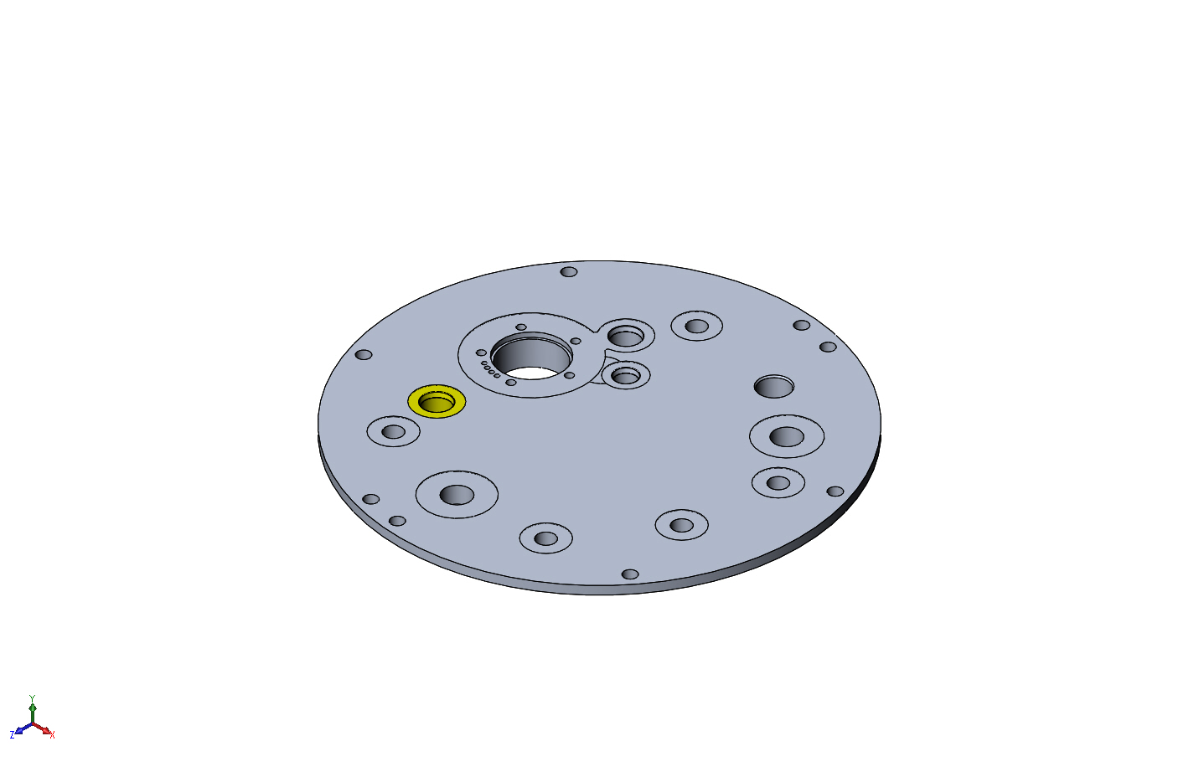
Model name: FFS topFlange-cpfV2
Current Configuration: Default
Solid Bodies
Document Name and Reference | Treated As | Volumetric Properties | Document Path/Date Modified
Split Line6  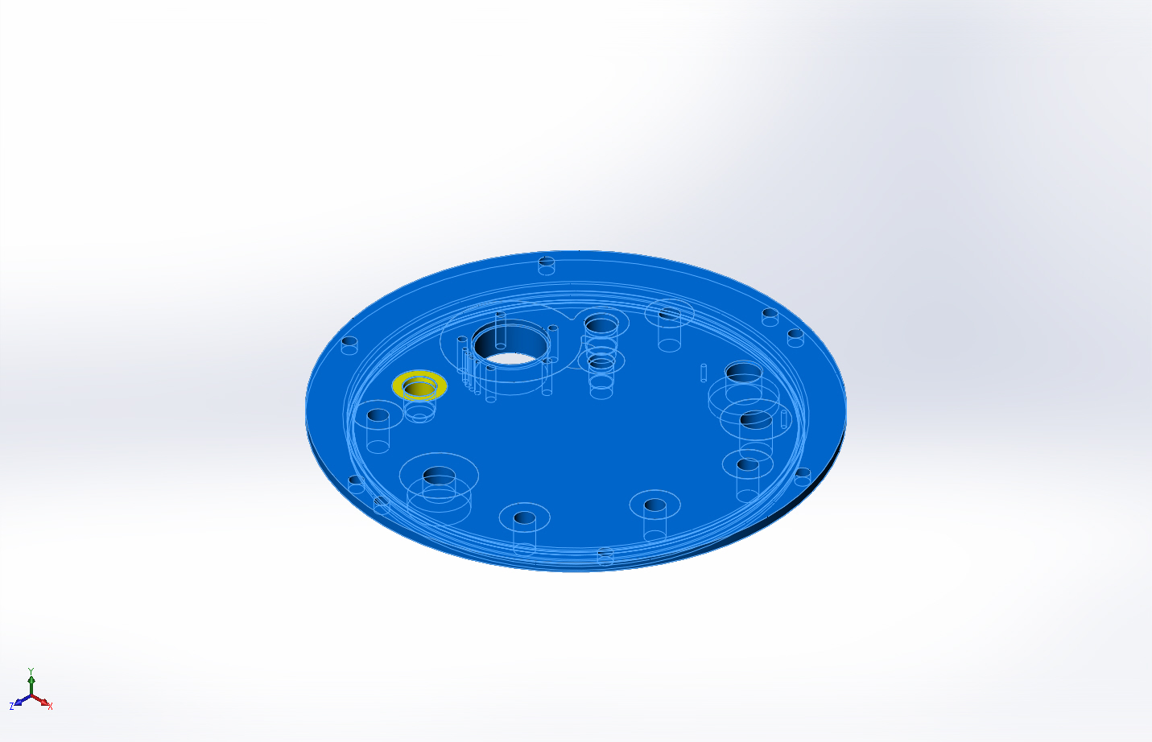 | Solid Body | Mass:3.53825 lb  Volume:36.2735 in^3  Density:0.0975437 lb/in^3  Weight:3.53585 lbf | X:\CPF\Mechanical Engr\Farley\CPF2015Feb03\FFS topFlange-cpfV2.SLDPRT  Apr 08 16:03:13 2015

Study Properties
Study name | 30Mar2015 Top Flange Cap with Holes Static Study 2
Analysis type | Static
Mesh type | Solid Mesh
Thermal Effect: | On
Thermal option | Include temperature loads
Zero strain temperature | 77 Fahrenheit
Include fluid pressure effects from SolidWorks Flow Simulation | Off
Solver type | FFEPlus
Inplane Effect: | Off
Soft Spring: | Off
Inertial Relief: | Off
Incompatible bonding options | Automatic
Large displacement | On
Compute free body forces | On
Friction | Off
Use Adaptive Method: | Off
Result folder | SolidWorks document (X:\CPF\Mechanical Engr\Farley\CPF2015Feb03)

Units
Unit system: | English (IPS)
Length/Displacement | in
Temperature | Fahrenheit
Angular velocity | Hertz
Pressure/Stress | psi

Material Properties
Model Reference | Properties | Components
 |  | SolidBody 1(9/32 (Split Line6)(FFS topFlange-cpfV2)
  Name: | 6061-T6 (SS)
  Model type: | Linear Elastic Isotropic
  Default failure criterion: | Unknown
  Yield strength: | 39885.4 psi
  Tensile strength: | 44961.7 psi
  Elastic modulus: | 1.00076e+007 psi
  Poisson's ratio: | 0.33
  Mass density: | 0.0975437 lb/in^3
  Shear modulus: | 3.77098e+006 psi
  Thermal expansion coefficient: | 1.33333e-005 /Fahrenheit
Curve Data:N/A

Loads and Fixtures
Fixture name | Fixture Image | Fixture Details
Fixed-1 | 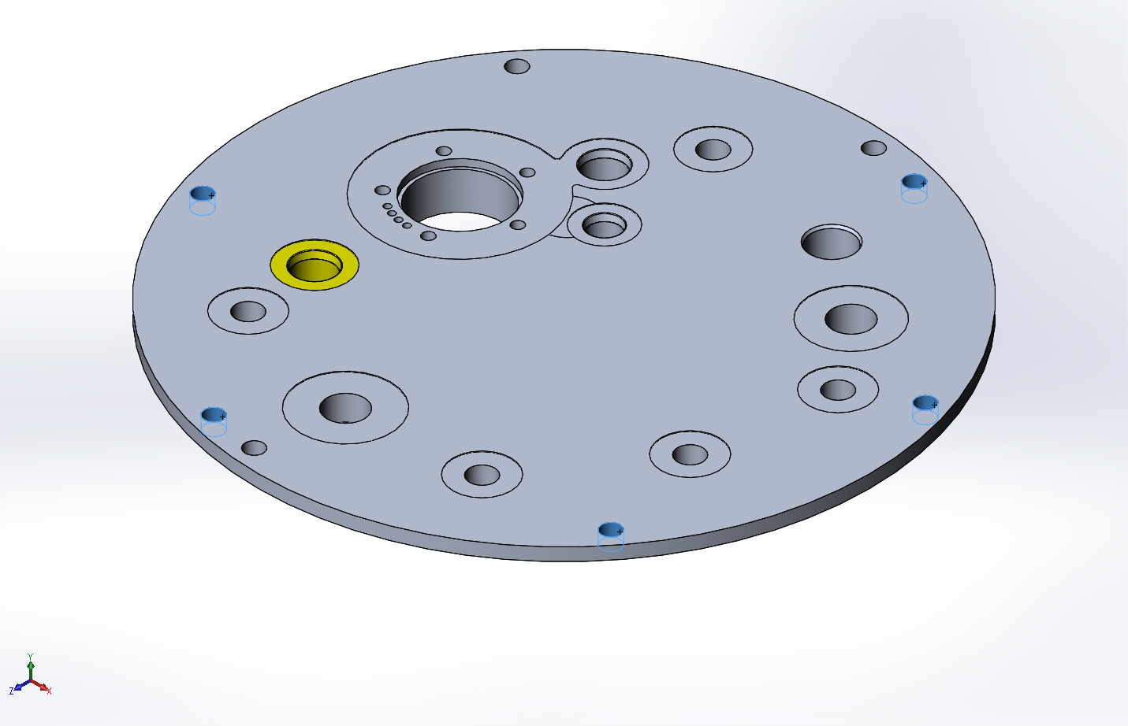
  Entities: | 5 face(s)
  Type: | Fixed Geometry
Resultant Forces
Components | X | Y | Z | Resultant
Reaction force(lbf) | 0.00500826 | 35067.5 | -0.00366872 | 35067.5
Reaction Moment(lbf.in) | 0 | 0 | 0 | 0

Load name | Load Image | Load Details
Pressure-1 | 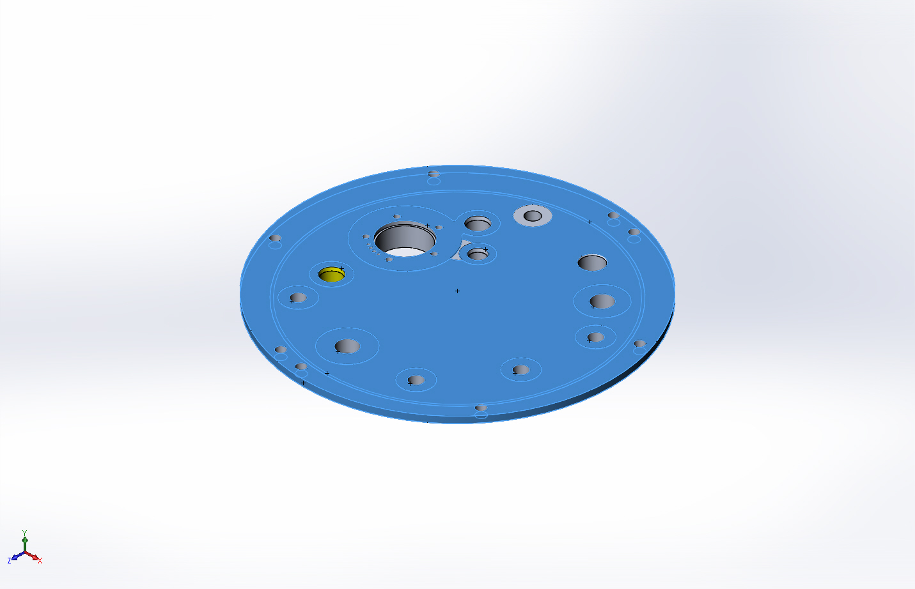
  Entities: | 13 face(s)
  Type: | Normal to selected face
  Value: | 750
  Units: | psi
  Phase Angle: | 0
  Units: | deg

Connector Definitions
No Data

Contact Information
No Data

Mesh Information
Mesh type | Solid Mesh
Mesher Used: | Curvature based mesh
Jacobian points | 16 Points
Maximum element size | 0.1 in
Minimum element size | 0.02 in
Mesh Quality | Draft Quality Mesh

Mesh Information - Details
Total Nodes | 159100
Total Elements | 778086
Maximum Aspect Ratio | 213.71
% of elements with Aspect Ratio < 3 | 96
% of elements with Aspect Ratio > 10 | 0.536
Time to complete mesh(hh;mm;ss): | 00:01:23
Computer name: | ENIGMA
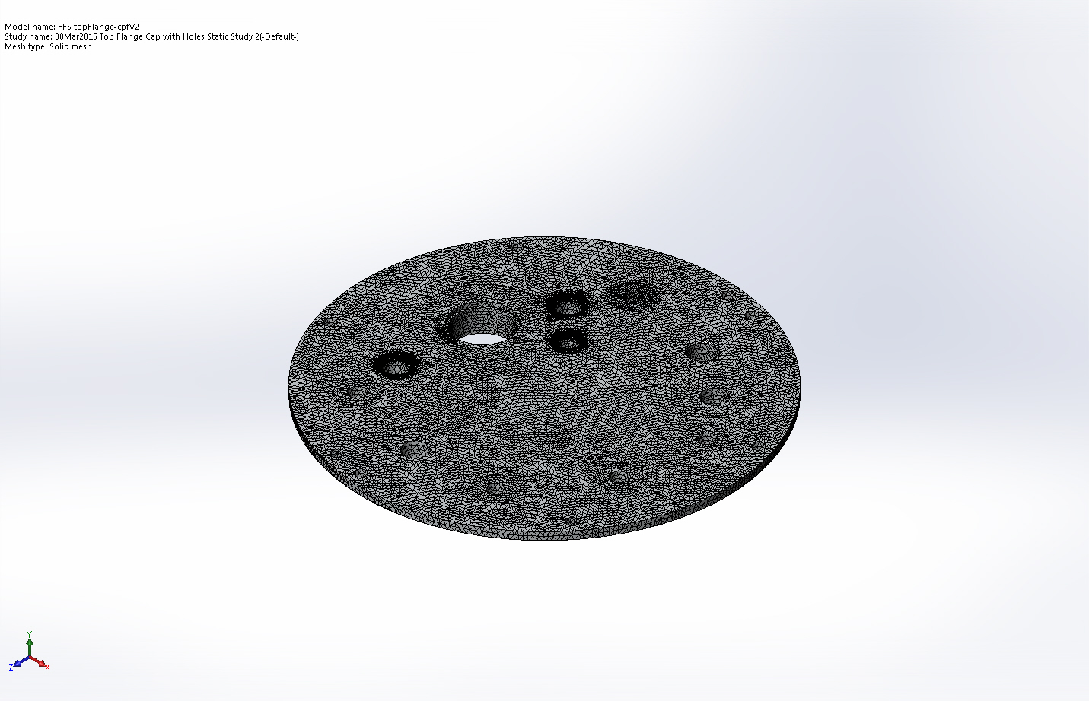

Mesh Control Information:
Mesh Control Name | Mesh Control Image | Mesh Control Details
Control-1 | 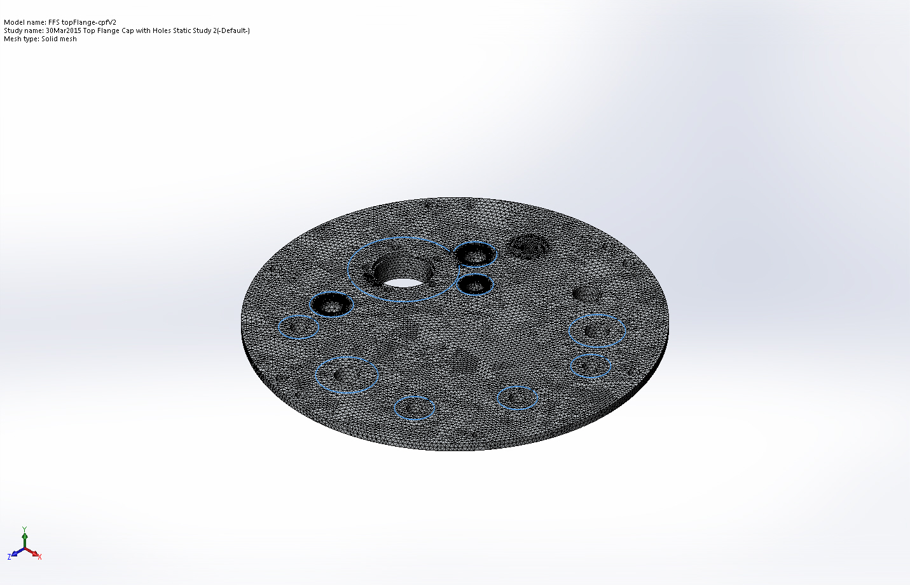
  Entities: | 11 face(s)
  Units: | in
  Size: | 0.0827772
  Ratio: | 1.5
Control-7 | 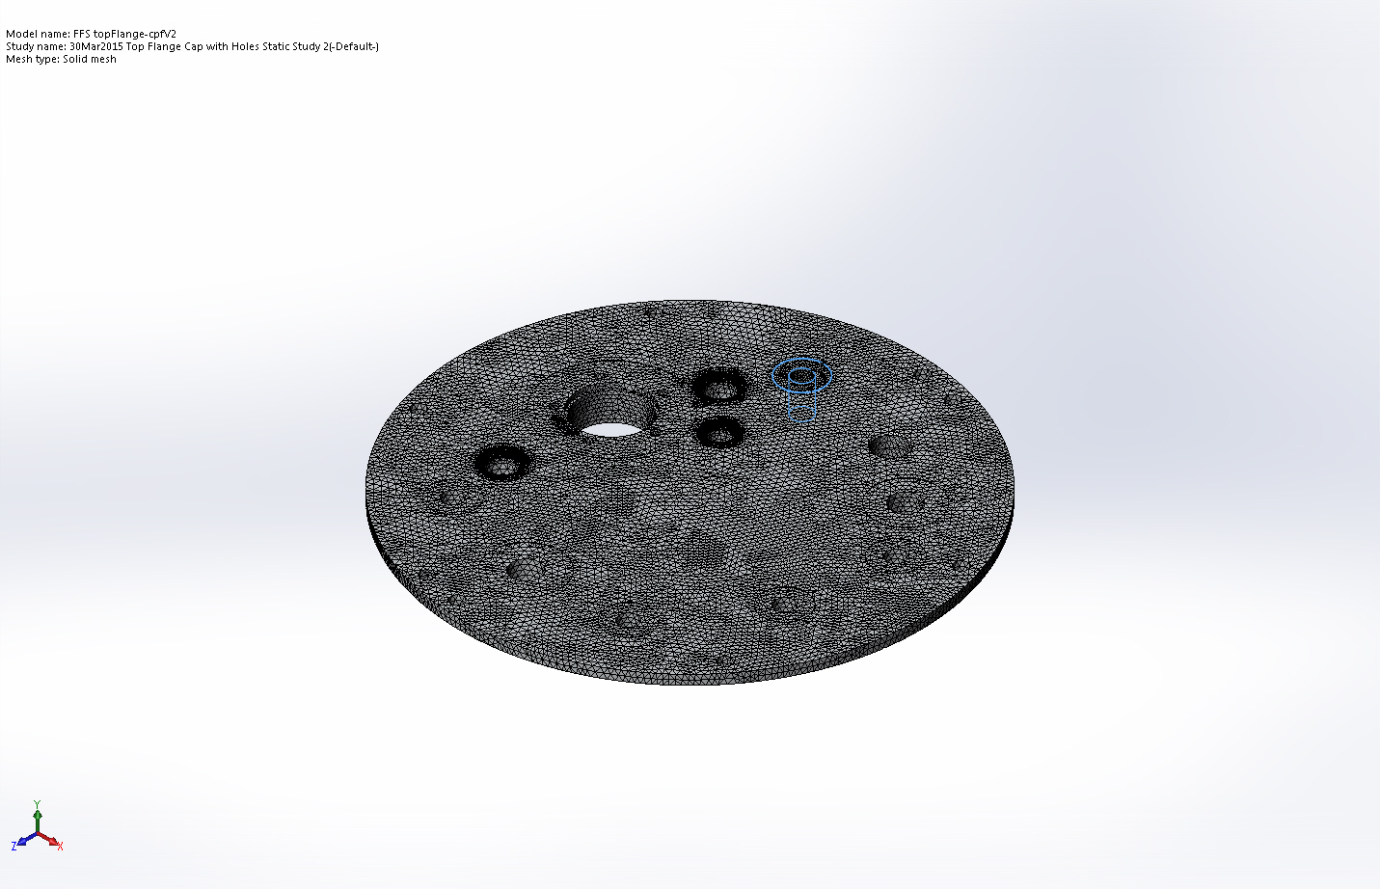
  Entities: | 3 face(s)
  Units: | in
  Size: | 0.05
  Ratio: | 1.5
Control-8 | 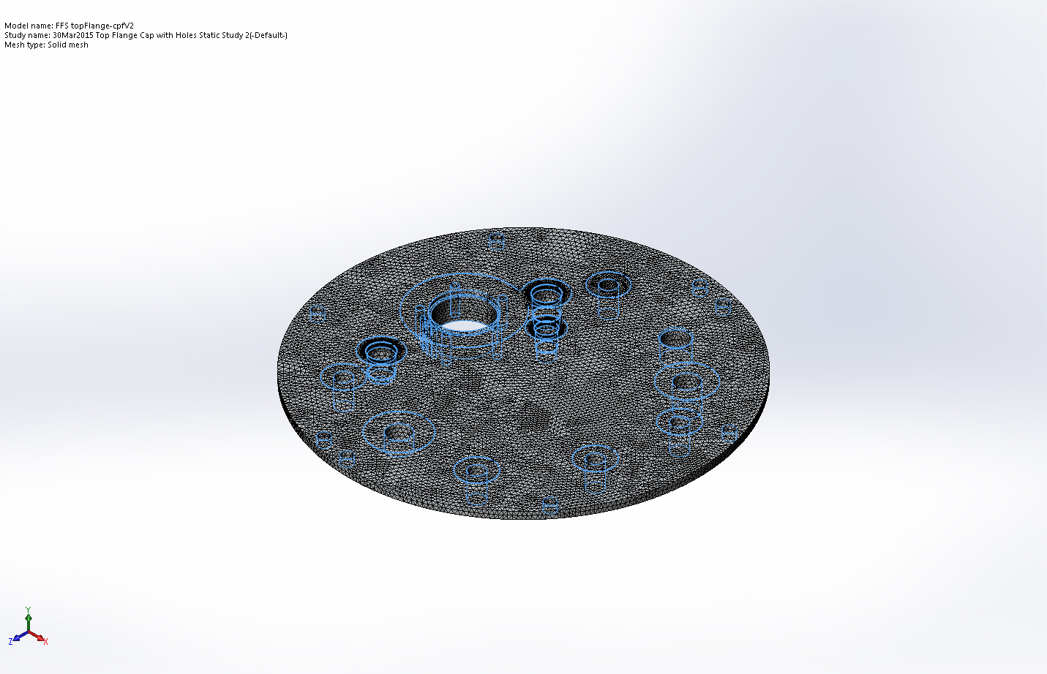
  Entities: | 67 face(s)
  Units: | in
  Size: | 0.09
  Ratio: | 1.5

Sensor Details
No Data

Resultant Forces

Reaction Forces
Selection set | Units | Sum X | Sum Y | Sum Z | Resultant
Entire Model | lbf | 0.00500826 | 35067.5 | -0.00366872 | 35067.5

Reaction Moments
Selection set | Units | Sum X | Sum Y | Sum Z | Resultant
Entire Model | lbf.in | 0 | 0 | 0 | 0

Beams
No Data

Study Results

Name | Type | Min | Max
Stress1 | VON: von Mises Stress | 180.392 psi  Node: 35361 | 391980 psi  Node: 15736
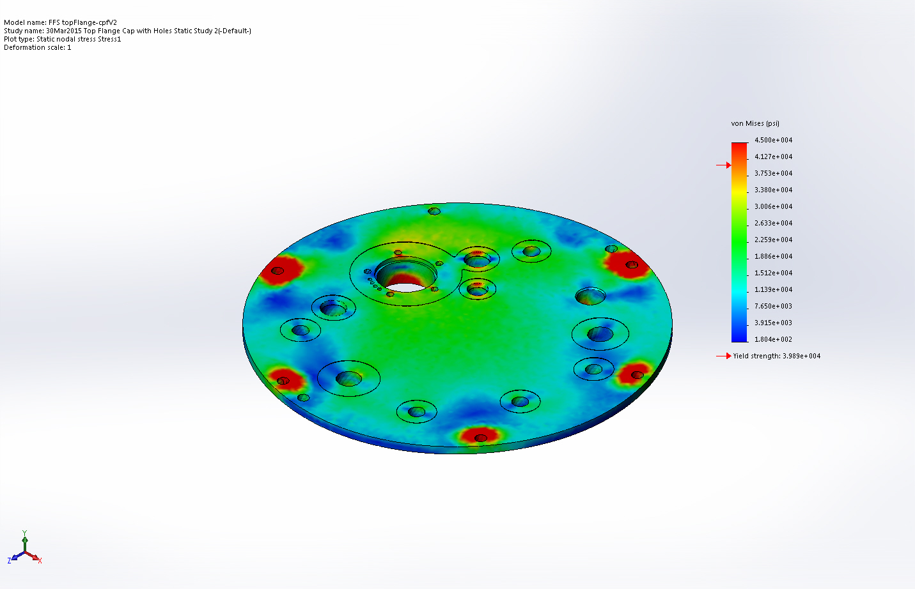
FFS topFlange-cpfV2-30Mar2015 Top Flange Cap with Holes Static Study 2-Stress-Stress1

Name | Type | Min | Max
Displacement1 | URES: Resultant Displacement | 0 in  Node: 15579 | 0.11256 in  Node: 690
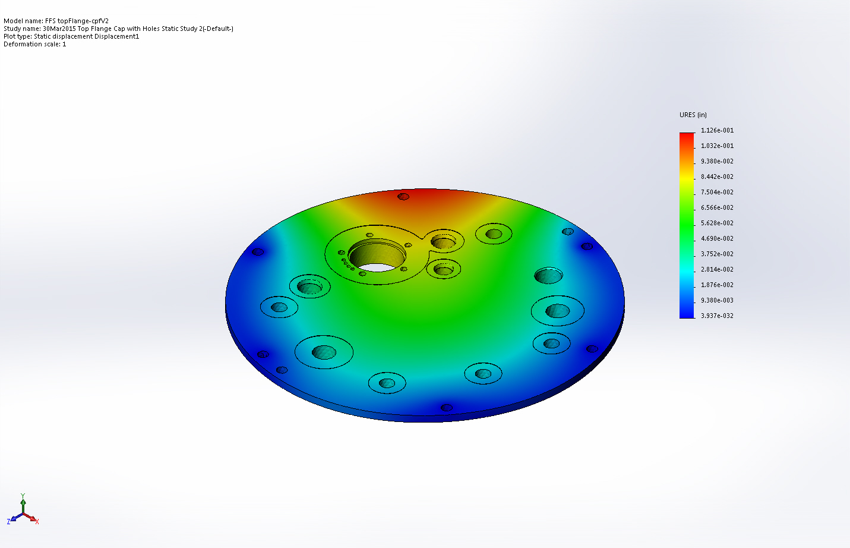
FFS topFlange-cpfV2-30Mar2015 Top Flange Cap with Holes Static Study 2-Displacement-Displacement1

Name | Type | Min | Max
Strain1 | ESTRN: Equivalent Strain | 1.18094e-005  Element: 570480 | 0.0413941  Element: 289127
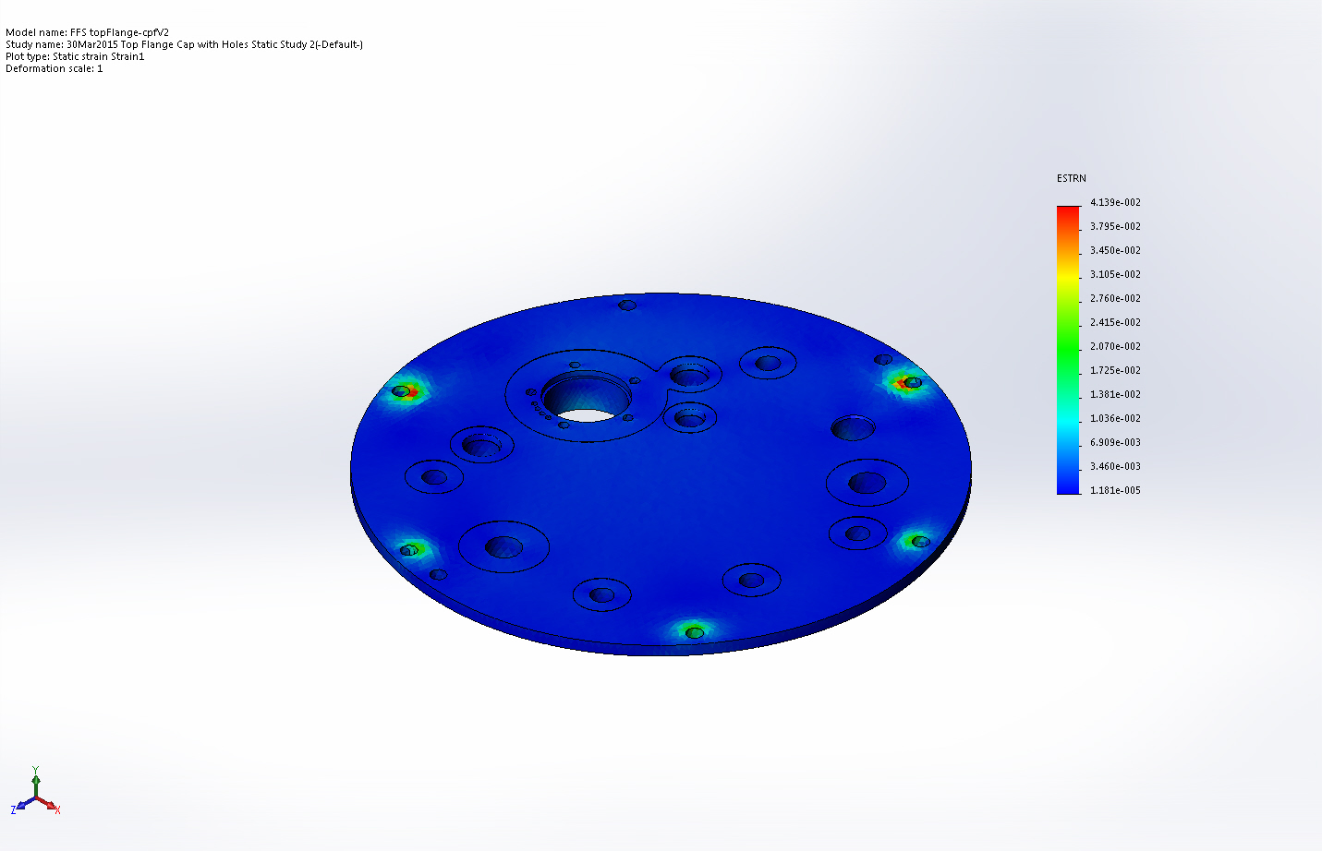
FFS topFlange-cpfV2-30Mar2015 Top Flange Cap with Holes Static Study 2-Strain-Strain1

Name | Type
Displacement1{1} | Deformed Shape
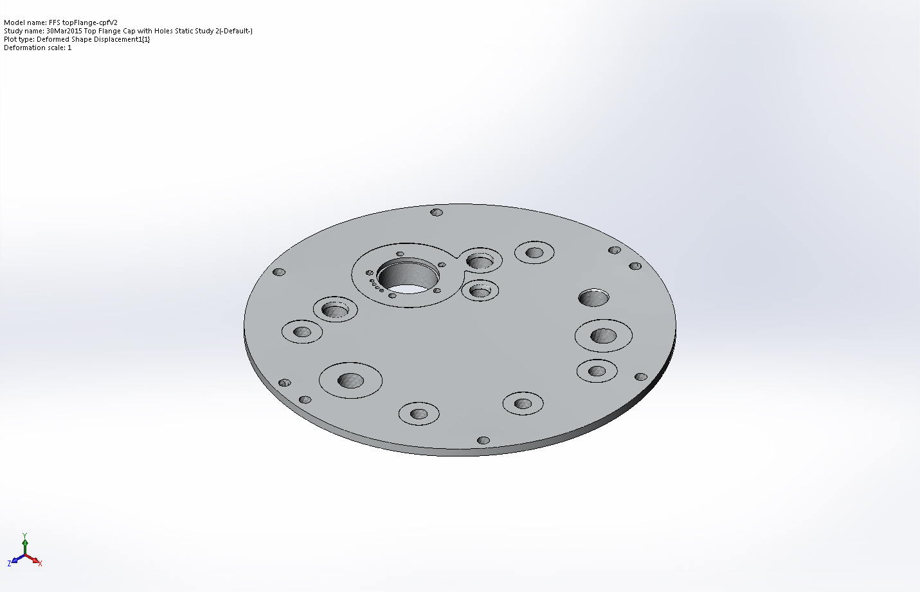
FFS topFlange-cpfV2-30Mar2015 Top Flange Cap with Holes Static Study 2-Displacement-Displacement1{1}

Name | Type | Min | Max
Factor of Safety1 | Automatic | 0.101754  Node: 15736 | 1.25  Node: 1
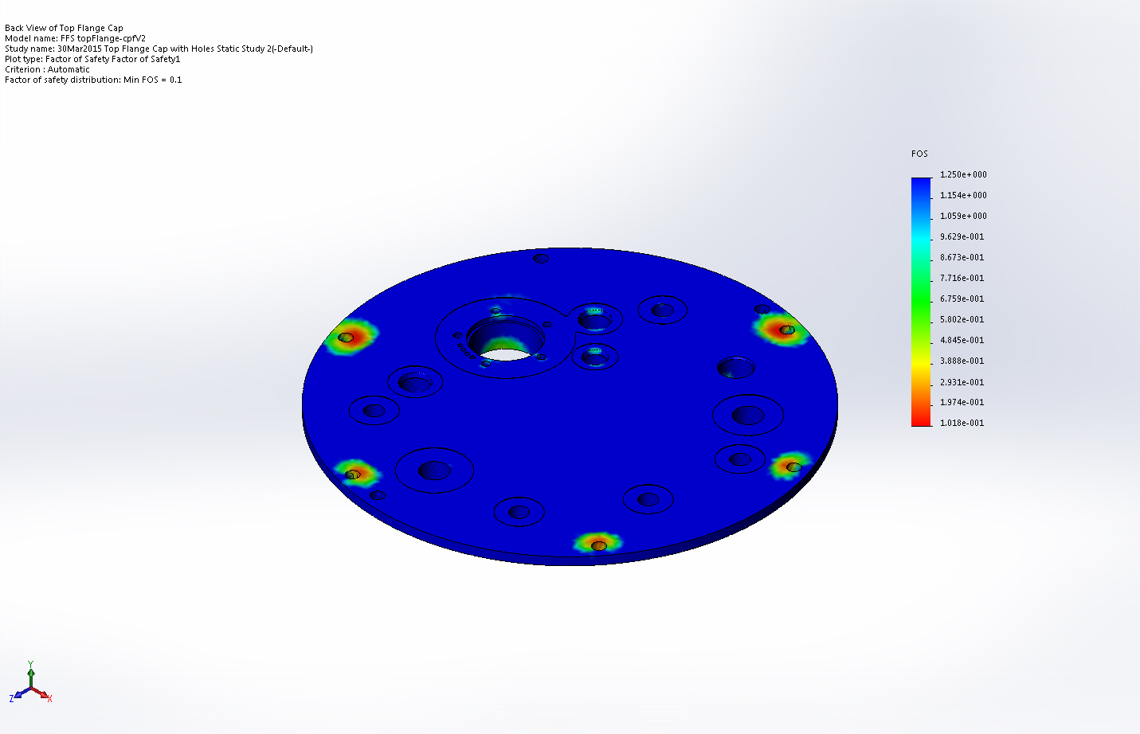
FFS topFlange-cpfV2-30Mar2015 Top Flange Cap with Holes Static Study 2-Factor of Safety-Factor of Safety1

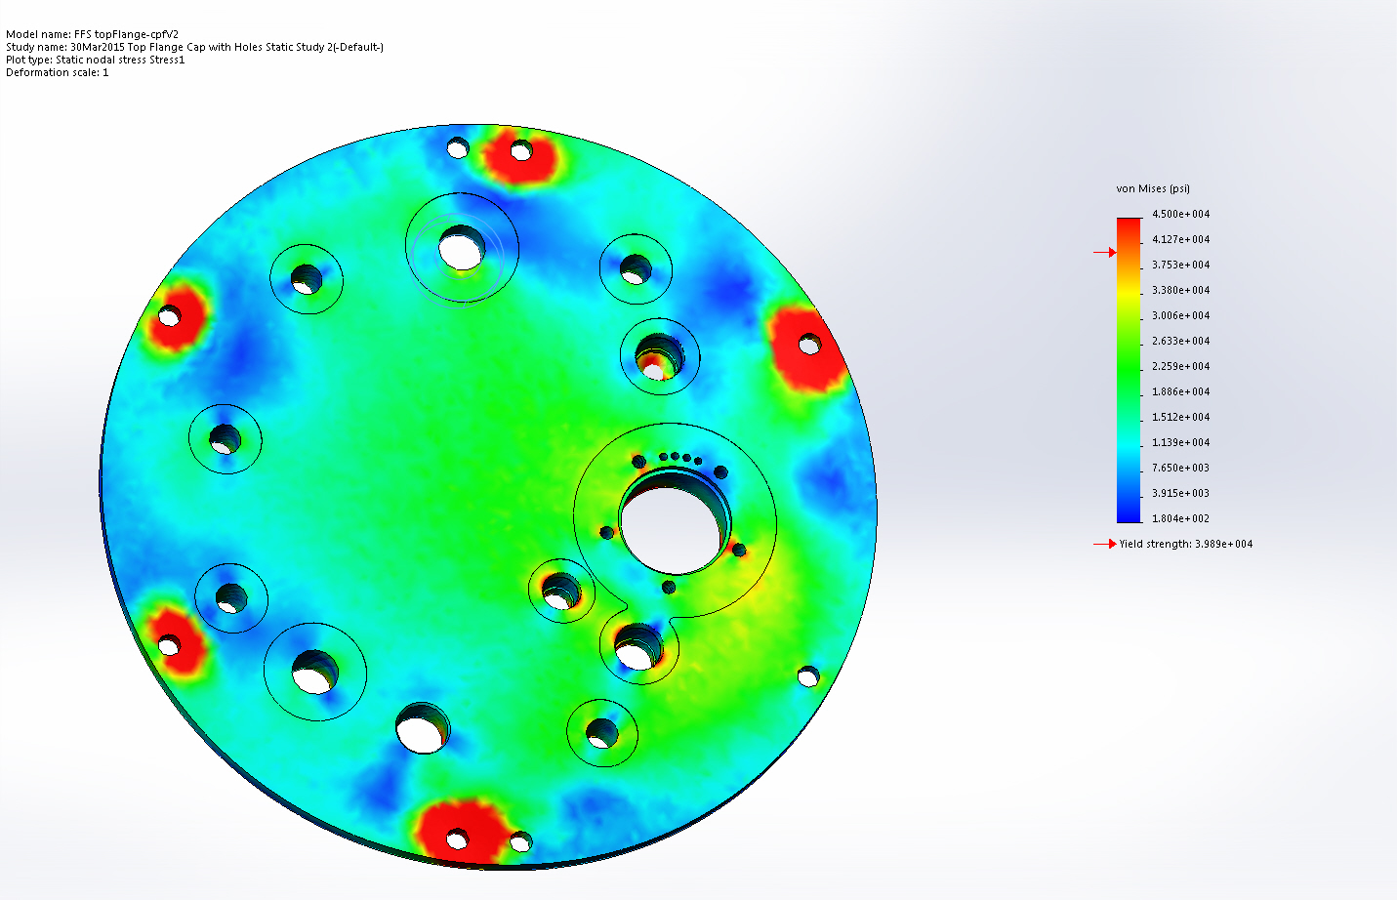
Top VIew Stress 1

Image Comments:
Orange and Red are High Stress Areas

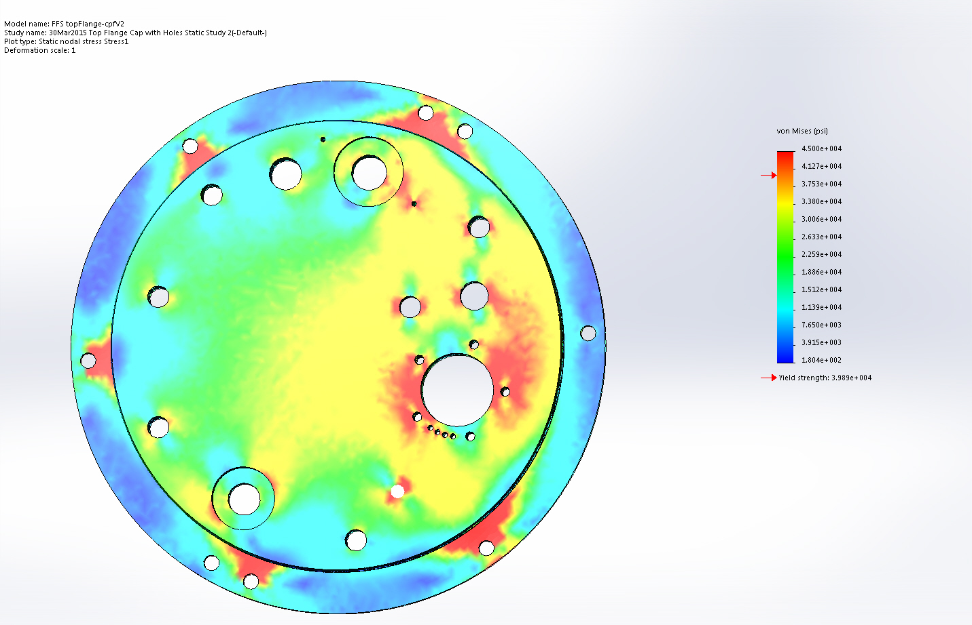
Bottom View Stress 2

Image Comments:
Orange and Red are High Stress Areas

Conclusion

