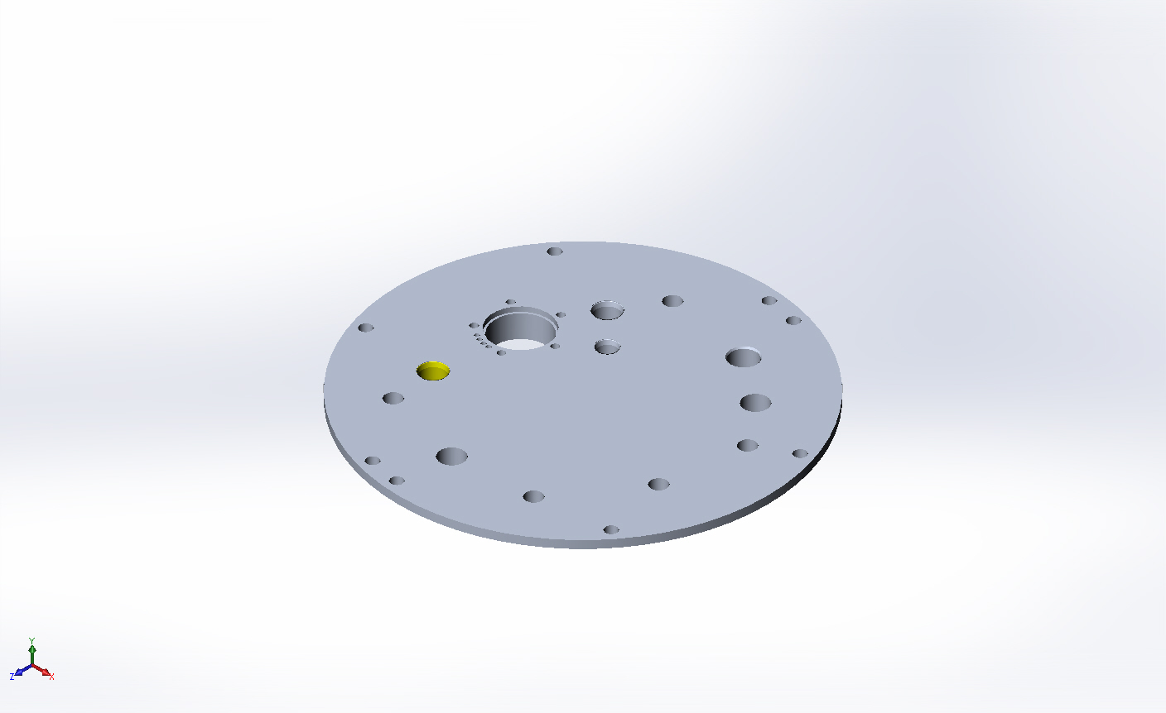
  Simulation of FFS topFlange-cpfV2
  Date: Monday, April 13, 2015
  Designer: FEA run by Farley F. Shane
  Study name: Gene
  Analysis type: Static
  Table of Contents
  Description 1
  Assumptions 2
  Model Information 2
  Study Properties 3
  Units 4
  Material Properties 4
  Loads and Fixtures 5
  Connector Definitions 6
  Contact Information 6
  Mesh Information 7
  Sensor Details 9
  Resultant Forces 9
  Beams 9
  Study Results 10
  Conclusion 17

Description
CPF Top Flange (Gene)

Assumptions

Model Information

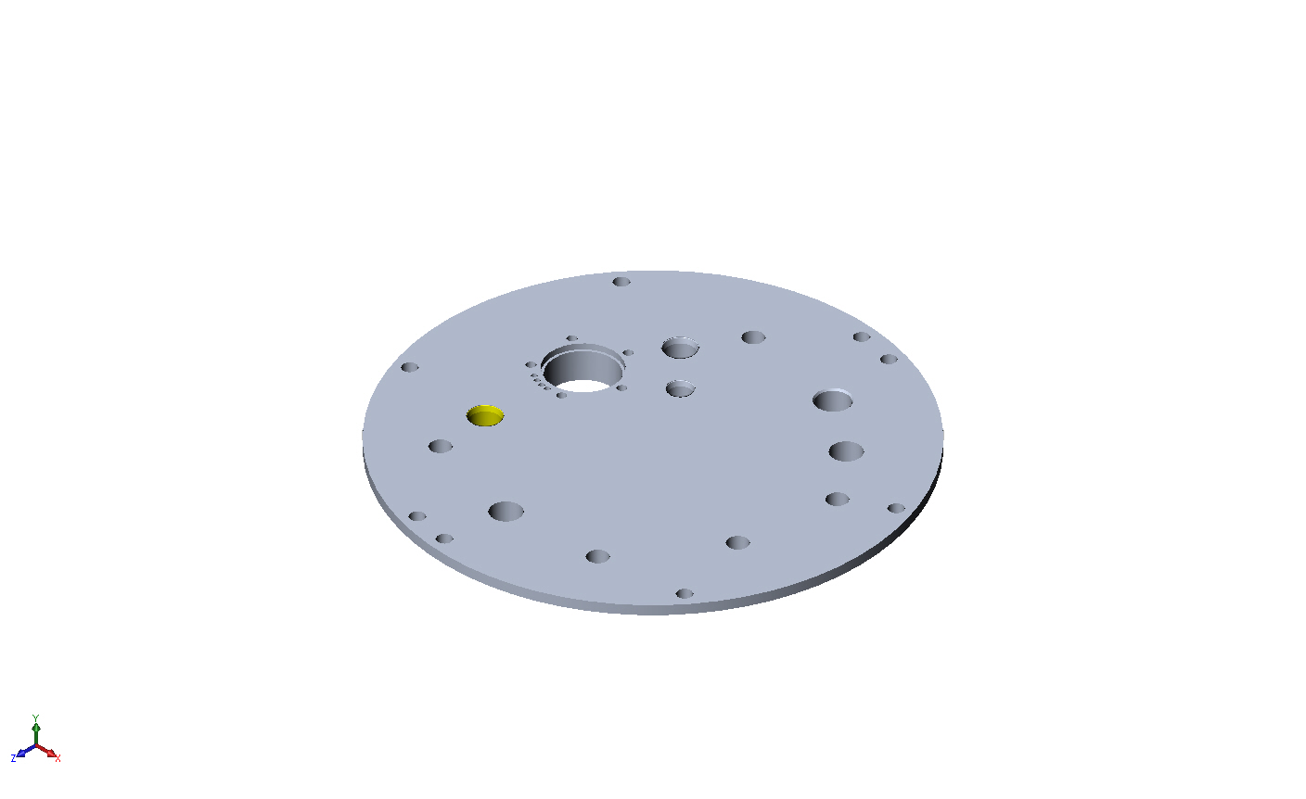
Model name: FFS topFlange-cpfV2
Current Configuration: Default
Solid Bodies
Document Name and Reference | Treated As | Volumetric Properties | Document Path/Date Modified
Boss-Extrude7  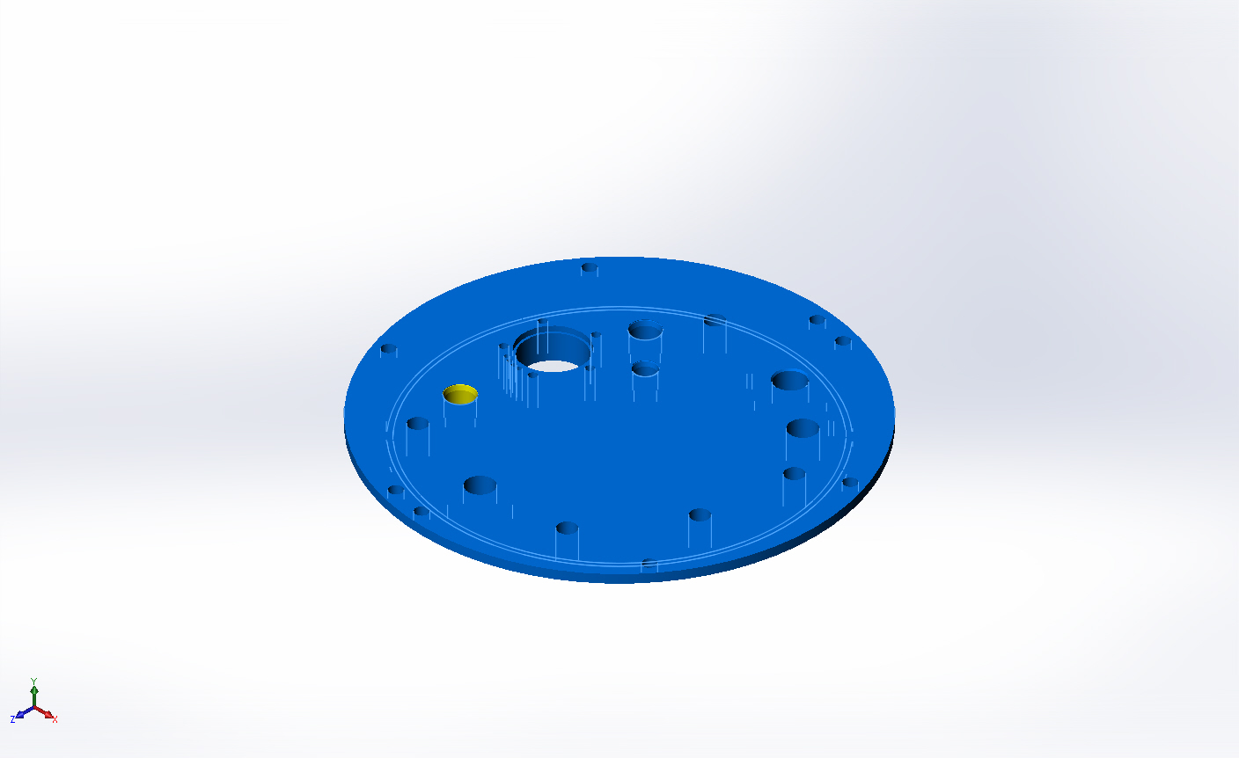 | Solid Body | Mass:3.54664 lb  Volume:36.3595 in^3  Density:0.0975437 lb/in^3  Weight:3.54424 lbf | X:\CPF\Mechanical Engr\Farley\CPF2015Feb03\FFS topFlange-cpfV2.SLDPRT  Apr 13 10:21:26 2015

Study Properties
Study name | Gene
Analysis type | Static
Mesh type | Solid Mesh
Thermal Effect: | On
Thermal option | Include temperature loads
Zero strain temperature | 77 Fahrenheit
Include fluid pressure effects from SolidWorks Flow Simulation | Off
Solver type | FFEPlus
Inplane Effect: | Off
Soft Spring: | Off
Inertial Relief: | Off
Incompatible bonding options | Automatic
Large displacement | Off
Compute free body forces | On
Friction | Off
Use Adaptive Method: | Off
Result folder | SolidWorks document (X:\CPF\Mechanical Engr\Farley\CPF2015Feb03)

Units
Unit system: | English (IPS)
Length/Displacement | in
Temperature | Fahrenheit
Angular velocity | Hertz
Pressure/Stress | psi

Material Properties
Model Reference | Properties | Components
 |  | SolidBody 1(Boss-Extrude7)(FFS topFlange-cpfV2)
  Name: | 6061-T6 (SS)
  Model type: | Linear Elastic Isotropic
  Default failure criterion: | Unknown
  Yield strength: | 39885.4 psi
  Tensile strength: | 44961.7 psi
  Elastic modulus: | 1.00076e+007 psi
  Poisson's ratio: | 0.33
  Mass density: | 0.0975437 lb/in^3
  Shear modulus: | 3.77098e+006 psi
  Thermal expansion coefficient: | 1.33333e-005 /Fahrenheit
Curve Data:N/A

Loads and Fixtures
Fixture name | Fixture Image | Fixture Details
Reference Geometry-1 | 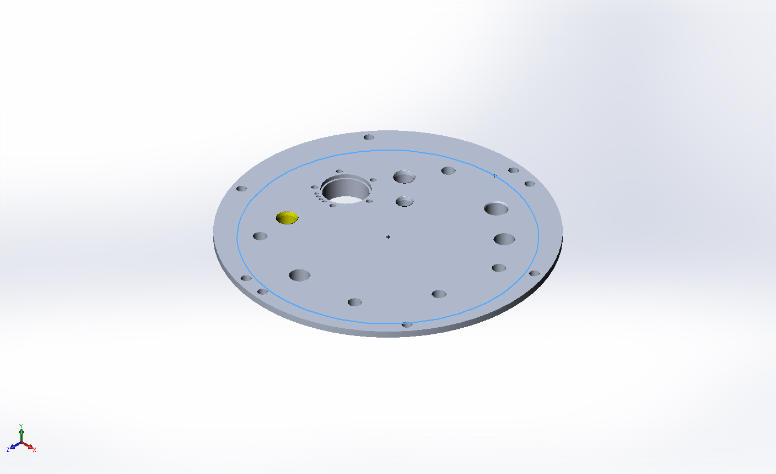
  Entities: | 1 edge(s)
  Reference: | Face< 1 >
  Type: | Use reference geometry
  Translation: | ---, ---, 0
  Units: | in
Resultant Forces
Components | X | Y | Z | Resultant
Reaction force(lbf) | 0 | 36898.7 | 0 | 36898.7
Reaction Moment(lbf.in) | 0 | 0 | 0 | 0

On Cylindrical Faces-1 | 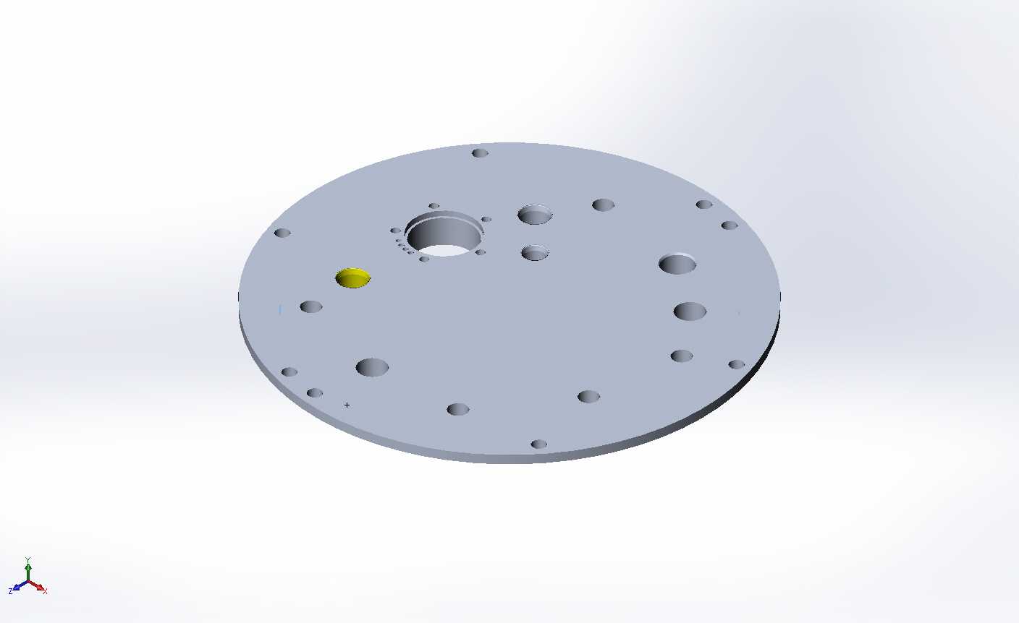
  Entities: | 1 face(s)
  Type: | On Cylindrical Faces
  Translation: | 0, ---, ---
  Units: | in
Resultant Forces
Components | X | Y | Z | Resultant
Reaction force(lbf) | 22.7486 | -0.795485 | -8.46881 | 24.2869
Reaction Moment(lbf.in) | 0 | 0 | 0 | 0

Load name | Load Image | Load Details
Pressure-3 | 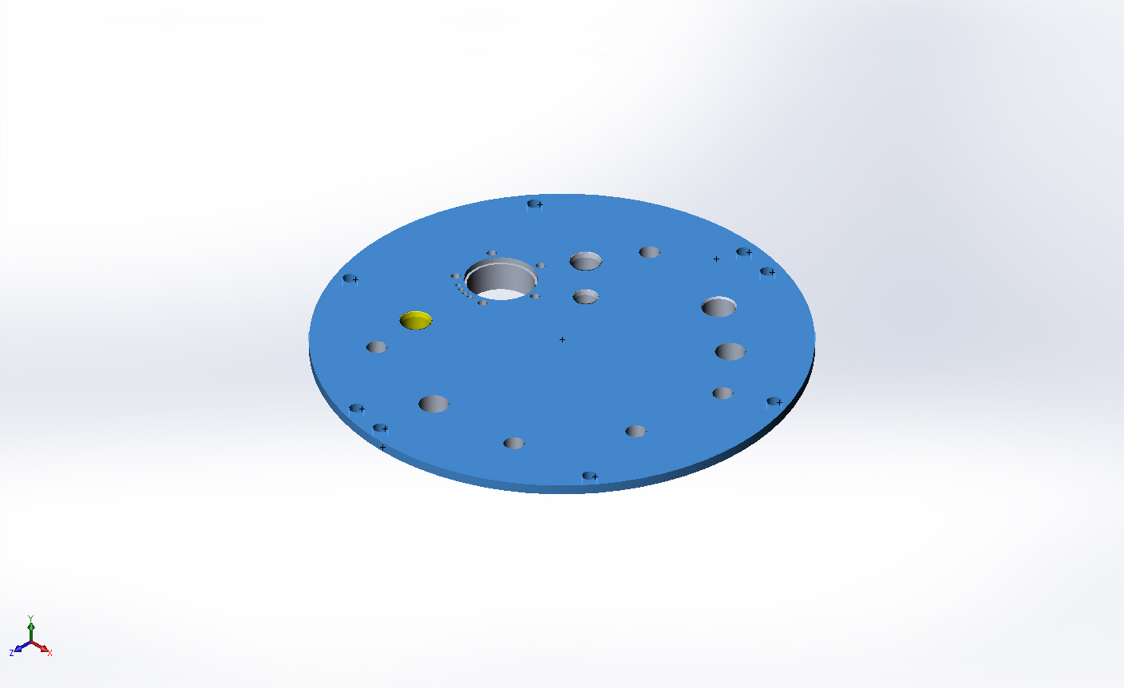
  Entities: | 11 face(s)
  Type: | Normal to selected face
  Value: | 750
  Units: | psi
  Phase Angle: | 0
  Units: | deg

Connector Definitions
No Data

Contact Information
No Data

Mesh Information
Mesh type | Solid Mesh
Mesher Used: | Curvature based mesh
Jacobian points | 4 Points
Maximum element size | 0.2 in
Minimum element size | 0.04 in
Mesh Quality | High

Mesh Information - Details
Total Nodes | 335925
Total Elements | 213417
Maximum Aspect Ratio | 107.75
% of elements with Aspect Ratio < 3 | 88.9
% of elements with Aspect Ratio > 10 | 2.56
% of distorted elements(Jacobian) | 0
Time to complete mesh(hh;mm;ss): | 00:00:32
Computer name: | ENIGMA
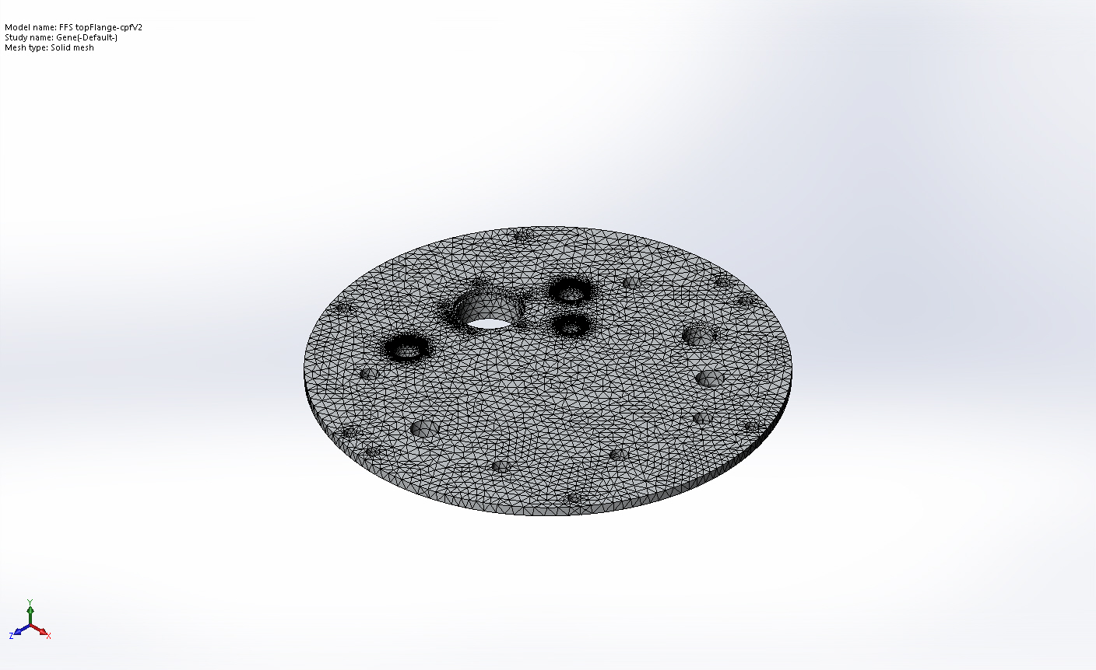

Mesh Control Information:
Mesh Control Name | Mesh Control Image | Mesh Control Details
Control-1 | 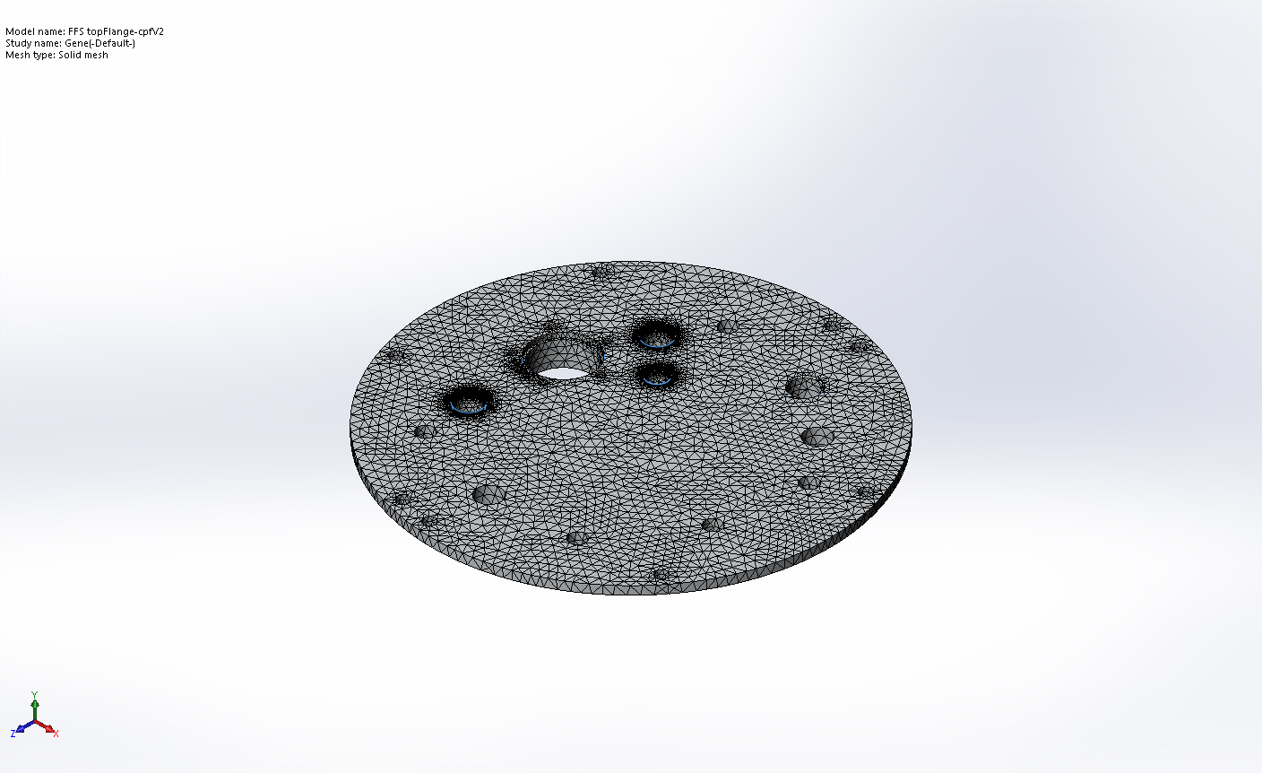
  Entities: | 11 face(s)
  Units: | in
  Size: | 0.1
  Ratio: | 1.5

Sensor Details
No Data

Resultant Forces

Reaction Forces
Selection set | Units | Sum X | Sum Y | Sum Z | Resultant
Entire Model | lbf | 24.5173 | 36898 | -7.73346 | 36898

Reaction Moments
Selection set | Units | Sum X | Sum Y | Sum Z | Resultant
Entire Model | lbf.in | 0 | 0 | 0 | 0

Beams
No Data

Study Results

Name | Type | Min | Max
Stress1 | VON: von Mises Stress | 11.4615 psi  Node: 75892 | 185498 psi  Node: 82000
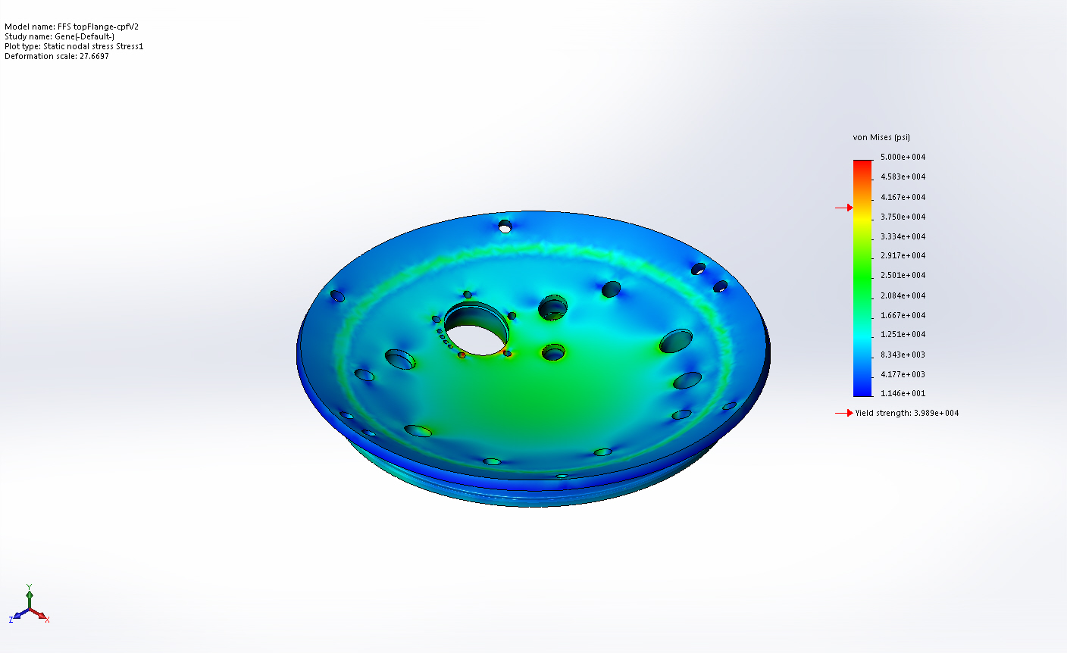
FFS topFlange-cpfV2-Gene-Stress-Stress1

Name | Type | Min | Max
Displacement1 | URES: Resultant Displacement | 0.00193302 in  Node: 108 | 0.0344965 in  Node: 180572
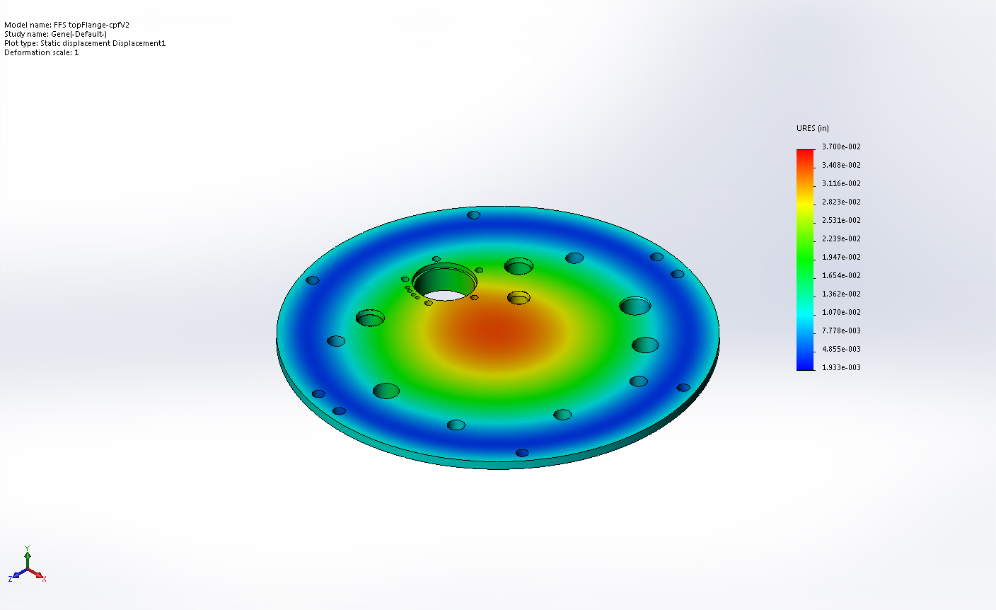
FFS topFlange-cpfV2-Gene-Displacement-Displacement1

Name | Type | Min | Max
Strain1 | ESTRN: Equivalent Strain | 1.17031e-005  Element: 109509 | 0.0129471  Element: 22984
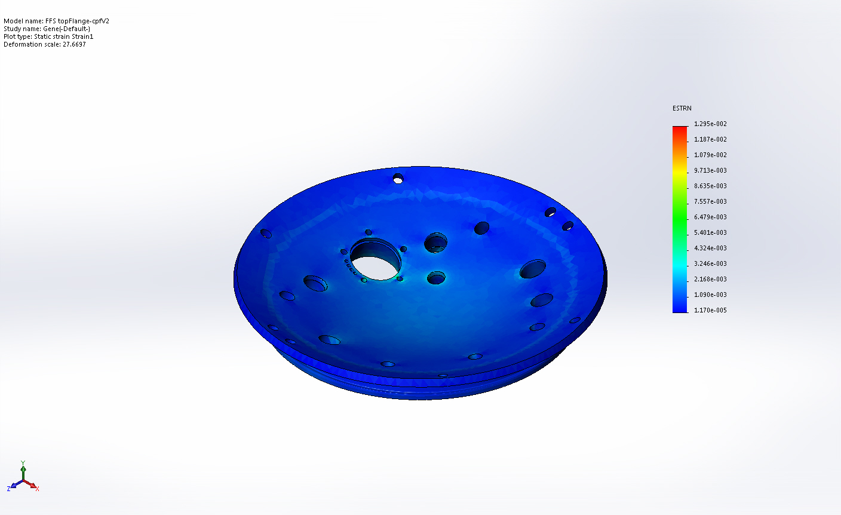
FFS topFlange-cpfV2-Gene-Strain-Strain1

Name | Type
Displacement1{1} | Deformed Shape
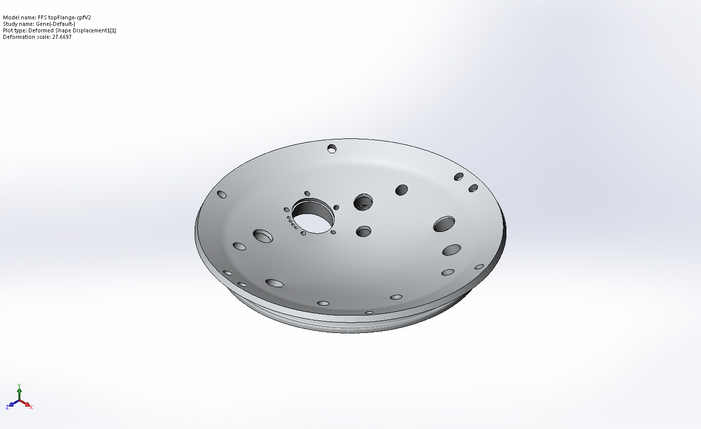
FFS topFlange-cpfV2-Gene-Displacement-Displacement1{1}

Name | Type | Min | Max
Factor of Safety1 | Automatic | 0.215018  Node: 82000 | 2  Node: 1
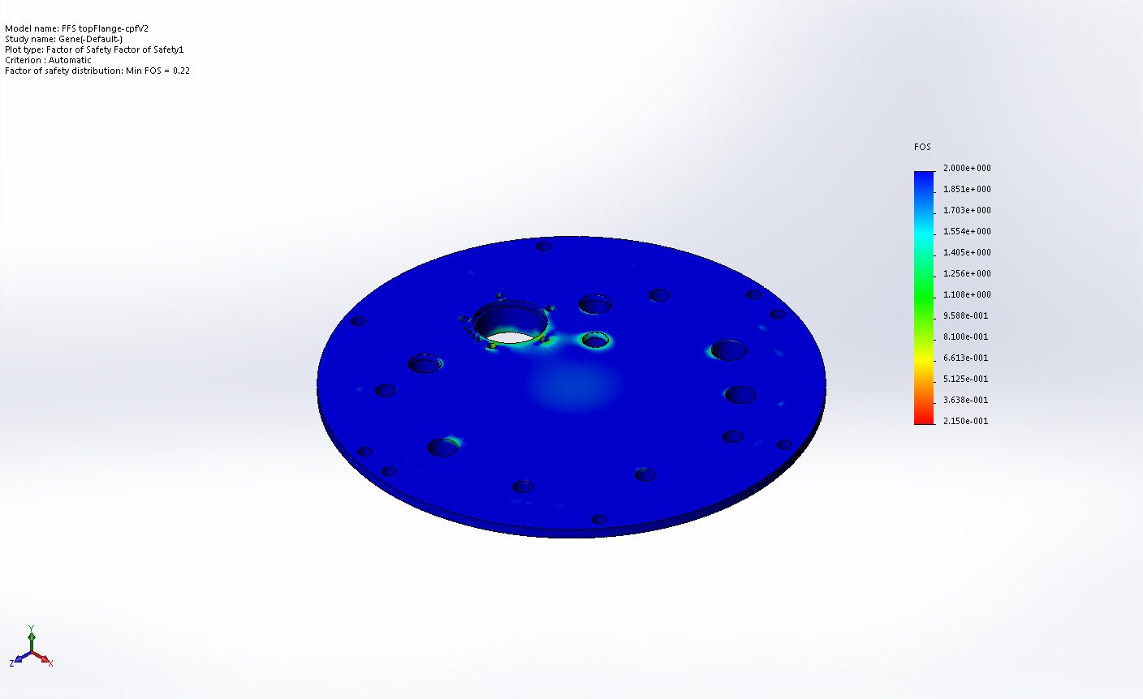
FFS topFlange-cpfV2-Gene-Factor of Safety-Factor of Safety1

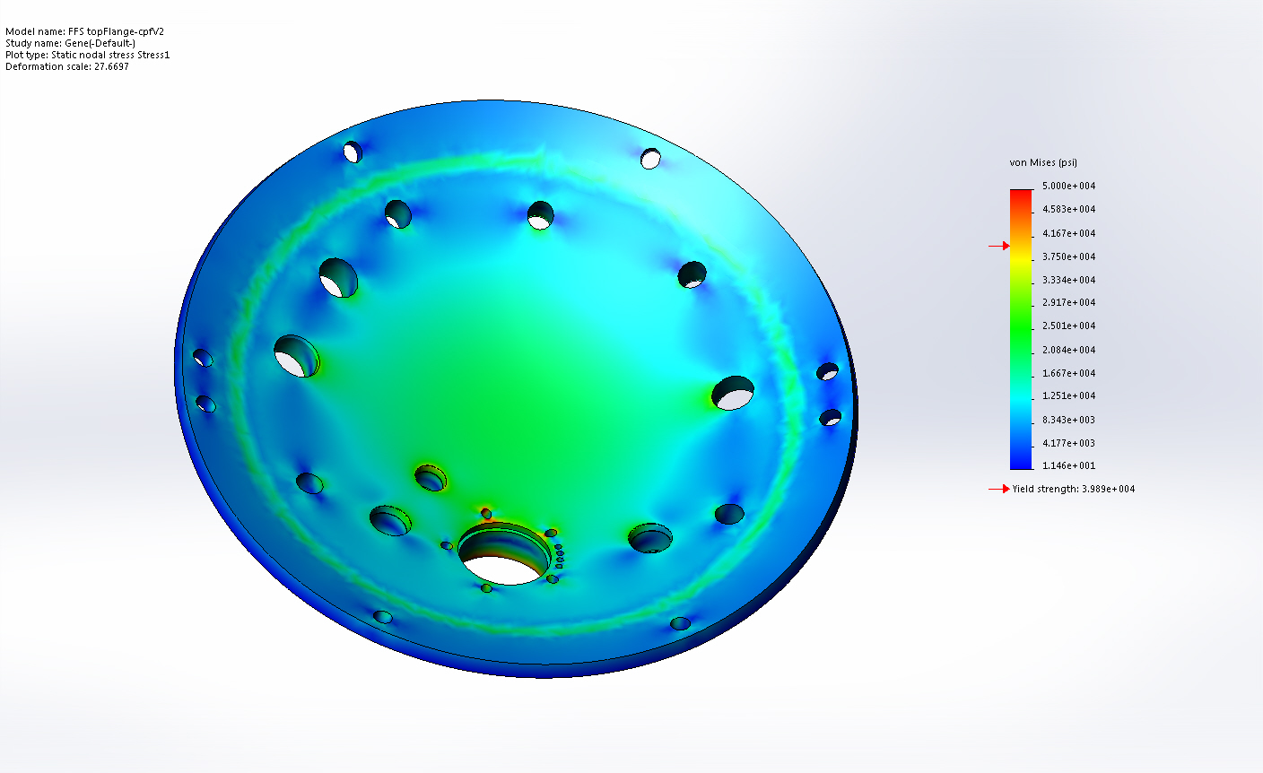
Top Von Mises

Image Comments:
Local Issues

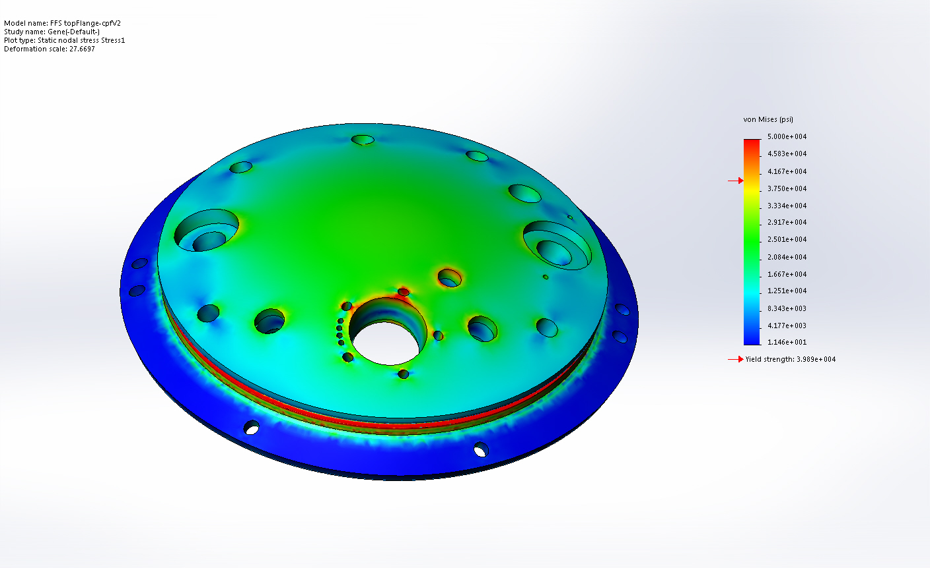
Bottom Von Mises

Image Comments:
Issues include threaded holes and O-Ring Groove

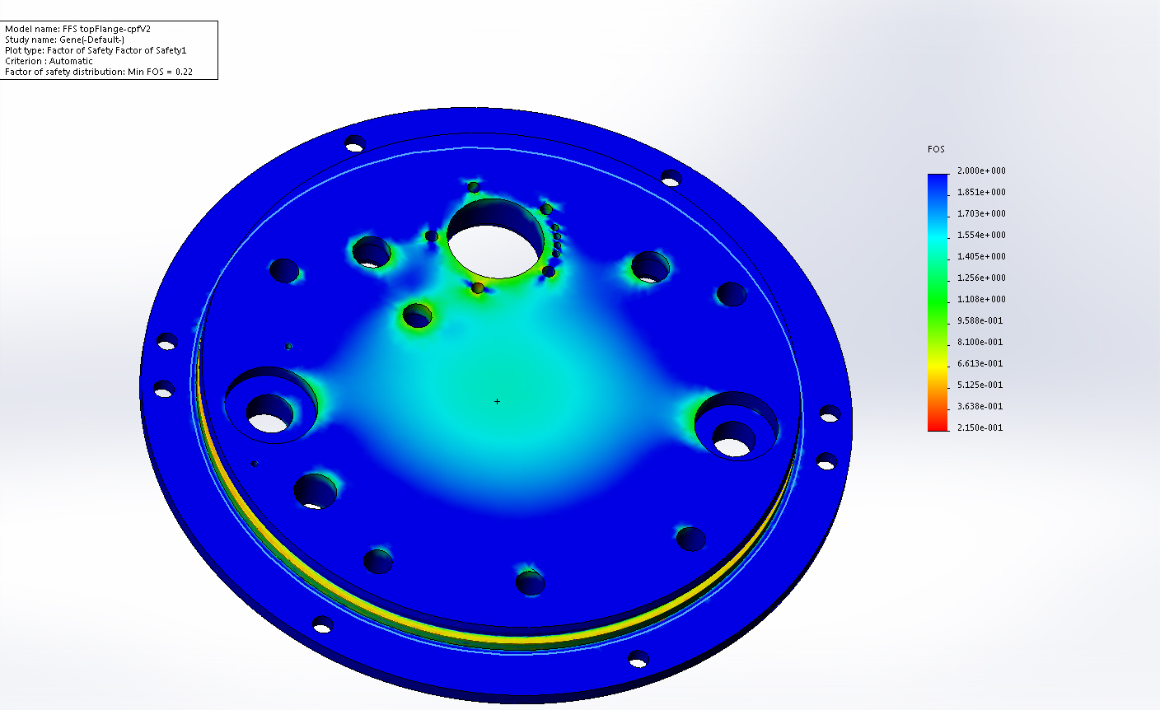
Bottom Max FOS=2

Image Comments:
Some threaded holes and O-Ring groove are only about 0.6 FOS

Conclusion

