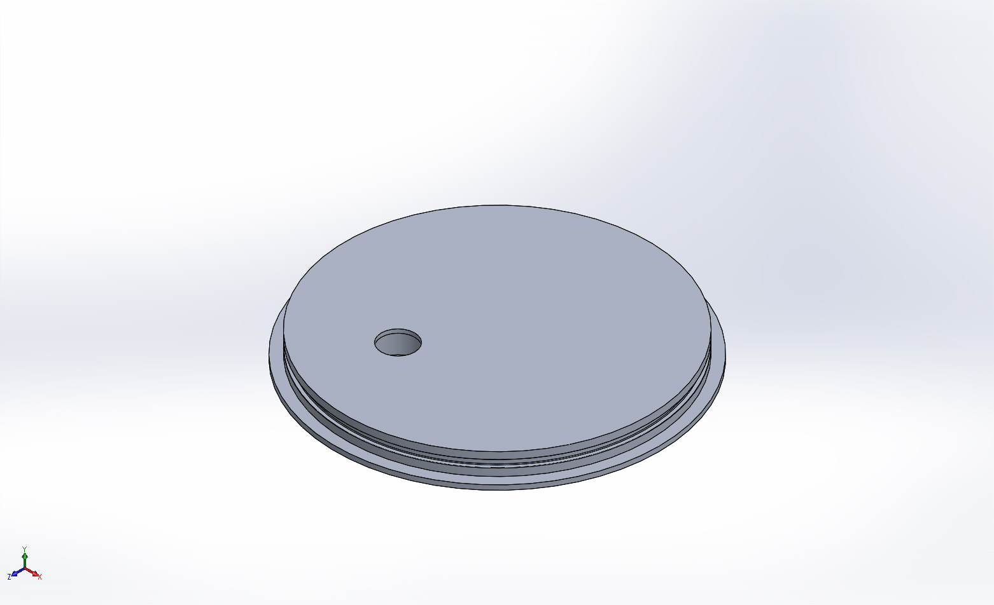
  Simulation of housingBase-cpfV2
  Date: Monday, June 15, 2015
  Designer: FEA Run by Farley F. Shane
  Study name: 11June2015 housingBase-cpfV2 Static 1
  Analysis type: Static
  Table of Contents
  Description 1
  Assumptions 2
  Model Information 2
  Study Properties 3
  Units 3
  Material Properties 4
  Loads and Fixtures 5
  Connector Definitions 5
  Contact Information 6
  Mesh information 7
  Sensor Details 8
  Resultant Forces 9
  Beams 9
  Study Results 10
  Conclusion 13

Description
Static FEA
for
housing Base-cpfV2 Static 1
11June2015

Assumptions

Model Information

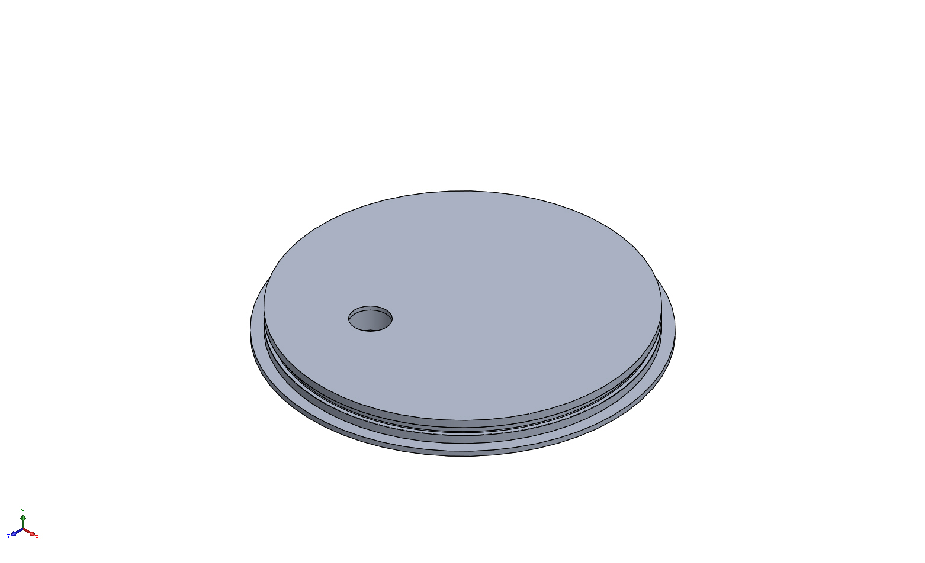
Model name: housingBase-cpfV2
Current Configuration: withBellows
Solid Bodies
Document Name and Reference | Treated As | Volumetric Properties | Document Path/Date Modified
Boss-Extrude1 | Solid Body | Mass:1.57435 kg  Volume:0.000583093 m^3  Density:2700 kg/m^3  Weight:15.4286 N | X:\CPF\Mechanical Engr\Farley\CPF2015Feb03\housingBase-cpfV2.SLDPRT  Jun 11 13:50:30 2015

Study Properties
Study name | 11June2015 housingBase-cpfV2 Static 1
Analysis type | Static
Mesh type | Solid Mesh
Thermal Effect: | On
Thermal option | Include temperature loads
Zero strain temperature | 298 Kelvin
Include fluid pressure effects from SOLIDWORKS Flow Simulation | Off
Solver type | FFEPlus
Inplane Effect: | Off
Soft Spring: | On
Inertial Relief: | Off
Incompatible bonding options | Automatic
Large displacement | Off
Compute free body forces | On
Friction | Off
Use Adaptive Method: | Off
Result folder | SOLIDWORKS document (X:\CPF\Mechanical Engr\Farley\CPF2015Feb03)

Units
Unit system: | SI (MKS)
Length/Displacement | mm
Temperature | Kelvin
Angular velocity | Rad/sec
Pressure/Stress | N/m^2

Material Properties
Model Reference | Properties | Components
 |  | SolidBody 1(Boss-Extrude1)(housingBase-cpfV2)
  Name: | 6061-T6 (SS)
  Model type: | Linear Elastic Isotropic
  Default failure criterion: | Unknown
  Yield strength: | 2.75e+008 N/m^2
  Tensile strength: | 3.1e+008 N/m^2
  Elastic modulus: | 6.9e+010 N/m^2
  Poisson's ratio: | 0.33
  Mass density: | 2700 kg/m^3
  Shear modulus: | 2.6e+010 N/m^2
  Thermal expansion coefficient: | 2.4e-005 /Kelvin
Curve Data:N/A

Loads and Fixtures
Fixture name | Fixture Image | Fixture Details
Fixed-1 | 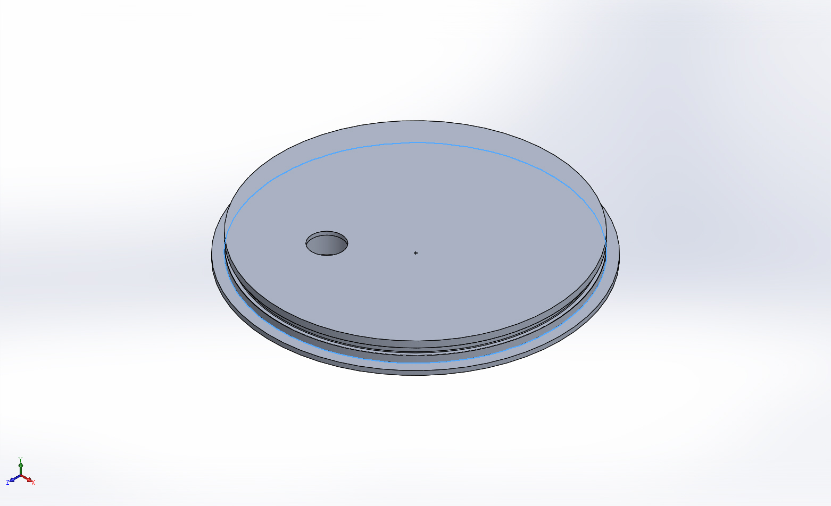
  Entities: | 1 edge(s)
  Type: | Fixed Geometry
Resultant Forces
Components | X | Y | Z | Resultant
Reaction force(N) | 0.598572 | -152126 | 8.61084 | 152126
Reaction Moment(N.m) | 0 | 0 | 0 | 0

Load name | Load Image | Load Details
Pressure-1 | 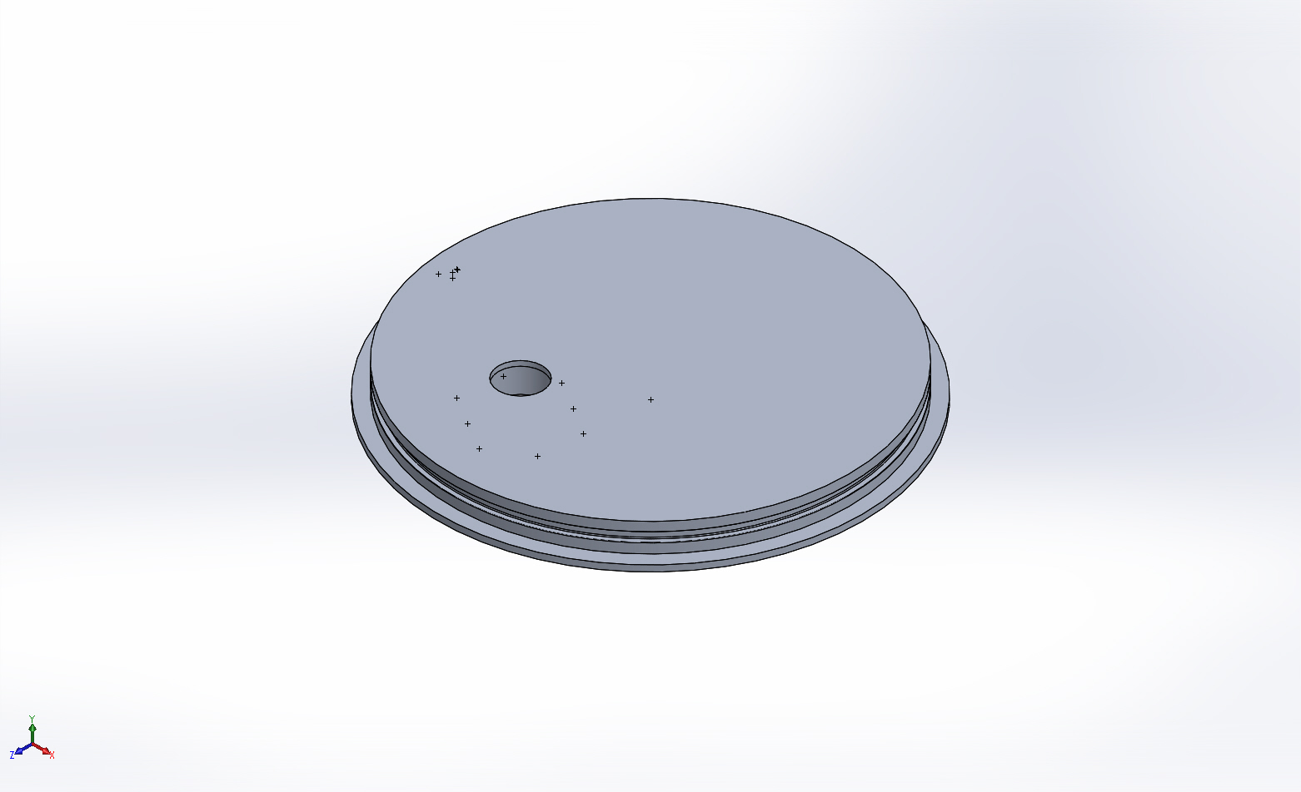
  Entities: | 14 face(s)
  Type: | Normal to selected face
  Value: | 750
  Units: | psi
  Phase Angle: | 0
  Units: | deg

Connector Definitions
No Data

Contact Information
No Data

Mesh information
Mesh type | Solid Mesh
Mesher Used: | Standard mesh
Automatic Transition: | Off
Include Mesh Auto Loops: | Off
Jacobian points | 4 Points
Element Size | 0.2 in
Tolerance | 0.01 in
Mesh Quality | High

Mesh information - Details
Total Nodes | 56482
Total Elements | 36209
Maximum Aspect Ratio | 13.9
% of elements with Aspect Ratio < 3 | 95.5
% of elements with Aspect Ratio > 10 | 0.102
% of distorted elements(Jacobian) | 0
Time to complete mesh(hh;mm;ss): | 00:00:07
Computer name: | ENIGMA
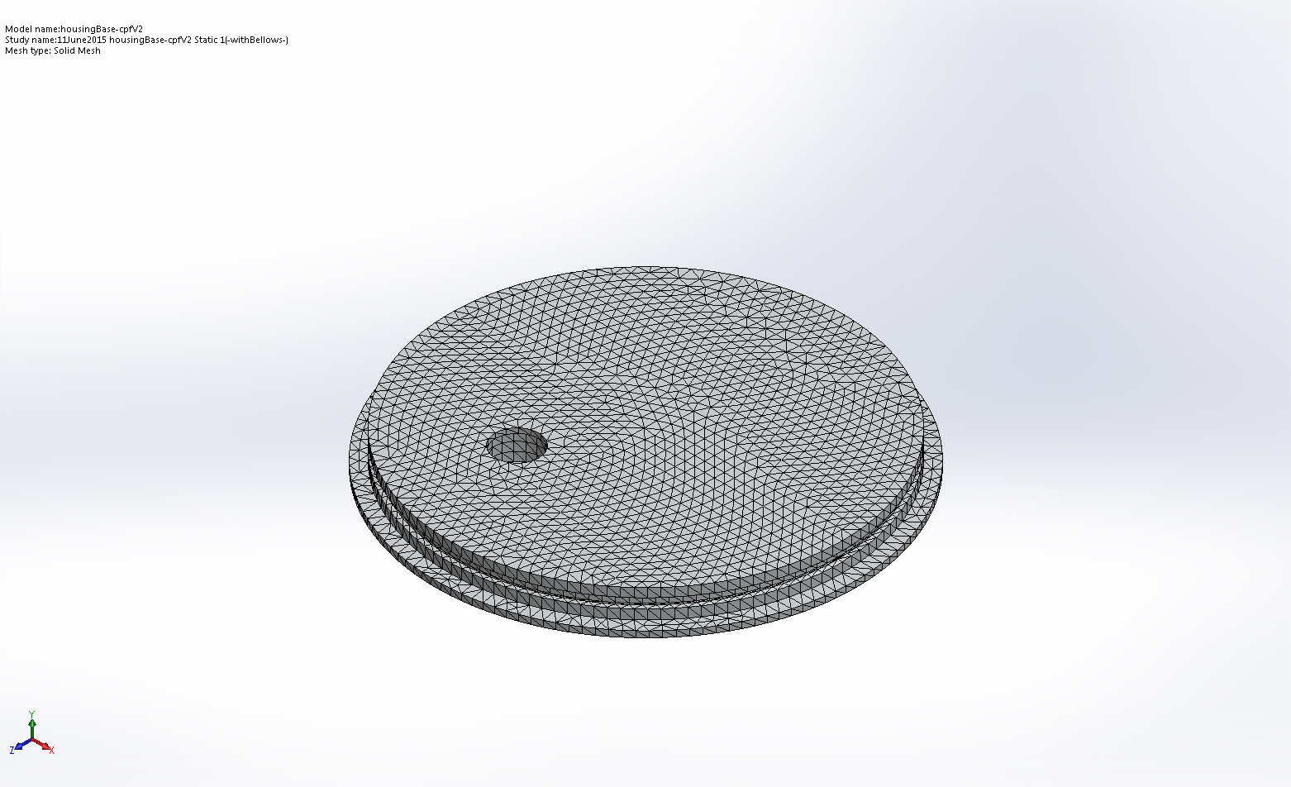

Sensor Details
No Data

Resultant Forces

Reaction forces
Selection set | Units | Sum X | Sum Y | Sum Z | Resultant
Entire Model | N | 0.598572 | -152126 | 8.61084 | 152126

Reaction Moments
Selection set | Units | Sum X | Sum Y | Sum Z | Resultant
Entire Model | N.m | 0 | 0 | 0 | 0

Beams
No Data

Study Results

Name | Type | Min | Max
Stress1 | VON: von Mises Stress | 59.4122 psi  Node: 39423 | 44530.4 psi  Node: 7
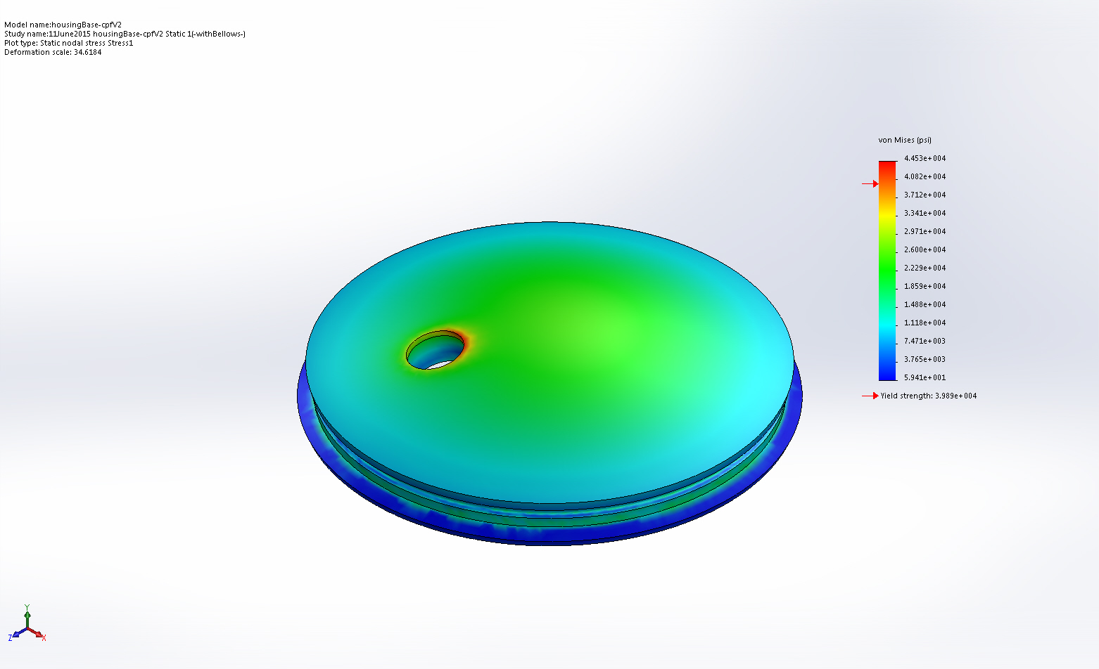
housingBase-cpfV2-11June2015 housingBase-cpfV2 Static 1-Stress-Stress1

Name | Type | Min | Max
Displacement1 | URES: Resultant Displacement | 0 mm  Node: 253 | 0.632832 mm  Node: 26587
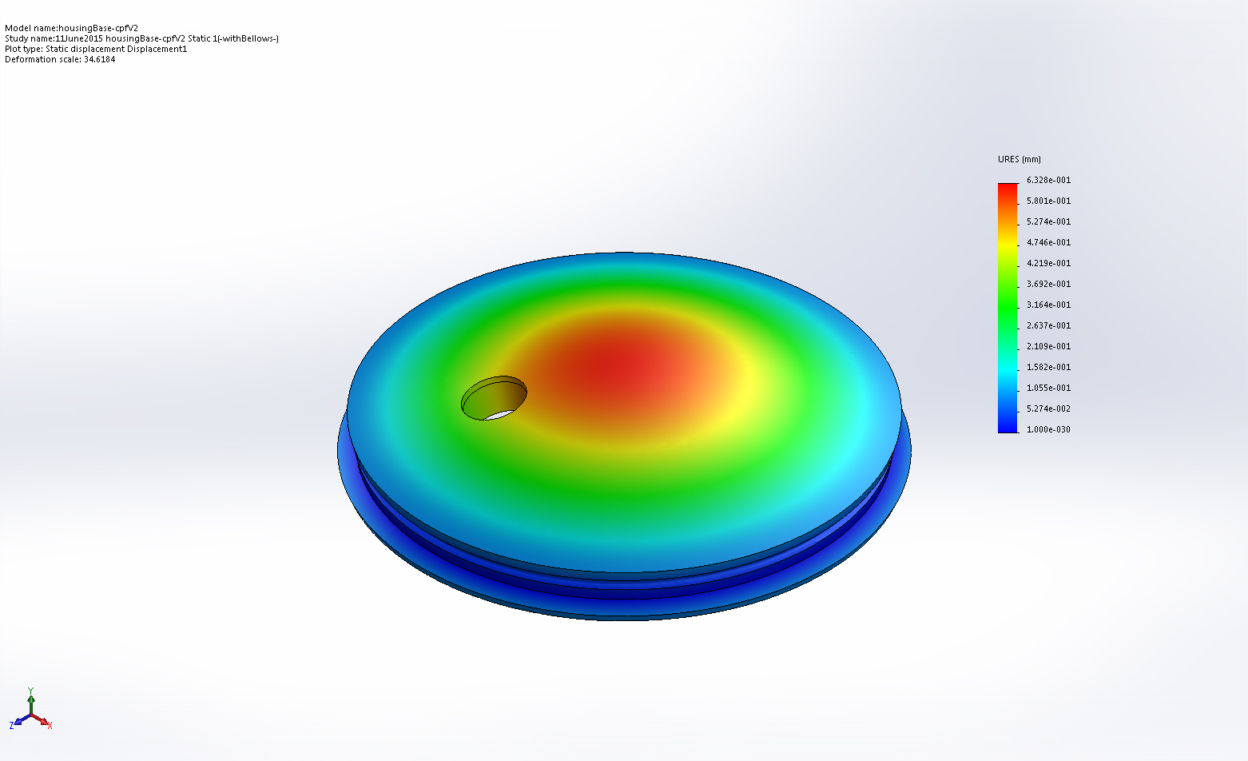
housingBase-cpfV2-11June2015 housingBase-cpfV2 Static 1-Displacement-Displacement1

Name | Type | Min | Max
Strain1 | ESTRN: Equivalent Strain | 1.56989e-005  Element: 13655 | 0.00335553  Element: 8597
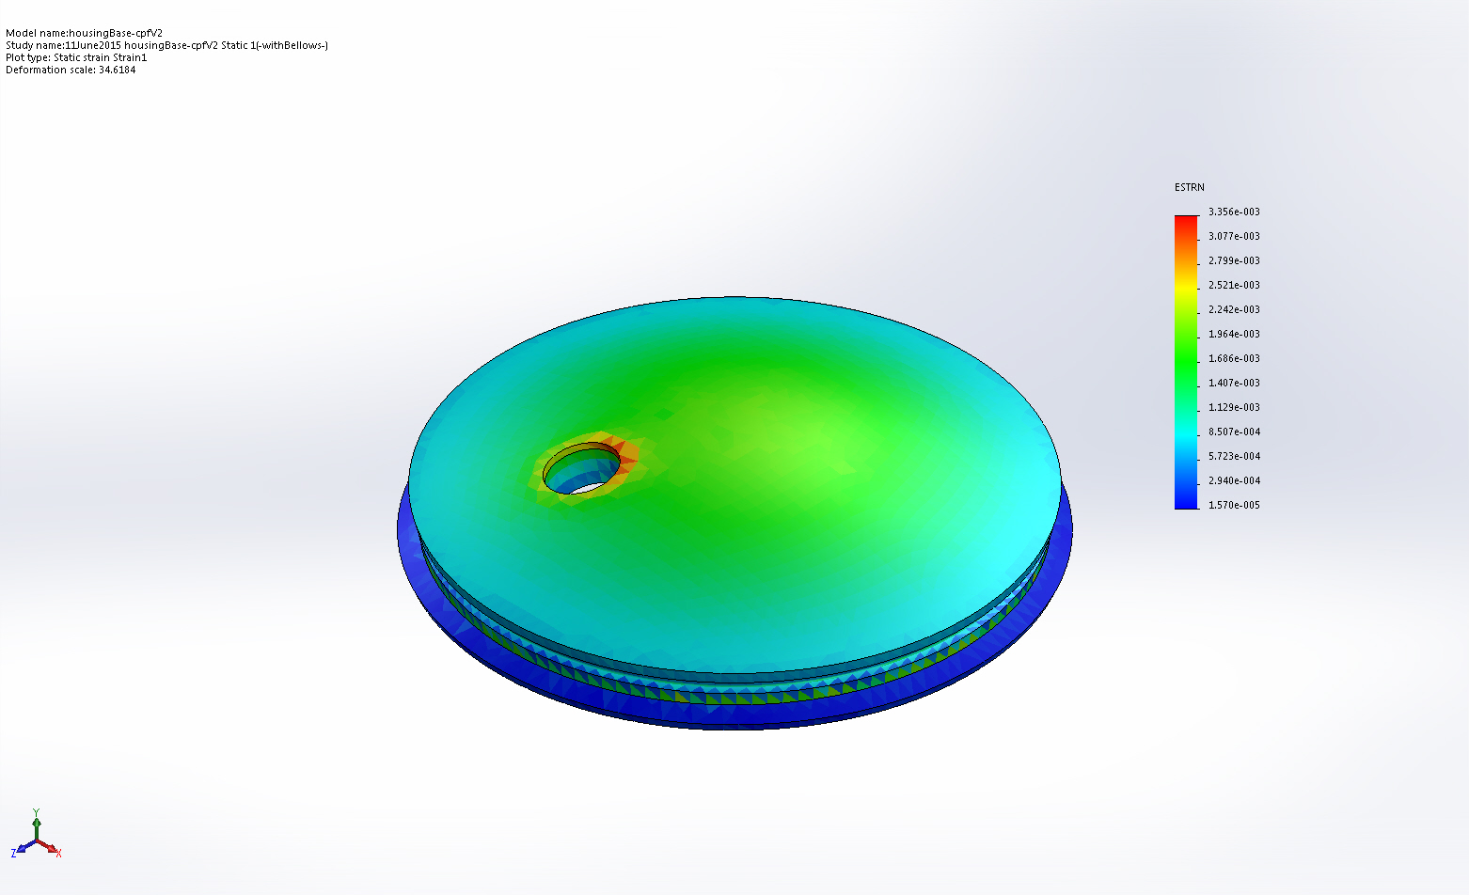
housingBase-cpfV2-11June2015 housingBase-cpfV2 Static 1-Strain-Strain1

Name | Type | Min | Max
Factor of Safety1 | Automatic | 0.895688  Node: 7 | 5  Node: 23
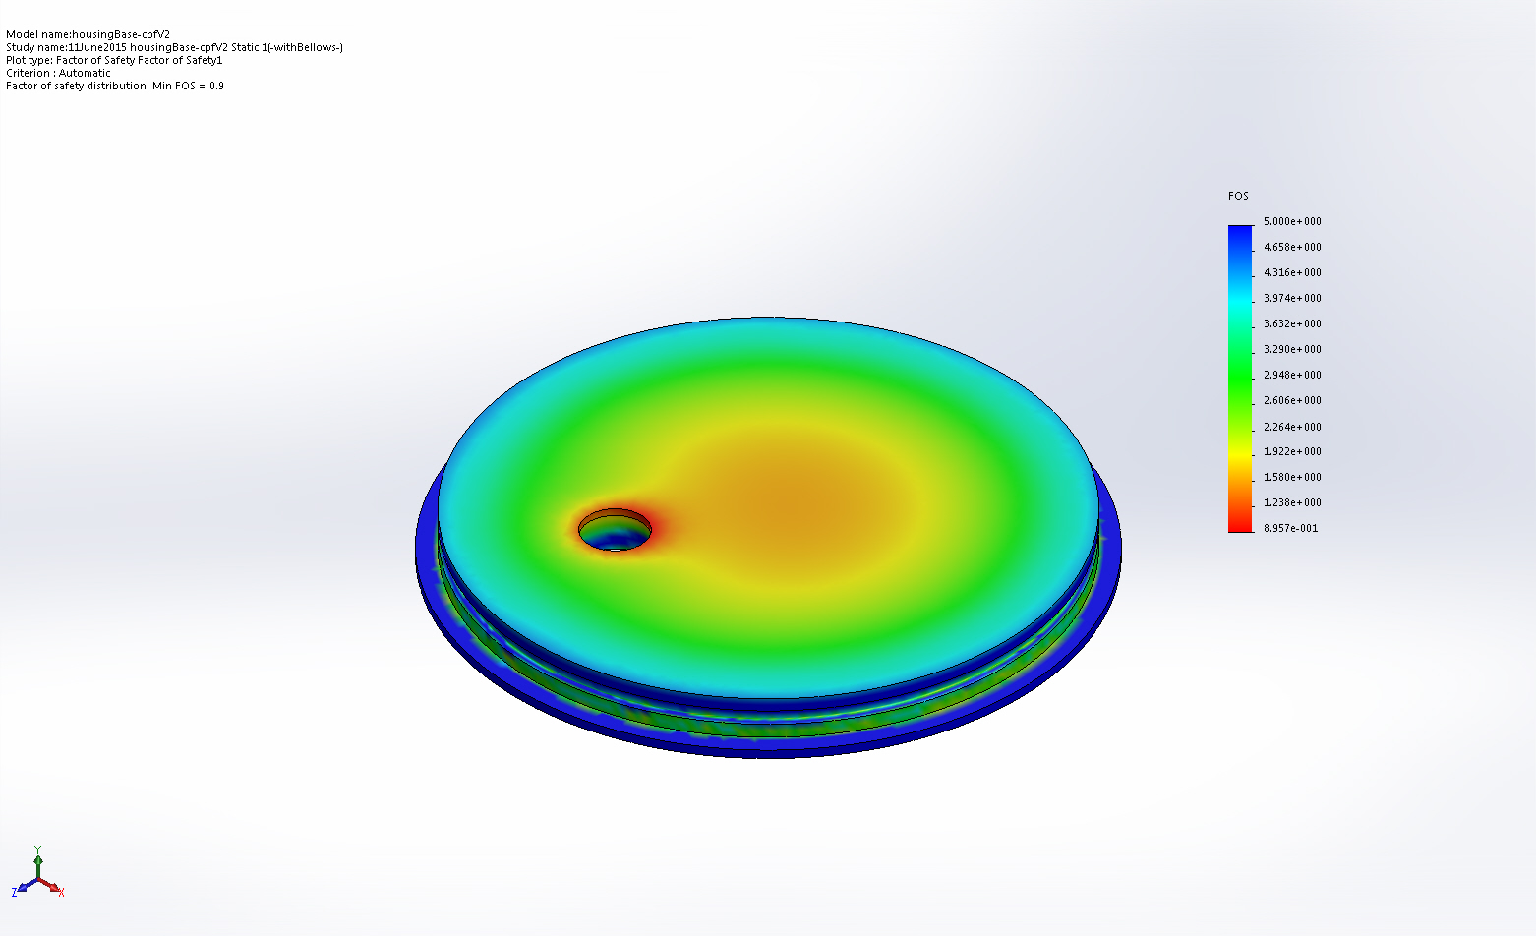
housingBase-cpfV2-11June2015 housingBase-cpfV2 Static 1-Factor of Safety-Factor of Safety1

Conclusion

