- ABSTRACT (all projects)
The continental shelves and slopes comprise only 5 to 10 % of the ocean’s area, but they contribute half of the global new primary production (Benway et al., 2016). Variability in this new primary production can be a major control on air-sea CO2 flux (Evans et al., 2015). The disproportionately high new primary production in coastal systems supports the vast majority of global fish production (Ryther, 1969), which may be significantly impacted by future climate change (Brander, 2007). Other than remote sensing of ocean color, there are no observing systems that provide a synoptic view of ecosystem processes such as new or net primary production in coastal systems. As a result, the CCARS Science Plan For Carbon Cycle Research (Benway et al., 2014) calls for greater use of autonomous platforms and sensors to assess carbon cycle processes, “All coastal regions of North America experience short-term events (e.g., winter storms, plankton blooms, hurricanes, upwelling and acidification events) that can strongly influence carbon delivery, processing, and fate, so there is a need to further develop our observational capacity (e.g., novel autonomous platforms) in all continental margin systems to be able to capture event scale processes and quantify their impacts on coastal carbon budgets.” Coastal profiling floats also provide an efficient means to monitor regional signals of ocean acidification (Chan et al., 2017) in open, shelf waters.

The CPF is designed specifically to provide a robust, highly capable, reasonably configurable and reasonably affordable array of observational platforms to support of the type of coastal science research described above. In this proposal, we are working on applying the current fleet of 3 CPFs to science tasks directly related to the MBARI Chem Sensor lab science mission and to related projects outside our lab.

- PROPOSAL (all projects)

Background
Provide context for the project, being sure to address these questions:
- What fundamental problem does this project address, and why is it important?
Please see the abstract above.

- What makes this work relevant to MBARI and the Packard Foundation?
This project is very much in line with MBARI’s 2011 strategic plan, the technology roadmap and the Packard Foundation’s Ocean Grantmaking Program. The 3 overarching goals from the 2011 strategic plan can be summarized as “Develop or adapt innovative technologies … to explore and understand how natural ocean systems operate and how they respond to natural and anthropogenic change …[and] transfer the knowledge gained, solutions devised, and the technology developed to communities outside of MBARI”. The CPF extends existing profiling float technology to allow a comprehensive suite of biogeochemical instruments to be deployed in the coastal zone and upper 500 meters of the world’s oceans in order to understand the effects of a warming climate, increased use of nitrogen fertilizers, acidification, loss of sea ice, decreasing oxygen concentrations and a variety of other natural and anthropogenically driven processes. The end goal for the CPF project is to transfer the technology to a commercial partner making it available to the entire oceanographic community.

The CPF fits in 2 of the 3 initiatives identified in the Technical Roadmap, “Taking the laboratory into the ocean” and “Advancing a persistent presence” and the “Biogeochemical cycles” challenge also identified in the Technology Roadmap.

The David & Lucille Packard Foundation U.S. West Coast Strategic Plan identifies 4 desired outcomes for their activities in the next 10 years. One of these is “Fisheries and protected area managers are equipped to implement ecosystem-based management and adapt to the impacts of climate change and ocean acidification”. The CPF is targeted at providing precisely the kind of fundamental, economically sustainable, ecosystem wide data required by fisheries and protected area managers to make science driven, ecosystem-based policy decisions.

- Is this effort linked to other internal or externally funded projects or collaborative efforts?
Magdalena and Yui used the CPF as the platform for their Mixing Rates from Autonomous Platforms in the Coastal Ocean project in 2021. Magdalena and Yui expect to continue using the CPF as a platform for their research efforts. Colleen Durkin has several ways to use the CPF both as a sediment collection platform and as a platform for advanced imaging technologies. We are pleased to report that Colleen has submitted an OTIC proposal using the CPF as a platform for advanced imaging technology. Andrea Fassbender has also indicated an interest in using the CPF in her research at PMEL. Thom Maughn has talked with us about putting the Planktivore on the CPF.

- Where does this work fit into the ~5–10 year plan for your group, at MBARI, and in the field?
By the end of 2023 we expect to have a fleet of 3 CPFs being used on an operational basis by the Chem Sensor and Takeshita labs. In addition, a goal for the last year of this project is to build the conversations we’ve had with potential collaborators into actual science missions they can propose as part of their on-going research projects.

With respect to the new Strategic Roadmap currently being developed, the CPF fits in Challenge #1: “Build technologies to assess, monitor, and predict ocean processes”, Challenge #4: “Explore and observe life in a dynamic ocean” and Challenge #5: “Study the impacts of climate change and other ocean threats”. We are particularly excited about the possibility of moving the CPF technology into the hands of policy makers as described in Challenge #6: “Share what we learn to inform and inspire ocean conservation”.

Nature and Scope of the Proposed Project
Please provide a sense of the scale and scope of the proposed work. Is this a large de novo R&D effort, modest platform/sensor integration, targeted science investigation with minimal or no engineering needs, extension of current program, small-scale scoping exercise expected to lead to a larger effort, or other? If the project is intended to be multiple years, how will the anticipated level of effort likely change over time?

2023 is the third and last year of the current project. We do not anticipate submitting a CPF specific proposal for 2024. The nature of the work we’ve been doing for the last year and half and expect to be doing for the next year and a half can be described as 2 parallel efforts. First, running pilot science missions in order to validate the CPF as an effective platform for science and refine the existing CPF functionality based on lessons learned from the pilot missions. At this point, we believe we’ve validated both the CPF functionality for science missions and the quality of the data acquired by the CPF. The second effort is finishing the last engineering work required to meet the requirements we set for the CPF at the beginning of the project. We hope to have all or nearly all of this work done this year but will be requesting some engineering time next year for contingencies as described in the rest of this proposal.

Does this activity relate to one or more 2023 proposals your team is submitting?
If so, provide a list of relevant projects by project/DQ # and provide a brief description of how they are related. Since resources are limited and cuts during Phase 1 are likely, please indicate where this project fits in the hierarchy of your priorities. Does this proposal take precedent over other ongoing or planned activities?

The science data processing for the CPF is done in the Chemical Sensor 901217 project.

Data
What data will be generated? How will they be managed/stored? Are any special data visualization needs anticipated?

Data from CPF deployments are processed and publicly available on the CPFViz web page https://www3.mbari.org/chemsensor/cpfviz.htm

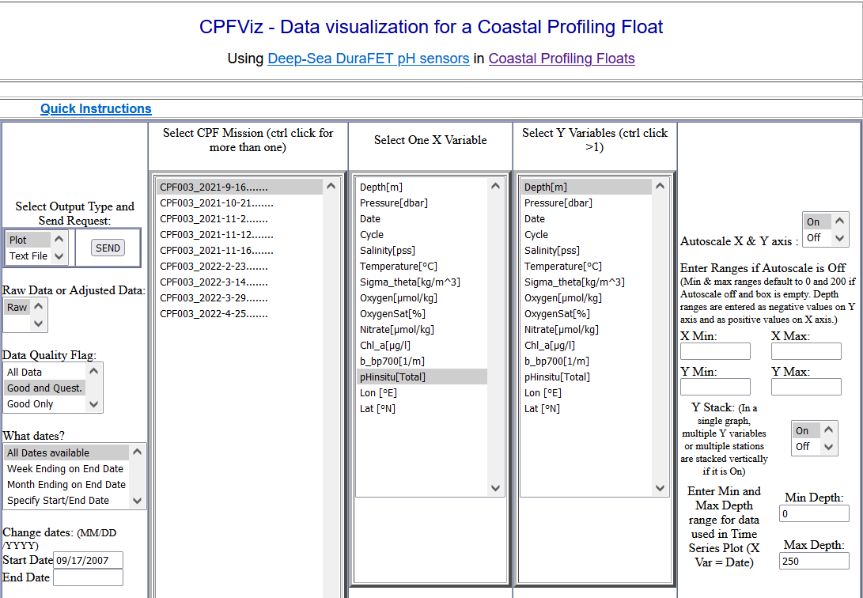
Figure 1

Examples of data products for profile data (Figure 2) and data gathered during anchoring mode (Figure 3) are shown below.

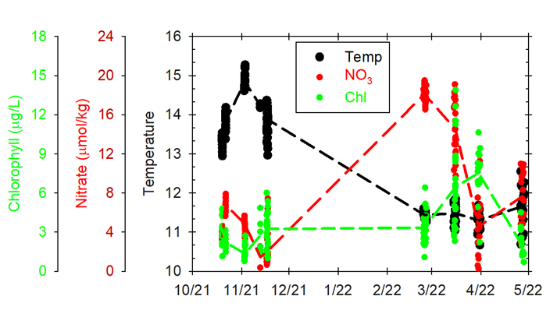
Figure 2 Temperature, nitrate and chlorophyll concentrations in the upper 10 m on each of the multiple profiles in 9 separate deployments of the CPF in 2021/22. The scatter in the deployments reflects the large variability that characterizes Monterey Bay on a scale of a few hours.
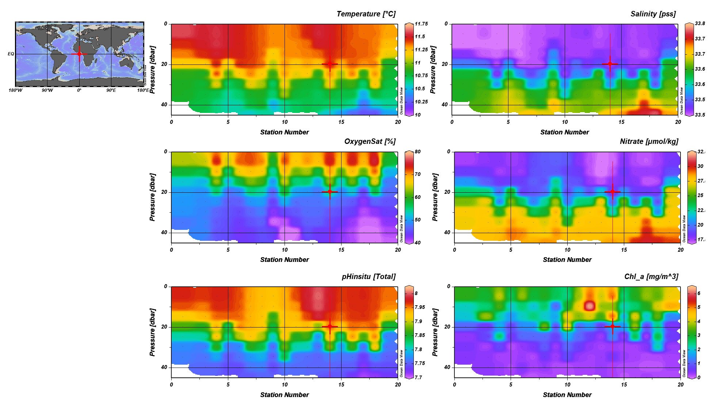
Figure 3 Example plots of profile data collected during a ~20-h CPF mission profiling every hour, for temperature, salinity, oxygen, pH and Chl-a fluorescence, accessible from CPFViz.

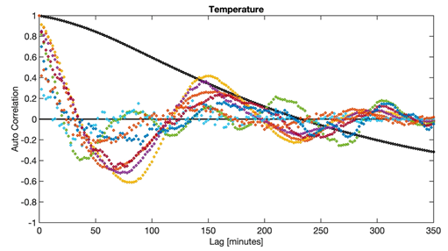
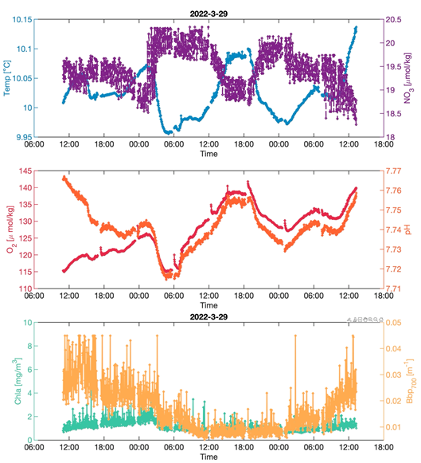
Figure 4 Left panel: Example plots of (top) temperature and nitrate, (middle) oxygen and pH and (bottom) Chl-a fluorescence and optical backscattering, parked on the seafloor at ~33m depth. All sensor data sampling at high frequency (every 2 minutes) March 29th 2022.
Right panel: Autocorrelation functions for temperature data from deployment in Figure 1. Note decorrelation timescales can vary from ~12-30 minutes (zero-crossings for colored lines) to ~3.8 h (zero-crossing for black line). Autocorrelations for subsets of 6h data are plotted in color for different segments of data (detrended to remove low-frequency signals), and for the ~ 24-h period in black. These data can inform optimal sampling frequencies to capture high-frequency dynamics characteristic of the Bay.

Anticipated Impact
Who are the consumers of the instruments, methods, technology, and data that will be generated within and beyond MBARI? Will the project create tangible connections with other organizations (e.g., academic, NGO, MBA, MBNMS, state or federal agency)?

Current users of the CPF and the data it generates include MBARI’s Chemical Sensor Program, Coastal Biogeochemical Sensing Program and the Biological Oceanography Group. The BOG deploys the CPFs we built with them monthly as part of their Monterey Bay Time Series and during their CANON experiments. Colleen Durkin has already submitted an OTIC proposal that will use the CPF as the platform for an advanced imaging system. We will continue working with Colleen to support her research. We believe the CPF has the potential to create tangible connections with a variety of external organizations. There is strong interest among the Ocean Mixing community in the CPF, as the Turbulence Experiment demonstrated it is an exceptionally quiet platform for turbulence measurements. As mentioned earlier in this proposal, we are particularly interested in moving the CPF technology into the hands of policy making agencies as mentioned in Challenge 6 of the new strategic roadmap.

Anticipated Outreach Needs
Thinking about the audiences/consumers you highlighted in the question above, do you anticipate needing to create outreach assets to help increase your impact? If so, please specify whether you anticipate needing to work with ITD and also specify what type of asset (story, graphic, animation, video, etc.) you might need.

We don’t see a need for ITD resources at this time. However, the CPF might be a compelling story and we’d be happy to work with ITD as appropriate to make this story known.

Continuing Projects Only: Status Report
Briefly provide an update of the current project relative to what was proposed for 2022 by responding to the prompts below. If the project includes multiple subproject projects, please list each of these under a subheading as you deem appropriate.

Current status of project and results to date

The milestones from last year’s proposal were
1. Upwelling experiment #1
2. Upwelling experiment #2
3. Turbulence Experiment
4. Test tank prototype with HDBP and new controller.

We have completed 5 pilot upwelling experiments (milestones 1. and 2.) with the important qualifier that these were done with only 1 CPF. We focused our efforts in the first half of 2022 on science deployments and our resources on addressing the lessons learned from these deployments. We expect to have the remaining 2 CPFs finished this year and be running upwelling experiments with our full fleet of 3 CPFs in the first half of 2023.

Milestones 3 is complete. A total of 10 CPF-MicroRider deployments were conducted in the fall of 2021, gathering 40 profiles of concomitant observations of biogeochemistry and turbulence including overnight missions profiling every hour (as part of the Turbulence Scoping Project 902108). This experiment required software modifications to profile in “glide mode” (i.e. turning the buoyancy engine off in the ascent) and at a higher profiling speed, resulting in unprecedented high-quality turbulence measurements. According to the staff at Rockland Scientific, the developer of the MicroRider turbulence probe we used for this experiment, the CPF proved to be an exceptionally quiet platform for these highly sensitive turbulence measurements. Dr. Rolf Lueck, a co-founder of Rockland Scientific, went so far as to send us an e-mail with this quote “I think that I am not going out on a limb when I say that the data looks amazing”. The turbulence data gather from these experiments will be used as a benchmark dataset by the SCOR working group that aims to establish best practices for the processing of shear-probe data (https://scor-int.org/group/analysing-ocean-turbulence-observations-to-quantify-mixing-atomix/). One slide from Magdalena’s recent talk at the Ocean Mixing Gordon Research Seminar that illustrates the quality of turbulence data is provided herein Figure 5.
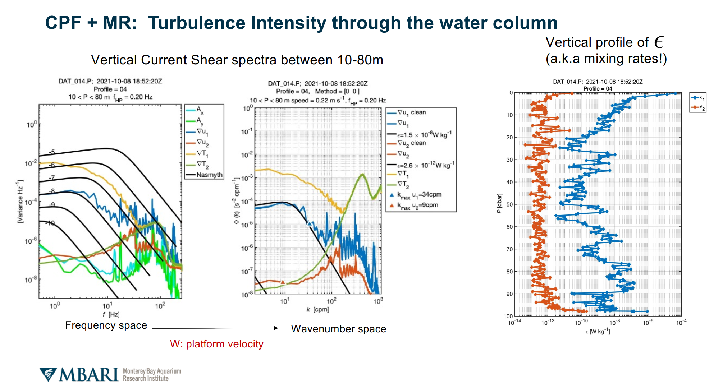
Figure 5 Example of microscale shear spectra (left and center plots) collected during a CPF-MicroRider deployment in the fall of 2021 in the south Monterey Bay shelf region, from which dissipation rates of turbulent kinetic energy are derived (blue profile, right plot). The agreement between the blue line (from a shear probe) and the theoretical Nasmyth shear spectra (black line) up to the triangle (in blue) is indicative of the quality of turbulence data (center plot). Note that deviations beyond the triangle at higher frequencies do not contaminate the dissipation rate estimates.
Milestone 4 is in progress and we expect to have it complete by the end of 2022.

A major focus of the engineering work this year has been decreasing the CPF energy consumption in order to increase mission duration. The turbulence experiment needed high frequency samples and we defined those missions to maximize sample rate at the expense of mission duration. The upwelling experiment prioritizes mission duration over sample rate. We’ve made significant progress in improving mission duration and our current energy model suggest we can get roughly 50X 100 meter profiles out of our current temporary battery pack. That number should increase to roughly 200X profiles when we’ve integrated the new Lithium primary battery pack. Mission duration is defined by how much energy each profile burns and how much energy we consume between profiles. We’ve made significant improvements in the profile energy and expect to make modest improvements in the future. The sleep mode functionality already built into the CPF electronics is intended to reduce the energy consumption between profiles to a small fraction of the total energy consumption. So, the overall mission duration is a function of duty cycle, i.e. how much of a mission is spent in sleep mode and how much is spent actively running profiles. With our current energy consumption numbers, sleep mode operational and the new Lithium primary pack, we estimate with a profile rate of 1 profile per day spread the mission duration will be 250 days. The mission duration scales almost linearly with profile rate e.g. a profile rate of 1 profile per 2 days gives an estimated mission duration of 490 days. It should be noted that these estimates are based on several assumption about how the sleep mode will operate that we won’t be able to verify until we have sleep mode operational.

Another significant result is the routine processing of CPF data with the results publicly available on the CPFViz website as described the Data section above.

Significant changes from previous project proposal

As mentioned elsewhere in this proposal, we have focused our efforts on science missions and addressing the lessons learned from these missions.

Over the past two years, what peer-reviewed publications, education and/or outreach activities have resulted directly from this project? Please be brief.

Magdalena Carranza (Monterey Bay Aquarium Research Institute, United States) "Can We Infer Vertical Mixing Rates from Argo Float’s Rising Velocities?". Invited talk: Gordon Research Seminar June 4-5 2022, Mount Holyoke College, South Hadley, MA.

All Projects: Specific Plans for 2023

Research Activities

Josh Plant, Magdalena Carranza and Ken Johnson have been processing and analyzing CPF data and this work will continue in 2023. These data are also being used to refine the design of the upwelling experiment. Most of the Johnson and Takeshita lab personnel have participated in CPF deployments, recoveries and mission monitoring and we expect this to continue. We expect to restart monthly (or so) pilot upwelling experiments later this year and through Q3 of 2023 with the final milestone being a 4 week long upwelling experiment with our fleet of 3 CPFs.

Engineering/technology development

We have 2 engineering/technology efforts left on our task list. First is an ongoing effort to improve the CPF platform based on lessons learned from science driven deployments. To date that has been primarily relatively minor modifications to the existing software. The second task is an ongoing effort to increase the CPF mission duration. The primary tasks here are 1) finishing the software implementation and testing of the system sleep functionality already designed into the hardware. 2) Finishing the design, test and integration of the higher energy density Lithium primary battery pack. We’ve improved the energy usage of the CPF buoyancy engine to the point where the CPF micro-controller is now a significant fraction of our energy consumption. The controller we’re currently using was declared end of life a couple of years ago and we’ve had a task on our list to replace that controller with a current generation controller with more than 20X lower power consumption. Nearly zero engineering hours have been spent on this task in recent years. The upwelling experiment is our highest priority but we’d like to restart this task when time is available. No shared engineering resources are requested for this effort.

Field programs (detail ship requirements/deployments/diver requirements)

In addition to describing anticipated field programs, please be sure to include requirements for specific platforms and equipment (Dorado AUVs, LRAUVs, Wave Glider, mini ROV, etc.) for each proposed field program so that expectations are clear. Requests must also be entered in the budget entry system.

We expect to be running about 1 CPF mission per month through Q3 of 2023. Each mission is nominally half a Paragon day for deployment and half a Paragon day for recovery. However, it seems prudent to add 4 Paragon days for contingency. At this point we have a number of Johnson and Takeshita lab personnel trained as crew for these deployments and recoveries. Several of these are “Paragon captains in training”. We have been covering the Paragon captain duties with a combination of Jared and Gene to help get our Paragon captains in training fully qualified.

Specific deliverables

A fleet of 3 CPFs and the requisite infrastructure ready for operational science missions.

