Project title: Coastal Profiling Float
Project leads: Gene Massion, Ken Johnson
Project manager: Gene Massion
Project team: Brent Jones, Ed Mellinger, Paul McGill, Eric Martin, Paul Coenen, Jose Rosal
Collaborators: Dana Swift, University of Washington

Project summary
The Coastal Profiling Float (CPF shown in Figure 1) has demonstrated the core functionality needed to meet its requirements in a variety of short term tests both at-sea and in the test tank. In addition to evaluating the engineering data acquired during these tests the applications needed to process the science data have also been developed to ensure the science data passes minimal quality controls. Examples of the science data are shown in Figure 2 and 3. Efforts for 2016 will be focused on running long term tests, again, at-sea and in the test tank and refining the existing system based on lessons learned from these tests. The goal for 2016 is successful completion of a month long mission. Software Engineering efforts will also include adding RUDICS satellite telemetry capability in addition to the existing SBD capability and continuing to improve our error detection and correction capability. Electrical Engineering efforts will also include integrating the new application specific mother and daughter boards designed in 2015. Mechanical Engineering efforts will also incude testing a new external buoyancy bladder design.

Figures
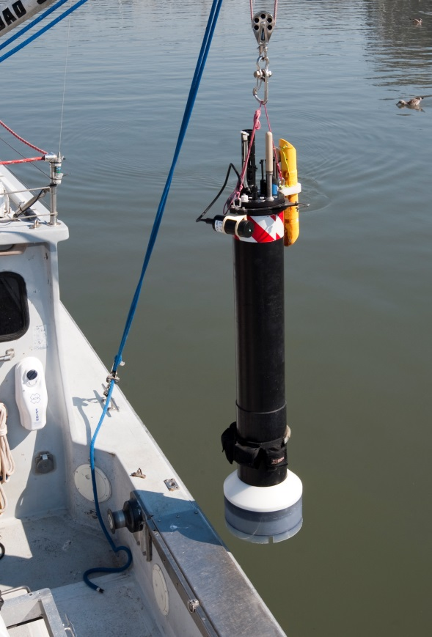
Figure 1 The Coastal Profiling Float

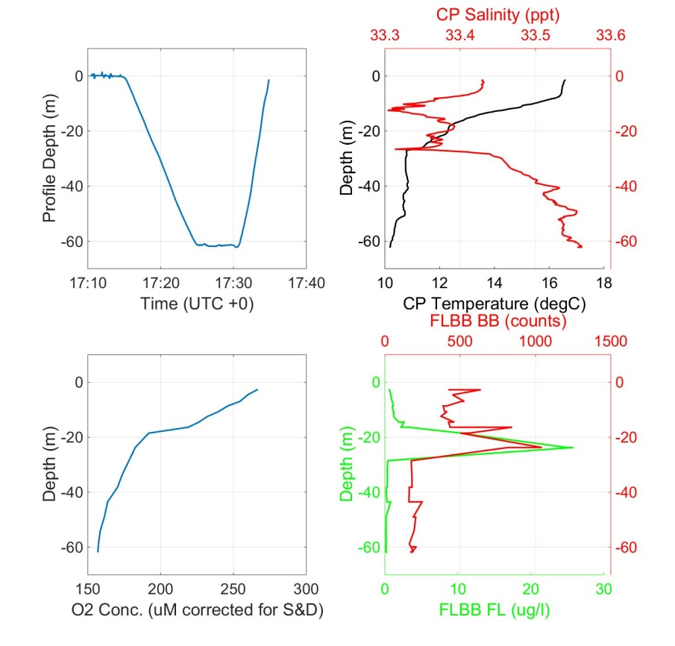
Figure 2 Detailed, high resolution profiles of biogeochemical data

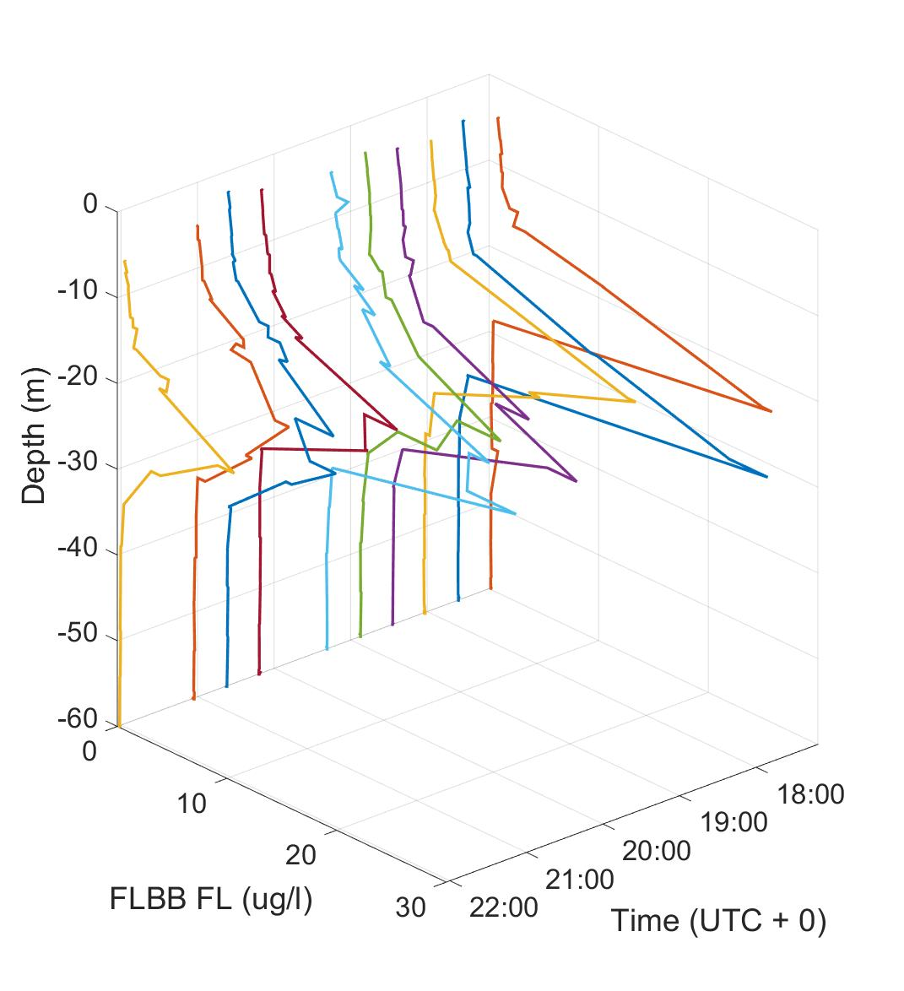
Figure 3 Waterfall plot of 10 fluorescence profiles acquired in 5 hours

