Project title: Coastal Profiling Float
Project leads: Gene Massion, Ken Johnson
Project manager: Gene Massion
Project team: Paul Coenen, Brent Jones, Eric Martin, Paul McGill, Ed Mellinger, Mike Parker, Josh Plant, Jose Rosal
Collaborators: Dana Swift, University of Washington

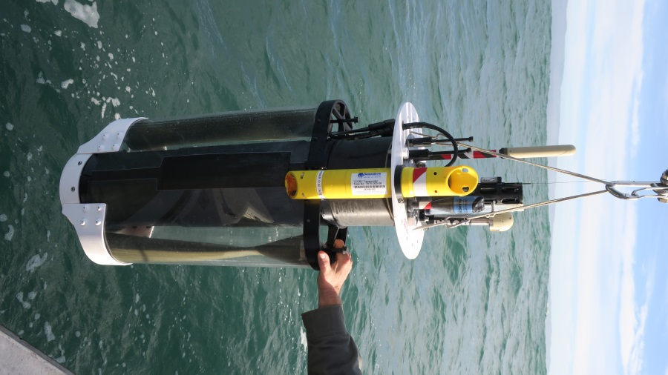
The Coastal Profiling Float (CPF) is designed for research questions aimed at understanding the health of the ocean. A warming climate, increased use of nitrogen fertilizers, acidification, loss of sea ice, decreasing oxygen concentrations and a variety of other processes are expected to impact coastal waters in the coming years and decades. Understanding the effects of these processes on fundamental biogeochemical processes such as net community production and carbon export will require years to decades of ecosystem wide measurements in the ocean’s coastal zone where the majority of primary production occurs. In order to provide this scale of observing capability, an observing platform that can be operated for decades with a life cycle cost in line with current and projected funding resources is critical. The global Argo array of profiling floats has proven the viability of profiling floats for large scale observing systems. We are adapting that technology for use in the coastal zone with an overall life cycle cost for the CPF similar to the floats used in the global Argo array. We are pleased to report that in 2016 the CPF has transitioned from the design–test–redesign phase of development to the test-refine phase. We finished an extensive set of one day at sea tests in 2016 and will start multi-day, unattended tests in January of 2017. Our development process includes the tools required to analyze the scientific data returned by the CPF and we routinely process the data acquired from our at-sea engineering tests to check the science data quality. Examples of the science products are shown below. The goal for 2017 is to complete the development process with a successful 30 day deployment and develop a strategy for commercialization of the CPF.

