Gene Massion
Development of a Coastal Profiling Float
The continental shelves and slopes comprise only 5 to 10 % of the ocean area but contribute as much as half of the global new primary production (Benway et al., 2015). This disproportionately high new primary production in coastal systems supports the vast majority of global fish production (Ryther, 1969), which may be significantly impacted by future climate change (Brander, 2007). There is no observing system that provides the synoptic data required to understand ecosystem processes such as new or net primary production in coastal systems in a way that enables science based management of these resources. The required observing system must be capable of a) making a range of biogeochemical measurement, b) in 3 dimensions, c) on a scale roughly the size of the west coast of North America, d) over at least several decades and e) at a cost that is economically sustainable. The Coastal Profiling Float (CPF) project is aimed at filling at least some part of this gap in ocean observing capability.
Profiling floats are one of the few (maybe the only) observing platforms that have proven effective at providing the research quality data on an economically sustainable basis over the decades required to develop an understanding of ecosystem scale processes. Over the last 10+ years, the MBARI Chemical Sensor lab has extended the capability of Argo type profiling floats to include biogeochemical measurements for programs like SOCCOM (https://soccom.princeton.edu/) and Argo ( http://www.argo.ucsd.edu/ ) These programs address climate scale dynamics like the fate of carbon in the Southern Ocean and warming of the world’s oceans where observations are primarily required in the deep ocean. The CPF leverages our experience with deep water floats to develop a profiling float optimized for work in the coastal zone. The end goal of the CPF project is to run a pilot project small enough to fit within our resources but large enough to demonstrate that this approach can economically scale up to the kind of coastal scale, decades long observing program described above.
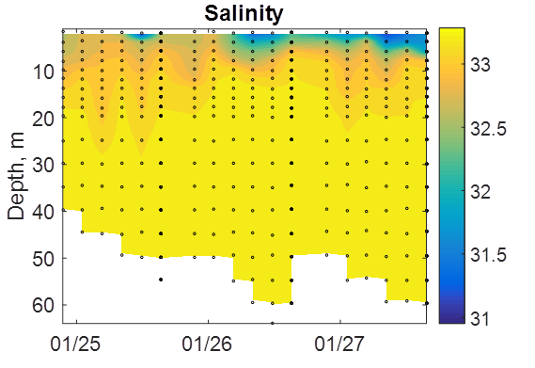
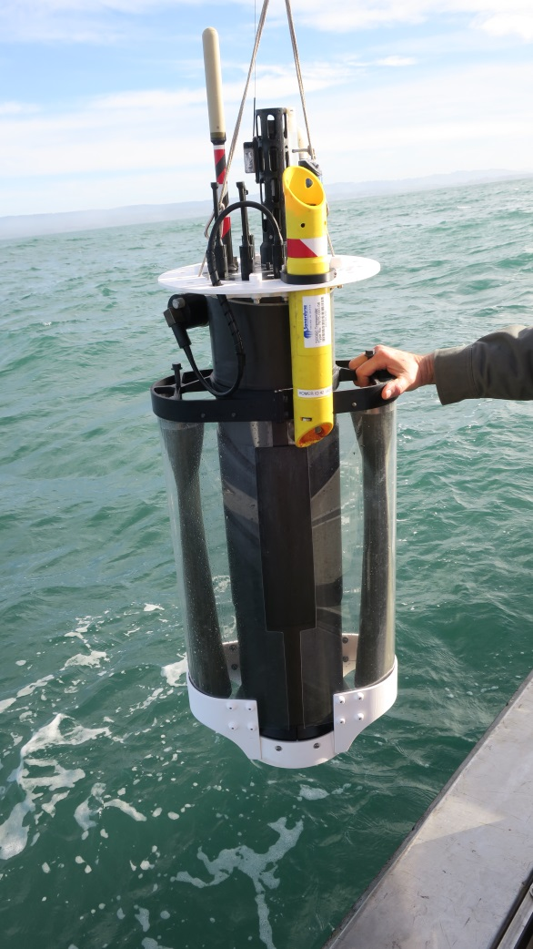
We have successfully completed a set of at-sea, multi-day, unattended missions with the second CPF prototype (CPF-P2). Examples of the science products from these missions are shown below. Successfully completion of this set of tests was the milestone we set for ourselves before building more CPFs. We are currently building 2 new CPF-P2 units with upgraded battery capacity and new electronics. The new electronics uses the same embedded computer hardware we’ve run for several years and adds the power control functionality required to meet our mission duration requirements. The new electronics were finished late in 2016 and we’ve been bench and tank testing them and developing the software required to take advantage of the new power control functionality since then. We anticipate at-sea testing of the CPF-P2 will start in the last quarter of 2017. The plan for 2018 is to run multi-CPF science missions that will demonstrate the capability of the CPF for larger scale coastal zone science missions. In addition to the work in our lab, the Chavez lab has been using the first CPF prototype (CPF-P1) as part of the CANON project. We are pleased to report they have already upgraded their CPF-P1 with the new electronics and have successfully completed several deployments in support of the Fall 2017 CANON experiment.

