Gene Massion
Development of a Coastal Profiling Float
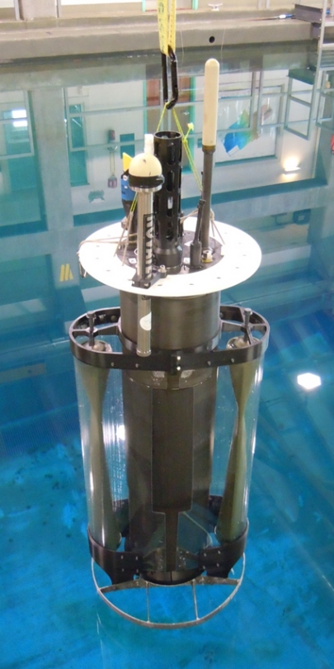
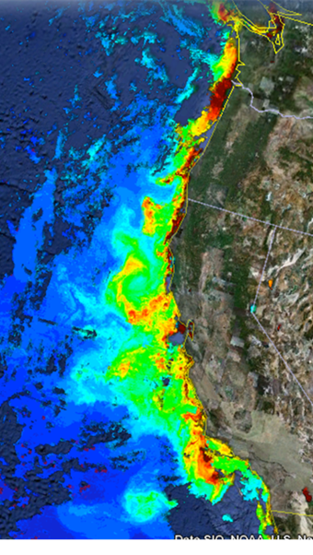
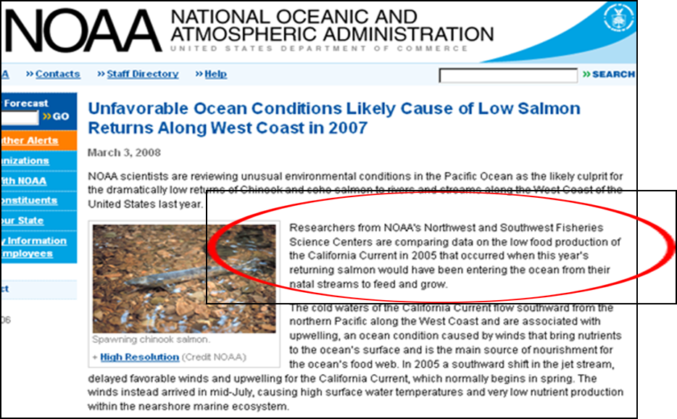
Understanding plankton biomass and production rates in the coastal zone at the scale of large ecosystems like the California Current is essential for researchers and policy makers to understand and manage important marine resources. For example, NOAA scientists have been trying to understand the return rate of Chinook and Coho Salmon to streams along the West coast of the United States. Unfortunately, the data available is inadequate for either proper understanding or management. Generating the necessary data requires measurement of important biogeochemical properties (e.g. salinity, temperature, oxygen, pH, chlorophyll and nutrient concentrations) across an entire ecosystem the size of the west coast of North America over decades. This makes the data acquisition problem fundamentally an economic issue in that whatever observing system is used must be sustainable given the available funding sources.

MBARI’s Chemical Sensor Lab has been a part of the Argo project: a global array of profiling floats designed to measure the heat content of the ocean in order to understand global change and its regional impacts. Argo has been operational since 2007 and has proven to be one, and possibly the only, economically sustainable large scale observing system. Research questions aimed at understanding the health of the ocean require ecosystem wide measurements in the ocean’s coastal zone and the Coastal Profiling Float (CPF) project is adapting Argo profiling float technology for just this purpose. We have developed 2 generations of CPFs and have been deploying both versions at sea since 2014. Examples of the kind of detailed, high resolution, 3D data acquired with the CPF are shown below. We are also pleased to report that the first generation of CPF is being used on the CANON project in 2016. Particularly gratifying is the fact the CPF design proved robust enough to support an even broader range of instrumentation for CANON including a (large) sediment trap and an (even larger) acoustic modem.
CPF Gen2
MODIS Chlorophyll June 28, 2011
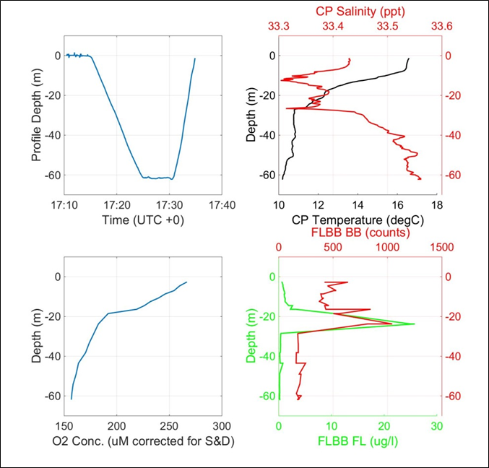
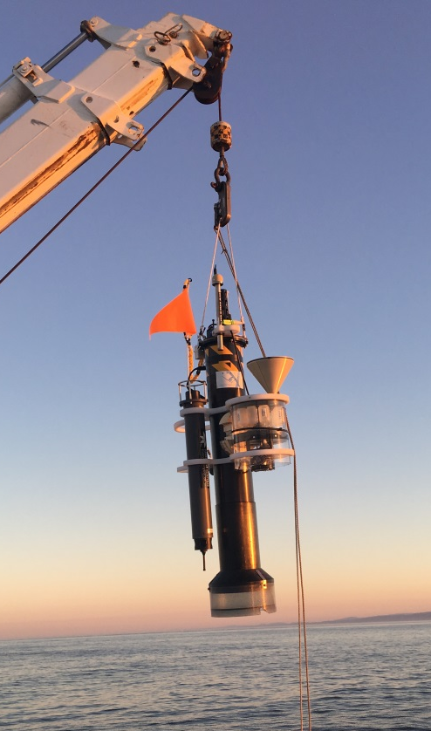

CPF Gen1 for CANON

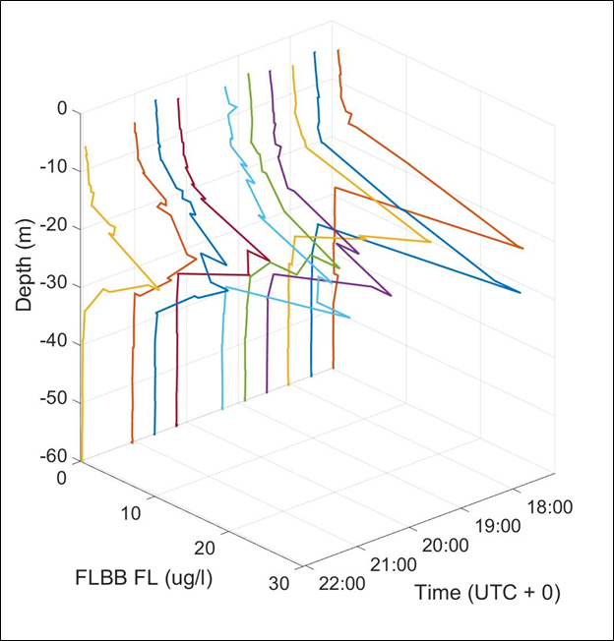
10 Profiles to 60 meter in 5 hours

Recent Professional Activities
Committee and Editorial Board Membership
- 2014 - present Marine Technology Society Journal Editorial Board
- 2014 - present KM3NeT Neutrino Observatory Science Technology Advisory Committee

