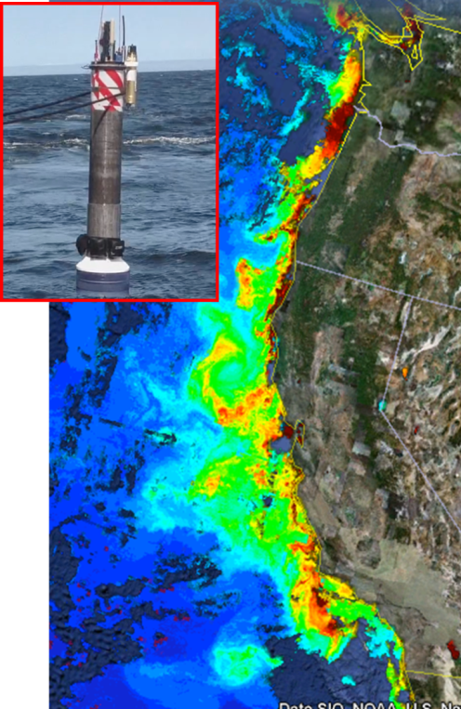
Annual Report 2014 CPF Box
A warming climate, increased use of nitrogen fertilizers, acidification, loss of sea ice, decreasing oxygen concentrations, and a variety of other processes are expected to impact coastal waters in future years. Further, the coastal zone can be an area of extreme variability. Large networks of sensor systems capable of sustained operations over decades are needed to characterize its changing properties. To address this need, the Chemical Sensor Lab is developing a Coastal Profiling Float (CPF) that can operate over the continental shelf. Building on the success of the global Argo array of profiling floats, the system is designed to anchor on the seafloor at depths up to 500 m, profile through the water column to the surface and transmit an array of chemical and biological measurements back to shore. The CPF is designed as a “fire and forgot” platform that requires no operator intervention after deployment other than on-shore processing of near real-time data. Minimizing at-sea operational costs is a requirement for the kind of large scale (100s of platforms deployed over 1000s of kilometers), long term (several decades) ocean observing systems required to address these societally important coastal ecosystem wide issues.

