901206 Development of a Coastal Profiling Float

Principal Investigator: Ken Johnson

Subproject 902108 Mixing Rates from Autonomous Profiling Floats in the Coastal Oceans
Investigator: Magdalena Carranza

Purpose
A warming climate, increased use of nitrogen fertilizers, acidification, loss of sea ice, decreasing oxygen concentrations, and a variety of other processes are expected to impact coastal waters. Since much of the global ocean carbon cycling occurs in relatively shallow coastal waters where nutrients are upwelled to the surface, an observing system that can be distributed on a global scale is needed to provide assessments of the effects of these processes on fundamental biogeochemical processes such as net community production and carbon export. This project is working to develop a profiling float optimized for use in coastal waters that can serve as the basis of an economically sustainable coastal observing system. The goal is to provide the kind of salient, credible and legitimate knowledge that can strengthen the role of science in public policy and decision making.

Our approach is to extend the reach of the existing, successful global Argo array into the coastal zone by modifying existing Argo profiling float technology for operation in coastal waters. Our unique contribution will be twofold. First, development of a platform with a bottom “parking” mode optimized to increase the float residence times in the coastal zone. Second, this platform will be optimized to ease integration of sensor suites specifically targeting coastal issues e.g., pH, nitrate, oxygen and bio-optical sensors.

Methods and Equipment
As mentioned above, an observing system is needed to provide assessments of the effects of these processes on fundamental biogeochemical processes. There are no such coastal observing systems that are now available. Coastal moorings are typically expensive, require a skilled labor force for continual maintenance, and are quite susceptible to damage from vessel traffic and fishing. Gliders are also expensive, require a highly trained group to service them between missions, and they carry few sensors.

The Argo array, based on a network of 3000+ profiling floats distributed throughout the open ocean, has been, arguably, the only successful model for global scale sensor arrays in the ocean. (A summary of the Argo float program can be found at http://celebrating200years.noaa.gov/magazine/argo/welcome.html#float.) The main focus of Argo is to provide a measurement of the changing heat content of the global ocean. The profiling floats used by Argo are optimized for deployment in waters deeper than their 2000 meter maximum profiling depth. Argo has not focused on the coastal zone simply because shallow coastal waters hold little heat. We are now successfully equipping profiling floats with biogeochemical sensors with a goal to provide similar assessments of the time variations in open ocean cycles of carbon, nitrogen and oxygen. However, in contrast to heat, much of the global ocean carbon cycling occurs in shallow coastal waters where nutrients are upwelled to the surface. Thus assessments of the changing elemental cycles in the open ocean will require sensor arrays that can be economically deployed in large numbers for decades throughout the coastal regions of the world. We believe that profiling floats are best suited for this type of global observing system.

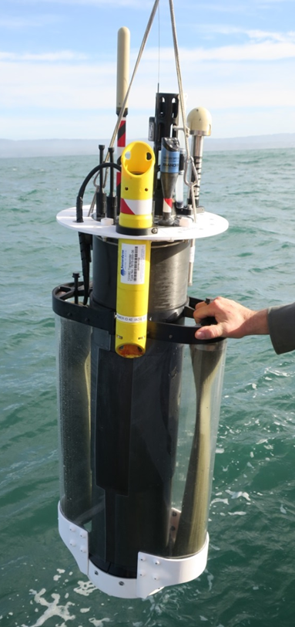
We are developing a profiling float optimized for operation in coastal waters. Our unique contribution will be twofold. First, development of a platform optimized for coastal operation (water depths less than about 500 meters). Second, it will be optimized to ease sensor integration, e.g., pH, nitrate, oxygen, and bio-optical sensors. Specifically we propose to add a bottom parking mode that will substantially increase the float residence time inside the coastal region. Current Argo floats have a buoyancy engine that provides a relatively small buoyancy change, not nearly enough to provide even a moderate ability to “park” on the bottom. In addition, this small buoyancy change requires a very precise pre-deployment ballasting process that currently must be run on each and every float. Because we will be working at shallower depths, we won’t need to overcome the same pressure difference and can use this saved energy to build in more buoyancy change.

Sanctuary Prohibition
Because these floats are deployed autonomously, they are considered “discharges” by the Sanctuary, although the floats will be recovered by the project team upon completion of deployments. The floats will also “park” temporarily on the seafloor during deployments. The current design exerts a parking pressure on the sea floor of less than 0.1 psi, so there will be very minor seafloor alterations. However, these changes are temporary and the seafloor will quickly return to the pre-deployment condition.

Activities in 2021
In 2021 we used the CPF as the data acquisition platform for project #902108 Mixing Rates from Autonomous Profiling Floats in the Coastal Oceans to measure turbulent mixing in the upper 200 meters. A Rockland Scientific Microrider instrument package (https://rocklandscientific.com/products/modular-systems/microrider/ ) was integrated on a CPF for this work. The deployments are document in the report for that project.

Plans for 2022
We are currently building two more Coastal Profiling Floats (CPF) bringing our total fleet of CPFs to 3. Our plan is to perform several science missions with our fleet of CPFs starting Q3 with duration of 10 to 30 days. The primary science focus will be the influence of lateral nutrient transport from upwelling plumes versus canyon upwelling on the development of high chlorophyll levels in the Monterey Bay “upwelling shadow” (Graham et al., 1997; Ryan et al., 2010). High concentrations of chlorophyll (Ryan et al., 2008) and high rates of net primary production (Johnson and Needoba, 2008) regularly occur in the northern part of the bay. The floats will be deployed in a grid, and data will be collected both during the vertical profiles every 2–6 hours and every ~15 minutes while they are parked on the bottom. That will enable detection of internal waves as they pass along the bottom, as well as plumes of surface water entering the northern area of the bay. All floats will be recovered at the end of each experiment. This experiment will include efforts to calibrate/validate the pCO2 values estimated from float pH using Wave Gliders equipped with pCO2 sensors. Operating the Wave Glider around the float array will provide independent assessments of the accuracy of carbon parameters estimated from float pH measurements, as well as the consistency of observations across the array and the influence of sub-mesoscale processes such as fronts.

