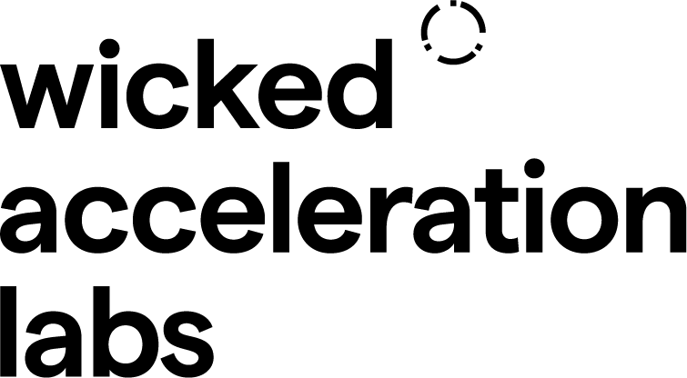

Wicked Imperial Module | 2024
Sponsor Challenge

About the Sponsor:
Add content about your organisation here. Who you are, your vision, how you achieve it.

The Challenge:
What’s the overall context of the Challenge? Who is affected and why? Please provide background information,evidence and data to gauge the importance of the challenge as well as relevant stakeholders.

Relevant Context and Specificity
- Please provide further specificity of the different layers of the problem, if any.
- You may also specify characteristics of previous suboptimal attempts to address the challenge
- You may also describe the components of the technology that has been used to tackle the challenge
- Please also provide the geographical and industrial context of the Challenge
- Please provide information of relevant stakeholders connected to the Challenge both locally and globally, if applicable.

Impact
Please estimate the impact (economic, social, environmental) of a potential solution to your Wicked challenge.

Potential Beneficiaries
Please briefly elaborate on the potential and Hypothetical beneficiaries of the wicked Solution, including users, customers, suppliers and/or stakeholders

Wicked Team Recommended Skillsets
Design research, Programming skills, Business Modelling, etc (example)

Resources
Articles, papers, journals, bibliography etc

Please download this template and email it back to:

