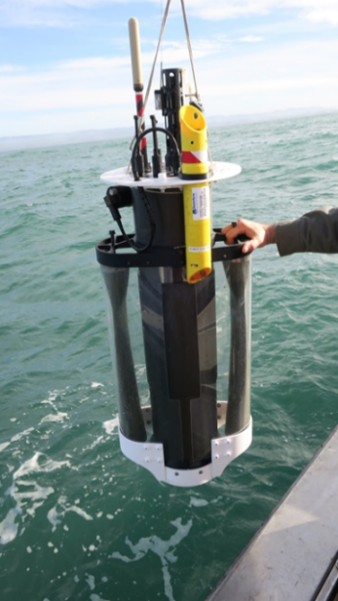
MBARI has designed, built and is currently field testing a Coastal Profiling Float (CPF). The science mission for the CPF is data acquisition for research experiments in the coastal zones of the world’s oceans with an ecosystem size spatial scale e.g. the salmon fishery along the west coast of North America and a time scale of years. The need for this kind of platform has been identified in several studies including the Coastal Carbon Synthesis planning activity of the Ocean Carbon & Biogeochemistry program which calls for greater use of autonomous platforms and sensors to assess carbon cycle processes (Benway et al., 2015), “All coastal regions of North America experience short-term events (e.g., winter storms, plankton blooms, hurricanes, upwelling and acidification events) that can strongly influence carbon delivery, processing, and fate, so there is a need to further develop our observational capacity (e.g., novel autonomous platforms) in all continental margin systems to be able to capture event-scale processes and quantify their impacts on coastal carbon budgets.”
The CPF is an upgrade to the existing range of profiling floats in order to work effectively in the coastal zone. It has 15 time the buoyancy change capability of Apex floats which gives the CPF the ability to anchor and, more importantly, de-anchor on the bottom along with accurate closed loop control of depth and profiling velocity all of these are required for effective operation in shallow water, supports the complete suite of 6 biogeochemical sensors with expansion for at least 3 more, is highly scalable in capability both up and down and should costly roughly the same as existing profiling floats. We have been field testing the CPF for several years and are planning pilot scale science missions for next year. In addition, we have an explicit goal to start transitioning the CPF to the community. Like many research projects, the CPF has been somewhat resource constrained and there are a wide range of things we’d like to do to finish the project that may not be possible with MBARI funding. These tasks fall into 3 basic goals. 1) “Hardening” the design to ensure no hidden mechanical, electrical or software bugs prevent the successful completion of science missions. 2) Improving and adding functionality consistent with the science mission. 3) Finalizing the design and starting the transition to the community.
My basic question is if any of these 3 goals is in line with the funding goals of the OTIC program? If so, I’d be very interesting in submitting a proposal. It we do, it would be useful to know if there is any priority among our 3 goals so we can tailor the proposed work to the goals of the OTIC program.
I’m particularly interested in effectively transitioning the CPF technology to the community. One somewhat novel possibility is a “managed” open-source approach instead of the usual approach of licensing the technology to a for-profit company. I’ve talked about this approach with a couple of people with experience open-sourcing various technologies with positive results but it is critically important to understand the community interest in this technology before developing any transition plan. I have been accepted for a CPF presentation at Ocean Sciences in February which will give me an opportunity to get some community feedback but unfortunately, too late for the OTIC proposal process.
Benway, et. al. (Editors), 2015. An interdisciplinary science plan for research in North American continental margin systems. Report of the Coastal CARbon Synthesis (CCARS) community workshop, August 19-21, 2014, Ocean Carbon and Biogeochemistry Program and North American Carbon Program, 68 pp.

