In 2019 we will begin preliminary science experiments in Monterey Bay using the CPF array. The CPF has the capability to park at a specified depth in the water column or on the sea floor based on commands received over the Iridium satellite network. A primary technical focus associated with the experiments will be using this capability to navigate individual floats to maintain the array geometry using high-resolution model output to select float parking depths. This experiment will use output from the ROMS ocean model operated by the Cooperative Ocean Prediction System (COPS, http://west.rssoffice.com/) that is led by Yi Chao. They operate a high-resolution model in real time with a three-day forecast. The forecast data are available on line in netCDF files. Each float sends its current position along with the science data after each profile. We currently have the tools to plot each float’s track in Google Earth. Navigating wayward floats will require finding a specific subsurface current from the forecast with a direction roughly toward the desired position for each float in the array. After a float surfaces and its offset from the desired position is determined, the depth of the desired current will be set as the new park depth for that float. If a serendipitous current is not found, we would park the float on the sea floor to minimize drift in any direction. Figure 1 shows an example of the predicted trajectories for floats at three depths in northern Monterey Bay. While there are not always days with complete reversals in current direction, it should be possible to maintain an acceptable array geometry by careful selection of parking depths. We are pleased to report we have just completed the first mission where we actively navigated CPF-P2 SN001. You can see the track from the recent July 2017 navigated mission stays much closer to the original deployment position than the un-navigated March 2017 track.

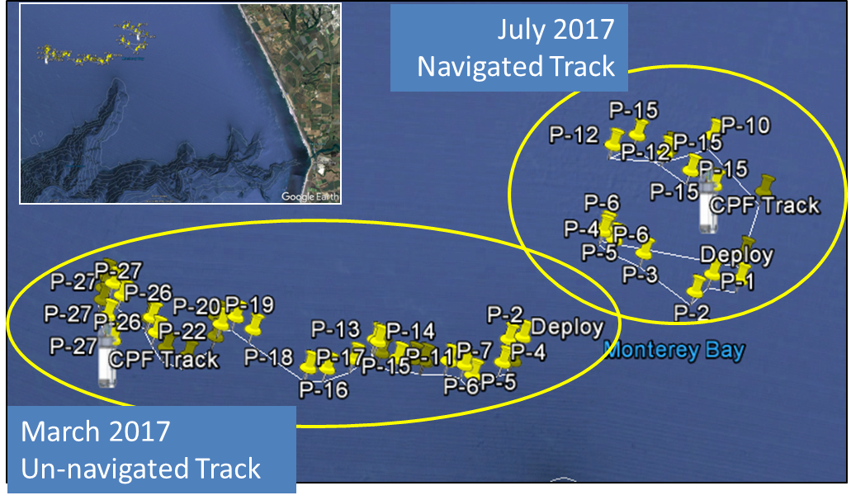

The primary science focus will be the influence of lateral nutrient transport from upwelling plumes versus canyon upwelling on the development of high chlorophyll levels in the Monterey Bay “upwelling shadow” (Graham et al., 1997; Ryan et al., 2010). High concentrations of chlorophyll (Ryan et al., 2008) and high rates of net primary production (Johnson and Needoba, 2008) regularly occur in the northern part of the bay. The floats will be deployed in a grid and data will be collected both during the vertical profiles every 2-6 hours and every 15 minutes (or so) while they are parked on the bottom. That will enable detection of internal waves as they pass along the bottom, as well as plumes of surface water entering the northern area of the bay. All floats will be recovered at the end of each experiment.

This experiment will include efforts to calibrate/validate the pCO₂ values estimated from float pH using Wave Gliders equipped with pCO₂ sensors. Operating the Wave Glider around the float array will provide independent assessments of the accuracy of carbon parameters estimated from float pH measurements, as well as the consistency of observations across the array and the influence of sub-mesoscale processes such as fronts. This will be of great value for the SOCCOM project in the Southern Ocean, where such comparisons are exceptionally difficult to obtain.

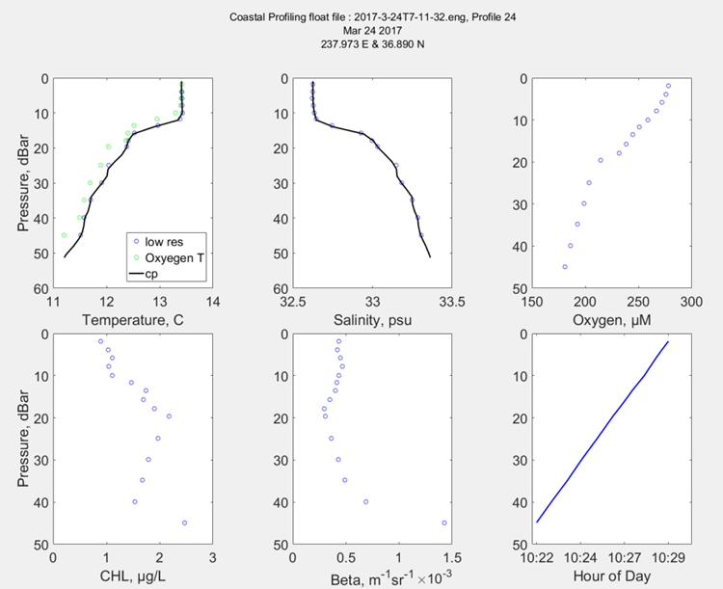
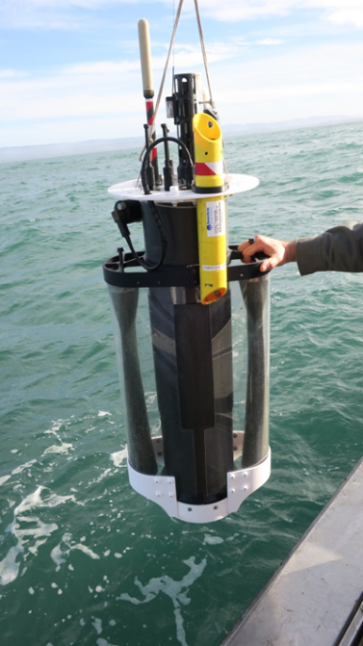
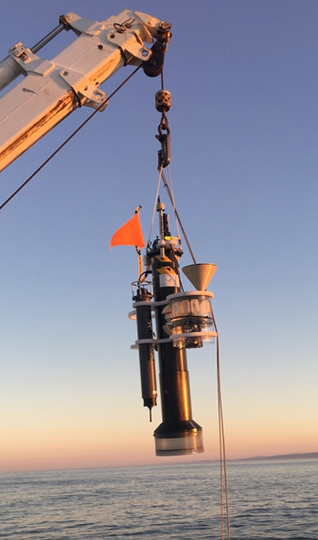
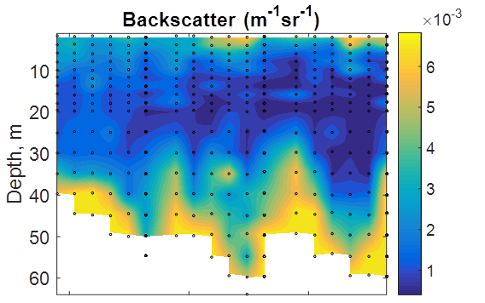
MBARI Coastal Profiling Float
- Profiling floats have proven the ability to provide biogeochemical data over ecosystem and decadal scales at a cost ($/data point) that can be sustained by existing national and international research program budgets
- The CPF leverages MBARI Chem Sensor Lab deep-water biogeochemical profiling float technology to optimize a profiling float for research in the coastal zone of the world’s oceans
CPF
Prototype 2
CPF
Prototype 1

