Project Number: | 901206

Project Start: Jan. 1, | 2018 | Project Duration (in years): | 3 of 3

Please indicate if proposal includes requests for any of the following (mark all that apply).

 | x |  |  |  |  |  |  |  |  | x
Ship Time |  |  | ROV |  |  | AUV |  |  | Wave Glider |  |  | Mini ROV

Please indicate what type of project is being proposed (mark only one).

 |  |  |  |  |  |  | x
Feasibility/Scoping  [Less than 100 days effort] |  |  | Development |  |  | Research |  |  | Infrastructure² |  |  | Education |  |  | Time Series |  |  | Institute Initiative

Project Manager: Gene Massion
Principal Investigator: Ken Johnson
Lead Scientist: Ken Johnson
Lead Engineer: Gene Massion

Project Title: Coastal Profiling Float Transition to Science Applications

Please indicate which category best describes the project theme (mark only one).

 | X
Ocean  biogeochemistry |  |  | Ecosystem dynamics |  |  | Ocean visualization |  |  | Exploration & discovery

Please indicate percentage of effort on this project anticipated for 2020 toward these three highest institutional goals (percentage total should equal 100%).

Goal | Developing/adapting innovative technologies | Utilizing developments to explore and understand ocean systems | Technology/knowledge transfer
Percentage | 15 | 75 | 10

- ABSTRACT (new projects only)

NA

- PROPOSAL

  - All Projects

Statement of the challenge, why it is important

The continental shelves and slopes comprise only 5 to 10 % of the ocean area (depending on definition), but they contribute half of the global new primary production (Benway et al., 2015). Variability in this new primary production can be a major control on air-sea CO2 flux (Evans et al., 2015). The disproportionately high new primary production in coastal systems supports the vast majority of global fish production (Ryther, 1969), which may be significantly impacted by future climate change (Brander, 2007). Other than remote sensing of ocean color, there are no observing systems that provide a synoptic view of ecosystem processes such as new or net primary production in coastal systems. As a result, the Coastal CARbon Synthesis (CCARS) Science Plan (Benway et al., 2015) calls for greater use of autonomous platforms and sensors to assess carbon cycle processes. “All coastal regions of North America experience short-term events (e.g., winter storms, plankton blooms, hurricanes, upwelling and acidification events) that can strongly influence carbon delivery, processing, and fate, so there is a need to further develop our observational capacity (e.g., novel autonomous platforms) in all continental margin systems to be able to capture event-scale processes and quantify their impacts on coastal carbon budgets.” Coastal profiling floats also provide an efficient means to monitor regional signals of ocean acidification (Chan et al., 2017) in open, shelf waters.

Relevance

How does it relate/contribute to MBARI’s mission and strategic plan?

The 3 overarching goals from the 2011 strategic plan can be summarized as “Develop or adapt innovative technologies … to explore and understand how natural ocean systems operate and how they respond to natural and anthropogenic change …[and] transfer the knowledge gained, solutions devised, and the technology developed to communities outside of MBARI”. The CPF extends existing profiling float technology to allow a comprehensive suite of biogeochemical instruments to be deployed in the coastal zone and upper 500 meters of the world’s oceans in order to understand the effects of a warming climate, increased use of nitrogen fertilizers, acidification, loss of sea ice, decreasing oxygen concentrations and a variety of other natural and anthropogenically driven processes. The end goal for the CPF is to transfer the technology to a commercial partner making it available to entire oceanographic community.

Does it relate to the Technology Roadmap? If so, please describe how.

Yes. The CPF fits in 2 of the 3 initiatives identified in the Technical Roadmap, “Taking the laboratory into the ocean” and “Advancing a persistent presence” and the “Biogeochemical cycles” challenge also identified in the Technology Roadmap.

How does it relate/contribute to the Packard Foundation’s Ocean Grantmaking Program

The David & Lucille Packard Foundation U.S. West Coast Strategic Plan identifies 4 desired outcomes for their activities in the next 10 years. One of these is “Fisheries and protected area managers are equipped to implement ecosystem-based management and adapt to the impacts of climate change and ocean acidification”. The CPF is targeted at providing precisely the kind of fundamental, economically sustainable, ecosystem wide data required by fisheries and protected area managers to make science driven, ecosystem-based policy decisions.

Overall approach to the challenge: Over the complete term of the project, what is needed to address the challenge (e.g., sensors, platforms, marine operations, de novo R & D, etc.)

Research

The CPF has the capability to park at a specified depth in the water column or on the sea floor based on commands received over the Iridium satellite network. A primary focus associated with the science missions will be using this capability to navigate individual floats during a mission to maintain the desired array geometry. The approach for this effort is to use high-resolution 3D model projections of the current field to select float parking depths with a current that will move each float in the desired direction. This experiment will use output from the ROMS ocean model operated by the Cooperative Ocean Prediction System (COPS, http://west.rssoffice.com/) that is led by Yi Chao. They operate a high-resolution model in real time with a three-day forecast. The forecast data are available on line in netCDF files. Each float sends its current position along with the science data after each profile. We currently have the tools to plot each float’s track in Google Earth. Navigating wayward floats will require finding a specific subsurface current from the forecast with a direction roughly toward the desired position for each float in the array. After a float surfaces and its offset from the desired position is determined, the depth of the desired current will be set as the new park depth for that float. If a serendipitous current is not found, we would park the float on the sea floor to minimize drift in any direction.

This experiment will include efforts to calibrate/validate the pCO₂ values estimated from float pH using Wave Gliders equipped with pCO₂ sensors. Operating the Wave Glider around the float array will provide independent assessments of the accuracy of carbon parameters estimated from float pH measurements, as well as the consistency of observations across the array and the influence of sub-mesoscale processes such as fronts. This will be of great value for the SOCCOM project in the Southern Ocean, where such comparisons are exceptionally difficult to obtain.

Engineering/Technology Development
Profiling floats have been in use by oceanographers for several decades. The primary new technologies needed to address the challenges for a coastal profiling float include the following.

1) Development of a buoyancy engine with significantly higher ∆V/V ratios (∆V is the change in volume the float’s buoyancy engine can produce and V is the overall volume of the float). Argo floats have a ∆V/V of 0.26/38 = 0.0068. The current CPF’s buoyancy engine had a ∆V/V of 3.5/40 = 0.0875, an improvement of more than an order of magnitude. The 3.5 ∆V number for the CPF is easily scalable up and down. The ∆V/V of the CPF enables its use in the Arctic and near river outfalls, where low salinity surface waters present too large a density gradient for conventional profiling floats. Observing change in the Arctic addresses on of the 10 National Science Foundation Big Ideas, Navigating the New Arctic.

2) Working in shallow coastal regions with target depths of 10s of meters requires better velocity and depth control than a profiling float designed for use in the open ocean with depths of 1000s of meters and lots of water column below the target depth. We addressed this issue early in the project and the existing velocity and depth closed loop control algorithms have been working quite well.

3) Keeping a float in a coastal region has an additional risk of the float drifting onshore or offshore to an ability to “navigate” a float with no horizontal actuators, limited power and volume is a challenge. We have 2 approaches to address this challenge: navigating by using ocean currents predictions from operational numerical models and potential development of a small, low power inertial sensor capable of inferring ocean current direction and velocity from a measurement of float acceleration.

4) Existing floats can support a limited number of sensors. We’ve designed the CPF to support the Chem Sensor lab’s standard biogeochemical instrument suite (CTD, Oxygen, pH, Nitrate, Optical Radiometer, Fluorescence/Backscatter) plus at least 4 more instruments.

5) Development of a robust oceanographic platform capable of continued autonomous operation over long durations across a range of conditions is always a challenge.

Marine Operations/Field Programs

Operation of a few coastal profiling floats along the coast doesn’t pose any particularly challenging marine operations. Running our long term goal of science experiments covering large coastal regions with 100s of floats economically is a challenge. Fortunately, the Paragon is an ideal coastal research vessel for this kind of experiment.

Data
What data products will be generated?

A science data log is sent by the CPF after each profile via the Iridium satellite network. The data is processed on shore and examples of the data products we are currently generating are shown below. Detailed engineering logs are also generated for each profile and stored on the CPF. They are too large to be telemetered and are downloaded after the CPF is recovered.
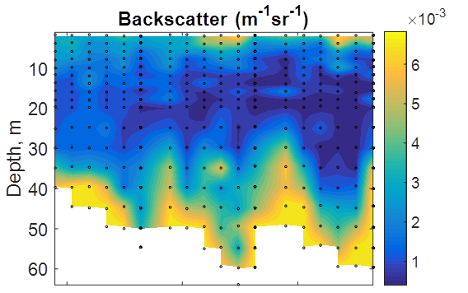
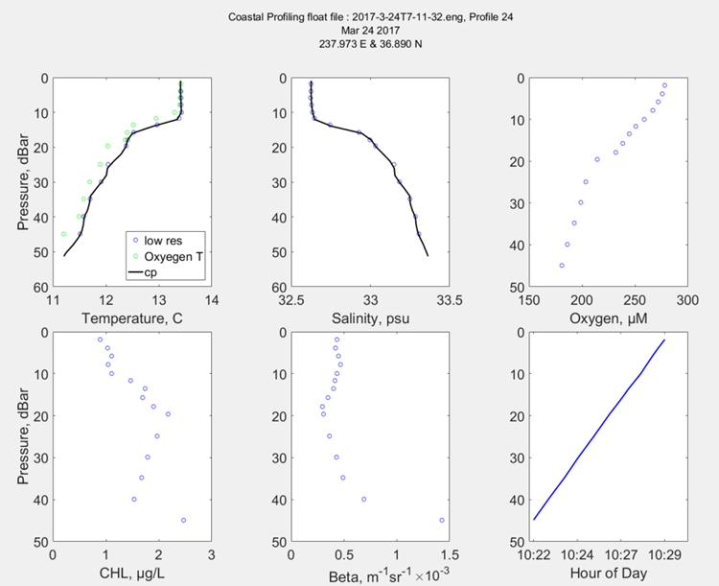

How will the data products be managed?
We have been working on the data management task since the first floats have been deployed and have developed the shore side infrastructure required to process and visualize the data telemetered from the floats. Data management will be handled in the existing FloatVIZ web site.

Describe data availability outside of the project team.

All CPF science data will be publically available in near real time on the FloatVIZ web site.
Describe data storage requirements.

Science data files are ~50K per profile. Engineering data files are ~2Mbytes per profile. As a rough estimate, assume 100 days of operations per year with 4 profiles per day.

4 profiles/day * 100 days/year * 2.05 Mbytes/profile = 820 Mbytes per year.

Anticipated Impact

The CPF project targets development of a platform that can support a broad suite of biogeochemical instruments and can be operated economically over large coastal ocean regions and for years at a time. We believe this technology is well suited to address the challenges described in more detail in the Statement of the Challenge section in this proposal including primary production, air-sea CO2 flux, ecosystem processes in coastal systems and ocean acidification in open, shelf waters.

Who are the consumers of the instruments, methods, systems, and data that will be generated?

The MBARI Fassbender and Takeshita labs are part of the science team planning, executing and consuming data from the proposed CPF science missions.

We are pleased to note that the CPF, even while still in the development process, has been used by MBARI researchers including the Chavez group as part of the CANON project, Tom O’Reilly and Ivan Masmitja as a platform of opportunity for jelly tracking work with the waveglider and by Eva Fritzsche as an O2, pH and C02 instrument testing platform¹. We continue to have discussions with and encourage other MBARI staff interested in using the CPF as part of their projects.

We hope the CPF will be of use to oceanographers who need a highly capable, long term, economical presence in the coastal zones of the world oceans. It is reasonable to expect that data generated by CPFs will be useful to policy managers responsible for fisheries management and other regulated activities in the coastal zone.

It has always been our intent to pursue commercialization of the CPF with an appropriate partner. We believe completion of the proposed 2019 science experiments is a reasonable predecessor to this task and will be pursuing this task in 2020.

  - Continuing Projects

If the proposed project includes multiple individual projects, please list each of these projects as a subheading in the proposal. For each subheading, please address the following:

Current status of project and results to date

Research activities

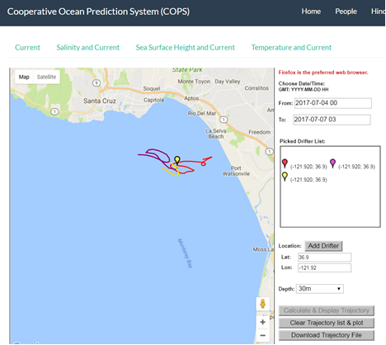
Understanding how to “navigate” CPFs is the primary research activity and we have run some experiments to get some basic data. Our first attempt at navigating the floats using sub-surface currents was in July of 2017. Figure 1 shows an example of the predicted trajectories from the ROMS model for floats at three depths in northern Monterey Bay at the same time. You can see in Figure 2 that we were able to keep this CPF much closer to the original deployment position than the un-navigated March 2017 track.
Figure 1 Predicted trajectories (4 Jul 2017 to 7 Jul 2017) at 1 m (red), 20 m (purple) and 30 m (yellow) computed using the Drop-a-Drifter interface to the COPS high resolution model.

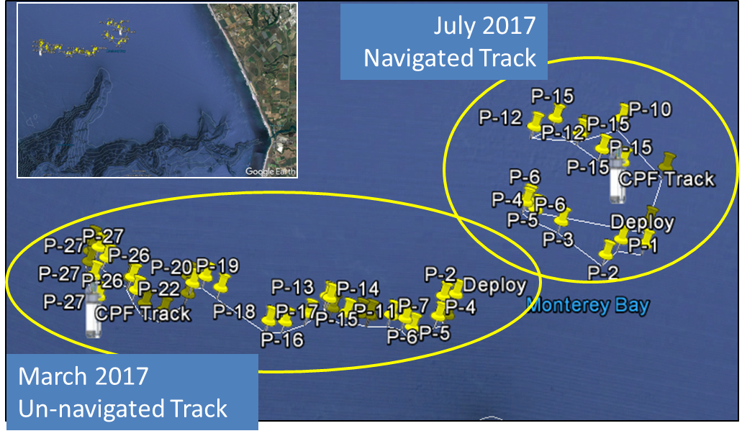
Figure 2 Results of July 2017 "navigated" mission vs March 2017 "un-navigated" mission

Engineering/Technology development

The development tasks identified in last year proposal for 2019 were 1) extending CPF mission duration, 2) hardening the CPF, 3) completion of the high energy density battery pack 4) development of a digital I/O circuit card and 5) development of a low power ocean current meter

Extending CPF mission duration
We have made significant improvements in the last half 2018 and this year cutting the power consumption by roughly 30%. The primary reductions were in reducing the amount of energy required to submerge from the surface and lift off from the bottom after anchoring. We have also integrated the power management capabilities of the new motherboard and daughter cards.

Hardening the CPF
We have complete enough test-modify cycles that we are comfortable that we are ready to deploy our fleet of CPFs in support of the proposed science mission.

High energy density battery pack.
This effort was delayed while we, along with the MBARI battery committee investigated the safety issues associated with Li-Ion battery packs. We have moved our efforts to using the same, lower energy density battery packs used on the LRAUVs which required a new circuit board, the lower half electronics circuit card assembly (LHE CCA) to be designed and built. The LHE CCA is currently being built and we’ll start integration in the 2nd half of July 2019. The science we are targeting along with the Fassbender and Takeshita labs will require the high energy density battery pack and we will be working on this in 2002.

Development of a digital I/O circuit card
The design is done and the card is in fabrication now. We hope to start integrating the card in early late July, 2019.

Inertial current meter
We’ve mentioned mitigating the risk of a CPF drifting on shore or off shore by developing a current meter capable of measure float velocities in the horizontal plane using the latest generation of inertial measurement units (IMUs). To date, we have used low cost/moderate performance IMUs to quantify their performance and make a reasonable prediction about what level of IMU performance we will need to help mitigate our drift risk. The low cost IMUs we’ve tested to date are capable of measuring currents in the upper range of what we expect during a deployment. At this point, we believe the recent generation of moderate cost/high performance IMUs have reached a price point that we can justify and will help us mitigate the risk due to drift over a more useful range of ocean currents.

The last 2 CPFs are built and waiting for integration with the LHE and Digital I/O cards. We hope to be tank testing in the last half of August followed by sea testing, pre-runs and the final execution of the proposed science mission by the end of 2019.

What percentage of labor and budget have been used through the 1st half of year?

Through July 12, 2019 labor hours used is 71% of the budget and expenses are 70% of the budget.

Will you complete the current year’s scheduled work?

We expect to complete everything except the high energy density battery pack

If you are at less than 50% resource usage, what is the plan to complete, or what work won’t be done this year?

NA

Significant changes from previous project proposal

None other than delaying development of the high energy density battery pack as described earlier.

Over the past two years, what peer-reviewed publications, education and/or outreach activities have resulted directly from this project? Please be brief.

¹Fritzsche E, Staudinger C, Fischer JP, Thar R, Jannasch HW, Plant JN, et al. A validation and comparison study of new, compact, versatile optodes for oxygen, pH and carbon dioxide in marine environments. Mar Chem. 2018;207:63–76.

  - All Projects: Specific Plans for 2020

Research Activities

We will begin science experiments in Monterey Bay using the CPF array in the last half of 2019. Our plan is to run this experiment twice more in 2020. The primary science focus will be the influence of lateral nutrient transport from upwelling plumes versus canyon upwelling on the development of high chlorophyll levels in the Monterey Bay “upwelling shadow” (Graham et al., 1997; Ryan et al., 2010). High concentrations of chlorophyll (Ryan et al., 2008) and high rates of net primary production (Johnson and Needoba, 2008) regularly occur in the northern part of the bay. The floats will be deployed in a grid and data will be collected both during the vertical profiles every 2-6 hours and every 15 minutes (or so) while they are parked on the bottom. That will enable detection of internal waves as they pass along the bottom, as well as plumes of surface water entering the northern area of the bay. All floats will be recovered at the end of each experiment.

We are continuing to develop our approach to “navigating” the floats based on the output from the ROMS model. Based on conversations with ROMS users and Dr. Yi Chao the ROMS PI, we’ve modified our approach somewhat. The current plan is to run a specific set of profiles this fall to acquire float drift data at depth that we can compare directly to the ROMS predictions. Yanwu Zhang is developing the detailed experiment plan but the overview is as follows. Let the CPF drift on the surface while recoding GPS position in the area we’ll be running the science missions. Descend to 10 meters (or so) as quickly as possible. Drift for an hour or so. Ascend to the surface and acquire GPS positions again. Repeat for 20 meters, 30 meters and so on. Calculate the CPF drift direction and velocity vs. depth. Since the CPF has a lot of buoyancy control we can dive quickly, at least 50 cm/sec, minimizing the errors in the drift at depth calculation due to drift while descending and ascending. Yanwu is also developing the tools we need to extract the current direction and velocity predictions for the experiment location and time from the ROMS model and compare the results with the field data. This has several benefits. First, we’ll get an idea of how useful the ROMS model data will be. Second, we may be able to develop some empirical data about CPF drift at depth for the targeted science mission location that can help our mission planning. Third, we’ve talked to Yi Chao, the PI for the ROMS model, and he’s very interested in this data as a way to improve the ROMS model.

Engineering/technology development

Engineering/technology development in 2020 will focus on the following

- Integrating lessons learned from running science missions
- Increasing mission duration
- Finishing development of the Intertial Current Meter described earlier
- Finishing the design and initial prototype of the high energy density battery pack

Field programs (detail ship requirements/deployments/diver requirements)

In 2020 we expect to run 2X 30 day experiments. We’ve talked to Mike Kelly and it seems reasonable to get support from the marine operations experts in DMO to help run these missions in order to keep the Chem Sensor lab staff focused on the long list of shore side operations. Running a mission consists of the following

We can of course provide Chem Sensor lab staff to fill in or handle DMO staff can’t support.

The waveglider is an integral part of the science missions we will be running and we are requesting 60 days of support for 2x 30 day missions.

Isotope Usage

None

Safety Disposal Needs

Will this project generate more than 1 gallon (4 liters) of battery waste per year?

No

If yes, please indicate the type of batteries (alkaline, NiCad, NiMH, lithium ion or lithium metal) and the approximate amount of each to be generated.

NA

Will this project generate more than 15 gallons (60 liters) of hazardous liquid waste per year?

No

If yes, please indicate the composition of the waste(s) and the quantity of each to be generated.

NA

Specific deliverables

- Completion of 2 science experiments with our fleet of 3 CPFs with data publically available on the FloatVIZ website.
- A reasonably well proven, scalable profiling float capable of support a variety of science missions anywhere in the world’s oceans to depths of 500 meters.
- Science publication (or conference presentation) describing the tools, techniques, processes and results from this experiment, probably Ocean Sciences in February 2020.
- A plan for commercializing the CPF technology in collaboration with a commercial partner

Development and infrastructure projects must complete the risk matrix (see end of the proposal form).
Not all projects will require all four titles to be filled in. Please indicate individuals only for those titles that are appropriate for your project.
This category includes transfer of hardware, know-how, publications, presentations, etc.

