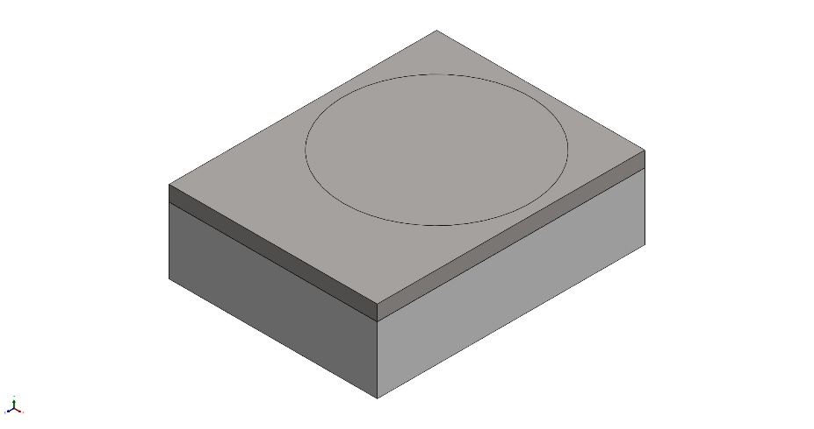
  Simulation of simpleISFETSpacerFEA
  Date: Thursday, September 14, 2023
  Designer: Solidworks
  Study name: Static 1
  Analysis type: Static
  Table of Contents
  Description 1
  Assumptions 2
  Model Information 2
  Study Properties 3
  Units 3
  Material Properties 4
  Loads and Fixtures 5
  Connector Definitions 5
  Interaction Information 6
  Mesh information 7
  Sensor Details 7
  Resultant Forces 8
  Beams 8
  Study Results 9
  Conclusion 15

Description
No Data

Assumptions

Model Information

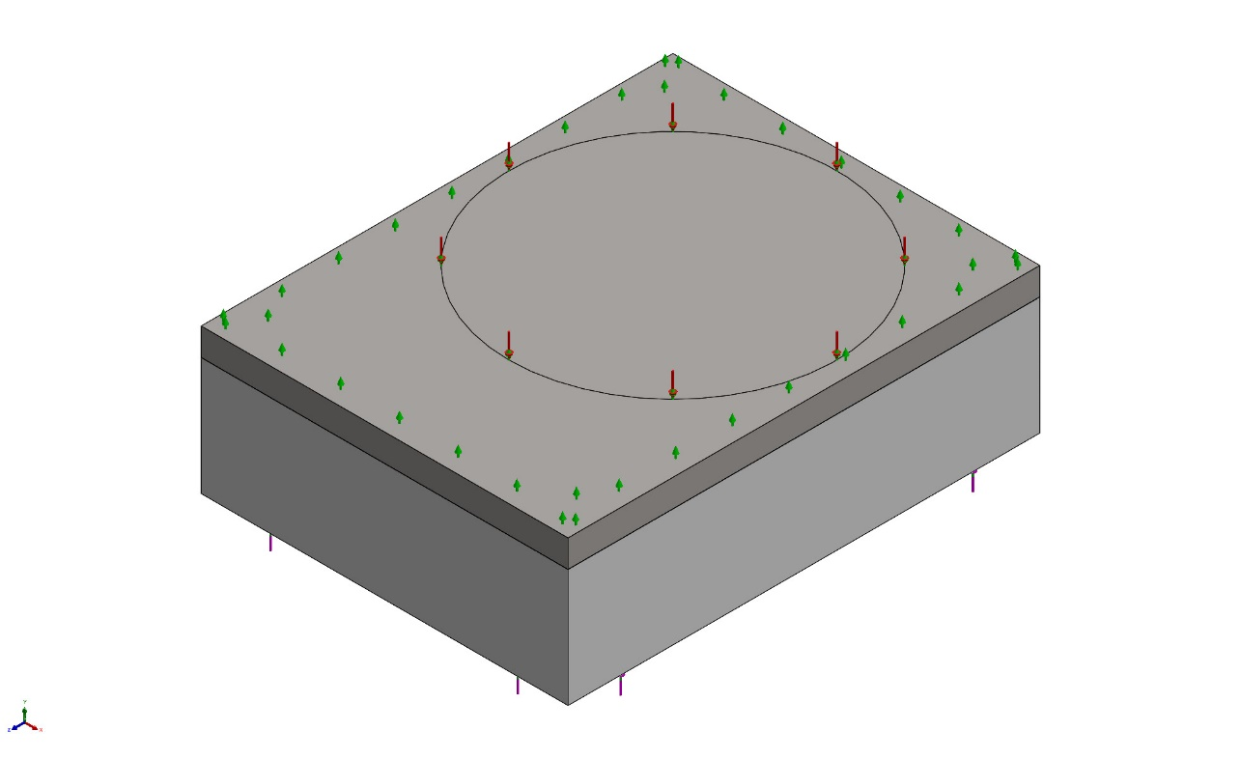
Model name: simpleISFETSpacerFEA
Current Configuration: Default
Solid Bodies
Document Name and Reference | Treated As | Volumetric Properties | Document Path/Date Modified
Boss-Extrude1  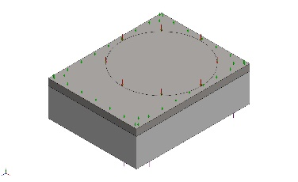 | Solid Body | Mass:0.000396511 lb  Volume:0.00864204 in^3  Density:0.0458817 lb/in^3  Weight:0.000396242 lbf | C:\PDM_Vault\Chemical Sensors\pH2018\Lionix\ISFETSpacerSimple.SLDPRT  Sep 14 10:10:52 2023
Split Line1  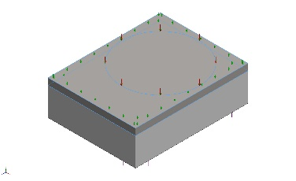 | Solid Body | Mass:0.000168507 lb  Volume:0.00200183 in^3  Density:0.0841766 lb/in^3  Weight:0.000168393 lbf | C:\PDM_Vault\Chemical Sensors\pH2018\Lionix\ISFET_FEA.SLDPRT  Sep 14 10:07:01 2023

Study Properties
Study name | Static 1
Analysis type | Static
Mesh type | Solid Mesh
Thermal Effect: | On
Thermal option | Include temperature loads
Zero strain temperature | 77 Fahrenheit
Include fluid pressure effects from SOLIDWORKS Flow Simulation | Off
Solver type | Automatic
Inplane Effect: | Off
Soft Spring: | Off
Inertial Relief: | On
Incompatible bonding options | Automatic
Large displacement | Off
Compute free body forces | On
Friction | Off
Use Adaptive Method: | Off
Result folder | SOLIDWORKS document (C:\PDM_Vault\Chemical Sensors\pH2018\Lionix)

Units
Unit system: | English (IPS)
Length/Displacement | in
Temperature | Fahrenheit
Angular velocity | Hertz
Pressure/Stress | psi

Material Properties
Model Reference | Properties | Components
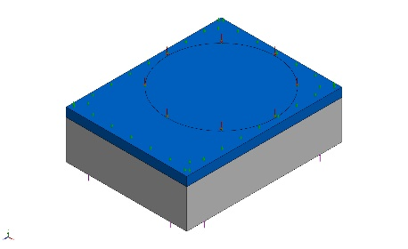 |  | SolidBody 1(Boss-Extrude1)(ISFETSpacerSimple-1)
  Name: | PEI
  Model type: | Linear Elastic Isotropic
  Default failure criterion: | Unknown
  Tensile strength: | 12,328.2 psi
  Compressive strength: | 20,305.3 psi
  Elastic modulus: | 449,617 psi
  Poisson's ratio: | 0.44
  Mass density: | 0.0458817 lb/in^3
Curve Data:N/A
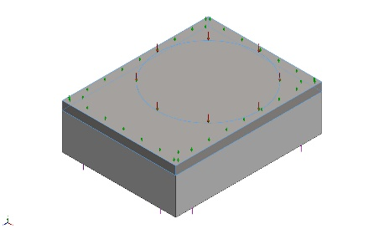 |  | SolidBody 1(Split Line1)(ISFET_FEA-1)
  Name: | Silicon
  Model type: | Linear Elastic Isotropic
  Default failure criterion: | Unknown
  Yield strength: | 17,404.5 psi
  Elastic modulus: | 1.63022e+07 psi
  Poisson's ratio: | 0.28
  Mass density: | 0.0841766 lb/in^3
  Shear modulus: | 7.10685e+06 psi
Curve Data:N/A

Loads and Fixtures
Fixture name | Fixture Image | Fixture Details
Roller/Slider-1 | 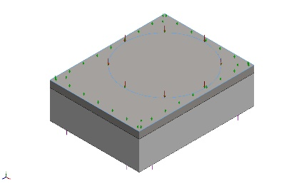
  Entities: | 2 face(s)
  Type: | Roller/Slider
Resultant Forces
Components | X | Y | Z | Resultant
Reaction force(lbf) | 0 | -0.0193953 | 0 | 0.0193953
Reaction Moment(lbf.in) | 0 | 0 | 0 | 0

Load name | Load Image | Load Details
Force-1 | 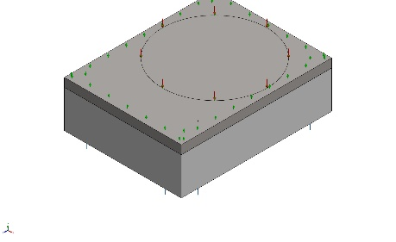
  Entities: | 1 face(s)
  Type: | Apply normal force
  Value: | 628 lbf
Pressure-1 | 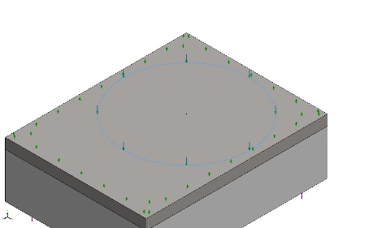
  Entities: | 1 face(s)
  Type: | Normal to selected face
  Value: | 3,000
  Units: | psi
  Phase Angle: | 0
  Units: | deg

Connector Definitions
No Data

Interaction Information

Interaction | Interaction Image | Interaction Properties
Global Interaction | 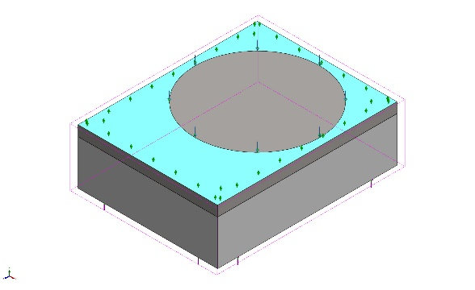
  Type: | Bonded
  Components: | 1 component(s)
  Options: | Independent mesh

Mesh information
Mesh type | Solid Mesh
Mesher Used: | Blended curvature-based mesh
Jacobian points for High quality mesh | 16 Points
Maximum element size | 0.0220086 in
Minimum element size | 0.0220086 in
Mesh Quality | High
Remesh failed parts independently | Off

Mesh information - Details
Total Nodes | 385610
Total Elements | 264276
Maximum Aspect Ratio | 3.7072
% of elements with Aspect Ratio < 3 | 99.9
Percentage of elements with Aspect Ratio > 10 | 0
Percentage of distorted elements | 0
Time to complete mesh(hh;mm;ss): | 00:00:08
Computer name: | KAVACHI

Mesh Control Information:
Mesh Control Name | Mesh Control Image | Mesh Control Details
Control-1 | 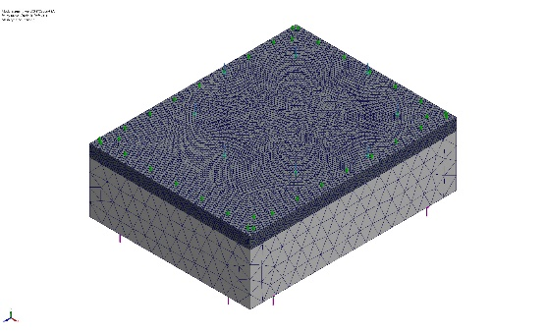
  Entities: | 1 component(s)
  Units: | in
  Size: | 0.004
  Ratio: | 0.004

Sensor Details
No Data

Resultant Forces

Reaction forces
Selection set | Units | Sum X | Sum Y | Sum Z | Resultant
Entire Model | lbf | 0 | -0.0193953 | 0 | 0.0193953

Reaction Moments
Selection set | Units | Sum X | Sum Y | Sum Z | Resultant
Entire Model | lbf.in | 0 | 0 | 0 | 0

Free body forces
Selection set | Units | Sum X | Sum Y | Sum Z | Resultant
Entire Model | lbf | -0.0018542 | 420.816 | -0.0013277 | 420.816

Free body moments
Selection set | Units | Sum X | Sum Y | Sum Z | Resultant
Entire Model | lbf.in | 0 | 0 | 0 | 8.85075e-33

Beams
No Data

Study Results

Name | Type | Min | Max
Stress1 | VON: von Mises Stress | 2.564e+01psi  Node: 113966 | 1.061e+05psi  Node: 198949
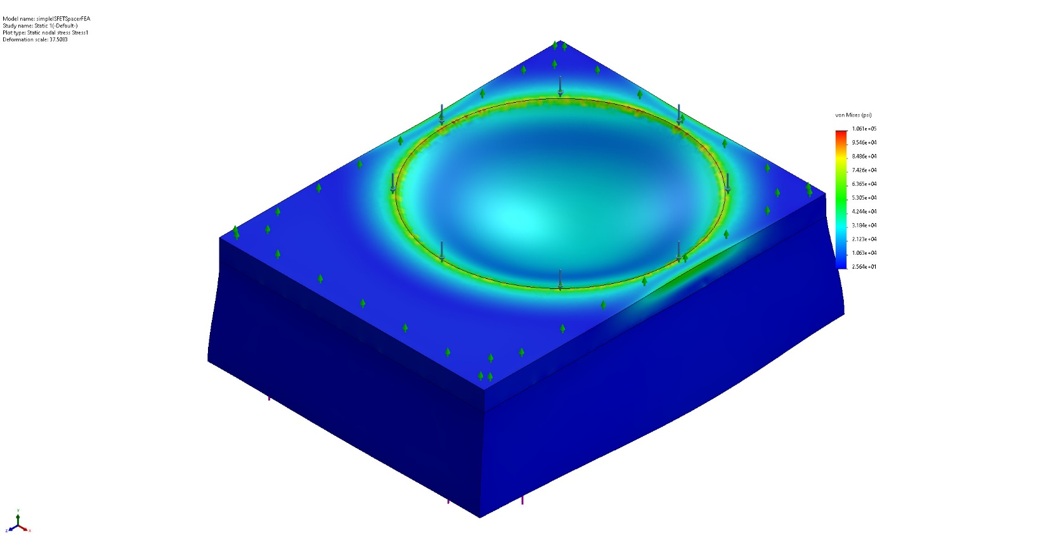
simpleISFETSpacerFEA-Static 1-Stress-Stress1

Name | Type | Min | Max
Displacement1 | URES: Resultant Displacement | 1.895e-07in  Node: 60334 | 9.447e-04in  Node: 85419
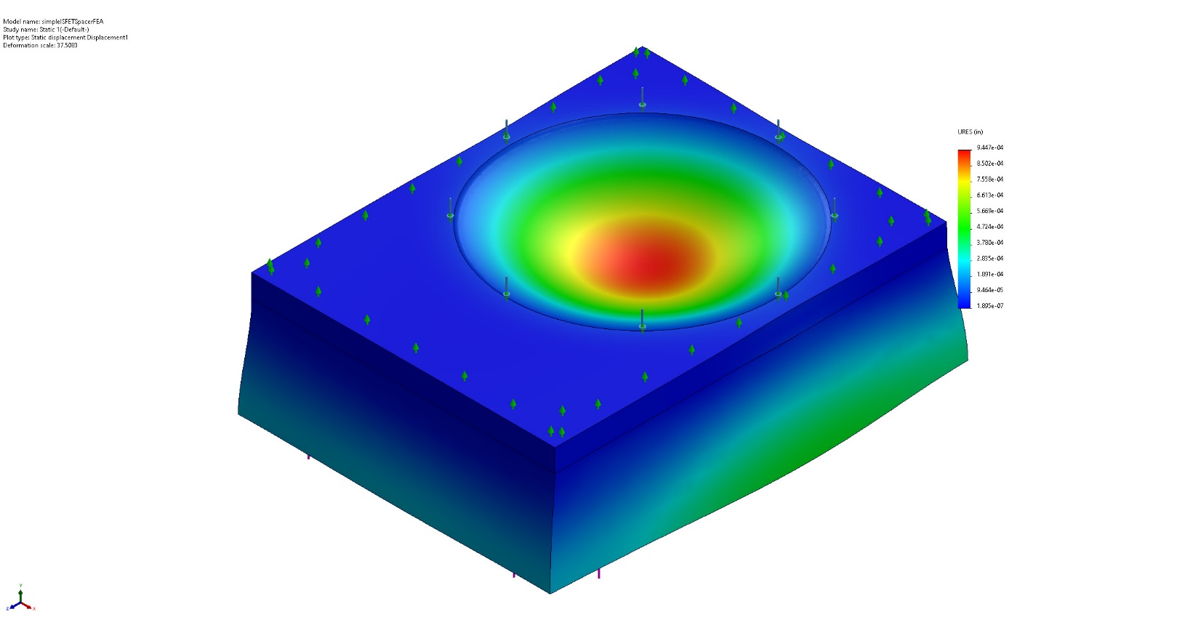
simpleISFETSpacerFEA-Static 1-Displacement-Displacement1

Name | Type | Min | Max
Strain1 | ESTRN: Equivalent Strain | 1.087e-06  Element: 12732 | 1.185e-02  Element: 2584
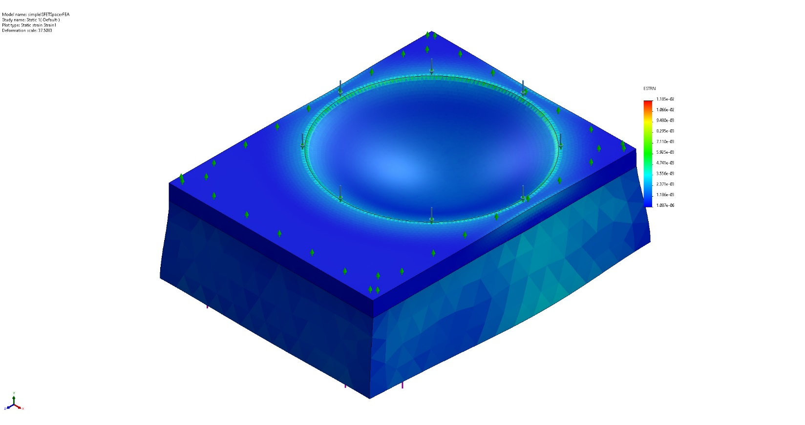
simpleISFETSpacerFEA-Static 1-Strain-Strain1

Name | Type | Min | Max
Stress2 | VON: von Mises Stress | 2.564e+01psi  Node: 113966 | 1.061e+05psi  Node: 198949
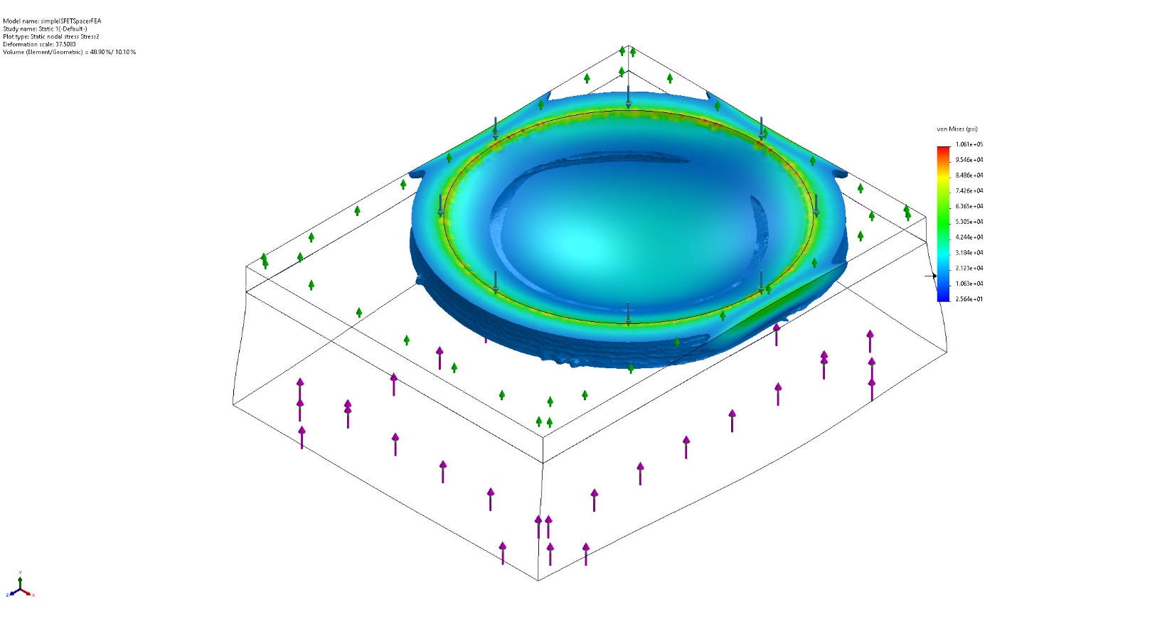
simpleISFETSpacerFEA-Static 1-Stress-Stress2

Name | Type | Min | Max
Stress3 | VON: von Mises Stress | 2.564e+01psi  Node: 113966 | 1.061e+05psi  Node: 198949
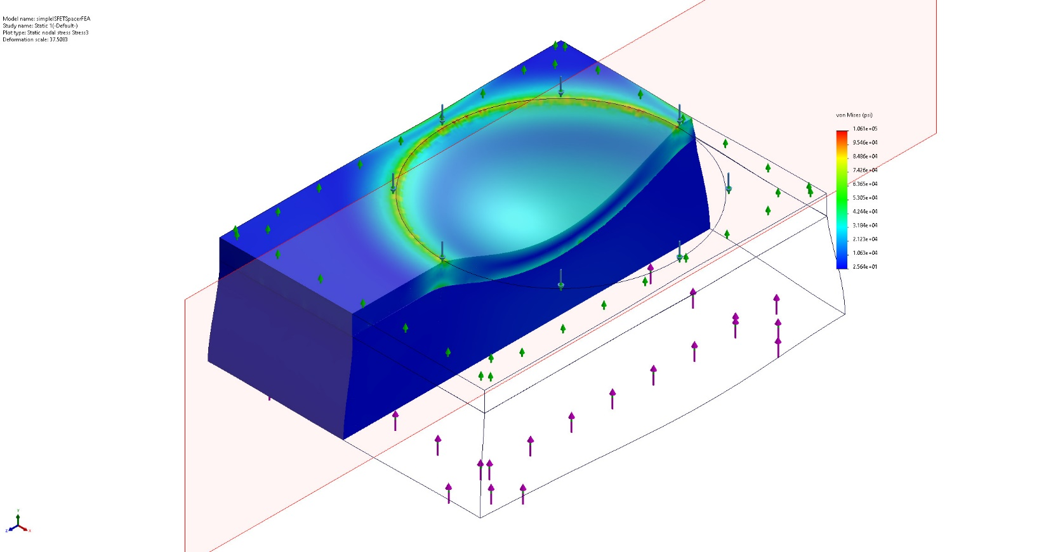
simpleISFETSpacerFEA-Static 1-Stress-Stress3

Name | Type | Min | Max
Displacement2 | URES: Resultant Displacement | 1.895e-07in  Node: 60334 | 9.447e-04in  Node: 85419
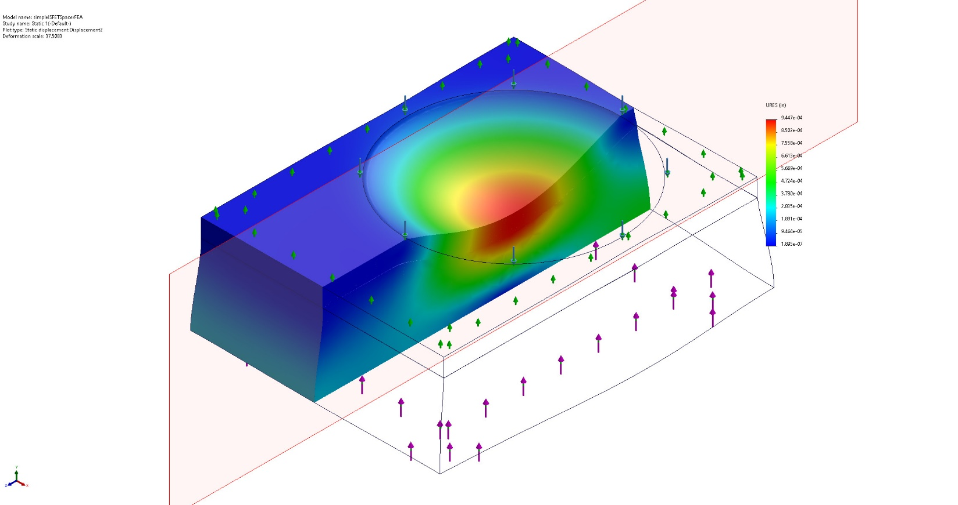
simpleISFETSpacerFEA-Static 1-Displacement-Displacement2

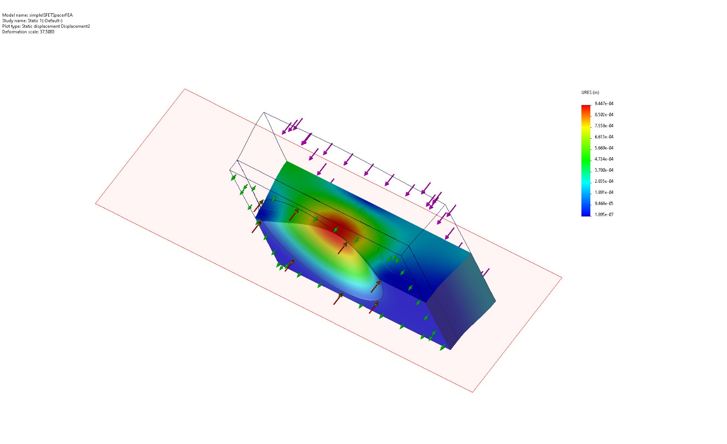
Image-1

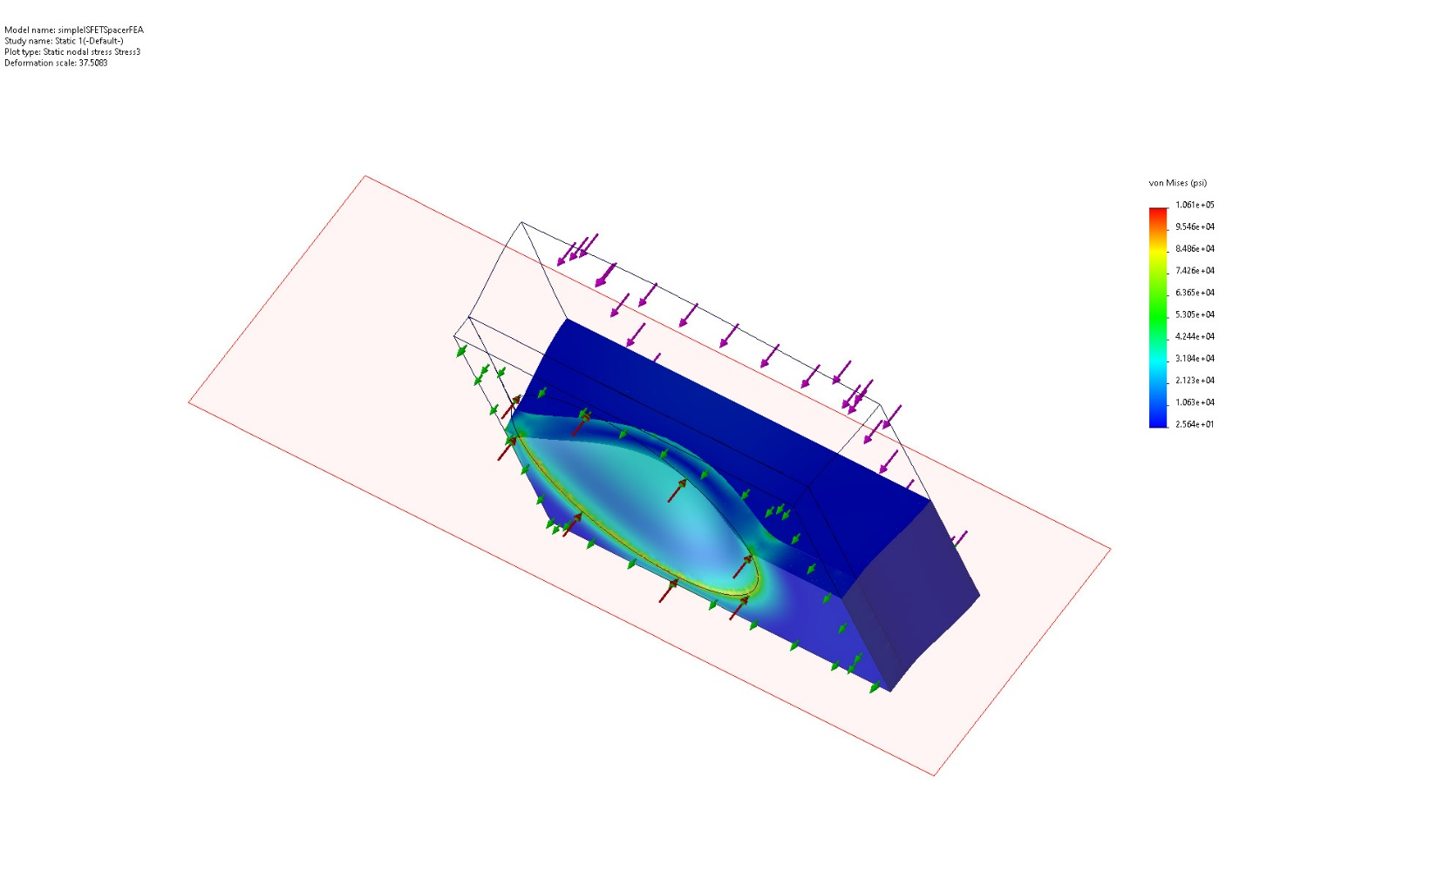
Image-2

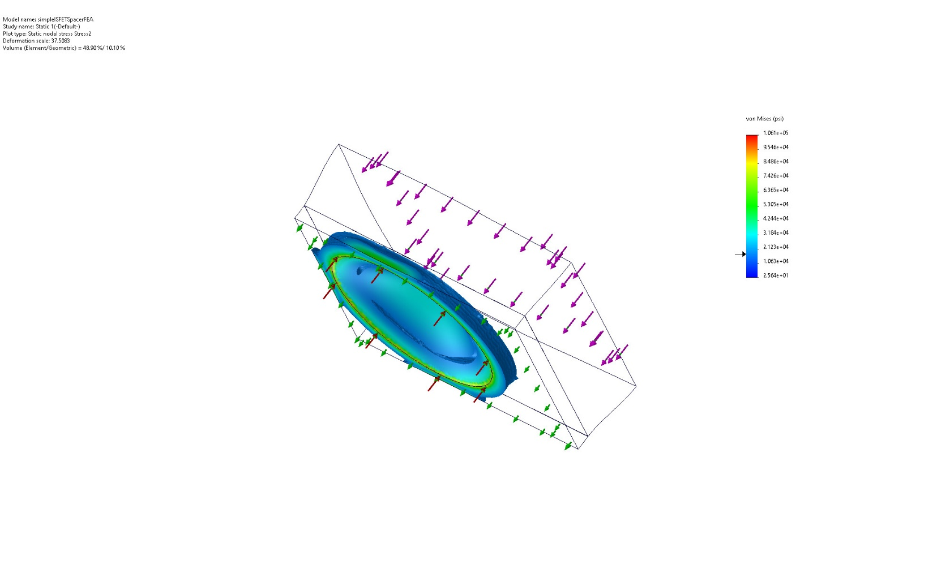
Image-3

Conclusion

