Principal Investigator:
Dr. Kenneth S. Johnson, Senior Scientist
Monterey Bay Aquarium Research Institute
7700 Sandholdt Road
Moss Landing, CA 95039
831 775 1985
johnson@mbari.org

Co-Principal Investigators:
Prof. Stephen C. Riser
School of Oceanography
University of Washington
Seattle, WA 98195
206 543 1187
riser@ocean.washington.edu

Prof. Jorge Sarmiento
Dept. of Geosciences
Princeton University
Guyot Hall
Princeton, NJ 08544
609 258 6585
jls@princeton.edu

Project Title: An autonomous chemical sensor network in the Eastern Tropical North Pacific

Total Funding Requested: $1,803,634

Proposed Period of Performance: 10/1/12 to 09/30/14

MBARI Authorizing Signature ________________________________

Date of Proposal Submission ________________________
Summary— Suboxic (O₂ < 4.5 µM) areas of the ocean play an important role in controlling the ocean carbon cycle, particularly by regulating the rates of nitrate loss through denitrification or anammox reactions and, ultimately, fixed nitrogen stocks (Keeling et al., 2009; Deutsch et al., 2011). The factors that control the volume of suboxic regions of the world ocean are not well understood and there are no extant observing systems that allow us to observe temporal variability in these systems at large scales. This proposal describes a chemical sensor network using profiling floats to be deployed in the Eastern Tropical North Pacific (ETNP), which contains the largest suboxic volume in the world ocean (Keeling et al., 2009). The network is designed to observe a variety of processes, including: 1) the seasonal to interannual variation in oxygen concentration around the oxygen minimum zone, 2) the coupling of net community production (NCP) in surface waters to the oxygen concentration changes observed in the oxygen minimum, 3) the impacts of low oxygen concentration and its variability on dissolved nitrate consumption through denitrification or anammox reactions, and 4) the stoichiometry of dissolved inorganic carbon (DIC) changes (inferred from pH variability) and nitrate in the oxygen minimum zone.

I. The problem— Our understanding of the interactions between the ocean, climate, human activity, and marine ecosystems is currently limited by a paucity of oceanographic data. Below the surface, the ocean is a vast, cold, and dark environment under extreme pressure that is challenging to observe. Satellite optics cannot penetrate beyond the surface layers of the ocean, and specialized oceanographic research vessels manned with trained scientists are too costly to characterize most of the ocean’s interior more than about once per decade. Additionally, the ocean’s properties are highly variable on almost all time and space scales, and resolving the effects of long-term trends from seasonal cycles and interannual variability requires observations that are denser in both time and space than manned research vessels can provide.

A potential solution: floats— At the turn of the millennium, an ambitious program was embarked upon to address the problem of limited observations for the study of ocean currents and heat content (Roemmich et al., 2009). This innovative program married the budding sensor technology of the era with what are known as “profiling floats,” or platforms designed to float at a depth where currents are weak, periodically return to the ocean’s surface while measuring the temperature and salinity on the way, then transmit the collected data via satellites to scientists on land, and return to the deep ocean to restart the cycle. These floats sample the ocean on a time scale of once every 5 to 10 days, or three orders of magnitude more frequently than most ship-based surveys. This program, now undertaken on a global scale with more than 3,500 so-called “Argo” floats deployed, has generated data helping to reveal robust evidence of widespread warming and freshwater transport trends associated with climate change (Lyman et al., 2010). However, the vast majority of these floats were developed and launched at a time when the sensors needed to assess the functioning of marine ecosystems and biogeochemical processes did not exist.

The proposal— A new generation of biogeochemical sensors has now been developed with the capacity to measure nutrient and oxygen concentrations, the optical properties of matter suspended within seawater, and, in the near future, seawater pH (Gruber et al., 2007, 2009; Boss et al., 2008; Johnson et al., 2009; Claustre et al., 2009). We propose to purchase/build twenty floats that are equipped with these novel sensors and to deploy the array in the ETNP (Fig. 1), an environmentally sensitive and economically important oceanic region. High-density float measurements in this region can be used to address longstanding scientific questions regarding oxygen and nutrient cycling, climate change, and the ecological impacts of human activity, and lay the foundation for a broader global “biogeochemical” float program that would parallel the existing Argo network. We will also develop a data management system to absorb the massive amounts of new data and make them publically available for scientific interpretation and for educational activities on the web. This program will provide a unique opportunity to understand the coupling of oxygen, carbon and nitrogen cycles at a sustained resolution in space and time that has not been previously possible.

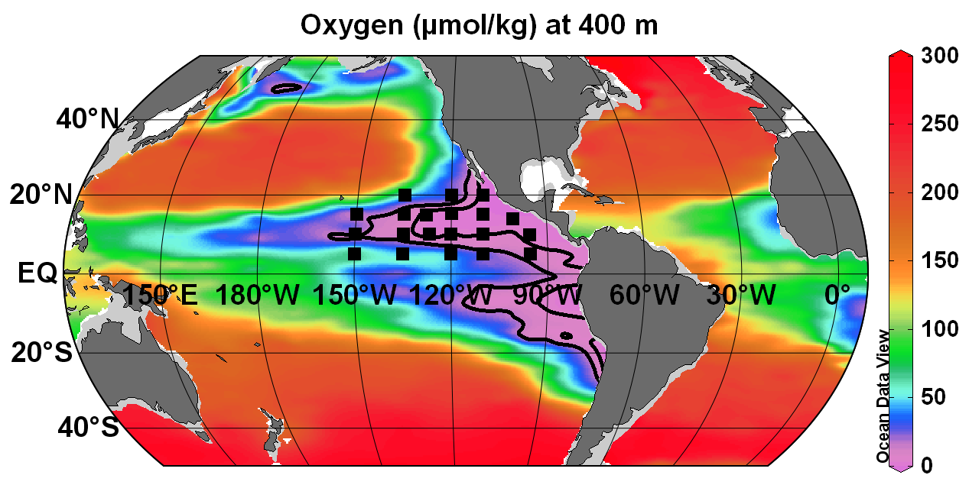II. Scientific background
Fig. 1. Dissolved oxygen concentration at 400 m depth. Contour lines are drawn at 5 and 10 µmol/kg. Black squares are possible deployment locations for 20 profiling floats. Oxygen data from the e-WOCE Atlas were accumulated over the past 25 years.

Why the ETNP?— A large fraction of the ETNP is nearly depleted in oxygen below the surface (Fig. 1). Recent modeling and observational research suggests that the world’s oxygen minimum zones are highly susceptible to climate and they may be expanding over time (Stramma et al., 2008; Keeling et al., 2010). However, much of our understanding of ocean oxygen is based on the World Ocean Atlas (WOA), which is a compendium of more than 50 years of data. There is clear evidence of significant errors in the WOA at very low oxygen levels and it is difficult to use the historical data to understand oxygen cycling at such low concentrations (Bianchi et al., in press http://www.agu.org/journals/gb/papersinpress.shtml#id2011GB004209). New approaches that provide persistent and high quality data are needed.
Fig. 2 Red dots are regions with sufficient oxygen data to compute temporal trends according to a minimal set of criteria for data availability (from Gilbert et al., 2010).

Declining oxygen concentration is also linked to nitrate loss, a key phytoplankton nutrient, as bacteria in low oxygen zones utilize fixed nitrogen in denitrification or anammox reactions (Koeve and Kahler, 2010). However, there are few direct observations with sufficient spatial and temporal resolution that can be used to understand the linkages between low oxygen concentration and nitrate loss. Furthermore, there is recent modeling evidence (Deutsch et al., 2011) that seasonal and interannual variability of the oxygen minimum zones may be far greater than the trend that has been seen in the limited data. The principal scientific goal of our proposal is to characterize the oxygen minimum zone of the ETNP in space and time as well as the processes that determine its extent. In addition, nitrate sensors on the floats will enable us to examine coupling of oxygen and nitrogen cycles. The measurements will also allow us to assess the biological productivity of the region, to estimate how much anthropogenic carbon dioxide this region has absorbed from the atmosphere, to monitor the acidification of the ocean that results from this uptake, and to assess the link between seawater pH and ecosystem productivity.

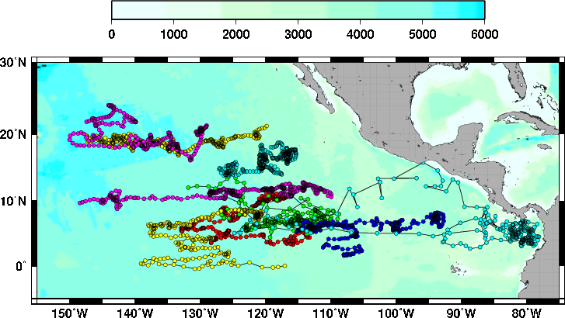We have chosen to focus on the ETNP for several reasons. First, it contains the largest volume of sub-oxic water in the global ocean, yet there is little data that allows variability to be assessed. Gilbert et al. (2010) mapped locations in the ocean where temporal trends in oxygen can be determined according to a minimal set of criteria for data availability (Fig. 2). Almost no areas of the ETNP have sufficient data for trend analysis. Second, the oxygen minimum in the ETNP is shifted further away from the equator than in the ETSP (Fig. 1). This makes the southern edge of the ETNP, which is north of 5° over most of the region, much easier to observe with floats. Floats deployed in the target region stay in the ETNP, while floats south of 5° are rapidly removed. Third, although there are several research programs now underway in the eastern Pacific with a focus on oxygen dynamics, their main emphasis is south of the equator. This includes work by O. Ulloa (Chile), L. Stramma (Germany) and R. Letelier (USA). We have had preliminary contact with these groups and will coordinate efforts if this project goes forward.
Fig. 3 Tracks of 9 floats deployed in the ETNP and which operated more than 5 years. Although flow is organized, it is weak and all floats remain in the target area for the full 5 years. Color bar is depth.

Why this team? — Steve Riser and Ken Johnson have worked closely to develop and apply chemical sensors on floats (Riser and Johnson, 2008; Martz et al., 2008; Johnson et al., 2010). The next step in this work is to extend the small sets of sensors to larger arrays that have a multi-year presence over large ocean regions. This will enable much broader questions to be addressed. The unique expertise brought by Jorge Sarmiento’s group in dealing with large data sets, complex ocean models and fundamental biogeochemical processes will enable our focus on these broader topics.

III. How the technology will transform the field

Oxygen sensor—An Aanderaa Optode oxygen sensor will be mounted on each float. This will allow us to assess net community production in surface waters and the linkage to temporal variablity of the oxygen minimum zone. Oxygen sensors have been placed on floats deployed near Hawaii for almost 10 years (Riser and Johnson, 2008; Johnson et al., 2010). Their utility in low oxygen systems has been demonstrated (Whitmire et al., 2009; also “Argo Float of the Month” for October 2011 - http://wo.jcommops.org/cgi-bin/WebObjects/Argo.woa/wa/floatMonth).

Factory calibration of Optodes is poor. Proper calibration can be achieved by matching sensor output to Winkler oxygen titrations on samples collected at deployment. Figure 4 shows nearly 10 years of data collected by floats deployed at the Hawaii Ocean Time-series (HOT) and calibrated in this manner. Although the floats then disperse as far as 1000 km in several years, the sensors yield a temporal record that closely matches the values measured by the HOT program at the surface and in the core of the oxygen minimum (750 m) using high quality oxygen titrations in the laboratory (Fig. 4). Both the float sensors and HOT oxygen measurements show a similar rate of increase over time at 750 m depth (~1 µmol kg⁻¹ y⁻¹; Fig. 4). This increase most likely reflects inter-annual variability in ocean circulation due to processes such as the Pacific Decadal Oscillation. The coherent change in sensor values and the oxygen measured in laboratories by the HOT program highlights a powerful attribute of the Aanderaa oxygen sensors: there is rarely, if ever, any detectable long-term drift in the output of these sensors, relative to independent estimates of oxygen concentration, when deployed on profiling floats (Gruber et al., 2007; Tengberg et al., 2005).
Fig. 4 Dissolved oxygen near Hawaii measured at the surface (top panel) and at 750 m in the core of the oxygen minimum (bottom panel) by Hawaii Ocean Time-series personnel using Winkler titrations and by seven profiling floats deployed by the Riser Lab near HOT. Each float was calibrated by fitting a linear regression between float data and the HOT Winkler data collected when the float was deployed.

The oxygen sensors also work well in low oxygen systems such as the Arabian Sea (Whitmire et al., 2009). Float 6381 in the Arabian Sea easily resolves lateral intrusions that carry small amounts of oxygen into the system (Fig. 5). These oxygen events are accompanied by elevated salinity and they are consistent with prior observations of outflow from the Persian Gulf (Prasad et al., 2001). Thus, we are confident that properly calibrated float oxygen sensors can be used to study oxygen variability at levels near zero concentration. Several laboratories are offering independent calibration of Optodes and we will use one of these to pre-calibrate sensors but will use at sea calibration as our primary reference.
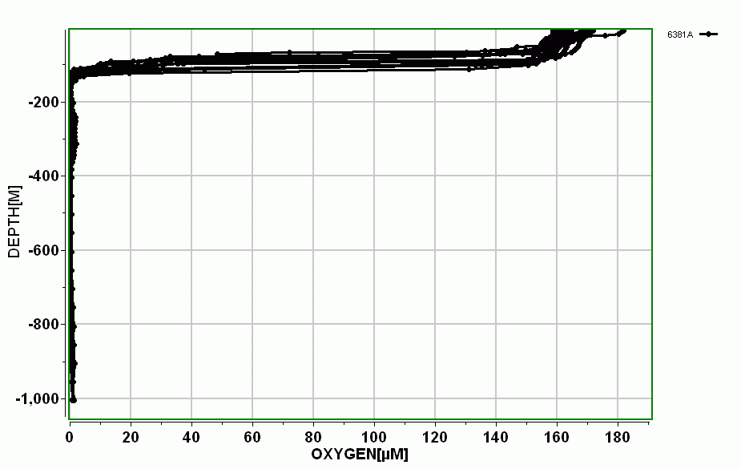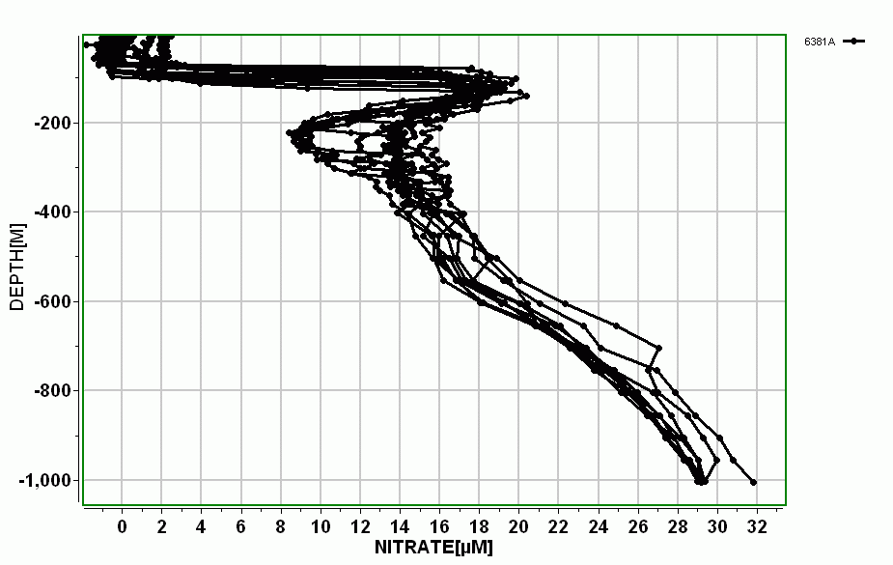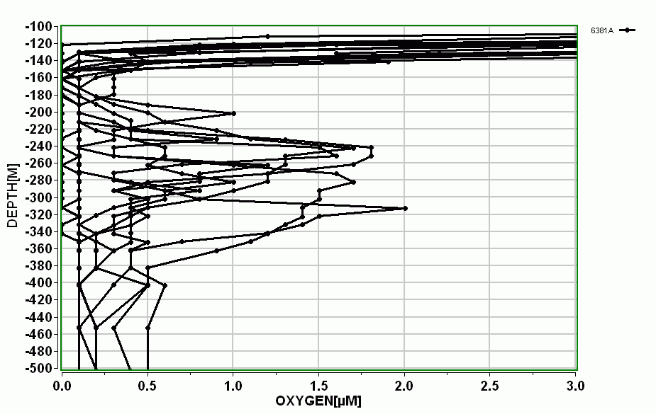
Fig. 5 Oxygen and nitrate profiles from float 6381, deployed in the Arabian Sea oxygen minimum on Dec. 16, 2011. The inset on the oxygen plot shows intrusions of modestly oxygenated, high salinity water from the Persian Gulf outflow between depths of 100 to 500 m on a scale from 0 to 3 µM O₂. Nitrate in these layers is also slightly elevated.
Float sensors clearly reveal temporal variability in the interior ocean. For example, Najjar and Keeling (1997) used the World Ocean Atlas compilation of subsurface oxygen data to demonstrate that there is an annual cycle in deep oxygen concentration. The deep oxygen cycle can be resolved by profiling floats (Martz et al., 2008). Data collected near Bermuda clearly shows the oxygen depletion is closely linked in time and magnitude to production of organic matter at the surface (Fig. 6). This confirms the ability of optodes to resolve changing oxygen concentrations on annual scales.

Further, we have validated the capability of profiling floats to measure upper ocean NCP by merging the calibrated float oxygen data from the 9-year long record near HOT (15 float years as there are multiple floats operating in many years) with mixed layer models with gas exchange (Glover et al., 2011) to compute annual Net Community Production (NCP). The combined float record yields a mean NCP over the full depth range of the euphotic zone of 2.6±0.6 (95% CI) mol C/m²/y. Quay et al. (2010) summarized the shipboard measurements at HOT and these yield a value of 2.8±0.9 (95% CI) mol C/m²/y, consistent with the float data.

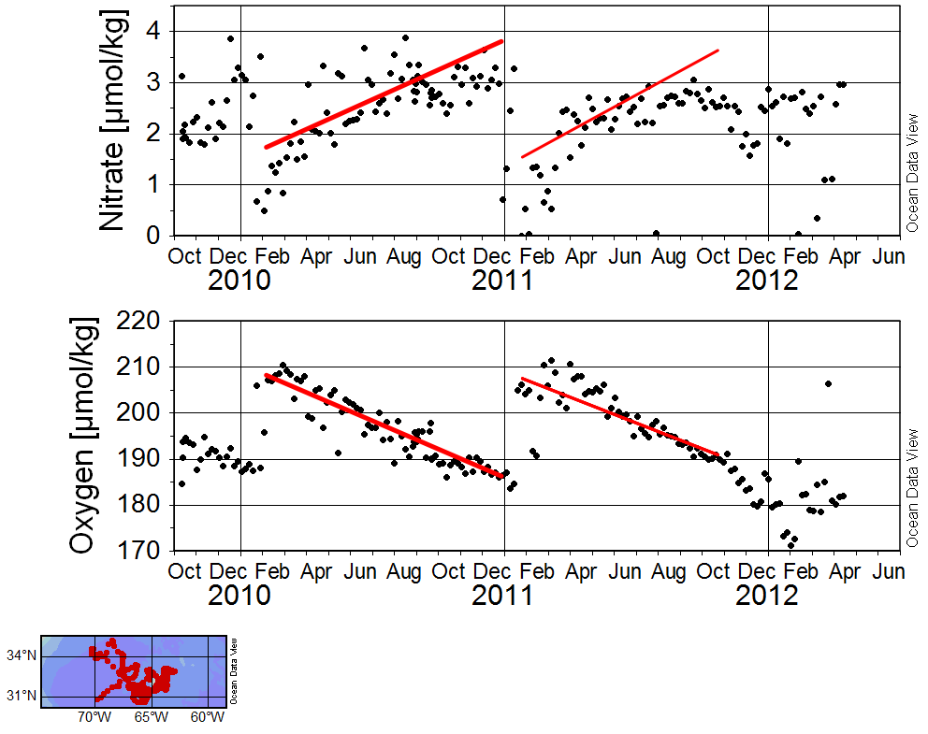Nitrate sensor—Each float will be equipped with an In Situ Ultraviolet Spectrophotometer (ISUS) nitrate sensor. These devices have been deployed on >20 profiling floats to date and have proven to be a robust tool for nitrogen cycle studies as well as a key tracer for net community production (Figs. 5 and 6 and Johnson et al., 2010). Utilization of the nitrate sensor is a unique feature of this work. No other groups have yet begun to deploy floats with nitrate sensors for multi-year periods. This capability allows us to observe the coupling of oxygen and nitrate cycles in suboxic regions. Our interest in low oxygen regions has led us to recently deploy one float in the Arabian Sea and two in the ETNP (www.mbari.org/chemsensor/floatviz.htm, floats 6381, 6960 and 7558). All are working well and showing interesting coupling of oxygen and nitrate (e.g. Fig. 5).
Fig. 6 Nitrate and oxygen data collected at 200 m depth by profiling float 6391 deployed near the Bermuda-Atlantic Time-series Study (BATS) station. The data show the seasonal cycle in oxygen and nitrate that occurs following deep mixing each year. Nitrate was corrected for a drift of 0.4 μM/yr by assessing change in surface values reported in summer when concentrations are known to be zero.

Previous deployments of the nitrate sensors on profiling floats have shown modest drift in time (Johnson et al., 2010). In the past, we have corrected for this drift in oligotrophic systems such as the ETNP by subtracting sensor output at the surface where concentrations are known to be zero from observations at all depths (Johnson et al., 2010). This works well because the nitrate sensor has the attribute that concentration errors occur as a constant offset over a whole vertical profile. A recently developed revision of the data processing algorithm appears to greatly reduce this problem. Early algorithms assumed that changes in spectrometer performance could be modeled as a simple baseline shift that was linear in wavelength (Johnson and Coletti, 2002). The revised algorithm seeks to understand the underlying physics of the light source and models its output with several adjustable parameters that change the output spectrum in a non-linear manner. This largely eliminates drift in nitrate concentration. Success of the algorithm suggests that most of the drift that we see is due to changes in the light source, rather than fouling of the optics. By observing a broad spectrum of light output where nitrate does not absorb, these changes can be modeled and used to predict light output in the region where nitrate does absorb much more accurately than in prior algorithms.

pH sensor—The Honeywell Durafet is an exceptionally stable pH sensor that is capable of ±0.005 pH stability on surface moorings over one year, in the absence of strong biofouling (Martz et al., 2010; Hoffman et al., 2011; unpublished results). Commercially available versions do not tolerate pressure greater than 70 m depth. Pressure tolerant versions of the Durafet pH sensor are now being produced at MBARI in a collaboration with the Honeywell Microsensors Group. Although the high pressure version is still an experimental design, first deployments on a profiling float are in progress and we anticipate that robust versions will be available for this work (Fig. 7). The demonstration of prototype units operating at high pressure (Fig. 7) and our observation of long-term stability on moorings (Martz et al., 2010) convince us that the risks in planning on a sensor that has not yet been demonstrated on a profiling float are manageable.
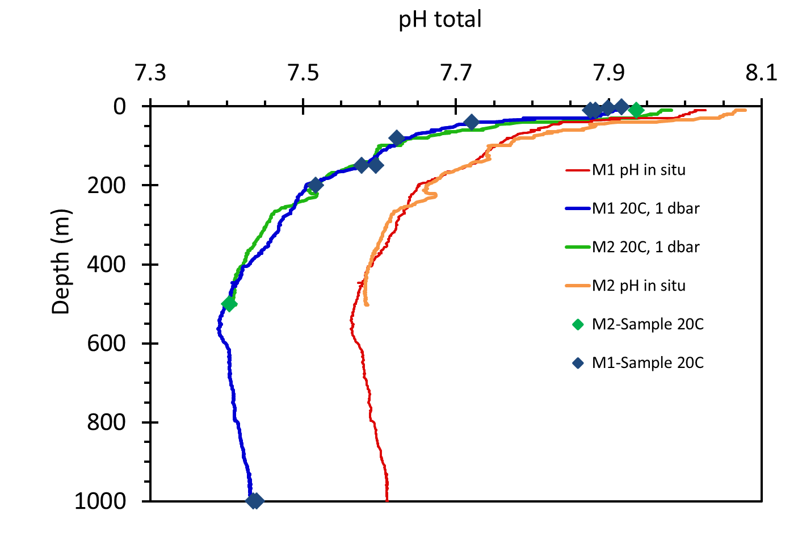
Fig. 7. pH measured in situ on a CTD/Rosette cast at two stations in Monterey Bay. This is the first set of deployments of a Deep-Sea Durafet sensor. The sensor was calibrated for P, T and pH response in the laboratory and no further adjustments to the data were made. In situ measurements were corrected to 20°C and 1 atm to allow comparison with spectrophotometric pH measurements on rosette samples (diamonds). The agreement indicates that pH measurements consistent to at least 0.02 with spectrophotometric laboratory values are possible through large P and T ranges.
The risk in proposing work with the pH sensor is mitigated by the fact that much of the proposed work can be accomplished without it, but pH sensor availability would strengthen some components. For example, there may well be a detectable, annual cycle in pH within the suboxic zone that reflects respiration driven by denitrification, while oxygen remains near zero. If anammox (autotrophic fixation of C using nitrite and ammonium oxidation as an energy source) is a variable cause of fixed nitrogen loss, then the stoichiometry of pH versus nitrate loss may vary in time, in response to inputs of carbon (Voss and Montoya, 2009; Ward et al., 2009) and this would be apparent in our observations. pH would also provide independent estimates of carbon production and export from the surface.

Quantification of changes in inorganic carbon system parameters requires one other variable, in addition to pH. We will derive the second variable from linear regressions fit to observations of Normalized (S=35) Total Alkalinity (NA_{T}). In the ETNP, NA_{T} in the GLODAP data set is well fit in the upper 1000 m by a simple, linear function of depth (R = 0.96, std. error of regression = 8 µeq/kg). The uncertainty in calculation of Dissolved Inorganic Carbon (DIC) (7 µmol DIC/kg) that arises from the uncertainty in NA_{T} predicted from a linear regression on depth is similar to that from a pH error of 0.015, which is at the high end of our expectations for sensor performance. These uncertainties would allow NCP values to be obtained from seasonal cycles in DIC with a precision corresponding to that achievable with the O₂ sensor (about 0.5 mol C/m2/y as noted above). We will use NA_{T} observations made on the deployment cruise to further refine our understanding of the processes that control its variability in the ETNP and its relationship to properties observable from a float. Alkalinity and DIC in samples collected on the cruise will be analyzed by Andrew Dickson’s laboratory at Scripps Institution of Oceanography.

Biooptical sensor—Biooptical sensors for chlorophyll fluorescence and optical backscatter are now routinely used on profiling floats for years with no evidence of fouling (Boss et al., 2009; Whitmire et al., 2009). They provide valuable tracers of biomass accumulation and carbon export. In particular, they are valuable tracers of the timing of the onset of events such as plankton blooms or carbon export. The detection of carbon export would be a key observation if we see changes in nitrate/pH relationships (see above) in time. We have also observed significant variability in particle backscatter within the suboxic zone using profiling floats (see also Whitmire et al., 2009). Such variability has been related to changes in the biomass and activity of denitrifying bacteria (Naqvi et al., 1993). Each float will be equipped with these biooptical sensors.

Oxygen minimum zone extent—We aim to address four scientific questions regarding the oxygen minimum zones of the ETNP:
- What is the extent of the oxygen minimum zones in this region?
- How variable is the extent of these regions in time?
- Is this variability linked to patterns of physical mixing, or more closely linked with biogeochemical cycling?
- Is there a long-term (>10 years) trend in the extent or intensity of the oxygen minimum zones? If there is, what is the cause?
This proposed float deployment is very likely to be able to answer the first question. The Sarmiento group has used a comparison of discreet measurements to the gridded World Ocean Atlas oxygen dataset to show that there is a systematic underestimation of the extent of mid-depth suboxia by as much as a factor of three (Bianchi et al. in press). Such gridded data products are used as initial conditions and as constraints for climate models. Correctly representing the extent of oxygen depletion in these datasets is therefore critical for correctly assessing the effects of the cycling of organic matter, denitrification and anammox, and ocean ventilation on the ocean’s properties. We expect that the excellent vertical measurement density achievable with floats will circumvent this systematic error for vertical interpolation, though some systematic interpolation errors may remain for horizontal interpolation.

The high temporal resolution of the floats’ measurements will aid in determining the variability of the ETNP oxygen minimum zone’s extent. With profiles collected every 5 days, the float measurements have the potential to resolve individual mixing and organic matter export events alongside the longer seasonal cycles. This factor of ~1000 improvement in temporal resolution over decadal hydrographic surveys should allow us to determine whether the high variability in OMZ extent suggested by models (Deutsch et al., 2011) is real and on what timescales it is most significant.

The extent of OMZs reflects a balance between the supply of oxygen to the depths from physical mixing and the utilization of this oxygen in the respiration of organic matter (Ito and Deutsch, 2011). The simultaneous collection of both physical and biogeochemical measurements should allow us to elucidate which of these processes underlies variability in the extent of oxygen minimum zones. Measurements of salinity and temperature can resolve the mixing between cold fresh intermediate waters and the warm salty waters of the upper thermocline, and depletion of oxygen from organic matter remineralization is accompanied by an accumulation of nitrate (except where denitrification or anammox is occurring). The mechanisms primarily responsible for observed variability can be determined by regression of oxygen concentrations against salinity, temperature, and nutrients (similar to the approach of Juranek et al., 2011) and an analysis of the variability in these predictive tracers.

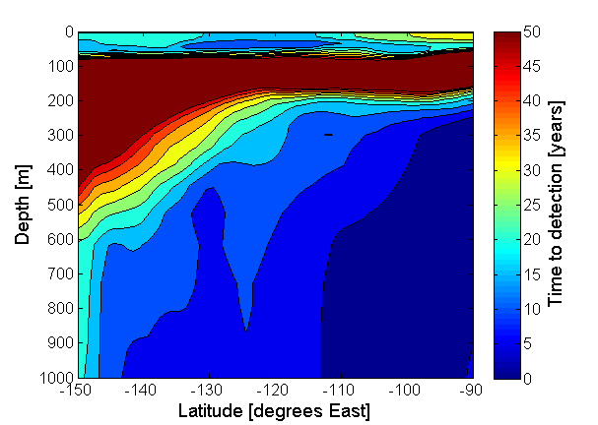
Figure 8 Estimates of the number of years of monthly measurements required to detect a trend of 0.34 µmol kg^{‒1} yr^{‒1} along 10 °N in the ocean. Estimates are obtained using variability derived from oxygen outputs of the Geophysical Fluid Dynamics Laboratory’s ESM2M model, and estimation strategy given by Weatherhead et al. (1998).
Addressing the fourth question may or may not be possible with this float deployment: determining whether a significant trend is present in a timeseries of data is straightforward, though determining whether an observed trend is the result of processes acting on timescales that are long relative to – for example – decadal variability, can require a timeseries of a significant length. Weatherhead et al. (1998) show that identifying such a trend requires the determination of the trend, the deviation about that trend, and the autocorrelation of the deviation about that trend. The Sarmiento group has experience using this approach to time series analysis to make careful and robust assessments of trends in primary productivity measured from satellite (Henson et al., 2009). Using this analysis on the variability in a global circulation model’s outputs suggests that 5 years of data might only be sufficient to identify a trend of the largest magnitude estimated by Stramma et al. (2008) (0.34 µmol kg^{‒1} yr^{‒1}) , and only in a portion of the water column. Figure 8 shows the estimated lengths of time to detect this trend for a given longitude and depth in the Northern ETNP. We intend for this float program to motivate the development of a global float array that will continue measurement long enough to detect a trend in oxygen, if such a trend exists, but it should be noted that the statistics determined by this deployment can also be used to better inform scientists whether long term trends found by repeat hydrographic transects are likely to be the result of short term oscillations or long term trends.

Ocean Biogeochemistry Models—We anticipate that the dataset produced by these floats will prove useful to the numerical models that are used to simulate ocean biogeochemistry. An exciting recent development for such models, "data assimilation," is the ability to use data to improve the models in an automated fashion. "Restoring" models (e.g. Pierce et al., 1995) adjust model properties towards measurements of the ocean where available to prevent the models' states from deviating far from the Earth's actual climate. Adjoint models go further and iteratively refine the models' parameters in order to reproduce the data (Wunsch and Heimbach, 2007). This approach uses data to improve both the models and the models' predictions, and gives modern climate models a tremendous appetite for data. Data assimilation is rapidly improving model representations of mixing from physical (e.g. Argo) data, but the approach is only now starting to be applied to improve representations of biogeochemical cycling. A critical impediment to this development is the lack of reliable biogeochemical datasets with high temporal and spatial resolution such as the one this deployment will produce.

While model data assimilation is beyond the scope of this proposal, our grand vision for the longer term is of a suite of models assimilating data from a global network of these proposed floats. In addition to our immediate goal of enhancing understanding of the extent and variability of oxygen minimum zones, our proposed research will contribute to the long term vision by producing data that will catalyze the development of physical-biogeochemical data-assimilation as well as engendering the improvement of marine sensor technology.

IV. Logistics and Equipment

Float ownership—Ownership of the floats and sensors could remain with MSTF or SOI or the University of Washington. However, as noted below, the owner must make the data freely available to all users. Floats will operate four to five years, at a profiling rate of once per five days. This allows reasonable sampling over the time scale of a phytoplankton bloom. Once the initial data systems are implemented, the partners in this project will maintain the data streams as a cost-sharing contribution to ensure open access to the information for the life of the floats.

Deployment Cruise—Deployment of the profiling floats in an array similar to that that shown in Fig. 1 will require 38 days of steaming at 12 knots from port in Costa Rica to Guatemala. An additional total of two days of station time (20 stations x 2 hours each) would be required for a hydrocast to 2000 m at each float deployment location. High accuracy oxygen, pH and nitrate measurements would be made on board ship at each of these stations to produce the final float sensor calibration. Alkalinity and DIC will be analyzed on shore at SIO. The time required for transits and stations is close to the reported endurance of R/V Falkor and adjustments to the array dimensions could be made, if necessary, to enable all floats to be deployed in one cruise. The ship will need to be equipped with a winch with at least 2000 m of 0.322” conducting wire, a Seabird 911plus CTD (or equivalent) and a 12 or 24 (preferable) position Rosette sampler with 10 liter Niskin bottles. About 20 m² of wet lab space would be required for chemical analyses.

V. Budget –The largest budget item is acquisition of 20 Teledyne/Webb Research Apex profiling floats that are equipped with Iridium telemetry, Li batteries, Aanderaa 4330 Oxygen Optodes, Wetlabs FLBB fluorescence and backscattering sensors, MBARI ISUS nitrate sensors and a Deep-sea Durafet pH sensor. The average cost for a float is about $66,000. This includes all costs for data transmission through the Iridium global communication system for the float lifetime, predeployment sensor calibration, predeployment ballasting and pressure testing of each float and shipping to the deployment cruise. While the hardware cost appears high, the sum will be comparable to the cost of ship operations for the deployment cruise at ship day rates near $30,000 and ignoring the cost to transit the ship to the deployment region. To achieve comparable data coverage in time and space, many cruises would be required at a far greater expense than the current proposal. Clearly, autonomous observations are the only, cost-effective, way to approach these problems.

The MBARI ISUS design has been licensed to Satlantic, Inc. and our preference would be to acquire the systems from them, rather than build them at MBARI. That frees our personnel to focus on new sensor development. They have quoted a “MBARI-only” price of $19,200, which reflects our status as developer of the system. That price is a bit higher than the budgeted amount ($18,000). We are currently implementing several simplifications in the design to lower complexity and final cost to make these systems more affordable by the community. We believe the budgeted price is achievable.

Costs for the Deep-Sea Durafet pH sensor are an estimate based on our experience in building the initial prototypes. This includes the cost of the Durafet silicon die that is produced at Honeywell, control electronics using a low power control system designed at MBARI, mechanical fabrication of housings and final assembly and calibration. Honeywell is currently exploring the feasibility of commercial production and our preference again would be to buy, rather than build. However, the $5000 amount has sufficient funds to cover MBARI costs in the likely event that we do the sensor construction and calibration.

The major, remaining costs are primarily for personnel at Princeton to develop numerical tools for data analysis as described in Section III. This will include assessments of spatial and temporal variability in suboxic zone extent and assessments of the feasibility of assimilating the float biogeochemical data into climate models. Our project will generate large amounts of biogeochemical data in a system that represents a prototype for a global observing system. It is essential that tools be developed for analysis of this data and the Princeton effort will be key to this effort.

Funds are allocated only for years 1 and 2. However, the floats are expected to operate up to 5 years. Additional labor in later years will be cost shared by participants. All additional personnel costs at MBARI will be cost shared with this proposal. This includes participation in the cruise (other than travel costs) to conduct high precision chemical analyses at each deployment site so that sensor calibration is either verified, or adjusted to the shipboard analytical data.

VI. Project deliverables:
ID | Deliverable | Responsible Person | Dependencies
1 | pH and nitrate sensors | Johnson
2 | Acquire float parts incl. O₂ and FLBB sensors, assemble, ballast, test | Riser | MBARI delivers NO₃⁻, pH sensors
3 | Deploy 20 float array | Riser | Falkor cruise
4 | Measure nitrate, pH, oxygen profiles at each deployment station | Johnson
5 | Manage Iridium data stream | Riser
6 | Analysis of oxygen, nitrate variability | Sarmiento | Calibrated data delivery by UW, MBARI
7 | Model assimilation of data | Sarmiento | Calibrated data delivery by UW, MBARI
8 | Research papers & presentations | All

Results and Outcomes—The main outcome of this project will be acquisition and deployment of a sensor network that will operate for 4 to 5 years. The data produced by the network will be used for a series of research papers that examine interactions of oxygen, carbon and nitrogen cycles. The system will be a major stepping stone towards the development of a global biogeochemical observing system, similar to Argo, that allows long-term observations of change in ocean biogeochemistry that is driven by climate.

Outreach Program— The major focus of our outreach program is to provide a biogeochemical data set in a form that is easy to use and which can be readily incorporated into educational curricula. All float data will be made available in real time using the FloatViz web interface at MBARI (http://www.mbari.org/chemsensor/floatviz.htm). This interface allows users to plot data from multiple floats and it provides direct access to the numerical data. Users can explore the impacts of processes such as photosynthesis on seasonal changes in oxygen and the role of nitrate in oxidation of organics within the oxygen minimum. We will actively work with educators and our institutional outreach partners to acquaint the community of users with these resources. For example, at the 2012 Ocean Sciences meeting, we gave a talk entitled “Understanding ocean chemistry and biology using real-time data from profiling floats” in a session on “Using data from autonomous vehicles and drifters to support education and outreach”.

We have used a similar approach with the Land/Ocean Biogeochemical Observatory (LOBO; http://www.mbari.org/lobo) system developed at MBARI. The LOBO data system has been used as a key resource in a number of workshops on realtime data in education and three papers have been published by educators that describe the use of the LOBO data set in the classroom (e.g., Adams and Matsumoto, 2007 and 2011).

Data Sharing Plan—The floats must be operated as “Argo-equivalents”, with the owner following the data sharing philosophy of the Argo program (http://www.argo.ucsd.edu). Real-time data will be made available as soon as it is received from the floats to the Argo data system and also using the FloatViz (http://www.mbari.org/chemsensor/floatviz.htm) web interface that supports novice users or educational programs. This data will include first order corrections for sensor calibration that are based on a comparison of the first profile data for each float with high quality measurements made on board ship. Subsequent, “delayed-mode” data with further quality control, based on detection of any change in sensor output at the deepest depths sampled will be made available as they become available, generally after one year of float operation. The “delayed-mode” data cannot be made available in real time because one of the key QC steps is to assess the data for temporal trends in the deep observations, relative to historical data sets, which might indicate sensor drift. Corrections are then made for any drift that is detected. The delayed-mode data will be archived at the US National Oceanographic Data Center. Computer codes developed for analysis of the data will also be made available.

Suggested Reviewers

Prof. Mark Altabet, Univ. of Massachusetts, Dartmouth, maltabet@umassd.edu
Prof. Katja Fennel, Dahlhousie Univ., Katja.Fennel@dal.ca
Prof. Niki Gruber, ETH Zurich, nicolas.gruber@env.ethz.ch
Prof. Dave Karl, Univ. of Hawaii, dkarl@hawaii.edu
Prof. Arne Koertzinger, Leibniz Institute for Marine Sciences, Kiel, akoertzinger@ifm-geomar.de
Prof. Ricardo Letelier, Oregon State Univ., letelier@coas.oregonstate.edu
Prof. Mary Jane Perry, Univ. of Maine, perrymj@maine.edu

E-mail contacts

Dr. Kenneth Johnson, Johnson@mbari.org
Prof. Steve Riser, riser@ocean.washington.edu
Prof. Jorge Sarmiento, jls@princeton.edu
References

Adams, L.G., and G.I. Matsumoto. 2007. Investigating Coastal Processes and Nitrate Levels in the Elkhorn Slough Using Real-Time Data. Oceanography 20(1), 200-204.
Adams, L.G., and G.I. Matsumoto. 2011 The Benefits and Challenges of Using Real-Time Data in the Classroom: Perspectives From the Students, Educators, and Researchers. Marine Technology Society Journal 45, September/October 2011, 55-58.\
Bianchi, D., J. P. Dunne, J. L. Sarmiento and E. D. Galbraith. In review. Data-based estimates of suboxia, denitrification and N2O production in the ocean, and their sensitivities to change. Global Biogeochemical Cycles.
Boss, E., D. Swift, L. Taylor, P. Brickley, R. Zaneveld, S. Riser, M.J. Perry, and P. G. Strutton. 2008. Observations of pigment and particle distributions in the Western North Atlantic from an autonomous float and ocean color satellite. Limnology and Oceanography 53, 2112-2122.
Claustre, H. et al. 2009. Bio-optical profiling floats as new observational tools for biogeochemical and ecosystem studies. Ocean Obs 09 Community White Paper. http://www.oceanobs09.net/blog/?p=465.
Deutsch, C., H. Brix, T. Ito, H. Frenzel, L. Thompson. 2011. Climate-forced variability of ocean hypoxia. Science 333, 336-339.
Gilbert, D., N. N. Rablais, R. J. Diaz, and J. Zhang. 2010. Evidence for greater oxygen decline rates in the coastal ocean than in the open ocean. Biogeosciences 7, 2283-2296.
Glover, D. M., W. J. Jenkins, S. C. Doney. 2011. Modeling Methods for Marine Science, Cambridge University Press, 588 pp.
Gruber, N., S. Doney, S. Emerson, D. Gilbert, T. Kobayashi, A. Körtzinger, G. Johnson, K. Johnson, S. Riser, and O. Ulloa, 2007: The Argo-oxygen program: a white paper to promote the addition of oxygen sensors to the international Argo float program. http://www.ioccp.org/Docs/o2_argo_whitepaper_15feb07_r.pdf
Gruber, N. et al. 2009. Adding oxygen to Argo: Developing a global in-situ observatory for ocean deoxygenation and biogeochemistry. Ocean Obs 09 Community White Paper. http://www.oceanobs09.net/blog/?p=665.
Henson S. A., J. L. Sarmiento, J. P. Dunne, L. Bopp, I. Lima, S. C. Doney, J. John, and C. Beaulieu 2009. Is global warming already changing ocean productivity? Biogeosciences 6, 10311-10354.
Hofmann, G. E., J. E. Smith, K. S. Johnson et al. 2011. High-frequency dynamics of ocean pH: a multi-ecosystem comparison. PLoS One 6, #12, e28983.
Ito, T., D. Deutsch 2010. A conceptual model for the temporal spectrum of oceanic oxygen variability. Geophys. Res. Lett. 37, LO03601, doi: 10.1029/2009GL041595
Johnson, K. S. and L. J. Coletti. 2002. In situ ultraviolet spectrophotometry for high resolution and long term monitoring of nitrate, bromide and bisulfide in the ocean. Deep-Sea Research I, 49, 1291-1305.
Johnson, K. S., W. M. Berelson, E. S. Boss, Z. Chase, H. Claustre, S. R. Emerson, N. Gruber, A. Körtzinger, M. J. Perry, S. C. Riser. 2009. Observing biogeochemical cycles at global scales with profiling floats and gliders: prospects for a global array. Oceanography, 22(3), 216-225.
Johnson, K. S., S. C. Riser and D. M. Karl. 2010. Nitrate supply from deep to near-surface waters of the North Pacific subtropical gyre. Nature. 465, 1062-1065.
Juranek, L. W., R. A. Feely, D. Gilbert, H. Freeland, L. A. Miller, 2011. Geophys. Res. Lett. 38, L17603, doi:10.1029/2011GL048580
Keeling, R.F., A. Körtzinger, and N. Gruber. 2010. Ocean deoxygenation in a warming world. Annual Review of Marine Sciences 2, 463-493.
Koeve, W. and P. Kahler. 2010. Heterotrophic denitrification vs. autotrophic anammox – quantifying collateral effects on the oceanic carbon cycle. Biogeosciences, 7, 2327–2337.
Körtzinger, A., J. Schimanski, U. Send, and D. Wallace. 2004. The ocean takes a deep breath. Science, 306, 1337.
Lyman, J. M. et al. 2010. Robust warming of the global upper ocean. Nature 465, 334-337.
Martz, T. R, K. S. Johnson and S. C. Riser. 2008. Ocean metabolism observed with oxygen sensors on profiling floats in the Pacific. Limnology and Oceanography, 53, 2094-2111.
Martz, T. R., J. G. Connery and K. S. Johnson. 2010. Testing the Honeywell Durafet® for seawater pH applications. Limnology and Oceanography: Methods 8, 172-184.
Najjar, R. G., and R. F. Keeling. 1997. Analysis of the mean annual cycle of the dissolved oxygen anomaly in the World Ocean. Journal of Marine Research 55, 117-151.
Naqvi, SWA., M. D. Kumar, P. V. Narvekar, S. N. De Sousa, M. D. George and C. D’Silva. 1993. An intermediate nepheloid layer associated with high microbial metabolic rates and denitrification in the Northwest Indian Ocean. Journal of Geophysical Research 98, 16,469-16,479.
Ono, T., T. Midorikawa, Y. W. Watanabe, K. Tadokoro, T. Saino 2001. Temporal increases of phosphate and apparent oxygen utilization in the subsurface waters of western subarctic Pacific from 1968 to 1998. Geophys. Res. Lett. 28, 3285-3288.
Pierce, D. W., T. P. Barnett, U. Mikolajewicz, 1995. Competing roles of heat and freshwater flux in forcing thermohaline oscillations. J. Phys. Oceanogr. 25, 2046-2064.
Prasad, T. G., M. Ikeda and S. Prasanna Kumar. 2001. Seasonal spreading of the Persian Gulf Water mass in the Arabian Sea. Journal of Geophysical Research 106, 17,059-17,071.
Quay, P. D., C. Peacock, K. Bjorkman, D. M. Karl. 2010. Measuring primary production rates in the ocean: Enigmatic results between incubation and non-incubation methods at Station ALOHA. Global Biogeochemical Cycles 24, GB3014, doi:10.1029/2009GB003665.
Riser, S. C. and K. S. Johnson. 2008. Net production of oxygen in the subtropical ocean. Nature, 451, 323-325.
Roemmich, D., G. Johnson, S. Riser, R. Davis, J. Gilson, W.B. Owens, and S. Garzoli. 2009. The Argo program: observing the global ocean with profiling floats. Oceanography, 22, 34-43.
Stramma, L., G. C. Johnson, J. Sprintall and V. Mohrholz. 2008. Expanding Oxygen-Minimum Zones in the Tropical Oceans. Science 320, 655-658.
Voss, M. and J. P. Montoya. 2009. Oceans apart. Nature, 461, 49-50.
Ward, B.B., A. H. Devol, J. J. Rich, B. X. Chang, S. E. Bulow, H. Naik, A. Pratihary and A. Jayakumar 2009. Denitrification as the dominant nitrogen loss process in the Arabian Sea. Nature 461, 78-82.
Weatherhead , E. C., Reinsel, G. C., Tiao, G. C., X. Meng, D. Choi, W. Cheang, T. Keller, J. DeLuisi, D. J. Wuebbles, J. B. Kerr, A. J. Miller, S. J. Oltmans, J. E. Frederick 1998. Factors affecting the detection of trends: Statistical considerations and applications to environmental data. J. Geophys. Res. 103, 17149-17161.
Whitmire, A. L., R. M. Letelier, V. Villagrán, and O. Ulloa. 2009. Autonomous observations of in vivo fluorescence and particle backscattering in an oceanic oxygen minimum zone. Optics Express 17, 21992-22004.
Whitney, F. A., H. J. Freeland, M. Robert 2007. Persistently declining oxygen levels in the interior waters of the eastern subarctic Pacific. Prog. In Oceanogr. 75, 179–199.
Wunsch, C., P. Heimbach 2007. Practical global oceanic state estimation. Physica D Nonlinear Phenomena. 230, 197—208.

