Git Basics

Laughlin Barker, Summer Intern 2014

This document outlines the setup and basic operation of Git using a network shared repository, suitable for a team collaborating on a codebase which is hosted on the MBARI network. All examples are given using the command line; GUIs are not addressed here. All examples are written and tested using the Git 1.9.4 for Windows, but should be suitable for Git installed on OS X or *nix systems (file path differences and syntax aside). Also, there are many ways to skin a cat, and this is just one interpretation of one way.

Scenario
The Chemical Sensors lab is working on the code for the Coastal Profiling Float (CPF), and wishes to implement a distributed revision control system using Git. The code needs to be accessible by multiple parties, and will reside in the lab’s project library on Atlas, so backup is taken care of.
Development of the CPF’s software should look something like the following:
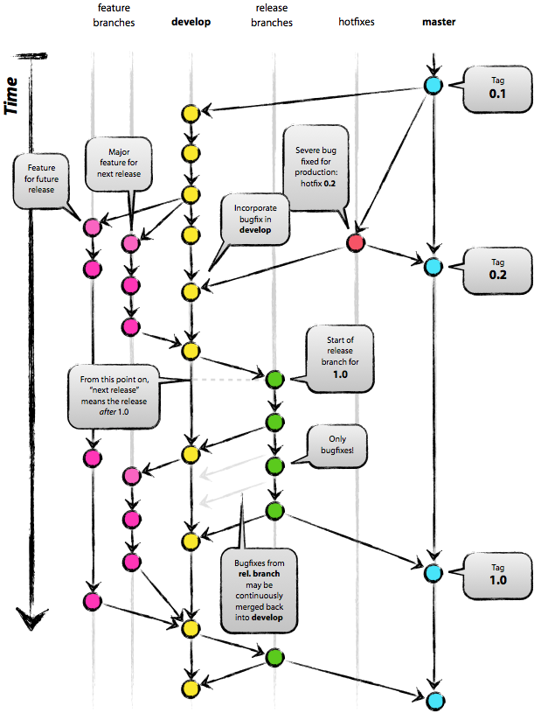
Figure 1: Source: http://nvie.com/posts/a-successful-git-branching-model/
(Note: The above linked blog post is one of the better descriptions of Git
I have found, and has pretty figures).
In the CPF scenario, this flow chart could look something like the following:
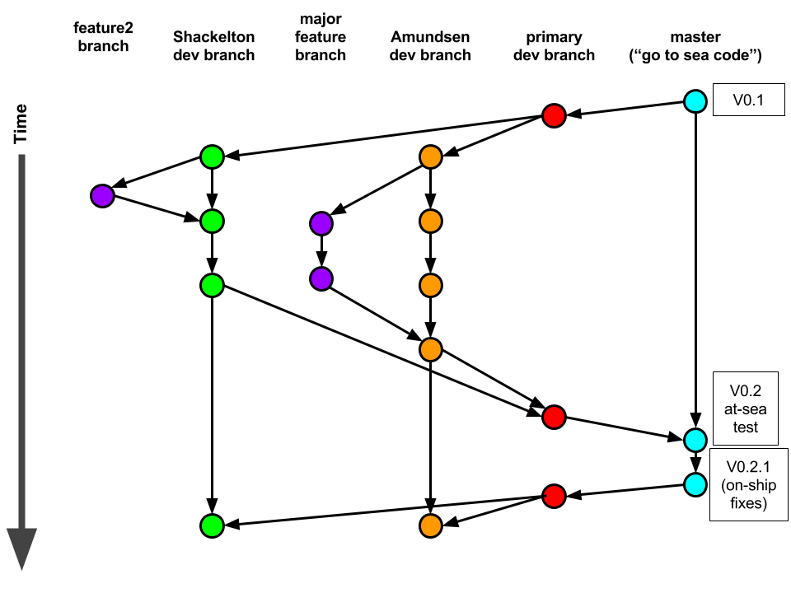
Figure 2: A possible branch diagram for a codebase that is being authored/modified by multiple parties (Schckelton & Amundsen).

Remote Repository Setup
The remote repository will reside in a shared folder on the network, specifically Z:\Software\repos (Z:\ is mapped in Windows to: \\atlas\ProjectLibrary\ChemSensors\GeneM). Note the Git Shell uses *nix-style paths, and the above is Windows-style, but they reference the same thing.
From within the Git Shell, cd and create the empty repository,
$ cd /Z/Software
$ git init --bare CPFcode.git
Initialized empty Git repository in z:/Software/CPFcode.git/
You can read about why a “bare” repository is most appropriate for a network shared repo here and here.

Local Repository Setup
The local repository is where a developer will interface with, and edit the code from their editors, compilers, etc. This folder can reside on a computer’s hard disk (typically C:\ in the Windows world), or on a user’s network home folder (which is automatically backed up, but not accessible unless on the MBARI network, or connected via VPN remotely). This example will place the local repository on the C:\ drive.
$ cd /C
$ mkdir code
$ cd code
$ git clone file:///Z/Software/CPFcode.git
Cloning into 'CPFcode'...
warning: You appear to have cloned an empty repository.
Checking connectivity... done.
$ cd CPFcode
Both repos (local and remote) are empty, but we will fill them with content soon. Let’s do that now:
$ echo "Gene M. has no sense of humor" > README.txt
Now there is a file called README.txt, but it needs to be committed to the repository.
$ git add .
warning: LF will be replaced by CRLF in README.txt.
The file will have its original line endings in your working directory.
$ git commit -m "First file in the new CPF software repo"
[master (root-commit) f0d41af] First file in the new CPF software repo
warning: LF will be replaced by CRLF in README.txt.
The file will have its original line endings in your working directory.
1 file changed, 1 insertion(+)
create mode 100644 README.txt
The git add command is used to add files to the staging area, this needs to be done prior to committing something to the repo. As the name implies, git commit commits the staging area to the repository. Put another way, it takes a snapshot. The -m flag is used to add a message. This is important and should be used to leave notes about what/why the commit is being made. “Added DGH class for pressure sensor communication” is an illustrative message that leaves little room for ambiguity as to what was done/changed in that commit.
With the new file (README.txt) created, added, and committed to the local repository, we want to push our changes to the remote repository.
$ git push origin master
Counting objects: 3, done.
Writing objects: 100% (3/3), 260 bytes | 0 bytes/s, done.
Total 3 (delta 0), reused 0 (delta 0)
To file:///Z/Software/CPFcode.git
* [new branch] master -> master
The git push syntax is:
$ git push <remote_repo_name> <branch_name>
One will only need to type the full git push origin master the first time to create the master branch. Each subsequent time
$ git push
will be sufficient.
This is a convenient time to talk about branch and repository names. By default, when a repository is cloned (git clone), it is given the name origin, likewise git created the default branch master. If you want to know what remote repositories and local branches exist you can use the following commands:
$ git remote
origin
$ git branch
* master
A nice feature of the Git Shell in Windows is that it displays the branch that is currently checked-out:
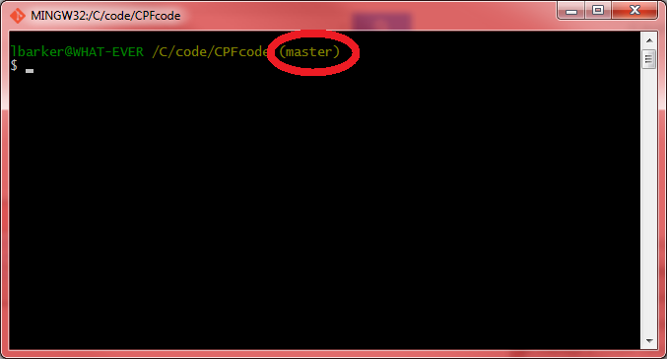
Figure 3: Git Shell displays the current branch

If a different user wants to work in the same repository, they can simply go through the same process, clone, add, commit, & push.
Lets say for a moment that both Shackelton and Amundsen cloned a remote repository to their local machines, and were working on the same branch of code. Amundsen completed a fix, and pushed his code to the remote repository. Disappointed he didn’t push the fix first, Shackelton wishes to examine the updated repo. To do this use the pull command
$ git pull
Note that git pull only works if the remote repository has already been cloned to one’s local machine.

Creating a New Branch
Following the model shown earlier, we can now create the various branches. To create the “primary development branch” from master do the following
$ git checkout –b primarydev master
The –b flag both creates, and checks out the new branch.
Go on creating files, making changes etc…
$ git add .
$ git commit –a –m “Added class, GPSdriver.cs”
$ git push –u origin primarydev
The –u flag tells git track changes in this branch remotely. In layman’s terms, it eliminates the need to type git push origin primarydev each time, and instead you can simply type git push when the primarydev branch is checked out.
If a different user wishes to download and work in a branch not created by them, they can do the following (they too would need to use git push –u origin primarydev the first time they push to properly setup upstream tracking):
$ git pull
$ git checkout primarydev

Merging branches
If a branch is completed and is ready to be merged, we do this like so,
$ git checkout master
(leave current branch, and check out master branch)
$ git merge --no-ff primarydev
(changes listed)
$ git push

Resources
http://gitref.org/
http://nvie.com/posts/a-successful-git-branching-model/
http://www.gitguys.com/
http://elegantcode.com/2011/06/18/git-on-windows-creating-a-network-shared-central-repository/

