Coastal Profiling Float “Nudge Control”

For Internal Reference Only

Laughlin Barker – Summer Intern

July 25, 2014

This document briefly describes the implementation and performance of the “nudge” strategy to control the Coastal Profiling Float. Several machine states were added to “Descend” and “Ascend” which adjust the float’s desired velocity (and by integration, position) based on a set of user-defined bands near a given target depth. The strategy shows good ability to control speed, achieve desired depth, and maintain a depth over time. In its current implementation, this strategy is energetically expensive as the PID controller is constantly making fine adjustments.
Results from test tank testing on July 25, 2014 are presented below. The code has been checked into the Git Repository located at
\\atlas\ProjectLibrary\ChemSensors\Gene M\Software\GitRepositories\Laughlin\TTPcode.git
Under the branch “nudge”

Control Strategy
Two separate sets of states were added to the “Ascend” and “Descend” states. This was done to clean up confusing nested if, else if, else statements. The two sub state machines with their respective states are as follows:
public enum VelStates : int
{
none = 0,
down, //descend at MissionConfig specified speed
downSlow, //descend at approach speed
stop, //PVSetPoint = 0
upSlow, //ascend at approach speed
up //ascend at MissionConfig specified speed
}
and
public enum MovingStates : int
{
none = 0,
transit, //when in transit to DepthSetPoint regardless of speed
enterPark, //triggered when arrives within DepthSetPoint (+/- IB)
parked, //period when float works to stay in park zone
leavePark, //triggered when park timer expires
sample, //triggered when passing a non-park DepthSetPoint
exitDescend, //triggered when leaving Descend state
exitAscend //triggered when leaving Ascend state
}

VelStates describes the velocity set point of the controller, in dbar/s (hereafter m will be substituted for dbar for simplicity’s sake).
MovingStates is used to cleanly move the system into and out of park (depth holding) periods or sample periods (sample at a given depth, but keep moving).
Switching of VelStates is done based on an inner and outer band (“IB” and “OB” respectively). This parameter lives within the configFile.cs class. Figure 1 shows how velocity is set diagrammatically.
Within the velocity states, a PID controller is used to command the motor to achieve the desired state-specific velocity.
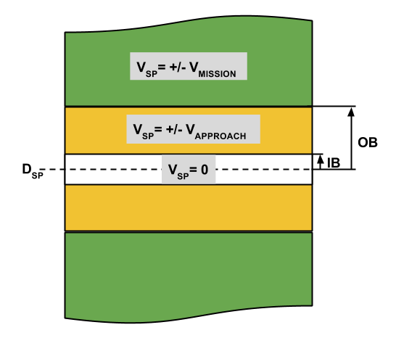
Figure 1: As the float approaches a set point, D_{SP}, with a park time > 0, it transitions from the mission defined velocity, V_{MISSION}, to an approach velocity, V_{APPROACH} when it is moving through the band bounded by OB and IB. Once inside the D_{SP} +/- IB, velocity is set to zero, and the park period begins. The park timer will continue to increment even if the float drifts out of the zero velocity band, but in doing so will adjust the velocity set point to move the float in the appropriate direction to return to the zero velocity band.

Test Results
The mission profile for this dive was:
ascendTable[0].depth = 4;
ascendTable[0].PV = 0.05;
ascendTable[0].parkTime = new TimeSpan(0, 0, 5, 0

ascendTable[1].depth = 0.0;
ascendTable[1].PV = 0.05;
ascendTable[1].parkTime = new TimeSpan(0, 0, 0, 0);

descendTable[0].depth = 7;
descendTable[0].PV = -0.05;
descendTable[0].parkTime = new TimeSpan(0, 0, 5, 0);

with IB, OB, and approach velocity set to:
public const double OB = 1; //"outer band" in meters
public const double IB = 0.2; //"inner band" in meters
public const double approachVel = 0.01;

PID gains used were:
KPlatVel = 80.0,
TiPlatVel = 50000.0,
TdPlatVel = 10.0
TfPlatVel = 2.0,
TtPlatVel = 100.0,
BPlatVel = 1.0,
uLowPlatVel = -3000.0 / 60.0,
uHighPlatVel = 3000.0 / 60.0,
hPlatVel = DGHSamplePeriod / 1000.0;

Figure 2: A plotted depth profile of the float using the nudge control strategy. Float achieves desired depths of 7 and 4m, and holds the desired depths for 5 minutes each. The system shows less than 0.5 m overshoot of the target depths. Descent and ascend velocity was +/- 0.05 m/s for each transit period. Note more significant waviness in the 4 m hold. A possible reason for this is a pocket of air trapped in the bellows. At lower pressures, dV/dP (as governed by PV = nRT) of the bubble is greater, and the controller must work harder to prevent a runaway ascent or descent.

Approach velocity
Figure 3: Commanded velocity and measured velocity (discrete differentiation and filtering of pressure samples) of the float over the course of the dive. Slight overshoot can be seen when the float approaches 0 velocity for the first hold period.

Figure 4: A linear fit to position samples shows a slope of 0.0533 m/s; close to the commanded 0.05 m/s. Note that steady state error is to be expected because of the low integral gain in the controller. A higher integral gain would be problematic because the bellows is itself effectively an integrator of control force.

