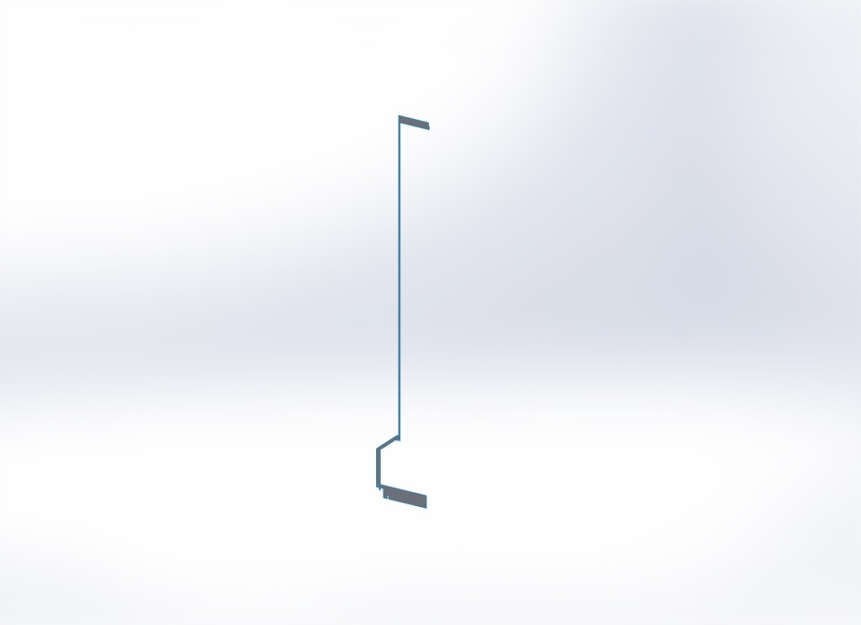
  Simulation of Housing
  Date: Thursday, March 01, 2012
  Designer: Solidworks
  Study name: Study 1 -thru rib
  Analysis type: Static - 2D Simplification
  Table of Contents
  Description 1
  Assumptions 2
  Model Information 2
  Study Properties 4
  Units 5
  Material Properties 5
  Loads and Fixtures 6
  Connector Definitions 6
  Contact Information 7
  Mesh Information 8
  Sensor Details 9
  Resultant Forces 9
  Beams 10
  Study Results 11
  Conclusion 16

Description
No Data

Assumptions

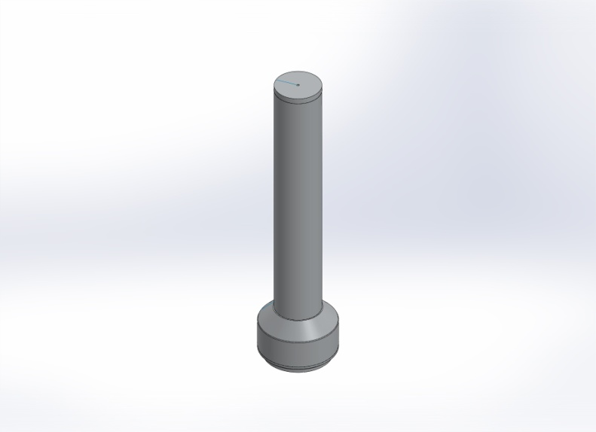  Original Model | 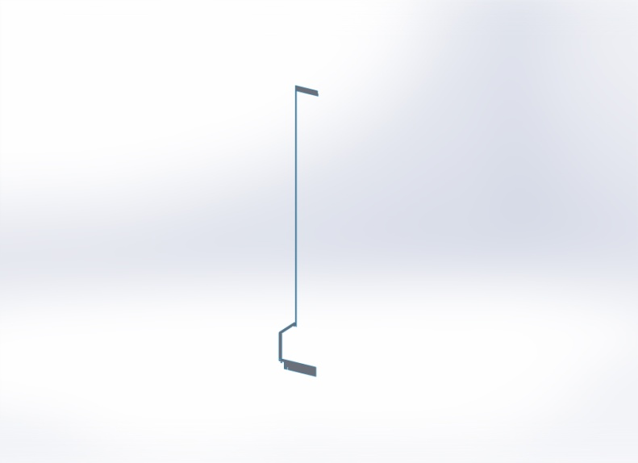  Model Analyzed

Model Information

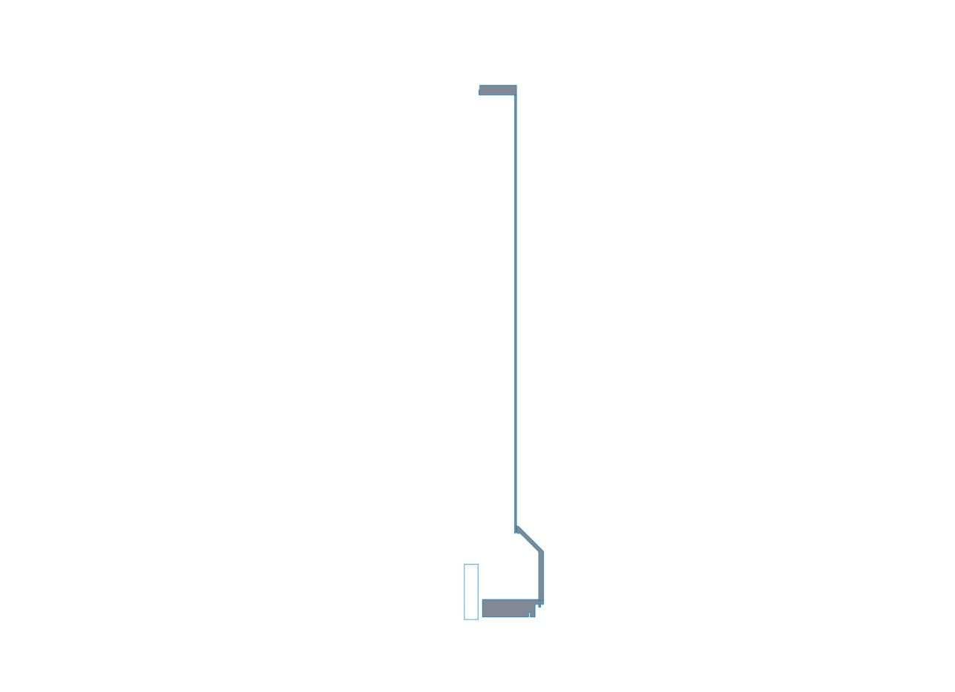
Model name: Housing
Current Configuration: Default
2D Bodies
Document Name and Reference | Study type | Volumetric Properties | Document Path/Date Modified
#10-32 Tapped Hole2-2  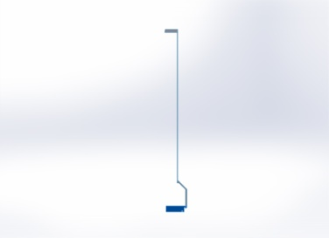 | Axi-symmetric | NA | C:\PDMWorkingDirectory\Housing.sldasm  Mar 01 09:41:29 2012
Revolve1-1  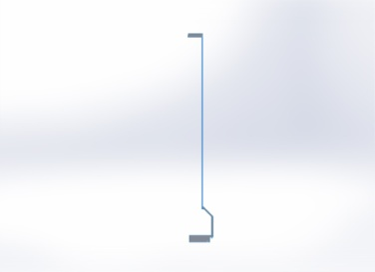 | Axi-symmetric | NA | C:\PDMWorkingDirectory\Housing.sldasm  Mar 01 09:41:29 2012
1/2-20 Tapped Hole1-2 | Axi-symmetric | NA | C:\PDMWorkingDirectory\Housing.sldasm  Mar 01 09:41:29 2012
Split Line5-2  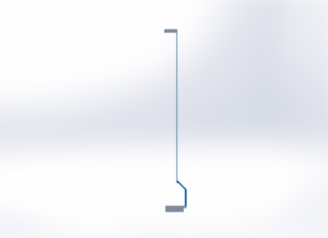 | Axi-symmetric | NA | C:\PDMWorkingDirectory\Housing.sldasm  Mar 01 09:41:29 2012

Study Properties
Study name | Study 1 -thru rib
Analysis type | Static - 2D Simplification
Mesh type | Planar 2D Mesh
Thermal Effect: | On
Thermal option | Include temperature loads
Zero strain temperature | 77 Fahrenheit
Include fluid pressure effects from SolidWorks Flow Simulation | Off
Solver type | Automatic
Inplane Effect: | Off
Soft Spring: | On
Inertial Relief: | Off
Incompatible bonding options | Automatic
Large displacement | Off
Compute free body forces | Off
Friction | Off
Use Adaptive Method: | Off
Result folder | SolidWorks document (C:\PDMWorkingDirectory)

Units
Unit system: | English (IPS)
Length/Displacement | in
Temperature | Fahrenheit
Angular velocity | Hertz
Pressure/Stress | psi

Material Properties
Model Reference | Properties | Components
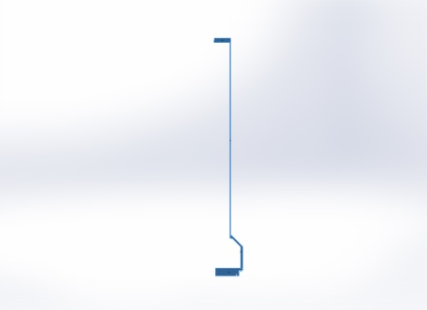 |  | SurfaceBody 2(#10-32 Tapped Hole2-2)(bellowsFlange-1),  SurfaceBody 1(Revolve1-1)(longShell-1),  SurfaceBody 1(1/2-20 Tapped Hole1-2)(topEndCapPF-1),  SurfaceBody 1(Split Line5-2)(transition-1)
  Name: | 6061-T6 (SS)
  Model type: | Linear Elastic Isotropic
  Default failure criterion: | Unknown
  Yield strength: | 2.75e+008 N/m^2
  Tensile strength: | 3.1e+008 N/m^2
  Elastic modulus: | 6.9e+010 N/m^2
  Poisson's ratio: | 0.33
  Mass density: | 2700 kg/m^3
  Shear modulus: | 2.6e+010 N/m^2
  Thermal expansion coefficient: | 2.4e-005 /Kelvin
Curve Data:N/A

Loads and Fixtures
Fixture name | Fixture Image | Fixture Details
Roller/Slider-1 | 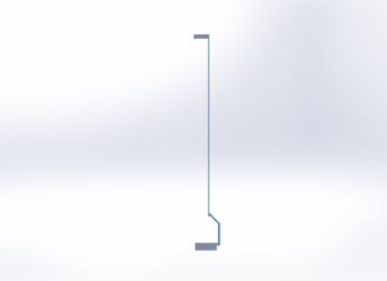
  Entities: | 2 edge(s)
  Type: | Roller/Slider
Resultant Forces
Components | X | Y | Z | Resultant
Reaction force(lbf) | -25.5161 | -36802.2 | 10.3863 | 36802.2
Reaction Moment(lbf-in) | 0 | 0 | 0 | 8.85075e-033

Load name | Load Image | Load Details
Pressure-1 | 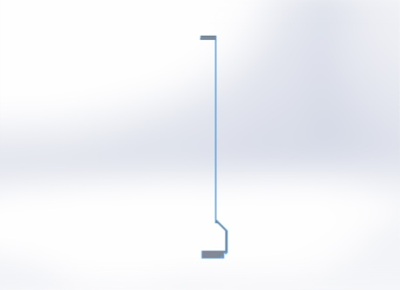
  Entities: | 28 edge(s)
  Type: | Normal to selected face
  Value: | 750
  Units: | psi

Connector Definitions
No Data

Contact Information

Contact | Contact Image | Contact Properties
Global Contact | 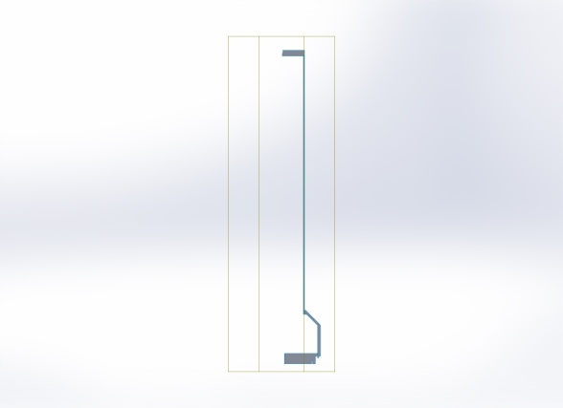
  Type: | Bonded
  Components: | 1 component(s)
  Options: | Compatible mesh

Mesh Information
Mesh type | Planar 2D Mesh
Mesher Used: | Standard mesh
Automatic Transition: | Off
Include Mesh Auto Loops: | Off
Element Size | 0.103519 in
Tolerance | 0.00517597 in
Mesh Quality | High

Mesh Information - Details
Total Nodes | 11525
Total Elements | 5111
Time to complete mesh(hh;mm;ss): | 00:00:05
Computer name: | MYOJIN
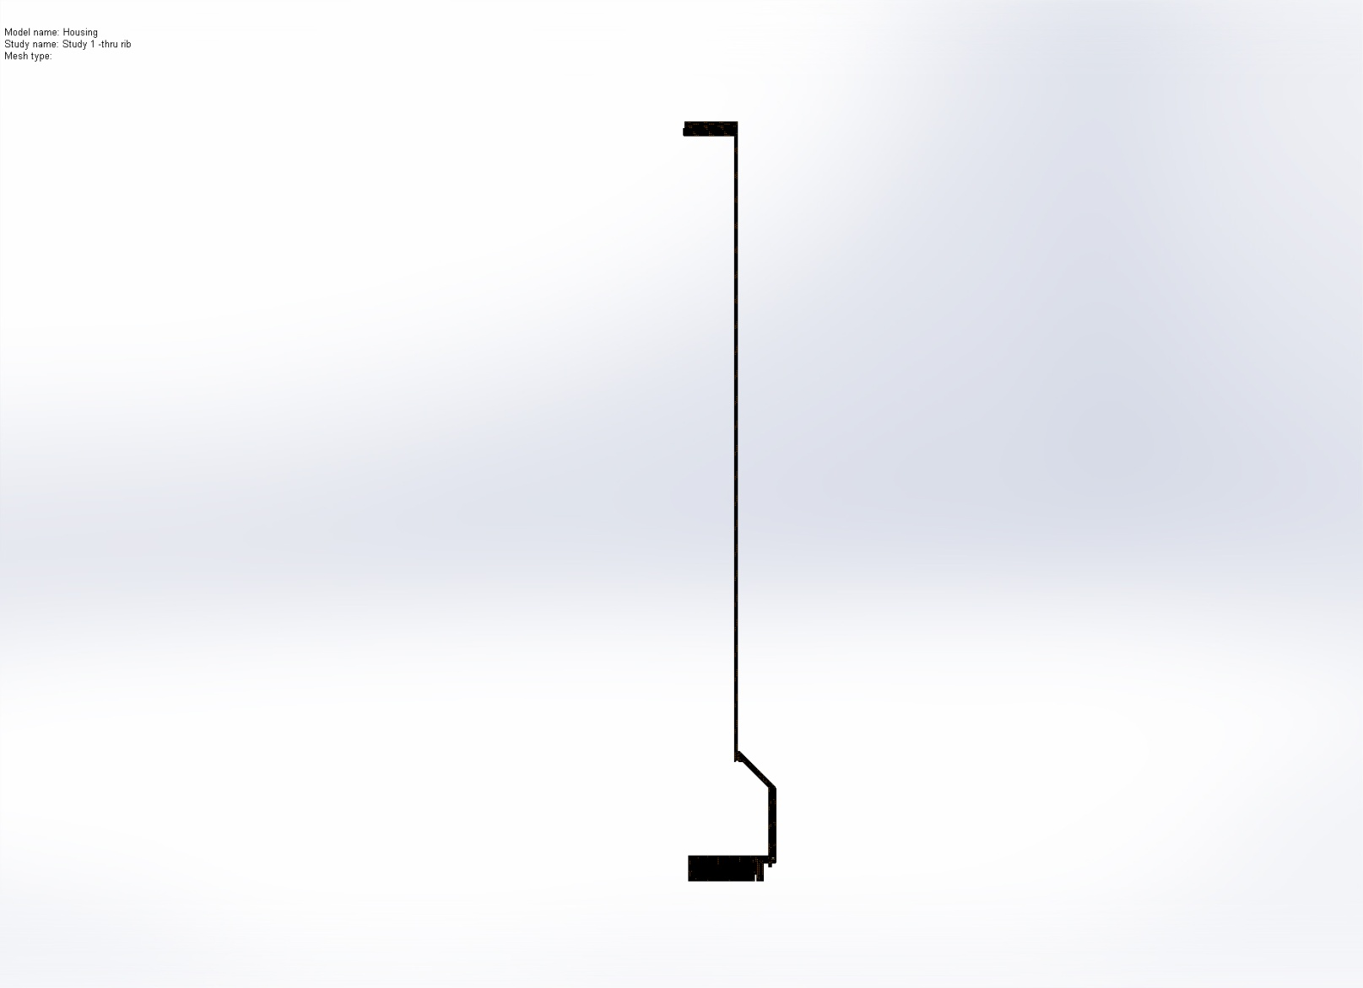

Sensor Details
No Data

Resultant Forces

Reaction Forces
Selection set | Units | Sum X | Sum Y | Sum Z | Resultant
Entire Model | lbf | -25.5161 | -36802.2 | 10.3863 | 36802.2

Reaction Moments
Selection set | Units | Sum X | Sum Y | Sum Z | Resultant
Entire Model | lbf-in | 0 | 0 | 0 | 8.85075e-033

Beams
No Data

Study Results

Name | Type | Min | Max
Stress1 | VON: von Mises Stress | 14.1467 psi  Node: 8984 | 19748 psi  Node: 11381
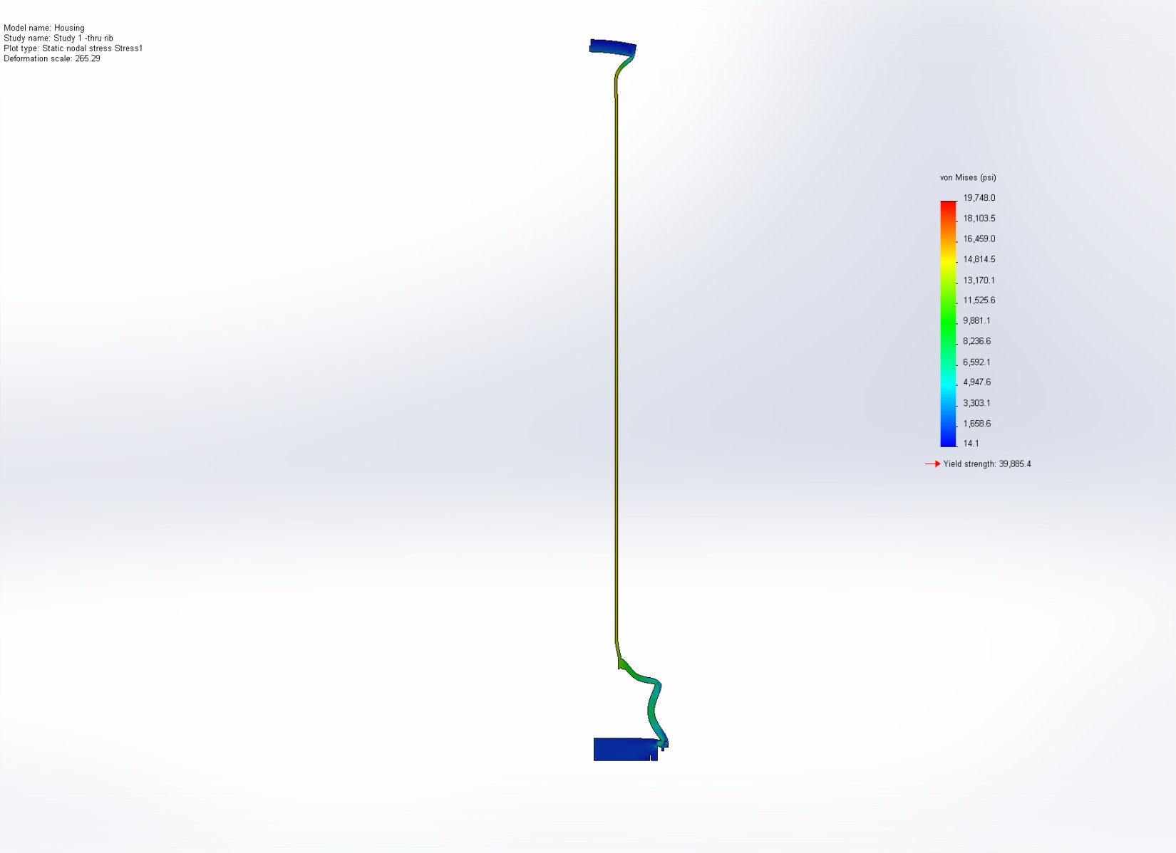
Housing-Study 1 -thru rib-Stress-Stress1

Name | Type | Min | Max
Displacement1 | URES: Resultant Displacement | 6.48193e-005 in  Node: 19 | 0.0205736 in  Node: 8327
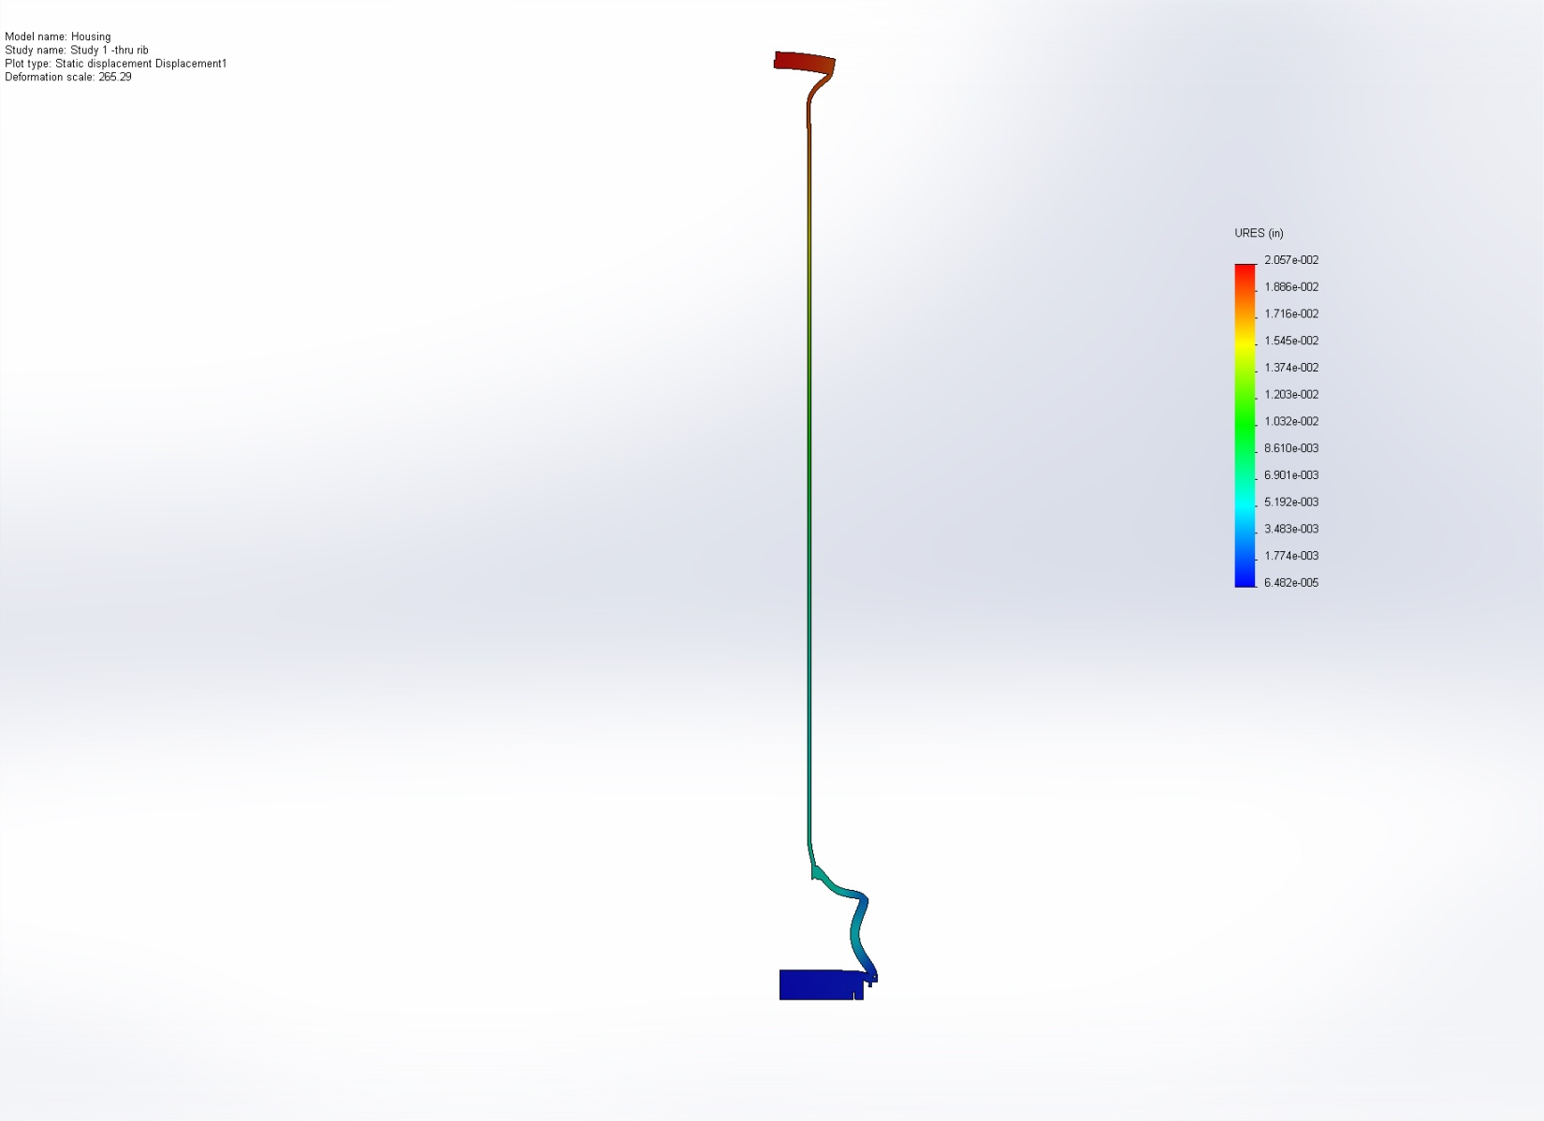
Housing-Study 1 -thru rib-Displacement-Displacement1

Name | Type | Min | Max
Strain1 | ESTRN: Equivalent Strain | 2.00749e-006  Element: 4179 | 0.00141102  Element: 1924
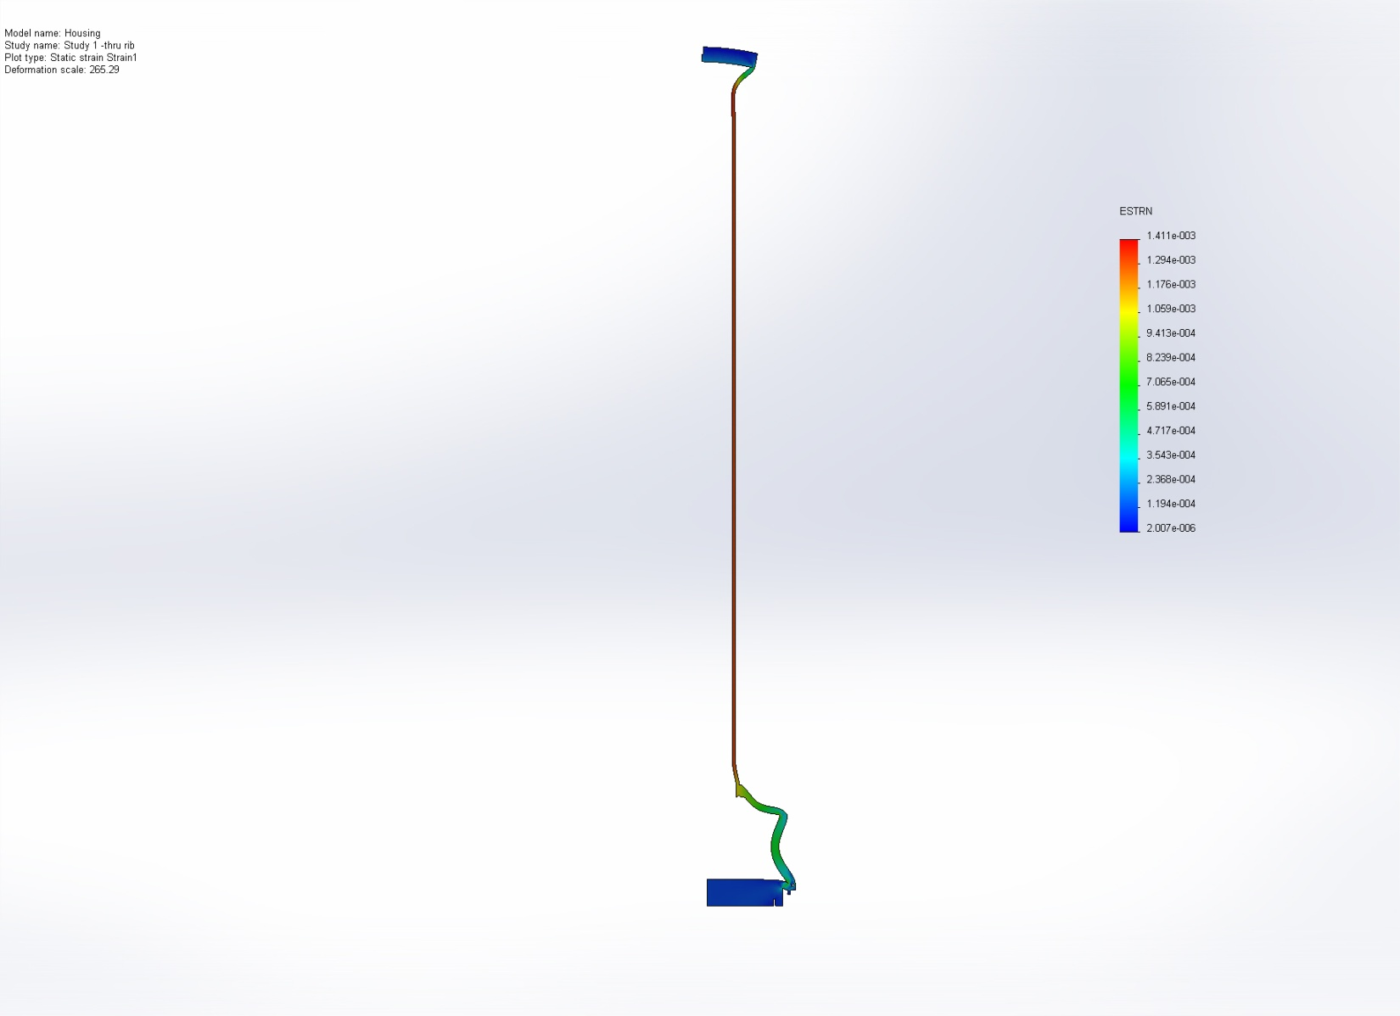
Housing-Study 1 -thru rib-Strain-Strain1

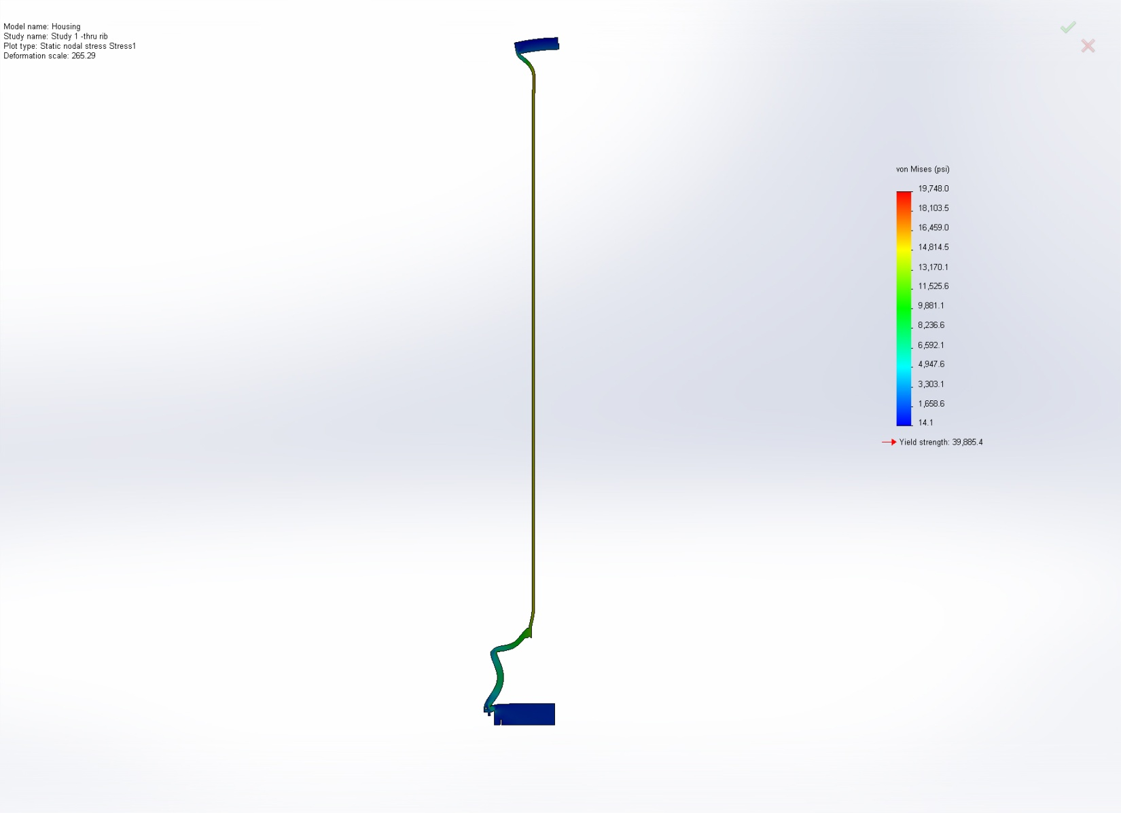
Image-1

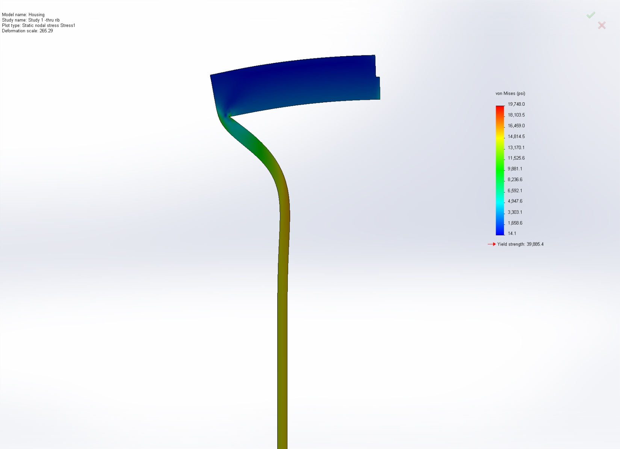
Image-2

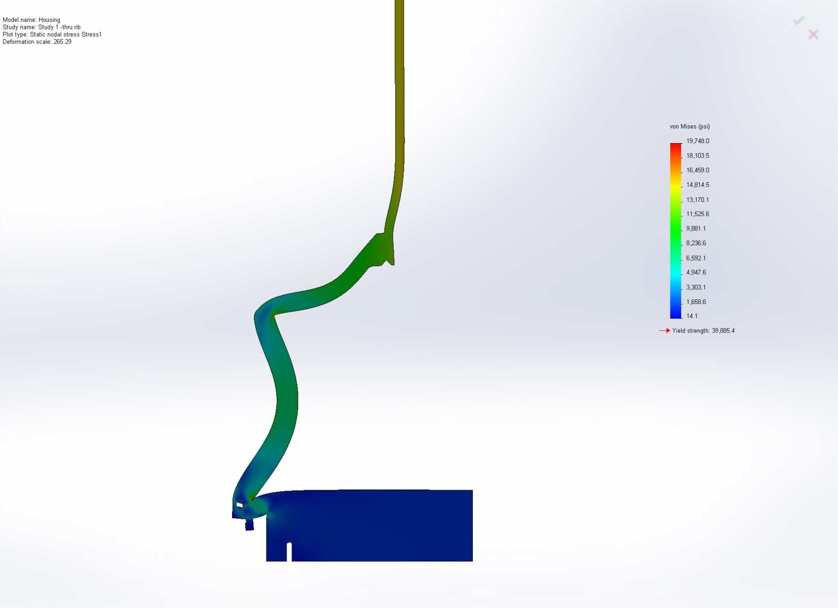
Image-3

Conclusion

