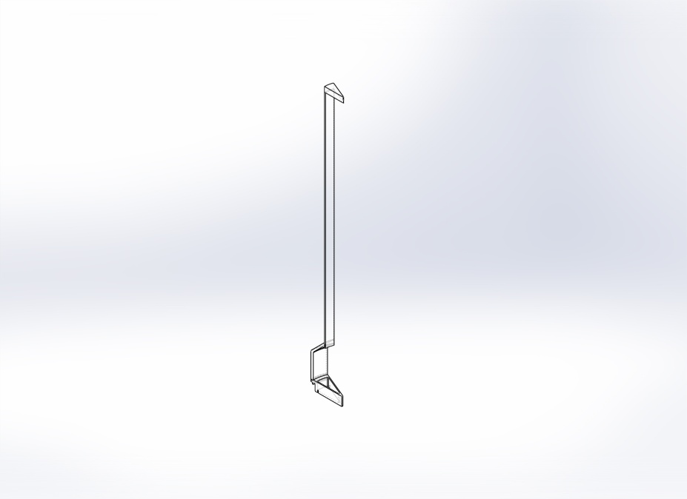
  Simulation of Housing
  Date: Thursday, March 01, 2012
  Designer: Solidworks
  Study name: Study 1
  Analysis type: Static
  Table of Contents
  Description 1
  Assumptions 2
  Model Information 2
  Study Properties 4
  Units 4
  Material Properties 5
  Loads and Fixtures 6
  Connector Definitions 7
  Contact Information 7
  Mesh Information 8
  Sensor Details 10
  Resultant Forces 10
  Beams 10
  Study Results 11
  Conclusion 14

Description
No Data

Assumptions

Model Information

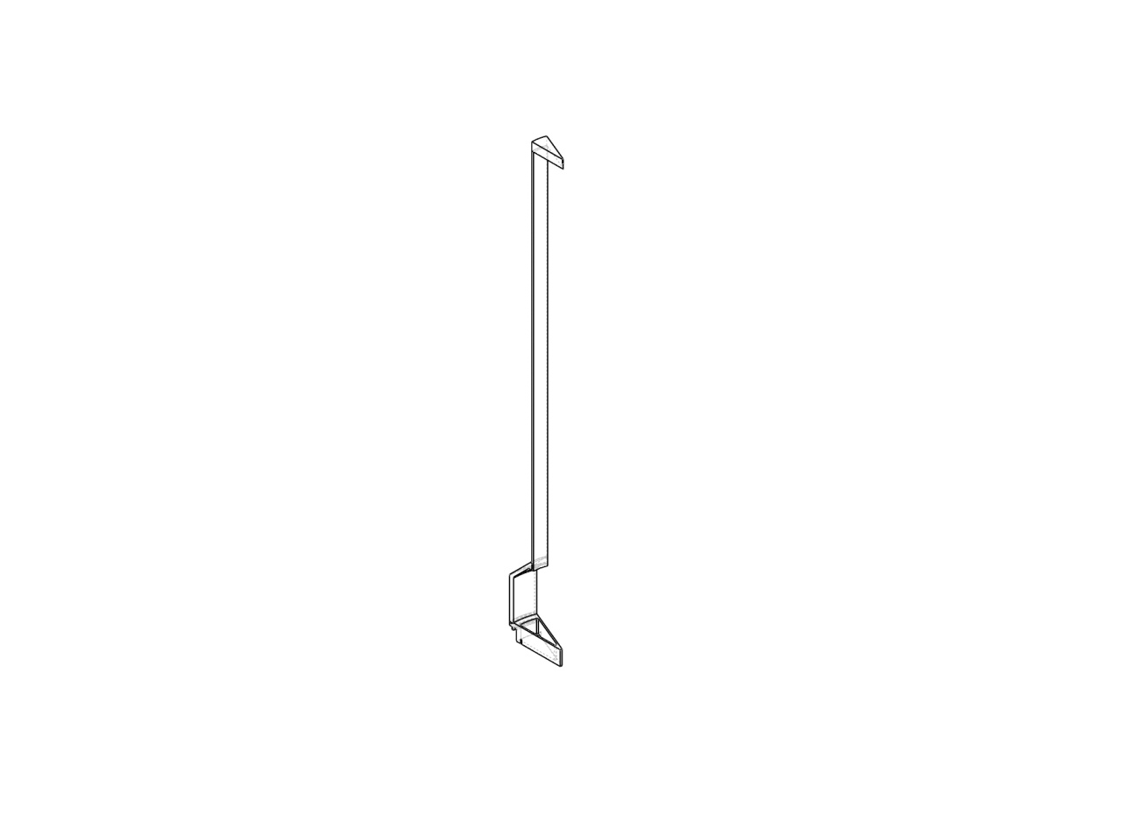
Model name: Housing
Current Configuration: Default
Solid Bodies
Document Name and Reference | Treated As | Volumetric Properties | Document Path/Date Modified
#10-32 Tapped Hole2  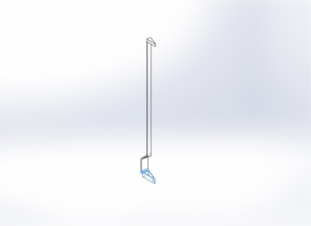 | Solid Body | Mass:0.573373 lb  Volume:5.87812 in^3  Density:0.0975437 lb/in^3  Weight:0.572985 lbf | C:\PDMWorkingDirectory\bellowsFlange.SLDPRT  Mar 01 09:41:28 2012
Revolve1  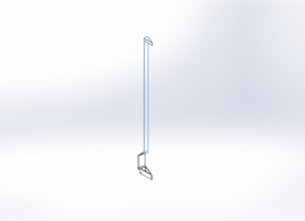 | Solid Body | Mass:1.34641 lb  Volume:13.8031 in^3  Density:0.0975437 lb/in^3  Weight:1.34549 lbf | C:\PDMWorkingDirectory\longShell.SLDPRT  Feb 29 16:44:49 2012
1/2-20 Tapped Hole1 | Solid Body | Mass:0.305762 lb  Volume:3.13461 in^3  Density:0.0975437 lb/in^3  Weight:0.305554 lbf | C:\PDMWorkingDirectory\topEndCapPF.SLDPRT  Feb 29 16:44:49 2012
Split Line5  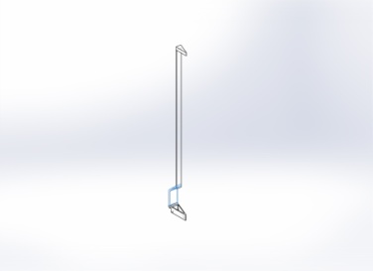 | Solid Body | Mass:0.907106 lb  Volume:9.29948 in^3  Density:0.0975437 lb/in^3  Weight:0.906491 lbf | C:\PDMWorkingDirectory\transition.SLDPRT  Feb 29 16:44:48 2012

Study Properties
Study name | Study 1
Analysis type | Static
Mesh type | Solid Mesh
Thermal Effect: | On
Thermal option | Include temperature loads
Zero strain temperature | 77 Fahrenheit
Include fluid pressure effects from SolidWorks Flow Simulation | Off
Solver type | Automatic
Inplane Effect: | Off
Soft Spring: | On
Inertial Relief: | Off
Incompatible bonding options | Automatic
Large displacement | Off
Compute free body forces | Off
Friction | Off
Use Adaptive Method: | Off
Result folder | SolidWorks document (C:\PDMWorkingDirectory)

Units
Unit system: | English (IPS)
Length/Displacement | in
Temperature | Fahrenheit
Angular velocity | Hertz
Pressure/Stress | psi

Material Properties
Model Reference | Properties | Components
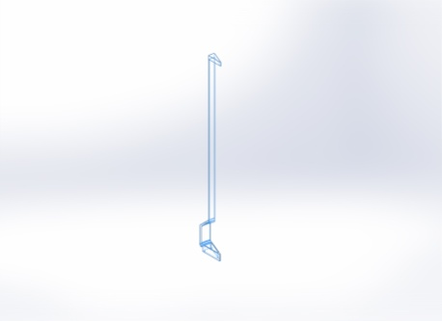 |  | SolidBody 1(#10-32 Tapped Hole2)(bellowsFlange-1),  SolidBody 1(Revolve1)(longShell-1),  SolidBody 1(1/2-20 Tapped Hole1)(topEndCapPF-1),  SolidBody 1(Split Line5)(transition-1)
  Name: | 6061-T6 (SS)
  Model type: | Linear Elastic Isotropic
  Default failure criterion: | Unknown
  Yield strength: | 2.75e+008 N/m^2
  Tensile strength: | 3.1e+008 N/m^2
  Elastic modulus: | 6.9e+010 N/m^2
  Poisson's ratio: | 0.33
  Mass density: | 2700 kg/m^3
  Shear modulus: | 2.6e+010 N/m^2
  Thermal expansion coefficient: | 2.4e-005 /Kelvin
Curve Data:N/A

Loads and Fixtures
Fixture name | Fixture Image | Fixture Details
Symmetry-1 | 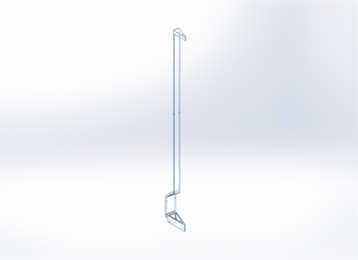
  Entities: | 8 face(s)
  Type: | Symmetry
Resultant Forces
Components | X | Y | Z | Resultant
Reaction force(lbf) | -69070 | 184.929 | -13678.8 | 70411.7
Reaction Moment(lbf-in) | 0 | 0 | 0 | 0

Fixed-3 | 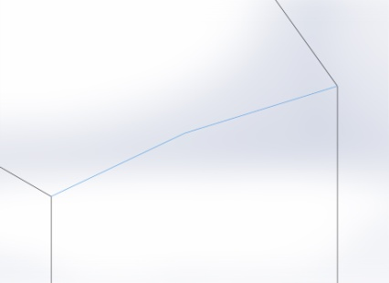
  Entities: | 1 edge(s)
  Type: | Fixed Geometry
Resultant Forces
Components | X | Y | Z | Resultant
Reaction force(lbf) | 884.337 | 447.803 | 171.593 | 1005.99
Reaction Moment(lbf-in) | 0 | 0 | 0 | 0

Load name | Load Image | Load Details
Pressure-1 | 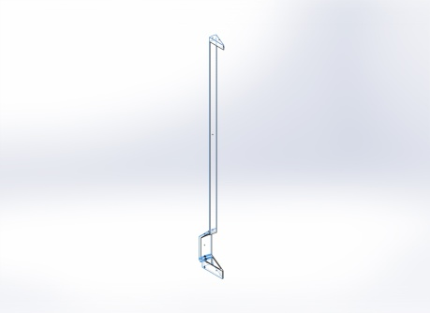
  Entities: | 25 face(s)
  Type: | Normal to selected face
  Value: | 750
  Units: | psi

Connector Definitions
No Data

Contact Information

Contact | Contact Image | Contact Properties
Global Contact | 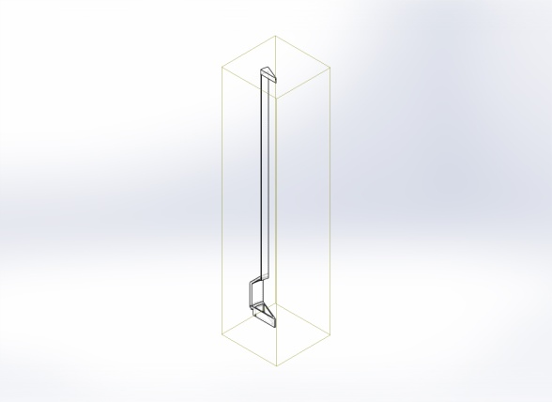
  Type: | Bonded
  Components: | 1 component(s)
  Options: | Compatible mesh

Mesh Information
Mesh type | Solid Mesh
Mesher Used: | Curvature based mesh
Jacobian points | 4 Points
Maximum element size | 0.337256 in
Minimum element size | 0.015 in
Mesh Quality | High
Remesh failed parts with incompatible mesh | Off

Mesh Information - Details
Total Nodes | 242989
Total Elements | 149973
Maximum Aspect Ratio | 46.775
% of elements with Aspect Ratio < 3 | 99.1
% of elements with Aspect Ratio > 10 | 0.0787
% of distorted elements(Jacobian) | 0
Time to complete mesh(hh;mm;ss): | 00:00:11
Computer name: | MYOJIN
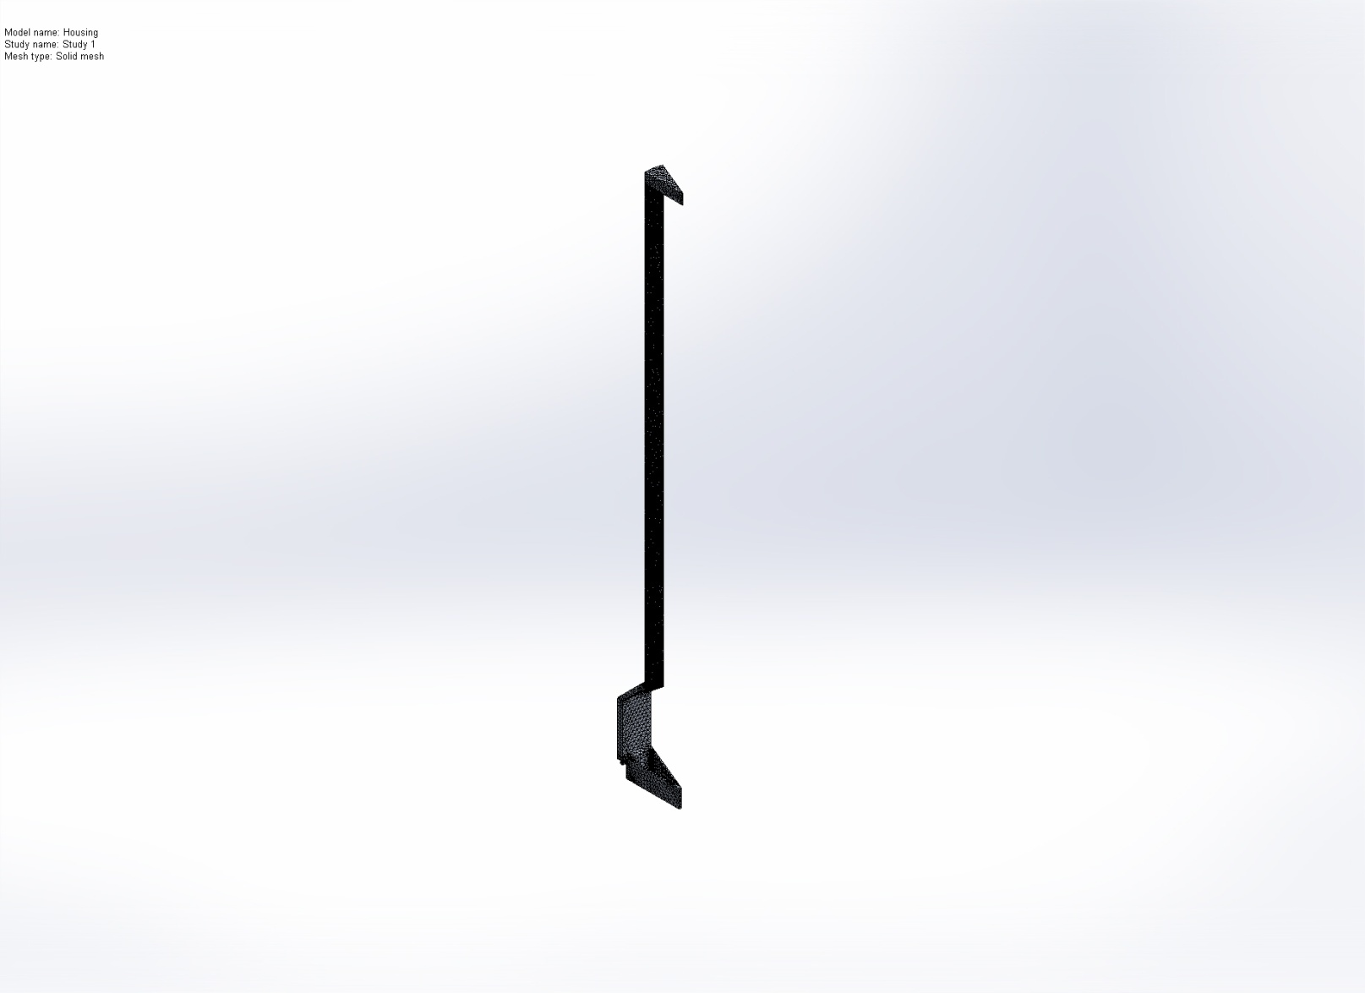

Mesh Control Information:
Mesh Control Name | Mesh Control Image | Mesh Control Details
Control-1 | 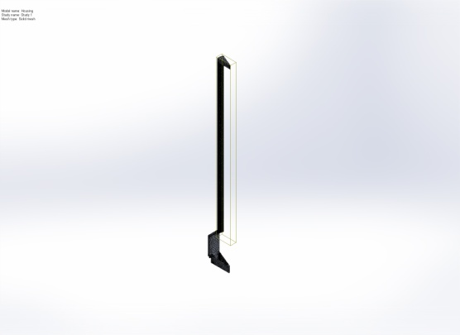
  Entities: | 1 component(s)
  Units: | in
  Size: | 0.1
  Ratio: | 1.5

Sensor Details
No Data

Resultant Forces

Reaction Forces
Selection set | Units | Sum X | Sum Y | Sum Z | Resultant
Entire Model | lbf | -68587.5 | 439.413 | -13585 | 69921.3

Reaction Moments
Selection set | Units | Sum X | Sum Y | Sum Z | Resultant
Entire Model | lbf-in | 0 | 0 | 0 | 0

Beams
No Data

Study Results

Name | Type | Min | Max
Stress1 | VON: von Mises Stress | 161.888 psi  Node: 8380 | 43785.6 psi  Node: 2209
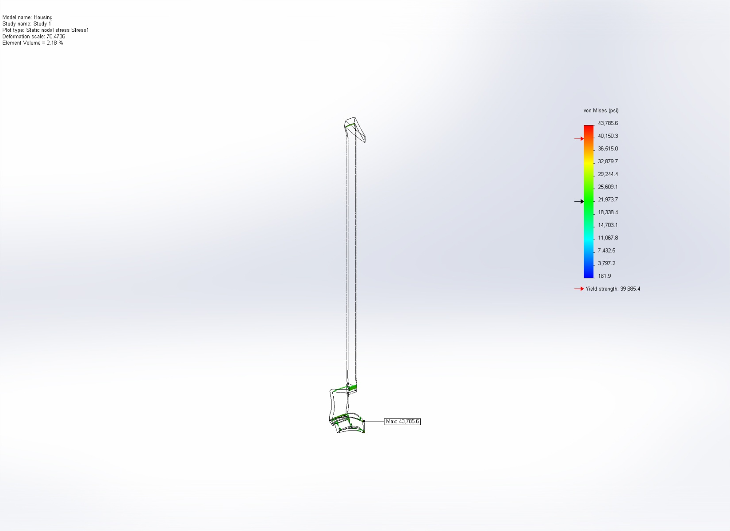
Housing-Study 1-Stress-Stress1

Name | Type | Min | Max
Displacement1 | URES: Resultant Displacement | 0 in  Node: 21 | 0.0695518 in  Node: 233463
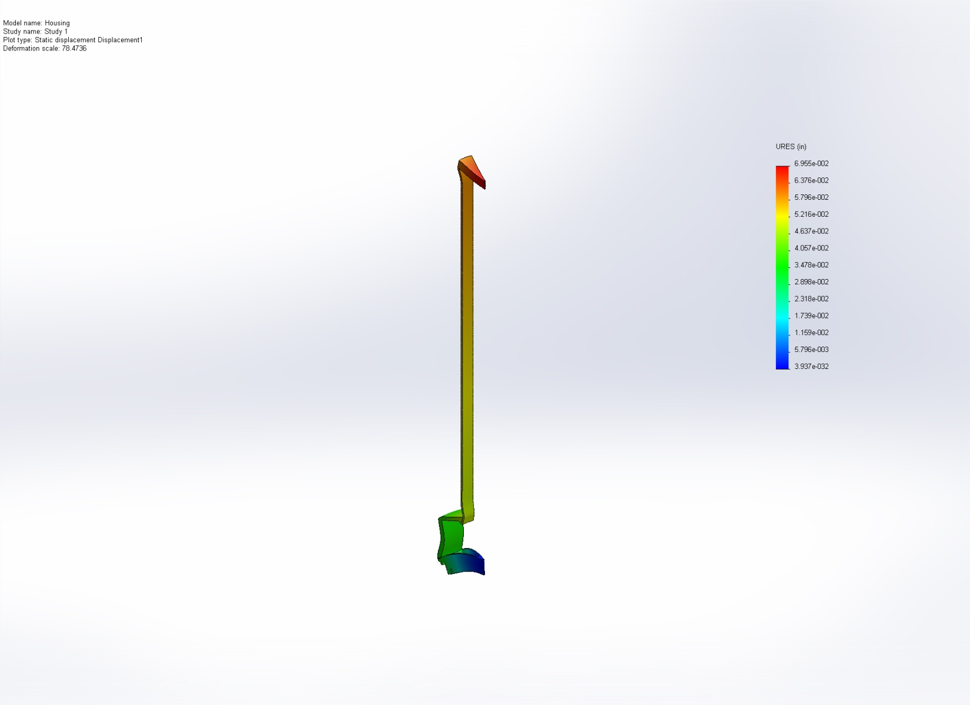
Housing-Study 1-Displacement-Displacement1

Name | Type | Min | Max
Strain1 | ESTRN: Equivalent Strain | 5.43383e-006  Element: 7010 | 0.00354947  Element: 149836
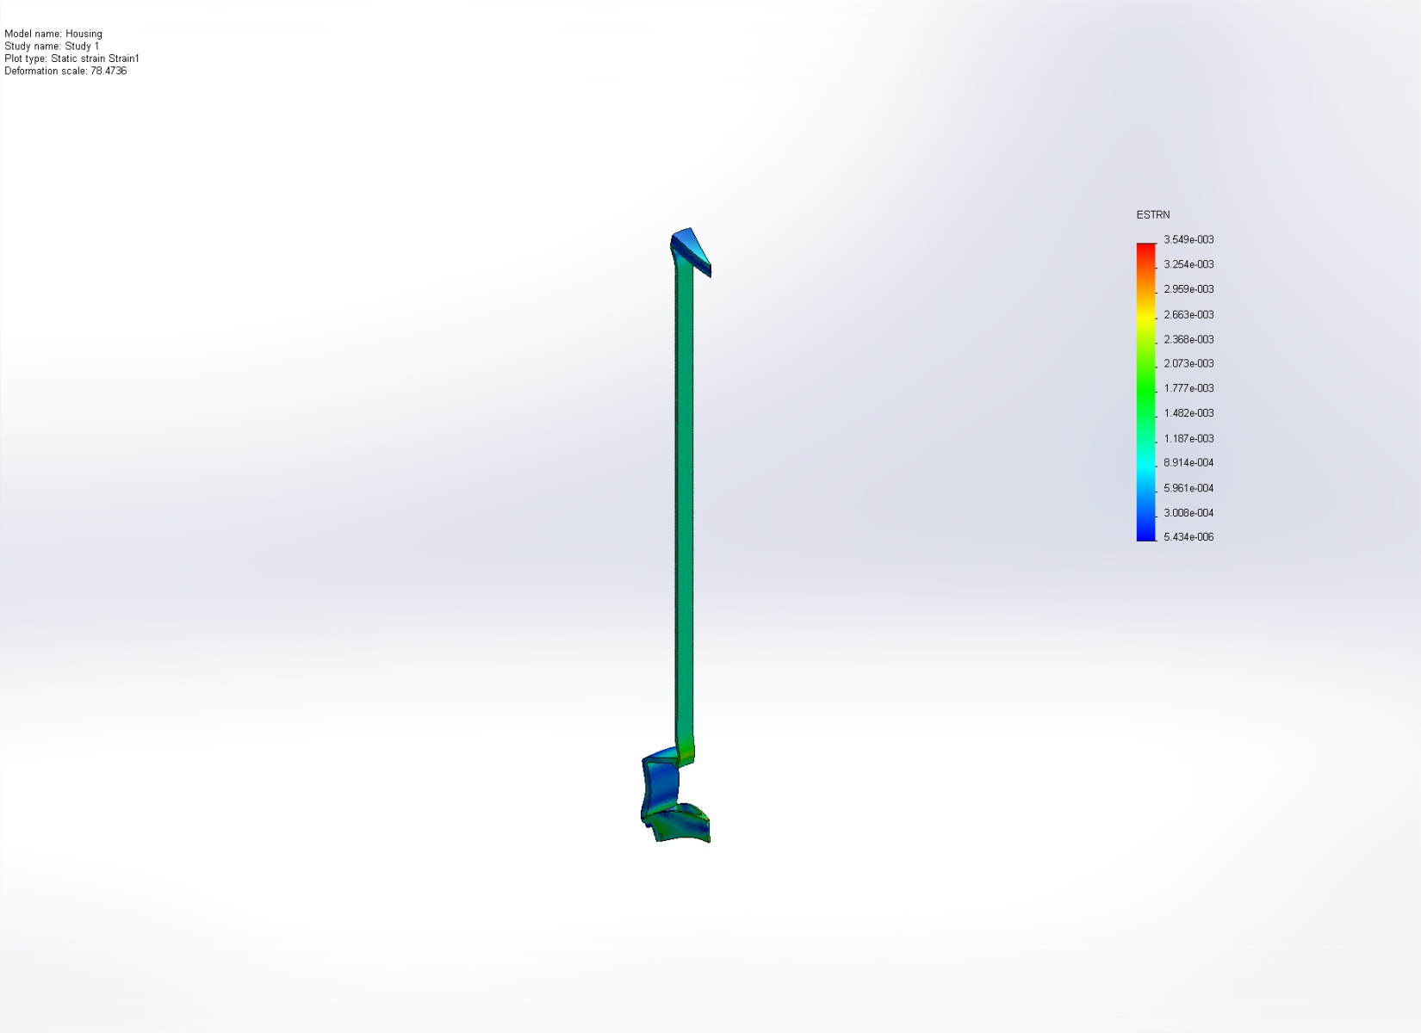
Housing-Study 1-Strain-Strain1

Name | Type
Displacement1{1} | Deformed Shape
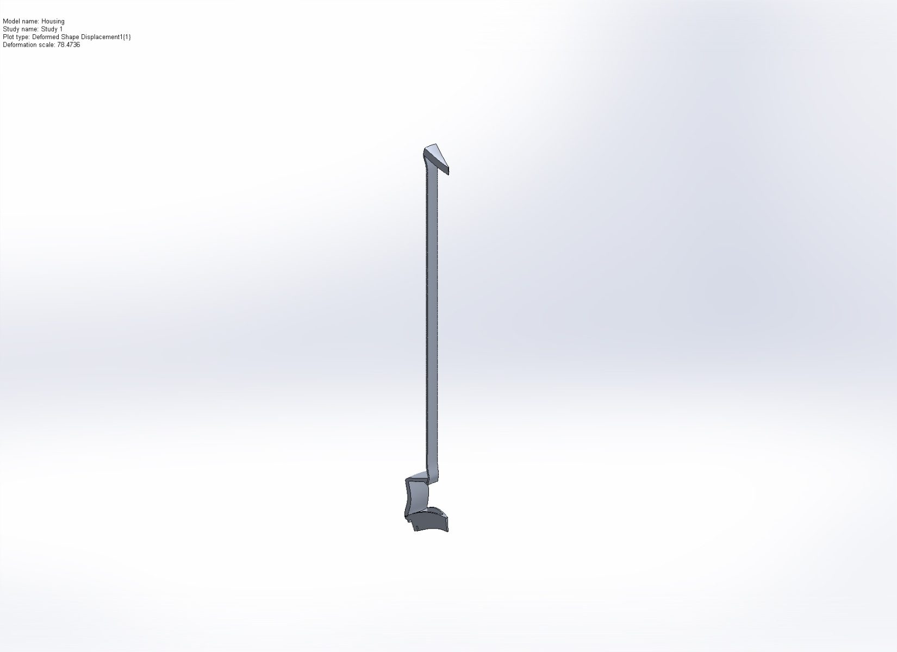
Housing-Study 1-Displacement-Displacement1{1}

Conclusion

