[company logo here] |  |   Cost Report
[company name here]
[address here]
[company website here]
[name] ∙ | [title] | [email address] ∙ | (###) ###-####

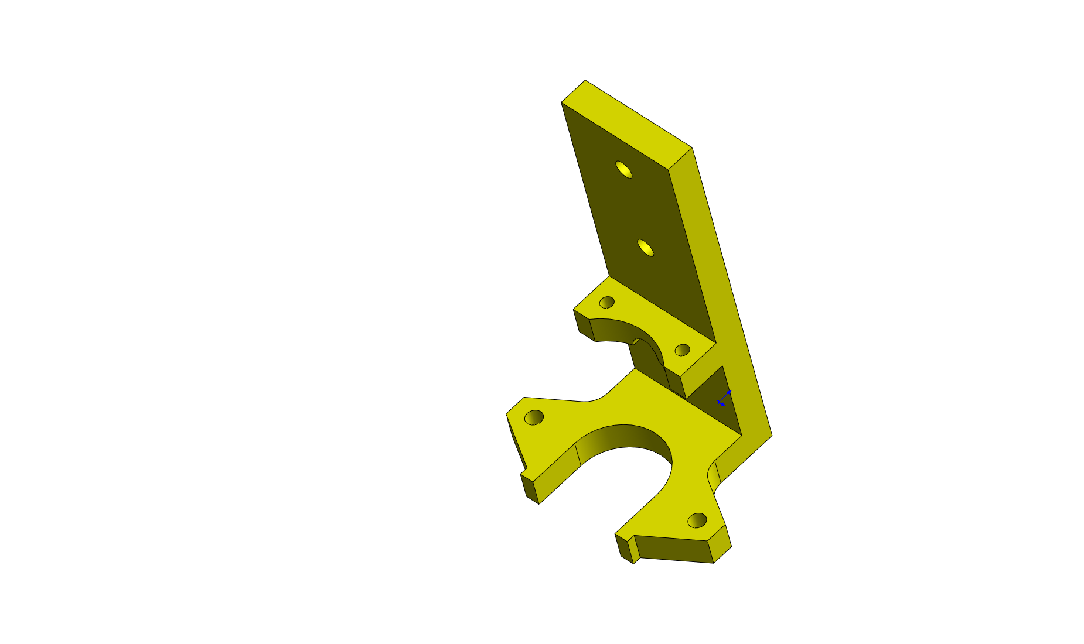  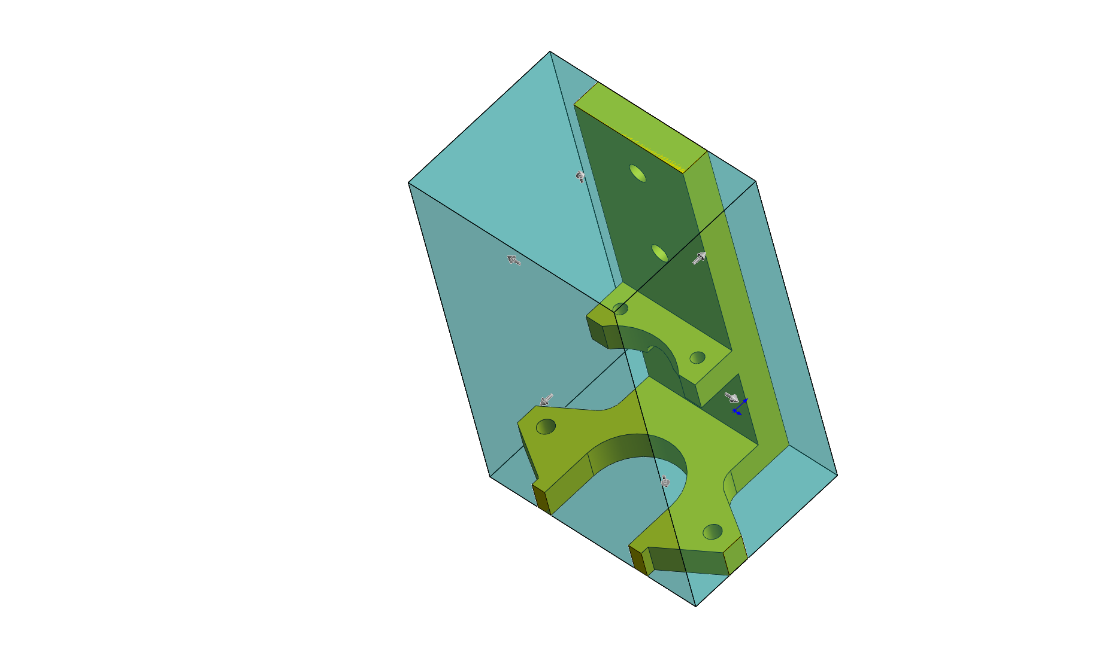
  Model name: | P-200987-11_ValveBrkt
  Date and time of report: | 5/29/2012 2:25:04 PM
  Material: | 6061 Alloy
  Manufacturing process: | Machining
  Weight: | 0.90 lb
  Stock type: | Block
  Block Size: | 50.80x36.51x81.79 in
  Material cost: | 6.00 USD/lb
  Shop Rate: | 100.00 USD
  Quantity to Produce
  Total number of parts: | 10
  Lot size: | 10
  Estimated cost per part: | 6.51 USD
  Costing template used: | default template (english standard units).sldctm
  Comparison: | 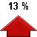 | 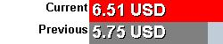
  Cost Breakdown
  Material: | 5.42 USD | 83 %
  Manufacturing: | 1.09 USD | 16 %
  Markup | 0.00 USD | 0 %
  Estimated time per part: | 00:04:16
  Setups: | 00:00:01
  Operations: | 00:04:14

Cost Report
Model Name: |  | P-200987-11_ValveBrkt | Material: | 6061 Alloy | Material cost: | 5.42 USD | Total per part:
 |  |  |  |  | Manufacturing cost: | 1.09 USD | 6.51 USD
 |  |  |  |  | Markup | 0.00 USD | 00:04:16
Manufacturing Cost Breakdown
Setups | Time (hh:mm:ss) | Cost (USD)
Setup Operation 1 | 00:00:00 | 0.00
Setup Operation 2 | 00:00:00 | 0.01
Setup Operation 3 | 00:00:00 | 0.01
Setup Operation 4 | 00:00:00 | 0.01
Setup Operation 5 | 00:00:00 | 0.01
Total | 00:00:01 | 0.05

Mill Operation | Surface Finish | Time (hh:mm:ss) | Cost (USD)
Slot 1 | Roughing | 00:01:49 | 0.03
Slot 2 | Roughing | 00:01:49 | 0.03
Total |  | 00:03:39 | 0.06

Hole Operation | Description | Time (hh:mm:ss) | Cost (USD)
Hole 1 | Drill | 00:00:08 | 0.23
Hole Pattern 1 | Drill | 00:00:09 | 0.27
Hole Pattern 2 | Drill | 00:00:07 | 0.21
Hole Pattern 3 | Drill | 00:00:09 | 0.25
Total |  | 00:00:35 | 0.98

No Cost Features
Cylinder 1
Cylinder 2
Fillet 1
Fillet 2

Setup Operations
- Setup Operation 1
  - Slot 1
  - Slot 2
- Setup Operation 2
  - Hole 1
- Setup Operation 3
  - Hole Pattern 1 - 2
  - Hole Pattern 1 - 1
- Setup Operation 4
  - Hole Pattern 2 - 1
  - Hole Pattern 2 - 2
- Setup Operation 5
  - Hole Pattern 3 - 1
  - Hole Pattern 3 - 2

