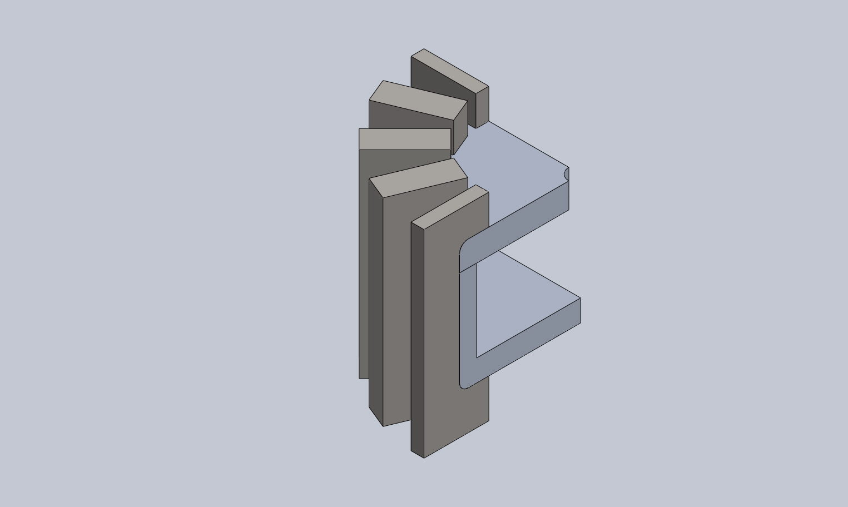
  Simulation of clipAssembly
  Date: Wednesday, July 03, 2013
  Designer: Nicholas Sohn
  Study name: fusedSupports
  Analysis type: Static
  Table of Contents
  Description 1
  Assumptions 2
  Model Information 2
  Study Properties 5
  Units 5
  Material Properties 6
  Loads and Fixtures 7
  Connector Definitions 8
  Contact Information 9
  Mesh Information 10
  Sensor Details 11
  Resultant Forces 11
  Beams 12
  Study Results 13
  Conclusion 16

Description
No Data

Assumptions

Model Information

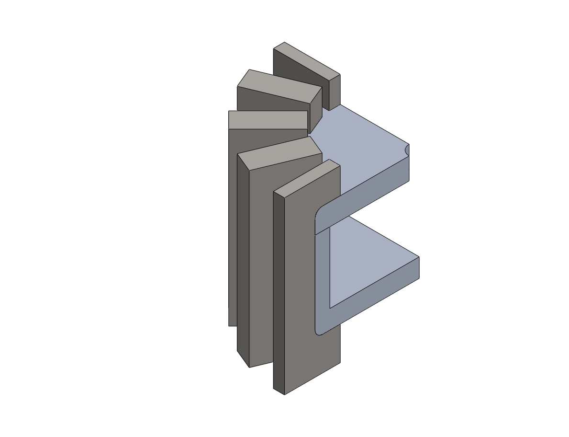
Model name: clipAssembly
Current Configuration: Default
Solid Bodies
Document Name and Reference | Treated As | Volumetric Properties | Document Path/Date Modified
Fillet1  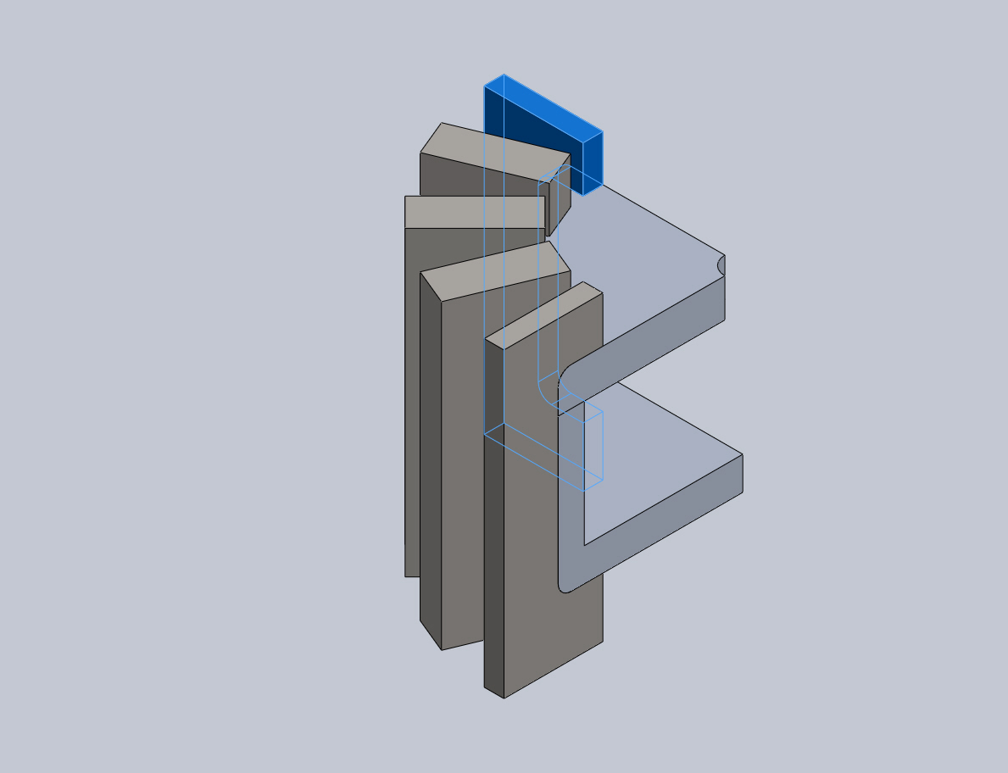 | Solid Body | Mass:6.58524 lb  Volume:22.7849 in^3  Density:0.289018 lb/in^3  Weight:6.58077 lbf | C:\Users\nsohn\Desktop\bucketClip.SLDPRT  Jun 25 10:06:06 2013
Fillet1  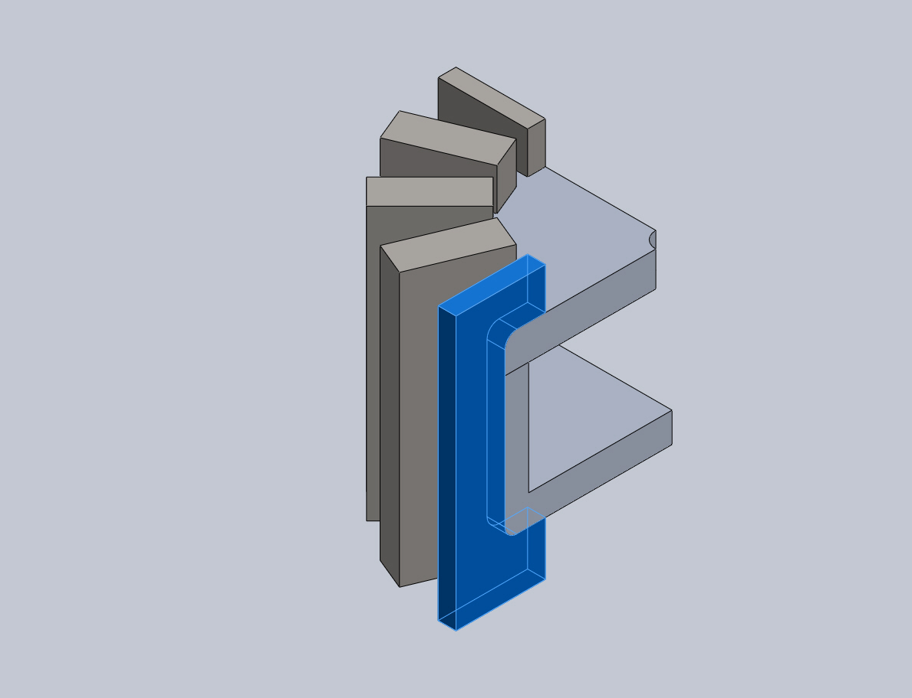 | Solid Body | Mass:6.58524 lb  Volume:22.7849 in^3  Density:0.289018 lb/in^3  Weight:6.58077 lbf | C:\Users\nsohn\Desktop\bucketClip.SLDPRT  Jun 25 10:06:06 2013
Fillet1  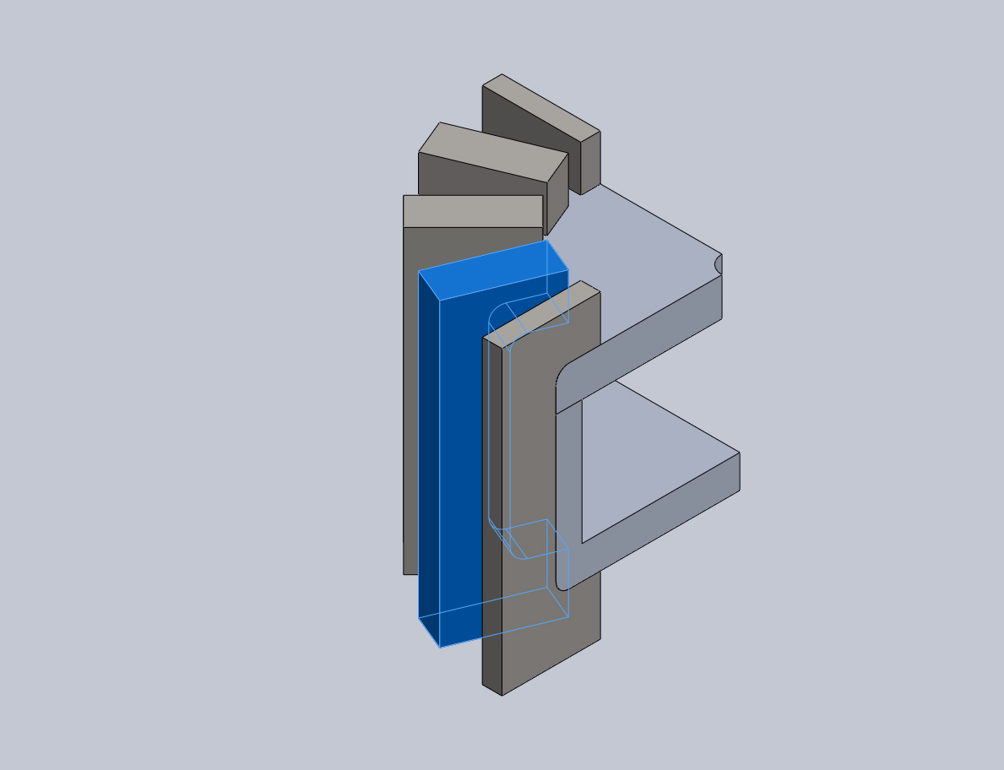 | Solid Body | Mass:13.1705 lb  Volume:45.5697 in^3  Density:0.289018 lb/in^3  Weight:13.1615 lbf | C:\Users\nsohn\Desktop\bucketClip.SLDPRT  Jun 25 10:06:06 2013
Fillet1  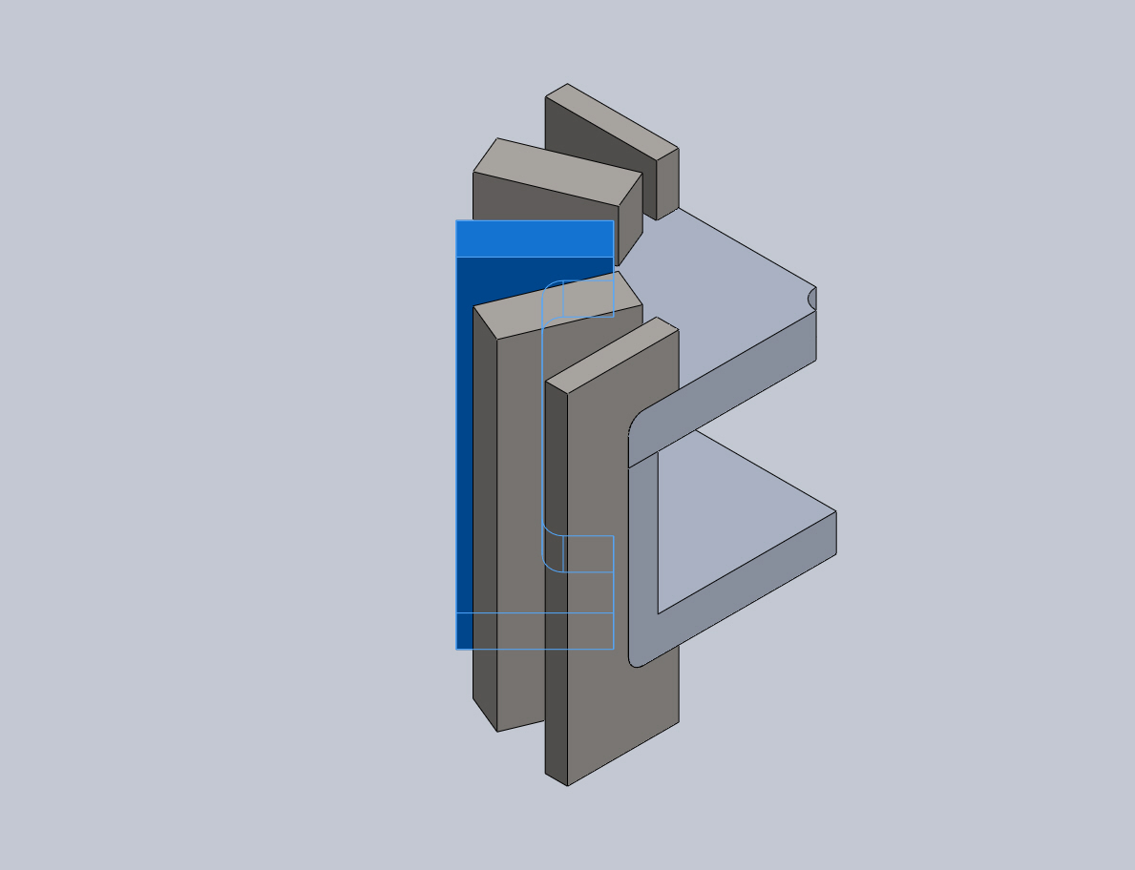 | Solid Body | Mass:13.1705 lb  Volume:45.5697 in^3  Density:0.289018 lb/in^3  Weight:13.1615 lbf | C:\Users\nsohn\Desktop\bucketClip.SLDPRT  Jun 25 10:06:06 2013
Fillet1  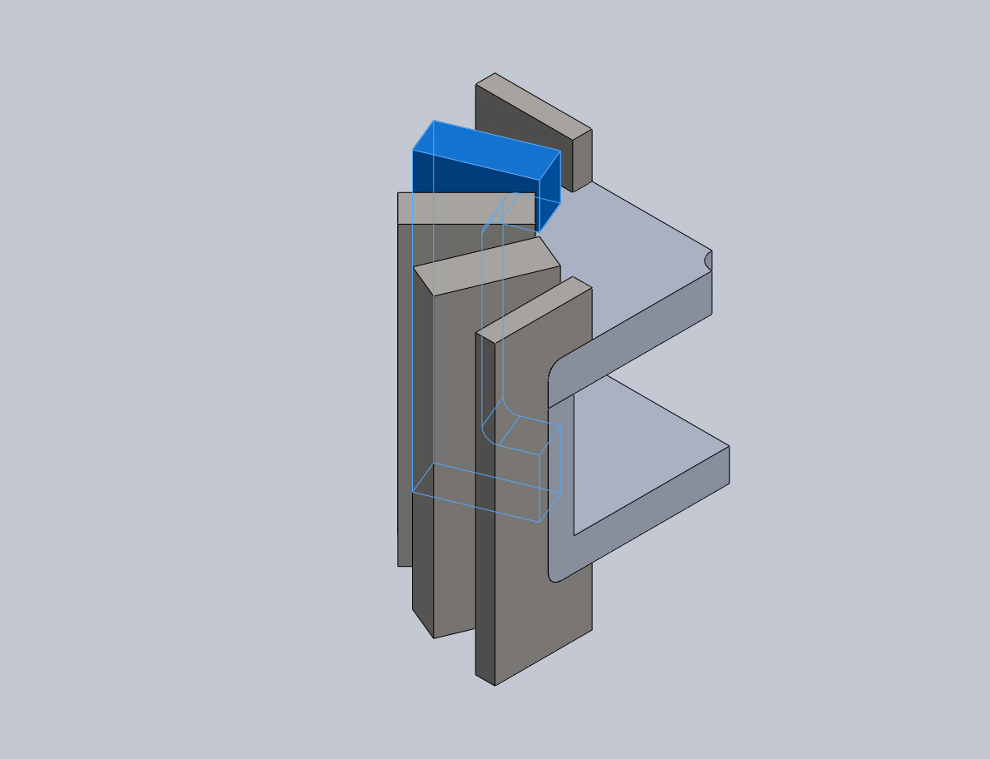 | Solid Body | Mass:13.1705 lb  Volume:45.5697 in^3  Density:0.289018 lb/in^3  Weight:13.1615 lbf | C:\Users\nsohn\Desktop\bucketClip.SLDPRT  Jun 25 10:06:06 2013
Fillet1  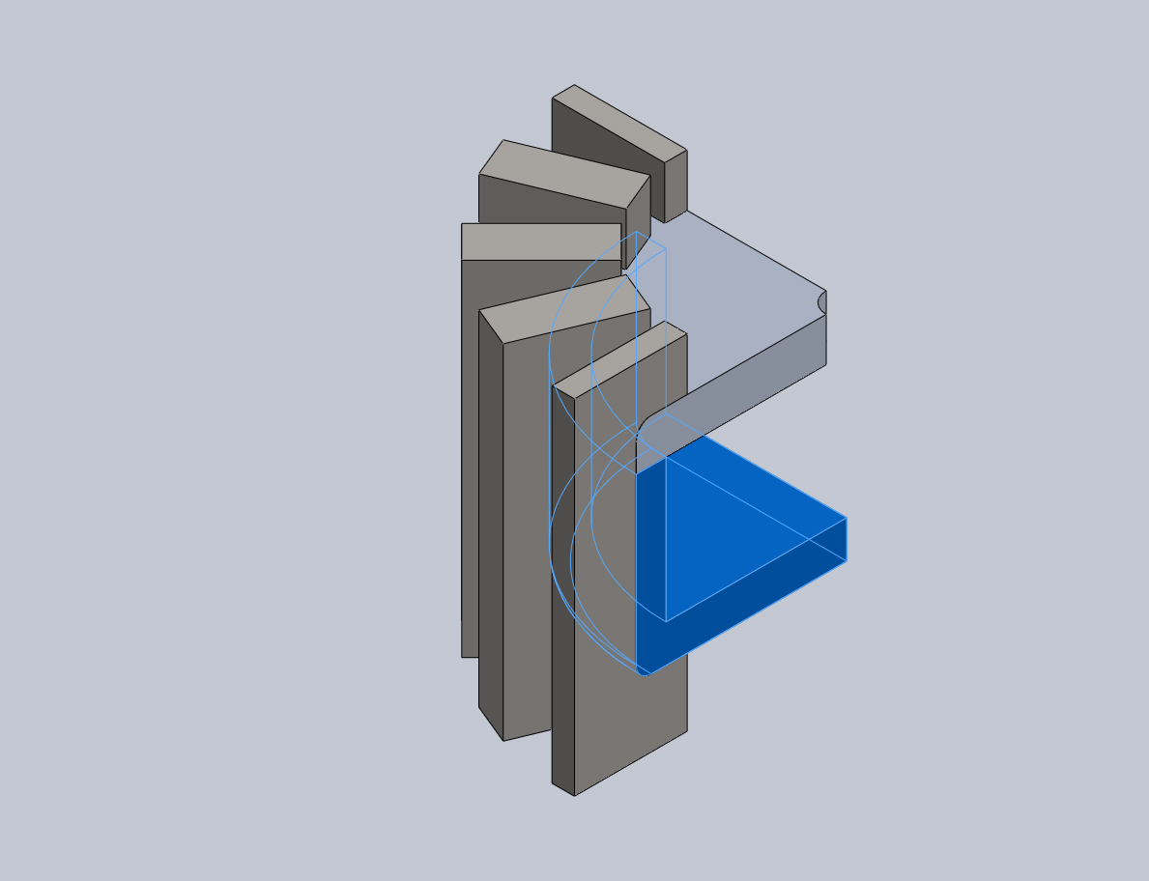 | Solid Body | Mass:9.32278 lb  Volume:95.5754 in^3  Density:0.0975437 lb/in^3  Weight:9.31646 lbf | C:\Users\nsohn\Desktop\clipHousing.SLDPRT  Jun 25 10:06:06 2013
Fillet1  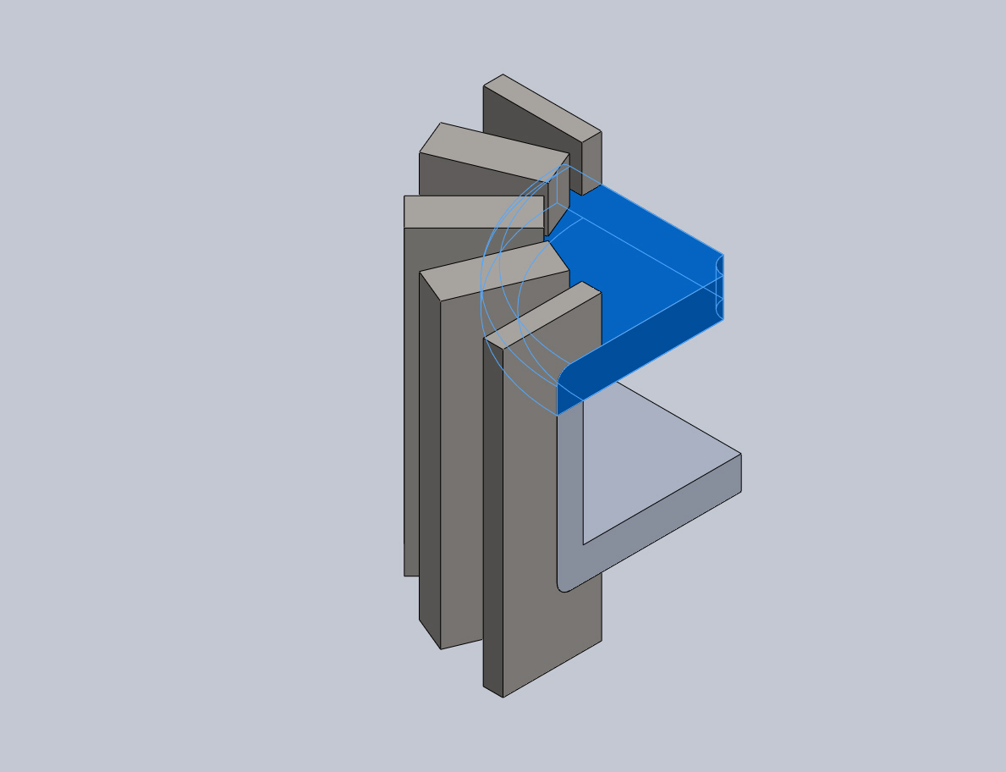 | Solid Body | Mass:5.33519 lb  Volume:54.6954 in^3  Density:0.0975437 lb/in^3  Weight:5.33158 lbf | C:\Users\nsohn\Desktop\clipTop.SLDPRT  Jun 25 10:05:52 2013

Study Properties
Study name | fusedSupports
Analysis type | Static
Mesh type | Solid Mesh
Thermal Effect: | On
Thermal option | Include temperature loads
Zero strain temperature | 298 Kelvin
Include fluid pressure effects from SolidWorks Flow Simulation | Off
Solver type | Automatic
Inplane Effect: | Off
Soft Spring: | Off
Inertial Relief: | Off
Incompatible bonding options | Automatic
Large displacement | Off
Compute free body forces | On
Friction | Off
Use Adaptive Method: | Off
Result folder | SolidWorks document (C:\Users\nsohn\Documents)

Units
Unit system: | English (IPS)
Length/Displacement | mm
Temperature | Kelvin
Angular velocity | Rad/sec
Pressure/Stress | psi

Material Properties
Model Reference | Properties | Components
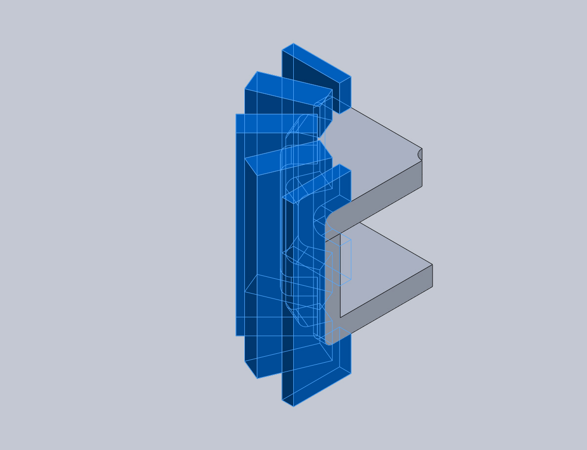 |  | SolidBody 1(Fillet1)(bucketClip-1),  SolidBody 1(Fillet1)(bucketClip-20),  SolidBody 1(Fillet1)(bucketClip-21),  SolidBody 1(Fillet1)(bucketClip-22),  SolidBody 1(Fillet1)(bucketClip-23)
  Name: | AISI 304
  Model type: | Linear Elastic Isotropic
  Default failure criterion: | Unknown
  Yield strength: | 29994.8 psi
  Tensile strength: | 74987 psi
  Elastic modulus: | 2.75572e+007 psi
  Poisson's ratio: | 0.29
  Mass density: | 0.289018 lb/in^3
  Shear modulus: | 1.08778e+007 psi
  Thermal expansion coefficient: | 1e-005 /Fahrenheit
Curve Data:N/A
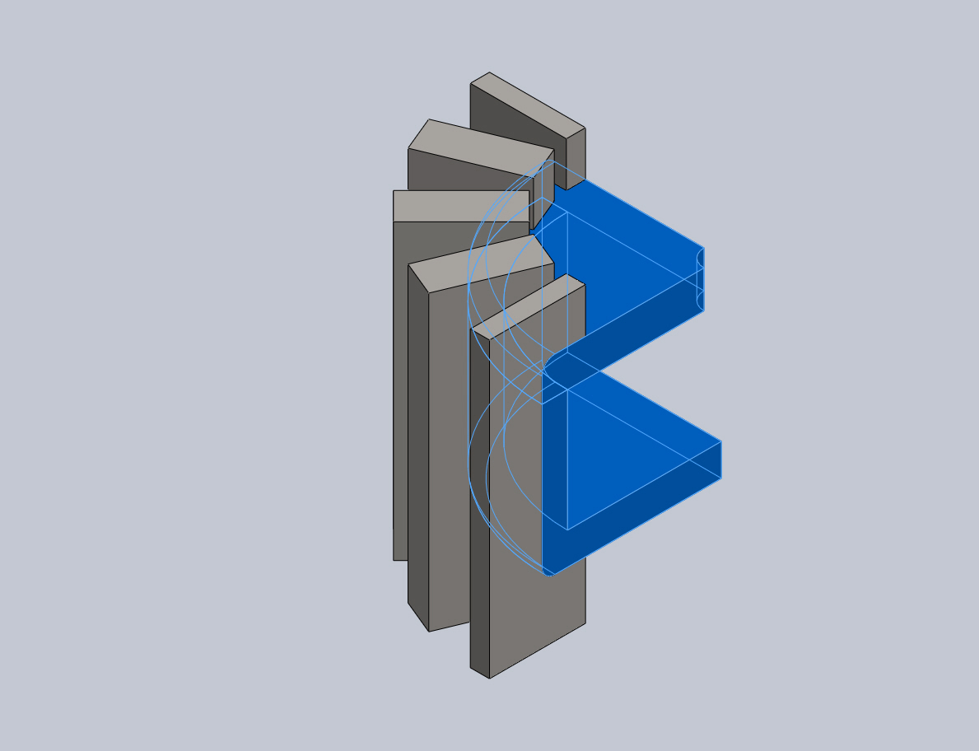 |  | SolidBody 1(Fillet1)(clipHousing-1),  SolidBody 1(Fillet1)(clipTop-1)
  Name: | 6061-T6 (SS)
  Model type: | Linear Elastic Isotropic
  Default failure criterion: | Unknown
  Yield strength: | 39885.4 psi
  Tensile strength: | 44961.7 psi
  Elastic modulus: | 1.00076e+007 psi
  Poisson's ratio: | 0.33
  Mass density: | 0.0975437 lb/in^3
  Shear modulus: | 3.77098e+006 psi
  Thermal expansion coefficient: | 1.33333e-005 /Fahrenheit
Curve Data:N/A

Loads and Fixtures
Fixture name | Fixture Image | Fixture Details
Symmetry-1 | 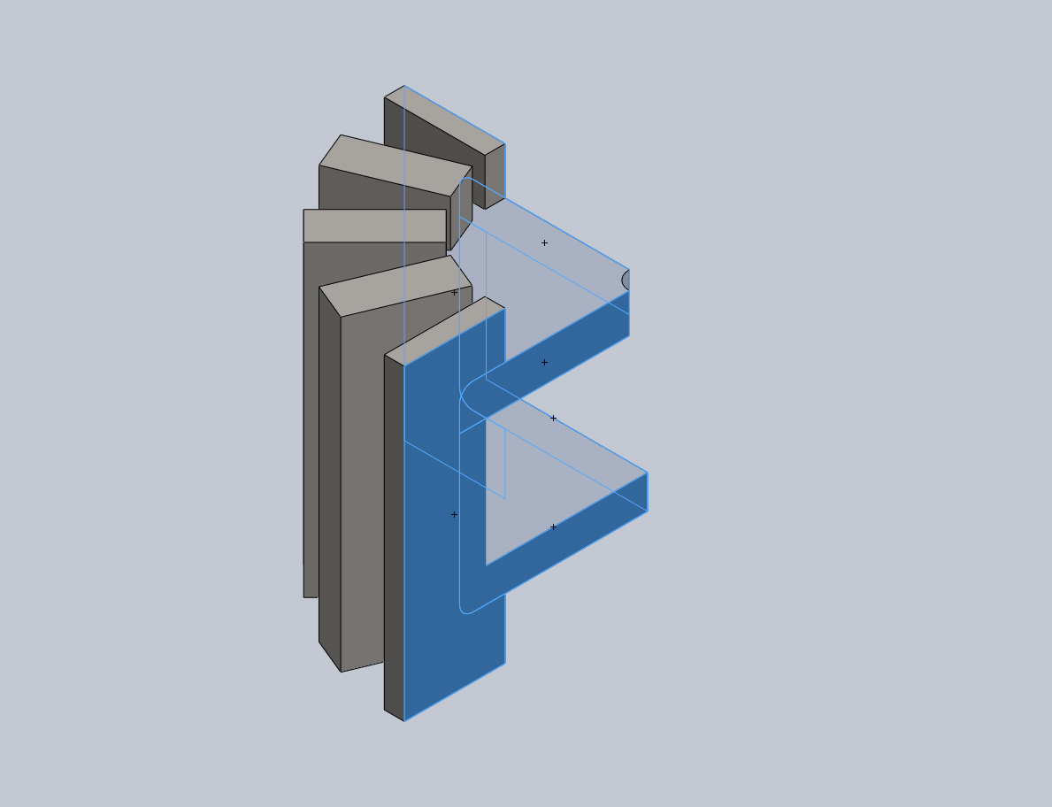
  Entities: | 6 face(s)
  Type: | Symmetry
Resultant Forces
Components | X | Y | Z | Resultant
Reaction force(lbf) | 21410.7 | 271.994 | -21410.6 | 30280.4
Reaction Moment(lbf·in) | 0 | 0 | 0 | 0

Fixed-1 | 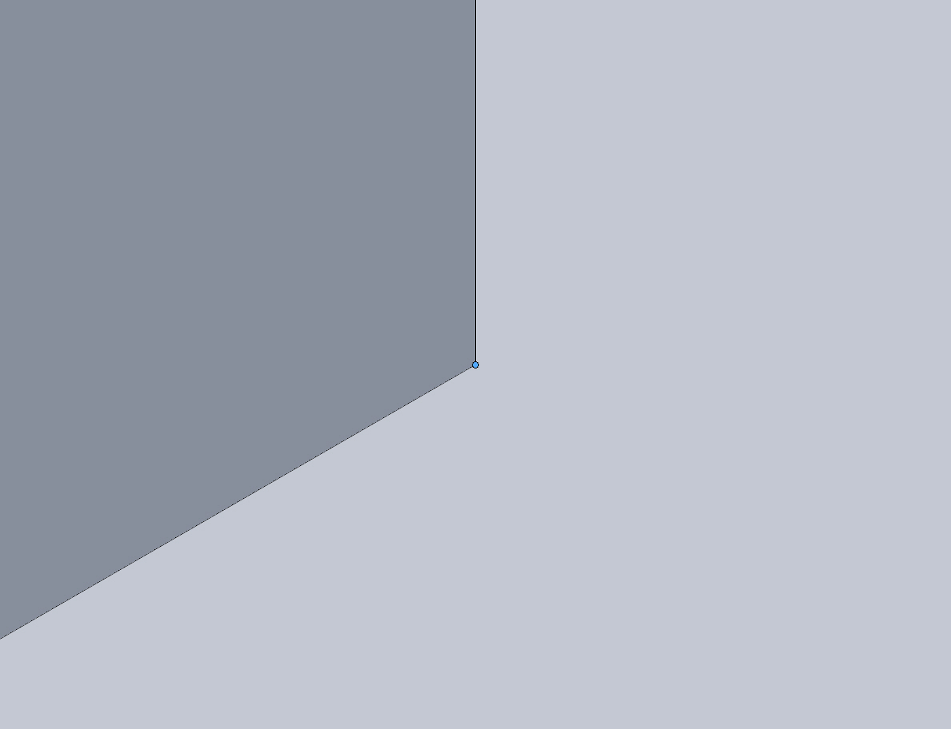
  Entities: | 1 vertex(s)
  Type: | Fixed Geometry
Resultant Forces
Components | X | Y | Z | Resultant
Reaction force(lbf) | -59.7906 | 272.12 | 46.8575 | 282.524
Reaction Moment(lbf·in) | 0 | 0 | 0 | 0

Load name | Load Image | Load Details
Pressure-1 | 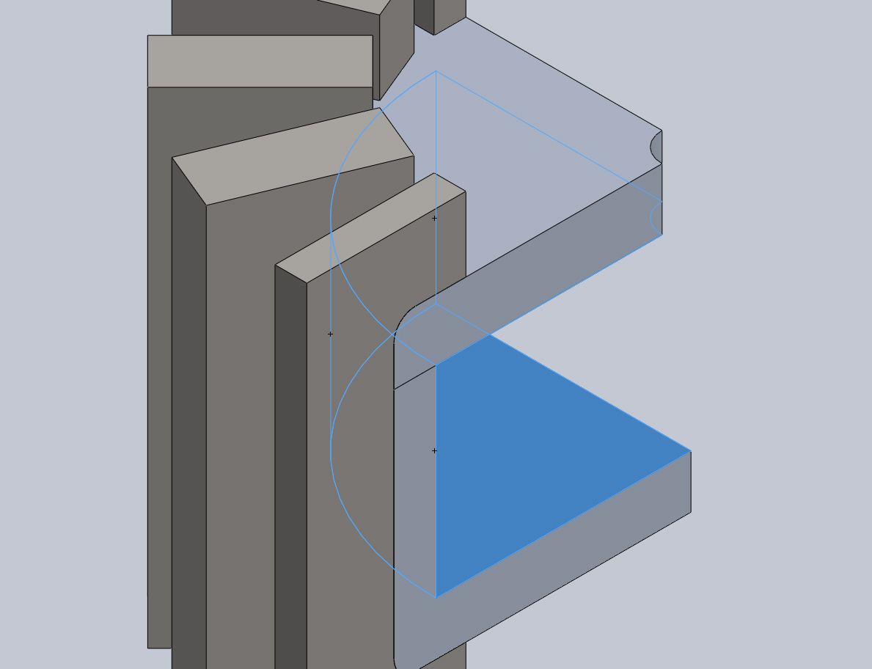
  Entities: | 3 face(s)
  Type: | Normal to selected face
  Value: | 750
  Units: | psi

Connector Definitions
No Data

Contact Information

Contact | Contact Image | Contact Properties
Contact Set-1 | 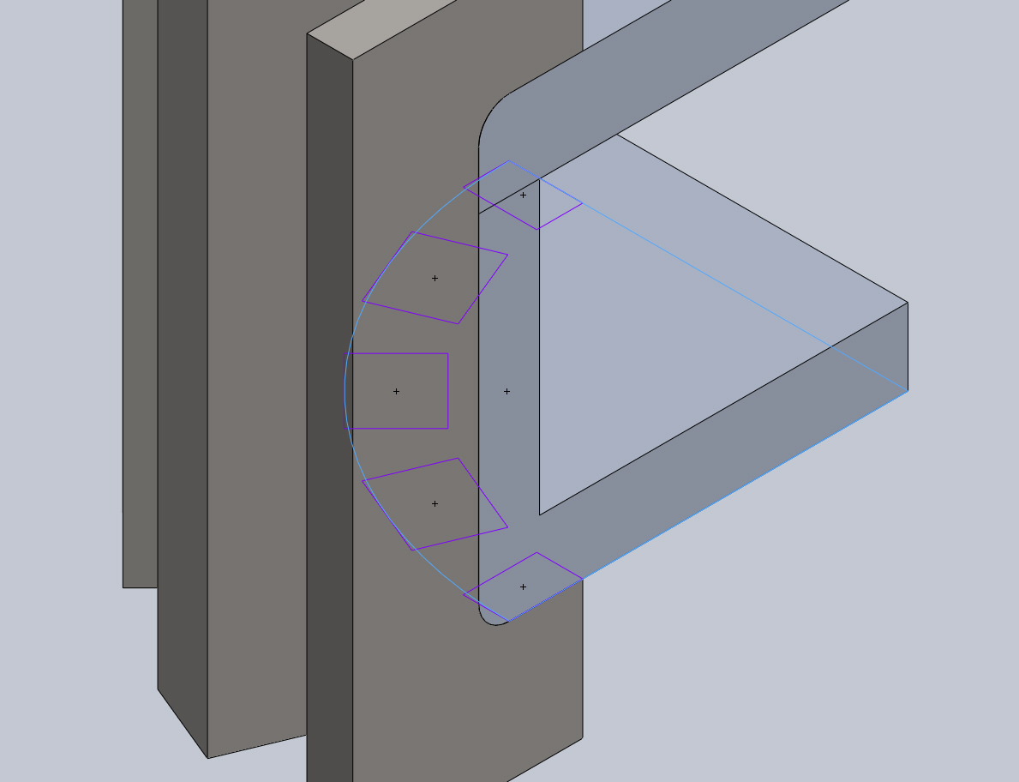
  Type: | Bonded contact pair
  Entites: | 6 face(s)
Contact/Friction forces
Components | X | Y | Z | Resultant
Contact Force(lbf) | -2.1314 | -94.243 | 1.7429 | 94.283

Global Contact | 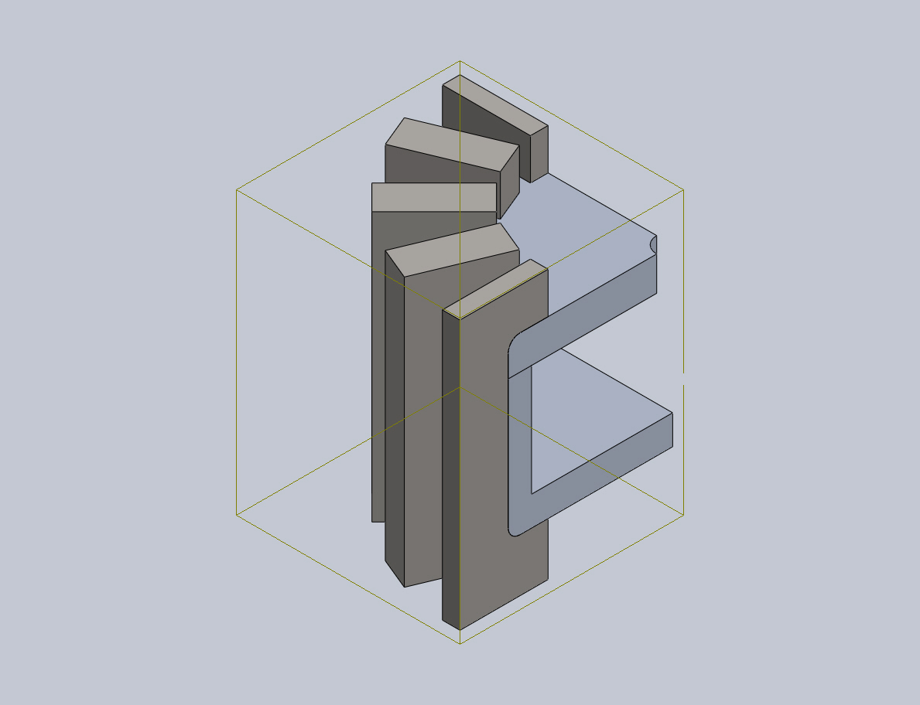
  Type: | Node to node
  Components: | 1 component(s)

Mesh Information
Mesh type | Solid Mesh
Mesher Used: | Curvature based mesh
Jacobian points | 4 Points
Maximum element size | 0.5 in
Minimum element size | 0.1 in
Mesh Quality | High
Remesh failed parts with incompatible mesh | Off

Mesh Information - Details
Total Nodes | 47627
Total Elements | 28683
Maximum Aspect Ratio | 7.0697
% of elements with Aspect Ratio < 3 | 99.2
% of elements with Aspect Ratio > 10 | 0
% of distorted elements(Jacobian) | 0
Time to complete mesh(hh;mm;ss): | 00:00:04
Computer name: | BRETAGNE
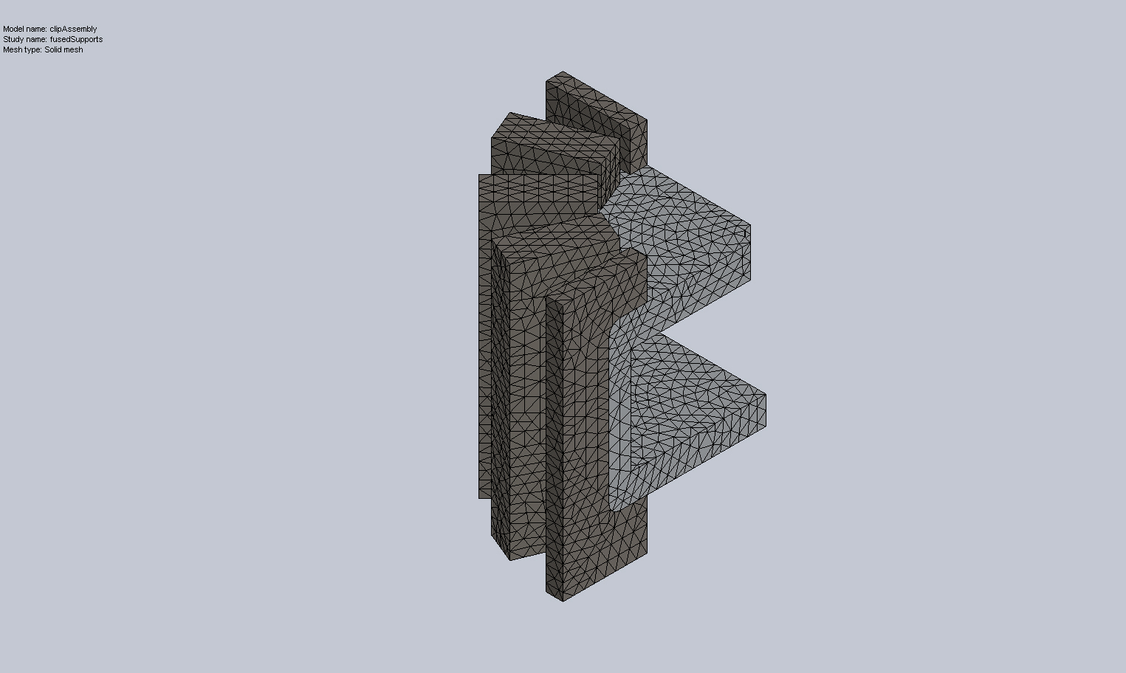

Sensor Details
No Data

Resultant Forces

Reaction Forces
Selection set | Units | Sum X | Sum Y | Sum Z | Resultant
Entire Model | lbf | 21410.7 | 271.994 | -21410.6 | 30280.4

Reaction Moments
Selection set | Units | Sum X | Sum Y | Sum Z | Resultant
Entire Model | lbf·in | 0 | 0 | 0 | 0

Beams
No Data

Study Results

Name | Type | Min | Max
Stress1 | VON: von Mises Stress | 8.45839 psi  Node: 26868 | 26571.4 psi  Node: 27628
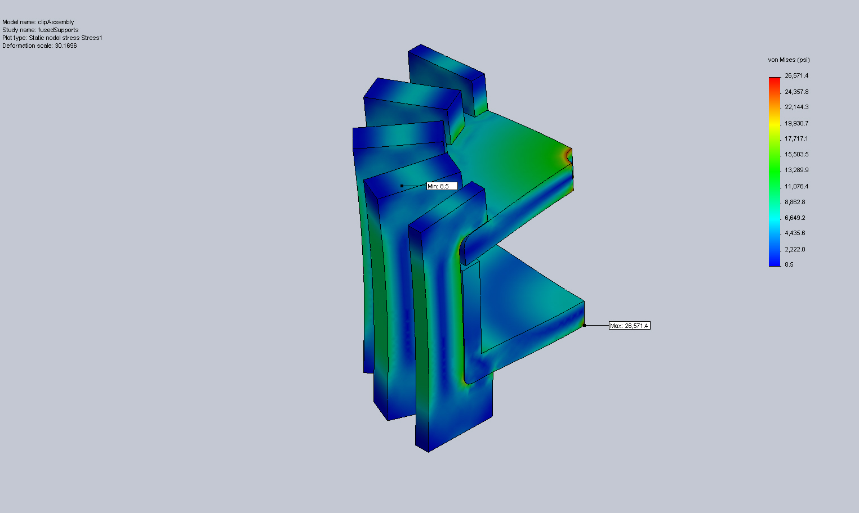
clipAssembly-fusedSupports-Stress-Stress1

Name | Type | Min | Max
Displacement1 | URES: Resultant Displacement | 0 in  Node: 27628 | 0.0379521 in  Node: 39233
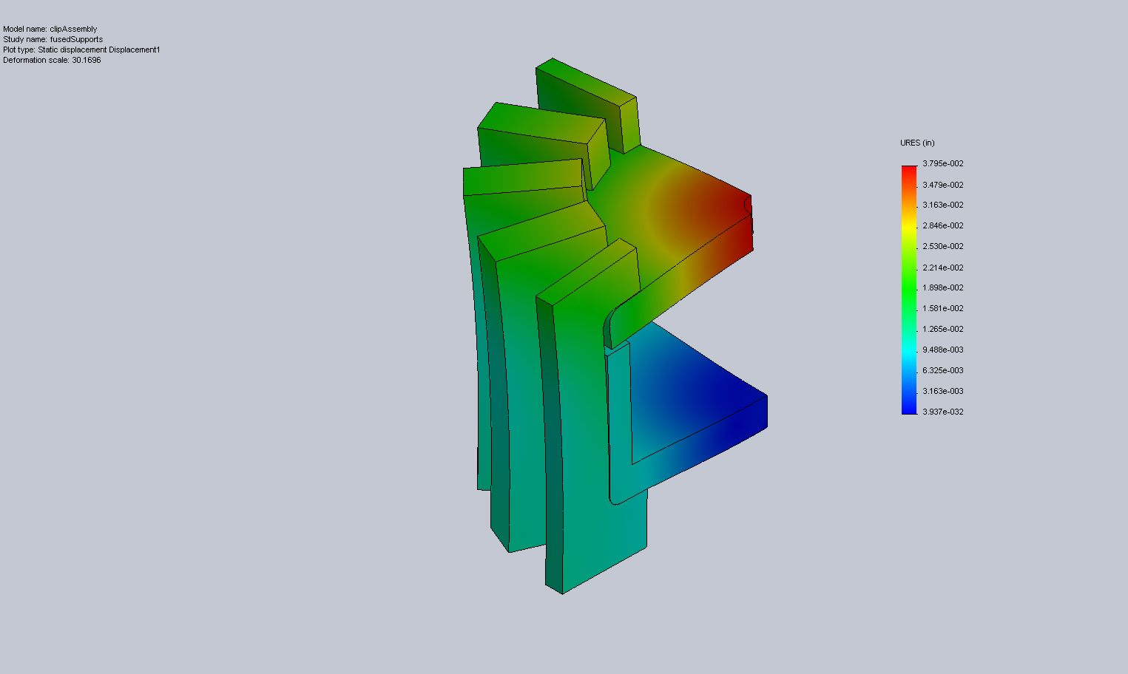
clipAssembly-fusedSupports-Displacement-Displacement1

Name | Type | Min | Max
Strain1 | ESTRN: Equivalent Strain | 1.51661e-007  Element: 10567 | 0.0016719  Element: 26298
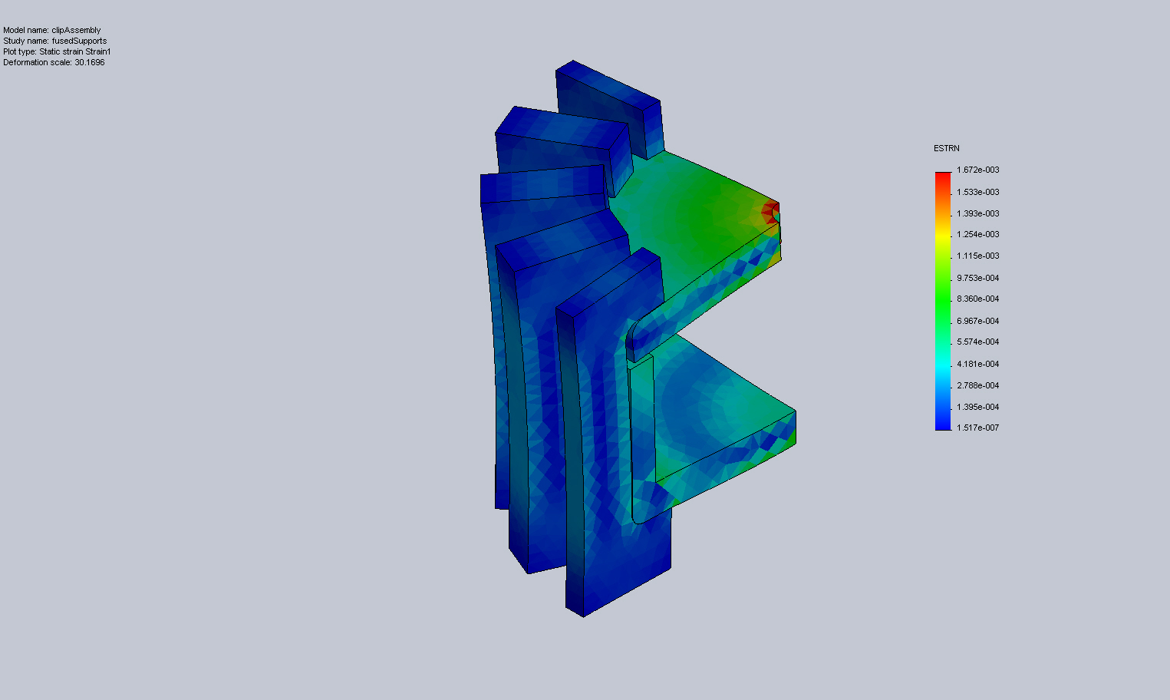
clipAssembly-fusedSupports-Strain-Strain1

Name | Type | Min | Max
Displacement2 | UY: Y Displacement | -0.000843492 in  Node: 29550 | 0.0379521 in  Node: 39233
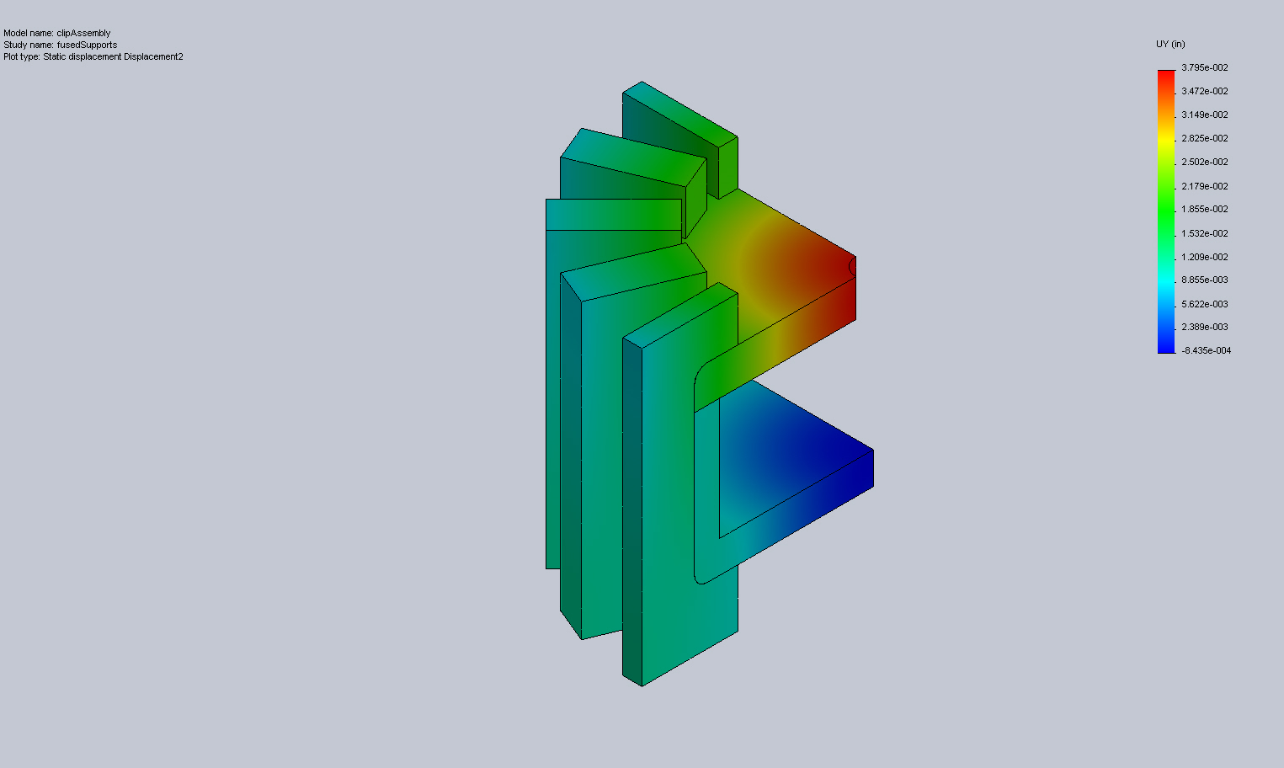
clipAssembly-fusedSupports-Displacement-Displacement2

Conclusion

