Title: Developing parameter estimation techniques for controller optimization of a Coastal Profiling Float
Sections:
Abstract
Introduction
Redesign of ballast engine simulator
Pump Efficiency Testing
System Characterization of Test Tank Prototype
Depth Controller Optimization
Conclusion
Acknowledgments
References

Introduction
An understanding of the ocean climate requires quantitative data with a level of temporal and geographic resolution that would be impractical to achieve using conventional ocean measurement systems. The Argo program proposed an alternative method for large scale measurement of heat exchange in the ocean using a network of autonomous profiling floats distributed on a global scale. Since the first deployment of Argo floats in 200 over 3000 new floats have been deployed by organizations spanning across 23 countries. The success of the program is emphasized by the fact that currently over 100 research papers per year cite Argo data.
Despite the large amount of data that have become available in the deep ocean because of Argo floats, coastal waters have largely been avoided as sites for float deployments. Shallow waters and the proximity to the shore pose significant dangers to profiling floats that make coastal deployments impractical, especially considering the low heat content in these environments. While coastal settings may not have a significant role in heat exchange however, studying coastal environments is critical for understanding ocean acidification, hypoxia, and other effects that result in part from anthropogenic waste. A series of ocean floats modified for coastal measurements could provide a cost efficient method of quantifying these changes.
The largest challenge associated with using floats for coastal measurements is containing the floats within the region of interest without significant allocation of resources. Coastal currents could potentially push a profiling float into the coastline or further out to sea. Either of these scenarios would prevent a coastal float from collecting useful measurements. One solution is to program the floats to anchor on the sea floor until they collect data. This would reduce the risk of drifting and additionally minimize the potential for biofouling. Another solution is to program the float to change its depth and take advantage of serendipitous currents to correct for drifting. Both of these methods require significantly finer control and stronger lifting forces than an Argo float can provide.
The purpose of this project is to aid in the design of a ballast engine for a Coastal Profiling Float (CPF) modified from the Argo float design. The primary goal is to redesign a pressure simulator for testing the ballast engine efficiency. Additionally, this project seeks to refine the physical model of the float dynamics and improve the PID control loop for regulating buoy velocity and position. The remainder of this report is divided into sections describing the reimplementation of the pressure simulator, efficiency testing of the ballast engine, system characterization of the test tank prototype, and depth controller optimization.

Ballast Engine pressure simulator reimplementation:
During a single profiling measurement a CPF must travel through the water column starting at a depth anywhere from 100 to 50 meters up to the surface. As a result, the float is exposed to pressures ranging from 1 atm at the surface to 1000 atm at depth. Varying pressure has a number of effects on the float including volume change from compression and the pressure head on acting against the float’s external oil reservoir. Consequently, the external pressure on the float influences the pump efficiency. One of the primary goals of this project was to re-implement a bench-top prototype to generate enough pressure to characterize the pump efficiency. Before testing could be performed the pressure housing for the simulator had to be modified to withstand larger pressures. The first phase of this project was to quickly fabricate a mechanism to secure the pressure housing lid with minimal modifications to the existing design, shown in Fig. X below.

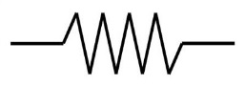
RPM
STP

STP
Reservoir
Bellows Housing
Bellows
Spring Loaded Piston
Pump
P

x1

x2

Oil is pumped from a reservoir kept at atmospheric pressure to the bellows, which is housed within an aluminum drum. The housing is flooded with oil, which may pass to a spring loaded piston. The spring emulates the linear relationship between depth and pressure by providing an elastic force that resists piston displacement. The simulated pressure is measured using a pressure transducer in line with the piston, or by measuring the spring displacement. The bellows position and motor speed are also measured using a data acquisition system, as shown in the electrical schematic (see diagram p. 30)

Modifications to the pressure housing
The lid to the housing was originally secured using 16 ¼-20 bolts. These bolts had insufficient cross-sectional area to resist tensile loading, and excessive bolt elongation caused the O-ring seal to fail. For a 90 durometer O-ring the limit for extrusion is 0.020 in. The primary goal of this design was to prevent the housing lid from exceeding this deflection limit. Time and ease of fabrication were also important design considerations.
Under elastic deformation the extension of a material is proportional to the applied load and member length, and inversely proportional to the elastic modulus and cross-sectional area. The latter two of these sources of elongation were addressed. Sixteen 302 Stainless Steel C-clips placed around the perimeter of the bellows housing were chosen as the load bearing components, each of which had a throat width of 2.2 in and a thickness of 1.5 in, as indicated in Fig. X. This method increased the tensile area by a factor of 60, resulting in an overall elongation of .006 in at the O-ring gap.

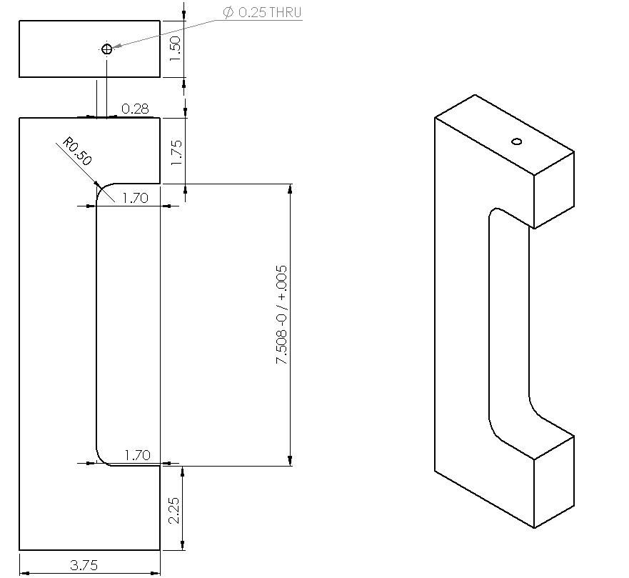

A simple 90 degree cut into bar stock would be the simplest solution in terms of fabrication. However, the sharp corners of the bar caused unacceptably large stress concentrations. FEA results suggested that adding a 0.5 inch fillet to each corner would reduce the stress to an acceptable amount. In order to reduce the amount of material required for each clip, the top and bottom edge of the bellows housing were also filleted. The FEA analysis of this solution is shown in Fig. X below. Note that the maximum VonMises stress is 26 571psi, which is well below the 40 000psi yield strength of 6061-T6 aluminum. As expected, the bellows housing undergoes some deformation as a result of the high pressure. The surface between the bellows housing and lid however has a difference in vertical displacement of .006 in, which is less than the extrusion limit.

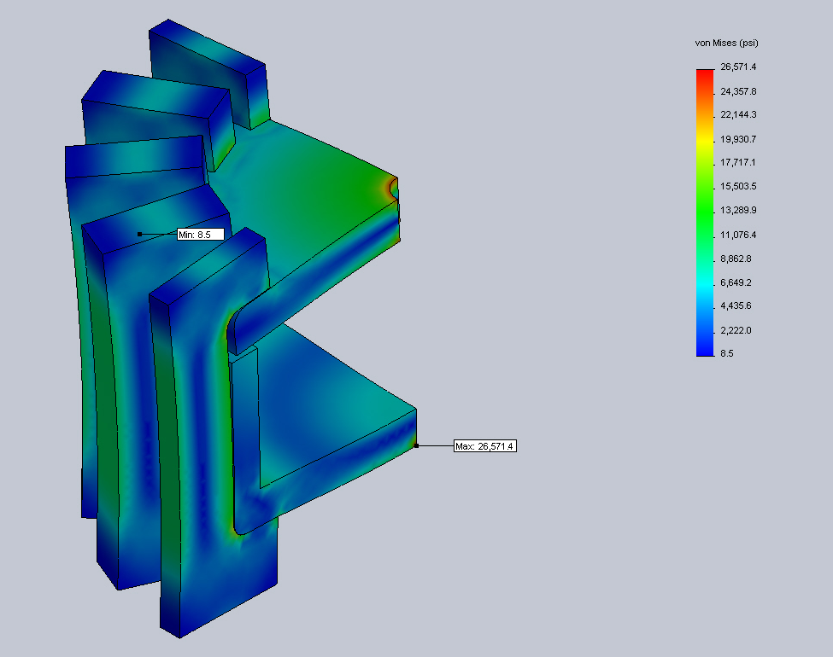

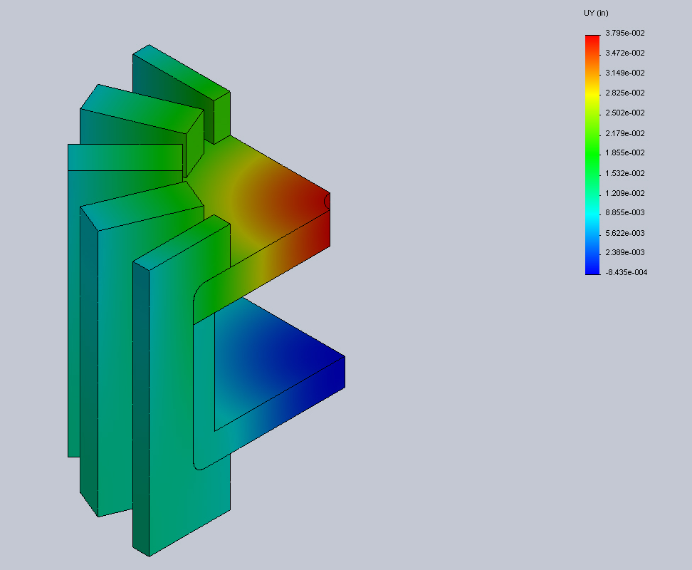

Such high magnitude pressures should also cause radial expansion of the housing, which could potentially dislodge the clips. A single bolt was run through the top of each clip into the ¼-20 threaded holes originally used to seal the housing. As indicated in Fig. X, the FEA simulation of this configuration verified that the addition of alignment bolts did not significantly change the loading of the pressure vessel.

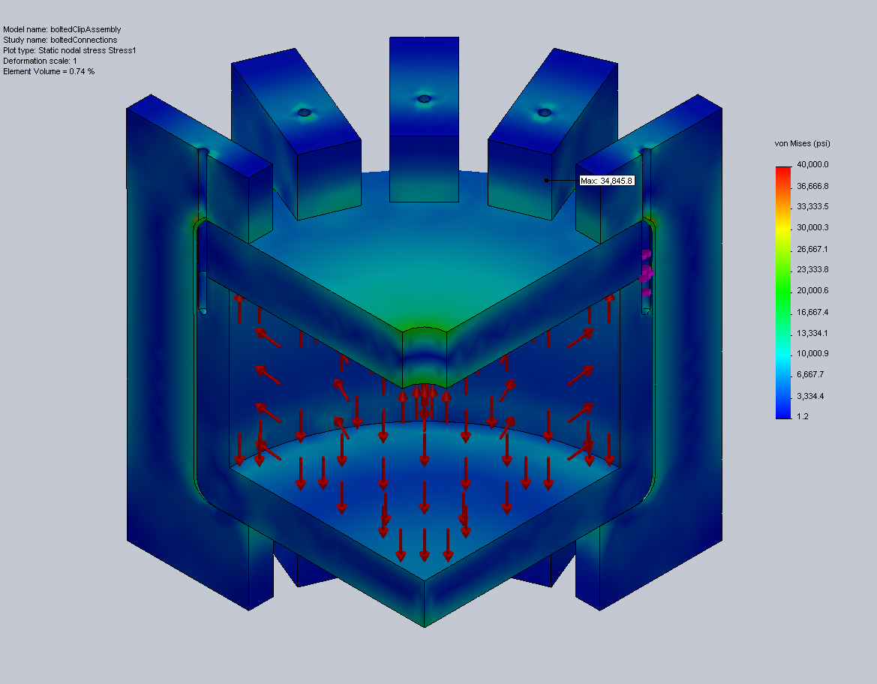

For the sake of clarity Fig. X has an ISO clipping such that only stresses greater than 20,000 psi are plotted. As expected, the point of maximum stress occurs at the junction between the C-clip and housing lid, and the maximum stress is below the yield strength. This solution was therefore chosen for the final design.
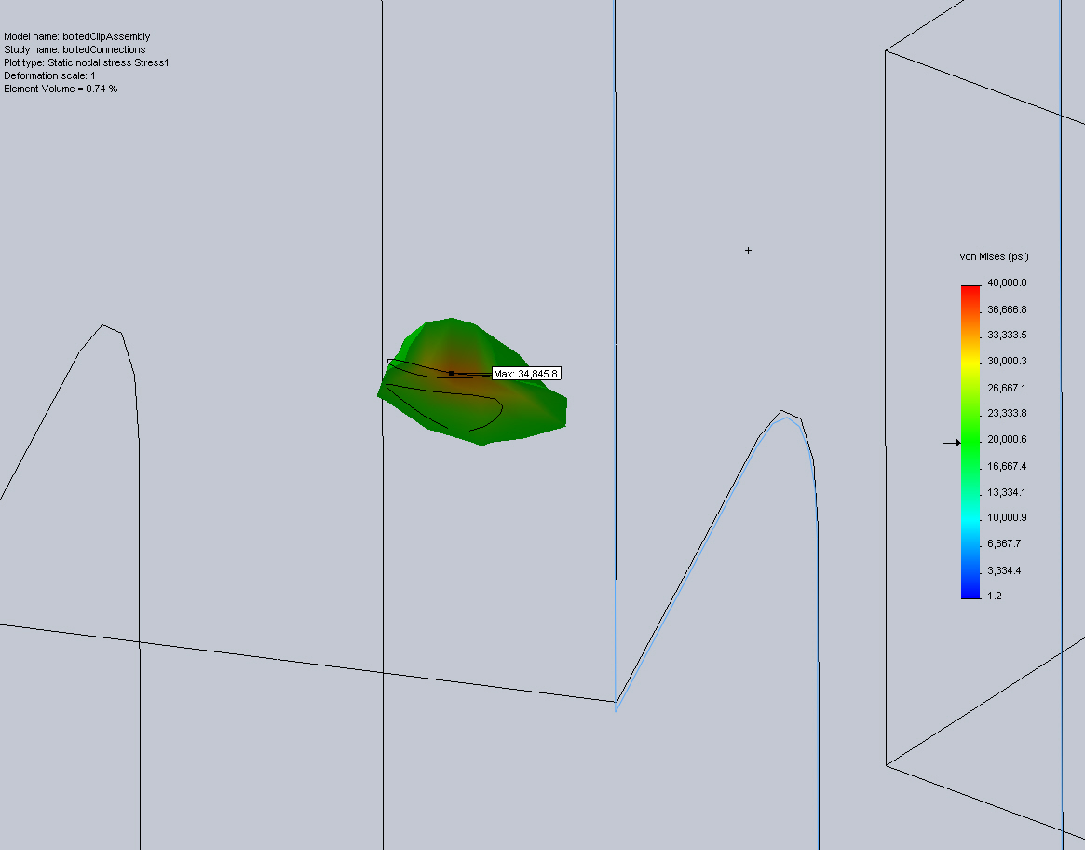

Hydraulic Assembly
The design for the bellows engine on the CPF uses an Oildyne 865mL miniature piston pump to transport oil between the internal reservoir and external bellows. The hydraulic schematic in Fig. X below provides a path for oil to flow in each direction without back-flowing through the filters.
Quarter inch Swagelok fittings were used for all pressurized lines. The motor, pump, and pilot valves were mounted to a frame fixed to the bellows housing. ClearFlex ¼ inch inner diameter PVC tubing was used for all low pressure lines.
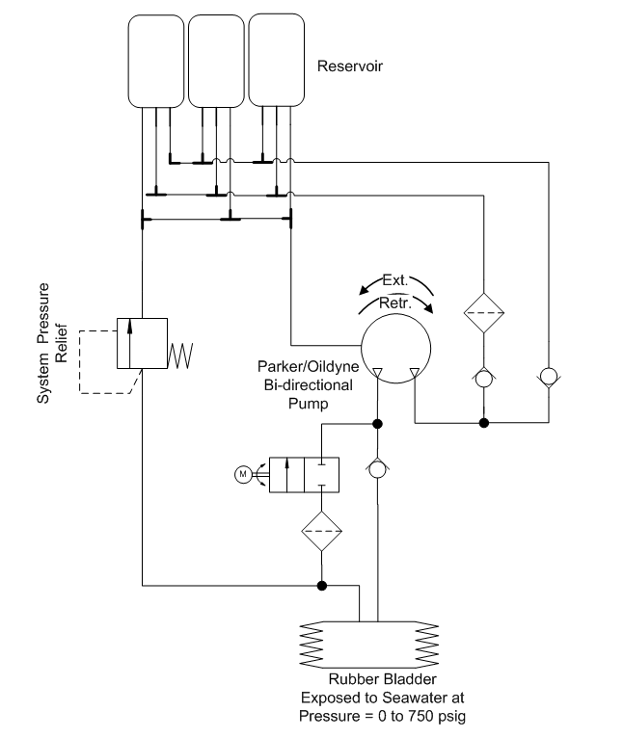

Sensor and Data Acquisition Module Integration
The pressure simulator employs several commercial-off-the-shelf devices for acquiring engineering data. Two MTS position transducers record the vertical positions of the bellows and spring-loaded cylinder respectively. An OmegaDyne PX329-1KG5V pressure transducer measures the pressure within the piston. Data from these devices are collected using a National Instruments cDAQ 9164. Analog data, including the voltage across a shunt resistor, are passed throuch a NI cRIO-9215 Analog input module. Digital data from the MTS position transducer must be extracted using a NI 9401 Digital input module. The Maxon motor is controlled by an Elmo Harmonica, which receives feedback data from an incremental encoder. The wiring schematic used is shown in Fig. X below:
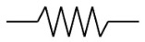

Diagnostic and
Control Sensors

MTS Position
Transducer (x1)
MTS Position
Transducer (x2)
1 Data -
2 Data +
3 Clk -
4 Clk +
5 VCC
6 GND
1 Sig +
2 Sig -
5 VCC
6 GND
Pressure
Transducer
1 Sig
2 VCC
3 GND
Motor Encoder
1 VCC
2 GND
3 A -
4 A +
5 B –
6 B +
7 I –
8 I +
Motor
1 Sig +
2 Sig -
3 GND

Elmo
Motor
Control

Main
Feedback
5
6
7
8
9
10
11
12

Main
Power
1
2
3
4 N/C
5
6
7

Aux.
Power
1
2

Data
Acquisition
cDAQ-9174

cRIO-9215
0
1
2
3
4
5

NI - 9401
19
20
22
22V
RS-232
USB

RS 422 to TTL

CPU

Pump Efficiency Testing
Pump efficiency was characterized using three metrics. Pressure varies significantly as the float changes its depth. Since the oil pump must work against the external pressure, determining the pump efficiency at different pressures was critical to designing a realistic model. The efficiency was measured as the bellows volume change per pump cycle and as the change of the product of volume and pressure per Joule of electrical power supplied by the voltage supply. The latter metric was also measured for different bus voltages at a constant pressure.

Volumetric efficiency measurements
Flow rate into the bellows was determined by measuring the vertical displacement of the bellows endcap. Qualitative observation of the filling bellows indicated a specific filling order, which was modeled using a piecewise-nonlinear equation. As indicated in Fig. X (p. 25), the bellows can be broken into two cylinders with a radius (r_{i}) of 4.72 and height (c) of 0.08 in, four cylinders with a radius (r_{o}) of 5.91 in and height (d) of 0.08 in, and eight partial cones. The partial cones may be thought of as a series of stacked circular sections, whose radii vary as a function of height according to the equation
$$r\left(h\right)=r_{0}+\frac{r_{i}-r_{o}}{h_{total}} ∙h$$
The cross-sectional area may also be expressed as a function of height as:
$$SA\left(h\right)={π\left(r_{0}+\frac{r_{i}-r_{o}}{h_{total}} ∙h\right)}^{2}$$
The volume at any given height for a partial conic section is therefore given by:
$$V\left(h\right)=\int_{0}^{h}{{π\left(r_{0}+\frac{r_{i}-r_{o}}{h_{total}} ∙h\right)}^{2}}dh$$
Qualitative observations of the bellows filling suggested that the large cylindrical sections fill first, followed by the conic sections, and finally by the small cylindrical sections. The final piece-wise equation used to relate the bellows height to the volume is given below:

The volumetric efficiency was measured by dividing the calculated volume change by the theoretical input flow rate. The input flow per pump cycle was assumed to be a constant __mL/rotation. The input flow could then be determined by multiplying this constant by the motor speed.

Energy Efficiency Measurements
Pump efficiency was also characterized in terms of work. The input work was measured from the current through a shunt resistor (_ ohms), following the equation P = I^2*R. The output work was calculated by multiplying the bellows pressure by the volumetric change.

Experimental Design
Flow rate v. Pressure
Prior to the experiment all oil was evacuated from the bellows and the pressure inside the bellows housing was measured. The pump was then driven at a rate of ___ cycles/minute until the vessel reached a pressure of __ psi. The resulting pump efficiency was plotted as a function of pressure using both energy and volumetric methods. This process was repeated in triplicate over a range of pump speeds from ___ to __ in __ intervals.

Energy Efficiency v. Bus Voltage
Prior to the experiment all oil was evacuated from the bellows and the pressure inside the bellows housing was measured. The pump was then driven at a rate of ___ cycles/minute until the vessel reached a pressure of __ psi. This process was repeated in triplicate over a range of bus voltages from ___ to __ in __ intervals. The total energy required to complete each cycle was plotted as a function of bus voltage.

System Characterization of Test Tank Float
Estimation of drag coefficient and added mass
The force of drag is commonly approximated using the empirical equation $F_{drag}=\frac{C_{d}v^{2}A}{2}$,
where C_{d} is an empirical constant known as the drag coefficient. The drag coefficient varies with the object’s shape, direction of flow, and the Reynolds number. The Reynolds number of the float should remain relatively constant as the float changes position in the water column, so only one drag coefficient must be calculated for each direction. Under ideal conditions the drag coefficient could be calculated from Eq. x by weighting the float with a known force and measuring its terminal velocity. Without writing a control loop to control bellows position however, the bellows will compress as the pressure increases beneath the surface. Since terminal velocity could not be achieved in a ten meter test tank, a steady state measurement could not be used and acceleration also needed to be considered. This required us to determine the drag coefficient and added mass to be measured simultaneously.
A test tank prototype of the CPF was loaded with known weights and released from the surface. The pressure data and bellows position were recorded over time. These results were compared to a numerical simulation where the coefficient of drag and added mass could be varied. The Simulink model shown in Fig. X was run iteratively varying each of these variables. A two-dimensional least squares regression was used to pick values for the drag coefficient and added mass that produced a position profile that most closely matched the experimental data.
[results]

Particle Counter Design
One of the sensors that could be equipped on a CPF is a particle counter, which could size and count particles that pass through an orifice during the float’s ascent. Typical Coulter counters measure the change in resistance in an orifice separating a hollow tube and the surrounding medium as a particle passes through. These sensors are capable of detecting particles anywhere from __% to __% of the orifice diameter. This project addressed the feasibility of using a Coulter based particle counter on a CPF.

Preliminary Design –
The first goal of this project was to demonstrate that particles could be detected using fairly low cost equipment in lab. The original apparatus is shown in Fig. X (P.34). Two platinum electrodes are submerged in an electrolytic solution. One of the electrodes is placed inside a hollow tube with a __ diameter hole in the bottom. The electrodes are in series with an AC voltage source, driven at __ Hz , and a __ shunt resistor, whose impedance is matched to bear half of the power. The signal is measured across the shunt resistor.
The input signal is a __ Hz square wave with a 4V peak to peak voltage. The alternating current prevents the electrodes from forming a potential gradient in the electrolytic solution, but it also requires that some signal processing be performed on the output in order to see the relatively slow changes in amplitude resulting from a passing bead. Basic envelope detection was applied to the output signal by applying a lowpass filter to twice the squared signal. A fourth order Butterworth filter with a cutoff of __ Hz was used for this process.

