Response to MT Phase 1 Comments 901206 Development of a Coastal Profiling Float

General Comment: “we’d like to see a long term operational plan that incorporates routine
recovery of these floats”

In order to minimize the impact on humans and marine wildlife and minimize any additional contribution to the growing volume of ocean debris, we will develop an operational capability to track the location of every float we deploy. It is relatively straight forward to integrate the float tracks into a GIS database (ArcMap and Matlab are likely candidates) in order to evaluate the float positions relative to the desired measurement volume and, just as important, any keep out areas such as Marine Protected Areas. We will be using MLML small boats to retrieve all floats we deploy when either a) the predefined mission ends or b) a float track becomes problematic based on some pre-defined criteria e.g, leaves the measurement volume with little chance of re-entry based on model predictions, approaches shore or approaches a MPA. Larger deployments beyond the scope of this project may have to identify additional appropriate small boats to retrieve floats when necessary.

Specific Comment #1: “There are inconsistencies between the labor requests written in the proposal, the labor detailed in the milestone chart, and the labor entered into the web system.”

We have modified the project schedule to make sure tasks do not span calendar years. We’ve also added time for the float tracking task described above and somewhat more machine shop and tech time. The web labor entries have been modified to reflect these changes. The new milestone table and Gantt chart are presented below.

 | Milestone 1 | Milestone 2 | Milestone 3 | Milestone 4 | Milestone 5 | Total Resources for each resource category for all milestones listed here
Milestone Date | June 2012 | Aug 2012 | Nov 2012 | Dec 2013 | Dec 2014
Milestone Description | Permitting addressed | PDR | CDR | Engr. Deployments | Science Deployments
EE
SE
ME | 120 hrs | 224 hrs | 280 hrs | 408 hrs | 488 hrs | 1520 hrs
EE Tech |  |  | 40 hrs | 80 hrs |  | 120 hrs
SE Tech
ME Tech |  | 40 hrs | 80 hrs | 128 hrs | 80 hrs | 328 hrs
Machine Shop |  |  | 120 hrs | 80 hrs |  | 200 hrs
Divers

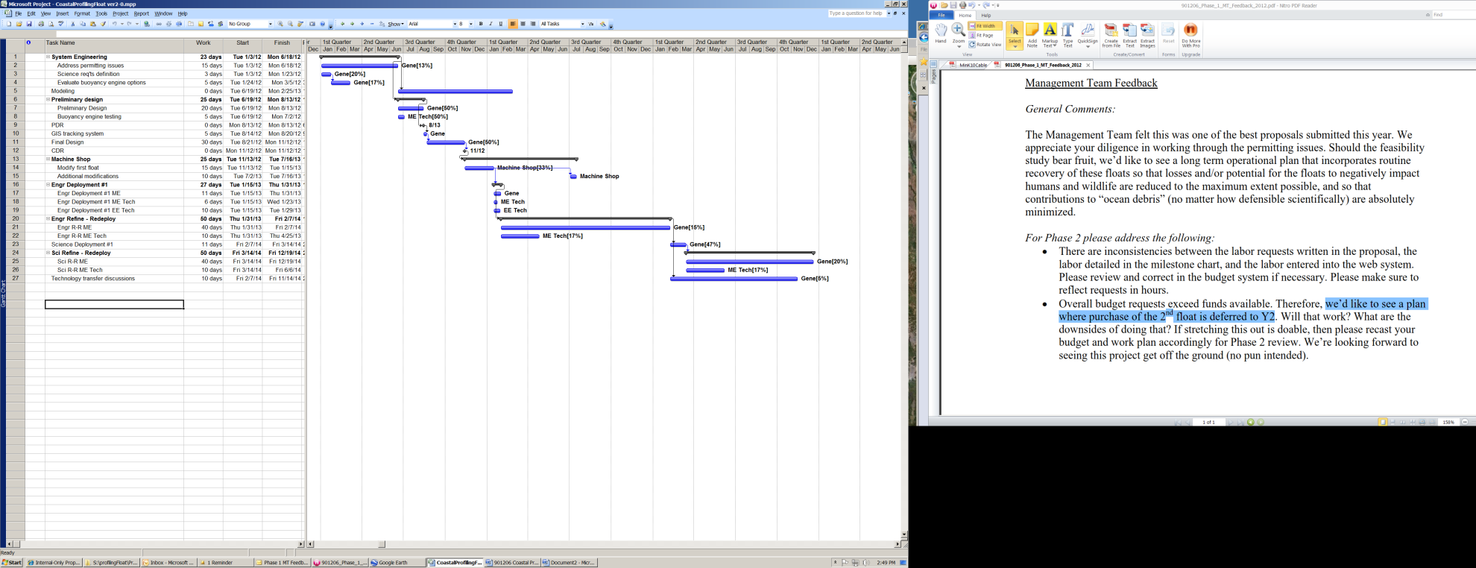
Specific Comment #2: “we’d like to see a plan where purchase of the 2nd float is deferred to Y2”

We have moved the purchase of the 2nd profiling float to the 2nd year of the project. This will have some impact on our development process. We were expecting to use both floats early on to address a) the question of how different the tracks of 2 floats deployed in the same general vicinity may vary and b) the effectiveness of various “parking” strategies. However, we do not anticipate this impact to seriously affect the project. We also increased the cost of the floats to include sales tax. The new budget for 2012 is presented here and the web entries have been updated.

 | Year 1 | Year 2
Float 1 | $42,900
Float 2 |  | $42,900
Buoyancy engine prototype | $3,000
Buoyancy engine deployable | $5,000
Buoyancy test fixture | $2,000
Pump interface | $1,500
Float frame material | $2,500
Iridium air time | $1,000
Travel to UW Riser Lab (1 person 2X) | $4,000
MLML small whaler (6X half days) | $1,260
John Martin (2X half days) | $3,290
Misc | $1,500
TOTAL | $67,950

This number should be the same number you entered on the resource requests for this particular resource.

