ZEISS LIGHTSOURCE ASS’Y FOR SPECTROPHOTOMETERS

2018-JIM SCHOLFIELD X:\ChemSensors\JimS\coletti\Spectr. mount-APEX
This Procedure describes how to properly secure the light sources in the mount plate.
-Assemble the necessary parts and tools -
Mount Plates-with finish machining
Zeiss light source-be aware of gentle bends in fiber optics
SS M2 x 2.5 set screws, 2 per ass’y
0.035” Allen key for above
Multiple substrate epoxy with 15-30 minute work time
Eye magnifier recommended, screws are really small
Special made alignment tool is helpful
Storage Rack is helpful as well

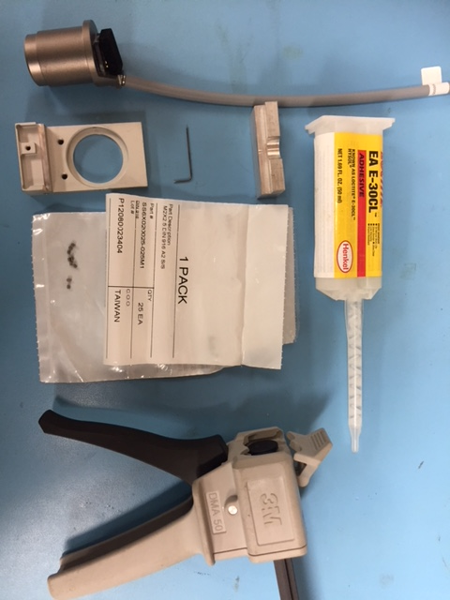

p.2
-Install a set screw in each threaded hole, just enough to hold in place.

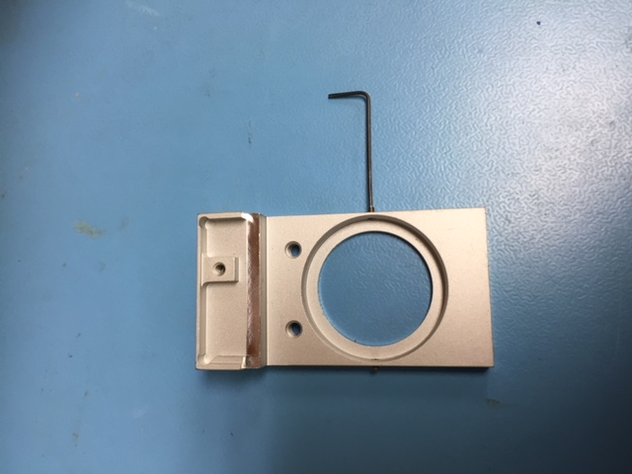

-Place a drop of epoxy in 2 places on land in mount plate
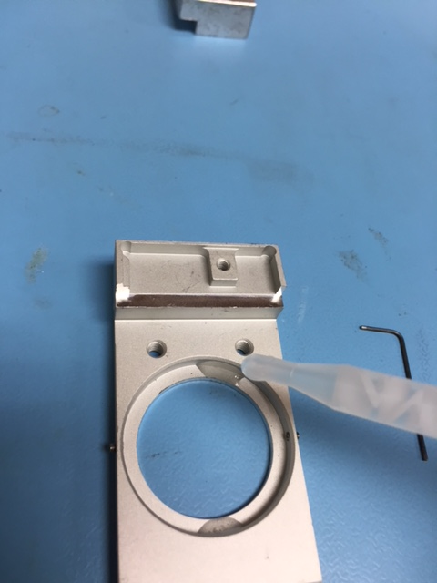
p.3
-Slide the light source into place, minding the fiber optics, Place Alignment tool into position against the flat on the source. Move/rotate the source slightly to align the flat surface. Gently tighten both set screws. The screws hold the source in position and allow positive grounding to the mount plate.
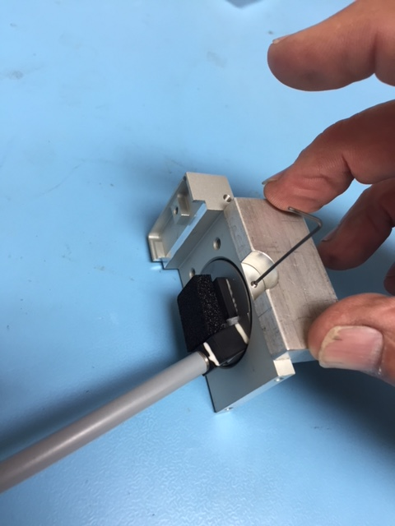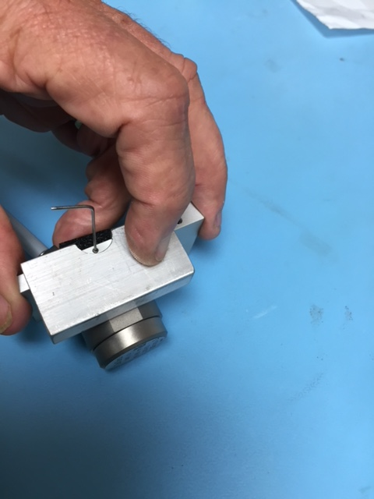

-Check for proper alignment of ass’y, Move ass’y to curing/storage rack. This is a good place to store most supplies.
