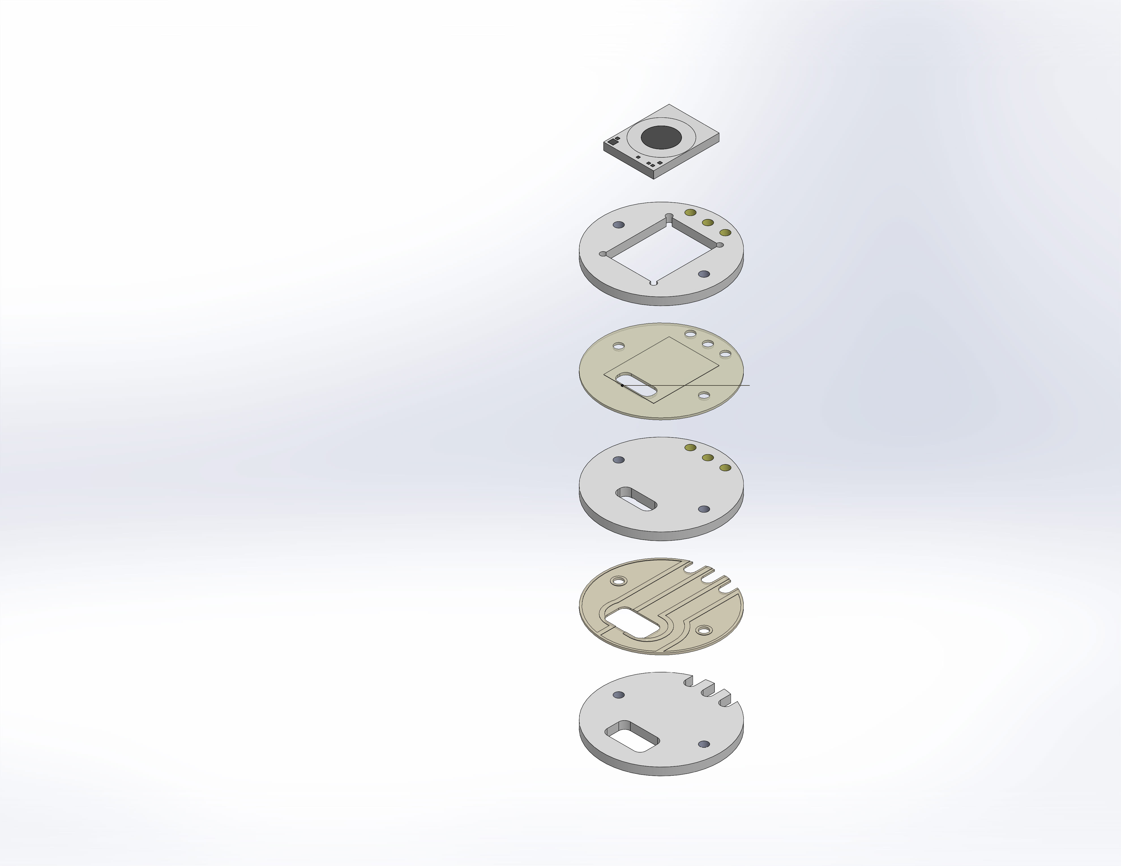
  Simulation of DFassy
  Date: Wednesday, July 13, 2016
  Designer: Solidworks
  Study name: Static 1
  Analysis type: Static
  Table of Contents
  Description 1
  Assumptions 2
  Model Information 2
  Study Properties 4
  Units 4
  Material Properties 5
  Loads and Fixtures 6
  Connector Definitions 6
  Contact Information 7
  Mesh information 8
  Resultant Forces 8
  Study Results 9
  Conclusion 38
  Appendix 38

Description
No Data

Assumptions

Model Information

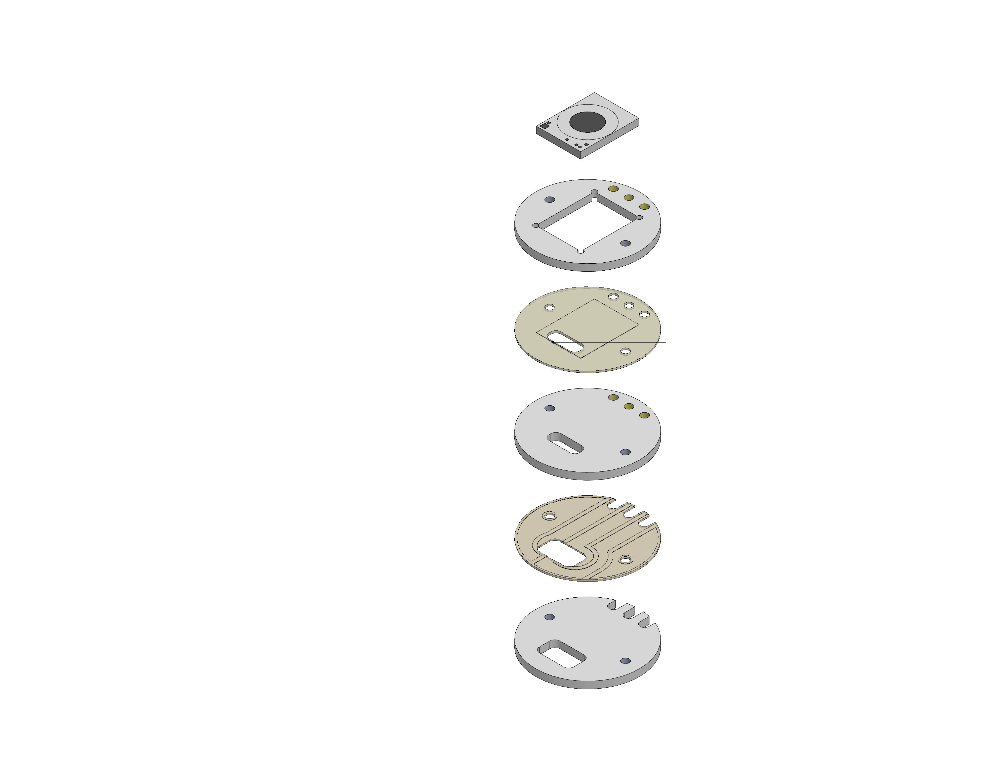
Model name: DFassy
Current Configuration: FullAssy
Solid Bodies
Document Name and Reference | Treated As | Volumetric Properties | Document Path/Date Modified
Cut-Extrude8  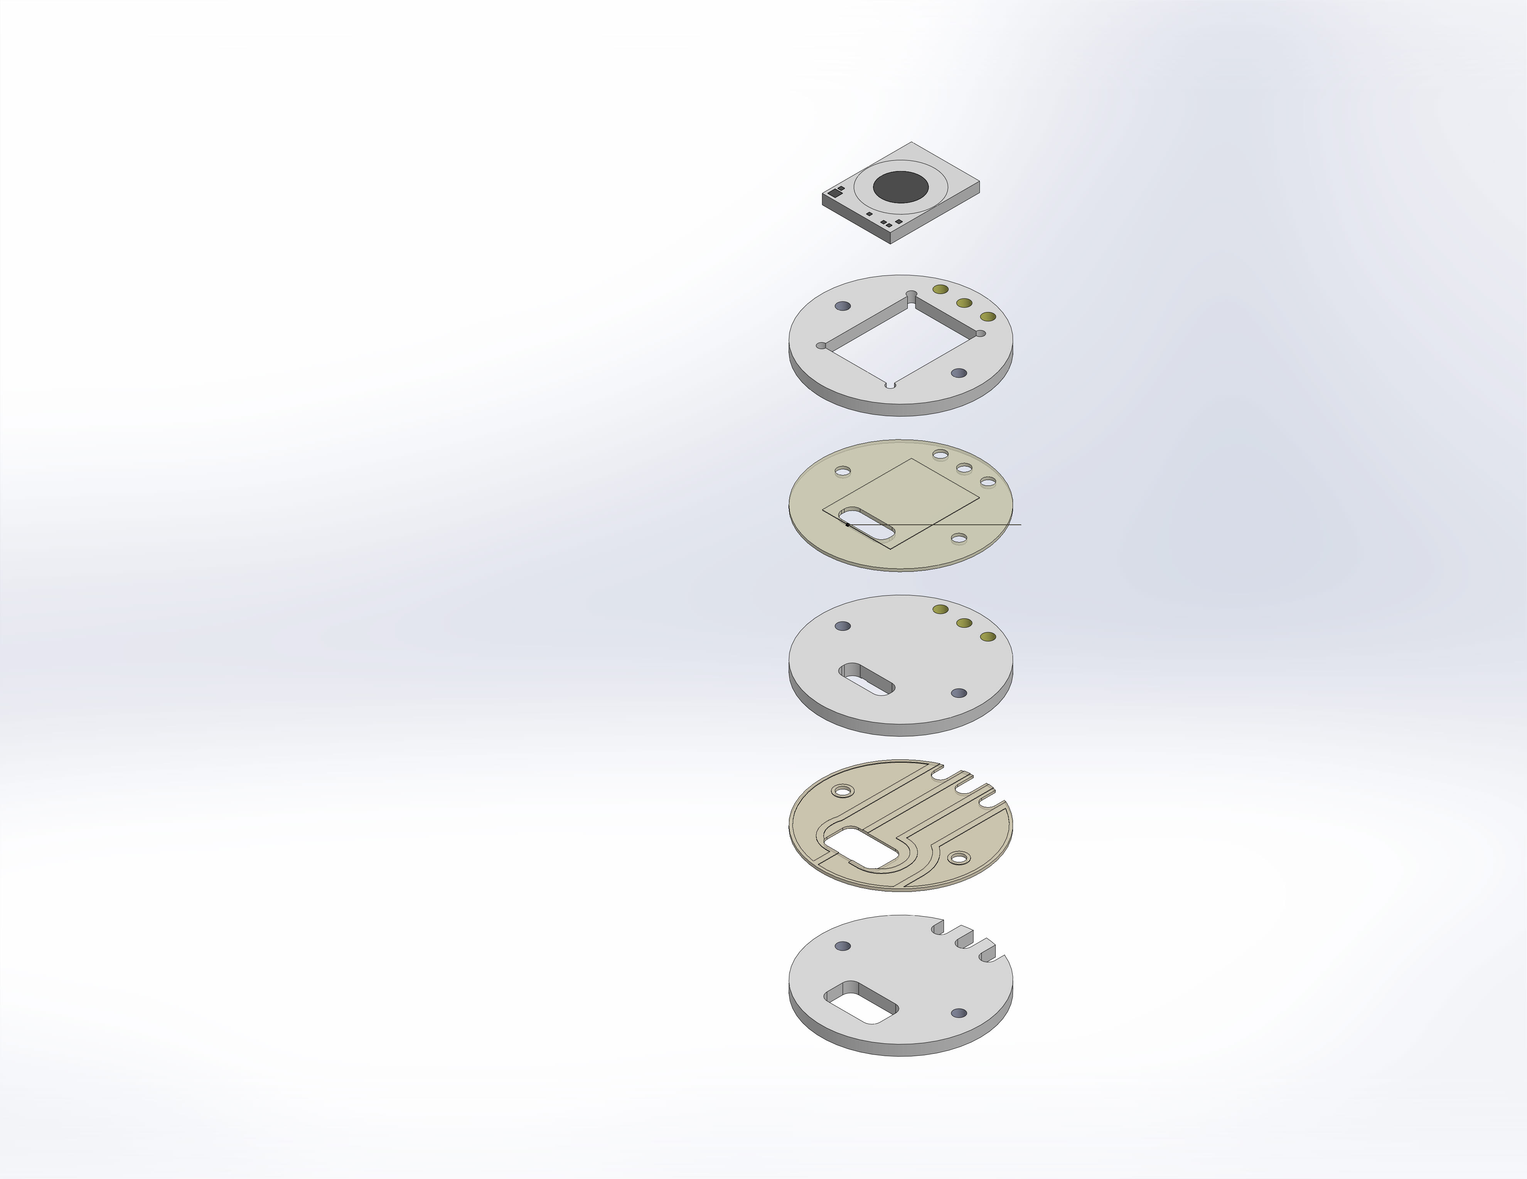 | Solid Body | Mass:0.000124513 lb  Volume:0.000926478 in^3  Density:0.134394 lb/in^3  Weight:0.000124428 lbf | C:\Users\jon\Desktop\Temp_DuraFet\DurFETpcb.SLDPRT  Jun 29 12:27:50 2016
Cut-Extrude7 | Solid Body | Mass:0.000184119 lb  Volume:0.00137 in^3  Density:0.134394 lb/in^3  Weight:0.000183994 lbf | C:\Users\jon\Desktop\Temp_DuraFet\DurFETpcb.SLDPRT  Jun 29 12:27:50 2016
BottomWires | Solid Body | Mass:0.000165465 lb  Volume:0.0012312 in^3  Density:0.134394 lb/in^3  Weight:0.000165352 lbf | C:\Users\jon\Desktop\Temp_DuraFet\DurFETpcb.SLDPRT  Jun 29 12:27:50 2016
Cut-Extrude1 | Solid Body | Mass:1.08693e-005 lb  Volume:0.000261545 in^3  Density:0.041558 lb/in^3  Weight:1.08619e-005 lbf | C:\Users\jon\Desktop\Temp_DuraFet\Epoxy_Bottom.SLDPRT  Jun 30 17:31:57 2016
Boss-Extrude2 | Solid Body | Mass:1.44967e-005 lb  Volume:0.00034883 in^3  Density:0.041558 lb/in^3  Weight:1.44869e-005 lbf | C:\Users\jon\Desktop\Temp_DuraFet\Epoxy_Middle.SLDPRT  Jul 06 12:23:37 2016
Split Line1 | Solid Body | Mass:3.41024e-005 lb  Volume:0.00040513 in^3  Density:0.0841766 lb/in^3  Weight:3.40793e-005 lbf | C:\Users\jon\Desktop\Temp_DuraFet\ISFET Die.SLDPRT  Jul 06 12:27:00 2016

Study Properties
Study name | Static 1
Analysis type | Static
Mesh type | Solid Mesh
Thermal Effect: | On
Thermal option | Include temperature loads
Zero strain temperature | 298 Kelvin
Include fluid pressure effects from SOLIDWORKS Flow Simulation | Off
Solver type | FFEPlus
Inplane Effect: | Off
Soft Spring: | Off
Inertial Relief: | Off
Incompatible bonding options | Automatic
Large displacement | Off
Compute free body forces | On
Friction | Off
Use Adaptive Method: | Off
Result folder | SOLIDWORKS document (C:\Users\jon\Desktop\Temp_DuraFet)

Units
Unit system: | English (IPS)
Length/Displacement | in
Temperature | Fahrenheit
Angular velocity | Hertz
Pressure/Stress | psi

Material Properties
Model Reference | Properties | Components
 |  | SolidBody 1(Cut-Extrude8)(DurFETpcb-1),  SolidBody 1(Cut-Extrude7)(DurFETpcb-2),  SolidBody 1(BottomWires)(DurFETpcb-3)
  Name: | CoorsTek AD-96
  Model type: | Linear Elastic Isotropic
  Default failure criterion: | Unknown
  Tensile strength: | 32053.3 psi
  Compressive strength: | 299938 psi
  Elastic modulus: | 4.4e+007 psi
  Poisson's ratio: | 0.21
  Mass density: | 0.134394 lb/in^3
  Thermal expansion coefficient: | 4.44444e-006 /Fahrenheit
Curve Data:N/A
 |  | SolidBody 1(Cut-Extrude1)(Epoxy_Bottom-1),  SolidBody 1(Boss-Extrude2)(Epoxy_Middle-1)
  Name: | 3M_2214_Non-Filled Epoxy
  Model type: | Linear Elastic Isotropic
  Default failure criterion: | Unknown
  Tensile strength: | 9000 psi
  Elastic modulus: | 700000 psi
  Poisson's ratio: | 0.394
  Mass density: | 0.041558 lb/in^3
  Shear modulus: | 46252.5 psi
  Thermal expansion coefficient: | 0.00013 /Fahrenheit
Curve Data:N/A
 |  | SolidBody 1(Split Line1)(ISFET Die-1)
  Name: | Silicon
  Model type: | Linear Elastic Isotropic
  Default failure criterion: | Unknown
  Yield strength: | 17404.5 psi
  Elastic modulus: | 1.63022e+007 psi
  Poisson's ratio: | 0.28
  Mass density: | 0.0841766 lb/in^3
  Shear modulus: | 7.10685e+006 psi
Curve Data:N/A

Loads and Fixtures
Fixture name | Fixture Image | Fixture Details
Fixed-1 | 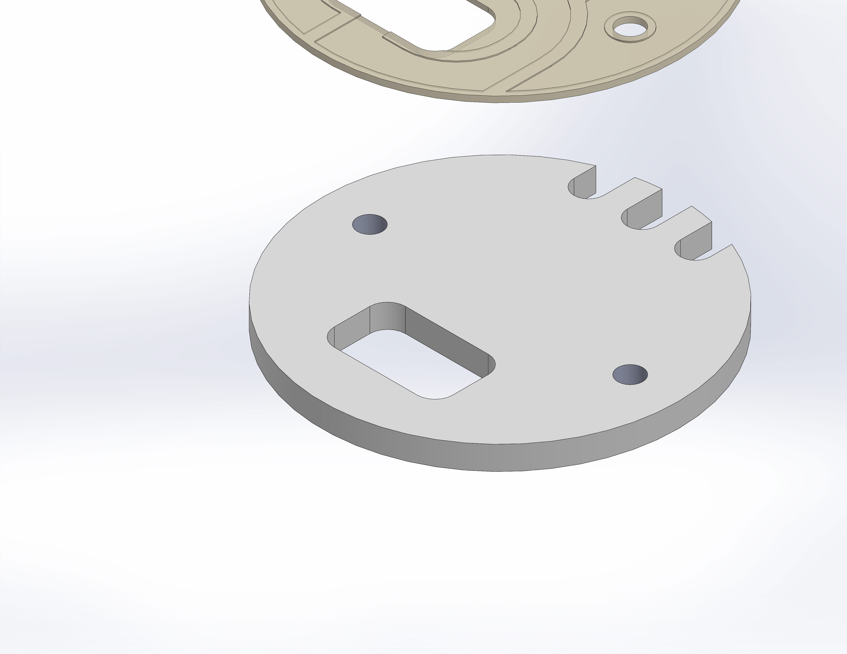
  Entities: | 1 face(s)
  Type: | Fixed Geometry
Resultant Forces
Components | X | Y | Z | Resultant
Reaction force(lbf) | -8.52237e-005 | 204.378 | -0.000174896 | 204.378
Reaction Moment(lbf.in) | 0 | 0 | 0 | 0

Load name | Load Image | Load Details
Pressure-1 | 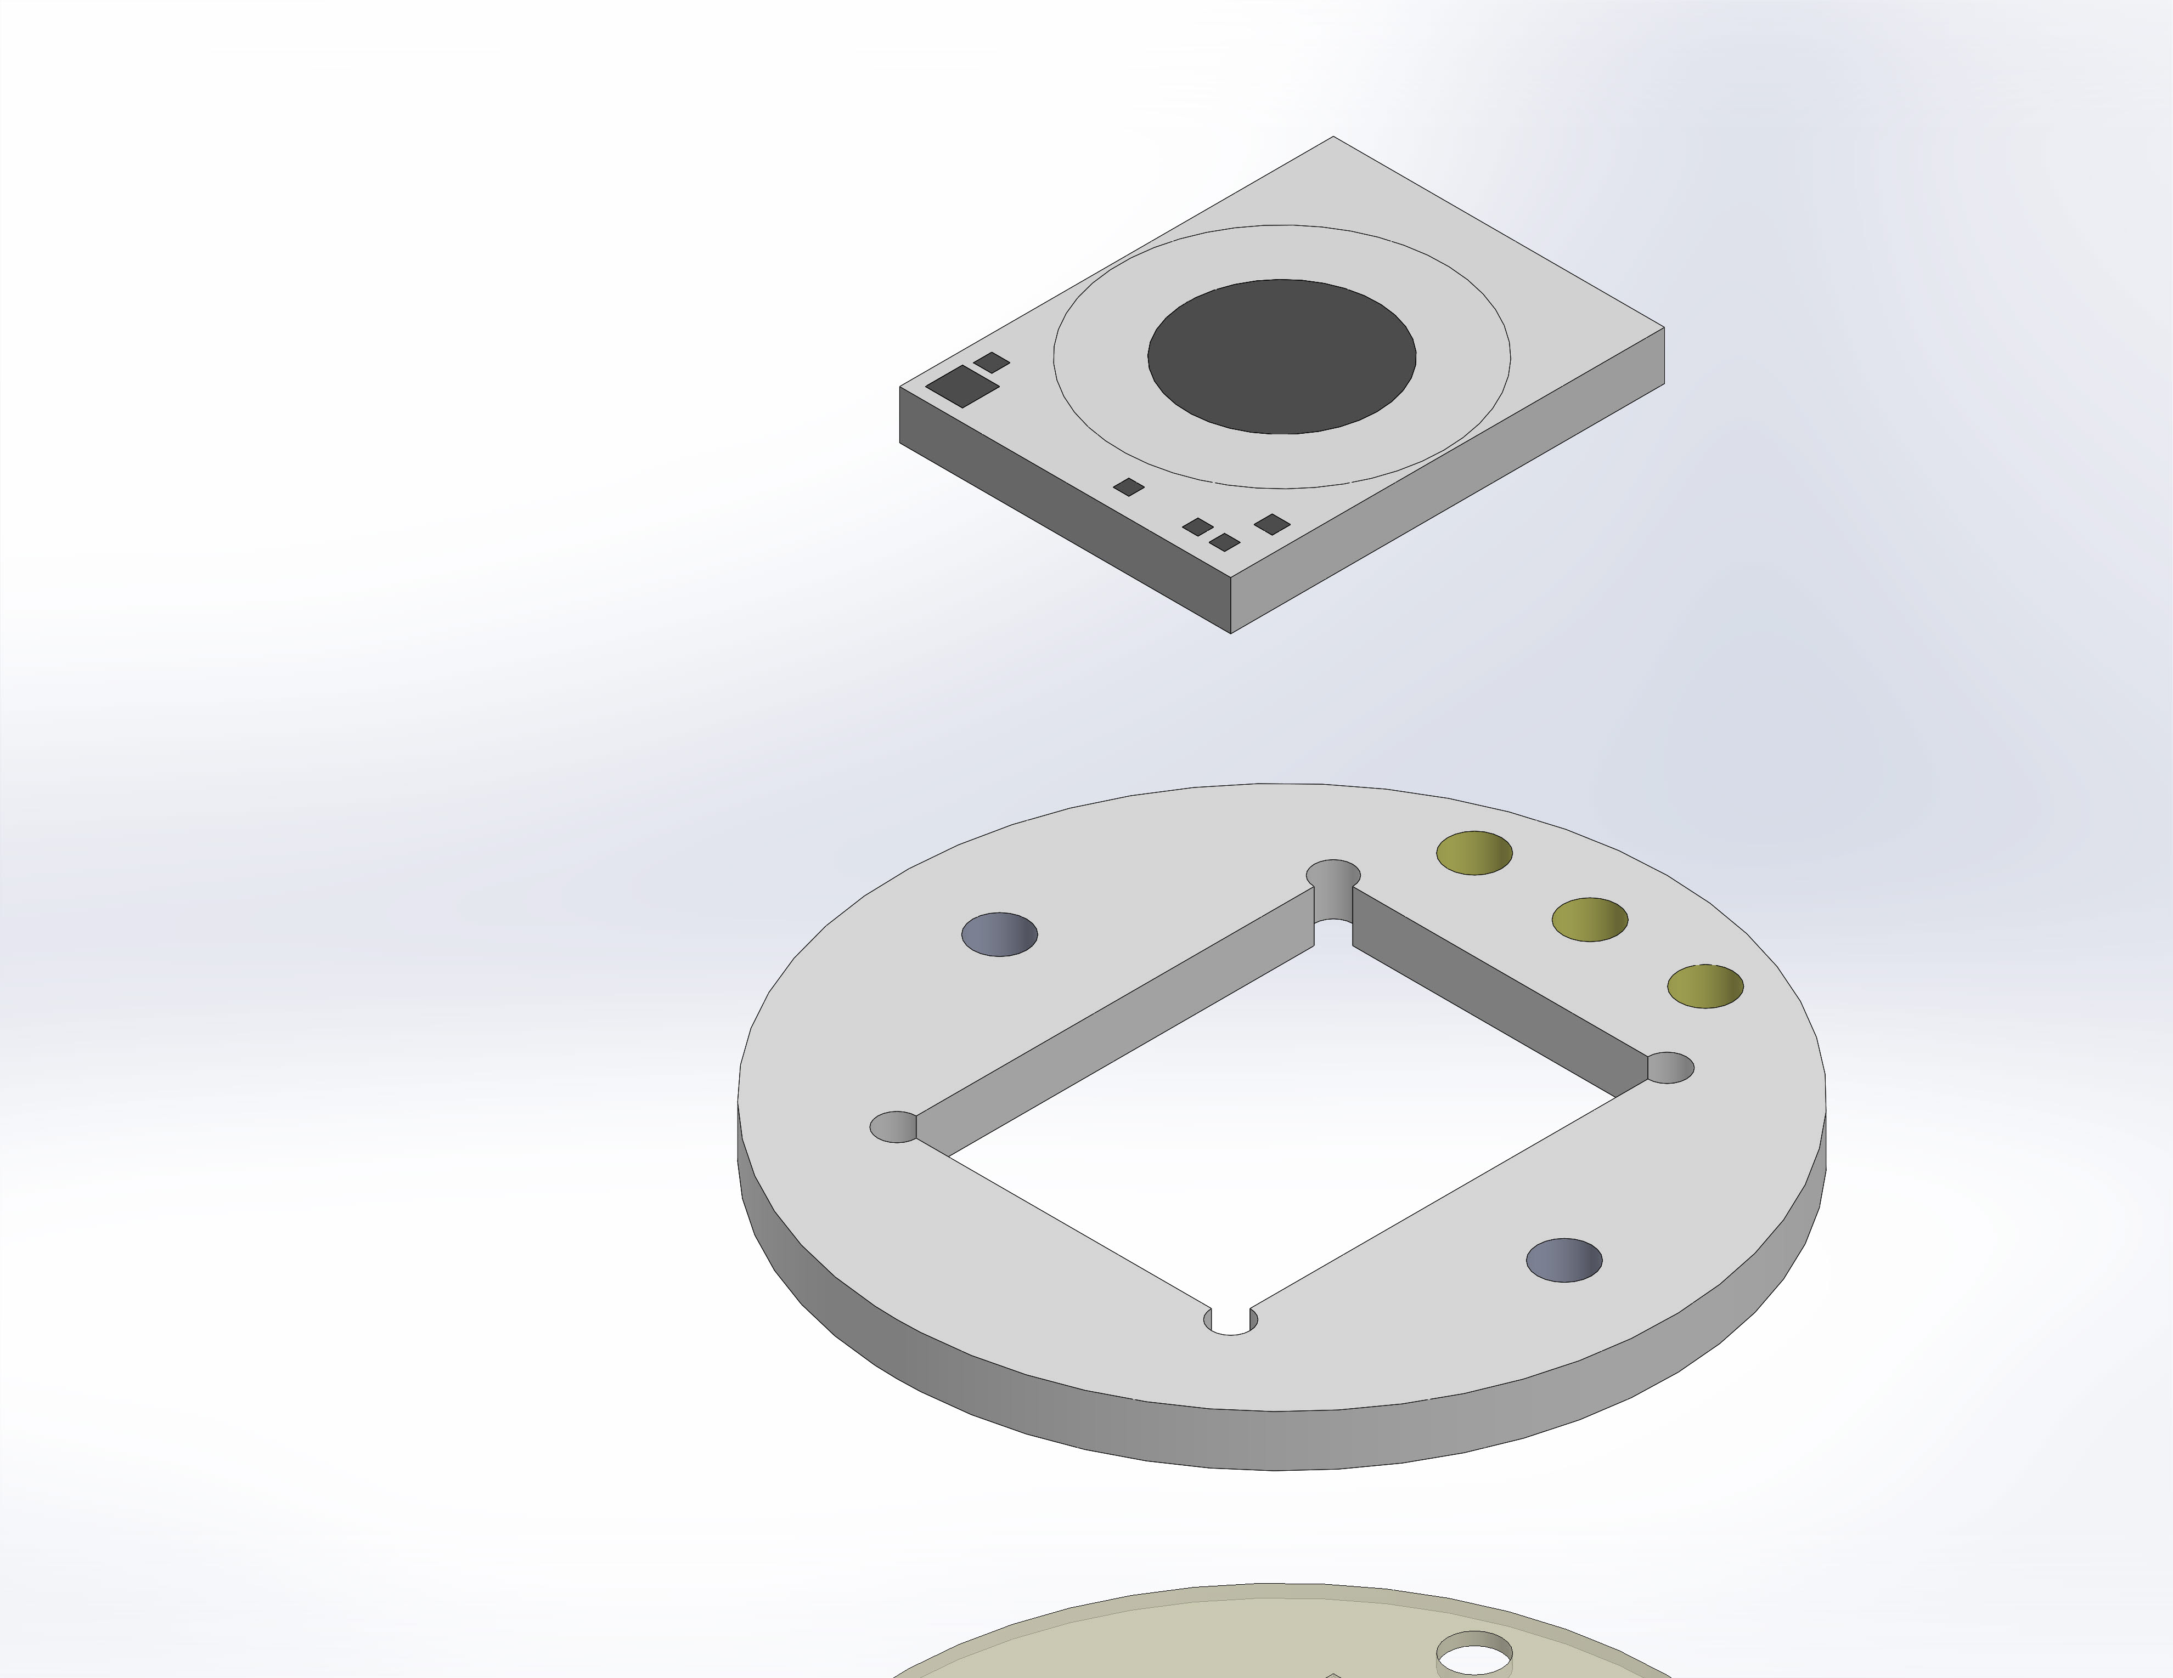
  Entities: | 10 face(s)
  Type: | Normal to selected face
  Value: | 3000
  Units: | psi
  Phase Angle: | 0
  Units: | deg

Connector Definitions
No Data

Contact Information

Contact | Contact Image | Contact Properties
Contact Set-1 | 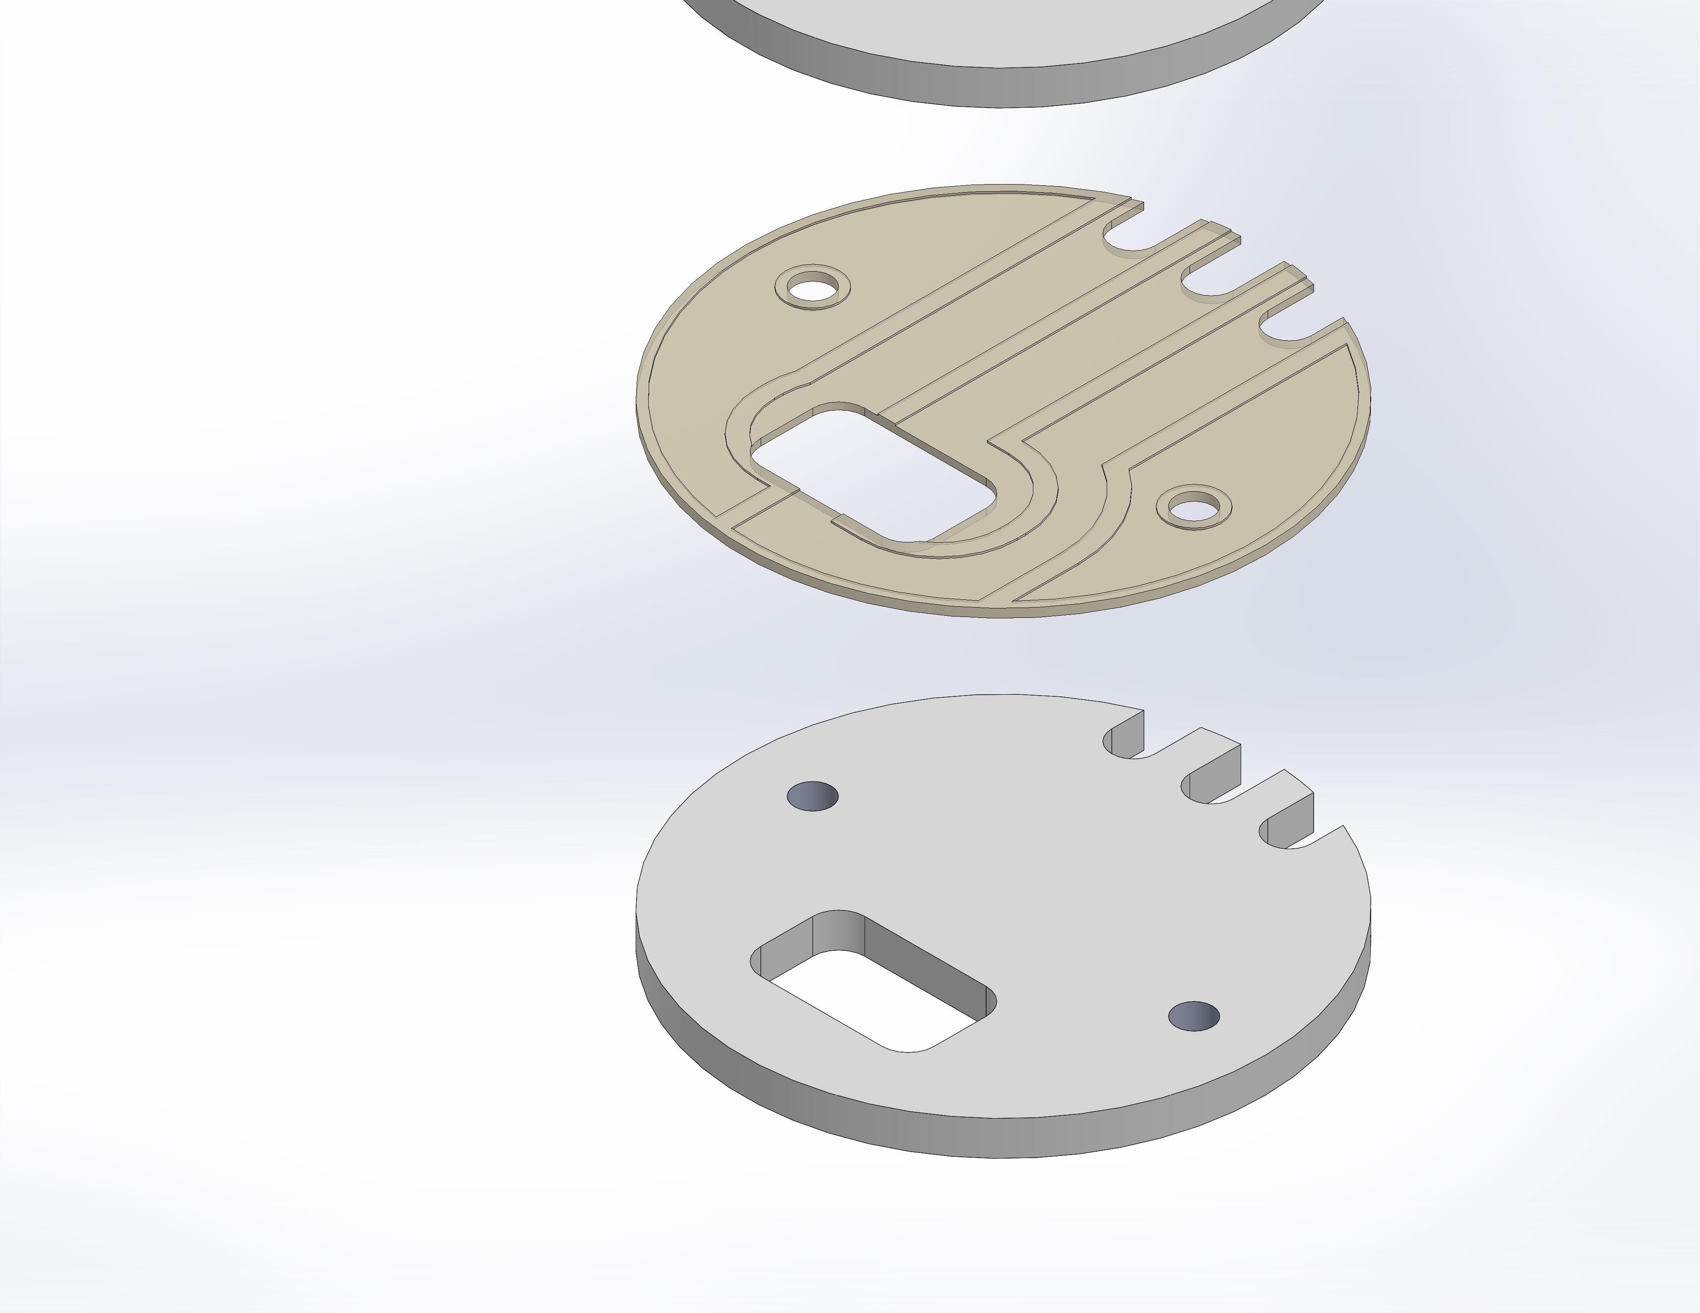
  Type: | Bonded contact pair
  Entites: | 2 face(s)
Contact Set-2 | 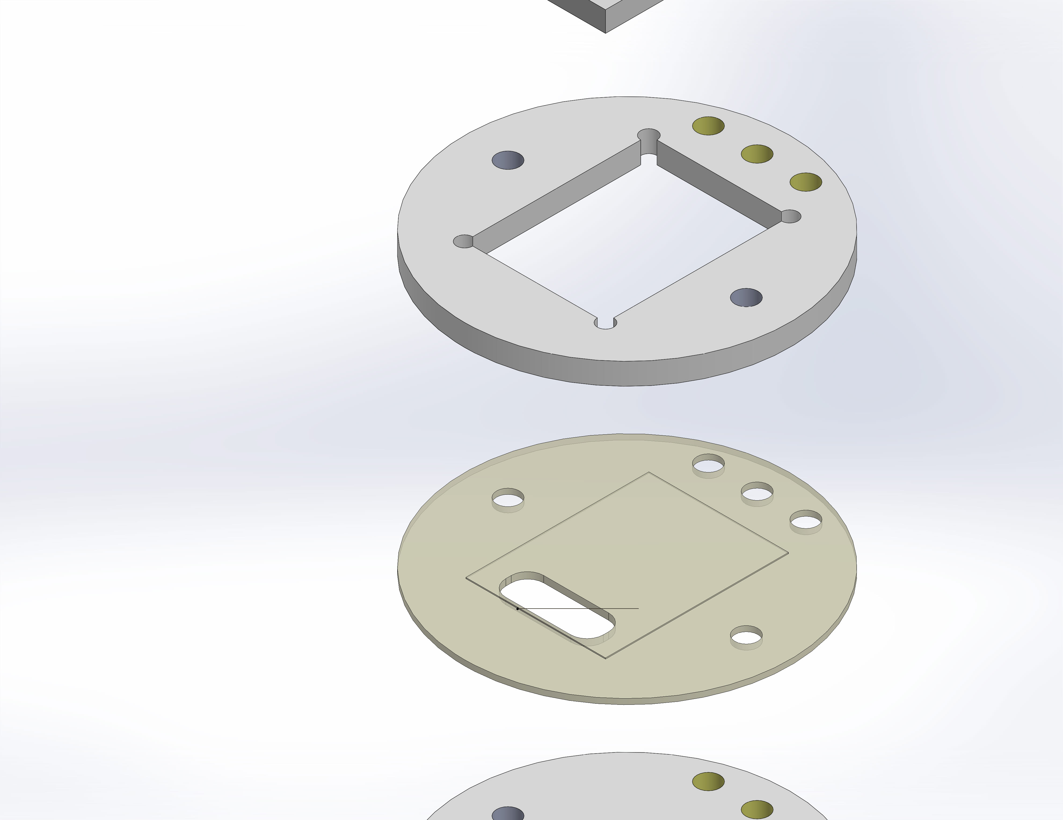
  Type: | Bonded contact pair
  Entites: | 2 face(s)
Global Contact | 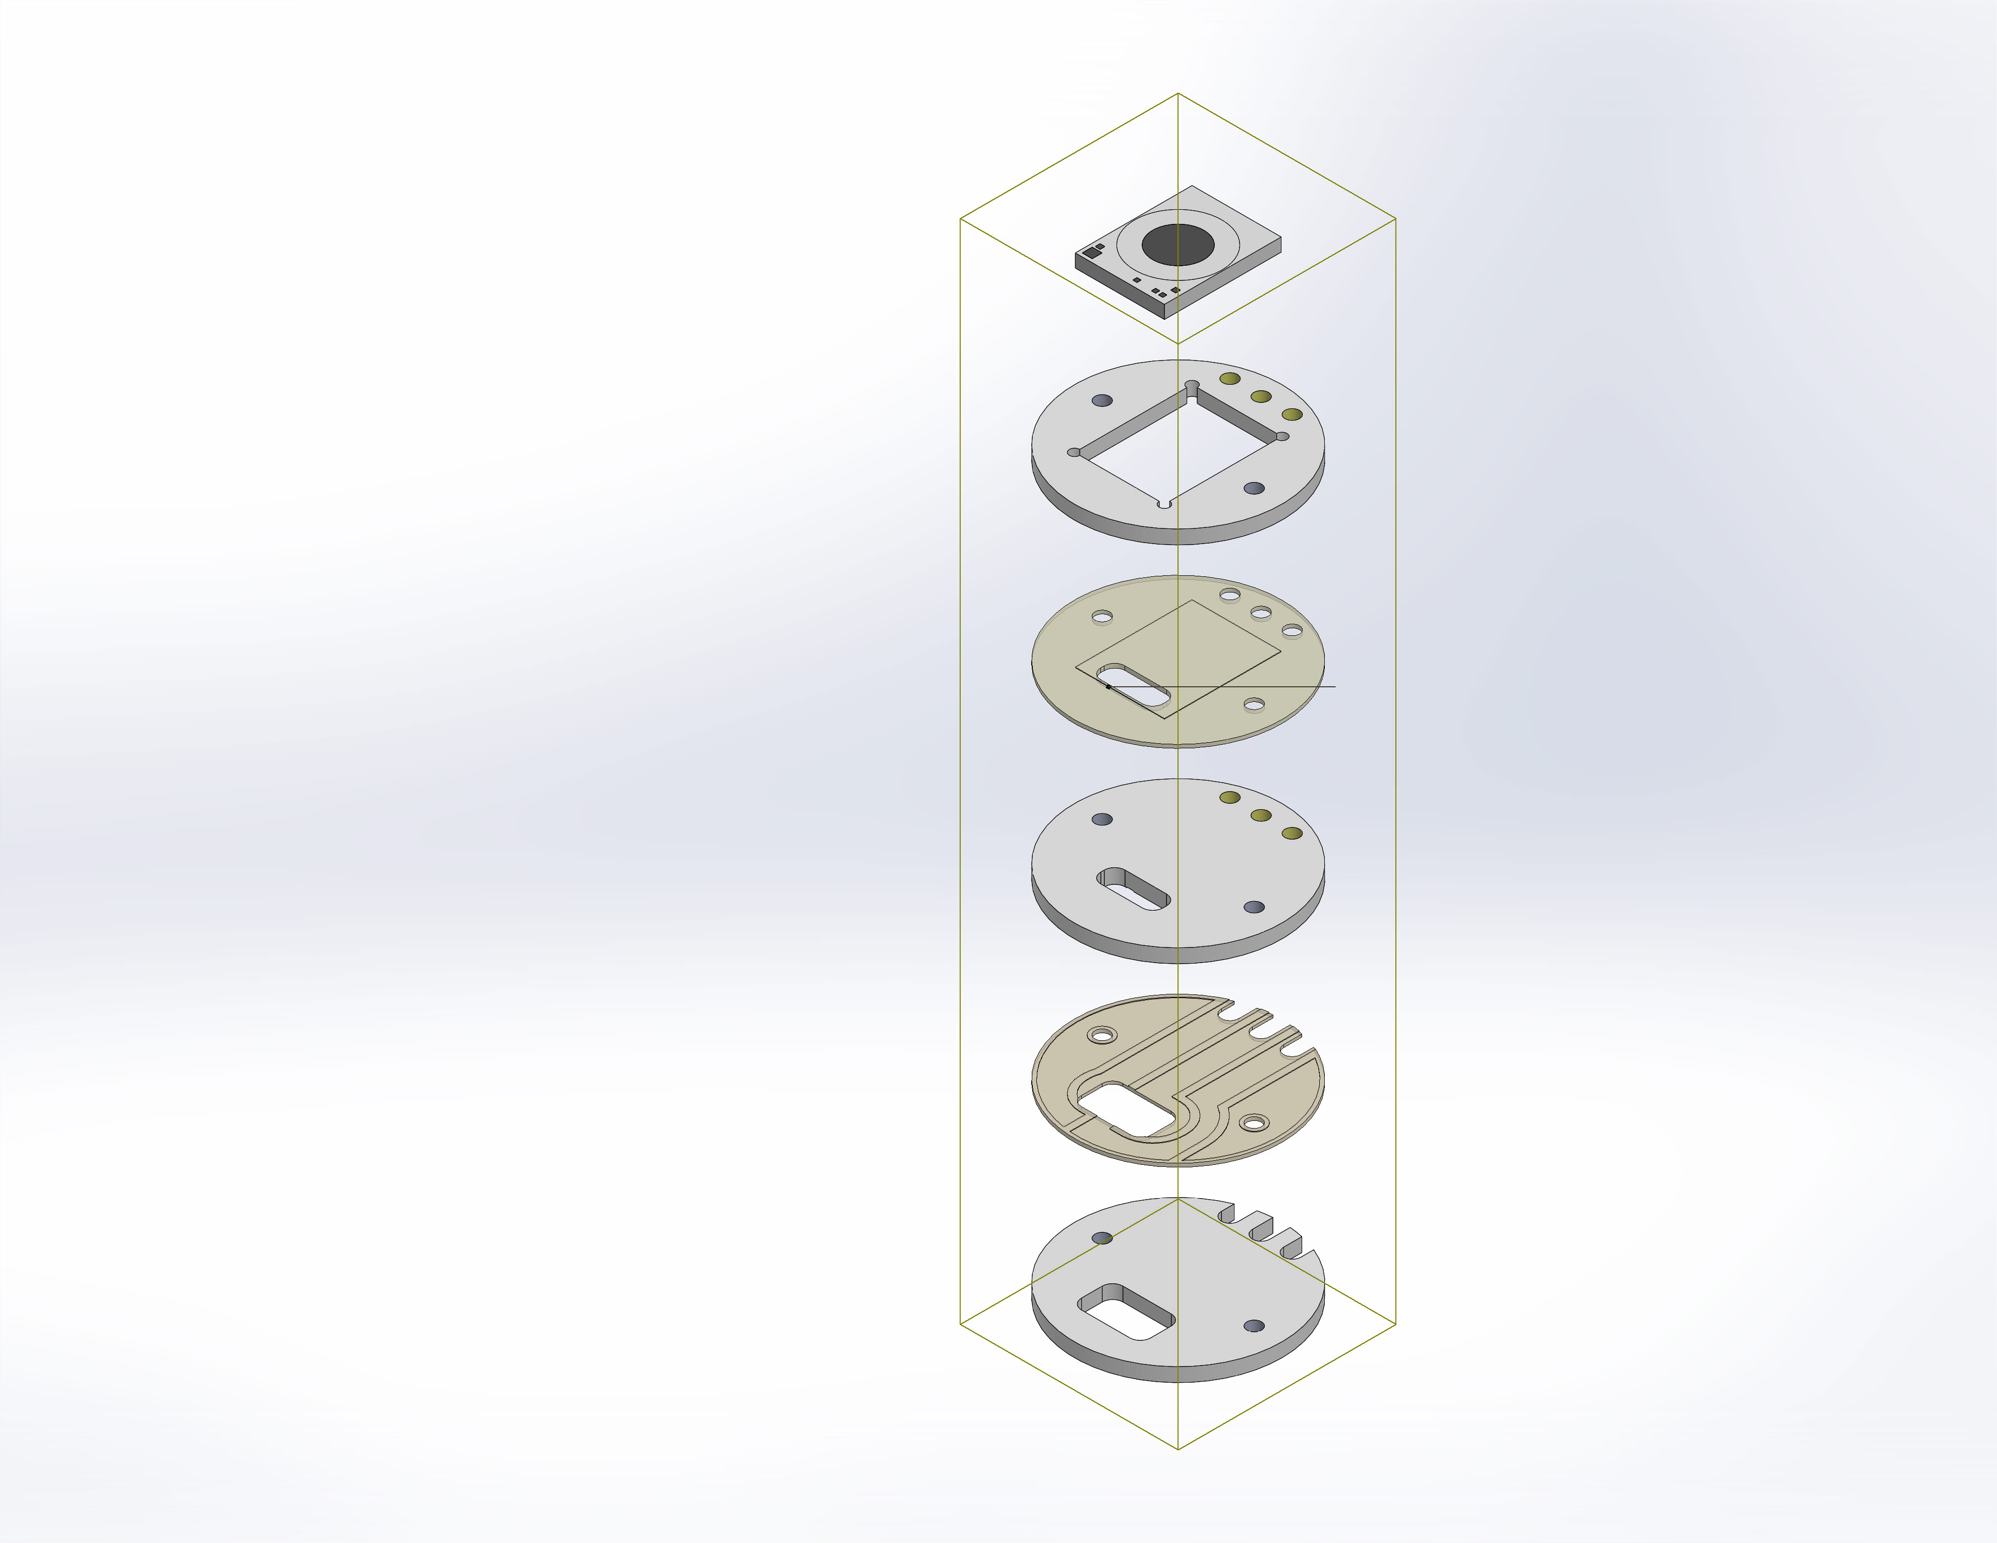
  Type: | Bonded
  Components: | 1 component(s)
  Options: | Compatible mesh

Mesh information
Mesh type | Solid Mesh
Mesher Used: | Standard mesh
Automatic Transition: | Off
Include Mesh Auto Loops: | Off
Jacobian points | 4 Points
Element Size | 0.008 in
Tolerance | 0.0004 in
Mesh Quality | High

Resultant Forces

Reaction forces
Selection set | Units | Sum X | Sum Y | Sum Z | Resultant
Entire Model | lbf | -8.52237e-005 | 204.378 | -0.000174896 | 204.378

Reaction Moments
Selection set | Units | Sum X | Sum Y | Sum Z | Resultant
Entire Model | lbf.in | 0 | 0 | 0 | 0

Study Results

Name | Type | Min | Max
Stress1 | VON: von Mises Stress | 0 psi  Node: 1789604 | 26038.1 psi  Node: 2402830
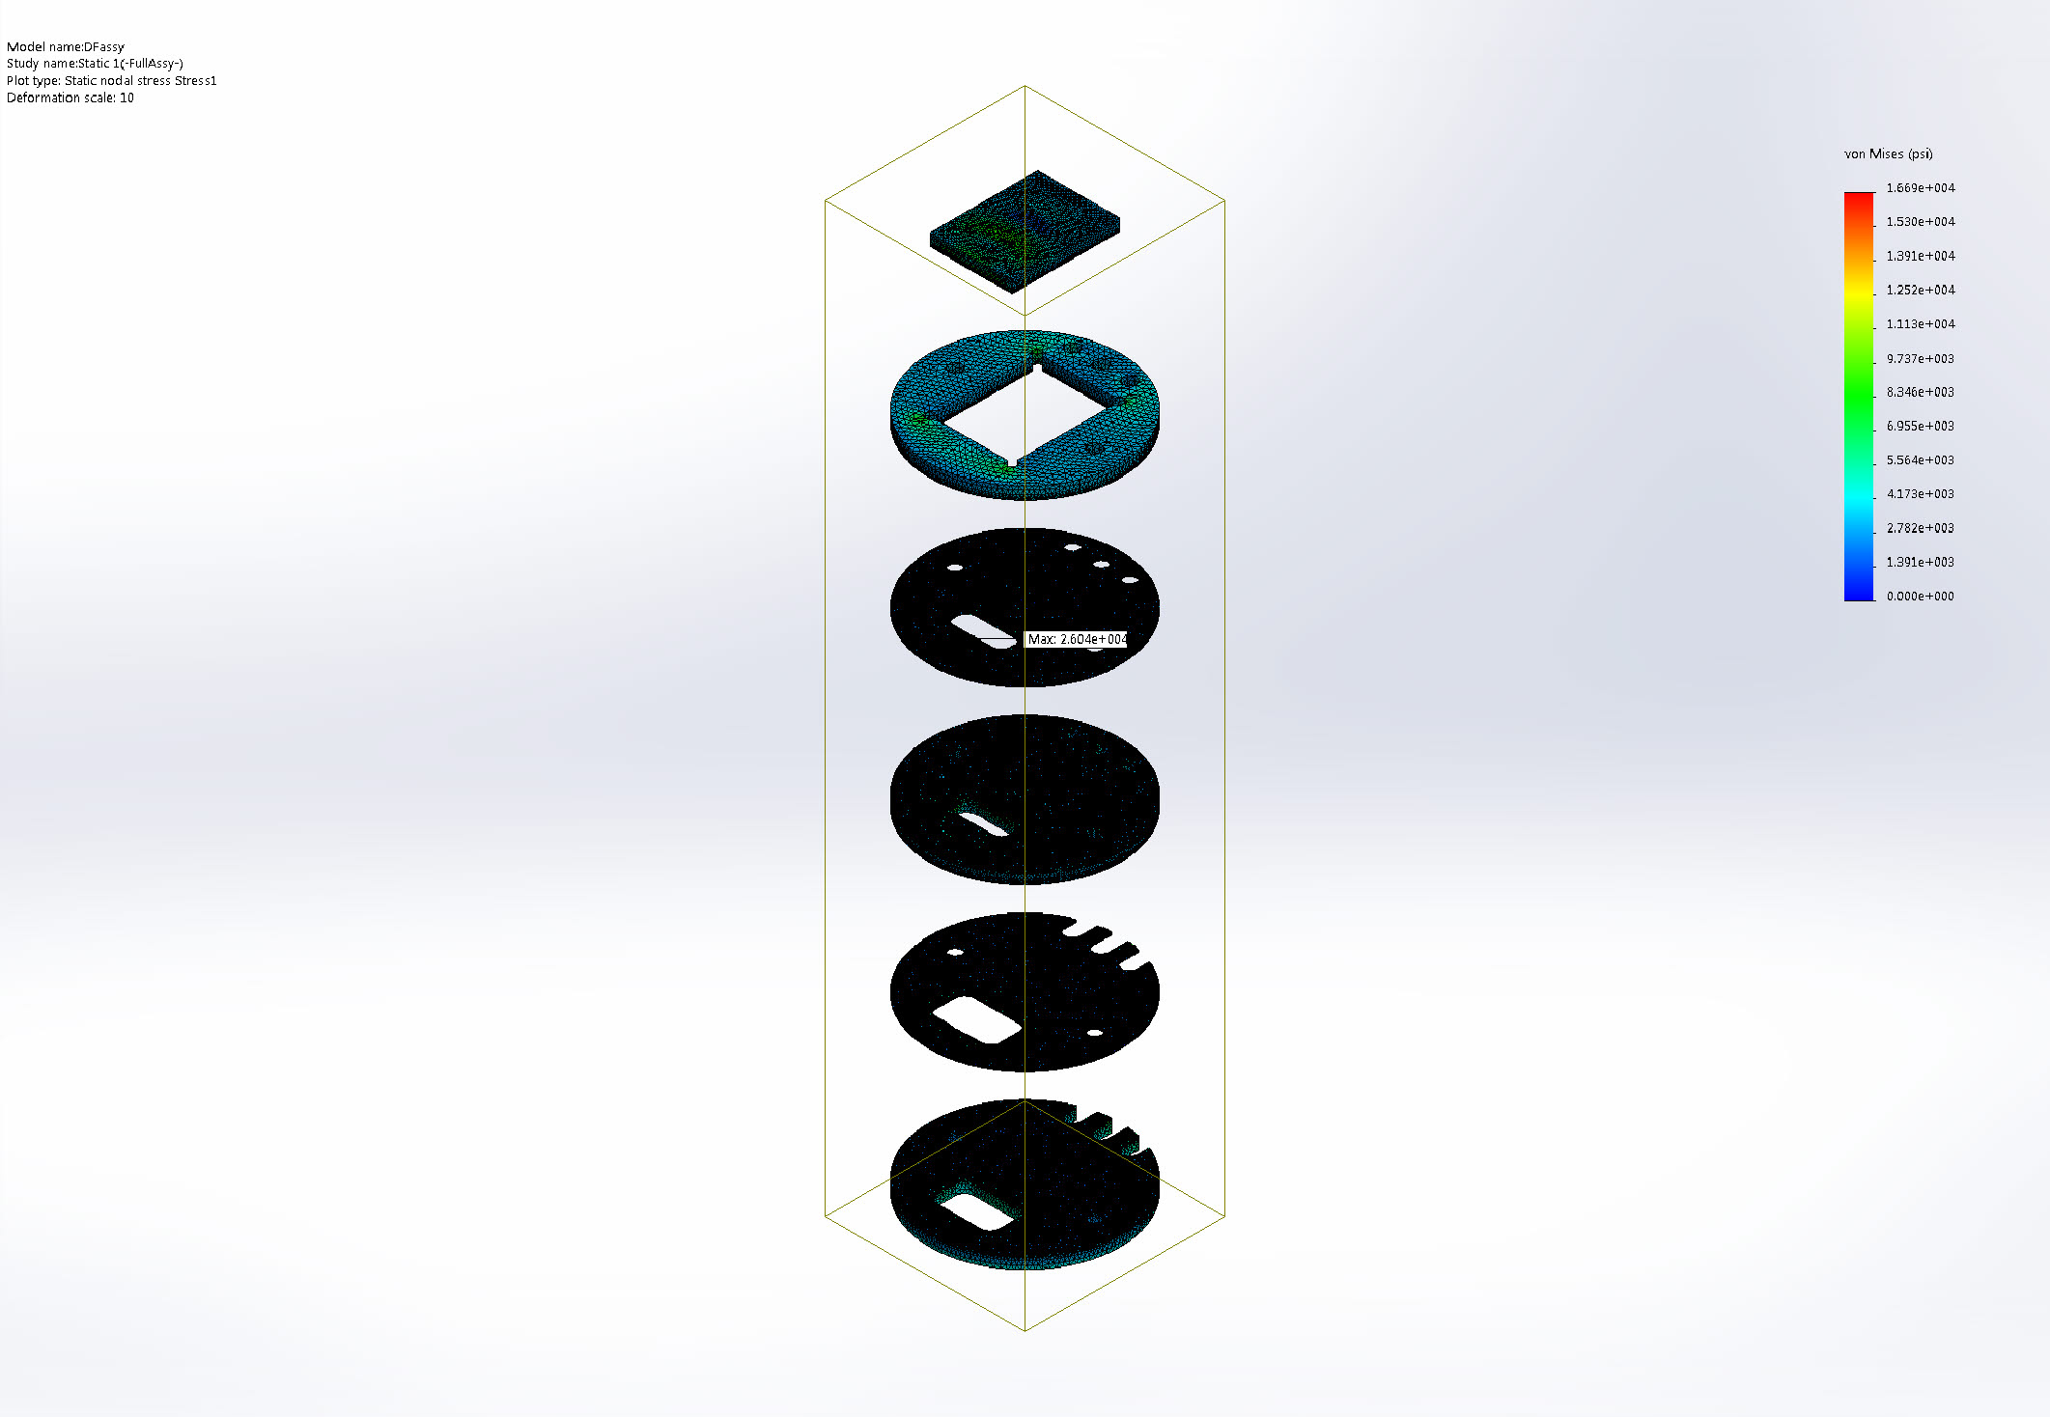
DFassy-Static 1-Stress-Stress1

Name | Type | Min | Max
Stress2 | VON: von Mises Stress | 0 psi  Node: 1789604 | 26038.1 psi  Node: 2402830
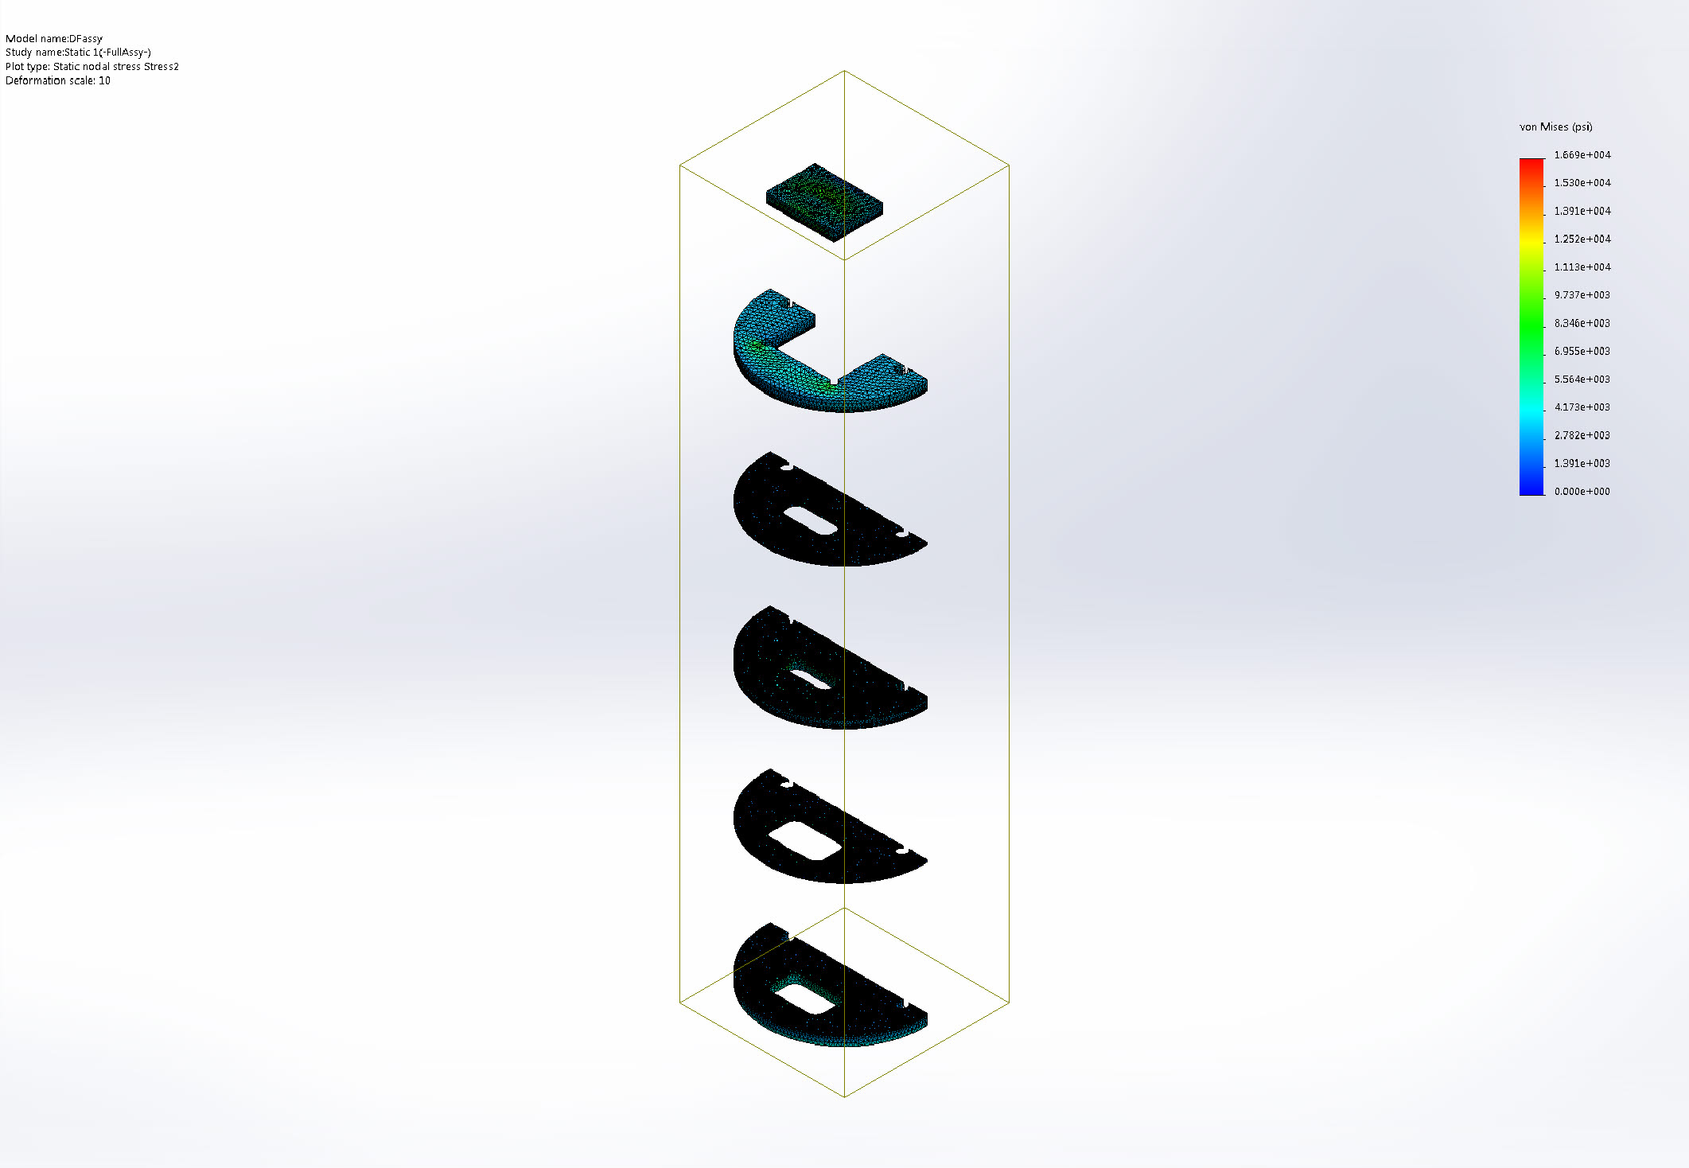
DFassy-Static 1-Stress-Stress2

Name | Type | Min | Max
Stress3 | VON: von Mises Stress | 0 psi  Node: 1789604 | 26038.1 psi  Node: 2402830
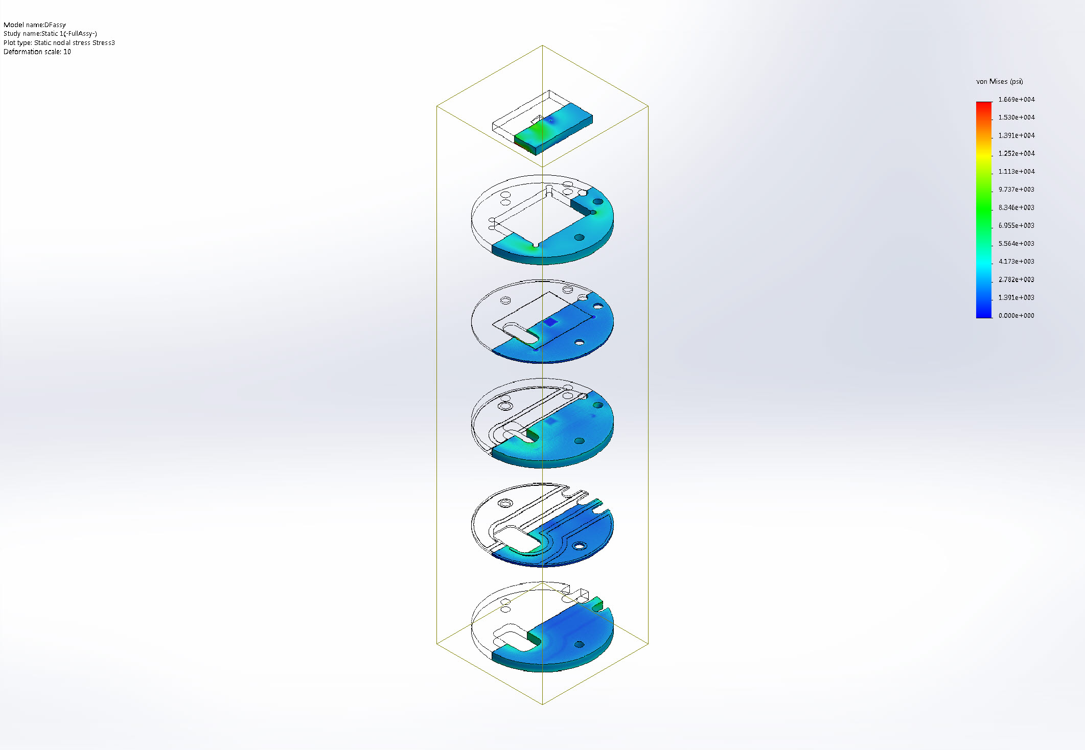
DFassy-Static 1-Stress-Stress3

Name | Type | Min | Max
Stress4 | VON: von Mises Stress | 0 psi  Node: 1789604 | 26038.1 psi  Node: 2402830
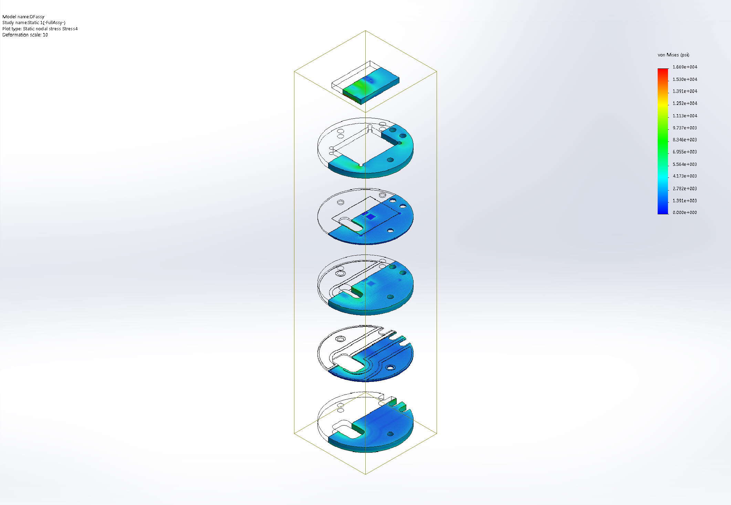
DFassy-Static 1-Stress-Stress4

Name | Type | Min | Max
Displacement1 | URES: Resultant Displacement | 0 in  Node: 1515005 | 0.000122687 in  Node: 2524983
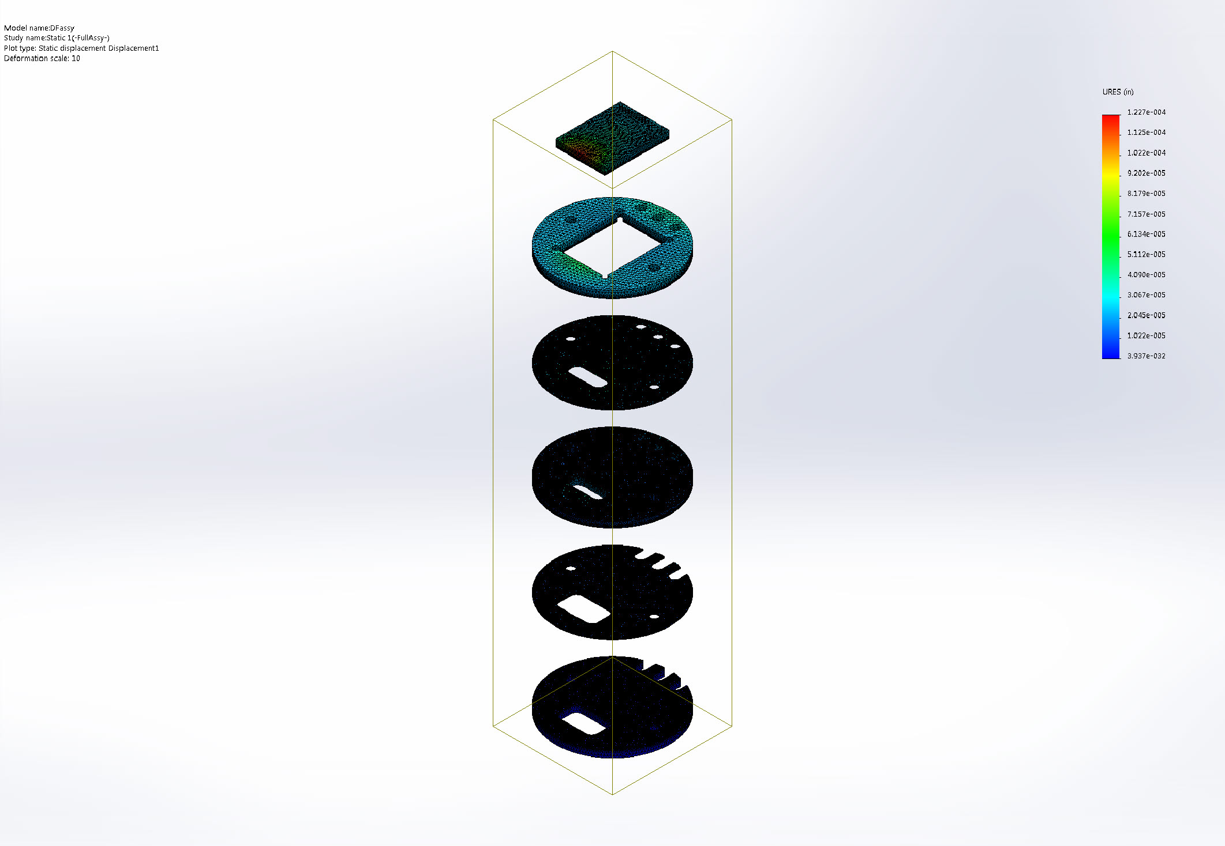
DFassy-Static 1-Displacement-Displacement1

Name | Type | Min | Max
Displacement2 | UY: Y Displacement | -0.000120886 in  Node: 2524983 | 0 in  Node: 1515005
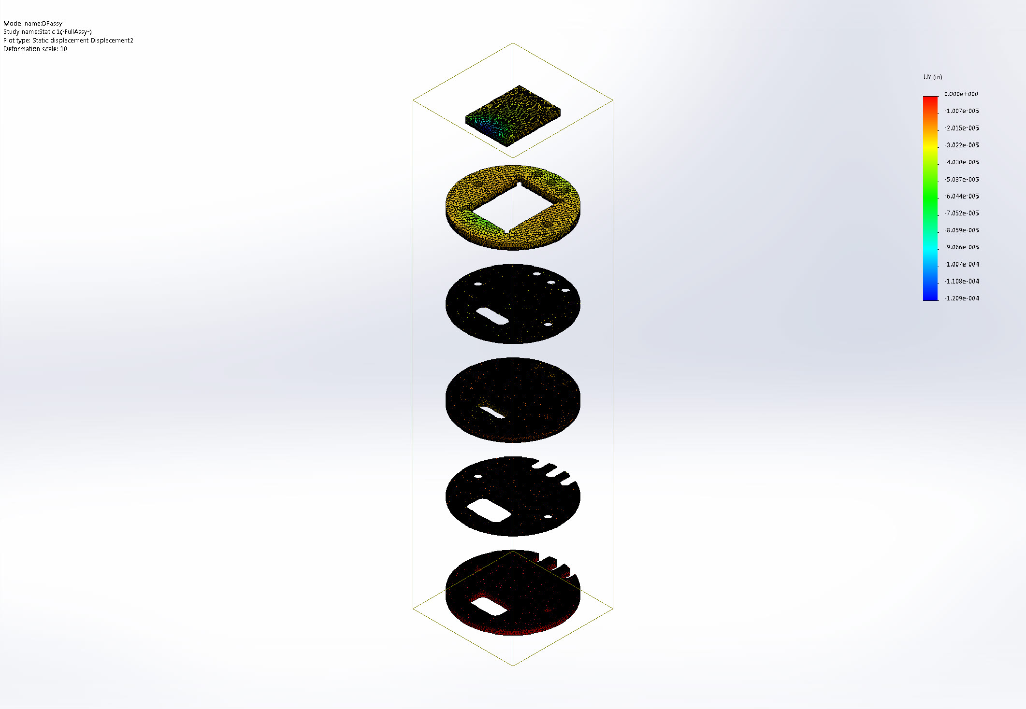
DFassy-Static 1-Displacement-Displacement2

Name | Type | Min | Max
Strain1 | ESTRN: Equivalent Strain | 1.034e-005  Element: 522125 | 0.0324084  Element: 1477912
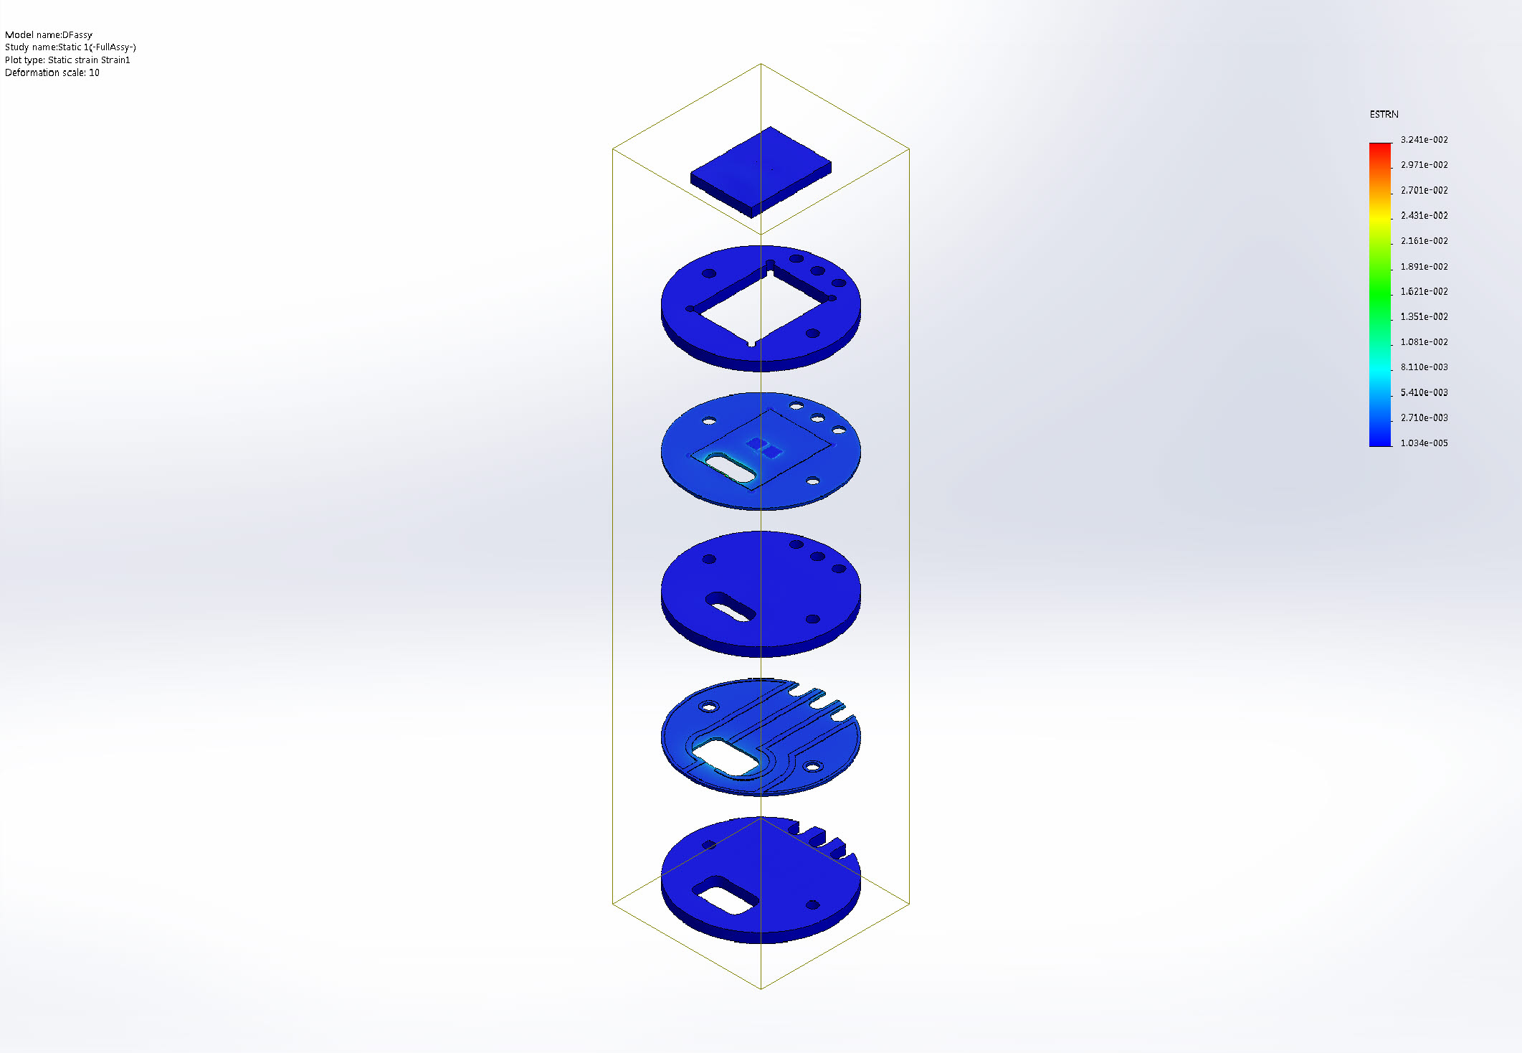
DFassy-Static 1-Strain-Strain1

Name | Type | Min | Max
Stress5 | P1: 1st Principal Stress | -10405.1 psi  Node: 2402826 | 19764.2 psi  Node: 2402734
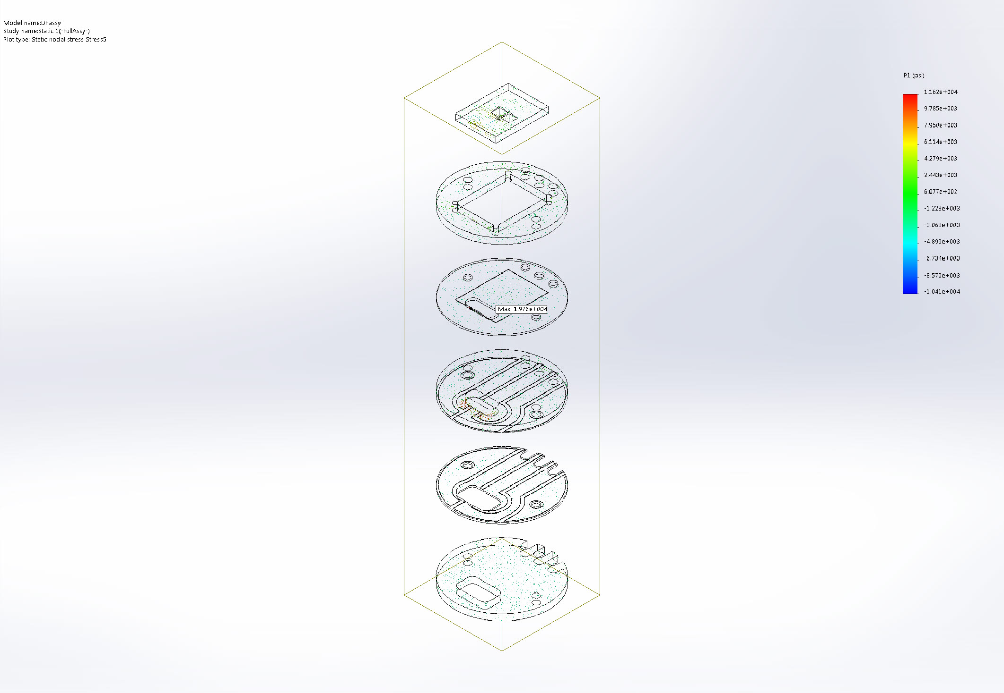
DFassy-Static 1-Stress-Stress5

Name | Type | Min | Max
Stress6 | P2: 2nd Principal Stress | -14534.3 psi  Node: 2402826 | 10288.8 psi  Node: 176737
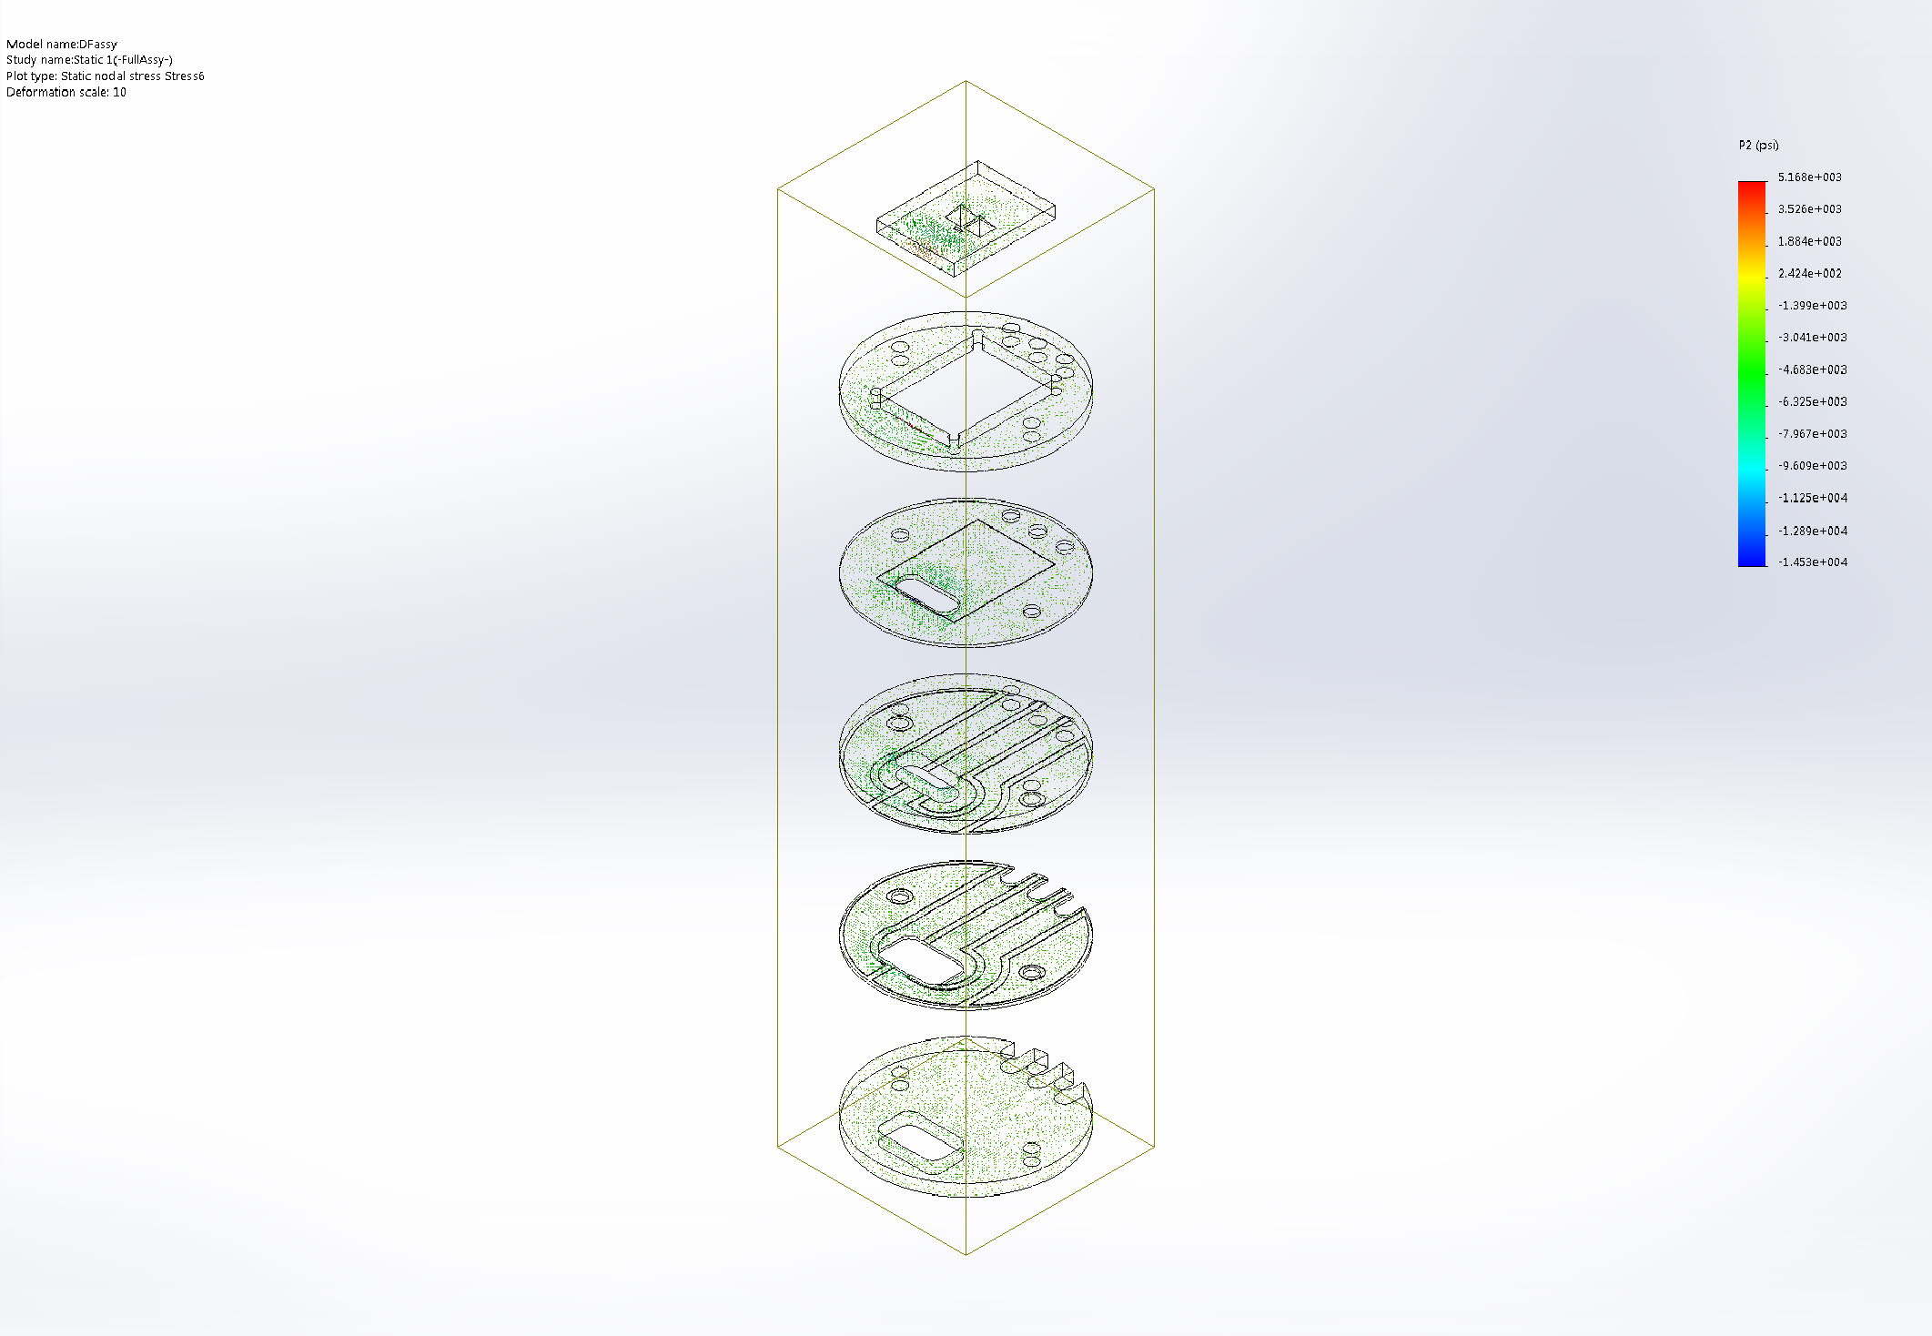
DFassy-Static 1-Stress-Stress6

Name | Type | Min | Max
Stress7 | P3: 3rd Principal Stress | -30736 psi  Node: 2402821 | 3800.56 psi  Node: 176720
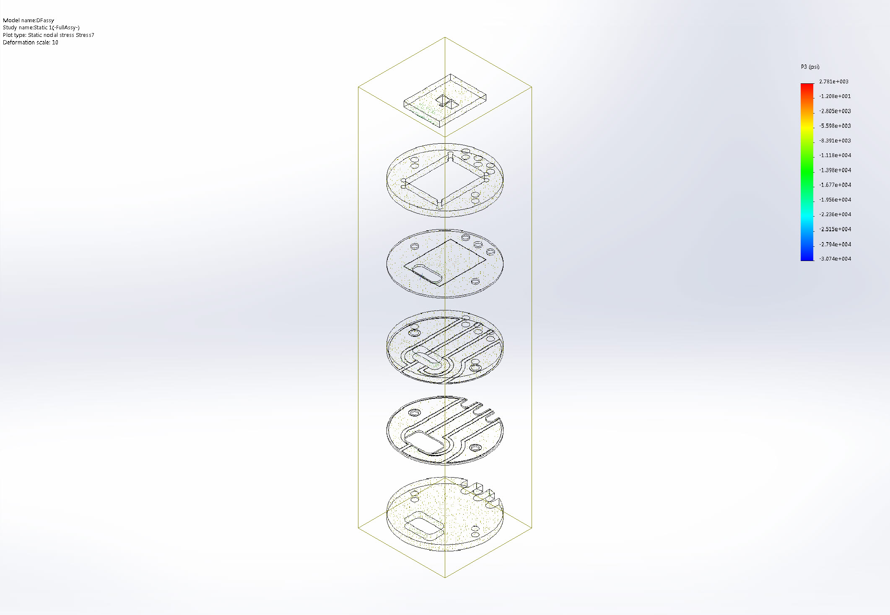
DFassy-Static 1-Stress-Stress7

Name | Type | Min | Max
Stress8 | P1: 1st Principal Stress | -10405.1 psi  Node: 2402826 | 19764.2 psi  Node: 2402734
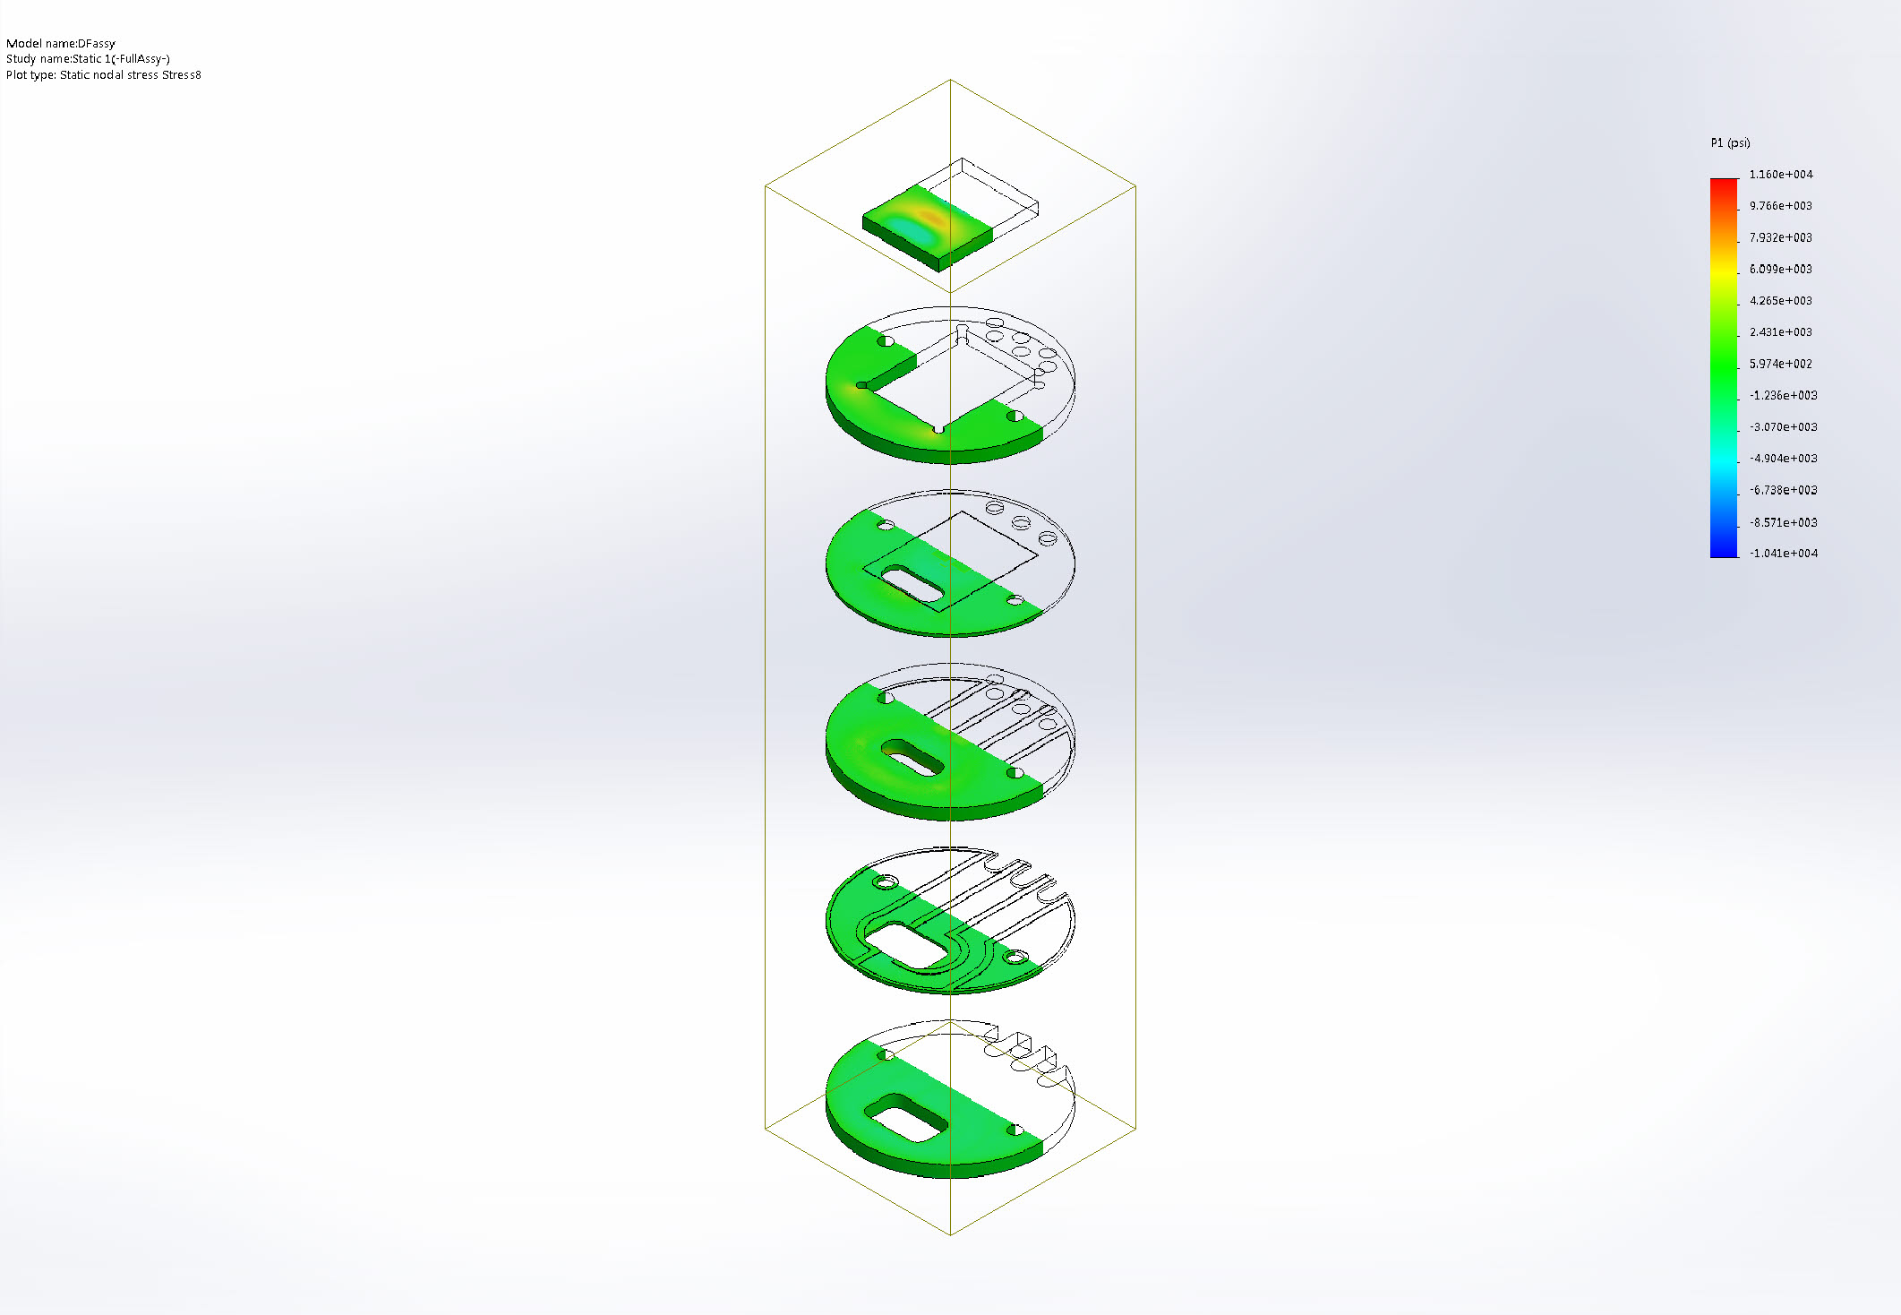
DFassy-Static 1-Stress-Stress8

Name | Type | Min | Max
Stress9 | P1: 1st Principal Stress | -10405.1 psi  Node: 2402826 | 19764.2 psi  Node: 2402734
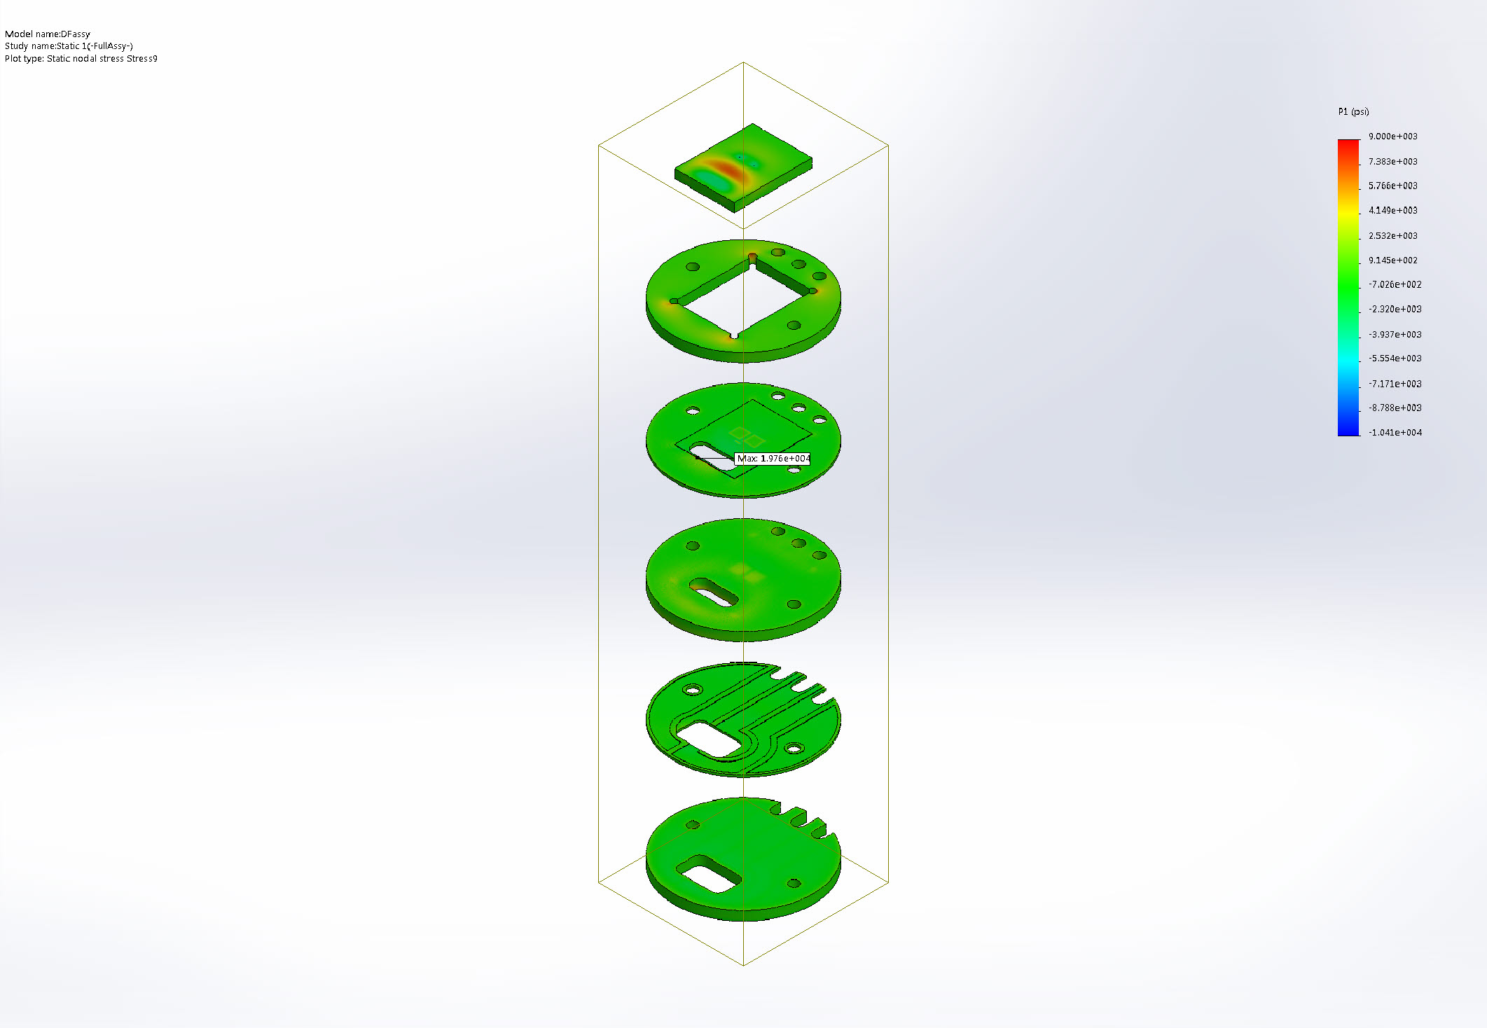
DFassy-Static 1-Stress-Stress9

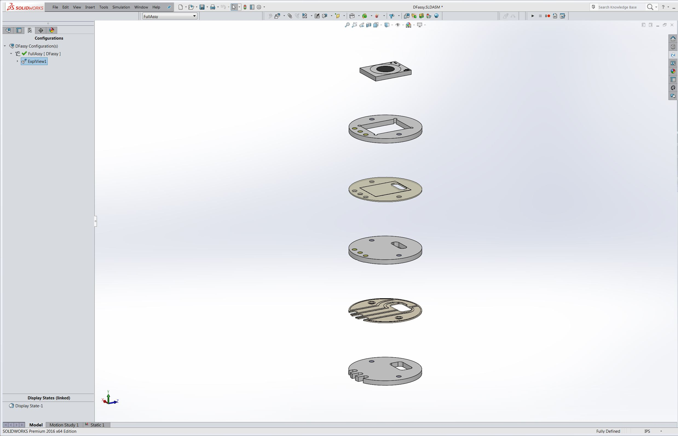
Image-1

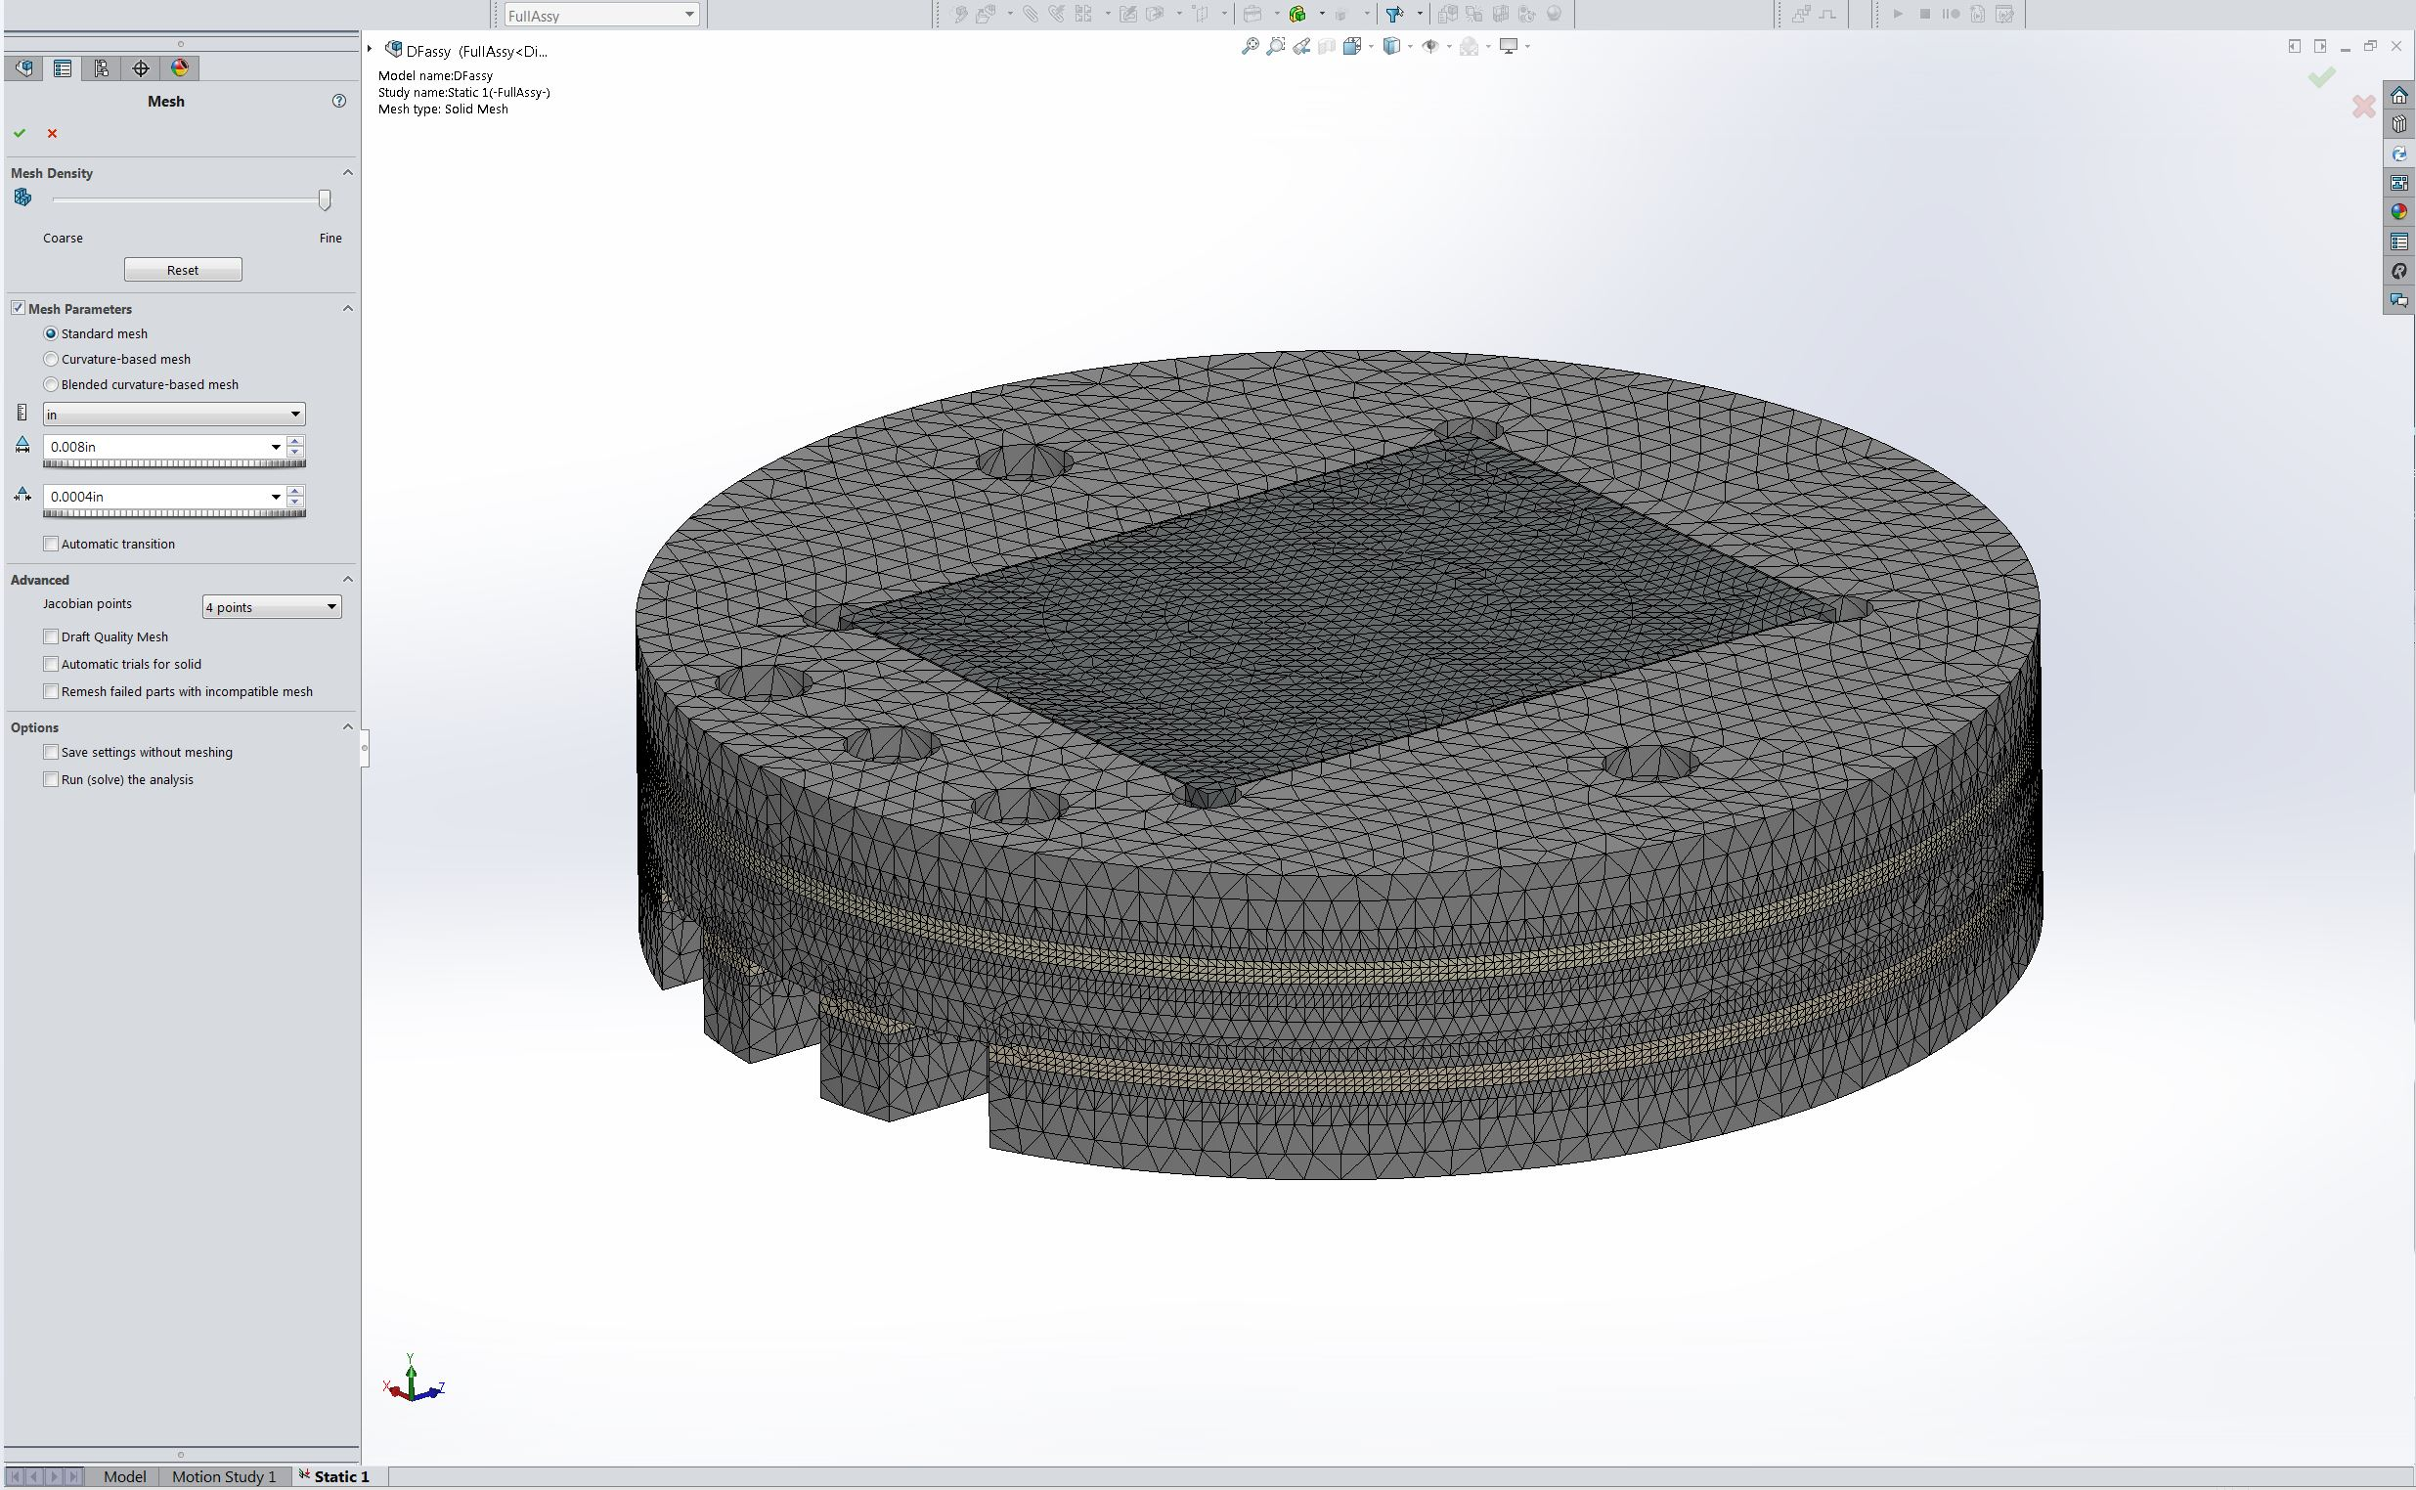
Image-2

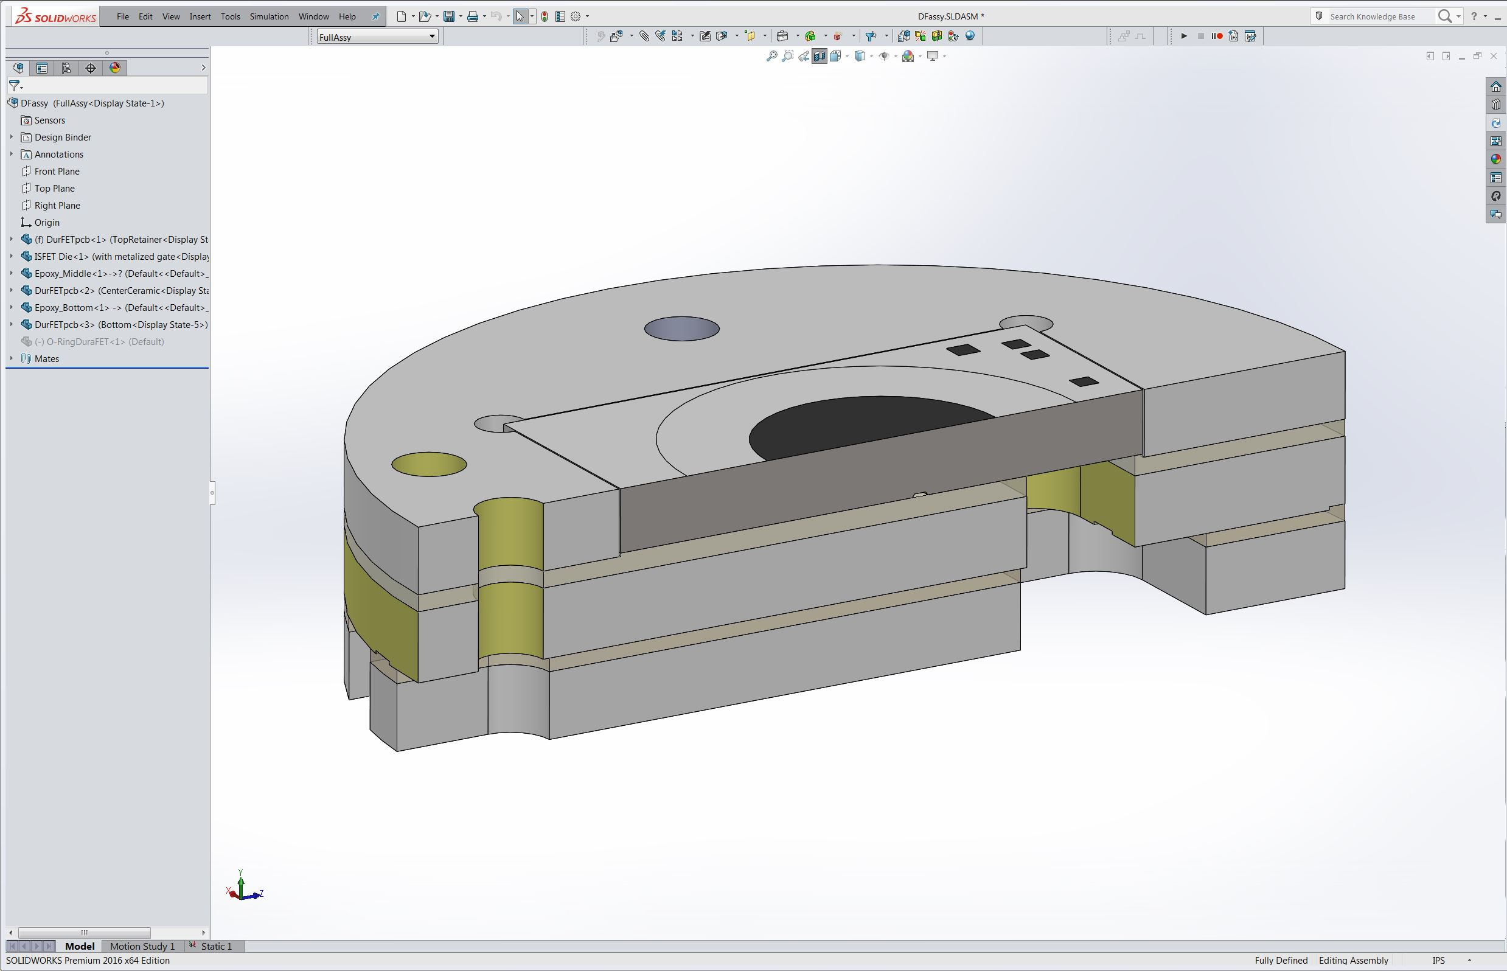
Image-3

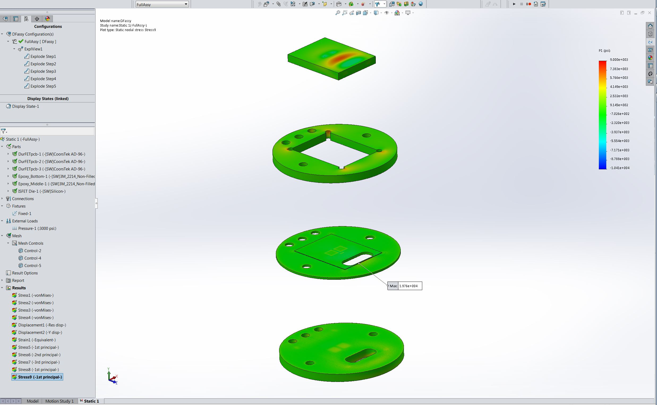
Image-4

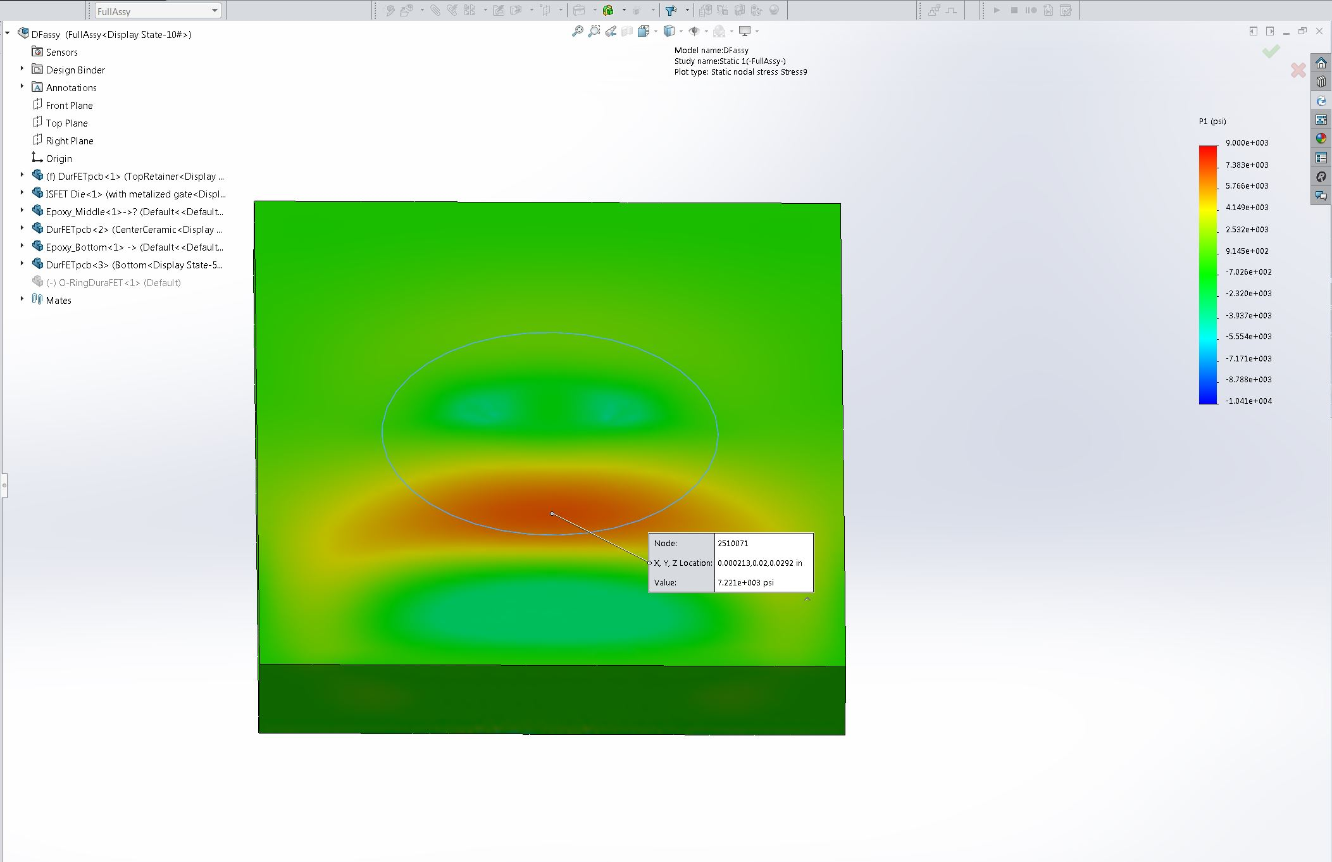
Image-5

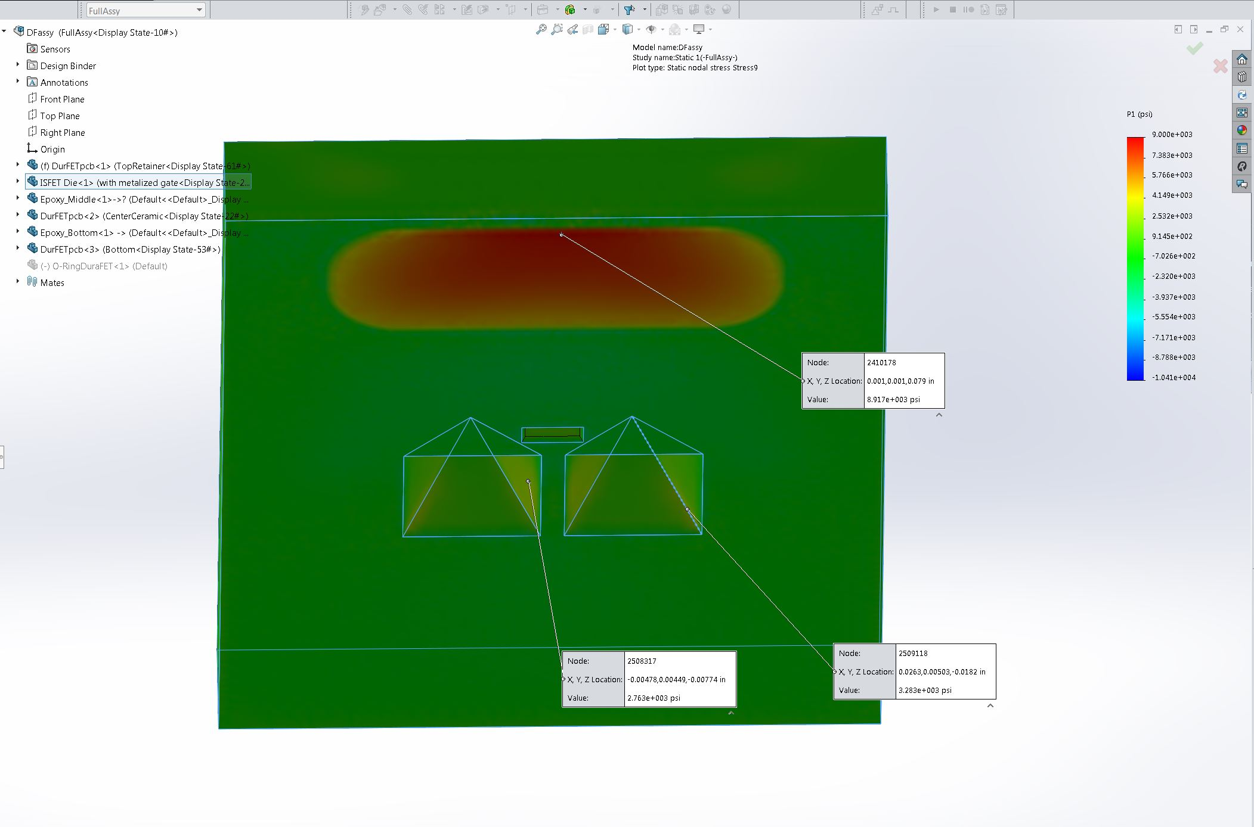
Image-6

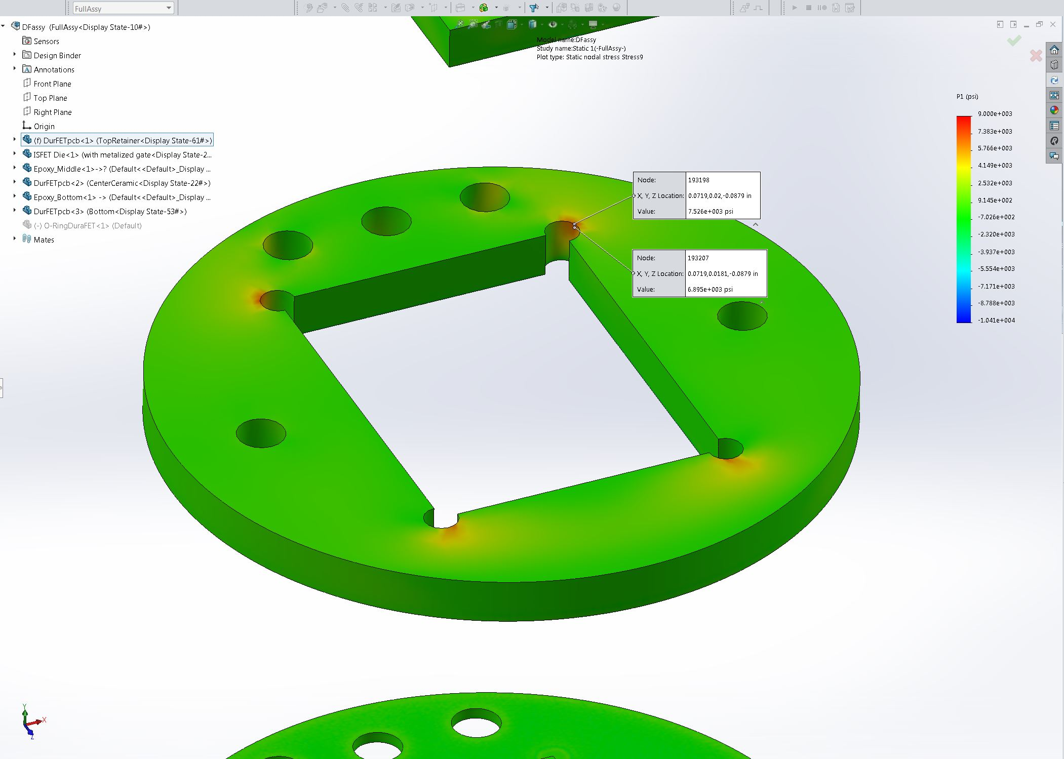
Image-7

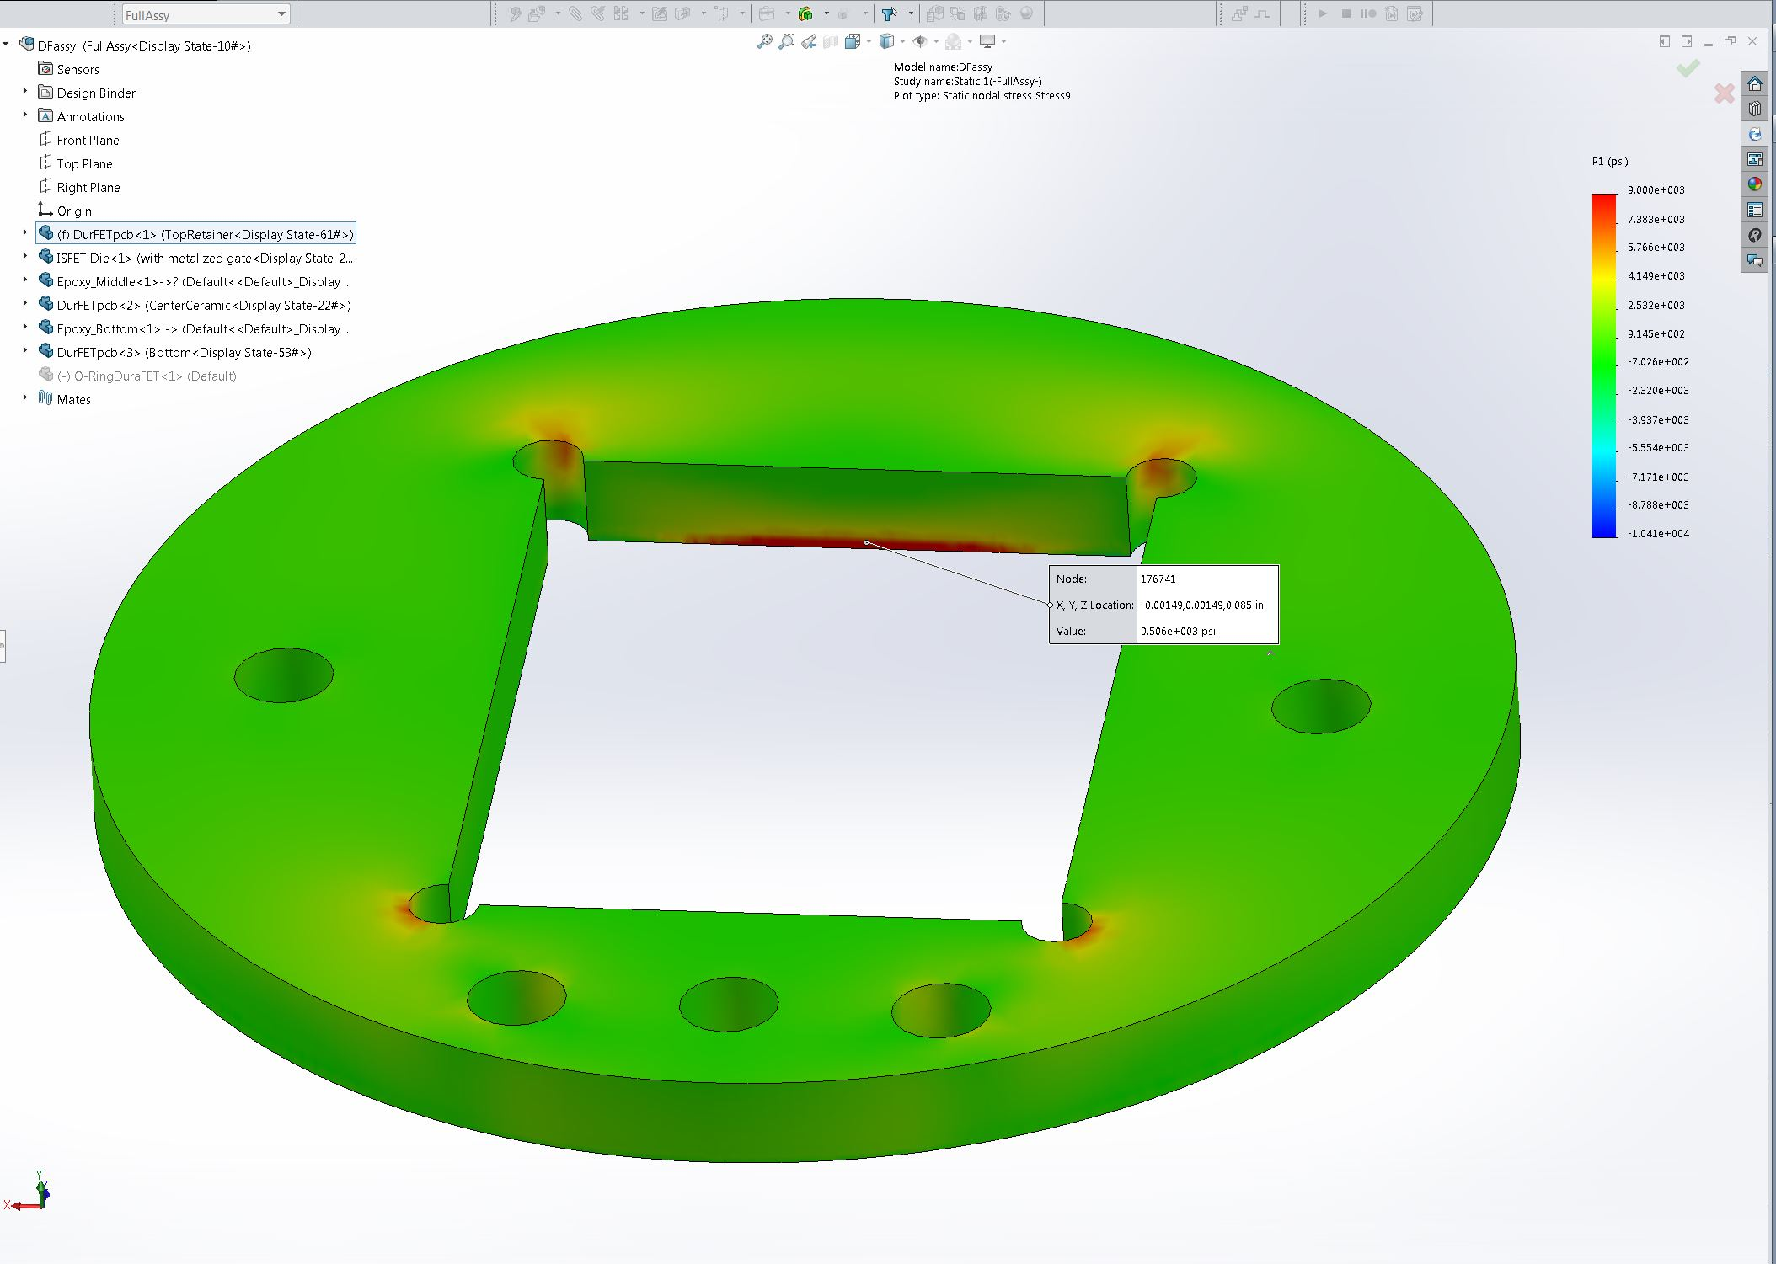
Image-8

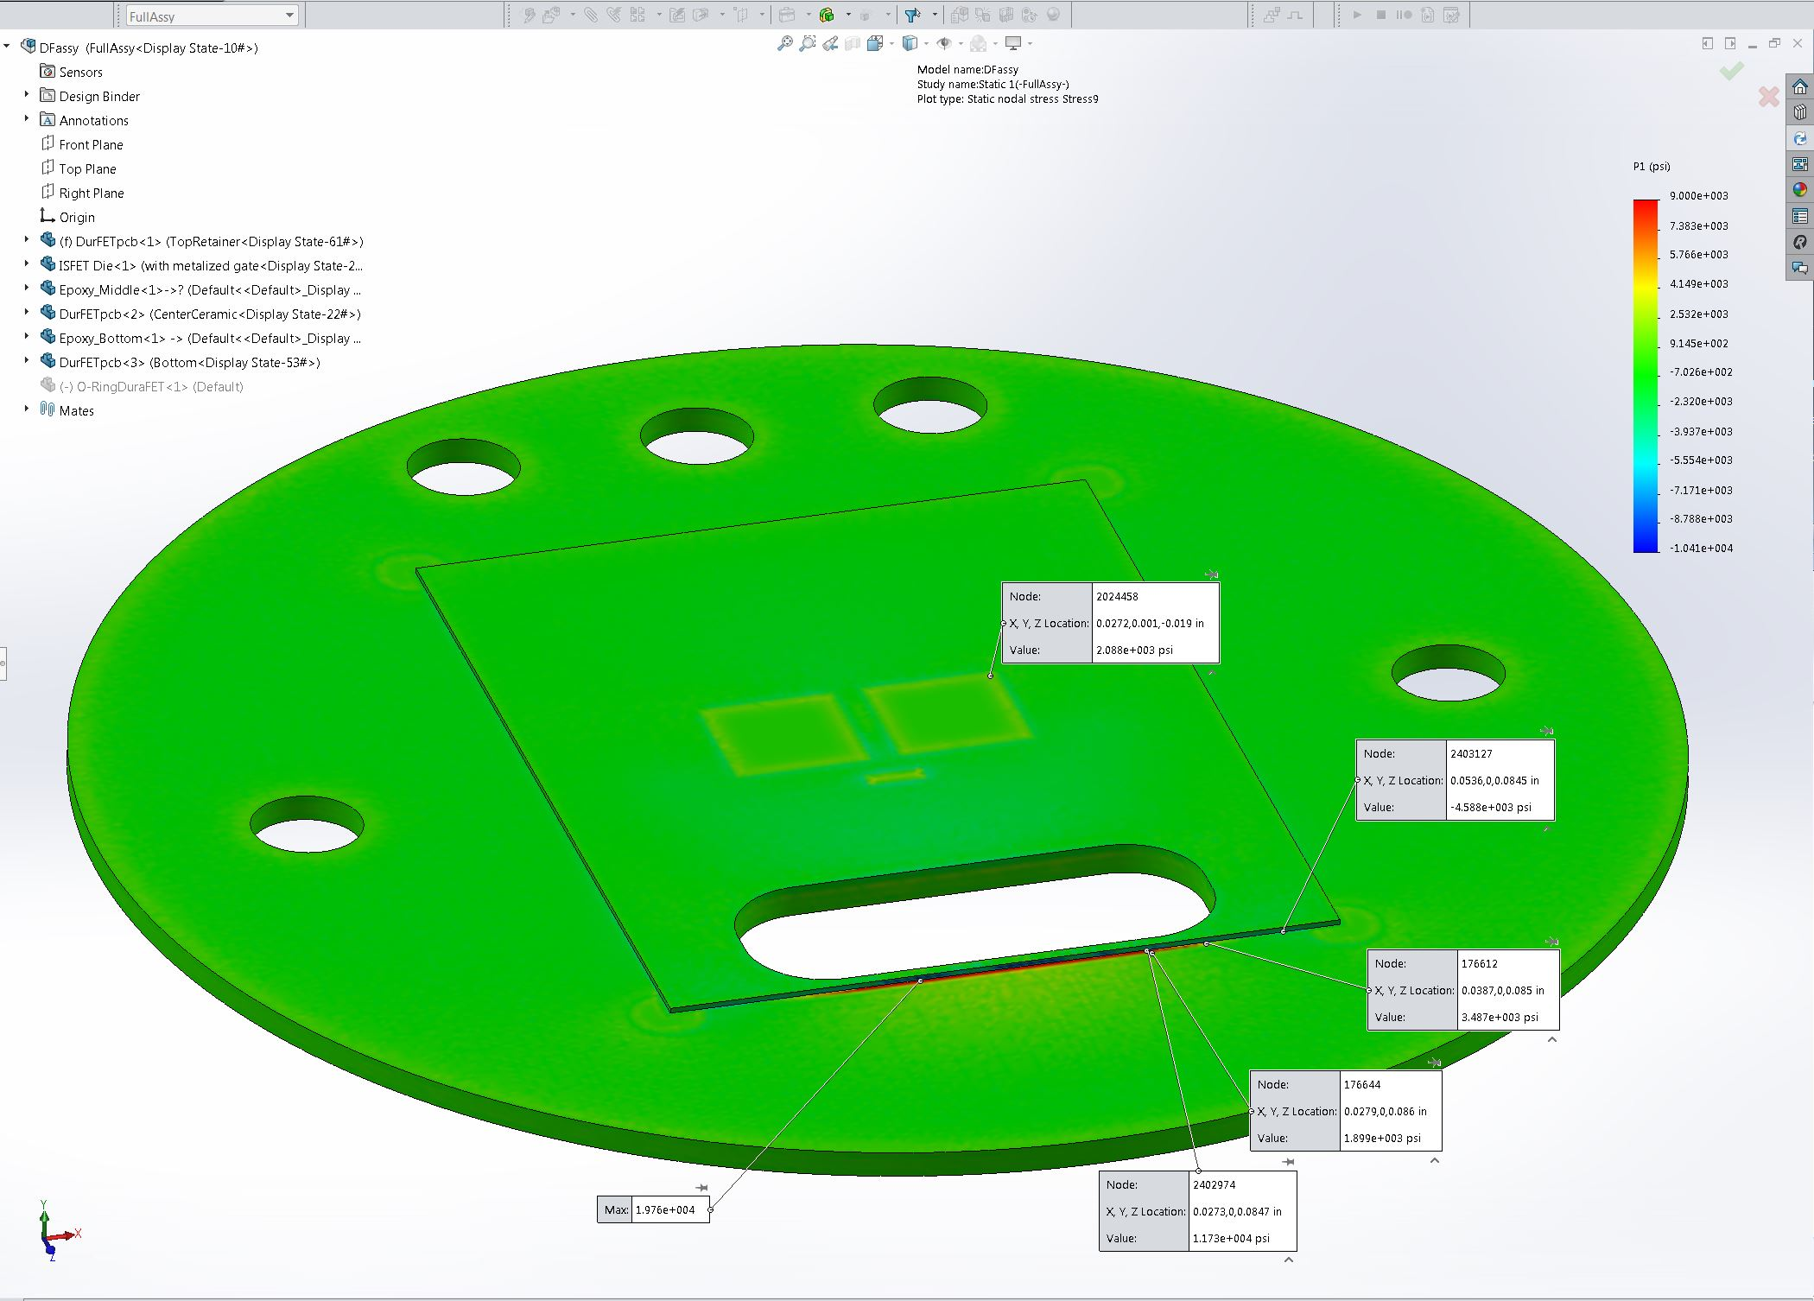
Image-9

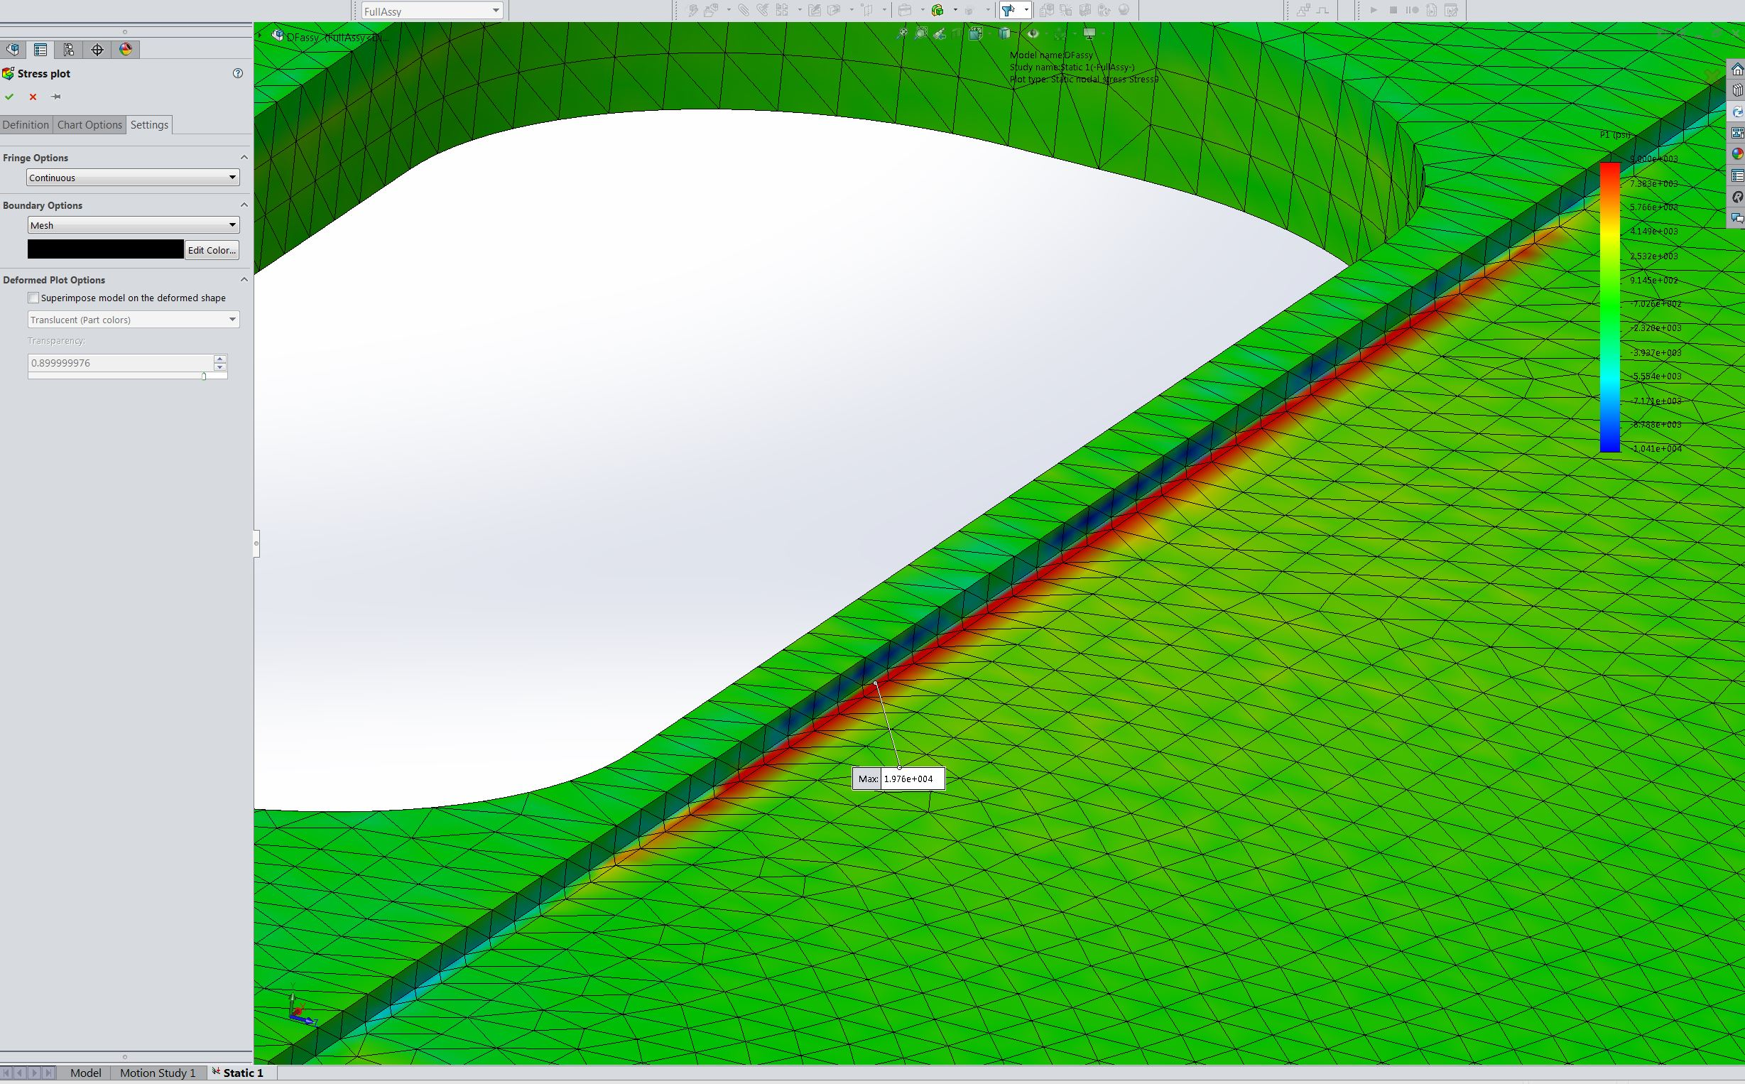
Image-10

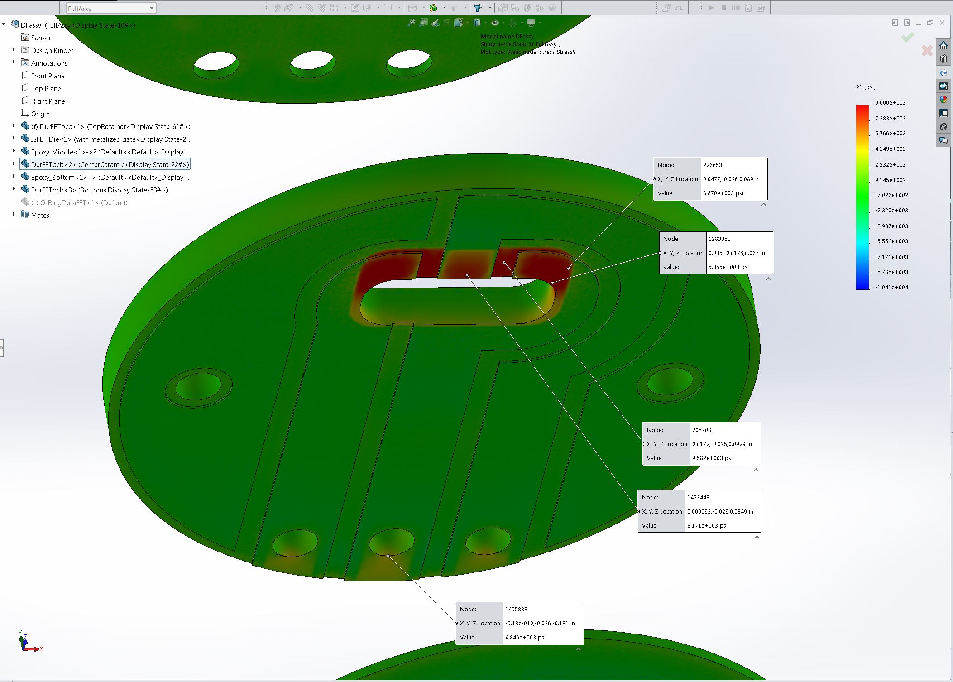
Image-11

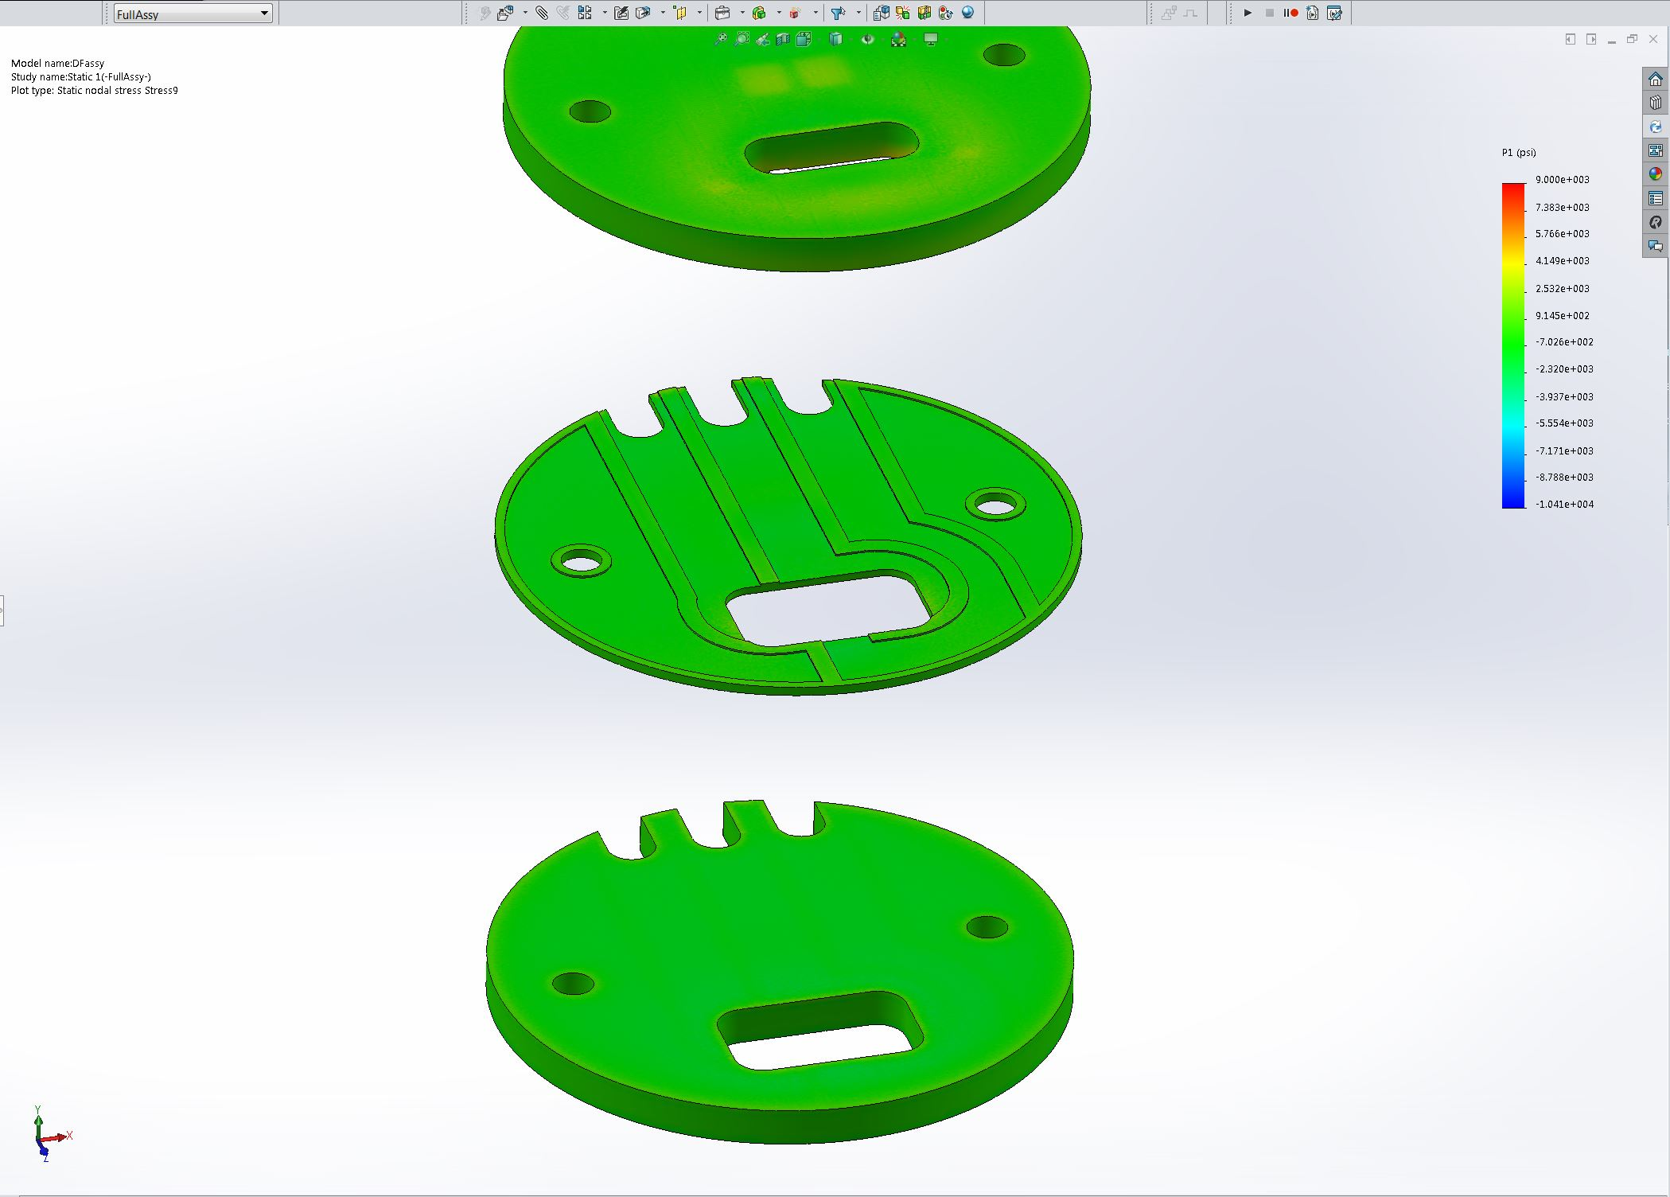
Image-12

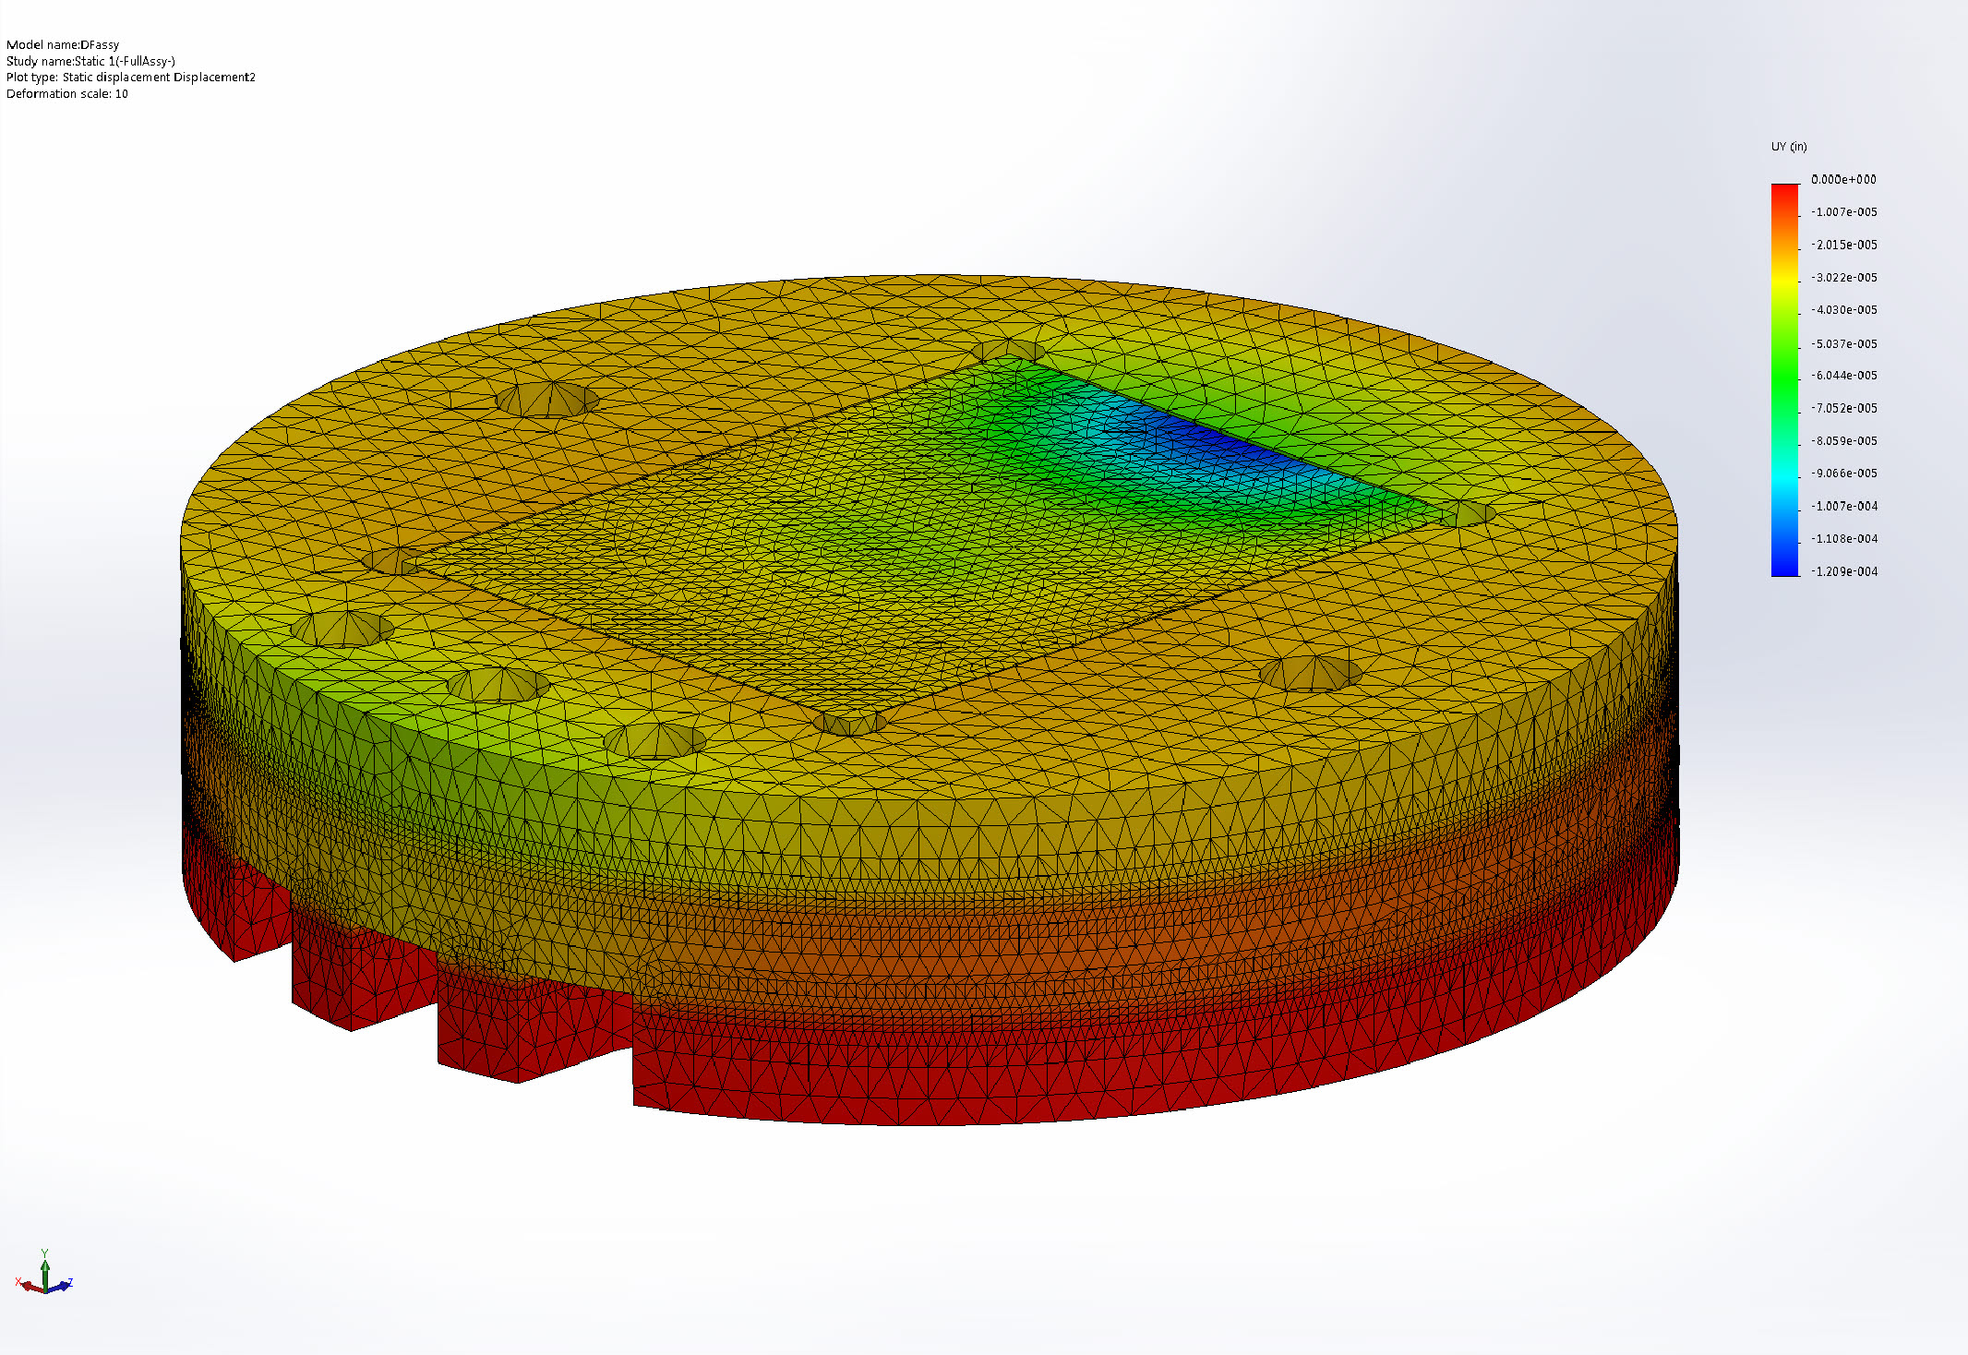
Image-13

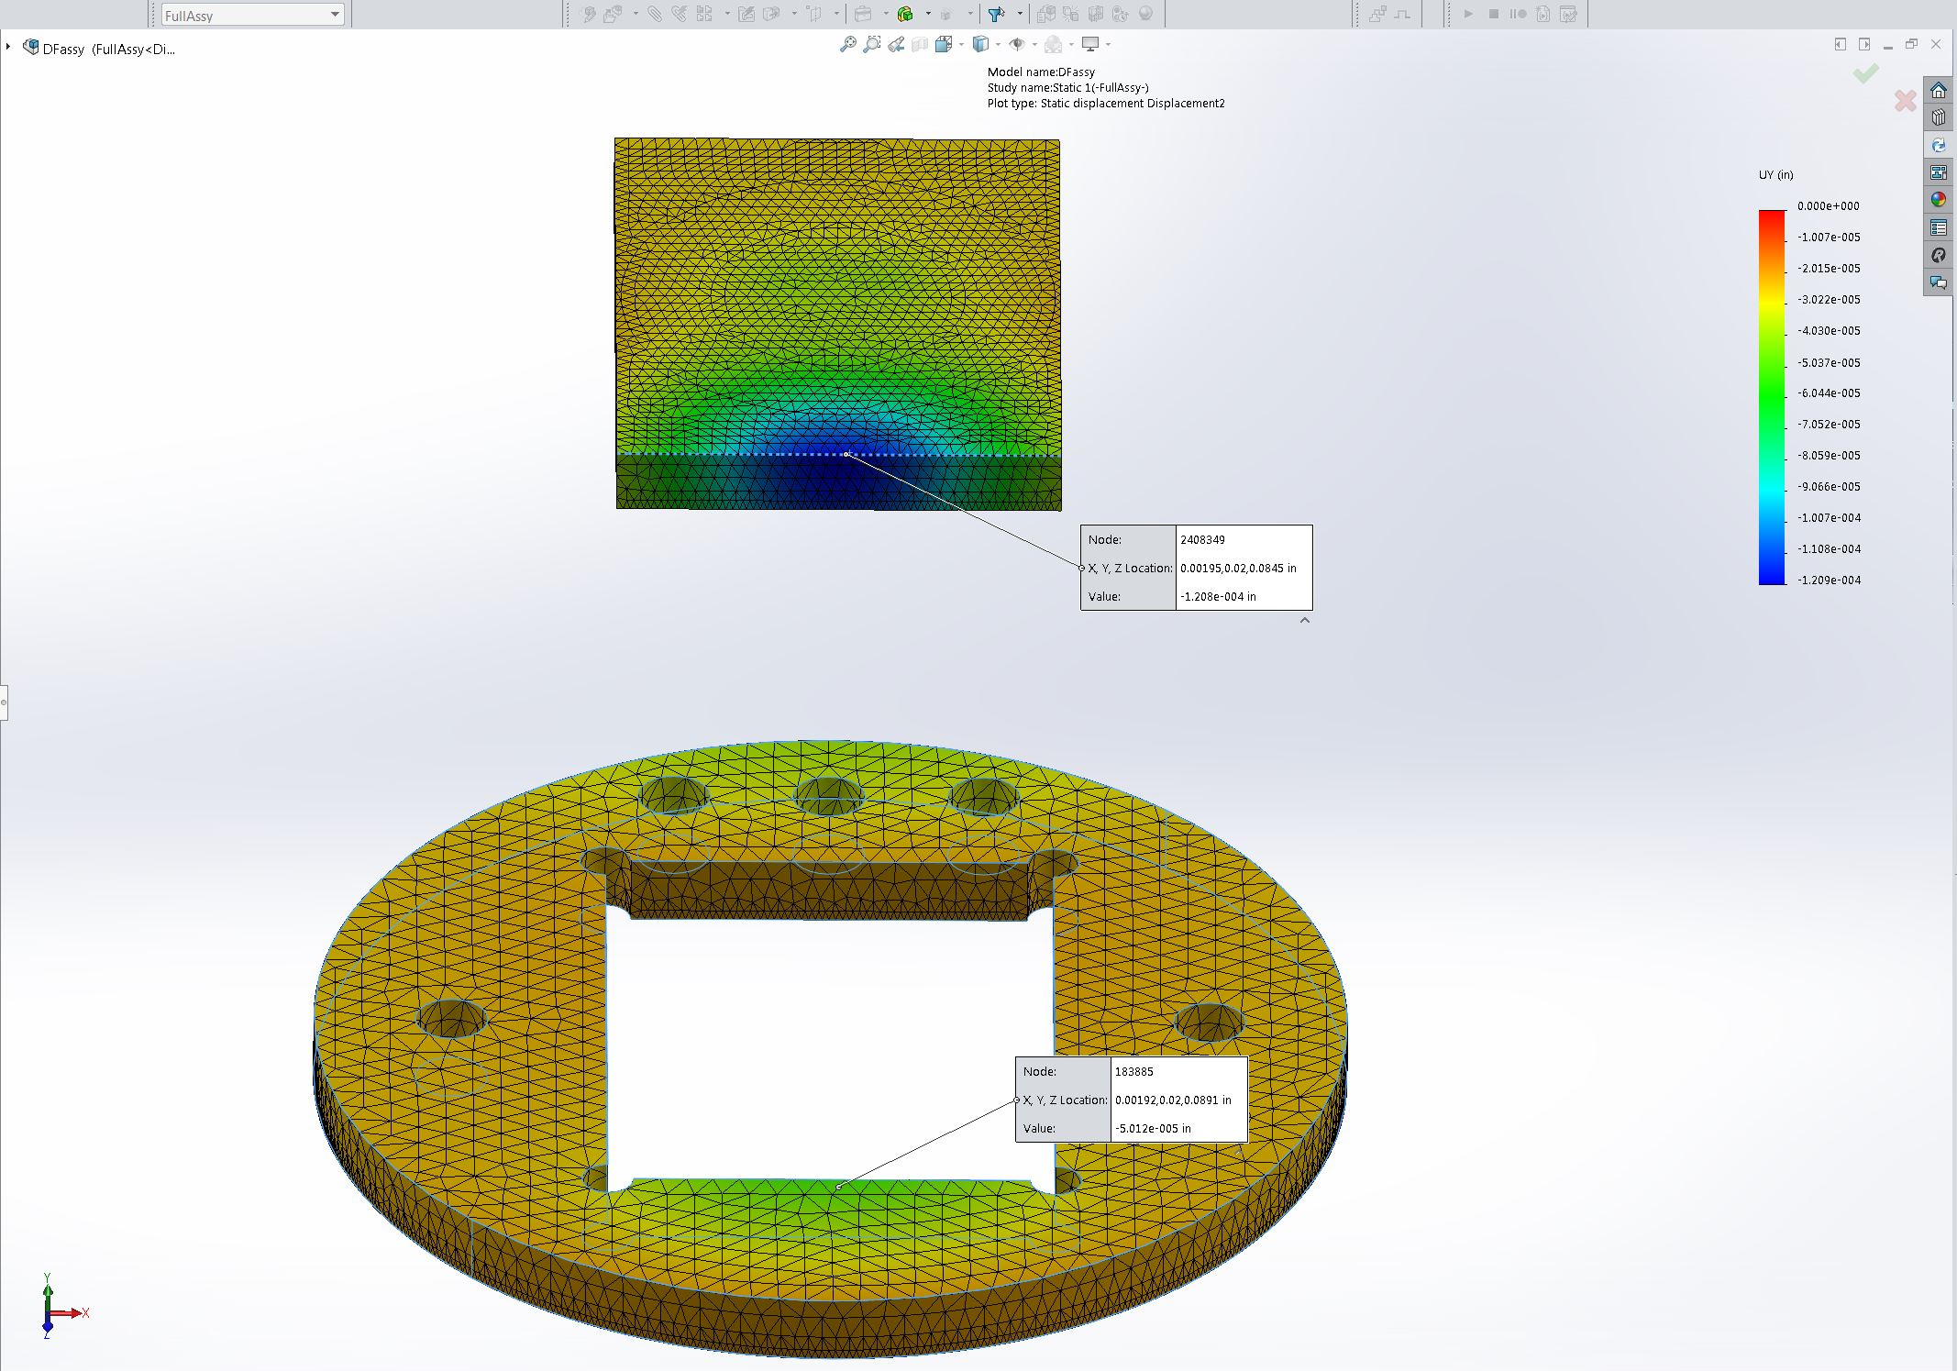
Image-14

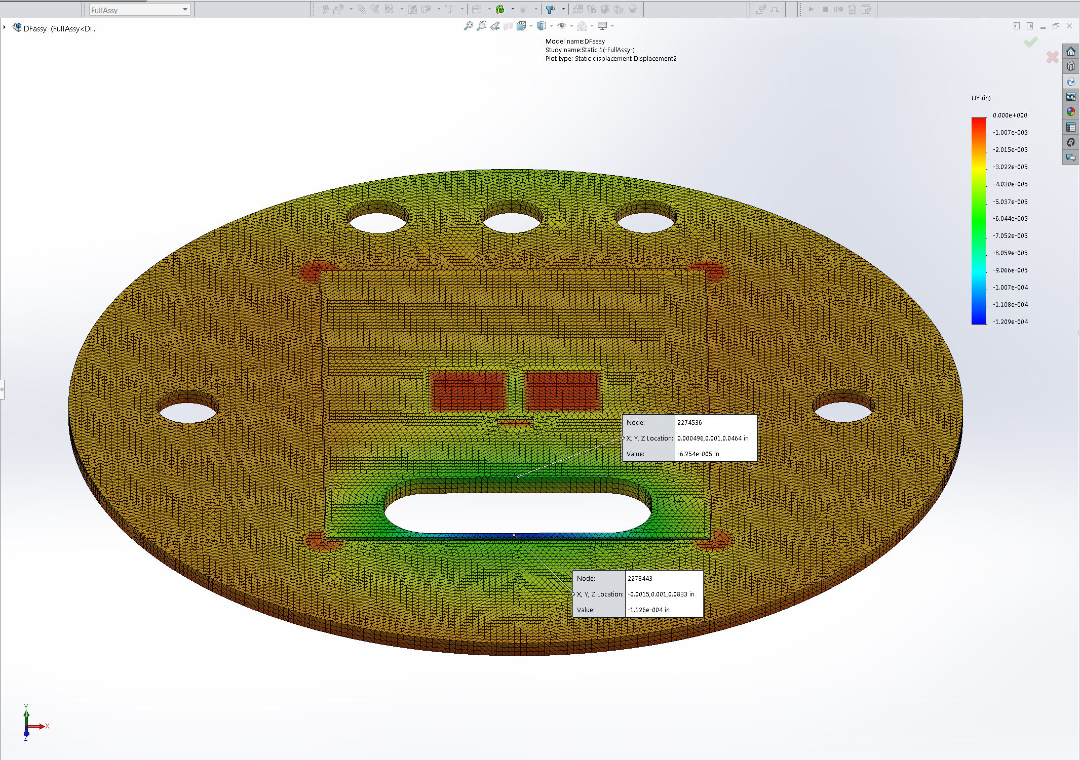
Image-15

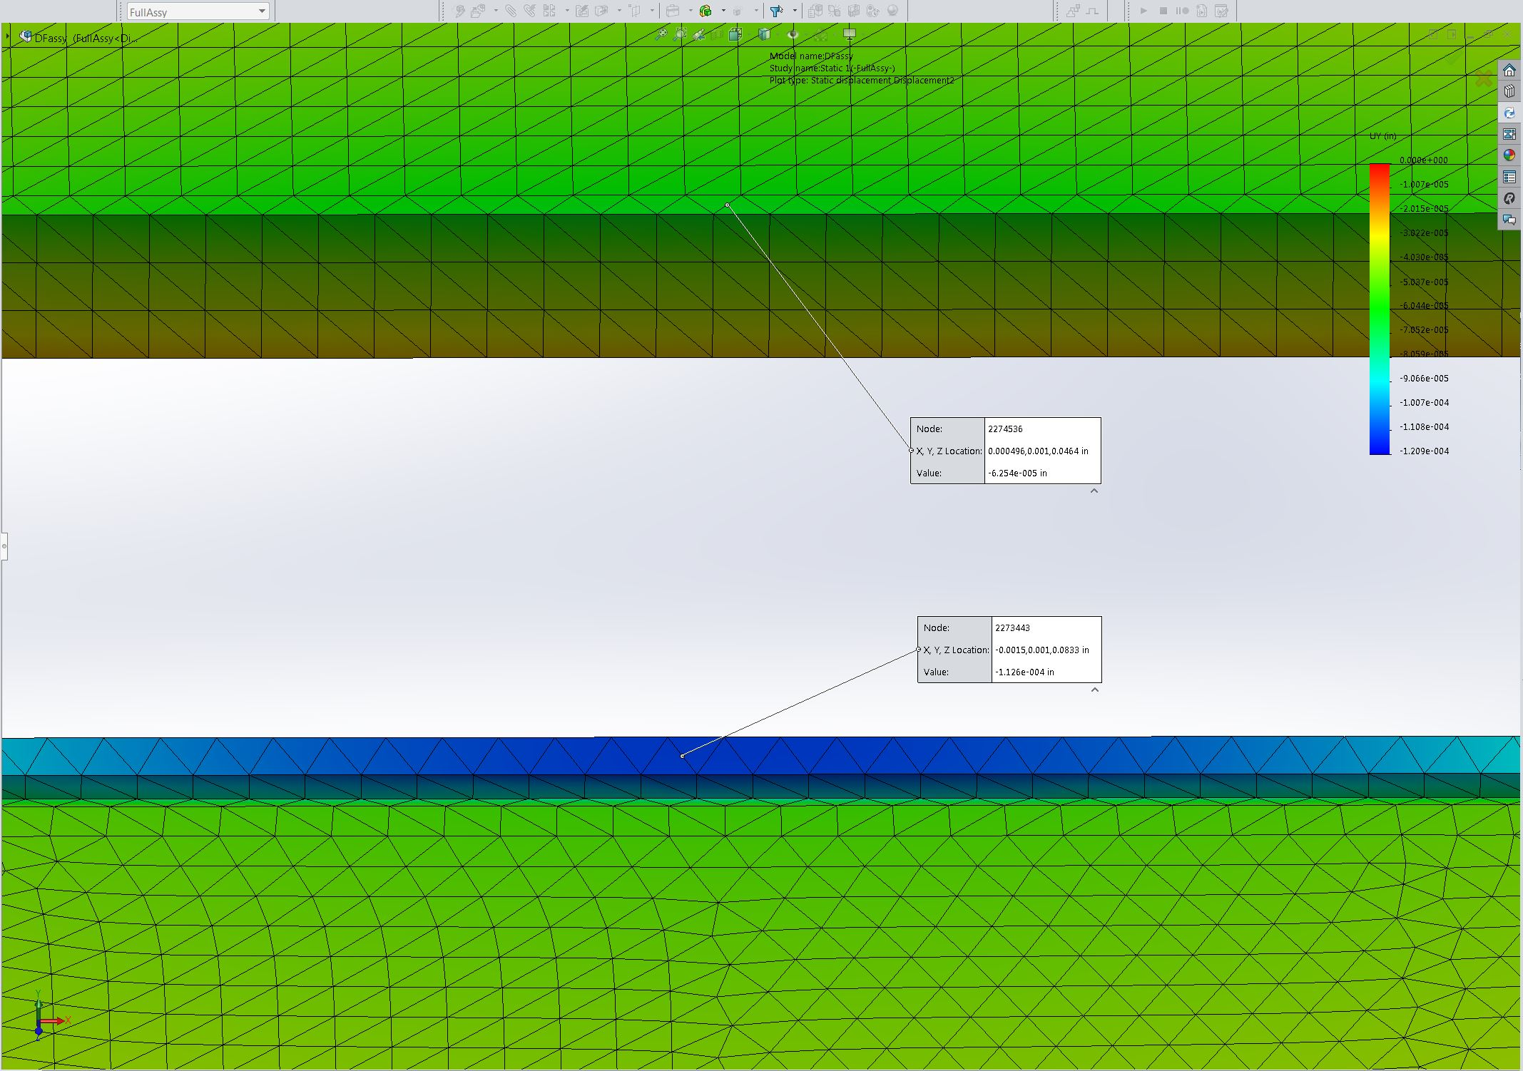
Image-16

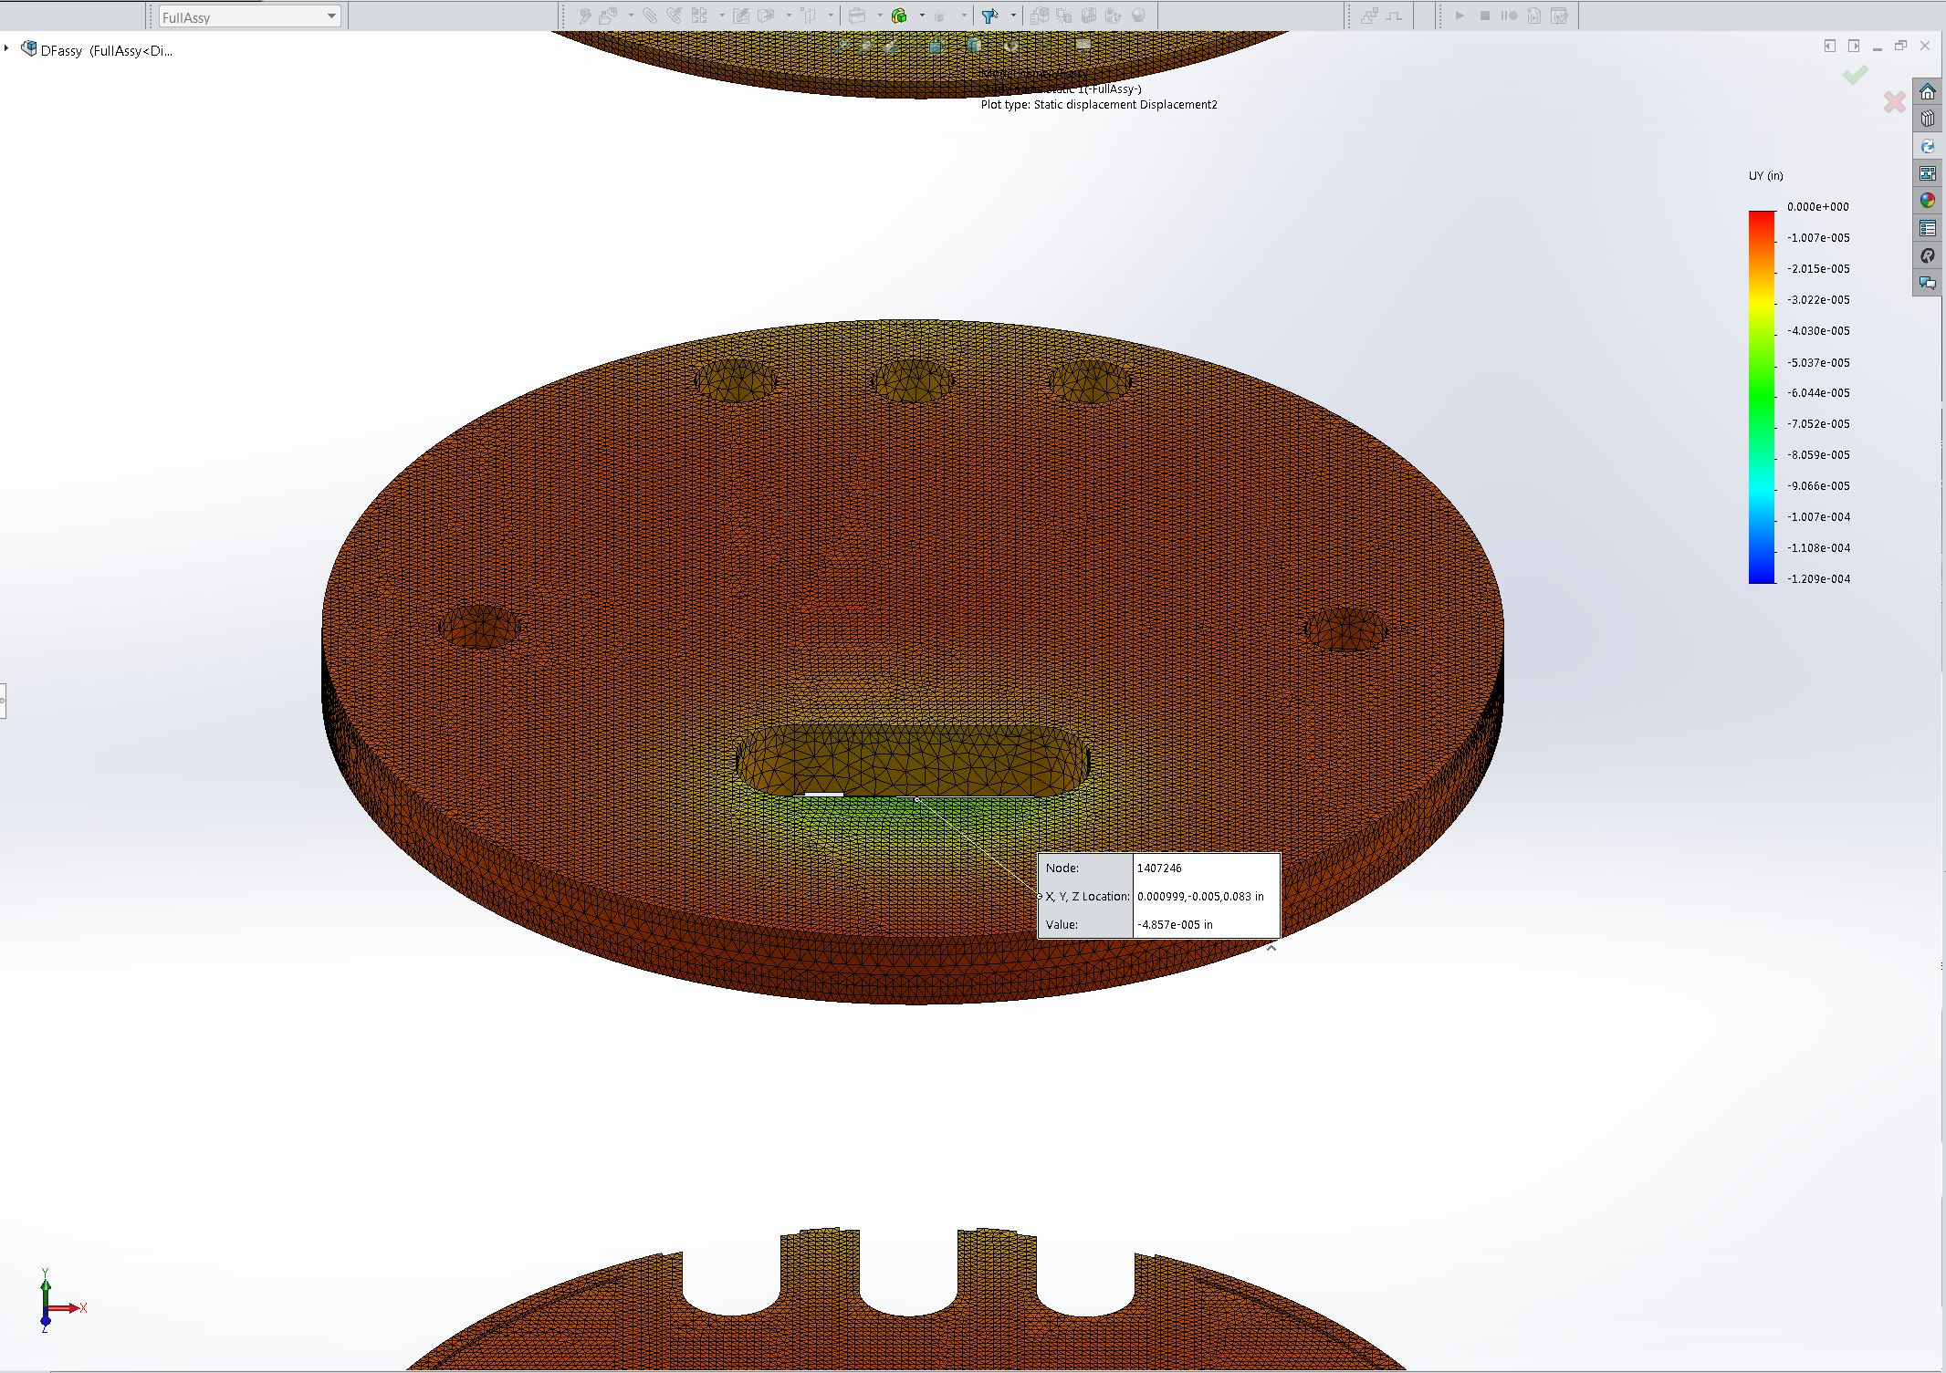
Image-17

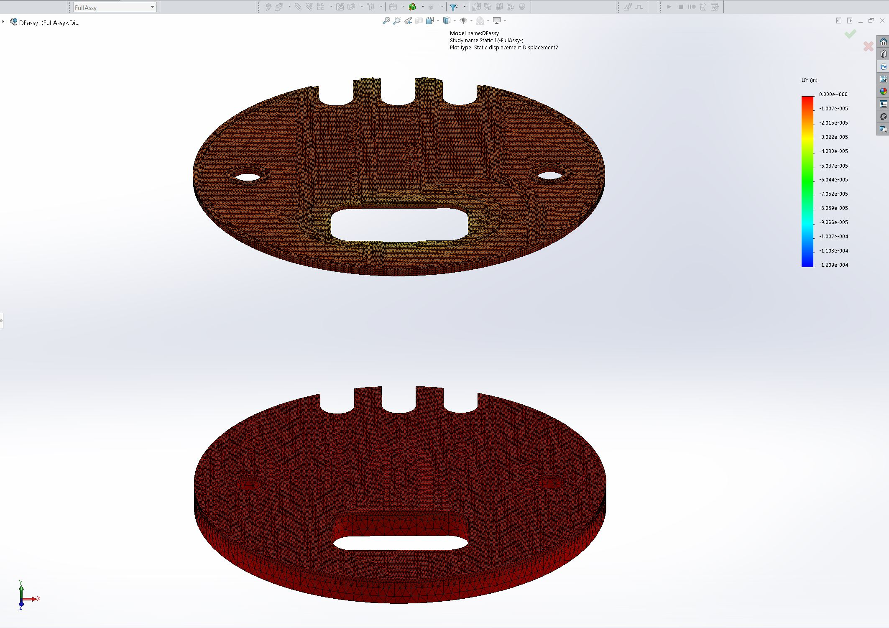
Image-18

Conclusion

Appendix

