Circuit Components:

RTC Plug
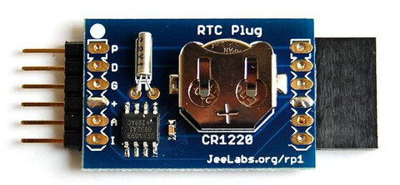
Is a clock
Can keep time when powered off due to internal battery
http://www.digitalsmarties.net/products/rtc-plug

Relay Plug
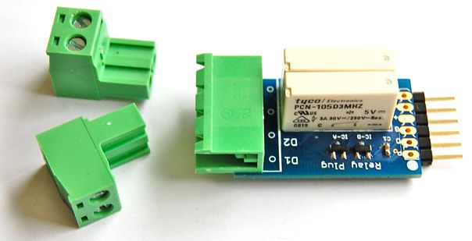
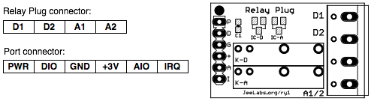
Normal relay switch.

Memory Plug
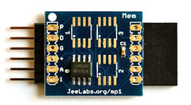
Ours has 2 memory blocks so 256 Kbyte of memory
3.3 V
UART Board
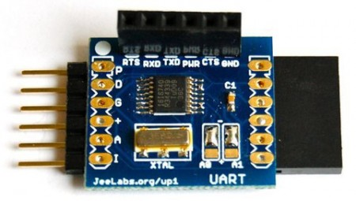
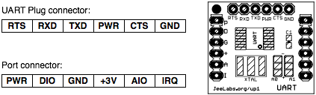
Allows to change voltage types.
Used to convert signal from the CO2 sensor so it is readable by the jeenode.

Carbon Dioxide Sensor
General Electric T6615 module
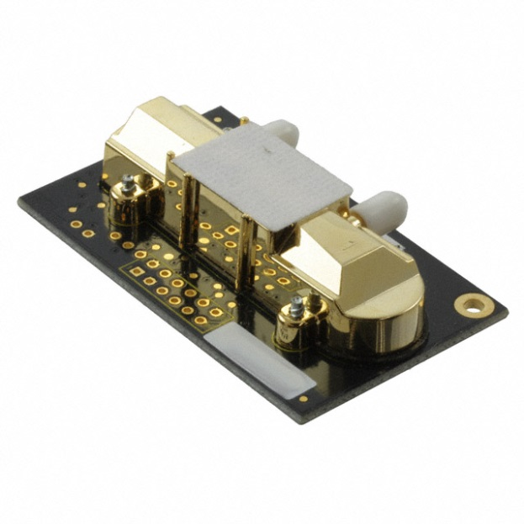
Infrared CO2 sensor
Readings are affected by humidity
Accuracy within 10% or 75 ppm

Air Pump
Thomas

