Deep Water Instrument for Microbial Identification, Quantification, and Archiving
Douglas M. Pargett, Scott D. Jensen, Brent A. Roman, Christina M. Preston, William Ussler,
Peter R. Girguis, James M. Birch, Christopher A. Scholin, Roman Marin III
Abstract—X xxx x xx x x x xxxx x xx x x x xxx xxxxx xx x x x x xxx x x x xx xxx x x xxx x x xxxx. X x xx x x x x x x x xxxxx x x x x x x x

x.

Index Terms—XXXXXXXXXXXXXXXXXXXX,XXX.

Abstract
Here we report on a robotic system known as the Environmental Sample Processor (ESP) that conducts molecular biological analyses in situ as a means of identifying and quantifying a variety of microscopic organisms at oceanic depths up to 4000m. The ESP concentrates microbes through filtration and then detects these microbes using low-density DNA probe arrays, protein arrays [1-3], and real-time quantitative PCR [4, 5]. Samples can also be preserved for further analysis after instrument recovery [6]. The deployment platform also carries external chemical and physical sensors to provide contextual measurements of the surrounding environment.
Because the ESP performs all collection and analytical functions within a one-atmosphere pressure housing using fluidic equipment rated for only 500kPa, several technical developments were necessary to acquire high pressure ambient water samples for processing by the core instrument. This 4000m depth-hardened version of the ESP is referred to as the Deep-Sea ESP, or D-ESP.
The D-ESP platform was designed to be easy to deploy, recover, manipulate while on the seafloor, and operate on batteries if necessary. In addition, the sample intake system can target specific areas nearby on the seafloor, safely collecting heated water from diffuse hydrothermal vents.
Here we report preliminary data from the deployment of D-ESP into the caldera of an active underwater volcano off the Oregon coast from July 15-20, 2011. To accomplish this, a number of items required special engineering consideration:

Fig. 1 (Image of ESP instrument. Convey how complex the robotics are and prevalence of low pressure COTS components and fittings. Backs up claim that big housing, DWSM and heater were better than redesigning the core. A scale reference on the picture would be good.)

Pressure Housing
The core detection instrument in the Deep-ESP is a robotic fluidic lab that handles raw seawater and chemical reagents. It required years of engineering effort to develop and refine, however the instrument is significantly larger than common deepwater pressure housings such as 43 cm glass spheres. Rather than attempting to miniaturize the core robotics, it was more effective for cost, risk, and schedule, to build a large pressure housing for the instrument. This spherical housing would be over 1m in diameter, machined from near-net-shape cast titanium, and hyperbaric tested to 41.4 MPa for ROV service to 4000m. It is the main pressure housing for the Deep-ESP system, but is also the major buoyancy element in the deployment platform, displacing 660 kg of seawater. A detailed description of the design and fabrication of this housing is a separate manuscript. [x]
There are temperature constraints for the ESP instrument necessary to maintain reagent viability. The instrument has to remain between 10C and 30C from the initial reagent loading, through shipping, during the deployment and even during the trip back to the lab for post deployment quality control runs. To maintain temperature while the instrument is deployed, it was more effective to setup a process for heating the sphere rather than try to develop and validate cold temperature reagents and processes. Therefore sphere has heaters, thermostats, and an insulation blanket just inside the shell. When deployed, it requires an average of 50W to maintain an air temperature inside the sphere about 10C above the ambient ocean. Note that this is the temperature of the air and instrument inside the sphere, not the sphere itself. Due to the very high heat transfer rates of liquid convection and metal conduction, the sphere is effectively at ambient temperature. Additional insulation could be added, but there is the upper limit. All the power conversion and battery charging equipment is located in the sphere and wastes heat to this space. This has the benefit when deployed of utilizing the waste heat, but also presents an over temperature risk when sphere is sealed but not submerged in water. More about the Deep-ESP’s power requirements and procedures to address heating and cooling will be discussed in more detail later in this manuscript.
This work was supported in part by the National Aeronautics and Space Administration (NNG06GB34G and NNX09AB78G), the National Science Foundation (OCE-0750058 and OCE-0314222), and by the David and Lucile Packard Foundation through MBARI.
D.M. Pargett is a mechanical engineer with the Research and Development Division, Monterey Bay Aquarium Research Institute, Moss Landing, CA 95039 USA, (phone: 831-775-2073; e-mail: pargett@mbari.org).

In Situ Pressure Reduction
To collect the particles for microbial detection, the core ESP instrument requires liters of raw seawater to flow through its filtration stage. However, the fluid handling components inside the instrument are rated only for 500 kPa service and cannot contain ocean pressures deeper than 50m.
For the same reason that we did not try to miniaturize the ESP, it was intractable to modify the robotics and fluid components to directly sample water at 4000m depth. Instead, we developed a pressure-modifying interface called the Deep Water Sampling Module (DWSM) which allows the ESP instrument to sample seawater from a low pressure envelop while it is deployed in the deep ocean.
The DWSM functions as a decompression gateway by drawing in a sea water sample (up to 10L) at ambient pressure, decompressing the sample to the instrument’s pressure, and feeding that sample through the filtration stage. The filtrate water coming back from the instrument is collected in a downstream reservoir, recompressed, and exhausted back to the ocean.
The DWSM assembly is two tower structures outside of the main pressure sphere, and has flexible water reservoirs bags housed in rigid oil chambers (Fig. 2). The system has oil pumps, valve manifolds, and an oil reservoir at ambient pressure. The oil pumps create differential pressures in the chambers for filling and empting the seawater reservoirs. An additional high pressure oil pump is used to generate the low pressure, decompressed state. The pumps only move oil (silicone oil in this case) and do not suffer corrosion from seawater contact, nor are microbes in the seawater destroyed if pumped directly. Recompression of the system is accomplished by allowing the ambient pressure oil to flow back into the chambers via a restriction valve.

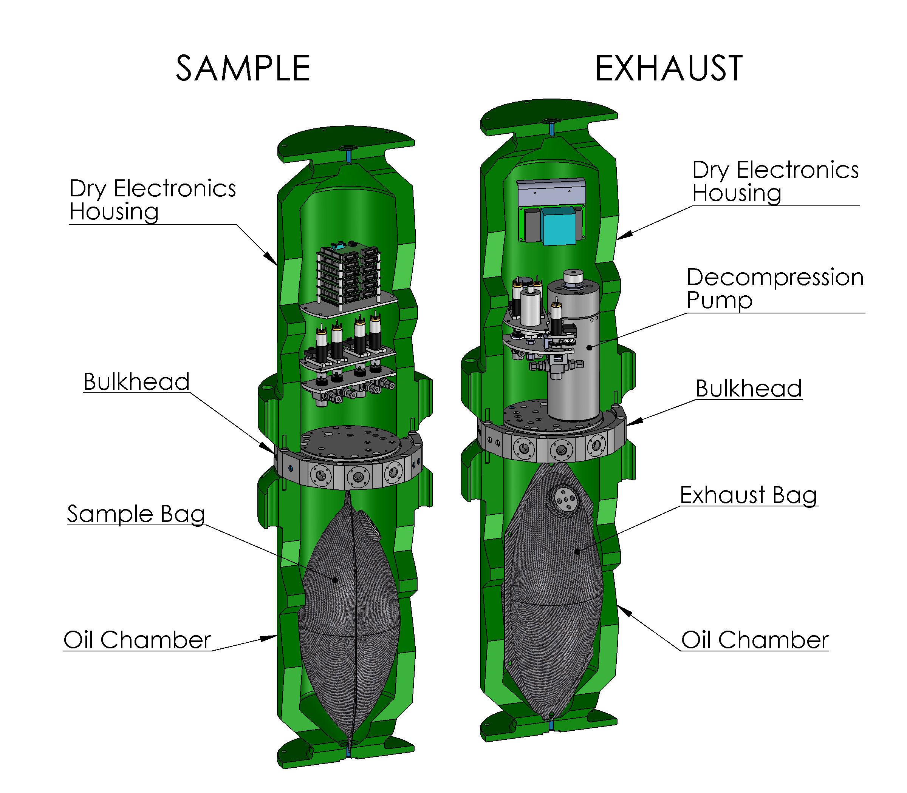
Fig. 2 Cutaway view of the DWSM tower architecture, showing pressure chambers, bulkhead plates, and major components.
Benthic Lander
When fully assembled and prepared for deployment, the Deep-ESP system is a free-fall benthic lander, about 2.5m tall and 2m in diameter (Fig. 1). This assembly contains the ESP sphere, DWSM, batteries, buoyancy foam, and a drop weight release system. There is a seawater source selection and wand system, which includes physical and chemical sensors that provide additional context about the seawater being collected. Typical sensors are an In Situ Ultraviolet Spectrophotometer (ISUS), an In Situ Mass Spectrometer (ISMS), and a CTD with flouometer and oxygen sensors.
The lander has beacons for tracking and an acoustic modem for ship-to-instrument communication while deployed. The modem can also trigger a galvanic corrosion wire that releases the lander’s drop weight. VHF and GPS tracking system are also used to locate the instrument when it returns to the surface. There is also a platform interface cable for connecting the Deep ESP to a submarine cabled observatory, ROV or an external battery pack.
The total mass of the Deep-ESP lander varies with the mission equipment and number of batteries on board. For the 2011 Axial seamount mission, the lander massed 1930 kg. The lander’s weight in seawater is trimmed by adding or removing syntactic foam blocks so that it is 350-530 N (equivalent to 36-54 kg) heavy during descent. After releasing the 119 kg steel drop weight (100 kg equivalent mass in seawater), the lander becomes 450-630 N (equivalent to 46-64 kg) buoyant and freely ascends to the surface. During descent and ascent, the Deep-ESP lander travels through the water column at about 30m/min.
A common question that gets asked is what happens if the lander falls over when it hits the sea floor. That cannot happen, otherwise it would always flip upside down during the free descent or ascent. The lander has been designed to have the center of buoyancy much higher that it’s center of mass. This gives the lander a very strong righting moment, and it will return to upright if any external forces act to tip it.

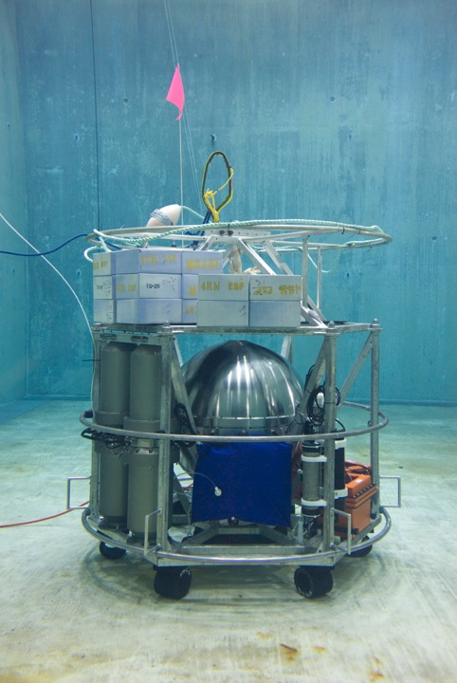
Fig. 1. Deep-ESP lander being tested in seawater tank prior to deployment. The titanium sphere in the center houses the ESP instrument. The green towers are the DWSM. The blue bag is the ambient oil reservoir. The orange boxes are batteries, and syntactic foam blocks are on the top.

Sampling Wand System
A significant capability of the Deep-ESP system is that it can sample different water patches within a local area, enabling the comparison of microbial populations at various seeps, vents, and ambient water. This source selection is accomplished by a tree of centrifugal pumps and check valves, each pump is able to supply a separate source water to the common header that feeds the ESP via the DWSM and the context sensors. These pumps are selected by the Deep-ESP, and such switching of source water does not require ROV servicing to reposition the instrument or intake tubing.
Only the water supplied by the pump being powered is fed to the header, and the check valves prevent back flow of water to the other sources. After passing through the last context sensor, the water is exhausted to the ocean about .5m above the sea floor, on the opposite side of the lander from the ambient seawater source, which is ~2m above the seafloor.
The microbes at diffuse thermal vents are an intended research target for the Deep-ESP, however the temperature limits of the instrument require that the lander be staged in cold ambient water, preferable some short distance from the vents. Therefore, a wand assembly has been developed which attaches to a pump and allows the intake of seawater from a source up to 15m from instrument. The wand head can be placed into cracks and vents to sample that specific water, and a screened intake excludes particles larger than 0.5mm, which could clog the ESP instrument. The wand head is a 1.5m titanium tube which acts as a heat exchanger, cooling the vent water prior to the flexible tubing and lander.
The wand head also contains a remote temperature sensor, to record the water temperature at the source collection point. This temperature is monitored in real-time via an auxiliary input channel on the CTD instrument.

(Describe diagram)

Power and Energy Storage
The Deep-ESP is not a low power system, and depending upon the mission plan and context sensors it averages about 170W, however it has been designed to make the best use of that power. Table 1 shows the major power consumers, on average, for the Deep-ESP system. The system is designed to typically be powered from a continuous supply, such as a submarine cable, however for very short periods that supply may become insufficient. When the high pressure pump decompresses the DWSM, the power draw can be over 600W for a few minutes, so the lander has onboard batteries to buffer the incoming power. The lander can be fitted with up to 8kW-hr of pressure compensated lead acid batteries, which also enable the Deep-ESP to operate for about 48 hours at locations where there is no submarine power.

Table 1 Power Consumption (averaged)
ESP Instrument and DWSM: 20 W
Sphere heater: 50 W
Mass Spectrometer: 100W

Because of the instrument’s power demands and the lack of submarine cable power at Axial seamount for the 2011 deployment, we developed in-situ charging processes and auxiliary battery sleds to augment the onboard battery power. There is limited bandwidth available with an acoustic modem, so is used for simple progress and update communications only. To get high bandwidth data from the Deep ESP, the typical mission profile calls for using an ROV to connect to the Deep-ESP almost daily for Ethernet and power, similar to what a cabled observatory would provide. During this “plug-in time” battery chargers in the sphere can back charge the lead acid batteries on the lander. For the Axial deployment, the ROV could provide a maximum of 500W to the lander, but since the platform would continue to consume 170W, only 330W could go into charging, subject to efficiency losses. In practice, devoting the entire ROV dive to just to charging would barely keep up with the 24 hour battery consumption. therefore an additional power option was developed.

Battery Sleds
Battery sleds extend the D-ESP operating time and allow for more flexible use of the ROV, as it could be used for other activities during the Deep-ESP deployment rather than just charging batteries. A custom sled fits into one half of the ROV tool drawer, and stores about 4 kW-hr in pressure compensated lead acid batteries. Two battery sleds are used, a charged one is carried down by the ROV to the Deep-ESP where it will replace the discharged battery sled (Fig. 2). After the ROV has plugged into the Deep-ESP and downloaded the previous day’s data or updated the mission, the new battery sled gets plugged into the Deep-ESP and the discharged sled is loaded into the tool drawer. When the ROV is recovered each day, the battery sled stays in the tool drawer and is recharged overnight.
The Deep-ESP’s circuitry prioritizes power from the battery sled over the lander’s onboard batteries. In theory a fully charged battery sled contains nearly 24 hours of energy for the Deep-ESP, setting up that a daily battery swap can provide the energy requirements. This schedule minimizes ROV plug-in time so that it can be used for other tasks around the research site.
This battery capacity also provides a time buffer in case an ROV system failure or bad weather prevents dives. The Deep-ESP can continue to run normally for about 72 hours from the last sled swap.

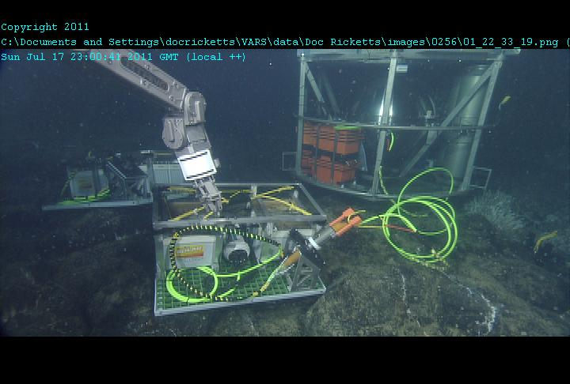
Fig. 2. Deep ESP deployed at the ASHES vent field within the Axial seamount caldera. An auxiliary battery pack is being repositioned by the ROV Doc Ricketts.

The acceptable weather window at Axial seamount can be short and unpredictable, and measures were taken to best ensure that the D-ESP could be recovered if the weather forced a deployment cancellation, or if the ROV became inoperable. The Deep-ESP lander does have an acoustic release for the drop weight, and will return to the surface via free ascent It can tracked from the ship. However, the underwater mateable connector that enabled the use of battery sleds and recharging from the ROV, was a risk to recovering the platform.
The battery sleds are more than the buoyancy of the lander after the dropweight is released. If the sled cone

It is not uncommon for any ROV to suffer a system failure when submerged that makes it inoperable. If this happens while submerged, unpowered haul up as the only means of recovery. The arrangement of the connector from the ROV to the Deep-ESP had to be arranged so that it would separate. In this situation if the D-ESP were still connected to the ROV, severe damage to both piece of equipment would be highly likely.
In the same manner, the D-ESP needed to be recoverable via the acoustic modem only, in the event that the ROV could not dive to separate the D-ESP from the battery sled.

(Image of inline connection)
Recovery Concerns
When connected to the ROV or the battery sleds, careful attention was paid to minimize the risks…

The underwater mateable connectors were removed from the connection rack and allowed to lay freely on the seafloor. The connectors were tethered to the cables such that tension on the coupling would pull in-line and separate the connectors. freeing the ROV from the D-ESP, or freeing the D-ESP from the battery sled.

Deep ESP preparations

Deployment
The typical Deep–ESP deployment scenario for dropping the lander a few hundred meters away from the intended research area, avoiding dangerous terrain like chimneys, steep crags, a thin crust, very soft sediment, or even other equipment. The risk of which would be the lander getting wedged or stuck. With the low in-water weight, the ROV’s manipulator can pick up the platform and carry it to the specific research site, which has usually been surveyed already. At that location the Deep-ESP is set back down and setup.

Axial Seamount Deployment
Axial Seamount is an active underwater volcano ~470km west of the Oregon Coast with a recorded history of eruptions. The most recent eruption was in 2011, only months before the Deep-ESP operations in that area. In the southwest part of the caldera floor, nearly 1600m deep, is a diffuse vent field known as ASHES (Axial Seamount Hydrothermal Emissions Study), which is a future site for cabled instrumentation via the OOI Regional Cabled Observatory.
In July of 2011, we deployed the Deep-ESP at ASHES to determine if microbial populations from diffuse flow vents could be distinguished from those living in the surrounding benthic water autonomously, in real-time. Diffuse flows are typically mixed and cooler than black smokers or chimneys, <100C. Sulfide mounds, bacterial mats and macrofauna can be common around these slow discharges.[8]
The lander was dropped onto a smooth lava flow, ~150m northeast of the field. Using MBARI’s ROV Doc Ricketts, a suitable vent was found and the Deep-ESP repositioned to a spot about 10m from the vent. The wand system was deployed, permitting sampling from both the diffuse flow vent and the ambient water at the lander.
Over five days the Deep-ESP collected several water samples from both the vent and the ambient water around the lander. Some samples were processed immediately by the instrument, but many samples were also archived by the Deep-ESP for further analysis in the lab. The context sensors continuously recorded the physical conditions of the water being drawn by the wand. The ROV was used to swap the battery sleds, which got recharged nightly aboard the ship, but also to plug in directly to the Deep-ESP to have a much faster data connection and recharge the lander’s batteries when needed. With the battery arrangement we were able to devote significant ROV time to other research around the vents, rather than just powering the Deep-ESP. The ROV was not operational for two days during the deployment, but the onboard batteries and battery sled allowed the Deep-ESP mission to be completed with minimal disruption.
The contextual sensors on the wand and lander showed significant difference in water properties being taken into the instrument for analysis, indicative of the different source waters (Fig. 3A). Real time quantitative polymerase chain reaction, qPCR, performed in-situ by this system shows a difference in 16S gene abundance between the two sources (fig. 3B) and in-situ sandwich hybridization assay (a direct detection method of ribosomal RNA with no amplification) also shows different community structures between the vent and ambient water sources (fig 3C).
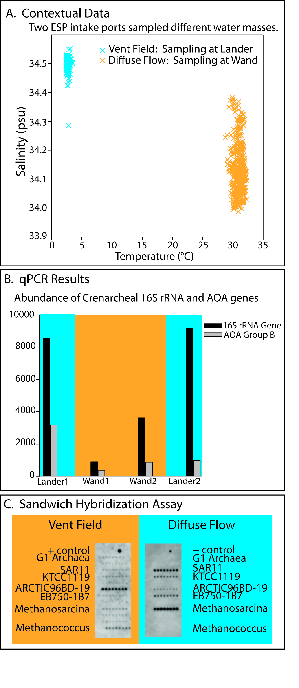
Fig. 3. Data obtained while operating the D-ESP at ASHES. (A) Temperature/salinity plots from context sensors show samples collected are from two distinct sources; (B) Real-time qPCR shows differences in gene copy number (Group 1A and AOAb genes) depending on collection site; (C) Sandwich hybridization shows differences in rRNA community structure when sampling away from or within the vent.

Conclusion
A system for real-time in-situ microbial analysis and archiving, including source water physical and chemical context monitoring, has been developed for use to 4000m ocean depth. The Deep-ESP is an evolution of technology that brings real-time in-situ microbial analysis to new environments. The general concept is to develop environment interface equipment for a core detection instrument so it can function under extreme conditions. Other versions of the ESP are deployed on shallow water moorings, open ocean drifting platforms, and on piers above the sea level.
At the time of this writing, the Deep-ESP is deployed and operating on the Monterey Accelerated Research System (MARS) in Monterey Bay [9], and will complete a six month deployment in October 2013. Future developments of the Deep-ESP will include integration of additional contextual sensors and adaptive sampling, where an ESP microbial sampling and processing event can be autonomously initiated when contextual sensors detect specific environmental conditions or patterns.

References
- Scholin, C, G. Doucette, S. Jensen, B. Roman, D. Pargett, R. Marin III, C. Preston, W. Jones, J. Feldman, C. Everlove, A. Harris, N. Alvarado, E. Massion, J. Birch, D. Greenfield, R. Vrijenhoek, C. Mikulski, K. Jones. “Remote detection of marine microbes, small invertebrates, harmful algae and biotoxins using the Environmental Sample Processor (ESP)” 2009, Oceanography 22:158-167.
- Environmental Sampling Processor website: http://www.mbari.org/esp/
- Greenfield, D., R. Marin III, G.J. Doucette, C. Mikulski, S. Jensen, B. Roman, N. Alvarado, C.A. Scholin. “Field applications of the second-generation Environmental Sample Processor (ESP) for remote detection of harmful algae: 2006-2007.” 2008, Limnology and Oceanography: Methods 6: 667-679.
- Preston, C., A. Harris, J. Ryan, B. Roman, R. Marin III, S. Jensen, C. Everlove, J. Birch, J. Dzenitis, D. Pargett, M. Adachi, K. Turk, J. Zehr, C. Scholin. “Underwater application of quantitative PCR on an ocean mooring.” 2011, PLoS ONE 6(8): e22522. http://www.plosone.org/article/info%3Adoi%2F10.1371%2Fjournal.pone.0022522
- Robidart JC, Preston CM, Paerl RW, Turk KA, Mosier AC, Francis CA, Scholin CA, Zehr JP. Seasonal Synechococcus and Thaumarchaeal population dynamics examined with high resolution with remote in situ instrumentation. ISME J. 2012 Mar;6(3):513-23
- Ottesen E, Robidart J, Preston, C. Scholin C., and E.F. DeLong 2011. “Metatranscriptomic analysis of autonomously collected and preserved marine bacterioplankton.” 2011, ISME Journal epub:
http://www.nature.com/ismej/journal/vaop/ncurrent/full/ismej201170a.html
- Roman, B., C. Scholin, S. Jensen, E. Massion, R, Marin III, C. Preston, D. Greenfield, W. Jones, and K. Wheeler, “Controlling a Robotic Marine Water Sampler with the Ruby Scripting Language” Journal of the Association for Laboratory Automation, Volume 12, Issue 1, February 2007, Pages 56-61
- Bemis, K., R.P. Lowell, and A. Farough. 2012. Diffuse flow on and around hydrothermal vents at mid-ocean ridges. Oceanography 25(1):182–191, http://dx.doi.org/10.5670/oceanog.2012.16.
- Massion, E. and K. Raybould (2006). MARS, the Monterey Accelerated Research System. Sea Technology, 47: 39-42.

