1.0 Project overview

As a step towards developing the scientific and technical capability for searching for life on other planets, we proposed a 4-year program to deploy the deep-sea Environmental Sample Processor (D-ESP; Scholin et al. 2009) for autonomously sampling and detecting microbes in Earth’s oceanic seep and hydrothermal vent environments.

The D-ESP and its attendant geochemical sensors will be fitted to a free-fall benthic lander, or “elevator.” The elevator will be deployed from a ship, and once on the bottom can be repositioned using a remotely operated vehicle (ROV). It will be capable of operating as a stand-alone system or integrated within a deep-sea cable observatory network. Deployment of the D-ESP will take place off the west coast of the U.S. with sites including Monterey Bay, Axial Seamount and methane vents off Southern California. The primary goal is to autonomously assess temporal and spatial changes in microbial populations and distribution of functional genes in relation to fluid source and water column chemistry. In addition, we will provide a mechanism for preserving discrete samples (particulates) in support of a variety of laboratory-based analyses following deployment and recovery of the instrument.

3.6 Axial Seamount hydrothermal vent deployment Q3 2011
The D-ESP was deployed within the caldera at Axial Seamount at the “Ashes” diffuse vent field from July 15-20 (Fig. 4). Several technological developments were necessary for this deployment because of the remoteness of the location, unpredictability of weather for recovery, and the need to harden the D-ESP to potential damaging (high) temperatures when sampling vent fluid. Because of the remoteness of Axial, we designed swappable battery sleds to maintain power to all systems in the event that the ship/ROV needed to be recalled or had it’s mission altered. Sampling high temperature water from cracks in the seafloor necessitated the design of a sampling wand, which acted both to collect water from a distance and as a heat exchanger, cooling water before it entered the D-ESP and ISMS. A brief video clip highlighting operations is posted here: http://www.mbari.org/staff/methane/ashes_highlights/ashes_highlights.html.

Our bottom time in the vent field was limited to five days, so we chose to focus on a mission plan that would demonstrate that the D-ESP can function in this environment and can reveal the fundamental differences between the cold, “background sea water” in the vent field versus hot fluids being expelled from the seafloor (Fig. 5). The D-ESP elevator was fitted with CTD, ISUS and ISMS contextual sensors. However, the ISUS failed not long after deployment, most likely due to a flaw in the mirror optical probe (i.e., manufacturing flaw).

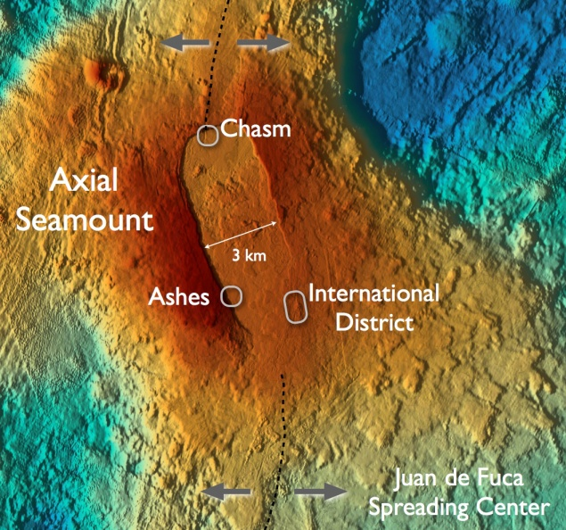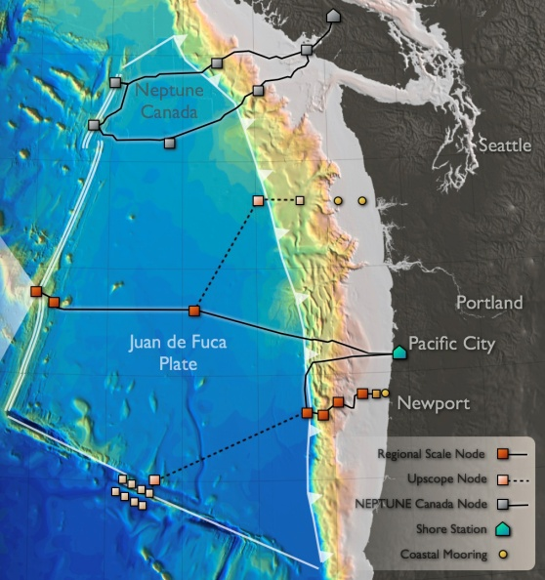

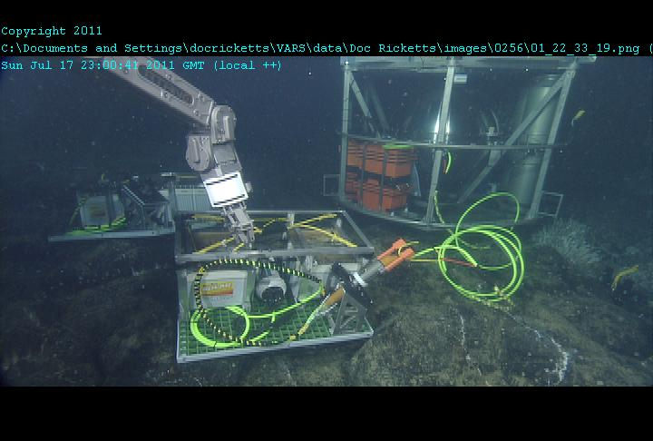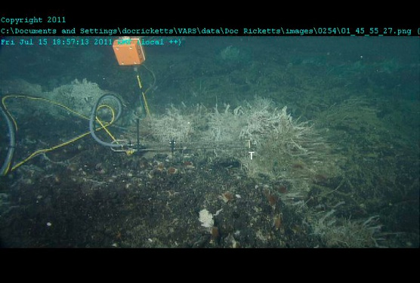
Figure 4. Site map showing location of the Ashes vent field within the context of NSF’s planned Ocean Observatories Initiative regional scale node cabled observatory (top; courtesy of J. Delaney) and the D-ESP deployed at the Ashes vent field within the Axial seamount caldera (bottom). Left bottom: elevator with external battery pack. Right bottom: the sample wand with its tip positioned in a crack along the seafloor that was expelling warm water.

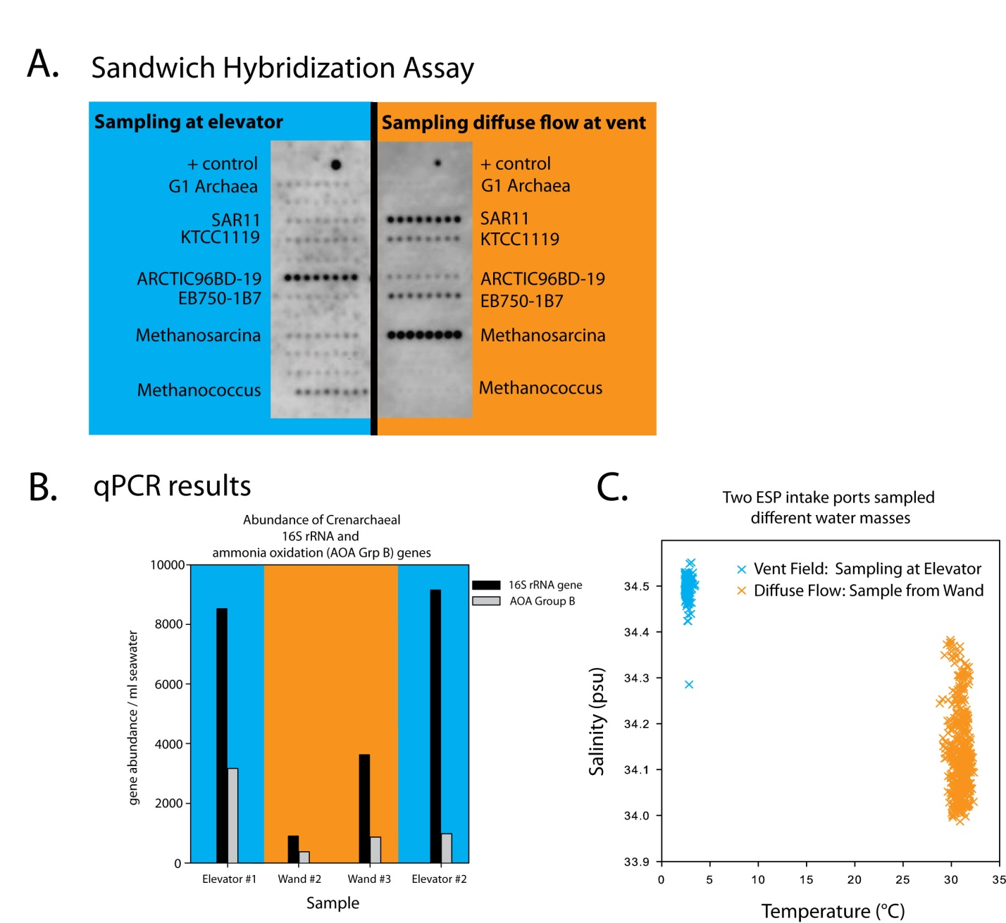
Figure 5. Examples illustrating data obtained while operating the D-ESP at Axial Seamount: (A) sandwich hybridization shows differences in rRNA community structure when sampling away from or within the vent; (B) real-time qPCR shows differences in gene copy number (Grp 1A and AOAb genes) depending on collection site; (C) temperature/salinity plot shows samples collected are from two distinct sources.

Hydrothermal vents are an ideal place to reveal the efficacy of the ISMS. Hydrothermal vents are exceedingly dynamic in temperature and geochemical composition, and there has been a long-standing desire among the vent scientific community to develop instruments that are capable of making high spatial and temporal chemical measurements in situ. The ISMS is equipped with a titanium heat exchanger that enables us to sample fluids to temperatures up to 350° C, which we have used in previous studies to constrain the geochemical flux from hydrothermal vents, as well as the metabolic activity of microbes in the subsurface biosphere (Wankel et al, 2011), as well as to constrain the uptake of hydrogen by vent mussels symbiotic with bacteria (Petersen et al, 2011). The ability of the ISMS to quantify hydrogen and other volatiles in fluids with widely varying temperatures is a key attribute of this instrument that makes it wells suited for these environments.

During the deployment at Axial, the ISMS was operated for the majority of the time that the D-ESP was sampling (though the ISMS was powered down for several hours while the D-ESP was sampling background seawater, in order to prolong battery life). The ISMS captured the striking differences in geochemical composition among the three sample regimes; highly diffuse fluids above the vent, warmer vent fluids near the bottom, and background seawater. It was apparent that there were variations in dissolved volatiles over short periods of time, and at different modalities. Specifically, while each of these geochemical regimes was quite different from one another, there is a periodicity in volatile composition that is evident in the reduced gasses (e.g., methane and hydrogen sulfide; see Fig. 6). It is not yet clear whether this is tidal in nature, or attributable to some other factor. Nevertheless, we were fortunate that some of these “peaks and valleys” correspond to discrete D-ESP sampling events; it remains to be seen whether these fluctuations in geochemical composition are apparent in microbial gene expression.

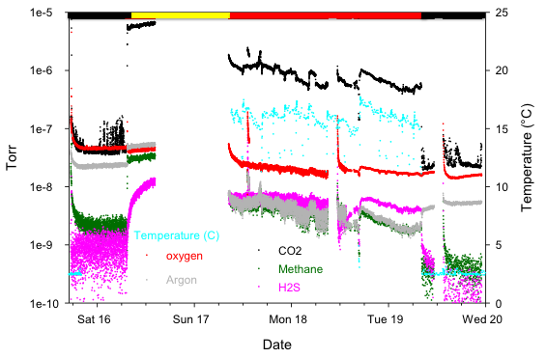

Figure 6. ISMS data collected over four days at the Ashes hydrothermal vent field. The horizontal lines at the top of the figure correspond to the sampling regime (Black = background; yellow = highly diffuse flow; red = warmer, focused flow). The gaps in the data correspond to periods during which the ISMS was switched off for power conservation. Temperature is shown in teal, key volatiles shown in their corresponding colors. Other volatiles that were measured, e.g. hydrogen, nitrogen, C2-C4 alkanes, are not shown for simplicity.

REFs cited are somewhere in this list

Ottesen, E.A., R. Marin III, C.M. Preston, C.R. Young, J.P. Ryan, C.A. Scholin and E.F. DeLong. Metatranscriptomic analysis of autonomously collected and preserved marine bacterioplankton. The ISME Journal (advance online publication, June 30, 2011; doi:10.1038/ismej.2011.70; leveraged activity).

Petersen J.M., Zielinski, F.U., Pape, T., Seifert, R., Moraru, C., Amann, R., Hourdez, S., Girguis, P.R., Wankel, S.D., Barbe,V., Pelletier, E., Fink, D., Borowski, C., Bach, W., and Dubilier, N. 2011. Hydrogen is an energy source for vent symbioses. Nature 474, 11 August 2011. doi: 10.1038/nature10325

Preston, C.M., A. Harris, J. P. Ryan, B. Roman, R. Marin III, S. Jensen, C. Everlove, J. Birch, J. M. Dzenitis, D. Pargett, M. Adachi, K. Turk, J. P. Zehr, C. A. Scholin. 2011. Underwater application of quantitative PCR on an ocean mooring. PLoS ONE 6(8): e22522. doi:10.1371/journal.pone.0022522

Robidart, J.C, C.M. Preston, R.W. Paerl, K.A. Turk, A.C. Mosier, C.A. Francis, C.A. Scholin, J.P. Zehr. Seasonal dynamics of Synechococcus and Thaumarchaeal microbial populations in Monterey Bay resolved in real time with remote in situ instrumentation. The ISME Journal (in press).

Saito, M.A., V.V. Bulygin, D.M. Moran, C. Taylor, C. Scholin. Examination of microbial proteome preservation techniques applicable to autonomous environmental sample collection. Frontiers in Aquatic Microbiology (in press).

Tavormina PL, Ussler W, Orphan VJ (2008). Planktonic and sediment-associated aerobic methanotrophs in two seep systems along the North American margin. Applied and Environmental Microbiology 74: 3985-3995.

Tavormina, P.L., V.J. Orphan, Marina K, M. Jetten, M. Klotz (2010a) A novel family of functional operons encoding methane/ammonia monooxygenase-related proteins in gamma-proteobacterial methanotrophs. Environ. Microbiol. Reports 3:91-100.

Tavormina PL, Ussler W, Joye, SB, Orphan VJ (2010b). Distributions of putative aerobic methanotrophs in diverse pelagic marine environments. ISME J. 4:700-710.

Ussler, W., P. Tavormina, C. Preston, S. Shah, P. Girguis, J. Birch, V. Orphan, C. Scholin. Autonomous qPCR in the Deep Sea. (in prep for Deep-Sea Research).
Wankel, S.D., Joye, S.B., Samarkin, V.A., Shah, S.A., Friederich, G., Kyriazi, J., and Girguis, P.R. 2010. New constraints on methane fluxes and rates of anaerobic methane oxidation in a Gulf of Mexico brine pool via in situ mass spectrometry. Deep Sea Research II. doi: 10.1016/j.dsr2.2010.05.009.
Wankel, S.D., Germanovich, L.N., Lilley, M.D., Genc, G., DiPerna, C.J., Bradley, A.S., Olson, E.J., and Girguis, P.R. 2011. Geochemical fluxes from low-temperature hydrothermal vents influenced by subsurface biosphere. Nature Geosciences. doi: 10.1038/Ngeo1183
Wankel, S.D., Adams, M.A., Joye, S.B., and Girguis, P.R. In review. The role of anaerobic methane oxidation in governing carbon flux from metalliferous hydrothermal vent sediments. Environmental Microbiology.

Zehr, J.P., J. Robidart and C. Scholin. 2011. Marine microorganisms, biogeochemical cycles, and global climate change. Microbe 6(4) 169-175. (http://microbemagazine.org/index.php/01-2011-home/3280-marine-microorganisms-biogeochemical-cycles-and-global-climate-change)

5.5 New blog/outreach web links

http://www.mbari.org/expeditions/Northern11/index.htm (Axial expedition cruise blog, Leg 1)

http://www.mbari.org/staff/methane/ashes_highlights/ashes_highlights.html (video clip highlighting some of the D-ESP elevator operations)

http://www.mbari.org/expeditions/BioLINCS/index.htm (leveraged activity - free drifting PCR-enabled ESP; same type of instrument and methods deployed on coastal mooring and at Axial)

http://centerforoceansolutions.com/initiatives/land-sea-initiative/rapid-detection-harmful-microbes-seawater (example of knowledge transfer – using PCR-enabled ESP as a model for automating water quality analysis)

6.0 References cited outside of those supported in whole or in part by this grant

Heintz, M et al. (2008) Methane consumption in waters overlying a hydrate associated mound in the Santa Monica basin: a project synopsis. Proceedings of the 6th International Conference on Gas Hydrates (ICGH 2008), Vancouver, British Columbia, CANADA, July 6-10, 2008.

Scholin, C, G. Doucette, S. Jensen, B. Roman, D. Pargett, R. Marin III, C. Preston, W. Jones, J. Feldman, C. Everlove, A. Harris, N. Alvarado, E. Massion, J. Birch, D. Greenfield, R. Vrijenhoek, C. Mikulski, K. Jones. 2009. Remote detection of marine microbes, small invertebrates, harmful algae and biotoxins using the Environmental Sample Processor (ESP). Oceanography 22:158-167.

Y. Zhang, R. S. McEwen, J. P. Ryan, and J. G. Bellingham. 2010. Design and Tests of an Adaptive Triggering Method for Capturing Peak Samples in a Thin Phytoplankton Layer by an Autonomous Underwater Vehicle IEEE Journal of Oceanic Engineering, Vol. 35, No. 4, pp. 785-796; DOI: 10.1109/JOE.2010.2081031 .

