Design and Fabrication of a 1m Titanium Sphere for 4000m Ocean Depth
Douglas M. Pargett

Abstract
A primary goal of the Monterey Bay Aquarium Research Institute (MBARI) is to extend the operating depth of ocean scientific instrumentation. The Environmental Sampling Processor (ESP) program utilizes complex, robotic instruments for in situ identification and quantification of larvae, bacteria and other microscopic organisms in near real time [1, 2], but typically in shallow water. The ESP instrument is roughly cylindrical, approximately 575mm in diameter and 800mm tall, much larger than common deep water pressure housings, such as 400mm glass spheres. However, a large spherical pressure housing fitting the current ESP architecture could be fabricated from titanium near-net-shape castings, and drastically reduce fabrication costs.
With past success designing and utilizing cast titanium housings, MBARI developed a spherical Ti-6Al-4V housing, with 1015mm inside diameter and 540L internal volume, for use to 4000m oceanic depth. I report on the design, fabrication, assembly and testing of this sphere.

Pressure Housing Size Selection
There are two options for taking a large science instrument into the deep sea; create a miniature version of the instrument to fit available pressure housings, or create a large pressure housing to fit the current instrument. Nearly 50-person-years of engineering development were invested to develop and refine the ESP instrument, and a comparable effort would have been necessary to miniaturize it. However, the large spherical pressure housing would require less than 1-person year to develop and less than $200k to manufacture, machine and test.

Design
The design is a horizontally split, spherical housing of 1015mm inside diameter with 14 electrical connectors and 4 fluid penetrators just below its equator. Design factors were selected to provide a high likelihood that the finished housing would pass a 41.4MPa hyperbaric test appropriate for 4000m unmanned systems. Four different design factors were used, depending upon the failure mode and consequences.
A 2.0 critical pressure buckling factor and a 1.5 factor to minimum compressive yield strength apply to the thin pressure shell. A reduced 1.375 factor applies to regions that require dimensional stability but where yielding does not affect stability of the pressure shell, e.g. seals and penetrators. A further reduced 1.10 factor applies to stress concentration regions that are not dimensionally critical, nor affect pressure shell stability, e.g. fastener holes.
Iterative FEA modeling was performed on a quarter section of hemisphere, fixed by symmetry on the cut faces, and a sliding, on-plane contact for the o-ring sealed face. I also report design considerations for fittings, penetrators, galvanic isolation, and manufacturing lead times.

Casting
Casting can provide a cost effective near-net-shape blank for final machining, thereby making affordable the manufacturing of large, complex geometries from expensive materials such as titanium [3]. The finished sphere is 400kg, machined from 500kg of castings instead of 4600kg if machined from solid stock.
Porosity and void pockets are a concern with any casting, and these underwent hot isostatic press (HIP) treatment to mitigate such conditions. One void pocket was found during machining (fig. 1), in a low stress area of the sphere. I report on the HIP process, illustrating the conditions where it does not remove voids, and how they can be detected.
The first casting had mild deformation that would likely impact the machined geometry. MBARI was given the option of accepting the first casting as is or the manufacturer could attempt a weld repair to build up the shell surfaces. Solid modeling determined that with some design modification, the full pressure rating could be met with the original casting. MBARI chose to accept the casting rather than risk the stresses and material inconsistencies imposed by the amount of welding required. Subsequently, the casting pattern was modified and the second casting did not have the deformation issues.

Machining
The castings were fully machined on all surfaces to remove excess mass, but also to bring the spheres to a specified uniform shape and geometry. Minor design changes were necessary to best machine the top hemisphere from the deformed first casting. However, even with these changes, design shape was not met as evident by residual cast surfaces (fig. 2). Inspection and post machining FEA determined that the hemisphere was still within the allowable for unmanned operations to 4000m.
The sphere was tested in a hyperbaric pressure chamber to 41.4Mpa and strain results are compared to FEA predictions, revealing a Young’s modulus property different from the typically accepted value (fig. 3).

Assembly and Leak Testing
A process for assembling and sealing the sphere has been developed to ensure clean, reliable sealing with full o-ring compression. This ensures proper o-ring seating and allows for leak testing to be done on the same seal geometry as when deployed.

Internal Mounting
The pressure at 4000m depth reduces the sphere diameter, so an internal mounting frame isolates the instrument and components from this deformation. Instead of typical rubber or flexible supports, a circumferential ring is held fixed in all directions by stems that have a loose sliding fit into the equatorial penetrator holes of the bottom hemisphere (fig. 4).

References
- Scholin, C. S. Jensen, B. Roman, E. Massion, R. Marin, C. Preston, D. Greenfield, W. Jones, K. Wheeler, “The Environmental Sample Processor (ESP) – An Autonomous Robotic Device for Detecting Microorganisms Remotely using Molecular Probe Technology.” Proceedings, OCEANS 2006 MTS/IEEE Conference. Boston, MA. Marine Technology Society, Columbia, MD.
- Environmental Sampling Processor website: http://www.mbari.org/esp/
- Ashraf Imam, M. Froes, F. “Low Cost Titanium and Developing Applications” JOM Journal of the Minerals, Metals and Materials Society: Volume 62, Number 5, Pages 17-20, DOI: 10.1007/s11837-010-0069-8
- Donachie, M.J. Jr, “Titanium: A Technical Guide” 2nd Ed., Materials Park, OH: ASM International, 2000, ch 6.
- Y.T. Lee, G. Welsch, “Young's modulus and damping of Ti---6Al---4V alloy as a function of heat treatment and oxygen concentration.” Materials Science and Engineering: A, Volume 128, Issue 1, 15 August 1990, Pages 77-89, ISSN 0921-5093, DOI: 10.1016/0921-5093(90)90097-M.

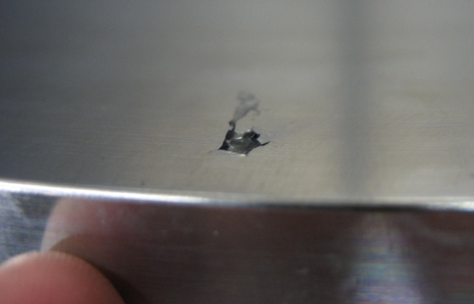
Fig. 1. 5mm wide void uncovered during machining. Such voids survive the HIP process only if open to the surface of the casting, a condition detectable with dye penetrant.

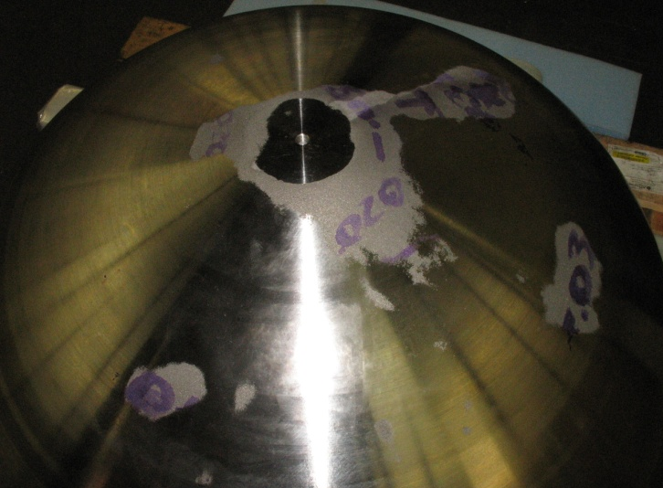
Fig. 2. Residual cast surfaces on top hemisphere after machining indicate that design geometry was not achieved. FEA determined that stresses are within allowable for unmanned systems to 4000m oceanic depth.

Fig. 3. Nominal surface strains during hyperbaric testing align with FEA strains for reduced modulus of elasticity, 104MPa instead of the 114MPa typically used.

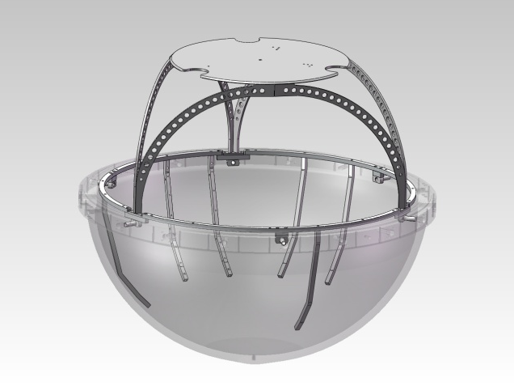
Fig. 4. Internal mounting structure is isolated from radial deformation when the sphere compresses at 4000m oceanic depth.

