Design and Fabrication of a 1m Titanium Sphere for 4000m Ocean Depth
Douglas M. Pargett
Abstract—A spherical pressure housing slightly greater than 1 meter inside diameter has been designed, fabricated from near-net-shape Ti-6Al-4V castings, and tested for robotic operations in 4000m seawater. This paper discusses the design considerations, methodology, fabrication processes, and hyperbaric testing of the sphere. An additional note on mounting equipment inside the sphere is included.

Index Terms—near-net-shape cast titanium, spherical pressure housing, hyperbaric testing.

INTRODUCTION
A
PRIMARY goal of the Monterey Bay Aquarium Research Institute (MBARI) is to extend the operating depth and duration of ocean scientific instrumentation. The Environmental Sampling Processor (ESP) program utilizes complex, robotic laboratory instruments for in situ identification and quantification of larvae, bacteria and other microscopic organisms in near real time [1], [2]. This avoids the time lag and changes of state that occur when samples are sequestered and transported to the laboratory for analysis. As a robotic system it can be deployed for months, enabling new research in tracking microbial activity over time without human presence.
An ESP instrument performs seawater collection and processing from within a one-atmosphere pressure housing, however it is typically operated at depths less than 50 m. In order to use the ESP’s scientific capabilities in the deep ocean, MBARI developed pressure interface equipment which enables the instrument to collect and process samples at ocean depths to 4000 m. One of the critical components was the deep ocean pressure housing for this instrument. With past success designing and utilizing cast titanium housings, MBARI engineers developed a spherical grade 5 titanium (Ti-6Al-4V) housing, greater than one meter in diameter, for use to 4000 m depth. This paper focuses on the design, fabrication, assembly and testing of this sphere.

Pressure Housing Size Selection
The ESP instrument is several times larger than typical deep water pressure housings, such as 434 mm glass spheres. There were two possibilities for developing a Deep ESP system, either create a large pressure housing to fit the current instrument, or create a miniature version of the technology.
For size comparison; the shallow water ESP pressure housing (50 m rated) is a welded aluminum cylinder with 210 L of volume. It was originally oversized for additional buoyancy, however the extra volume allowed for technology improvements as add-on modules expanded the instrument. An early 1000 m deep ESP project used a spun cast nickel-bronze-aluminum alloy housing, almost half the volume of the 50m shallow housing. However no add-on modules could be included, significantly limiting the science potential.
The small pressure housing option would have limited the instrument to only 34.5 L of space and required a major size reduction to the instrument without changing its functionality. Nearly 50 person-years of engineering development were necessary to develop the current ESP instrument, and refine its functionality. Miniaturizing the instrument would have been an intractable, high risk development.

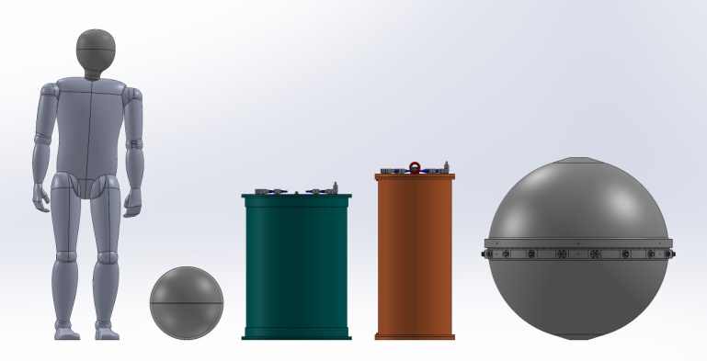
B
A
C
D
Fig. 1. Size comparison of instrument housings: A. Glass spherical housing, 404 mm ID, 34.5 L volume; B. ESP 50 m rated cylindrical aluminum housing, 210 L volume; C. ESP 1000 m rated cylindrical housing, 103 L volume; D. ESP 4000 m rated spherical titanium housing, 540 L volume.

However, the casting of near-net-shape titanium structures can drastically reduce cost [3], and a feasibility review determined that developing a large spherical pressure housing to fit the current ESP architecture, would be more cost and time effective. The large pressure housing was proposed to be a sphere for efficient mass use, and modeling determined a 860 mm sphere (333 L internal volume) was the smallest the core instrument could fit within. However, a 1015 mm sphere was selected as it would allow the instrument with add-on modules to be deployed. This sphere has an internal volume of 540 L (Fig. 1). It would require less than one person-year to develop, and less than $200k to manufacture, machine and test. The large housing options was chosen as the most time and cost effective, but it would also allow for future resources to be focused on expanding the scientific capabilities of the instrument, rather than miniaturizing the current capability.

Design
The 4000 m pressure housing design was refined to a horizontally split, spherical housing of 1015 mm inside diameter. Most of the design work involved iterative finite element analysis (FEA) to manage the stress concentrations from bolting flanges, mounting points, and penetrator holes, as well as balancing the contact force between the two halves.
For bolting, sealing, and penetrations, there are areas of the sphere that do not follow the perfect spherical geometry. A thickened cylindrical hub at the equator provides area for penetrators and fittings, and gradually transitions to the spherical shell. At the crown of the hemisphere, the outside of the sphere transitions to a truncated cone top to provide a threaded lifting point, however the inside maintains spherical geometry.
The sphere is sealed with two concentric o-rings, creating a redundant face seal. The o-rings are compressed 25% during assembly, and fill 90% of the groove. This narrower than typical groove is used to prevent “snaking” of the o-ring in the groove, but also leaves more bearing metal contact area between the sphere halves.
Large diameter o-rings must be custom fabricated, but are available from many manufacturers as spliced or serpentine molded. The serpentine molded o-rings, although more expensive, seem to have better material consistency without the splice and likely provide a more reliable seal. The o-rings are ordered 1.25% smaller in diameter than the groove. The slight stretch during installation holds the o-ring against the inner wall of the groove and in the direction of the pressure gradient. Molded o-rings have been supplied by both Marco Rubber (North Andover, MA) and Atlantic Rubber (Littleton, MA).

Design Factors
The Deep ESP is a robotic system, serviced by remotely operated vehicle (ROV). As such the sphere was required to pass a hyperbaric test equal to the depth rating of the sphere, 4000 m of seawater. Design factors were set to provide a high likelihood that the finished pressure housing would pass the 41.4 MPa hyperbaric tests. After considering the novel design, casting and machining tolerances, material inconsistencies, and other complications that could affect the strength of the sphere, MBARI engineers used four design factors when evaluating the sphere. These factors varied depending upon the failure mode and consequences.
A design factor of 2.0 for critical pressure buckling was used on the spherical shell, and subsequently became the limiting condition for the spherical wall thickness.
The following stress design factors are applied with the limiting condition being minimum yield compressive strength.
A factor of 1.5 was applied for the pressure shell. Although most of the shell is design limited by buckling, stress risers in the shell were limited to this.
A 1.375 factor was applied for regions that require dimensional stability, but yielding will not likely affect stability of the pressure shell. Such stress concentrations are mostly around holes and sealing faces for the fittings and penetrators; places where yielding might affect the fitting, but would be unlikely to result in a leak or buckling deformation due to the pressure.
A 1.10 factor was applied for regions that are not dimensionally critical, nor likely to affect the pressure shell stability. The stress concentrations around holes that pass wires and fluid plumbing from the penetrators and fittings into the sphere are designed to this factor. If yielding occurs, the result is a smaller, somewhat deformed hole with minimal residual strain.
The material properties used for this design are: minimum compressive yield strength (Syc) of 930 MPa, minimum tensile yield strength (Syt) of 827 MPa, Modulus of Elasticity (E) of 113 GPa. However during hyperbaric testing, the modulus of elasticity was determined to be lower and will be discussed later in this paper.
By the design factors and material properties, a 4000 m depth-rated Ti-6Al-4V spherical shell, of 1015 mm ID, is limited by buckling at 23 mm thick. The combined weight of the assembled sphere is 405 kg, and displaces 660 kg of seawater, making it buoyant. The mass to displacement ratio in seawater is 0.61.

Computer Modeling, FEA
The sphere was designed with Solidworks, with the Simulation package for finite element analysis (FEA) to determine the maximum static stresses and localized concentrations. This also was used to predict the deformation of the sphere under pressure loading, such that predictive stains could be compared against during hyperbaric testing. The FEA modeling was done on one quarter of the hemisphere, fixed by symmetry on the cut faces, and a sliding, on-plane contact for the o-ring sealed face (Fig. 3).

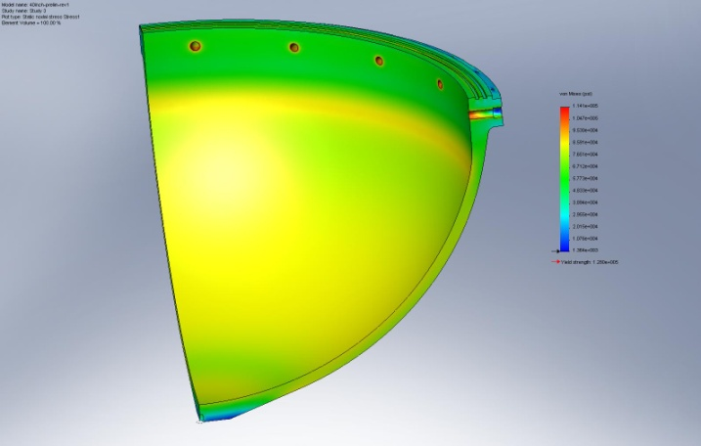
Fig. 3. FEA analysis was performed on a quarter section of the hemisphere.

The hub required significant attention to manage the sealing face bearing pressure and minimize the stress risers due to the penetrator holes. To balance the bearing pressure of the two hemispheres across the seal face, the cylinder of the hub is a smaller inside diameter than the sphere; 990 mm opposed to 1015 mm. If not balanced, the hub could “smoke ring”, deform in a toroidal roll, which could cause seal gapping, o-ring extrusion, and seal failure.
All the stress and buckling analyses were duplicated using differing methods, providing high confidence in the design. MBARI performed FEA on a solid model, with validating results from a cross section shell analysis using Ansys. The critical pressure for buckling was calculated with a spreadsheet implementation of Roark’s formulas for stress and strain, with validating results using the Under Pressure software from Deep Sea Power and Light.

Fittings
All fittings and penetrators are mounted on the bottom half of the sphere so that the ESP instrument, wiring and plumbing remains intact and functional while the sphere is open. System requirements called for a minimum of 11 electrical fittings and four fluid penetrators. Three spare electrical fittings were added for future expansion, making the spacing work out well at 18 equidistant ports, skipping between the 36 sphere closure fasteners. There are also six blind radial holes tapped into the outer hub of each hemisphere for use in lifting and mounting the sphere on a deployment platform.
The electrical penetrators are SeaCon Mini-con MINK FCR in titanium. The FCR version was chosen as they mount in a smooth bore port and are held with external fasteners, as opposed to the BCR version which screws into a threaded port. This eliminates the risk of accidentally unthreading the fitting from the housing when disconnecting a cable.
Of the four fluid penetrators into the sphere; two pass a decompressed seawater sample through the ESP instrument for microbial identification, and two are used for venting, helium leak detection, and nitrogen purge cycles when sealing the sphere for deployment. After the nitrogen purge, one of the vent penetrators is fitted with a pressure relief valve, set to vent at 27 kPa internal pressure.

Galvanic Isolation
Titanium is a very noble metal, even the Ti-6Al-4V alloy. As there is a lot of exposed surface area on a sphere this size, it can sustain aggressive galvanic reactions. Material matching and isolation is necessary for protecting against corrosion. The electrical fittings and all fasteners are titanium for this reason. The four fluid penetrators are made from 316 stainless steel, to match the material of tubing and valves feeding seawater to the ESP. As these penetrators are of dissimilar metal to the sphere, an o-ring sealed PEEK dielectric isolator was designed and included during hyperbaric testing. If the external tubing and valves are replaced with titanium components for long deployments, these penetrators can be replaced with titanium.

Forward Design
As there can be long lead times for titanium castings of this scale, the sphere design needed to be completed early in the project. The design and drawings were completed and casting patterns ordered when the rest of the Deep ESP system was only at a conceptual stage. Early communication with the casting company was critical to getting onto the pour schedule and estimating the lead times and costs.

Casting
Casting can provide a near-net-shape blank for final machining, thereby making affordable the manufacturing of larger, complex geometries from expensive materials such as titanium [4]. For this design, each machined hemisphere weighs about 200 kg and could be machined from a near-net-shape blank of approximately 250 kg (Fig. 4), or from a 2300 kg cylindrical billet. Forging can also provide a lower mass hemispherical blank, however in-house experience with cast hemispheres indicated that a much closer net shape could be obtained by casting and a forged machinable blank was not pursued.

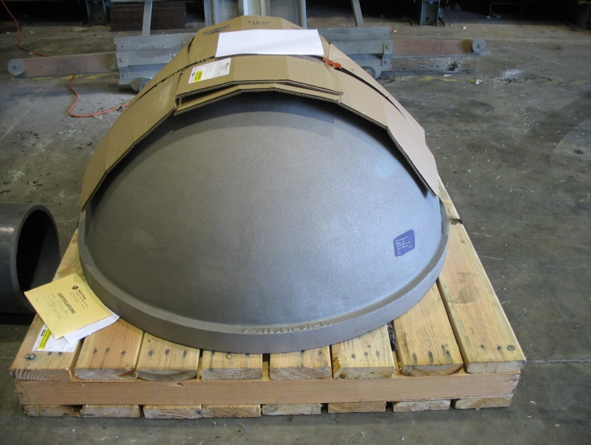
Fig. 4. Ti-6Al-4V near net shape cast hemisphere, weighing 250 kg. Such castings are poured in a rammed graphite mold, produced from hardwood patterns. The time to produce the patterns, make molds and pour the castings can exceed a year.

As pattern costs can be significant, the sphere was designed for both hemispheres to be machined from castings of the same pattern. Wah Chang (Albany, OR) produced the castings and coordinated the fabrication of hardwood patterns based upon MBARI machining drawings. The mold cope and drag are made from this pattern with rammed graphite. The castings were poured from Ti-6Al-4V, with coupons cast and processed at the same time for material property validation.
Post casting processes include weld repair of voids, annealing and other heat treatments. The casting process forms an oxidized surface layer, an alpha phase case on the casting. This highly brittle surface can initiate stress concentrating cracks into the base metal, reducing the load capacity. Wah Chang used sandblasting and chemical stripping to remove this surface.
A concern with any casting is the potential for porosity and void pockets in the metal. Instead of regular annealing, the cast hemispheres underwent hot isostatic press (HIP) treatment. In the HIP process, the casting is heated above the annealing temperature, in an inert, high pressure atmosphere. Any voids collapse and the material diffusion bonds, effectively eliminating porosity. With an exception being that any voids open to the surface can equalize pressure during the HIP and not collapse. One such open void was found in the machining of the top hemisphere (Fig. 5). However, as this void was in the thick hub section and in an area where surface finish is not critical, it was evaluated as zero risk and was not repaired.

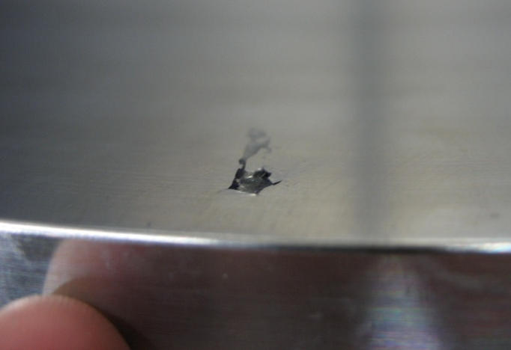
Fig. 5. 5 mm wide void on inside surface of sphere was uncovered during machining. Such voids can survive the HIP treatment if open to the surface, which also makes them detectable with dye penetrant. Weld repair can be performed prior to machining.

Typically, such voids are readily visible on the surface and are weld filled. To verify that there were no other voids, Wah Chang recommended dye penetrant testing as a cost effective alternative to 100% radiography. After machining was completed, both sphere halves were shipped back to Wah Chang for dye penetrant testing, and no other open voids were found.
The two hemispheres were cast separately, with several weeks between for the first hemisphere to complete processing and measured against the desired shape. If needed, the pattern could be modified so future castings will better fit the required geometry.
The first casting did deform somewhat, possibly during casting or during HIP treatment. It ended up slightly shorter and a little wider at the hub diameter, as if the casting had sagged slightly. However, the first casting was very close to the desired geometry and MBARI was given the option of accepting the first hemisphere as is or Wah Chang could perform a weld repair. The repair action would have been to build up weld material over the upper portion of the casting, adding thickness so that a full shell could more likely be machined from the casting.
To assist in making this decision, Wah Chang provided a measured drawing of the casting, and MBARI compared that to the final machine model. It was likely that with some modification to the design, the full pressure rating could be met with the original casting. MBARI considered the options very carefully as the face seal of the hemisphere would require a very flat finish. Considerable stresses and material inconsistencies would be imposed by the amount of welding required. Although annealing could mostly normalize these stresses, machining through the weld material could cause the sphere to deform. MBARI chose to accept the casting as is, rather than risk the uncertainties of the weld build up.
The pattern was adjusted for the second casting, which did maintain more than sufficient dimensions for machining. Therefore the first cast article was chosen for the sphere top, as it would require less machining. If needed, it could be replaced at less cost.

Machining
The castings were fully machined on all surfaces for two reasons; primarily to remove excess mass, but also to bring the spheres to a specified shape and uniform wall thickness. Although casting provided a near-net-shape to the design, the actual wall thickness and curvatures can vary drastically. Indentations, thinned areas or even flats can be expected on the as-cast finish.
The design factors considered tolerances for a machined surface, not a cast surface. If much of the hemisphere surface were to be left as the uneven cast finish, the shape and wall thicknesses would be less uniform and strains could be unbalanced, invalidating the buckling calculation. If the surface were to be left as cast, wall thicknesses and spherical geometry could have been mapped in detailed and modeled extensive FEA to estimate the critical buckling pressure, but accuracy would be suspect. Also, there is no expectation that one casting would have the same tolerances as another, even if the mold is rammed from the same pattern. Each casting would need to undergo mapping and FEA for critical buckling.
The finished castings were machined at Tapemation Inc (Scotts Valley, CA). Along with having the skill and equipment to machine the hemispheres, a major benefit of Tapemation was their location, a short drive from MBARI. Inspections were done regularly and at machining milestones, and design adjustments made when needed to obtain the best pressure rating from the emerging geometry.
Prior to machining, each hemisphere was mapped in a coordinate measuring machine, to generate point cloud models for comparison to the design final geometry. A change was made to the design to best fit the top hemisphere within the casting. This change was to shorten the height of hemisphere by 2.5 mm. This would place the center of the sphere slightly below the face and additional FEA was done to ensure that it would not affect the bearing contact or the seals. The bottom hemisphere required no design changes.
After machining, a few cast surface spots were still present on the outside of the top hemisphere, indicative of a thinner wall at these locations (Fig. 6). However, the inside did get full clean up and met geometry. These outside spots were measured with a spherical depth gauge and the shell thickness was at least 95% of the 23 mm, and modeled as a worst case condition: a flat spot 1.5 mm deep and 80 mm in diameter, to determine if it is still within our design factor for stress. Buckling was modeled as well, but the analysis was not definitive. The critical pressure for buckling was estimated to be less than the design factor of 2.0, but still well above our planned hyperbaric testing pressure. MBARI engineers decided to continue with this top hemisphere and test for 4000 m depth, with real-time strain monitoring of these points.

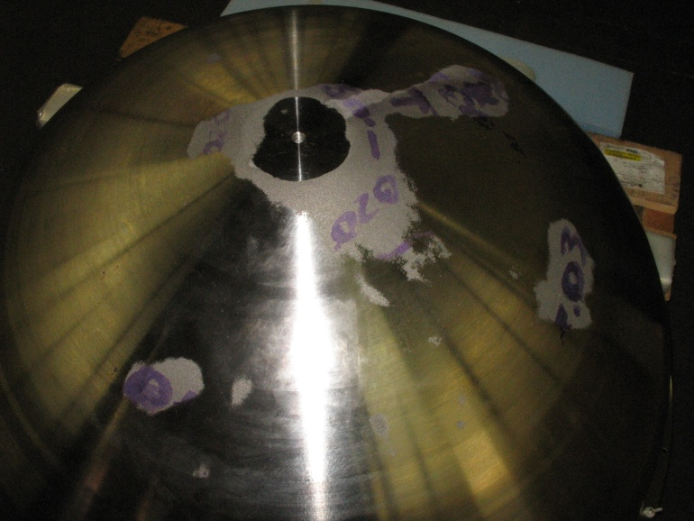
Fig. 6. Residual cast surfaces on top hemisphere after machining indicate localized thin spots on the shell. Additional FEA would determine that the stress concentrations would still be within our design factors.

One action that reduced risk during machining was switching to finer threaded fasteners. The MINK FCR connectors are typically mounted with 6-32 screws. However, tapping 6-32 holes in Ti-6Al-4V is difficult and notorious for resulting in broken taps stuck in holes. A simple modification is to tap the holes for 6-40 screws, which requires much less tapping force due to the finer thread. The tap has a larger minor diameter and is less likely to break. The drawback is that 6-40 titanium screws are not common. These needed to be custom ordered at some additional cost, but well worth the expense to offset the risk. The 6-40 screws, as well as all other titanium fasteners for the sphere, were supplied in grade 2 titanium by United Titanium (Wooster, OH).

Assembly
A process for assembling and sealing the sphere has been developed to ensure reliable sealing with even o-ring compression. Although ocean pressure will quickly provide more than sufficient force to fully close the sphere, mechanically seating the seal in a parallel motion guarantees even compression of the o-rings, avoiding any misalignment and pinching. This also allows for leak testing to be done on the identical seal geometry as when deployed.
The 36 housing fasteners (1/4-20 thread) are tightened in a cross pattern. Starting from finger tight, each fastener is turned only one quarter turn at a time, with an initially low torque limit. The cross pattern continues, until all fasteners require the same low torque. At which point a go/no-go gauge is used in the recessed groove around the equator to determine if the sphere is fully seated metal to metal. This indicates that the o-rings are fully within the grooves and not extruding or pinched anywhere. If the initial gauge test fails, further tightening of the fasteners can be performed and the gauge test repeated. A set maximum torque can be used to pass the gauge test, however if the gauge still indicates the sphere is not closed metal to metal all around the circumference, the housing is opened and the o-rings inspected and possibly replaced.
This assembly process in not fast but has provided reliable sealing for each deployment. To date, the few times the sphere has not passed the gauge test, a pinched or bad o-ring was found. Not only is such a condition a potential leak when deployed, but can result in damage to the titanium sealing faces. Any material pinched between the sphere halves would form a gap; however the incredibly high forces from the sea pressure will try to extrude the material and close that gap. As that gap gets smaller, the pressure extruding the o-ring material through it will eventually be greater than the bearing strength of the titanium surface, embossing the titanium face or groove edge.

Testing

Helium leak testing
Helium leak testing is a critical step in testing the integrity of the housing, but also when preparing the instrument for each deployment. The first assembly of the sphere, prior to installation of any internal equipment, was helium leak tested under vacuum to verify seal integrity of all the components prior to performing the hyperbaric tests.
For leak testing prior to deployments, a mild inner pressure test is performed. The ESP instrument contains many liquid reagents which cannot be exposed to the vacuum typical of helium leak testing. The vent and purge penetrators are located on the hemisphere equator, but have tubes to the top and bottom inside the sphere. The sphere is slowly filled with helium from the top down, displacing the air out the bottom vent. This provides a high concentration of helium along the equator seals and also displaces the oxygen out of the sphere. Because of the large pressure area of the sphere and relatively low tensile capacity of the fasteners, the helium is pressurized to no more than 13.8 kPa for the leak test. The leak test is performed with a mass spectrometer detector in sniff mode, inspecting the equator seal and all fittings and penetrators. This test validates that all the seals are in place, not scratched, damaged or dirty. It will not however, detect a structural fault that could become a leak such as a pinched o-ring. Hence the need for the go/no-go gauge test discussed earlier.
After leak testing is complete, the helium is displaced out with nitrogen but from the bottom up. The helium is not left in the housing as it can be absorbed through the plastic tubing into the ESP reagents, subsequently forming bubbles in the fluid lines. Additionally, the pure nitrogen atmosphere inside the sphere, instead of air, is a simple safety precaution against combustion as many of the reagents used by the ESP are ethanol based and there are open electronics and brushed motors in the ESP.

Hydrotesing
After the initial assembly and vacuum leak testing verified that the sphere could be sealed, it was shipped to Southwest Research Institute (San Antonio, TX) for hyperbaric testing.
Several strain gauges were placed at points inside and outside of the sphere, at the thin spots on the top hemisphere and nominal locations that did machine to design geometry. These provided real-time monitoring of the nominal, maximum, and minimum strains at the inside and outside of the shell. All of the fittings and penetrators were installed for the testing, with one penetrator being used to pass the conductors to the internal strain gauges.
During hyperbaric pressure testing, strains were compared to the FEA predictions. The initial pressurization was done in stages, and if strains indicated a maximum shell stress had reached a design factor limit or that any strain had become non-linear, the pressure test could be truncated and the sphere de-rated. The hyperbaric test was completed to full design pressure for 4000 m seawater, 41.4 MPa (Fig. 8). During pressure testing, the maximum stress seen in the shell, at one of the cast surface patches, was 520 MPa, compared to a nominal outside shell stress of 450 MPa. This matched very well with the FEA predicting max stress of 540 MPa. Stress wise, it is within the design factor, however this should not be construed as operational reserve as the limit to operation depth will be due to buckling.

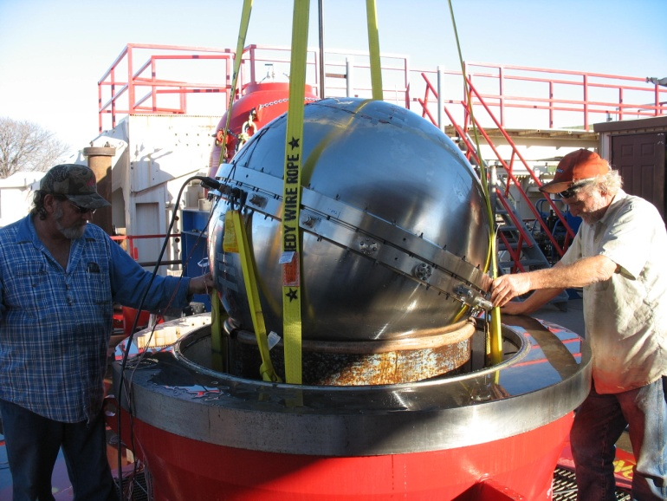
Fig. 8. Sphere being removed from hyperbaric chamber at SwRI after pressure testing to 41.4 MPa.

An important finding resulted from the hyperbaric test stresses, which are calculated from the actual strains, being uniformly larger than predicted by FEA. This finding justified a reevaluation of the modulus of elasticity for the metal. Either the shell was uniformly 10% thinner, which inspection had proven to not be the case, or the modulus of elasticity for the material must be lower than the design had considered. Further investigation has found that the modulus of elasticity for Ti-6Al-4V can vary from 100 to 130 GPa [5]. Aligning FEA and calculated strains with the nominal shell strains monitored during testing determined that both castings have a modulus of elasticity around 104 GPa (Fig. 9). This revised modulus was used to recalculate the design factor to buckling as 1.8 instead of the original 2.0.
The actual buckling factor is probably even lower due to the shell thin spots; however the critical buckling pressure of the imperfect pressure shell has not been modeled effectively. It is important to remember, that this sphere is designed for robotic operations and required a 41.4 GPa hyperbaric test, which was fully accomplished. If deemed necessary in the future, a new top hemisphere can be cast from the modified pattern and machined.

Fig. 9. Nominal strains measured during hyperbaric testing aligns with calculated strains for a modulus of elasticity of 104 GPa, very near the low end of the 100-130 GPa range.

Internal Mounting Structure
Mounting equipment inside the sphere posed a challenge, as any internal structure needs to isolate pressure deformation from the internal components. As with any pressure housing, sea pressure strains the shell of the sphere, slightly reducing its diameter. At 4000 m seawater depth, the diameter of this sphere could decrease 5 mm in some shell locations. As an example, a common mounting technique in spherical housings involves adhering posts to the sphere which then have flexible rubber mounts to the internal equipment. The rubber mounts provide flexural isolation between the equipment and the pressure housing.
As this instrument has significant mass, a completely different method was used to mount equipment in this sphere. It does not flex but provides secure, rigid support to the 60 kg of internal equipment and still allows the sphere to deform freely. A circumferential ring like an internal halo is supported at six equidistant locations by radial stems that have a loose sliding fit into equatorial holes in the bottom hemisphere (Fig. 10). These holes are the wire feed through bores from the penetrators mounted on the outer diameter. The sliding stems that fit into these holes are hollow as well and the wires from the penetrators still pass through to the core equipment.

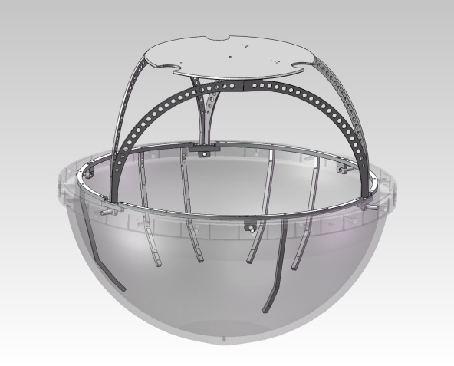
Fig. 10. Strain isolated internal mounting structure provides rigid support, allowing only concentric motion on the sphere.

This mounting arrangement locks the internal equipment to the sphere in all six axes, but allows concentric expansion and contraction along the radial stems. As the sphere deforms under pressure, its diameter reduces uniformly, but the sliding fit on the support stems keep the mounting ring from changing geometry and transfers no strain into the equipment. The ring itself is made in sections, so that parts of it can be removed and modified for new hardware.
The ESP instrument was designed to be suspended from the top lid of a cylindrical housing, so in the sphere it hangs from a spider structure that sits on three points of the mounting ring. Legs extend above and below the halo ring to support electronic power and data equipment. The shaped legs follow the inward curve of the sphere but stand off from it.

Deployment and Usage
The Deep ESP instrument and sphere has been deployed several times on a benthic freefall elevator to depths up to 1800 m. At the time of this writing, it is deployed in the Monterey Bay canyon for a six month mission, attached to the Monterey Accelerated Research System (MARS) cabled observatory (Fig. 11).

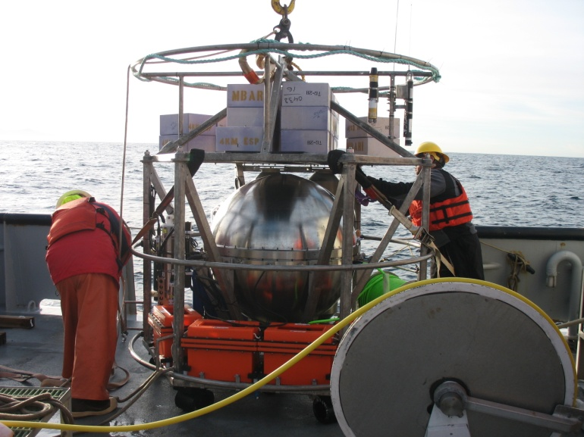Fig. 11. The sphere, mounted in a freefall benthic lander, is being readied for deployment in the Monterey Canyon from the R/V Point Lobos.

Conclusion
A spherical pressure housing, slightly greater that 1m in diameter has been fabricated from near-net-shape Ti-6Al-4V castings and tested for robotic/remote operations to 4000 m depth in seawater. The design factors chosen were sufficient to pass the 41.4 MPa hyperbaric test series, however indications are that actual reserve factors are less than the design factors.
Thin spots in the shell, evident by residual cast surfaces, can make stress concentrations in the pressure shell, although the action to repair such a material deficiency in the casting could be even more detrimental to pressure rating, or sealing success. In the future, it would be beneficial to have test articles fabricated to evaluate the stability of significant weld repair to a casting.
Hyperbaric testing strains indicate that the actual modulus of elasticity or the material is significantly less than typically referenced. Although not commonly performed during material certification testing, modulus of elasticity and other material properties can be obtained from casting coupons if requested. Future efforts of similar scale should consider this during design and testing.

Acknowledgment
The development of this sphere required the support of many individuals. Special thanks are given to Chris Scholin for leading the advancement of ESP technology, and the ESP team for considering novel engineering solutions. The author wishes to recognize Jon Erickson, designer of a 400mm cast titanium sphere, for the material input, debate about analysis methodology, and design reviews. Thanks to Mark Greise for the validating ANSYS analysis. Special thanks to the crews of the R/Vs Point Lobos, Western Flyer, and Rachel Carson for their expertise during field deployments.

References
- Scholin, C. S. Jensen, B. Roman, E. Massion, R. Marin, C. Preston, D. Greenfield, W. Jones, K. Wheeler, “The Environmental Sample Processor (ESP) – An Autonomous Robotic Device for Detecting Microorganisms Remotely using Molecular Probe Technology.” Proceedings, OCEANS 2006 MTS/IEEE Conference. Boston, MA. Marine Technology Society, Columbia, MD.
- Environmental Sampling Processor website: http://www.mbari.org/esp/
- Ashraf Imam, M. Froes, F. “Low Cost Titanium and Developing Applications” JOM Journal of the Minerals, Metals and Materials Society: Volume 62, Number 5, Pages 17-20, DOI: 10.1007/s11837-010-0069-8
- Donachie, M.J. Jr, “Titanium: A Technical Guide” 2nd Ed., Materials Park, OH: ASM International, 2000, ch 6.
- Y.T. Lee, G. Welsch, “Young's modulus and damping of Ti---6Al---4V alloy as a function of heat treatment and oxygen concentration.” Materials Science and Engineering: A, Volume 128, Issue 1, 15 August 1990, Pages 77-89, ISSN 0921-5093, DOI: 10.1016/0921-5093(90)90097-M.

This work was supported in part by the National Aeronautics and Space Administration (NNG06GB34G and NNX09AB78G), National Science Foundation (NSF-OCE0750058), and by the David and Lucile Packard Foundation through MBARI. D.M. Pargett is a mechanical engineer with the Research and Development Division, Monterey Bay Aquarium Research Institute, Moss Landing, CA 95039 USA, (phone: 831-775-2073; e-mail: pargett@mbari.org).

