ESP Integration into Existing Del Mar and CCE2 Moorings

This report outlines the mooring design considerations necessary to include an ESP in the existing Del Mar and CCE moorings. These systems are traditional chain-catenary oceanographic moorings that support inductively-linked instrumentation along jacketed wire-rope (Figure 2 and Figure 3). The intent is to deploy a system at the calmer Del Mar site as a stepping stone towards the more challenging deployment of Pt Conception at the CCE2 mooring site. For this reason, the design work here considers both sites with the intent that at least some elements of the design for the Del Mar site will be transferable to the CCE2 site. Figure 1 illustrates the locations off southern California.
The ESP in its shallow water housing is very massive compared to traditional oceanographic instrumentation. The instrument as typically deployed in its pressure casing (33” long and 24” in diameter), along with two battery cans (18” long and 10.5” in diameter) and a supporting frame has a mass of about 850lbs (390kg) and a displacement of about 300kg SW, making the entire assembly about 200lbs buoyant. The added mass of the water that must be accelerated when this is moved can be roughly approximated as if the instrument has the shape of a sphere, such that the added mass equals one half of the mass of the displaced water, representing an additional 150kg. Thus, the ESP instrument represents a mass of about 540kg inserted into the mooring string, with a mass per unit length of approximately 360 kg/m. The fact that the ESP mass is approximately equivalent to the surface buoy, makes the ESP a dominant feature of the dynamics problem for these moorings. When complaint mooring members are introduced, resonance features of the resulting dynamics can become important to consider. Additionally, typical wire rope used for the strength member in this type of mooring is about 0.3 kg/m, three orders of magnitude smaller. The abrupt change in mass-density of the mooring string raises the potential for cyclic bending of the strength members at the locations of change due to transverse dynamics which are harder to characterize than the axial resonance features.
The ESP includes other constraints that must also be considered. The accelerations that the device can tolerate for operation (or survivability) are not well characterized but are certainly a consideration as the instrument has many moving parts. The best information that is available is experience with previous deployments in which there have been no apparent failures due to high accelerations. Additionally, the instrument may not be tipped over more than about 30 degrees at any point in the operation, including deployment and recovery. This consideration drives the system design and deployment technique.
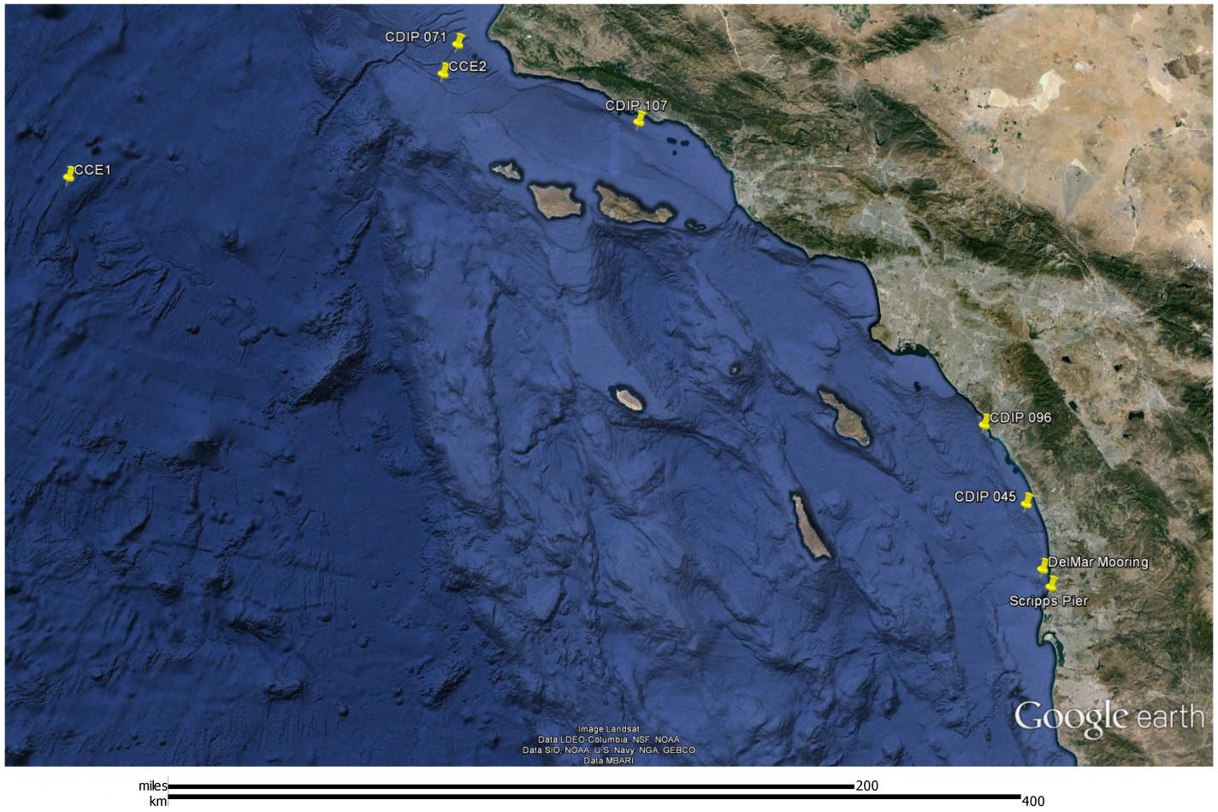
Figure 1: Location in Southern California of Del Mar buoy, CCE2 buoy, and relevant wave measurement sites.

Environment
Figure 1 illustrates the locations of the two sites (Del Mar and CCE2) relative to the location of wave-measurement instrumentation that has been in place long enough to provide some statistics (although none of these have been in place to reliably predict traditional measures such as the sea state present in a storm with an extended return period, i.e. 100 years). CDIP site 045 is likely to provide a reasonable representation of the Del Mar site and CDIP site 071 is quite close to the CCE2 mooring site. Figures A1-A3 in Appendix A illustrates the observed sea state at CDIP 0045 over the past 18 years. It is clear that this is an extremely mild location as ocean sites go, in this time the largest observed significant wave height over a 30 minute period was 4.8m with a peak period of 9s. Figures A4-A6 in Appendix A illustrate 9 years of data at CDIP 071 near the CCE2 site, in this time the largest observed significant wave height over a 30 minute period was 10.0m with a peak period of approximately 14s.
Current and wind data has not been collected at these sites. For wind in the subsequent analysis the wind required to create the fully developed sea state under consideration will be used (i.e. as per Pierson-Moskowitz). For currents the effects of an artificial range of estimates will be examined.

Table 1: Summary of observed conditions at sites close to deployment locations.
 |  | Max Observed Sea State (30 min period)
Site | Duration of Observations | Hs | Tp | Wind Speed (from PM)
CDIP 071 (near CCE2) | 9 Years | 10.0 m | 15 s | 41 kts
CDIP 045 | 18 Years | 4.8 m | 9 s | 27 kts
CDIP 096 | 15 Years | 4.2 m | 9 s | 27 kts

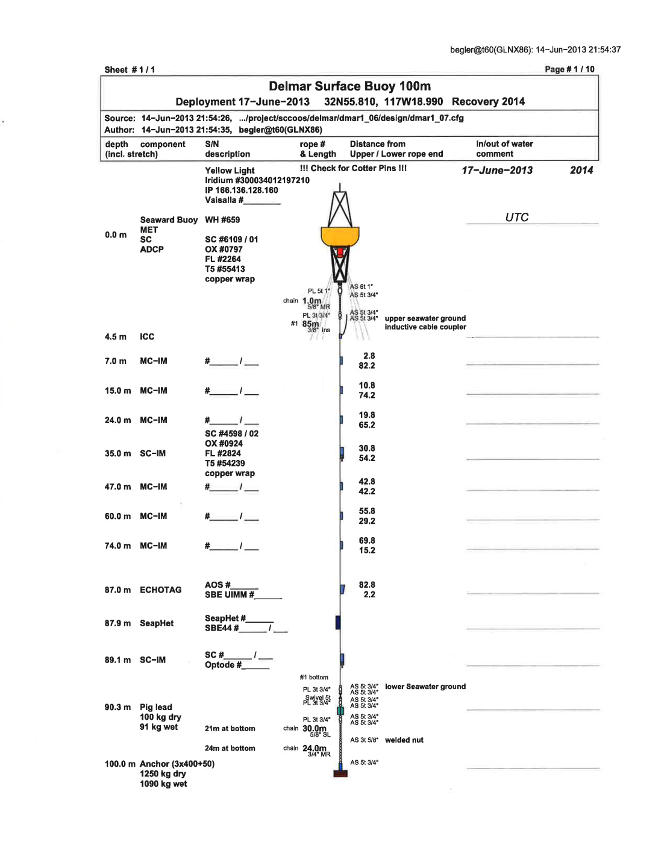
Figure 2: Layout of existing Del Mar mooring in 100m of water.

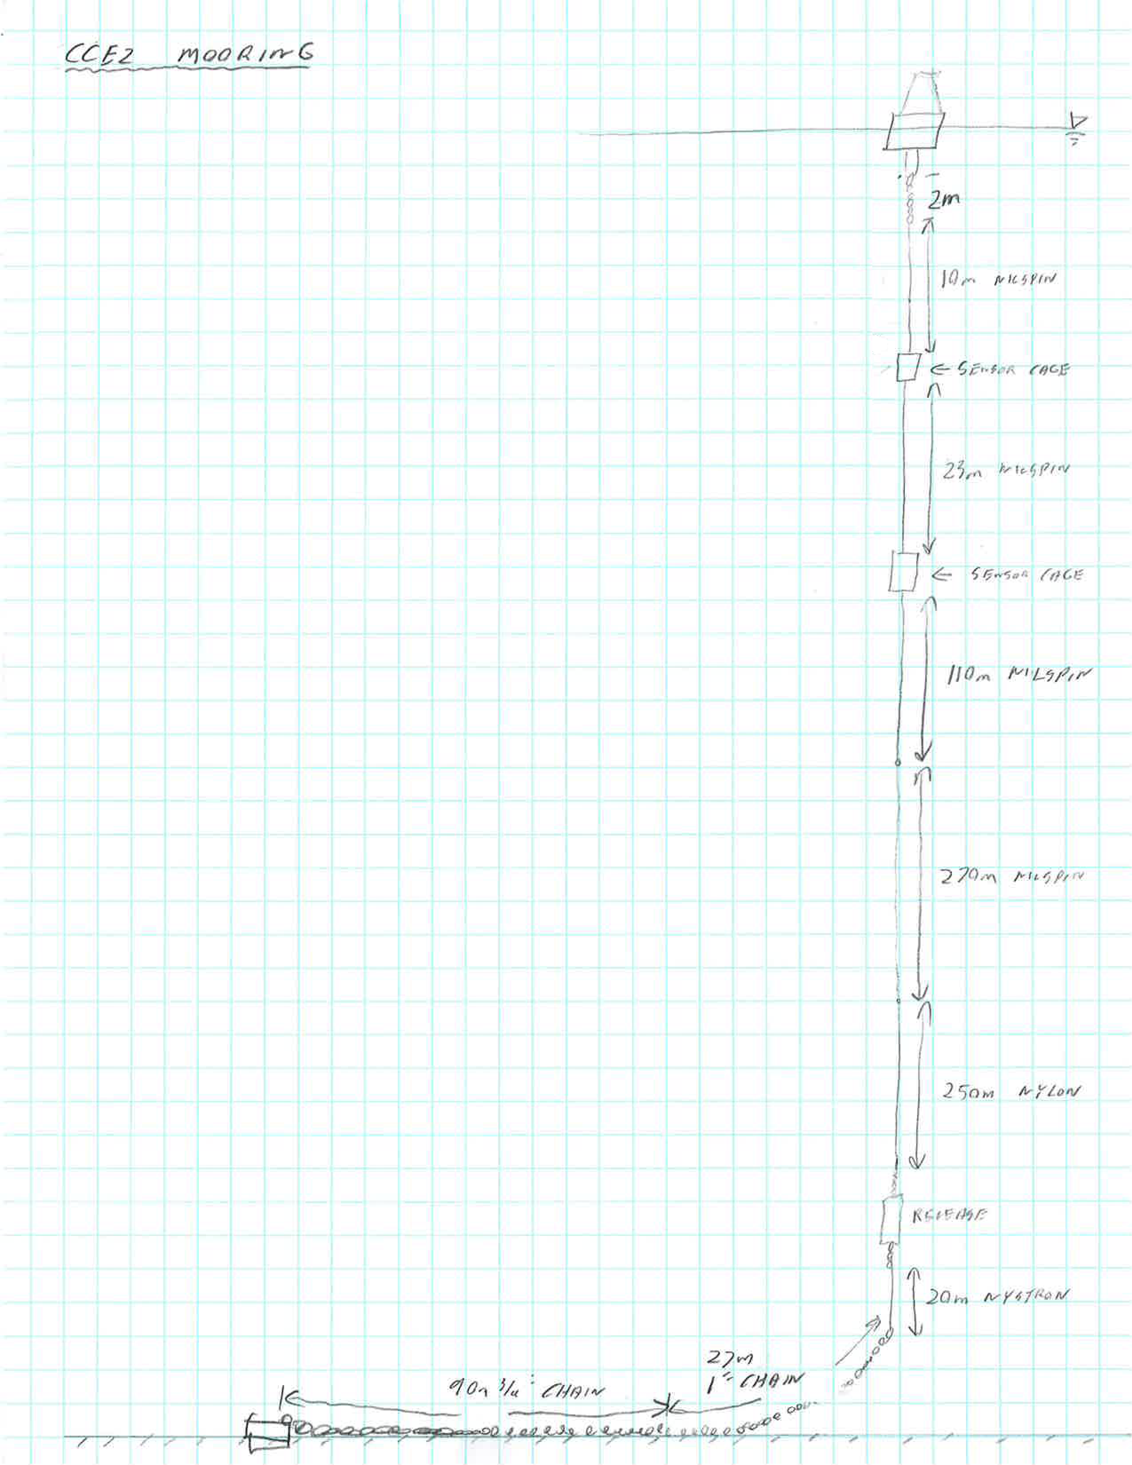
Figure 3: Layout of existing CCE2 mooring, deployed in 770m meters of water.

Relevant experience from previous designs
The ESP has been successfully engineered into two mooring systems, which are similar but address the above issues in different ways. The original ESP mooring design which has been successfully deployed many times is shown in Figure 4 and consists of a taut mooring below the ESP with a compliant member in the lower section (~200lbs/m). The surface buoy in this design is very small, with limited reserve buoyancy, mass, or area presented to wind and currents. This buoy is connected to the ESP instrument by a very stiff (axially) steel-jacketed wire-rope and a pivoted bail that transfers the buoy load to the instrument at about its center of mass (i.e. it doesn’t pull on the top of the instrument). The instrument assembly is ballasted to be about 200lbs buoyant and has a positive metacentric height (height of center of buoyancy minus the height of the center of mass). Thus there are three features of this design that keep the instrument vertical; buoyancy stability which is augmented by the mooring line tension at the bottom of the instrument, relatively small buoy loads, and the buoy attachment location at the instrument center of gravity. This system is deployed by lowering the anchor partway first and then hanging the ESP assembly over the water while the anchor is lowered the rest of the way to the bottom. Because the instrument is lacking both the buoyancy and anchor line tension contributions to upright vertical stability during the time it is being craned overboard, pins are present in the bail that keep the attachment point above the center of mass for this portion of the deployment, these pins must be subsequently removed by divers. Although the wire-rope EM cable between the instrument and buoy does little to attenuate forces due to wave excitation of the surface buoy from affecting the ESP, in this design the small size and mass of the surface buoy limits the resulting accelerations of the instrument. The compliant member in the lower mooring section is stiff enough that the resonant frequency of the system is above the wave exciting forces. The depth stability of the instrument in different current environments is provided by the fact that the instrument is hanging upwards from the anchor in the sense that the mooring stiffness below the instrument is higher than above it. However, the instrument is only 200lbs buoyant so is pulled deeper when large currents are present. Wind loading contributions to this effect are smaller due to the limited area presented by the surface buoy.
More recently, a mooring system for the ESP instrument has been engineered to include a considerably larger buoy (~2m diameter). This system (see Figure 5) also has a taut mooring lower section below the ESP, but introduces compliance into the mooring above the instrument through the use of a stretch hose that stretches to about twice its length at peak loading (see Figure 6 for a comparison of material stretch characteristics). This hose isolates the surface buoy motions somewhat from the instrument by its stretchy nature but is attached directly to the top of the instrument. This necessitates a higher metacentric height for the instrument package to keep the system vertical when faced with horizontal buoy loads. The ESP instrument packaging used in this system (Figure 7) achieves this higher vertical stability by lowering the center of mass of the package and raising the center of buoyancy. The effect is a package that is vertically stable enough to remain upright during the buoy-first deployment without additional measures being required. In this system the total mooring length is selected to introduce some limited pre-stretch into the upper surface hose in calm conditions. Again, depth stability of this design is achieved by hanging the buoyant instrument upward from the anchor.
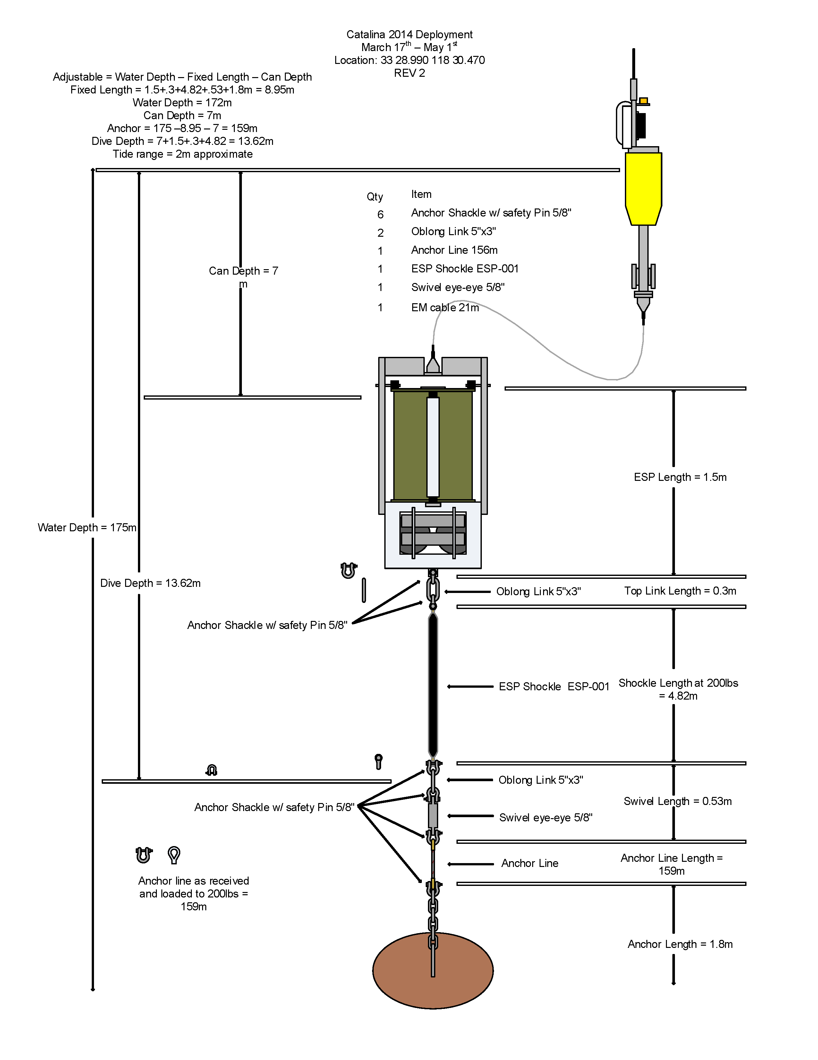
Figure 4: Configuration of standard ESP mooring with minimal surface expression.
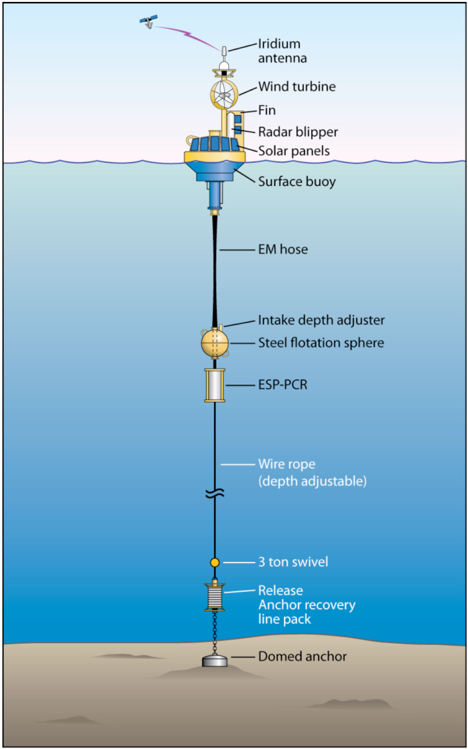
Figure 5: Diagram of mooring to support ESP with larger surface expression and stretch hose.

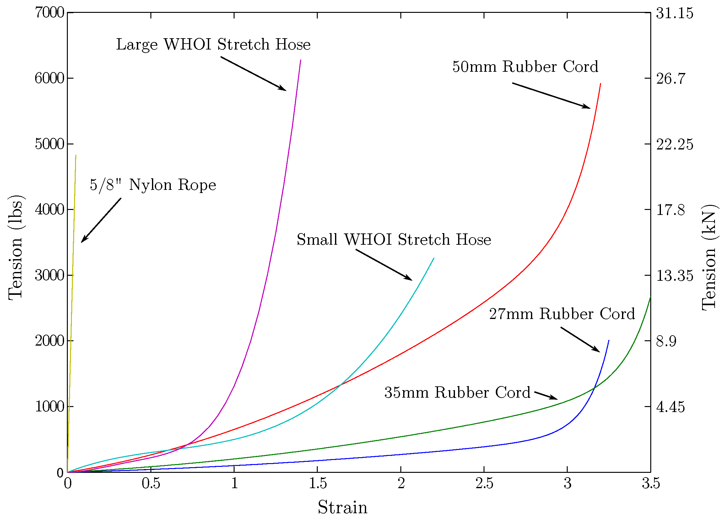
Figure 6: Comparison of stretch behaviors of various mooring materials.
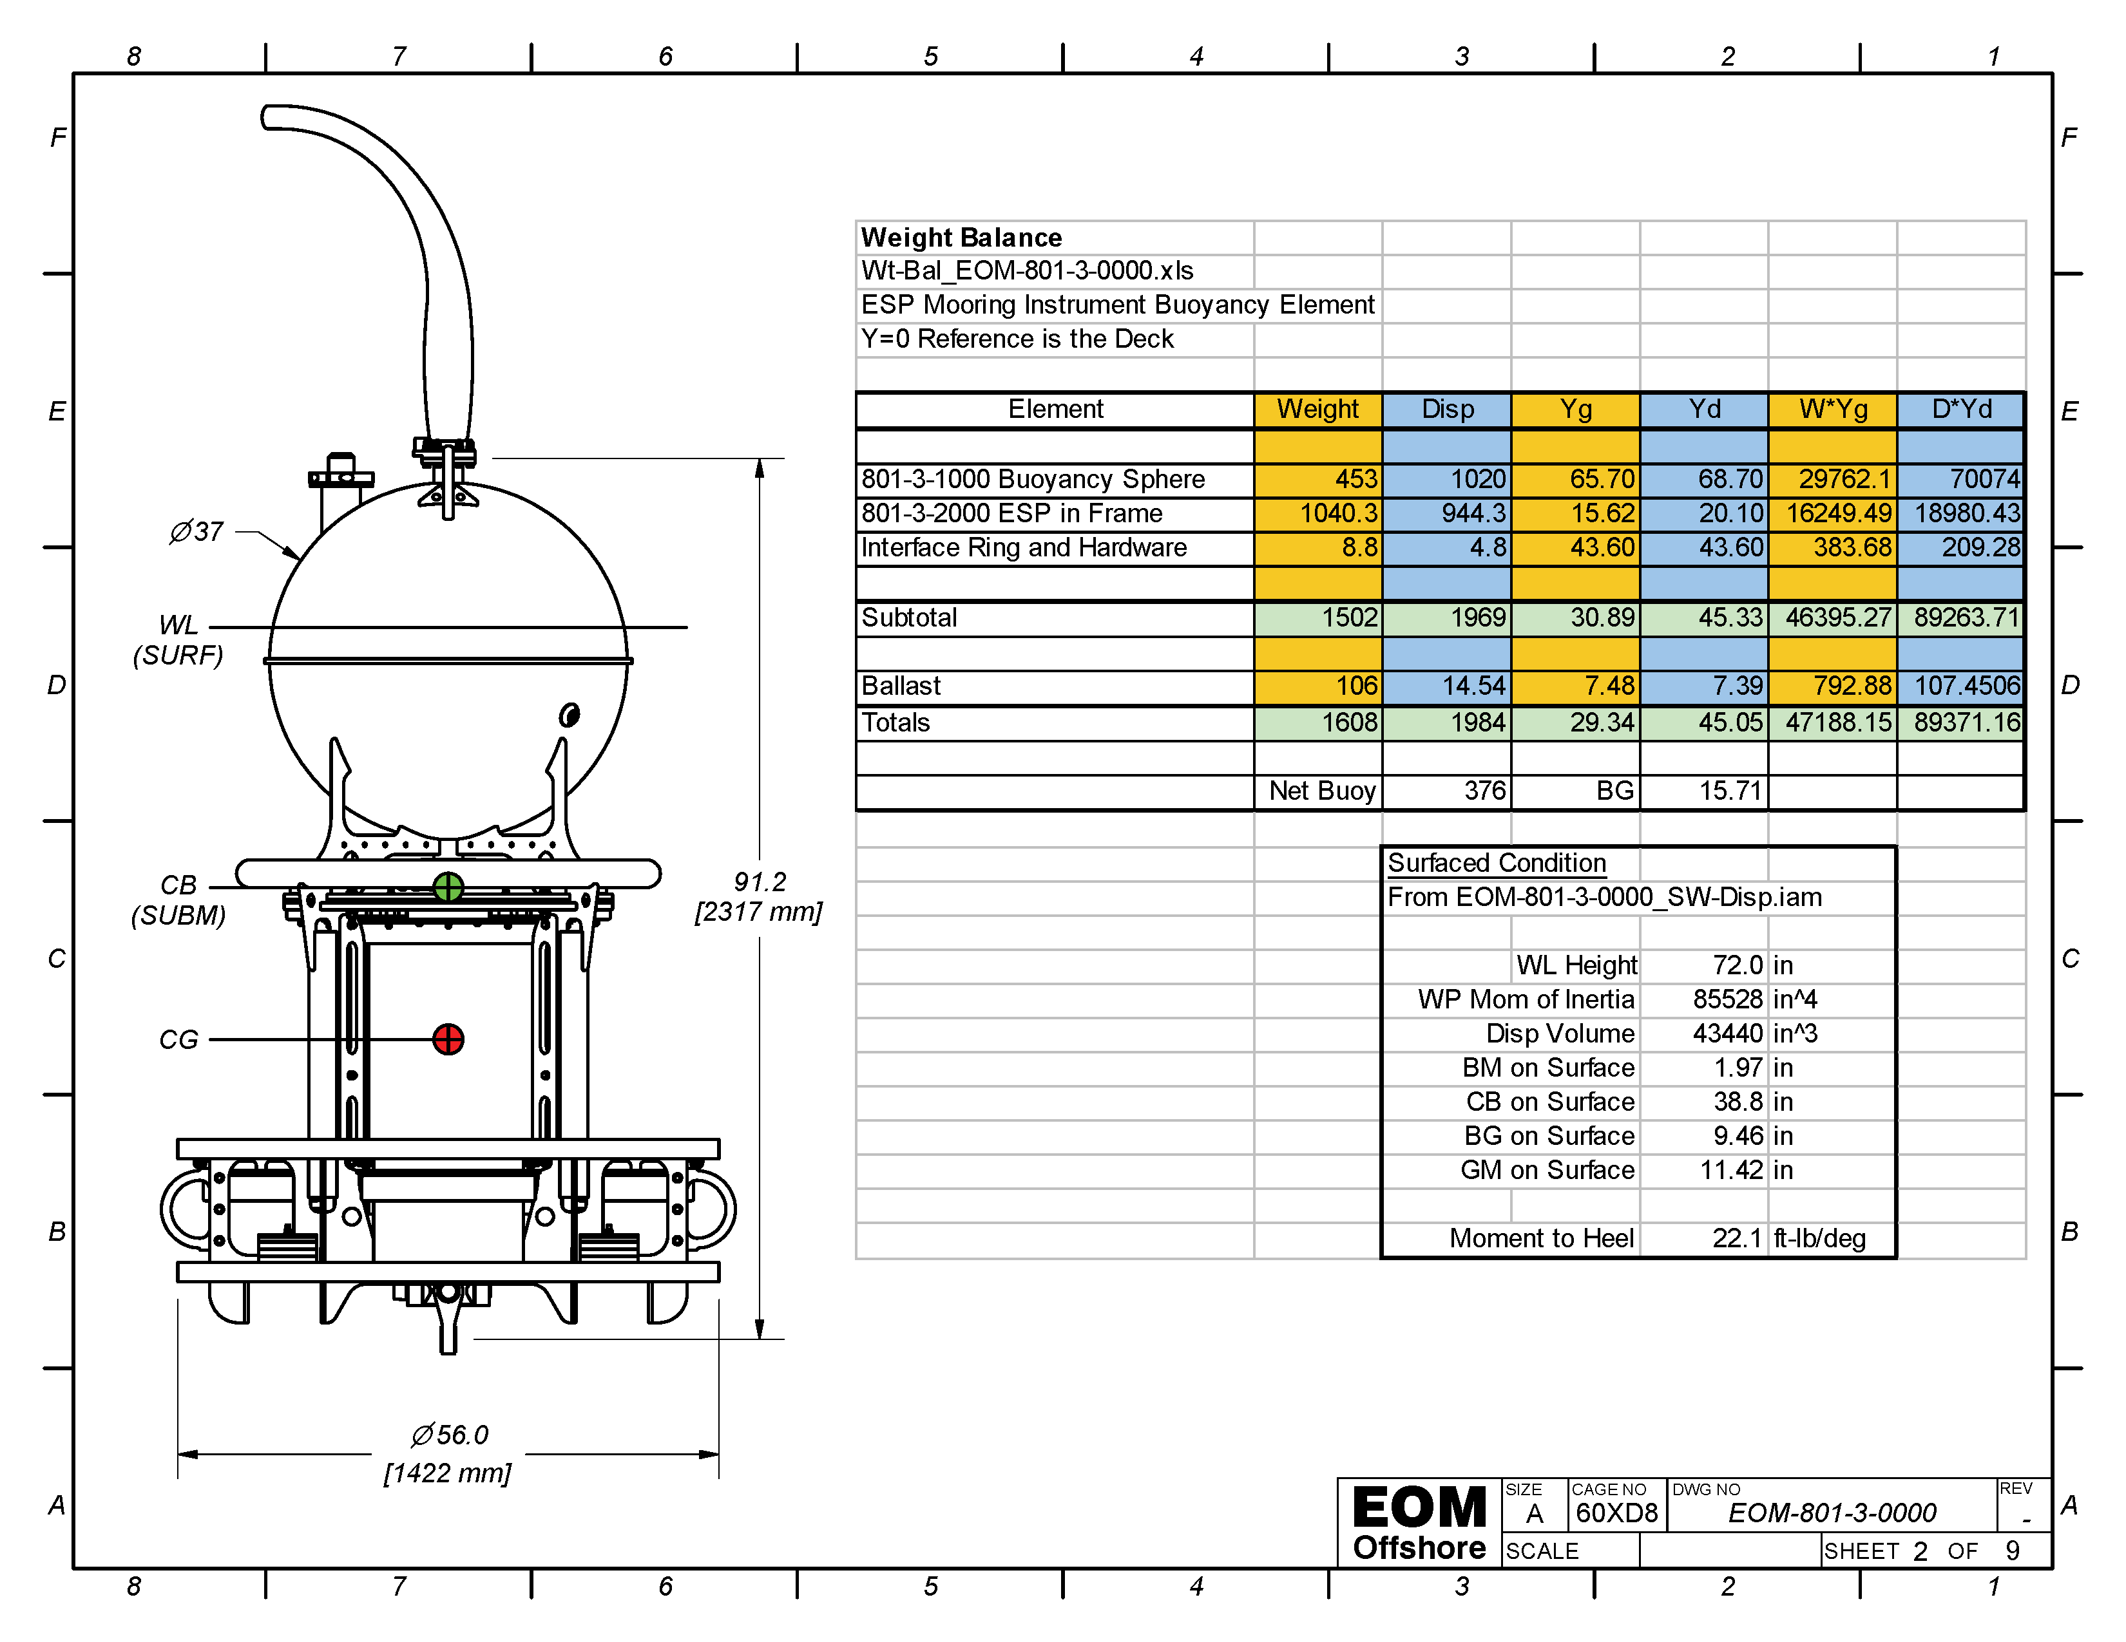
Figure 7: WHOI/EOM designed ESP housing with integral buoyancy.

Del Mar and CCE Mooring Challenges and Design Options
A significant issue that is faced in integrating with the Del Mar and CCE moorings is that these are chain-catenary moorings that utilize chain lying on the seafloor as compliance. The weight of the chain that is off the seafloor at any given time provides down force on the mooring, and increases as more chain is lifted, the result is a soft spring compared to a taut mooring design that pulls directly on an anchor (i.e. 10’s of lbs per meter compared to 100 lbs per meter for the complaint element used below the instrument in the small-buoy system described above, and 1000’s of lbs per meter for the large buoy system that includes the stretch hose). This will have implications upon the resulting vertical motions of the instrument in this system.
Because the intent is to integrate this instrument into an existing mooring design we will not attempt to change away from the chain catenary mooring or introduce changes to the bulk of the mooring string our buoy. The elements available and the variables under consideration consist of complaint elements above or below the instrument, the ballasting and vertical metacentric height of the instrument package, the attachment point of the mooring string to the instrument package, changes to the seafloor chain, and the possible addition of a clump weight above where the chain impacts the seafloor.
Three basic mooring configurations are analyzed here, shown in Figure 8. Configuration 1 inserts the ESP into the existing chain-catenary mooring and places a stretch hose between the buoy and the ESP. Configuration 2 is the same but replaces the stretch hose with a stiff chain element. Configuration 3 is the WHOI ESP design with a taut mooring below the ESP, and a stretch hose above.

Figure 8: Configuration options analyzed for DelMar/CCE sites.

Linearized Analysis
Mooring dynamics typically include non-linear forces and effects that preclude the use of linear analysis and one must resort directly to numerical simulation of the non-linear problem. This case however is dominated by a large mass, and some insights can be gained by analyzing the simplest possible system that may represent the behaviors at work. For this purpose a mass suspended between two springs is considered in which the system is excited by prescribed motions at the end of one spring, as illustrated in Figure 9. This heave-only model makes a quite a number of simplifying assumptions, including
- the surface buoy is a perfect wave follower (typically a good assumption for small buoys).
- The mooring components are perfect springs with no inertia, drag, or structural damping.
- The springs never go slack, this is a good assumption as long as the amplitude of the resulting force remains less than the static tension caused by weight, buoyancy, etc.
- The ESP mass consists of it’s mass plus the added mass of the water it must accelerate along with itself.
- The drag forces on the ESP are linearized.
The linear drag coefficient is chosen such that the drag on ESP is estimated correctly at the RMS velocity of the exiting motions. In the results below, this choice is validated by also computing (in the time-domain) the results with the quadratic drag on the ESP characterized by a drag coefficient.
This model is only expected to give insight into the heave behavior of the system, side-to-side swaying of the mooring is a highly nonlinear effect so will be analyzed in the non-linear section below.
Figure 9: Linearized heave-only model.

Figure 10 shows the results for the chain catenary mooring configuration with a stretch hose between the ESP and the surface buoy. The top pane shows the amplitude of the sinesoidal motion of the ESP itself, as can be seen there is a resonance at a period of about 9 seconds that is problematic because this lies in the center of the expected wave-exciting forces. However, the system is well damped by the drag of the ESP moving through the water, and this damping is higher at larger wave amplitudes because the drag is linearized as a function of wave height and period. Furthermore, when the quadratic drag forces are included, the resonance feature is further damped. Nevertheless, the vertical amplitude of the ESP in this configuration is of the same order of magnitude as the surface waves. The second pane shows that the vertical accclerations of the ESP are as high as 0.2g’s, potentially causing an issue for the ESP mechanism and puck storage arrangements. Pane 3 and 4 show the amplitudes of the forces in the upper and lower mooring elements. In order for the mooring components to keep from going slack, the static configuration of the system must be biased to a tension higher than these amplitudes. In other words, in this arrangement the ESP is hanging from the surface buoy and should be ballasted several hundred pounds heavy, or such a weight should be present at the bottom of the lower mooring string, or a combination. The amount of reserve buoyancy in the surface buoy will factor into the viability of this configuration as well.
Figure 11 shows results for configuration 2, which is similar to configuration 1 but replaces the stretch hose with a nearly rigid chain. Because of this link, the ESP heave motions follows the surface profile almost exactlty, the accelerations are higher, and the force amplitudes in the upper mooring element are higher. Again the ESP would need to be ballasted heavy and the practical limit of surface expression buoyancy limits the usability of this configuraiton in wave amplitudes of 2 meters or so. At wave amplitudes of 2 meters, the accelerations predicted are comperable to those present in configuration 1 in waves of 5m amplitude.
Figure 12 presents results for a taut mooring below the ESP, couple with a stretch hose above. Because of the fairly rigid connection to the seafloor, the ESP motions are very small, practically the lateral accelerations not modelled will dominate the motions. In this configuration the ESP is “hanging” from the anchor, and must be ballasted such that it floats and pulls up against the anchor with a tension greater than the max expected amplitude shown in the bottom pane. For there to simultaneously be tension in the stretch hose at all times, the overall mooring length must be carefully chosen relative to the water depth. This makes this mooring design difficult to implement in areas of unknown depth, or with large tidal variations.
These linearized heave-only results for the three configurations do not capture many important processes such as lateral motions of the mooring and ESP, but are useful to gain some insight into the fundamental behavior of moorings with a large mass included. The features described here will be evident also in the non-linear analysis below, an analysis that provides a much better quantative estimate of expected forces and motions, but in which it can be harder to see the fundamental pheonomenon.
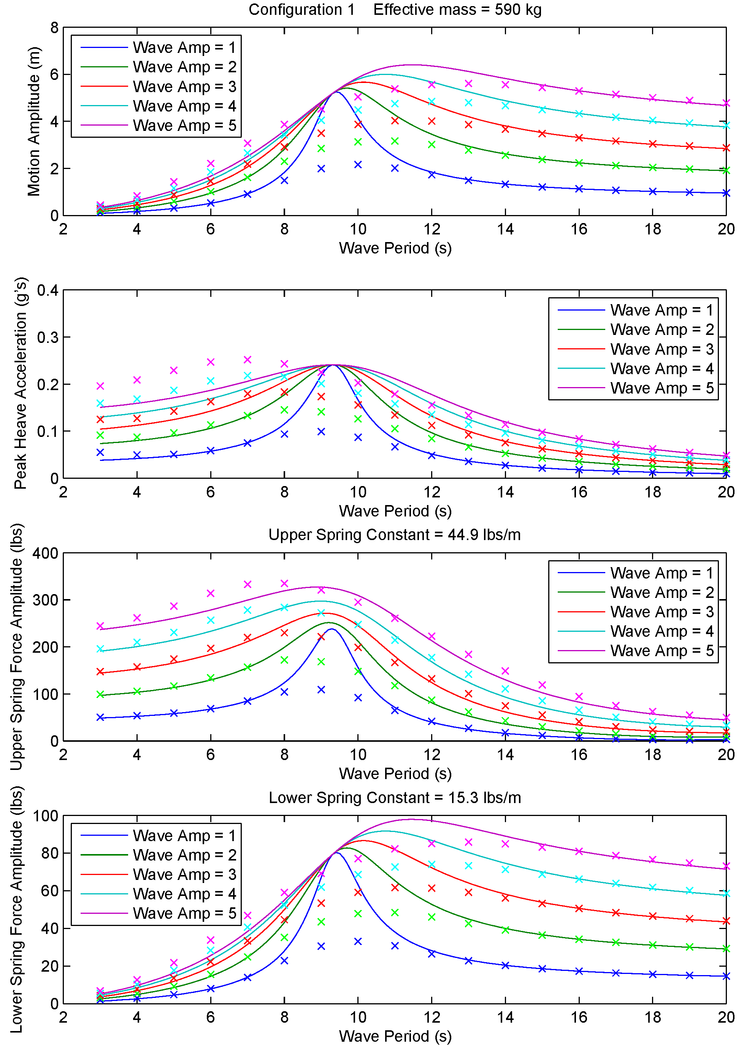
Figure 10: Configuration 1, chain catenary mooring below ESP and stretch hose above ESP. Solid lines are results with linearized drag; markers show results including quadratic drag on ESP only.
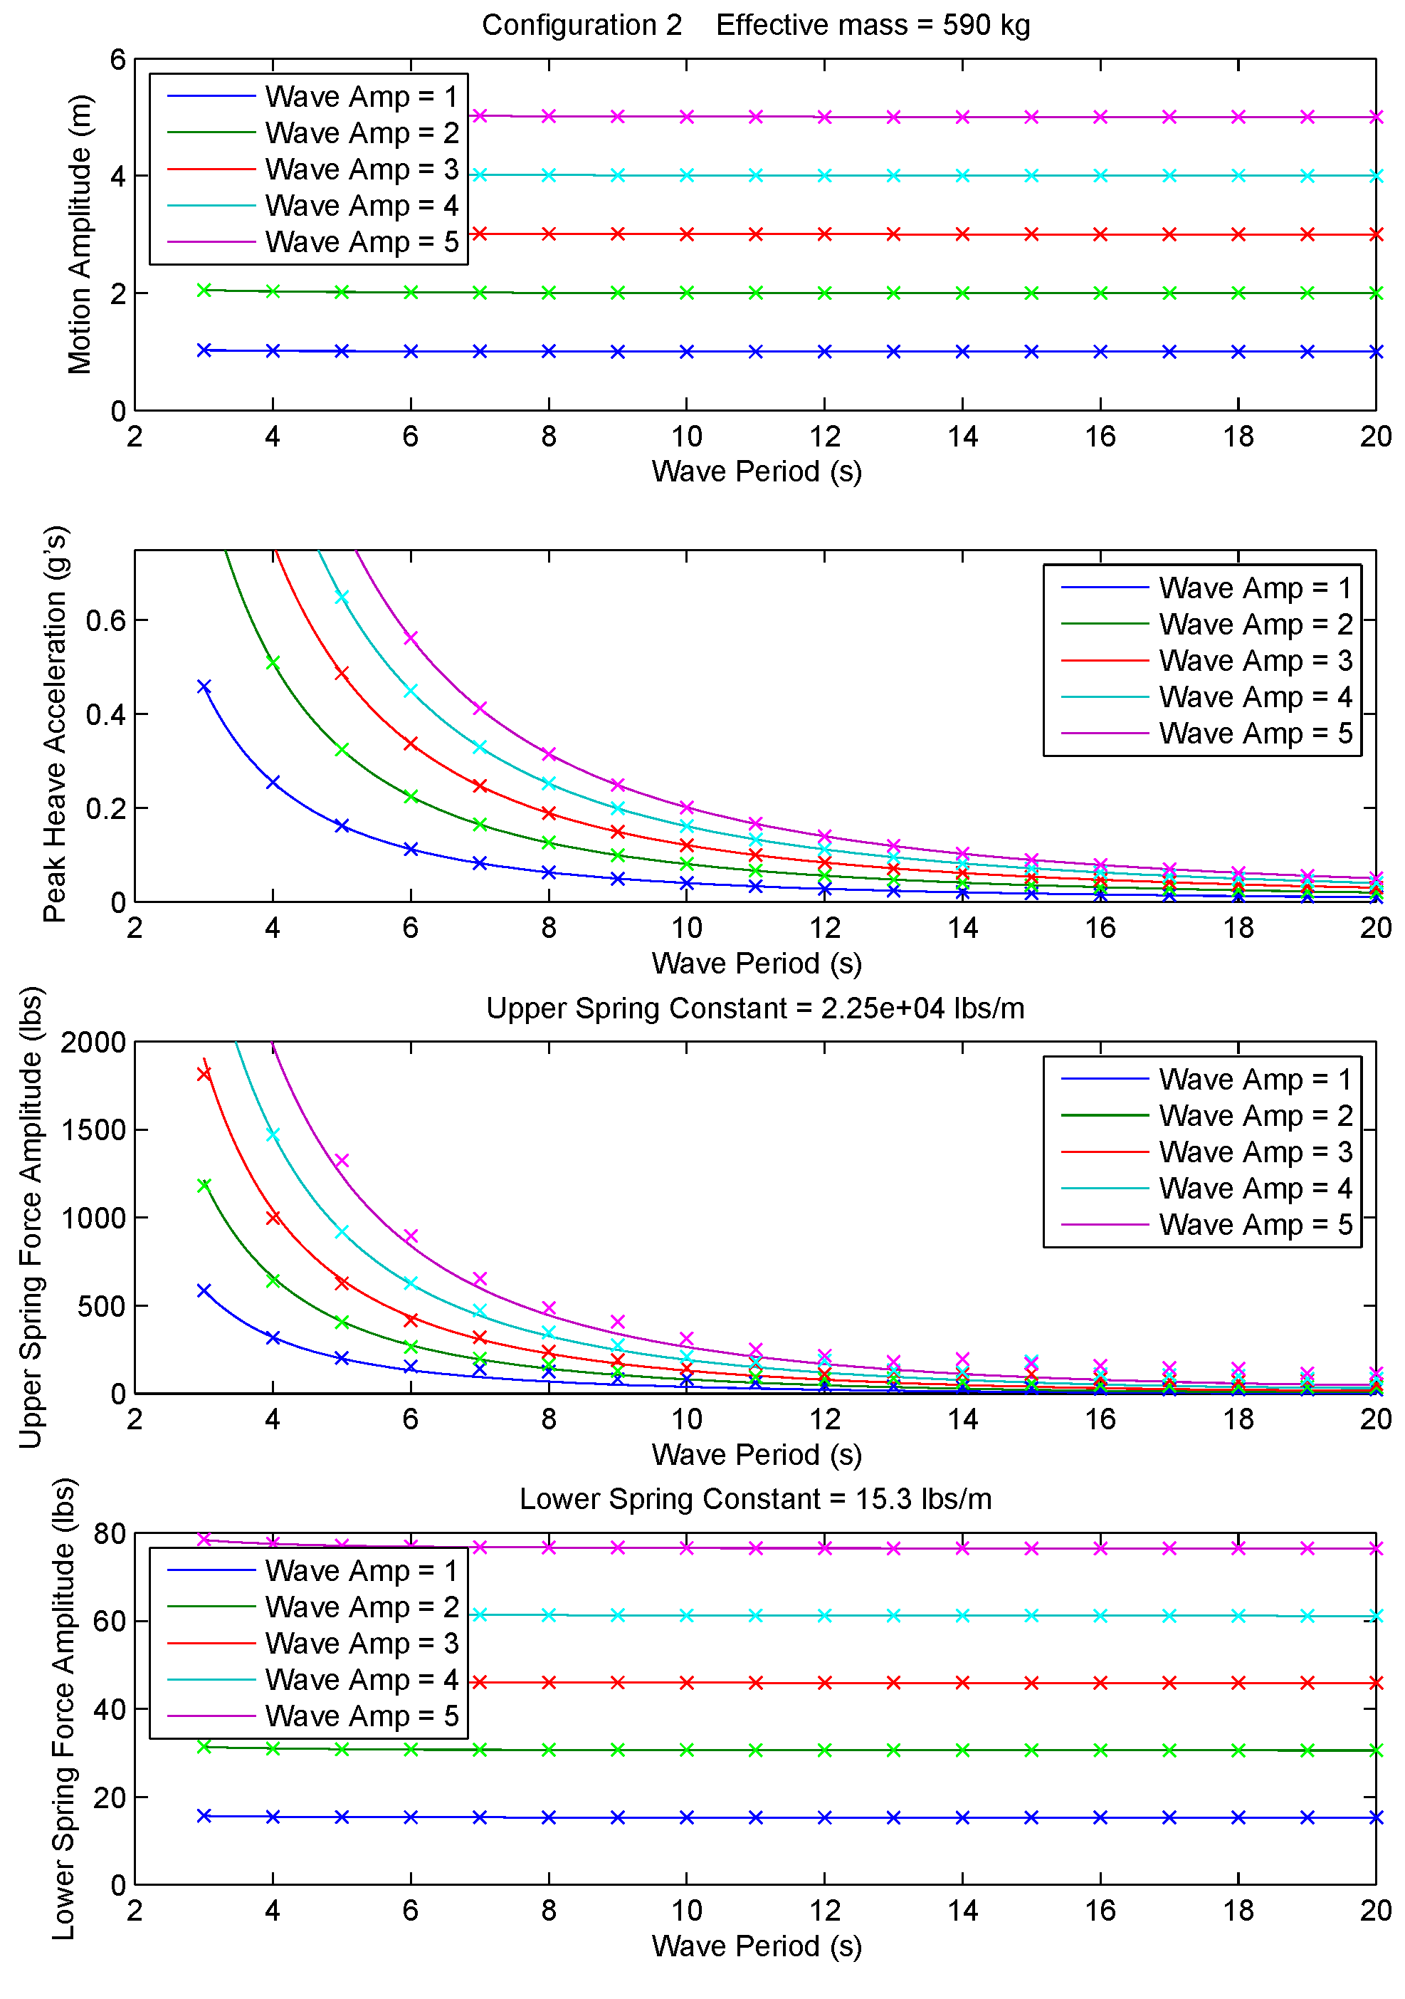
Figure 11: Configuration 2, chain catenary mooring below ESP and E/M chain connection above ESP. Solid lines are results with linearized drag; markers show results including quadratic drag on ESP only.
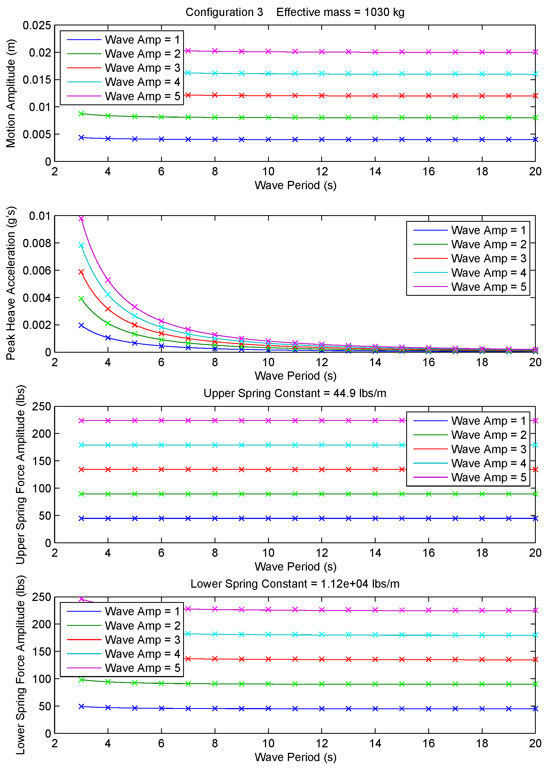
Figure 12: Configuration 3, taut mooring below ESP and stretch hose above ESP. Solid lines are results with linearized drag; markers show results including quadratic drag on ESP only.

Non-Linear Analysis
A much more accurate prediction of mooring forces and motions can be obtained by numerical solution of the nonlinear equations of motion of the mooring string. This requires defining the mass, density, size/shape, modulus, drag coefficients, and other parameters of each component of the mooring system. With the mooring thus described the procedure is to define the environment (wave height/period, wind speed and current profile) and solve the problem in the time domain. This is performed here using the WHOI “cable” program and the result is a time history of the mooring position and tensions in a variety of sea-states. Because of the computation required, it isn’t practical to analyze all conditions and some judgment is needed to determine what cases to run.
Important nonlinearities in mooring problems in general include the quadratic drag forces as discussed above and the geometrical nonlinearities that are present when the mooring forms a catenary type shape. For moorings that include a stretch hose, the dramatic stiffening of the stretch element as the strains get higher (see Figure 6) are also very important. This feature of these elements presents challenges in designing these moorings for a range of wind speeds and currents. The stretch hose and hence the mooring can behave quite differently in high current conditions because the stretch hose is extended (and therefore is stiffer).
The results shown below (Figure 13 - Figure 15) are for the three mooring configurations described above in a relatively rough sea state at Del Mar (Hs = 3m, Tp = 10s). At the CCE2 site, configuration 1 and 3 have been analyzed in a moderate (Hs = 2m) and storm (Hs = 8m) condition. In each case, the primary results shown below are tensions below the buoy and below the ESP, the depth history of the ESP, the stretch hose behavior, and the tangential and normal accelerations of the ESP in the various conditions.
At Del Mar, the current profile used is a 1 kt surface current that exists down to 20 meters depth, and then decays to 0.2kts at the bottom. The results clearly show that the taut mooring with a stretch hose (configuration 3) produces the smallest ESP accelerations and that the chain-catenary mooring with a stretch hose (configuration 1) produces considerably higher motions of the ESP. The chain-catenary mooring that includes a stiff chain between the buoy and ESP results in accelerations of about twice those present when the stretch hose is included. For configuration 2, it is necessary to increase the size of the “pig weight” at the bottom of the mooring string in order to keep the chain between the ESP and the buoy from becoming slack in this sea state, and even then a slack condition occurs occasionally.
Similar results are computed at the CCE2 site for the stretch hose case of the chain-catenary mooring and for the taut mooring. In these runs the current profile is the same as for Del Mar down to 100m, and then remains a constant 0.2kts from 100 meters down to the bottom. Figure 16 - Figure 19 shows the results for two sea conditions, a moderate condition and a storm condition. As expected the nonlinear effects of the deep mooring become more evident than in the Del Mar case. In particular the current loading becomes significant, pulling the ESP down and causing the stretch hose to extend to the point at which its stiffness increases. In the case of the taut mooring, this reduces the insulating effect the stretch hose has on the motions of the ESP. Combined with the effectively softer lower mooring due to geometrical compliance, this causes the axial motions of the ESP to become noticeable even in the taut mooring case.
The chain-catenary mooring in the deeper water also is affected significantly by the current loading, extending the stretch hose significantly into the stiffer portion of its stress-strain curve. The runs shown here are for the same neutral ballasting used for the chain-catenary case at Del Mar, relying on the weight of the mooring below to bias the tensions in the stretch hose to eliminate zero-tension conditions. However, the current loading is large enough in the cases analyzed to effectively over-bias the stretch hose in the static condition, reducing its compliance and causing the ESP to sit deeper than desired as show in Figure 16 and Figure 18. Model runs with adjustments to the current profile and/or the ballasting of the ESP can characterize this effect and a final design would be a trade-off between motions and depth stability, and would require a good estimate of the current profiles present in the area. These tradeoffs are discussed further in the Summary section below.

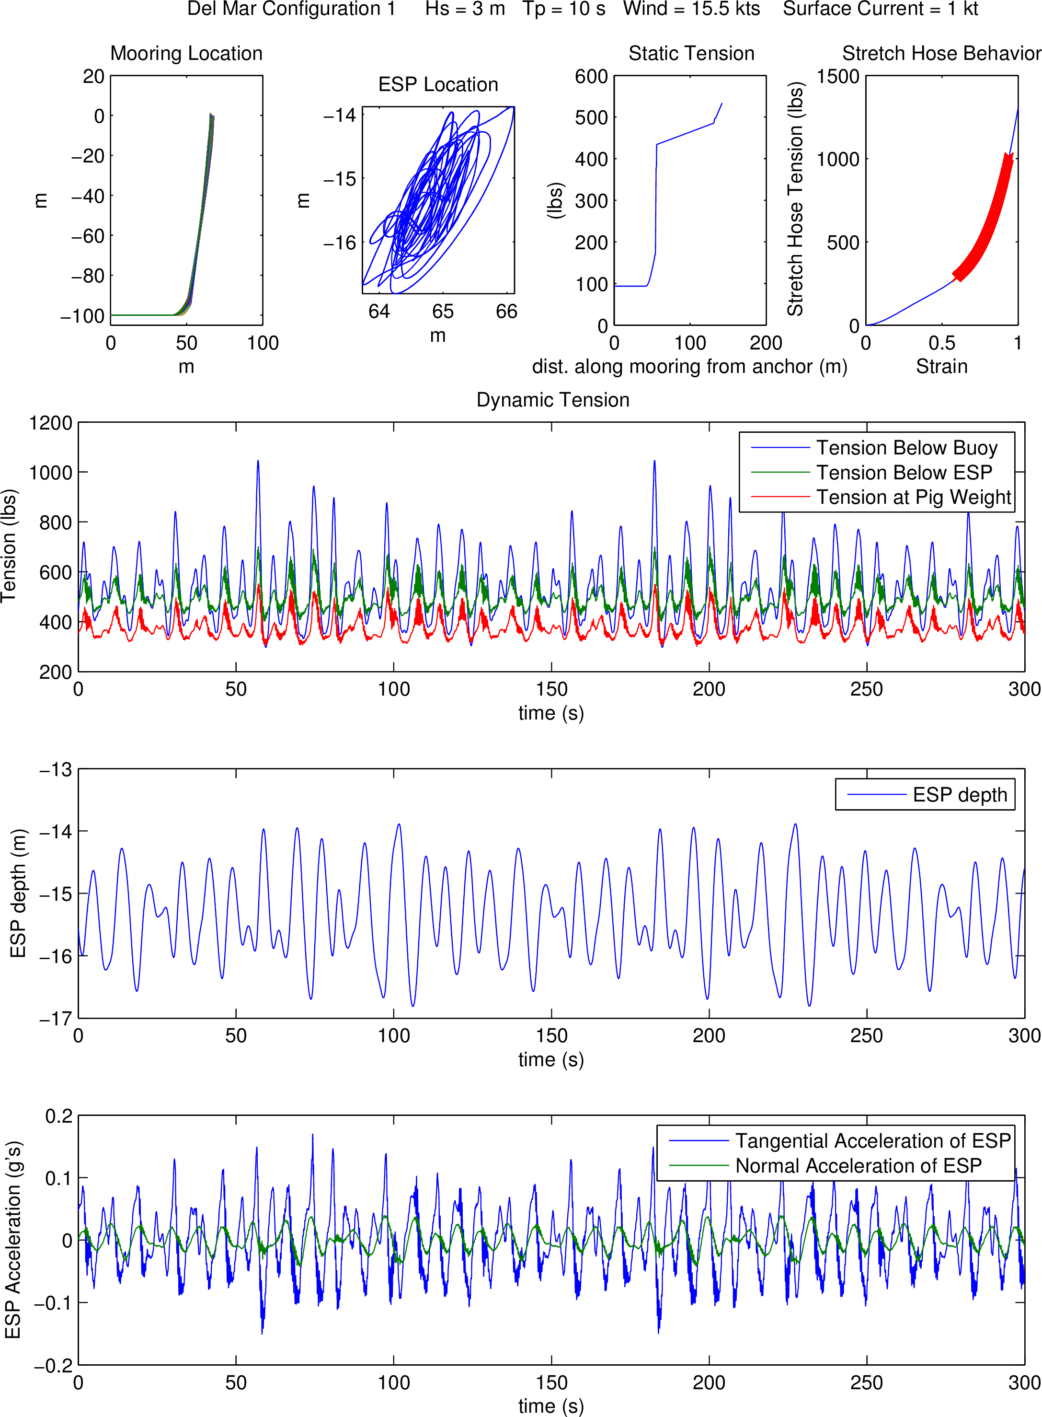
Figure 13: Chain-catenary mooring with stretch-hose between the surface buoy and the ESP. ESP is ballasted neutrally.
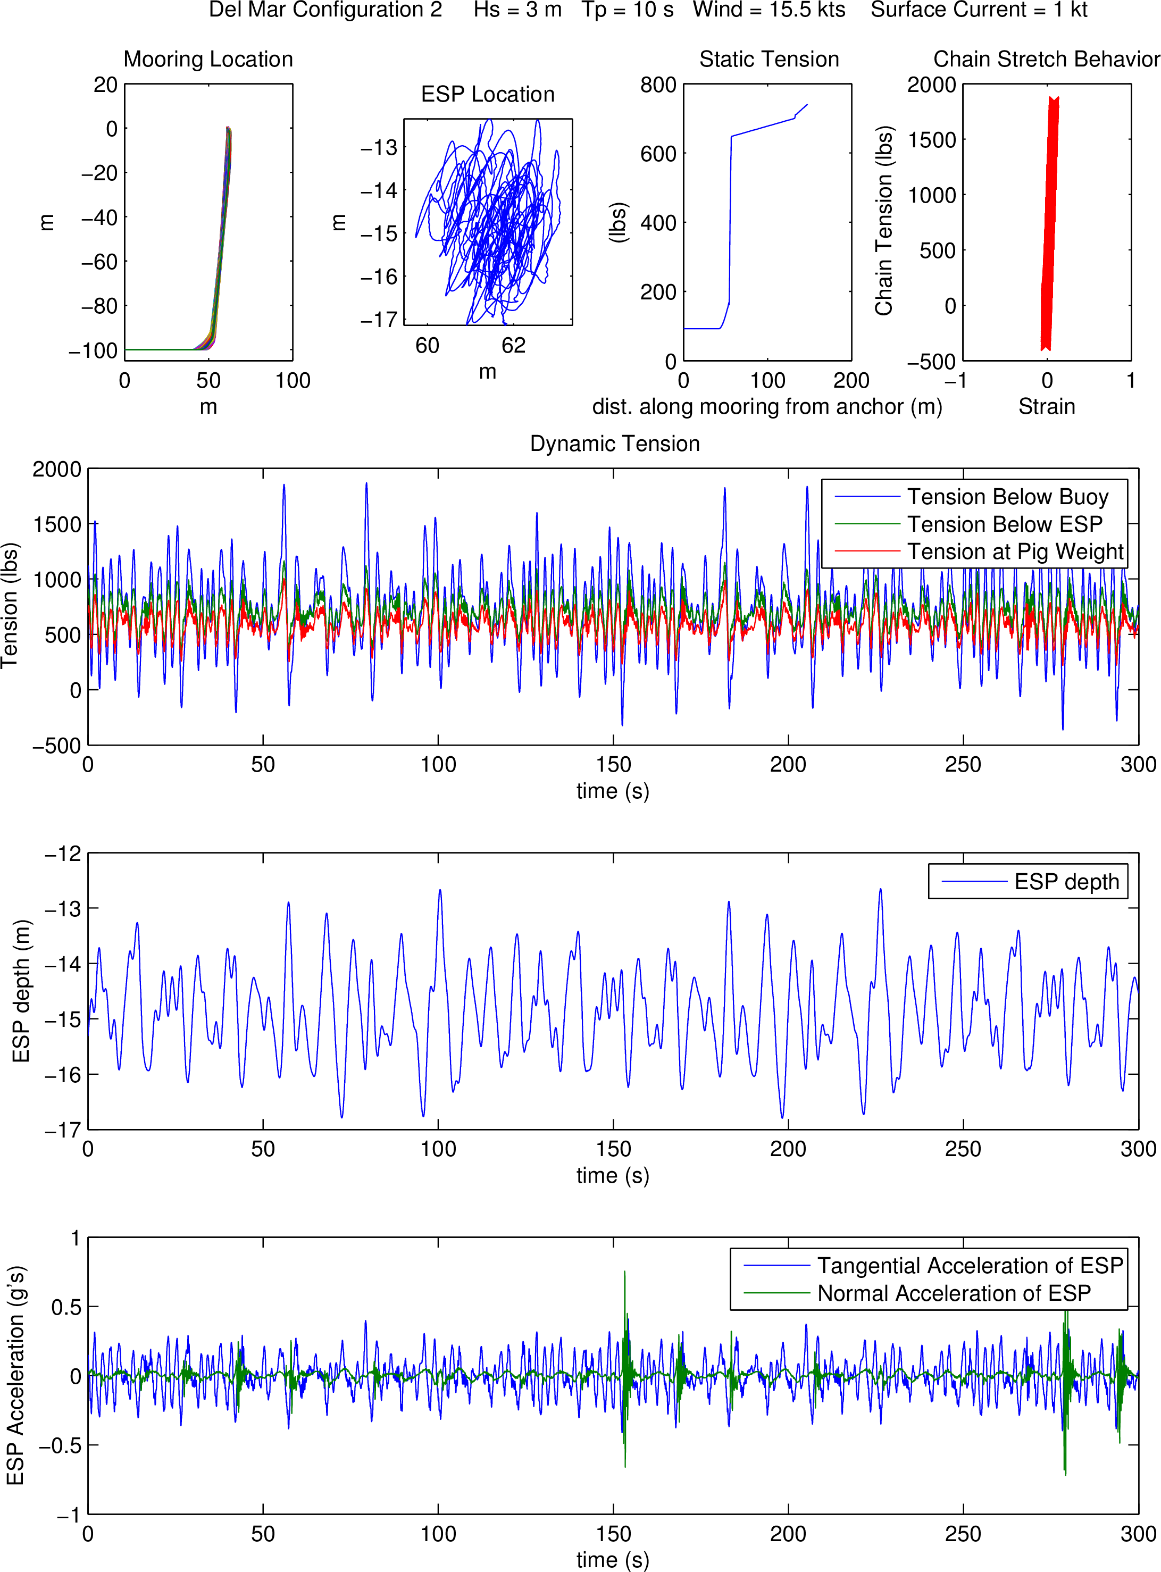
Figure 14: Chain-catenary mooring with chain between the surface buoy and the ESP. ESP is ballasted neutrally.
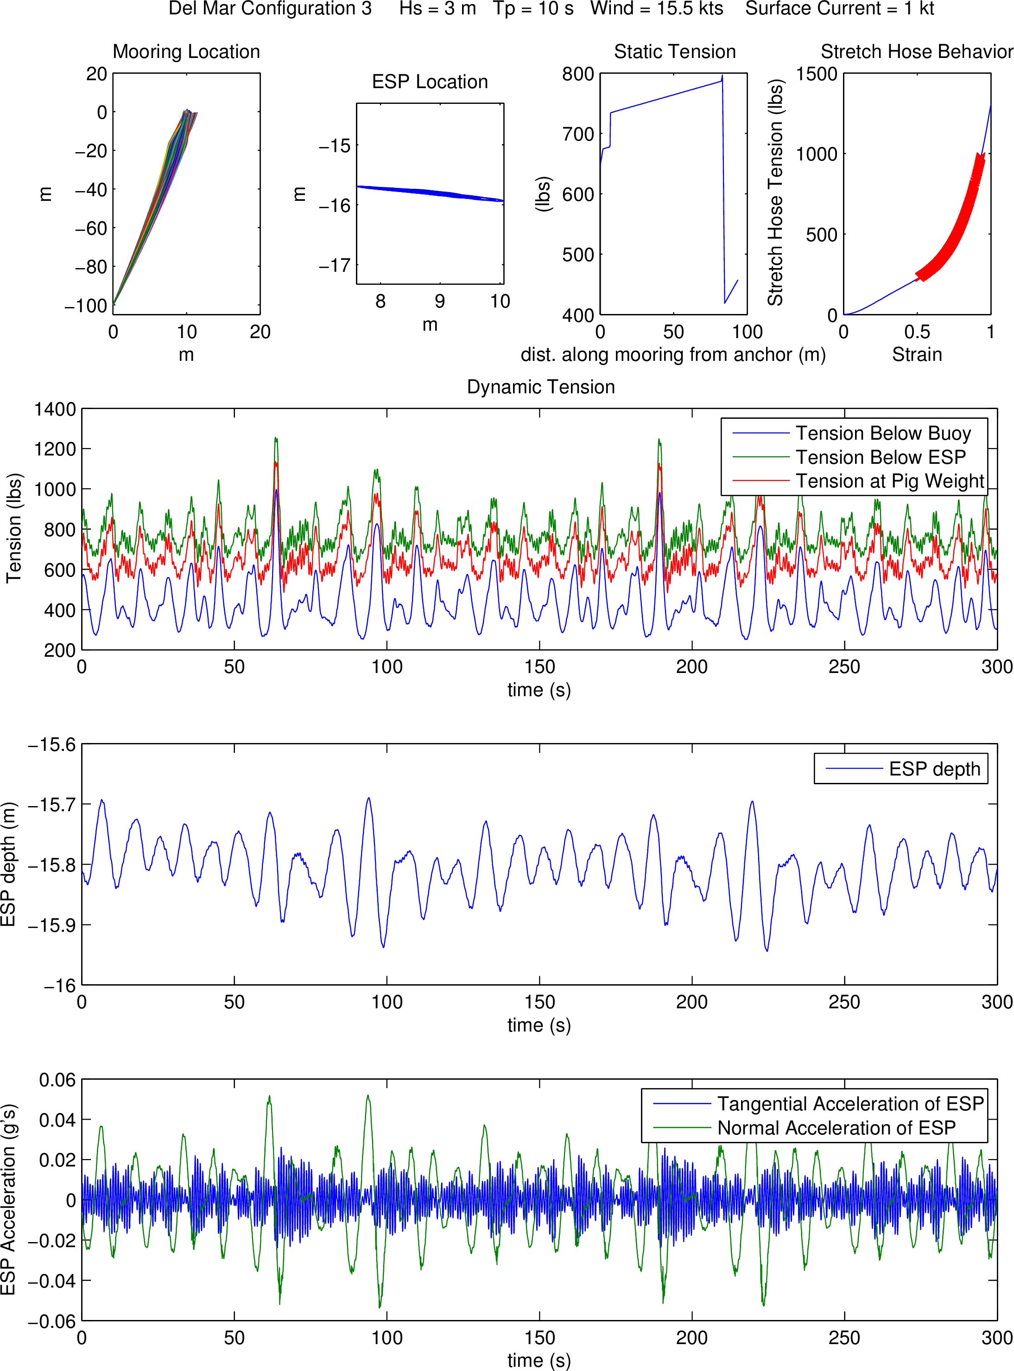
Figure 15: Taut mooring with stretch hose between the surface buoy and the ESP. ESP is ballasted buoyant.
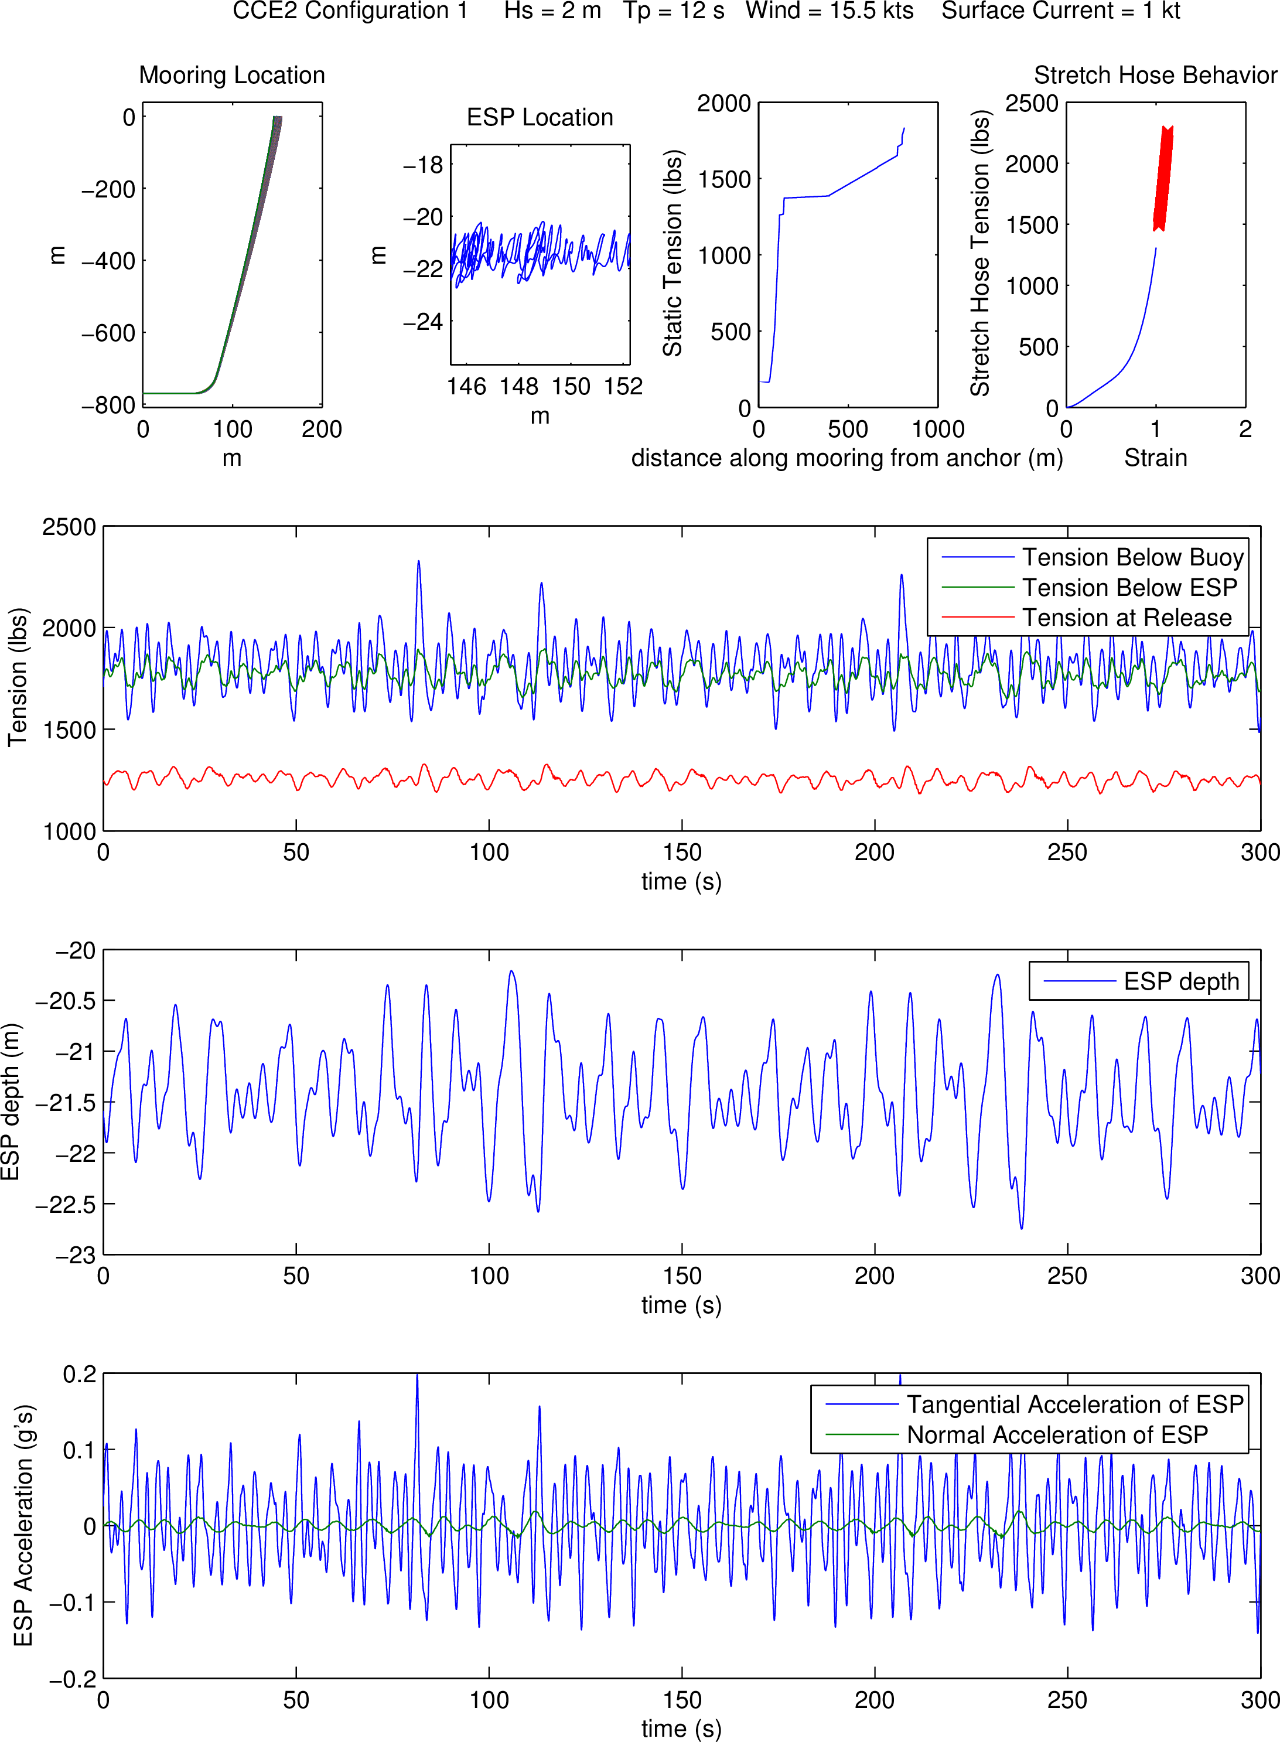
Figure 16: Chain-catenary mooring with stretch-hose between the surface buoy and the ESP in moderate conditions. ESP is ballasted neutrally.
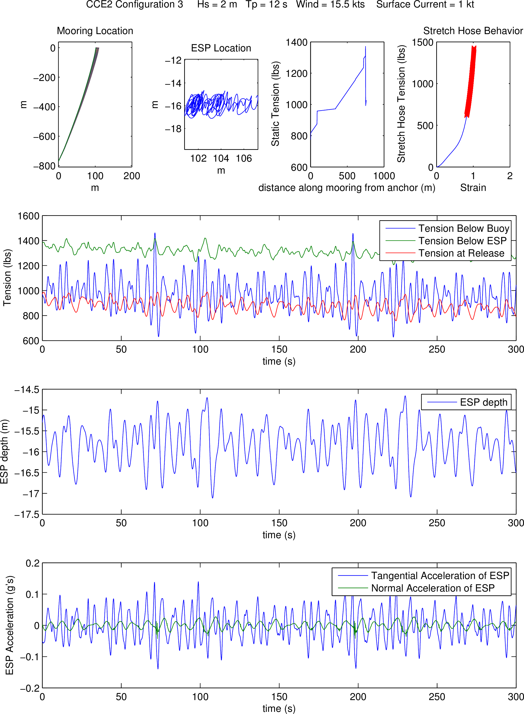
Figure 17: Taut mooring with stretch hose between the surface buoy and the ESP in moderate conditions. ESP is ballasted buoyant.
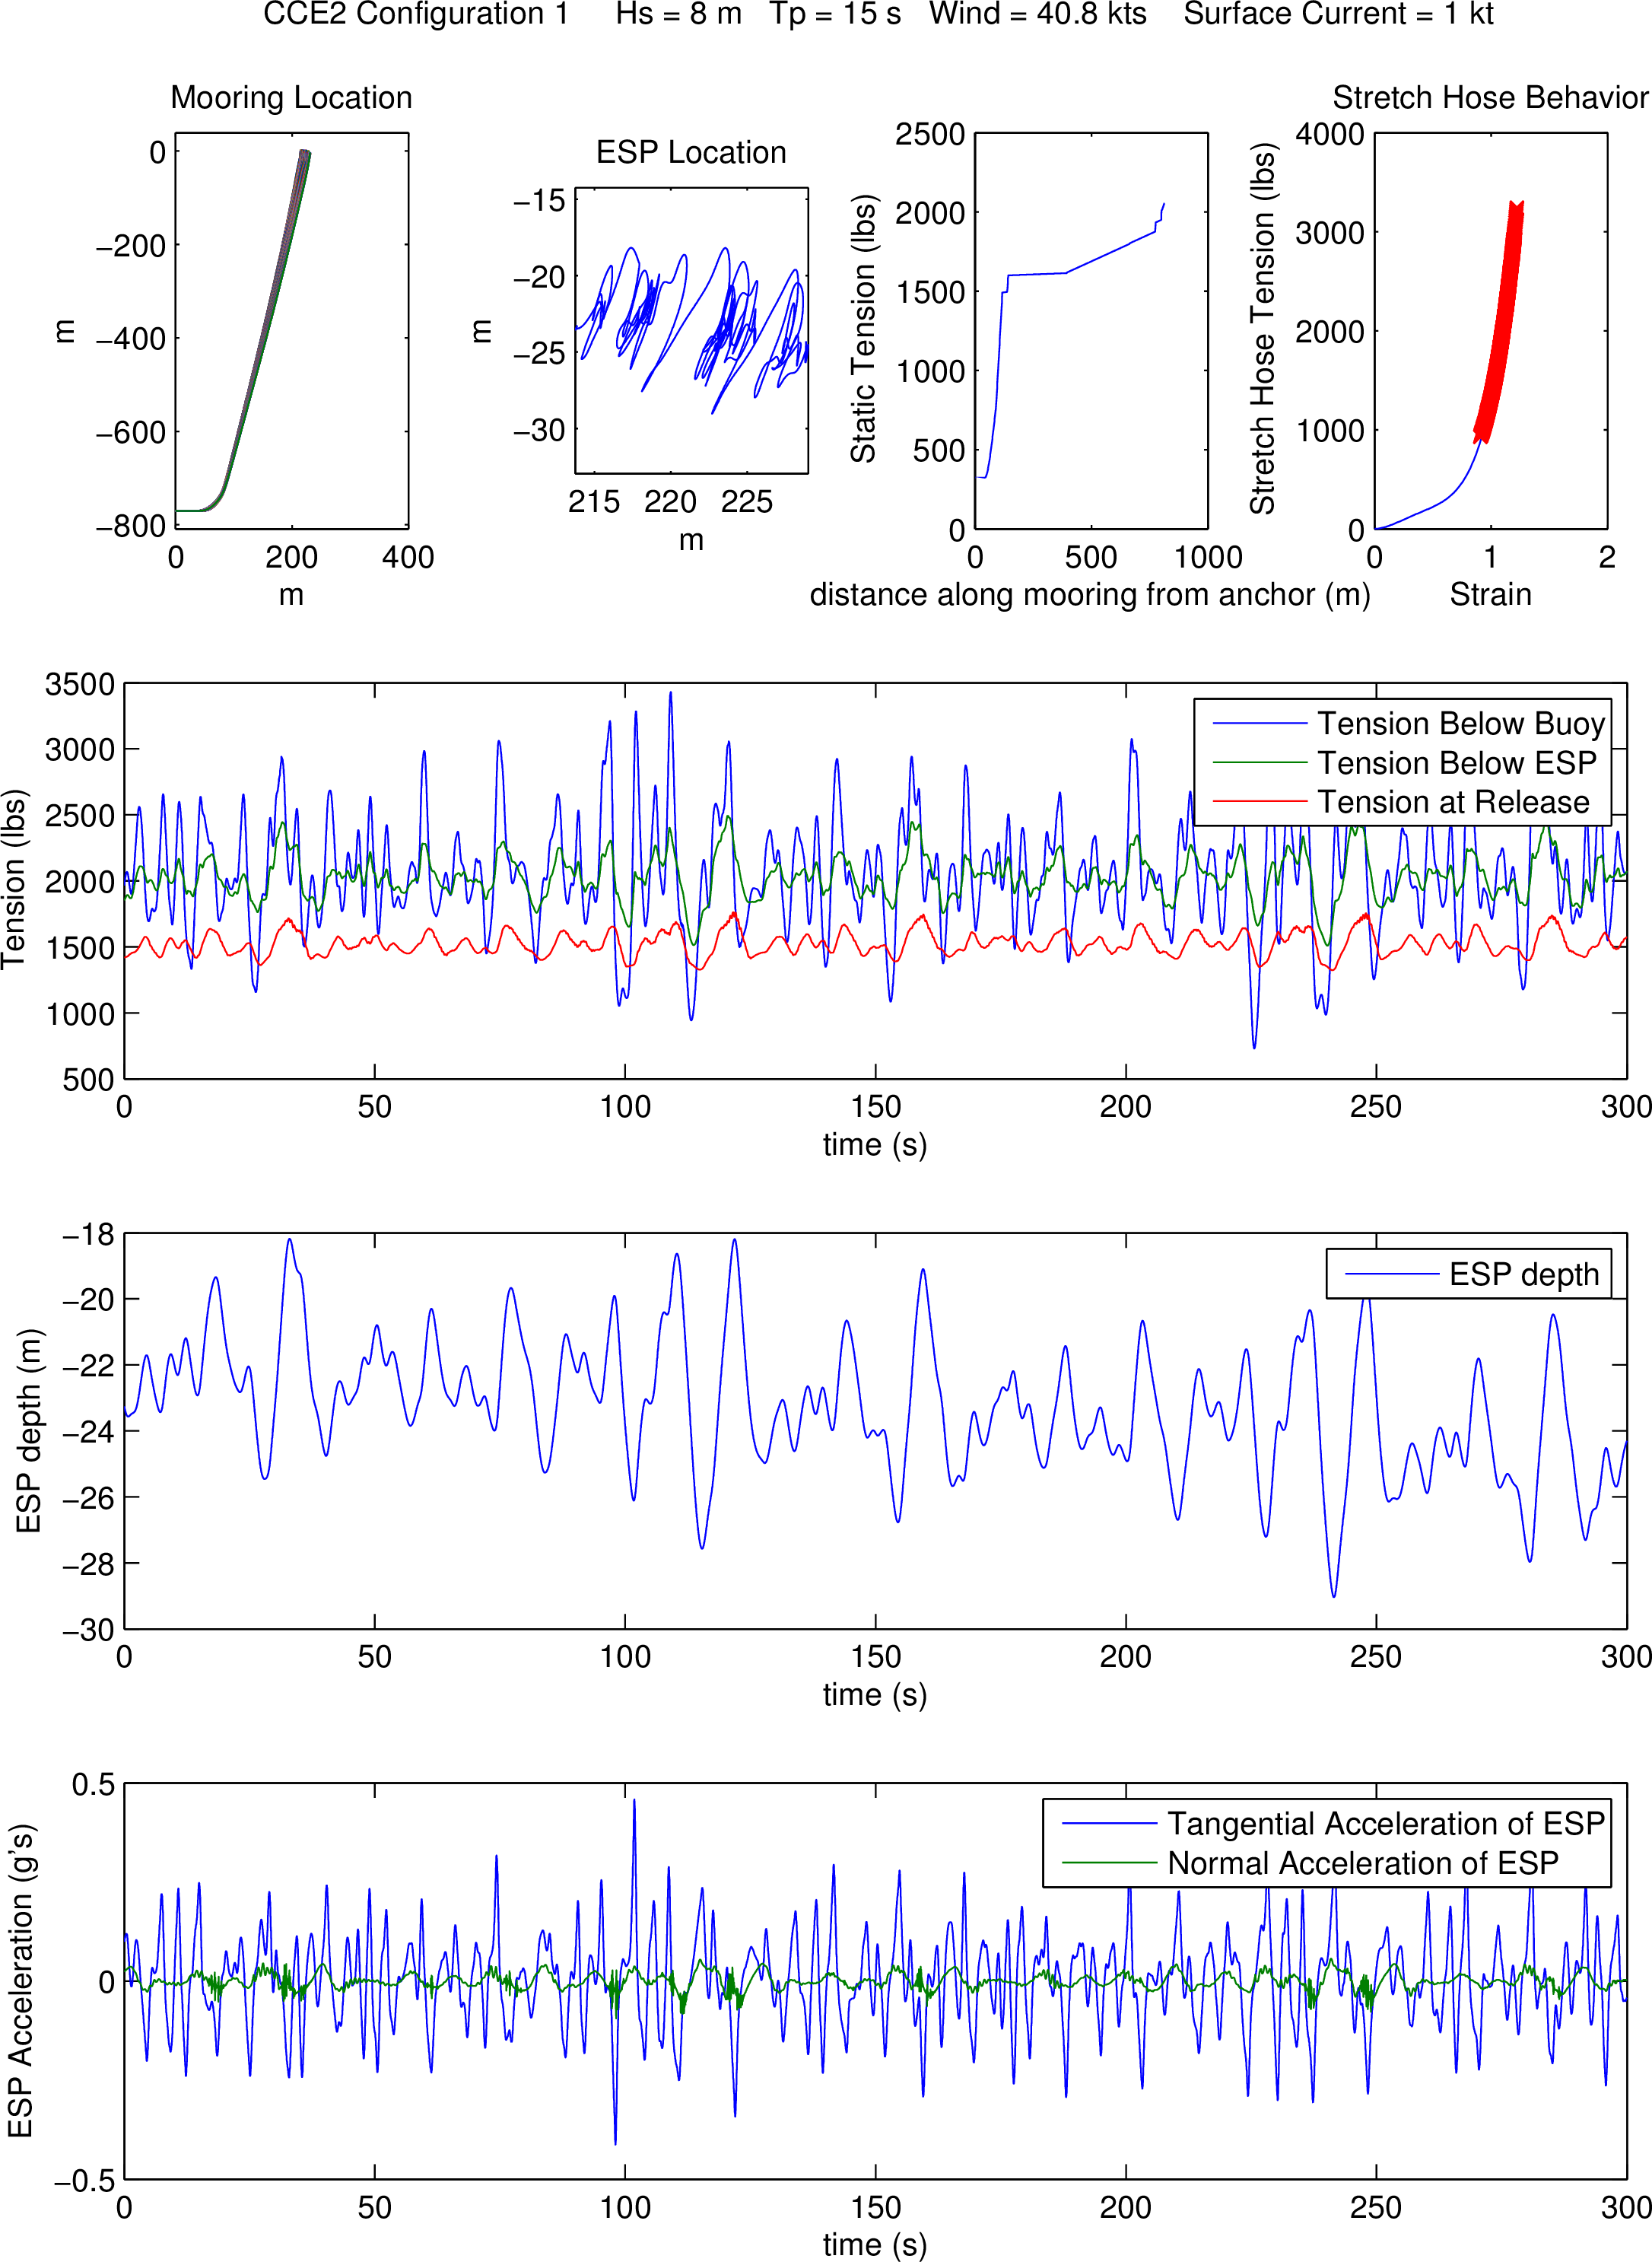
Figure 18: Chain-catenary mooring with stretch-hose between the surface buoy and the ESP in storm conditions. ESP is ballasted neutrally.
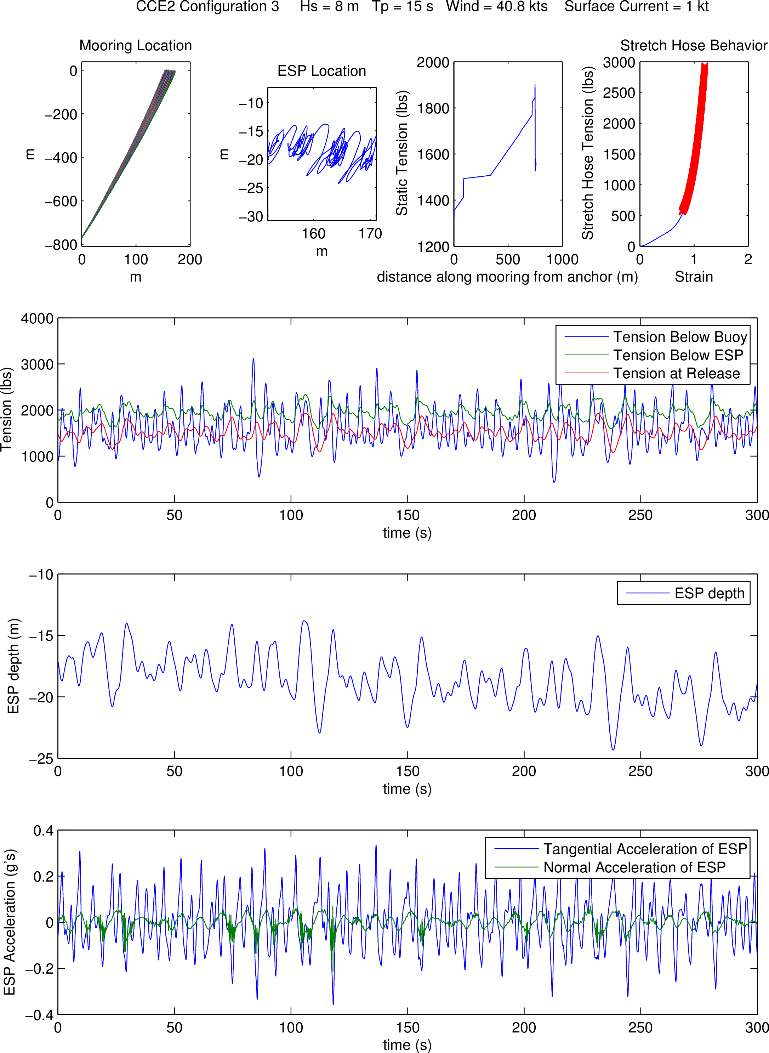
Figure 19: Taut mooring with stretch hose between the surface buoy and the ESP in storm conditions. ESP is ballasted buoyant.

Summary and Conclusions

The analysis described above indicates that the taut mooring design with a stretch hose between the ESP and the surface buoy results in the minimum ESP motions and the most consistent instrument depth in various current conditions. The downsides of such a mooring system are intolerance to large tidal variations and a requirement of accurate deployment depth knowledge and attention to detail in assembling the mooring string. Additionally in this case, the fact that the taut mooring design is a significant deviation from the chain-catenary moorings that have been deployed at these sites for some time is a consideration.
The implementation of an ESP into the existing chain-catenary mooring designs is certainly an option at the Del Mar site, and may be possible at the CCE2 site but requires a more careful evaluation of the current profile at that site to evaluate fully. At Del Mar, the ESP would need to be ballasted slightly heavy, and the combination of its weight in water and the existing clump weight at the bottom of the Del Mar mooring string would introduce some pre-stretch into the stretch hose between the surface buoy and ESP. Such a system has a natural frequency that corresponds to likely wave excitation frequencies, but the system is heavily damped so the ESP motions will largely be constrained to match the amplitude and frequency of the surface buoy.
Transitioning the ESP/stretch-hose combination to the CCE2 site introduces some challenges related to the larger cumulative current loading present in the deeper depth situation. Larger current loading causes the ESP to sink to a deeper depth until the stretch hose stiffens to support the added effective weight. In addition to resulting in a deeper than intended instrument depth, the stiffer stretch-hose transfers more wave-energy to the ESP. One option to mitigate this problem is to ballast the ESP positive to pull upward against the current loading, but slack current conditions then may become an issue. A careful trade-off analysis would need to be performed to make this design work in deeper water, and knowledge of the expected current profile would be needed. When transitioning the taut mooring design to deeper water, the added current loading is also an issue, but there is a more clear mitigation strategy present by simply ballasting the ESP more buoyantly. Due to the additional geometric compliance of deeper moorings, the ESP motions won’t approach the low magnitudes present in the shallow-water case, and will be approximately the same as the surface wave motions.
Because of the very calm conditions at the Del Mar site, the stretch-hose solution there should result in benign ESP motions. Replacing the stretch-hose with an electro-mechanical chain element would make this site mimic the expected ESP motions at the CCE2 site and could be considered for that reason. A larger clump weight than is currently used at Del Mar may be required in this case, depending on how the ESP is ballasted.
In all cases, the target depth of 15m for the ESP is approaching the practical minimum. Closer to the surface than this and the length of the stretch hose must be reduced to the point where it doesn’t provide appreciable compliance.

