iv. Proposed development of a “Europa generation” ESP
Legacy in Earth-ocean operations. There are two legacy ESPs from which the EG-ESP design and operations concept draws upon. The NASA-ASTEP supported development of the second generation Environmental Sample Processor (2G ESP; Fig. Xa-c) allows for in situ deployments where autonomous sample collection, processing and real-time use of DNA and protein probe arrays as well as quantitative PCR detection chemistries are conducted (reviewed by Scholin et al. 2013). Central to system operations are sample pucks which can contain a variety of filters, or chemically reactive media, depending on the specific application required. Pucks are stored in a rotating carousel and manipulated by robotic mechanisms to collection, processing, or imaging stations (Scholin et al. 2009). By specifying a sequence of loading pucks, collecting a sample, and applying reagents in a timed and temperature defined sequence, the ESP can carry out an extensive suite of sample manipulation and analytical operations autonomously.
A “third generation” (3G) ESP was designed to fit in MBARI’s 30cm diameter long-range autonomous underwater vehicle (LRAUV, Fig Xe; Hobson et al. 2012). The new ESP design applies a modular concept that separates the functions of sample collection and handling from sensory systems needed for real-time molecular analytical analyses (Fig Xf). Engineering challenges in this redesign included device volume reduction to 10% of 2G ESP, reduction in mass and power consumption, and included a modular architecture enabling flexible interfaces that allow for a greater variety of sample processing and analytical methodologies. Though functionally similar, engineering solutions in the 3G ESP include primary sample acquisition and handling operations that rely on single-use “cartridges” containing media for concentrating particles or dissolved substances, as well as the necessary reagents for processing that material for subsequent analysis (Fig. xg). The interface between the cartridges and the “core ESP sampler” has a fixed design. Cartridges can evolve to accommodate different sample handling and processing needs so long as they meet that interface specification, similar to how different 2G ESP pucks are used.
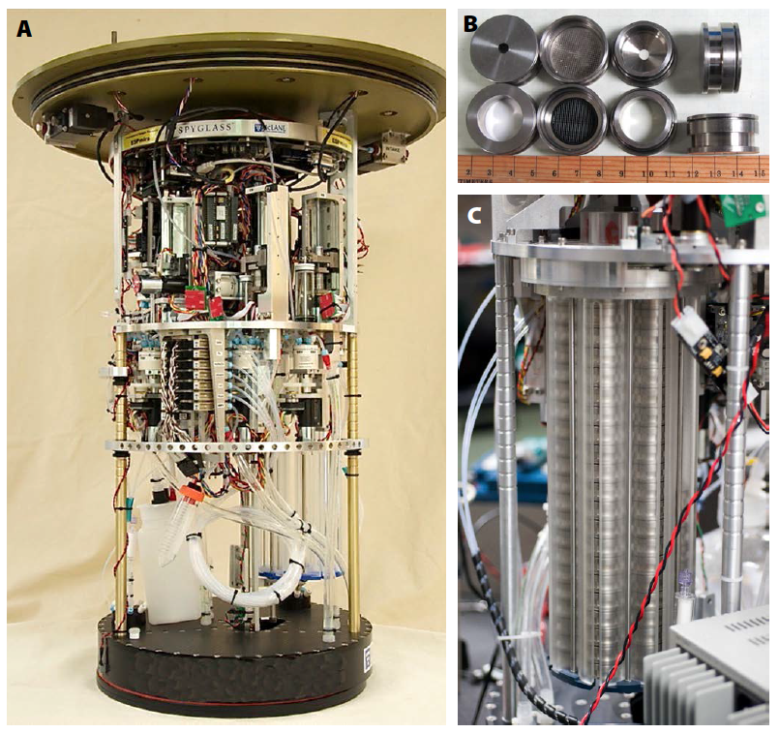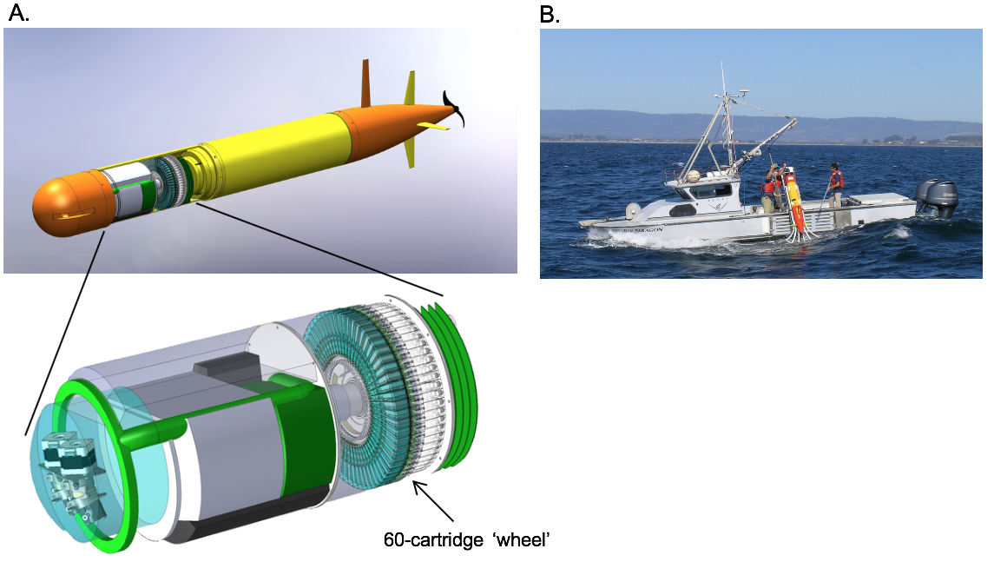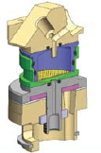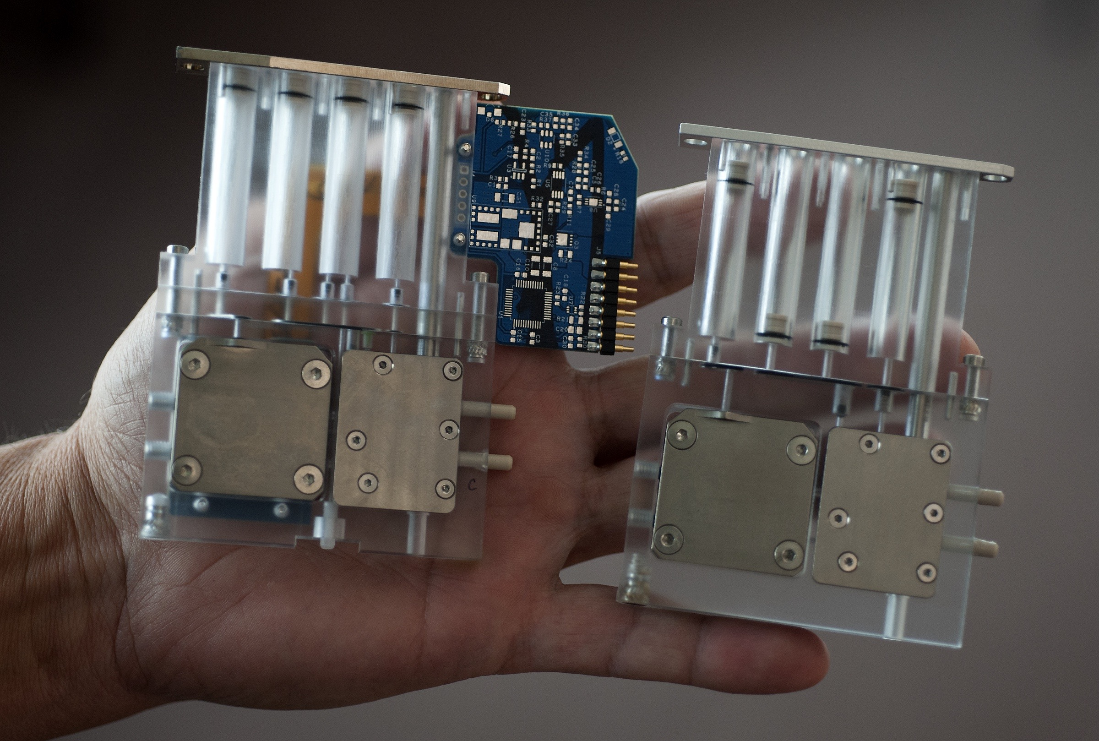
Fig. X. The 2G ESP (a) collects and processes samples using a sample puck (b) system in which pucks are manipulated in a rotating carousel (c). The 2G puck clamp (d) provides a means for injecting fluids/gas, pressure monitoring, and heating. MBARI’s long-range autonomous underwater vehicle (LRAUV; e) can accommodate a 3G ESP which holds 60 cartridges in a rotating valve assembly driven by actuators that divert sample/other solutions through the cartridge.
Sampler overview and concept of operations. We propose to merge elements of the 2G and 3G ESPs to devise a prototype that aims to meet the needs of processing samples collected from the near subsurface of Europa with ANTONIE’s primary objectives (Table 1). The ultimate design and strategy are driven by the technology developments to mitigate instrument/environment and risk associated with the unknown nature of the samples to be collected. The development will leverage significant prior investments in mechanical, electrical, and software design employed in the 2G and 3G ESPs. At the conclusion of the 2-year ICEE2 project, we will demonstrate operation of the sampler in a vacuum at temperatures below -20°C (RME1) with a suite of Europa analogue reference samples designed by our team for use throughout the instrument development process to achieve TRL5 classification (RME2). The proposed EG-ESP subsystem, or elements thereof, is envisioned to potentially also serve needs of other Europa Lander payload instruments, and could serve in central sample processing for infusion into a future Europa mission. Development steps (a-c) are described below follow the process flow diagram (Fig X).
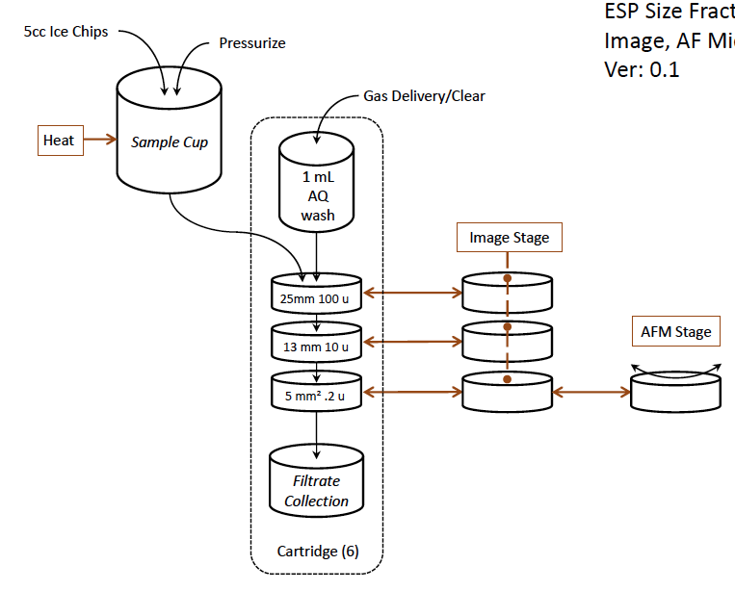
a. Sample vessel. We will use an open top 2G ESP array imaging-like puck as the primary vessel into which surface chip material is loaded. That vessel – the sample delivery puck (SDP) – will have a tapered pan leading to a small egress hole fitted with a 250$µ$m coarse filter to eliminate large insoluble from entering the sample processing path. After loading the SDP with sample, it will be robotically placed open end up into the EG-ESP system onto a single use, 3G ESP-type cartridge which houses a stack of thin filter wafers and liquid water for sample rinsing.
b. Sample handling and size fraction collections. In order to search for putative biosignatures in the particulate fraction of the collected sample, we have devised a strategy that mitigates sample composition which could be anywhere on the spectrum from ice-dominated to salt dominated. A clamp analogous to that used in the 2G ESP will seal the SDP to the surface of the cartridge atop the stack of filter wafers that contain progressively finer filtration media (100$µ$m, 10$µ$m, 0.2$µ$m) with progressively smaller filtration area. This series mitigates clogging of the finest pore size fraction, and maximizes or ability to image and characterize the properties of different size fractions of Europa’s non-ice materials. The clamp provides gas and fluid delivery mechanisms as well as thermal control similar to the 2G ESP. Dry inert gas will be applied to pressurize the sealed SDP and the flow path through the stacked filter wafers through to a sealed filtrate receiving chamber in the cartridge that can potentially be directed to another payload instrument. Heat will be applied to melt the sample as needed, with temperatures not to exceed 50C; gas pressure will drive any fluids through the filter wafers to the receiving chamber. Water in the cartridge will be heated and driven through the SDP-wafer stack-receiving chamber path using gas pressure to hydrate, and potentially solubilize any remaining salts and liberate biosignatures, or other particulates for collection as the fluid passes through the wafer stack. We propose to conduct a thermal tolerance and cycling study (RME5) as part of this effort, that will be folded into the Risk and spacecraft accommodation ICEE2 activities.
c. Imaging platform. Once done, the pressure will be relieved, and the individual wafers will be separated onto a linear or rotational actuator plane that will position each under the optical microscope for imaging; the design will allow for both the 10 and 0.2 µm wafers to be positioned under the AFM for high resolution imaging. Each imaging position is static, and can accommodate either imaging microscopes that are assembled as a unit or two individual imaging positions if they are separated. This design facilitates collaboration and co-development with additional sample observation or processing operations at defined wafer positions. Upon completion of imaging, and organics analysis (in the baseline concept) the wafers will be restacked into the spent processing cartridge or offloaded to some other destination. Fluids captured in the cartridge could be made available to other instruments, e.g. a mass spectrometer. The processing clamp fully opens and the cartridge with its sample cup is removed from the processing position. The cycle is repeated by loading a new cartridge, followed by delivery of a new SDP, clamp closure, etc.

