Current Consumption of STM32L4A6ZG (V= 3.3V) from datasheet page ~130

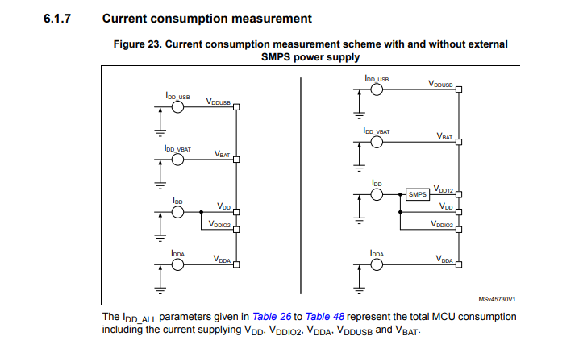
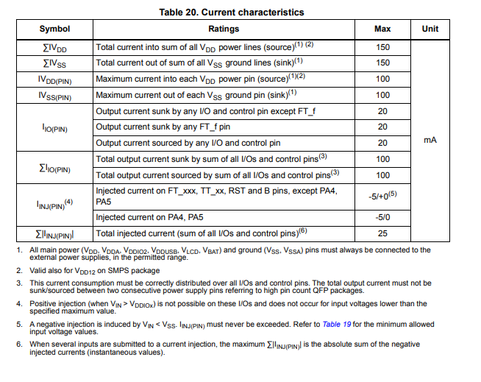
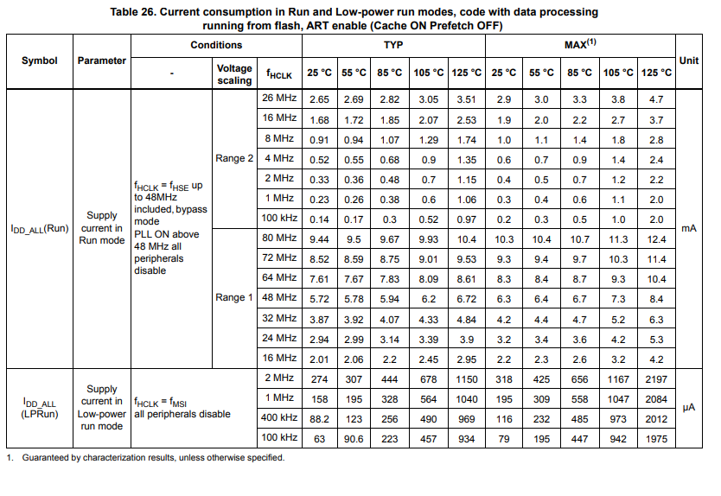

Power supplies
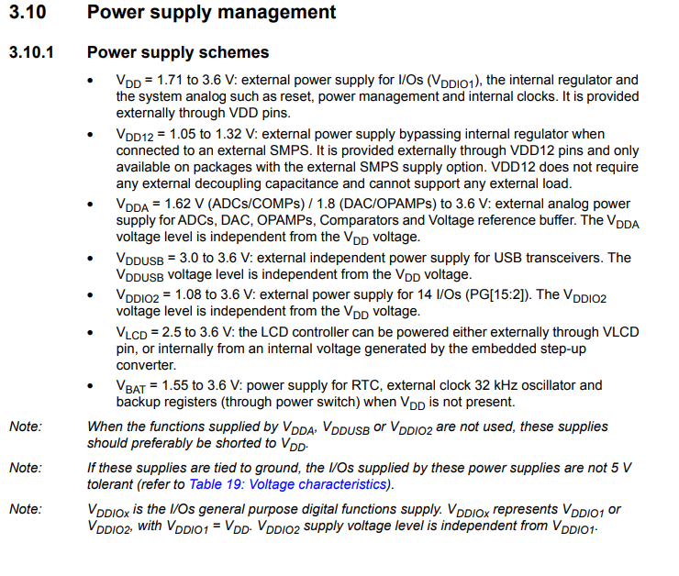

We are only using on 3.3V power supply on this board thus:
- Vdd connects to 3.3V supply
- Vdd12 = ? nc??
- Vdda = tied to 3.3V
- Vlcd = not used- NC or short to Vdd?
- Vddio2 short to Vdd like on nucleo board

6 pin Jtag/SWD

