From data sheet

p.1
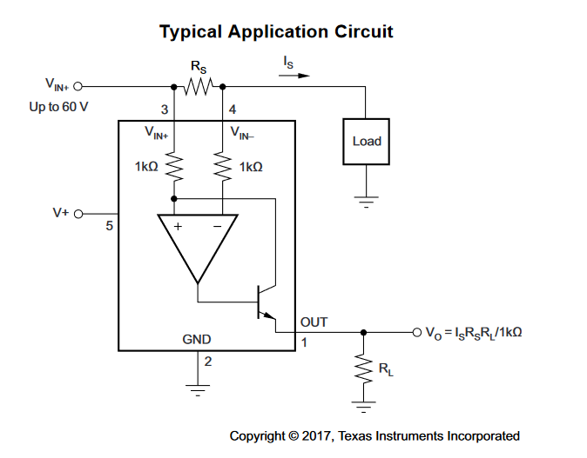
p.11

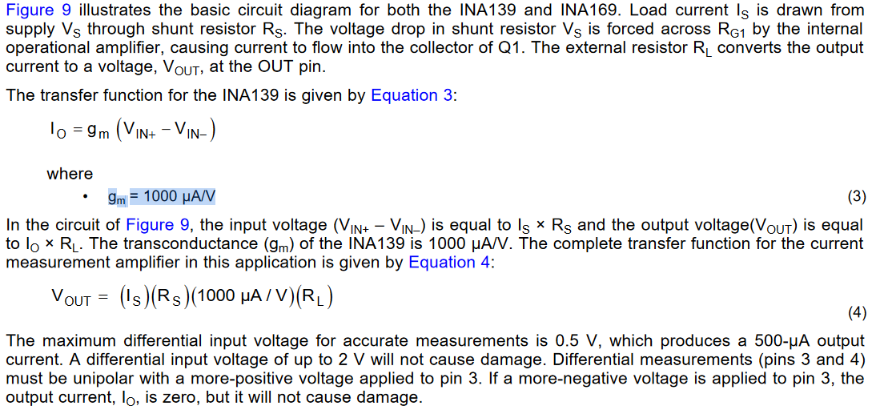

Maximum load on Vbat= 10A
V_{shunt_recommended}= (10A)(R_{S})(1000uA/V)(R_{L}) = 50 - 100mV
Thus for 10A and V_{shunt} = 100 mV, Rshunt = 10 mOhms

optimal shunt voltage is 50mV- 100mV so for a max voltage of 10A, Rshunt =
R_{L}<100kOhm
.

