ESP Sampler Firmware
Version 0.0 – initial release
0.1 – added Decon pump to list of motors
Motors
Cylinder
Arm
Clamp
Reagent pump
Decon pump

Solenoids
Intake
N2
RNA
Waste
Decon
Vacuum Select
Vacuum Break
Exhaust
Vacuum pump

Sensors
Intake pressure (Wheatstone)
Vacuum switch
N2 pressure
RNA Scale (Wheatstone)
Decon Scale (Wheatstone)
Flow
Opto-interrupter
Force
Cylinder present

Interfaces
Command
NFC
Sample pump

Motors controlled by Allegro A4988
https://www.allegromicro.com/-/media/files/datasheets/a4988-datasheet.pdf
Step and Direction with sleep
Timer and capture compare
Opto-interrupter or Force for location

Solenoids actuated by Analog MAX22200
https://www.analog.com/media/en/technical-documentation/data-sheets/MAX22200.pdf
SPI
NFC currently a NXP PN532 but not recommended for new designs
https://www.nxp.com/docs/en/nxp/data-sheets/PN532_C1.pdf
Looking for similar with a serial or SPI interface

Sample pump currently TBD
Possibly a contact closure or a power and serial interface

Wheatstone
HX711 or TI ADS1234
https://cdn.sparkfun.com/assets/b/f/5/a/e/hx711F_EN.pdf
https://www.ti.com/lit/gpn/ADS1234
SPI or Bit-Bang serial

Flow
Paddle wheel flow and rate sensor.
https://assets.omega.com/pdf/test-and-measurement-equipment/flow/turbine-flow-meters/FTB300_Series.pdf
Pulse output.
Pulse rate = flow rate
Pulse count = volume

Motor Trajectory
Simple constant acceleration (see figure)
Plateau Pace
Final Pace begins a specified amount before and after terminating event
Tail Pace after event for a specified count ends motion
Pace is inverse of velocity and is counts of timer between steps
Event may be a state from
opto-interrupters for Arm and Cylinder or,
Force sensor for Clamp

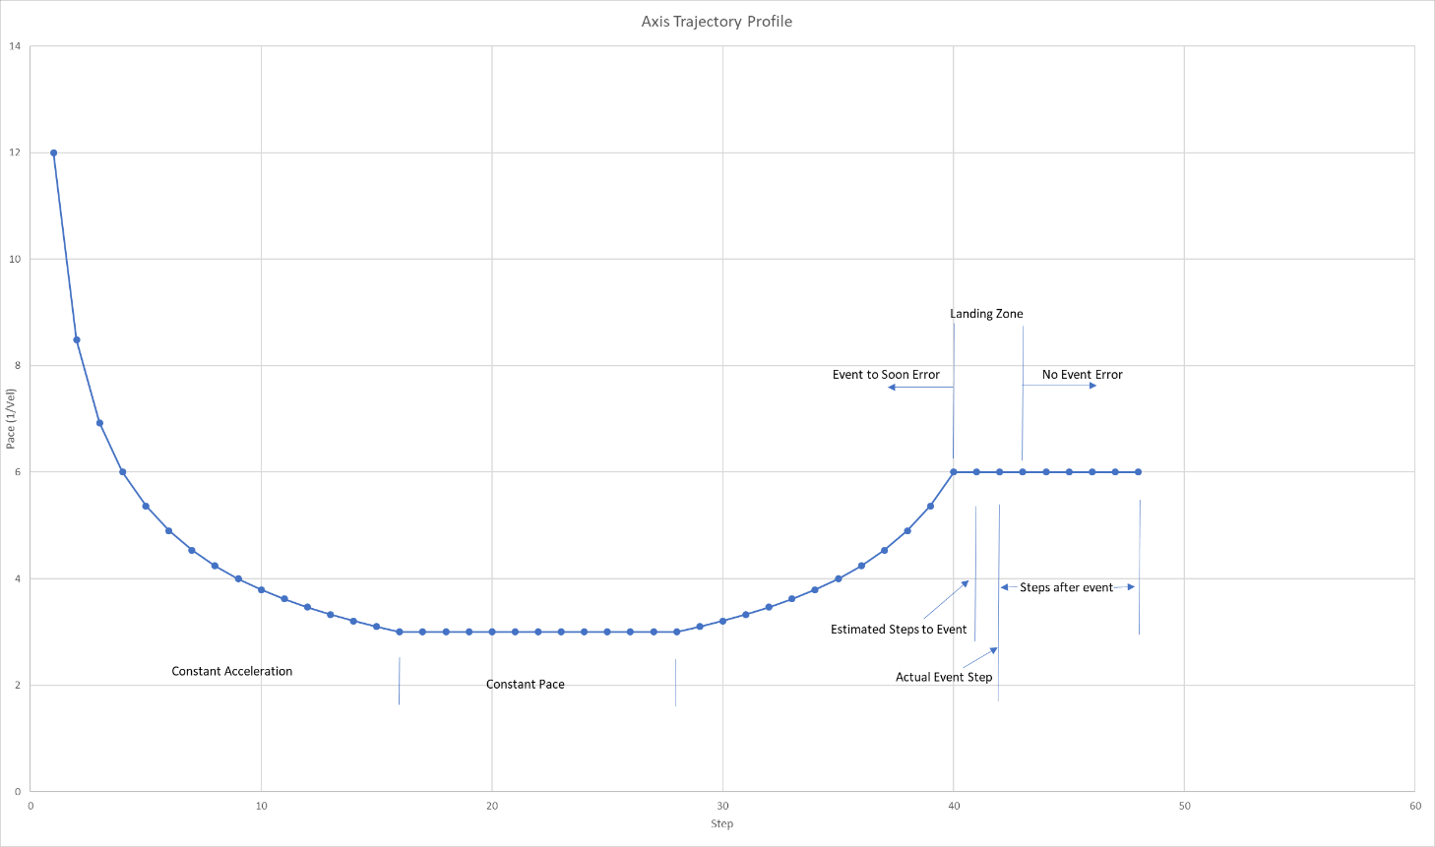

Low level hard coded basic functions such as:
Motor moves
Simple number of steps and fixed Pace, sleep
Trajectory estimated steps, Landing zone, event state, after event steps, sleep
Trajectory estimated steps, Landing zone, event force, under or over, after event steps, sleep
Solenoid
On and errors
Off and Errors
Multiple on at same time
One per command
All off command
NFC
ID puck
Read puck
Type
Serial number
Write Puck
Sample volume
Terminating rate
Start time
Stop Time
Sample temperature

Flow rate and volume
current

User Interface
Command Line
Asynchronous
Serial
Non-Volatile scripts/functions/routines
Micro-Python a possibility
Changeable without compiling or flashing
Example:
Sample tube,filter type,volume,min rate,max sample time,purge time
Decon volume,time

Status Responses:
Sample begin
Loading puck
Cylinder to tube 1
Arm to cylinder
Vacuum reached
Arm to clamp
Clamp to pinch
Puck release
Clamp to clamped

All motion axis should use incremental moves. Optical sensors have transitions between states at the various required positions. Referring to the Axis Trajectory Profile figure, the estimated steps is a predefined number from the current position state to the requested state. The end of the trajectory has a constant Pace that is specified and starts Landing Zone steps before the estimated move steps. This constant pace may continue beyond the estimated steps by Landing Zone steps. This constant Pace phase is terminated be either the requested state being observed or Landing Zone steps beyond Estimated Steps has been reached.

The trajectory accelerates the pace to a minimum value. This value

Cylinder
Is a round object that is like the cylinder of a revolver. The cylinder holds the pucks for sampling. It consists of 12 tubes which each hold 12 pucks. The cylinder is located with a set of 6 opto-interrupters that provide a transition at the center of each tube. Therefore, there are 12 valid states of the 64 possible from the 6 sensors. The cylinder may rotate in either direction infinitely rotating. should be positioned for a tube in one direction.

Arm
The main puck manipulation axis with one degree of freedom, rotation. It has a vacuum enabled end effector with a vacuum switch to detect when a puck has been acquired. The rotation is located with a set of 4 opto-interrupters that provide a transition at the center of or near each position. When a near position transition is reached a fixed number of steps beyond is required to reach the ultimate destination.

Clamp
Is a C-clamp shaped structure that makes the fluidic connection to the puck. It has a single degree of freedom that is located using a force sensor. The clamp is moved estimated steps until a force level is reached for either a above or a below force.

