October 28, 2013
Protocol: FilterEvacuate w/ air) Add ReagentEvacuate w/air

Parts List:
Accel Puck-Fixture Combination (Fall 2013 version)
Accel Puck Version 4, cut gasket w/ amber plastic or Ti top
0.2um filter, 35psi pressure on intake, through torrid valve
V4 puck Fixture
(Figure 1: 2-way stopcocks on intake, accumulator, and exhaust ports)
(Note: Below protocol cannot be run in current archive cartridge version)

Actuation Changes
- Utilizing the diaphragm as an exit port and valve (=Accumulator)
- Independent opening/closing of the intake and exhaust
- Independent opening/closing of accumulator valve

Figure 1
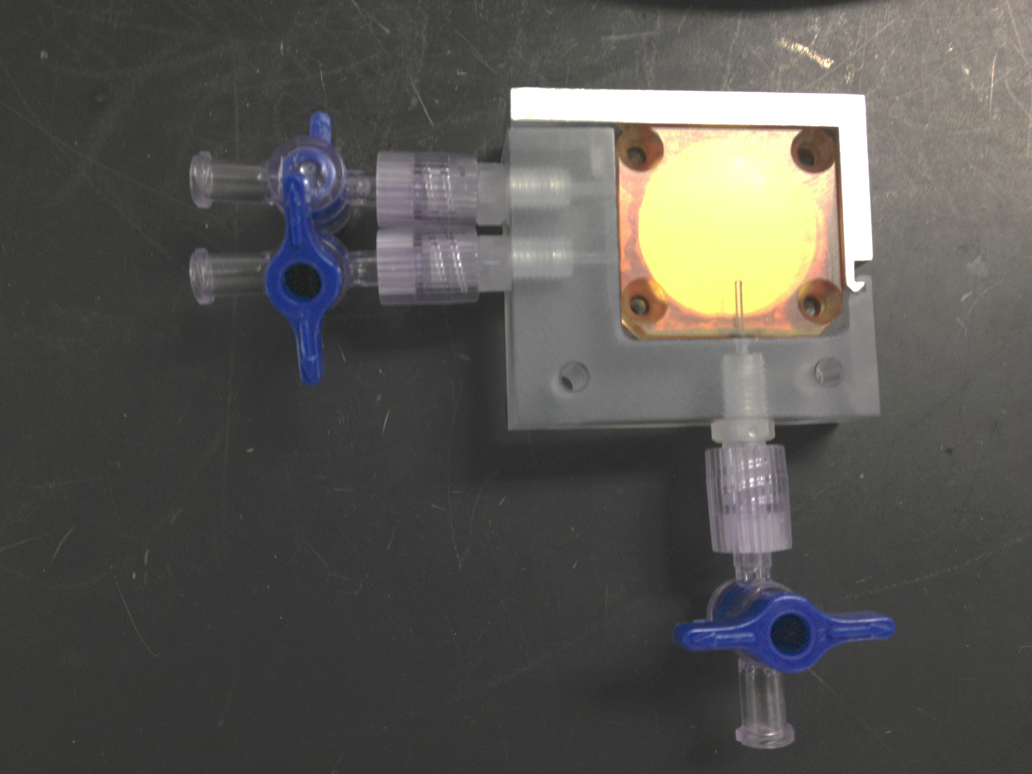

- Assemble fixture and place fixture on angle to position the accumulator outlet at the location where the air bubble accumulates as the puck is being filled.
- Filtration (All valves closed)
  - Intake, exhaust and accumulator valves closed. Pressure pot at 30psi off.
  - Hook up lines to intake and exhaust.
  - Open pressure pot valve. Check for leaks.
  - Open exhaust valve
  - Open intake valve
  - Measure the filtration rate to at least 300ml volume
  - Turn off intake valve
  - Turn off pressure pot valve
- Evacuation (Intake and accumulator valves closed, exhaust open)
  - Remove intake line
  - Attach a 3cc syringe containing 1.5ml air to the intake
  - Hold syringe firmly. Open intake valve to deliver 1.5ml air to puck, with syringe bottomed out close the valve
  - Repeat b-c for a total of 4, 1.5 ml pushes
- Reagent delivery (Intake and accumulator valve closed, exhaust open)
  - Slowly open the accumulator valve to vent off the air pressure
  - Attach 3cc syringe containing 1.5ml of reagent to Intake valve
  - Open intake valve (There should be no backpressure on the syringe. All valves on fixture are open)
  - Slowly deliver 1.4 ml of the reagent to puck.
  - Close the accumulator and exhaust valves.
  - Deliver the remaining fluid in the syringe.
  - Close intake when the syringe bottoms out.
  - Incubate X min at X temperature (Dependent on lysis or fix procedure)
- Evacuation and Reagent recover
  - Repeat evacuation steps b-d, but with the exhaust tube positioned in a 2ml tube to recover the reagent

