G3 Concept Development
Turbine is name of the lead concept instrument we are progressing with. Instead of the whole instrument being involved in each sampling event like the G2 instrument, Turbine is a cartridge based system. All the consumables for a single ESP sample “event” are housed in a single use cartridge; filter, reagents and purification membranes/beads. All the sample filtering and preparation is done in the cartridge, which outputs the refined sample to the detection module. Each cartridge is essentially a single ESP, but with no power, pumping force, or drivers to dispense the reagents. The cartridges are arrayed on a rotatable cylinder assembly, which has a single processing station of cartridge actuators. The main instrument becomes a mechanism that pumps seawater through a cartridge, powers and actuates it.
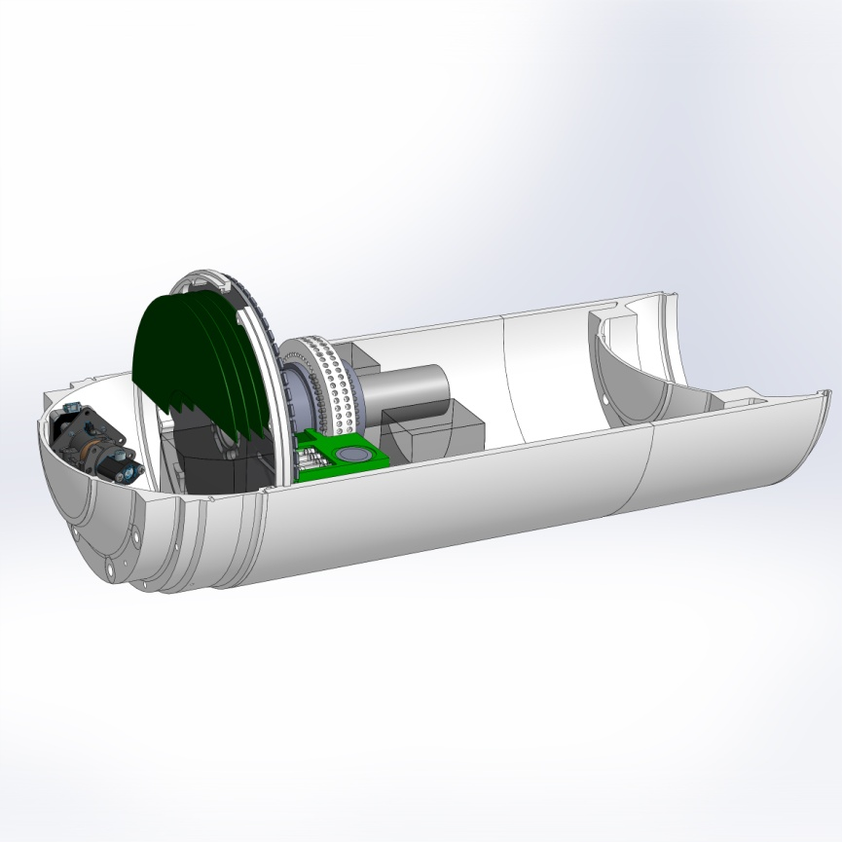
Solid model of Turbine Concept
Attached Examples:
- Slides from latest annual meeting
- Modular cartridge diagrams
- Sketches of cartridge flow schematics

