LRAUV Integration, Mass/Size and Risk
I recognized at the very beginning of the G3 project that success will be most affected by how we manage the size and mass of the instrument. Although the G3 ESP may be used on various platforms, the LRAUV sets the most restricted design space. The LRAUV effectively has a maximum length, so the volume for an ESP payload (instrument plus pressure housings) is limited.
Working with the LRAUV team, we determined the max size for the ESP payload to be a 2 foot extension on the LRAUV. This will allow for a G3 ESP pressure housing roughly 1/8th the volume that the G2 instrument uses. As the vehicle also needs to be neutrally buoyant, this extension will need to be near the density of seawater. I estimated the G3 instrument mass (without pressure housing) could be 40 pounds, about half that of the G2 ESP. This quick evaluation determined that the G3 design would be most constrained by the volume limit. From design literature searches and discussion with aerospace engineers, I set up the decreasing reserve margin for the G3 ESP.
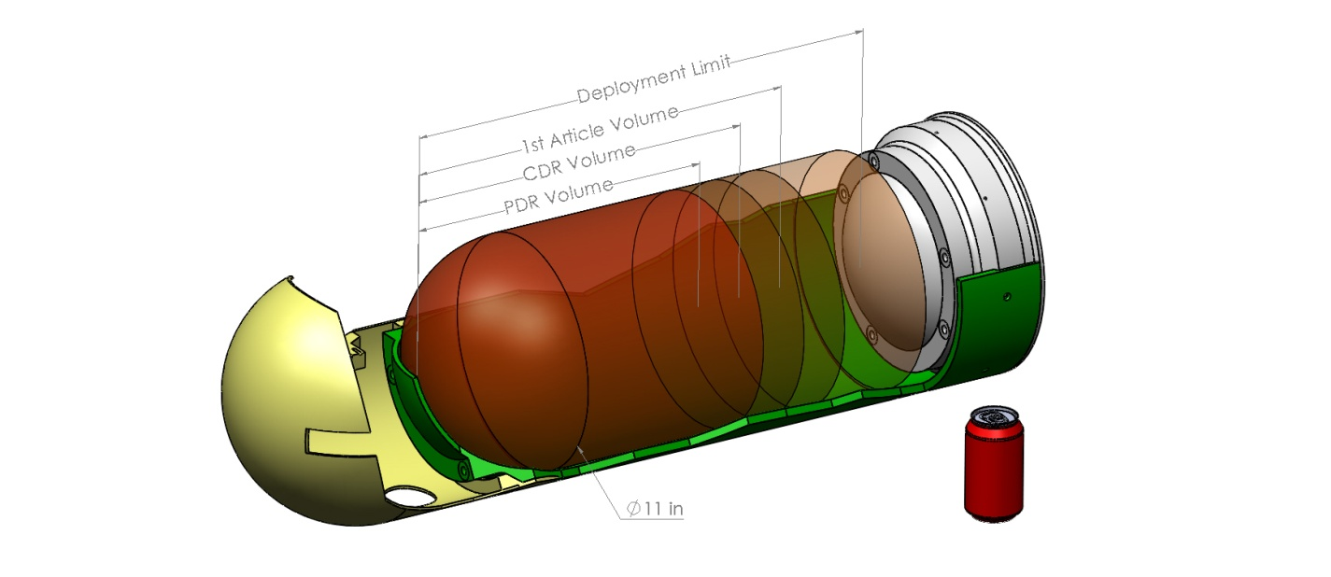
G3 ESP size limits at various design stages.
I’ve been coordinating the G3 design for integration onto the LRAUV, tracking a number of points. We did generate an interface control document, but we also maintain informal communication between the teams. The G3 will be in its own pressure housing, between the nose and the LRAUV battery/drive section. The tie-rods that run the length of the LRAUV drive section cannot pass thru the ESP “turbine”. To be valid, the G3 Turbine concept needed a pressure housing arrangement that could be assembled and not structurally weaken the vehicle. I developed the two pressure housing design sufficiently to demonstrate this and have a full scale half section mock-up made.
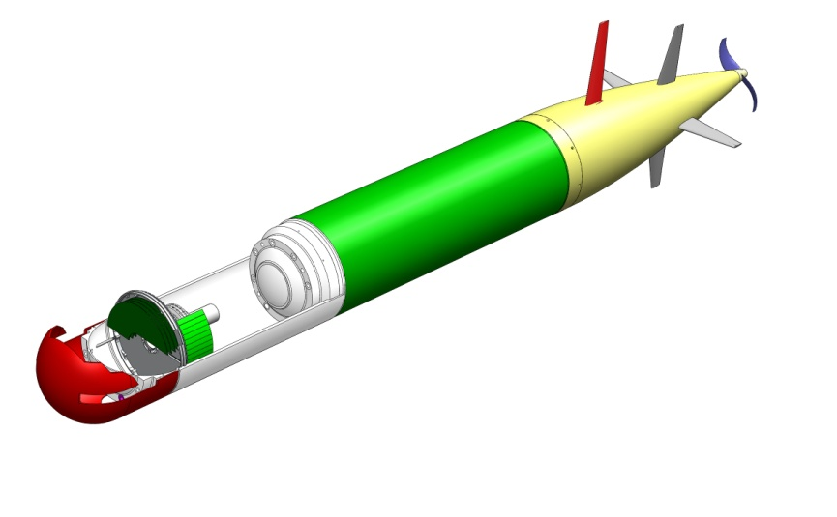
Solid model of Turbine concept in the ESP bay on an LRAUV
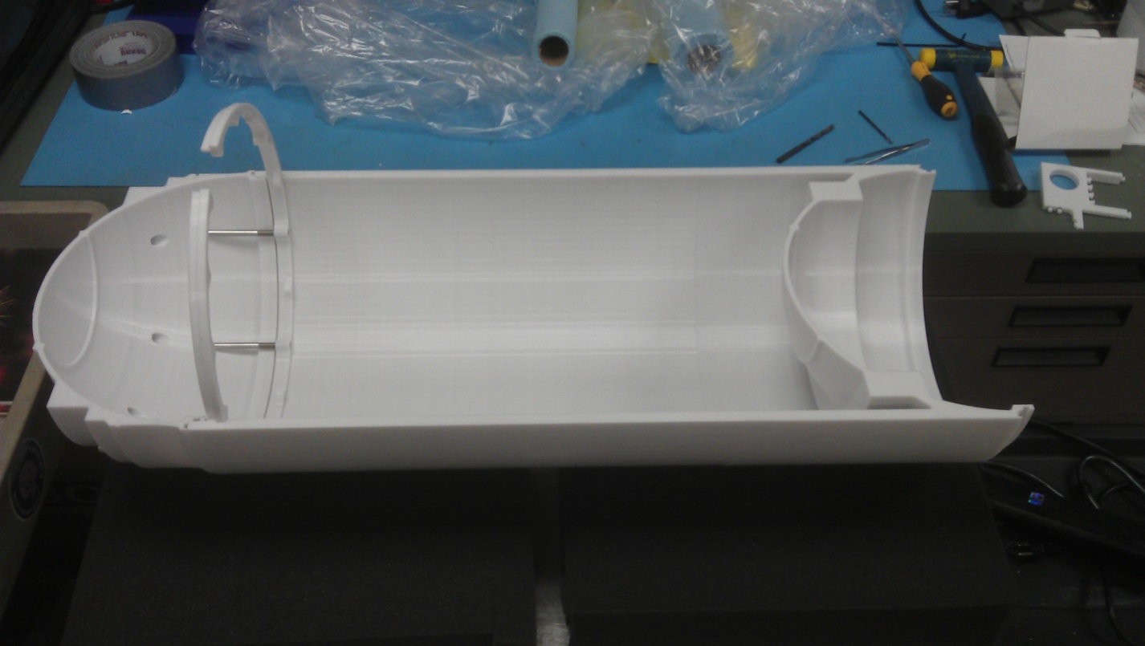
Half section of G3 ESP Bay
Attached Examples:
- Volume and weight estimation spreadsheet. (G3weight.xlxs)
- Slides from LRAUV interface control meeting (LRAUV ICD mtg 12-05-11.pdf)
- Last version of the G3ESP-LRAUV Interface Control Document (3G-LRAUV ICD ver1-0.pdf)

