Cartage Assembly Procedure: 9/9/13:

Tools Required:
- 2mm Allen wrench
- 1.5mm Allen wrench
- 0.9mm Allen wrench
- O-ring tool
- Snap ring pliers or tweezers

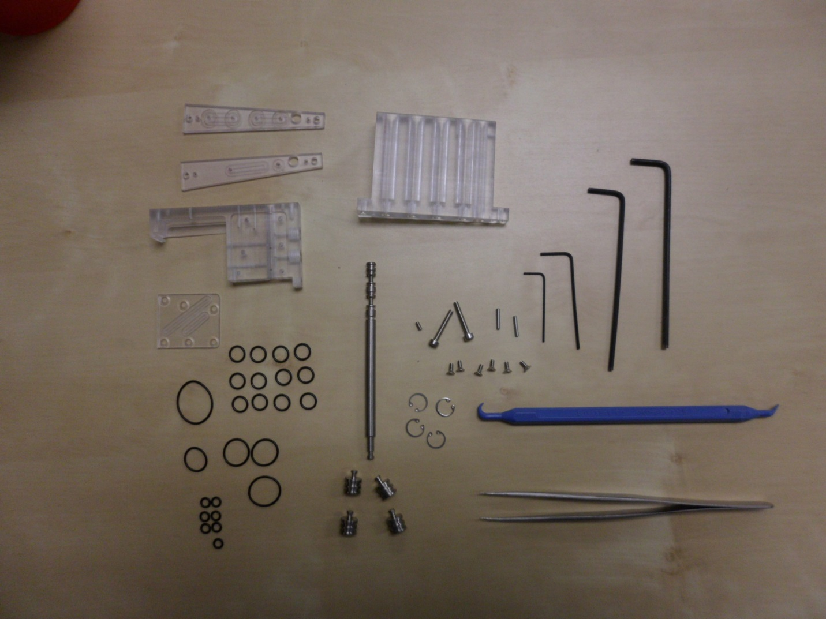
Assembly Instructions:
- Put 6 1X3mm O-rings on plunge valve piston in the grooves 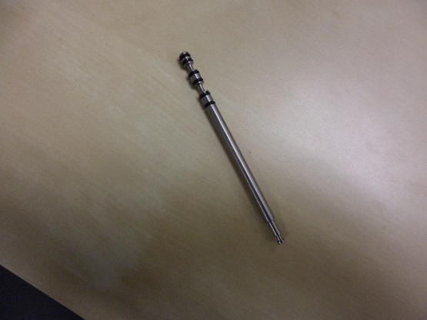
- Put 2 1X6mm O-rings each (4) short titanium plungers 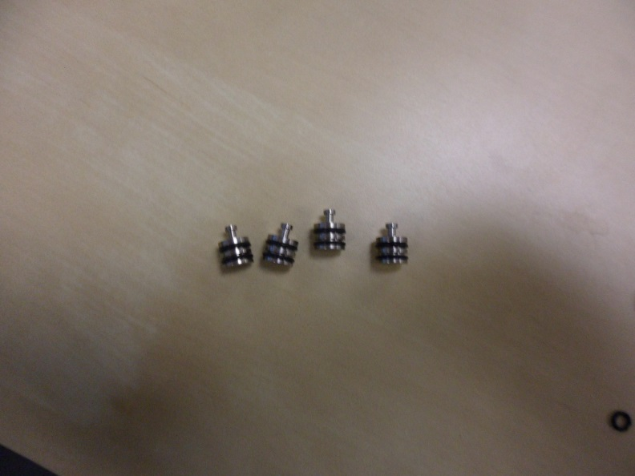
- Press plungers into syringe block 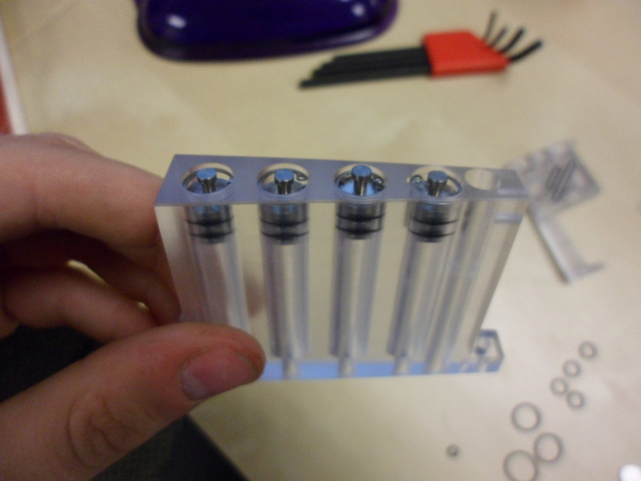
- Insert snap rings into syringe block
- Place one 1X17mm O-ring and 1X9.5mm O-ring on the cover
- Slide cover onto the puck cassette block 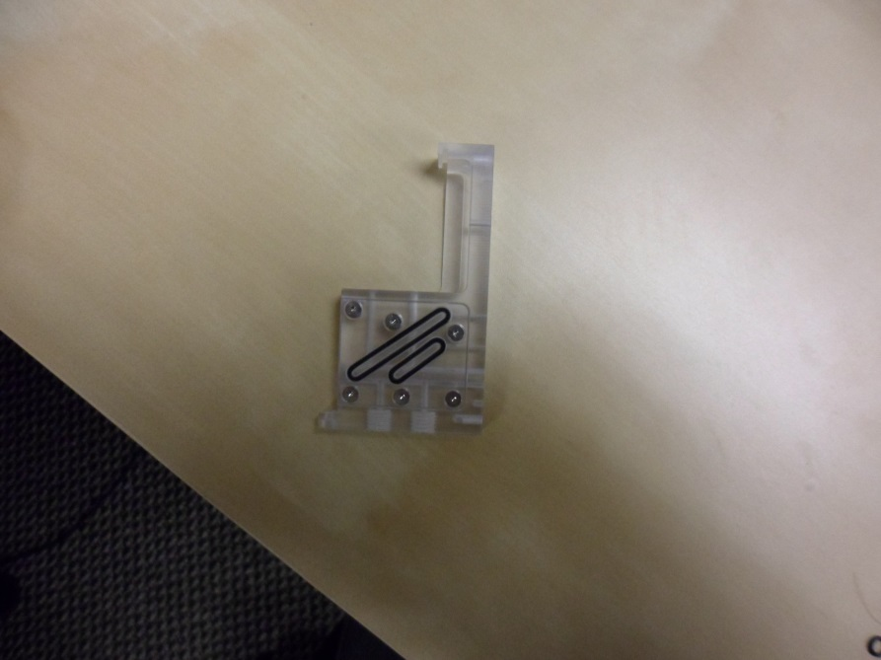
- Insert one 1/16th dowel pin into puck cassette block
- Place 1X13mm and 1X3mm O-ring on evac. manifold wedge
- Place wedge on puck cassette block
- Place two 1X11mm O-rings on syringe manifold wedge
- Place syringe manifold wedge on evac. Manifold wedge 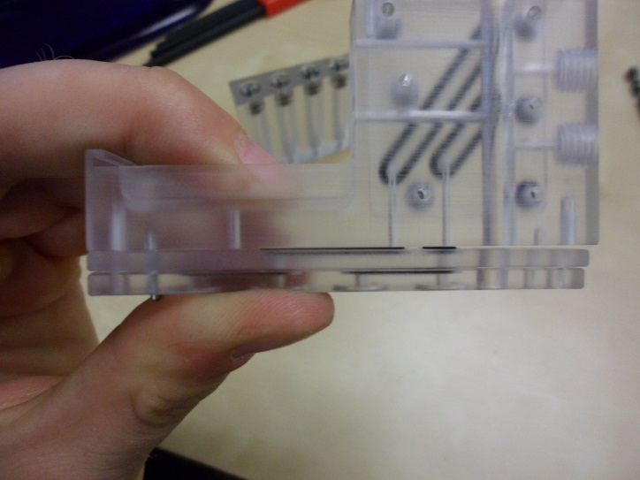
- Place four 1X6mm o rings on
- Insert second dowel pin
- Press syringe block and puck cassette block together
- Screw together with M2.5 screws 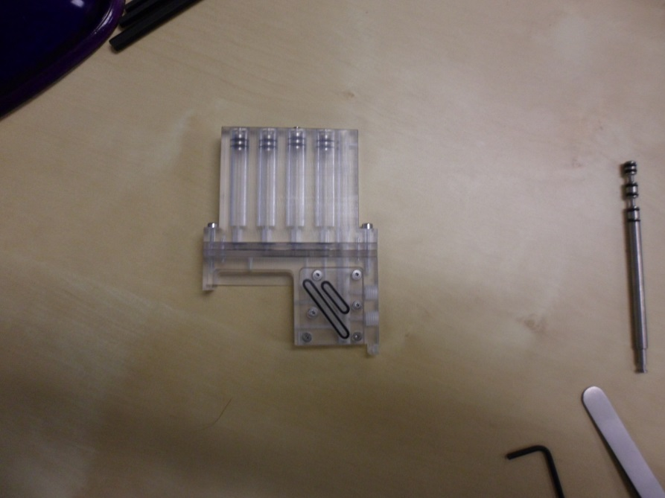
- Insert plunge valve piston from the bottom up (so the O-rings go in last) 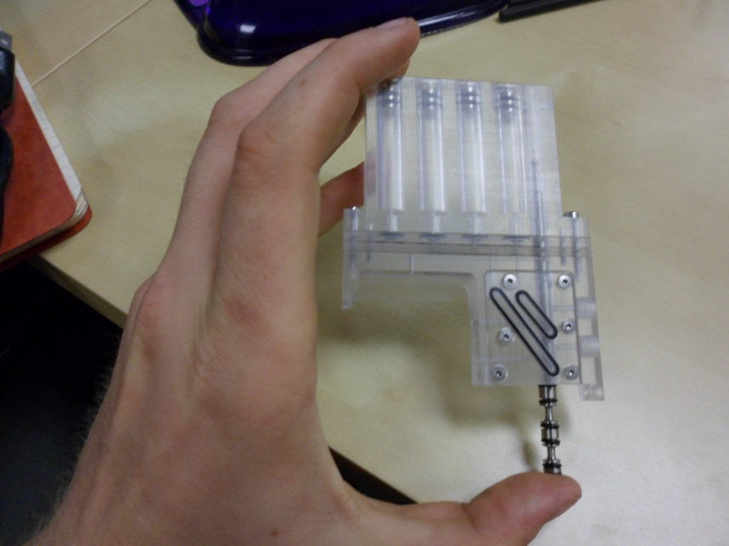
- Screw in M2 set screw
- Set puck assembly into puck cassette block
- Slide puck bracket into place
- Screw puck bracket in from the side first
- Then screw in from the bottom
