G3 Environmental Sample Processor (ESP)
Analytical Module

DRAFT Requirements and Interface Specification DRAFT

Version 1.0

28 October 2011

Point of contact:
Chris Scholin, 831-775-1779, scholin@mbari.org
Jim Birch, 831-775-2062, jbirch@mbari.org

Collaborators:
Dierdre Meldrum, Deirdre.meldrum@asu.edu
Cody Youngbull, cody.youngbull@asu.edu

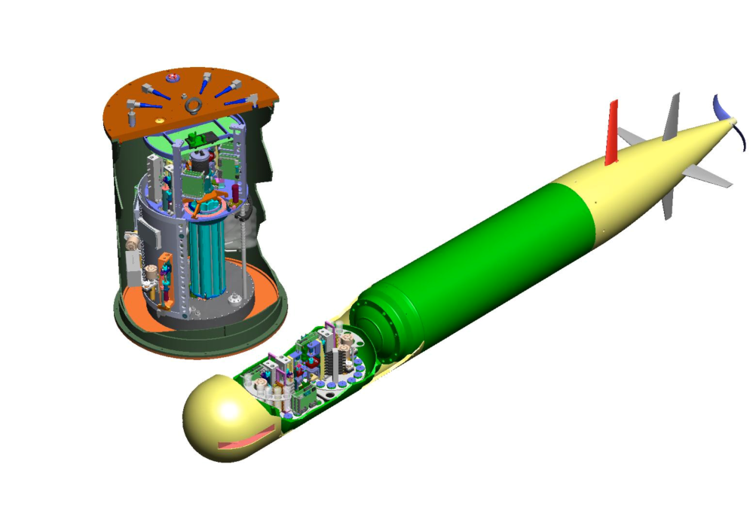

Funding is provided by the Monterey Bay Aquarium Research Institute (MBARI) from the Moore Foundation project “qPCR-based analytical module for the Environmental Sample Processor (ESP)” (grant #2728). Grant is slated to run four years, concurrent with the calendar year. Year one ends Dec 31, 2011.

Concurrence sheet

ESP Analytical Module Requirements Specification Version 1.0

Date: _____________________

Submitted by:

___________________________________

Approval:

___________________________________

Executive summary (needs work)

This document is the central repository both for specifications of requirements and for interface-control information for the G3 Environmental Sample Processor (ESP) Analytical Module(s) being developed at ASU’s Institute of Biodesign. This project is funded by a 4 year grant by the Moore Foundation, running from Nov 8, 2010 until Dec 31, 2014. The main section is 2. Requirements specifications for the Analytical Module, which documents requirements for the module that ASU is developing for MBARI. This includes electrical, electronic, software, mechanical, thermal, and optical aspects. Another section is 4. Requirements for the ESP fluidics related to , which will help MBARI configure and operate the G3 ESP to use the module effectively.
Since this is the authoritative repository of requirements and interface information, any substantial changes to the document after release Version 1.0 need to be made through a change request and approval process.

Table of contents
Concurrence sheet 3
Executive summary 4
Table of contents 5
Table of figures 7
Table of tables 8
Table of revisions 9
1. Introduction 10
1.1. Document content 10
1.2. ESP and Moore Foundation background 10
1.3. Goals for Analytical module project 10
1.4. Analytical module scope definition 11
2. Requirements specifications for the Analytical Module 12
2.1. Voltage 12
2.2. Current 12
2.3. Energy 12
2.4. Data interface standard 12
2.5. Message syntax 12
2.6. Commands and Responses 12
2.7. Optical data 13
2.8. Thermal data 13
2.9. Data modes 13
2.10. Detection algorithm 13
2.11. Size 13
2.12. Mass 13
2.13. Shock & Vibration Error! Bookmark not defined.
2.14. Orientation while running 13
2.15. Reaction temperatures 13
2.16. Heating rate 13
2.17. Cooling rate 13
2.18. Thermal environment 13
2.19. Humidity 13
2.20. Number of optical channels 13
2.21. Optical wavelengths 13
2.22. Reaction volume 13
2.23. Tubing outer diameter 13
2.24. Serial numbers 13
2.25. Fan reliability 13
2.26. Documentation 13
3. Examples of Analytical module protocols and their implementation 14
3.1. Introduction 14
3.2. Real-time PCR 14
3.3. Melting curve Error! Bookmark not defined.
3.4. Thermal calibration 14
4. Requirements for the ESP fluidics related to Analytical Module 15
4.1. Introduction 15
4.2. Reagents 15
4.3. Valves 15
4.4. Pumps 15
4.5. Tubing 15
4.6. Fluidics protocols 15

Table of figures
Figure 1: Analytical Module and various interfaces. Error! Bookmark not defined.
Figure 2: Transit vibration (MIL-STD-810F Fig. 514.5C-I). Error! Bookmark not defined.
Figure 3: Functional shock (MIL-STD-810F Table 516.5-I and Fig. 516.5-8). Error! Bookmark not defined.
Figure 4: Vibration minimum integrity (MIL-STD-810F Fig. 514.5C-17). Error! Bookmark not defined.
Figure 5: fluidics diagram using 3 valves to achieve a choice of 2 sample sources, 2 master-mixes, 8 different multiplexed reactions, and DNA extraction. Error! Bookmark not defined.

Table of tables
Table 1: Document revisions. 9
Table 2: Details of commands and responses. Error! Bookmark not defined.
Table 3: Transit drop test (MIL-STD-810F Table 516.5-VI). Error! Bookmark not defined.

Table of revisions
Table 1: Document revisions.
Date | Version | Major changes
2011_10_31 | 0.6 | First draft begun

Introduction

Document content
This document is the central repository for specifications of requirements and interface-control information for the G3 Environmental Sample Processor (ESP) Analytical Module. The main section is 2. Requirements specifications for the Analytical Module, which documents the module that ASU is developing for MBARI. Another section is 4. Requirements for the ESP fluidics related to , which will help MBARI configure and operate the ESP to use the module effectively. To force clarity and make changes easier to track, information should appear in either one section or the other, not both.
This document will evolve continually up to the preliminary design review (PDR). After that point, the plan is to have an approved version of the document that is only changed by agreement of both ASU and MBARI through documented change requests.

ESP and Moore Foundation background
The Analytical Module is being developed by ASU for MBARI using funding from a four year grant from the Moore Foundation. This grant was part of the Marine Microbiology Initiative, and was focused on supporting the miniaturization and enhancement of the ESP. Funding would be used to increase the analytical throughput (reaction speed and total number of samples) by an order of magnitude to enable new knowledge of specific marine microbes and how they function in natural environments.
ASU is participating as a co-investigator on the project with responsibility for delivering Analytical Modules for the project.

Goals for Analytical Module project
The overall objective is to develop an analytical module for oceanographic microbiology to function in MBARI’s third generation Environmental Sample Processor (3G ESP). This analytical module will be used in the ESP to perform in-situ, real-time genetic analyses. The plan includes demonstrating qPCR and microarray processing in a prototype in XXXXXX.
The general and specific goals for the module that feed into its requirements include
- Have performance similar to bench-top machines: appropriate thermal range, fast heating and cooling rates, et cetera.
- Be usable in the 3G ESP: small size, low power, moderate energy per reaction, compatible electronic interface, compatible fluidic interface, readily programmable, et cetera.
As part of this project, MBARI will provide guidance to help ASU configure and operate the ESP to use the Analytical Module effectively.

Analytical Module scope definition
The 3G ESP will be a host platform capable of mating with various “analytical modules”. In typical use, the Analytical Module will receive electrical power, electronic commands, and a fluid sample from the G3 ESP. The Analytical Module will execute real-time PCR thermal protocols, perform fluorescence measurements, and return optical results.
Will the module require active fluidic functions (pumps, valves, et cetera)?
From ASU Proposal:
We propose to develop and validate a quantitative Polymerase Chain Reaction (qPCR)-based
analytical module for the ESP to perform high throughput detection and quantification of gene
expression of marine microbial communities. The analytical module will perform quantitative
qPCR for both DNA and RNA samples. To improve the throughput of the assays, we will
fabricate microfluidic chips patterned with embedded microwells, or use droplet based emulsion
methods as reaction chambers. Successful development of this instrument will accomplish two
major technical advances. First, genomic and metagenomic information of marine microbes will
be utilized for probe selection and design for qPCR. The qPCR analysis will incorporate both the
“signature” DNA (16s or 23s rRNA for relevant prokaryotes and 18s rRNA for relevant
eukaryotes) and conserved sequences of selected functional genes, such as those related to
nitrogen fixation and photosynthesis. The instrument will thus be capable of assessing both
composition and productivity in microbial communities at high specificity and sensitivity.
Second, chip-based design and smaller volume qPCR reactions will allow more sensitive
detection and quantification of multiple genes in a cost effect format that meets the requirements
of the next generation ESP.

Requirements specifications for the Analytical Module

Voltage
Nominal 10 – 18 volts
Absolute Maximum 10 – 24V

Current

Maximum 2 A continuous
Inrush 3A upon contact closure

Energy
Need to think about this one

Power Switched

Analytical module power will be under control of the ESP and may be turned on and off

Data interface standard
Physical protocol 5 wire RS-232
Naming convention is from ESP perspective
TX Transmit Data ESP Drives
RX Receive Data AM Drives
HSO Handshake out ESP Drives
HSI Handshake in AM Drives
SGnd Signal Ground
Handshake function
HSO signals AM that ESP is able to receive
HSI signal ESP that AM is able to receive
Baud Rate 1200,9600,19200,115200

Message syntax

Commands and Responses
In this section, we outline the types of commands and responses.

Types of commands
The Analytical Module will accept the following types of commands from the Host.

Types of responses
The Analytical Module will provide the following types of responses to the Host.

Details of commands and responses

Optical data

Thermal data

Data modes

Detection algorithm

Size

Mass

Orientation while running

Sample delivery

Inter-sample contamination
What the module cleans between samples

Waste

Reagents

Reaction temperatures

Heating rate

Cooling rate

Thermal environment

Humidity

Number of optical channels

Optical wavelengths

Reaction volume

Tubing outer diameter

Serial numbers

Fan reliability

Documentation

Examples of Analytical Module protocols and their implementation

Introduction
The rest of this section contains examples of Analytical-Module-specific protocols and their implementation as related to qPCR.

Real-time PCR

Description in English

Description in the Analytical Module’s programming language

Thermal calibration

Description in English

Description in the Analytical Module’s programming language

Requirements for the ESP fluidics related to Analytical Module

Introduction
This is the place to put requirements for the ESP fluidics related to the Analytical Module that are not specifically addressed by specifying requirements for the module, above. There should be no redundant information here, meaning no information should appear both here and above.

Reagents

Valves

Pumps

Tubing

Fluidics protocols

