Going with the flow: tracking coherent microbial populations to better understand how environmental perturbations modulate gene expression in the open sea
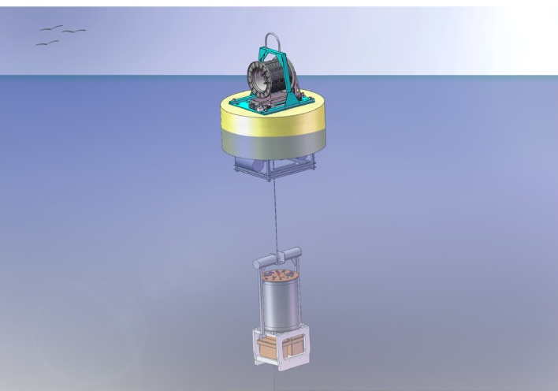
Modern molecular biological techniques have revolutionized our understanding of the diversity, function and community structure of marine microorganisms. For field research, molecular analytical analyses are often applied to discrete samples wherein the microbial community structure and function is referenced against physical, chemical and bulk biological conditions that are assessed at the instant samples are collected. However, the biological community collected at any instant is derived from past as well as present conditions. Thus, there is an inherent difficulty in establishing detailed cause and effect relationships since the history of the population in question is generally not known. A team from the Monterey Bay Aquarium Research Institute and its counterparts from the Center for Microbial Oceanography Research and Education (C-MORE) are working to overcome this limitation by developing submersible autonomous platforms that are capable of actively identifying, tracking and sampling coherent microbial populations so that changes in their community structure and gene expression can be assessed over time in response to changing environmental conditions. The long term goal is to develop a system that is capable of both sample archival as well as in situ molecular analytical analyses so that targeted sampling and analyses can be accomplished in remote locations without necessarily requiring a human presence at sea. NSF, the David and Lucille Packard, and Gordon and Betty Moore Foundations are supporting this effort.
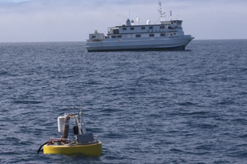
To model this system, MBARI teamed with microbial ecologists from MIT and deployed a free-drifting Environmental Sample Processor (ESP) roughly 100 miles from the central California coast for five days. The ESP is a robotic underwater molecular biology lab that is about the size of a kitchen garbage can. It was suspended below a surface float and allowed roam freely while it performing a range of tasks from collecting water samples and carrying out a number of DNA probe tests in real-time, to preserving samples for examination after the instrument was recovered. At the same time, an autonomous underwater vehicle circled the drifting ESP, automatically altering its trajectory by tracking the position, heading and speed of the drifter, thereby providing a volume view around the instrument as is meandered at the whim of ocean currents
The drifting Environmental Sample Processor (in the foreground) with the research vessel Western Flyer off central California. Image: Phil Sammet © 2010 MBARI

