ESP Drifter Deployment Plan
Gene Massion

Revision
- May 12, 2011 Initial Draft

Ship: University of Hawaii R/V Kilo Moana
Departure Date: September 6, 2011
Return Date: September 21, 2011

MBARI Crew
- Julie Robidart jrobidar@ucsc.edu
- Gene Massion magene@mbari.org 831 7751922 (work) 831 4199188 (cell)
- Roman Marin maro@mbari.org

Time Line (details TBD)
- September ( August?) x MBARI Shipping Container arrives at UH Marine Center
  - UH offloads container and connects to shore power
- September (August?) x MBARI crew arrives at UH Marine Center
- September x MBARI crew moves ESP to 10’ container (Question 1,2)
- September x-y MBARI crew prep and check ESP
- September x-y MBARI & KM crew mount antennas and run cables
- September x Load ship
- September x Deploy ESP
- September x Recover ESP

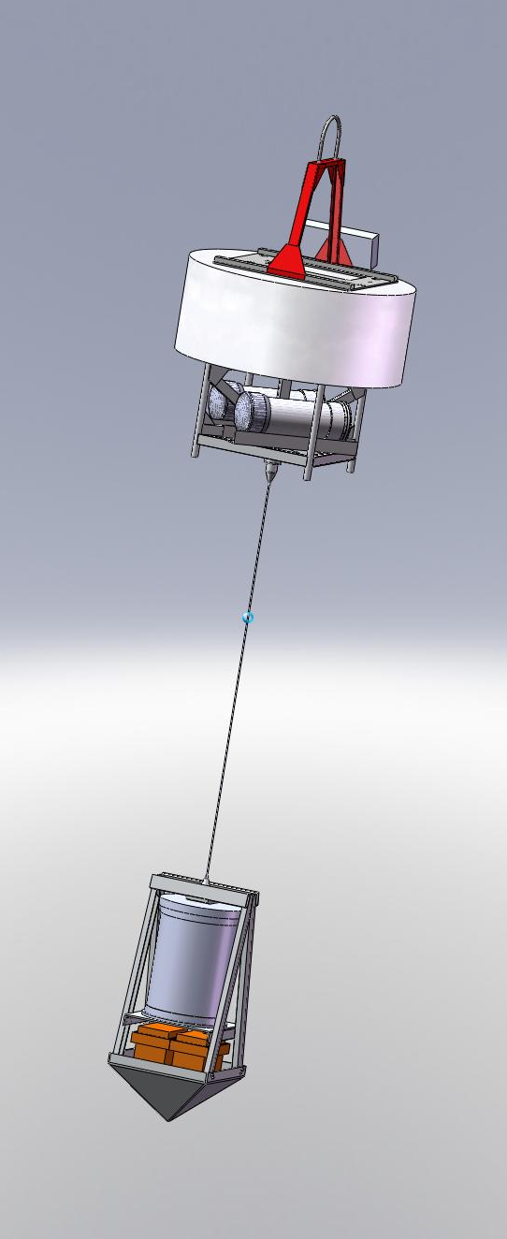
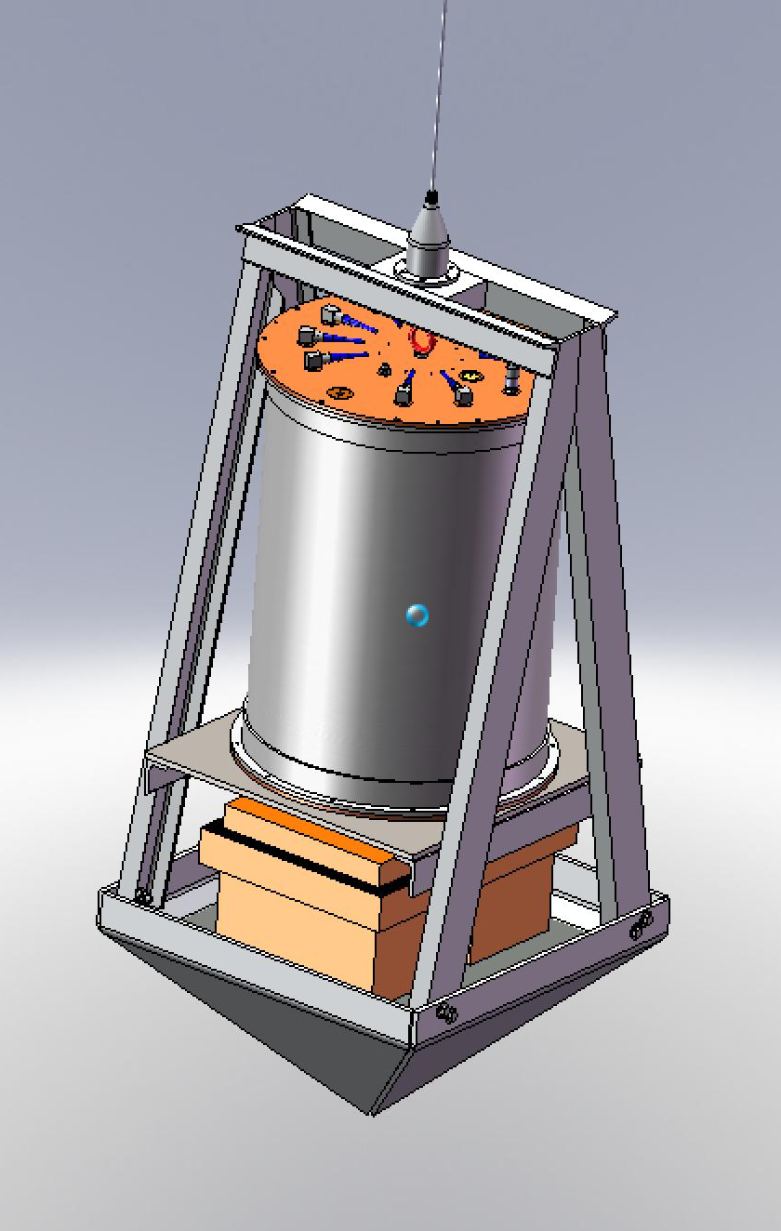
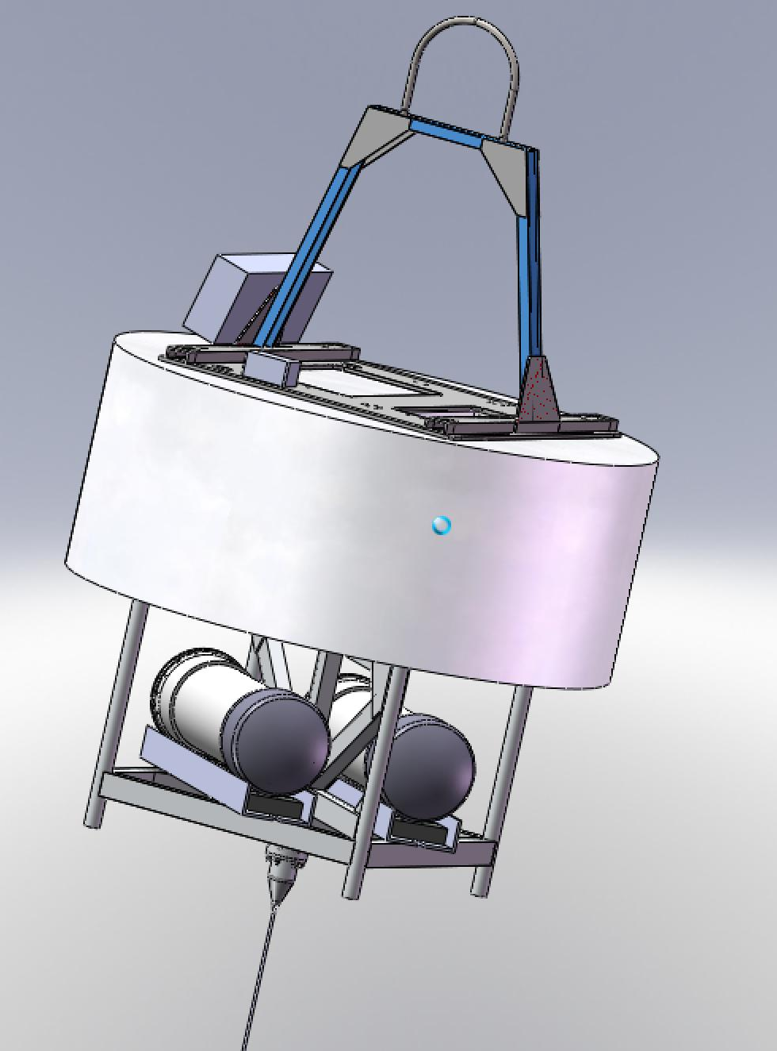
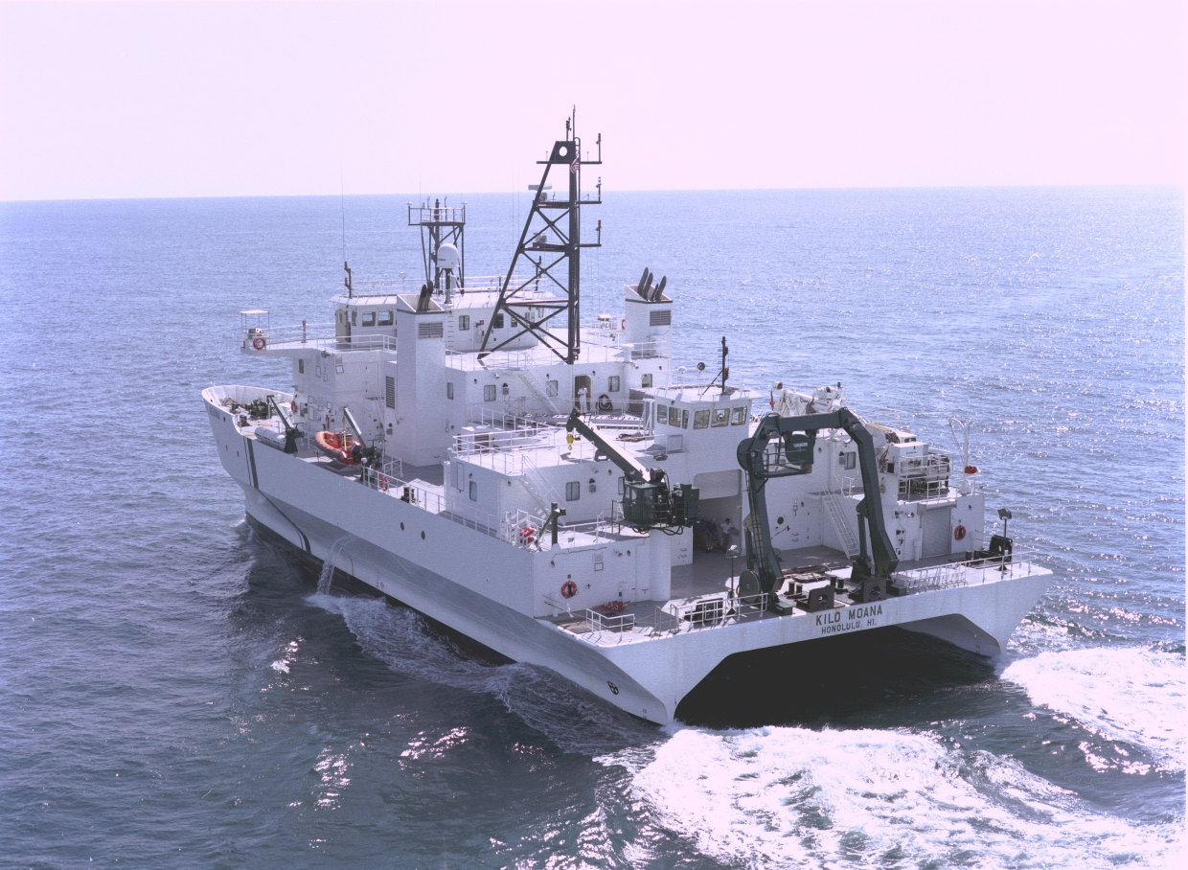

Deployment plan
Crew required: Deck supervisor, 2 tag line handlers, 1 quick release tender, 1 E/M cable tender, winch operator, crane operator, acoustic release operator

- Test Benthos release on winch wire at 23 meter depth
- Stage the ESP under the U-frame
  - Soft line on winch (Q4)
  - Mark the soft line at about 20 meters
  - MBARI supplied Benthos acoustic release between winch line and ESP pad eye (Q3)
  - 2 tag lines
  - E/M cable tender tends E/M cable between buoy and ESP
  - Check everything is clear for deployment
- Stage the buoy under the crane (port side of U-Frame?)
  - Crane hook to 20’ sling to MBARI supplied “Sea-catch” manual quick release to buoy bale REMOVE THE SAFETY PIN
  - 2 tag lines
  - Check the recovery line bundle and grapple loop
  - Check everything is clear for deployment
  - Quick release tender tends release line
- Confirm ESP and Buoy are working properly
- Put the buoy in the water slightly port of the U-frame and leave it on the crane hook
  - Put enough slack in the 20’ sling so the buoy isn’t snapping tight but the crane hook isn’t banging into the buoy
  - Recover the tag lines
- Put the ESP in water and lower away
  - Recover the tag lines
  - Slow down when approaching the 20 meter mark
  - We should see the ESP and the buoy start to move toward each other
  - Continue lowering until the winch line gets near the buoy
- Trigger the acoustic release
- Confirm ESP is free: should see the winch line swing away
- Recover winch line
- Pull the buoy quick release
- Done

Recovery Plan
Crew required: Deck supervisor, 2 tag line handlers, 1 E/M cable tender, winch operator, crane operator

- Find the buoy
  - We should have a recent GPS fix, a nav light on the buoy and a RF beacon (Q7)
- Position the KM as appropriate for grappling
- Grapple the recovery lines bundle off the buoy
  - The recovery lines bundle has a light line and loop for grappling. The bundle itself will have a line attached to the buoy bale, a pair of tag lines for the buoy and the ESP safety/recovery line. The ESP safety/recovery line is attached to a quick release on the bottom of the buoy.
  - The ESP safety/recovery line should release from the Buoy when we pull up the recovery lines bundle, if it doesn’t see below.
- Put the buoy recovery line on the crane hook (Q5)
  - Position the ESP relative to the U-frame similar to deployment
- Put the ESP recovery line on the winch wire/line
  - Note: if the ESP recovery line doesn’t release from the ESP when the recovery line bundle is grappled up from the buoy, skip step 5-6 and do the following
- Winch up the ESP to ~10 feet below the surface
- Recover the buoy
If the ESP recovery line didn’t release in step 5 do the following
  - Pick the buoy straight up until the buoy deck is a couple of feet higher than the KM deck
  - Swing the crane until the buoy is near the transom
  - Pull the ESP safety/recovery line release with a boat hook
  - Recover the buoy and attach the ESP recovery line to the winch and take the load on the winch (Q6)
- Recover the ESP
  - Attach tag lines ASAP with MBARI tag line boat hooks.
- Done

Questions
- Does UH already have a suitable refrigerated container?
- Is a fork lift available? Can qualified MBARI crew drive it?
- Answered- Can UH supply 2 acoustic releases (1 primary and 1 spare)? Does the deckbox use a hull mounted transducer or a dunker?
- Does UH have appropriate soft line for the ESP (2500 lbf weight in air, ~20,000 lbf break strength)? We don’t need a lot of line, can we wrap it over the top of the wire on the winch if necessary?
- Can the crane pick the buoy if it has a ~20’ recovery line?
- Can we pass a master link & shackles through the various turning blocks on the U-frame? We have a wide mouth Skookum block if necessary.
- Answered- What kind of RF beacon locator does the KM have? Will it work with a standard Novatech beacon?

UH Contact Information
Matt Church Co-chief Scientist mjchurch@hawaii.edu
Dan Fitzgerald Ocean Technology Group Lead danfitz@hawaii.edu
Blake Watkins blakewat@hawaii.edu
Steve Poulos poulos@soest.hawaii.edu
Ross Barnes Port Operations Manager (808) 842-9815 begin_of_the_skype_highlighting end_of_the_skype_highlighting

Shipping Information:
Attn: Blake Watkins / (CMORE cruise Sept. 6-21, 2011 R/V Kilo Moana)
C/O UH Marine Center
#1 Sand Island Access Road
Honolulu, HI 96819
Phone (808) 842-9813 begin_of_the_skype_highlightingend_of_the_skype_highlighting, Fax (808) 842-9833 Toll Free 1-888-800-0460 begin_of_the_skype_highlighting

