R/V Paragon (22,000 lb)
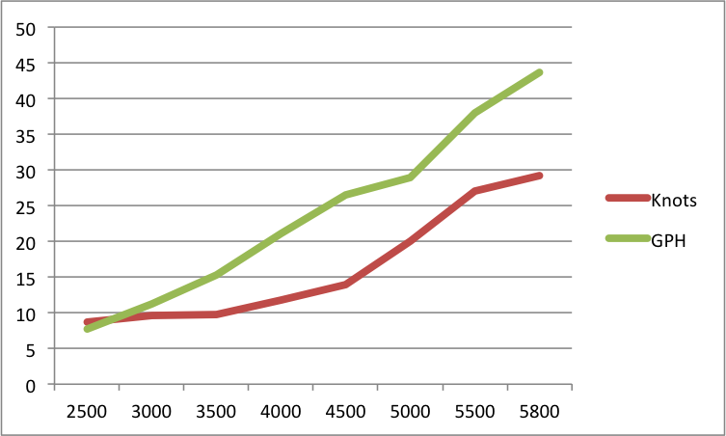
Boat with twin F350s (11,500 lb)

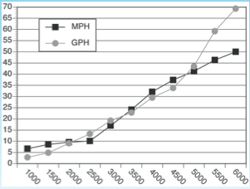
Boat with twin F250s (8,000 lb)
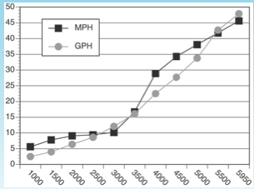

You can see how the other boats begin to plane around 2500-3000 RPM, whereas the R/V Paragon planes around 3500-4000 RPM.

Rikk Kvitek at CSUMB (6/11/13)
I spoke with Rikk about their boat. They also have a large research vessel that was underpowered with twin 225 Hondas. They repowered to twin F350s and sing their praises.

Armstrong 34’. 20,000 pounds.

Top speed 45 knots. Cruise 30 knots at 4000 RPM. Economy is 1 mile/gallon.

