R/V Paragon
Incline Experiment for CTD Carousel Deployment

Experiment performed by: Jared Figurski and Erich Rienecker
February 16, 2017

Carousel Specifications:
SBE 32SC Sub-compact Carousel Water Sampler
12 x 1.7 Liter Niskin bottles
Seabird 19 CTD w/ 43 O₂ Sensor
Wetlabs Wetstar Fluorometer
Wetlabs C-star Transmissometer
Weight in air: 380 lbs. (Full Bottles)
Weight in water: 150 lbs. (Full Bottles)

CTD Winch Specifications:
InterOcean 10031-5HLW Hydraulic Winch
Capacity: 1250 m of 0.38” diameter cable (Loaded with 1000 m)
Load/Speed: 470 lbs. @ 45 m/min (bare drum)
370 lbs. @ 55 m/min (mid drum)
300 lbs. @ 70 m/min (full drum)
Cable: Falmat FM088095-1MOD1
Diameter: 0.38”
Weight: 63 lbs./1000m in Air; 13 lbs./1000 m in water
Break Strength: 2400 lbs.
Weight: 550 lbs. without cable; 780 lbs. with 1,000m of cable

CTD Winch Base Plate and Bulkhead Mounts Specifications:
Base Plate Weight: 74 lbs.
Bulkhead Mount Attachment Strength: see summary of structural analysis

MBARI CTD Davit specifications:
Capacity: Designed to 300 lbs. SWL (FEA to 1500 lbs.) at full extension (24”)
Sheave Load Rating: 4000 lbs.
Weight: 150 lbs. with block
Attachment Strength: : see summary of structural analysis

Deck configuration:
The carousel can be transported on the starboard forward deck just forward of the CTD winch boom (Fig. 1). We tested the position just aft of the CTD winch boom, but confirmed that the vessel boom is too short to deploy the carousel from that position (Fig. 2). Existing deck hardware is ample to secure the carousel during transport, but a custom base plate for easy deployment is recommended.

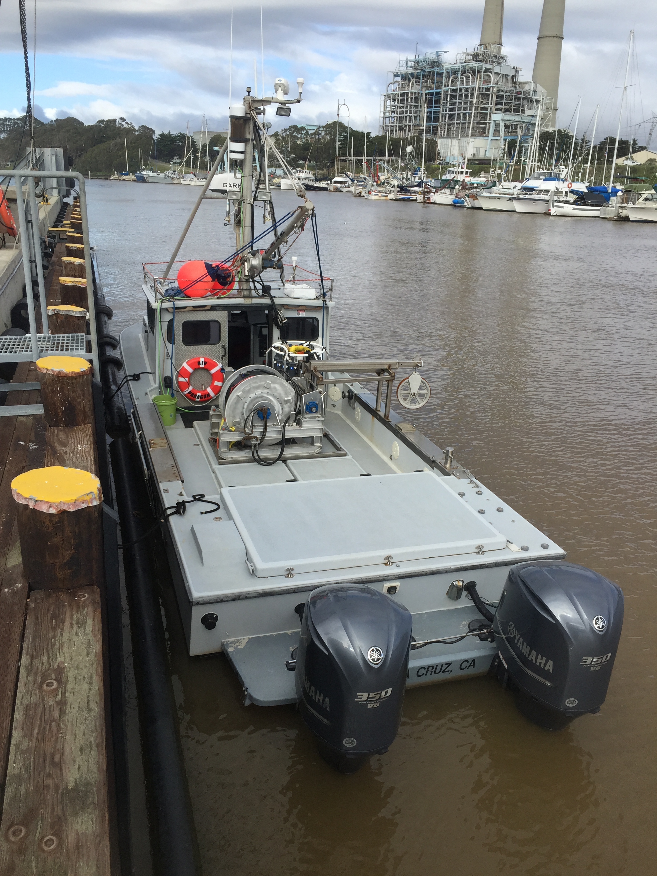
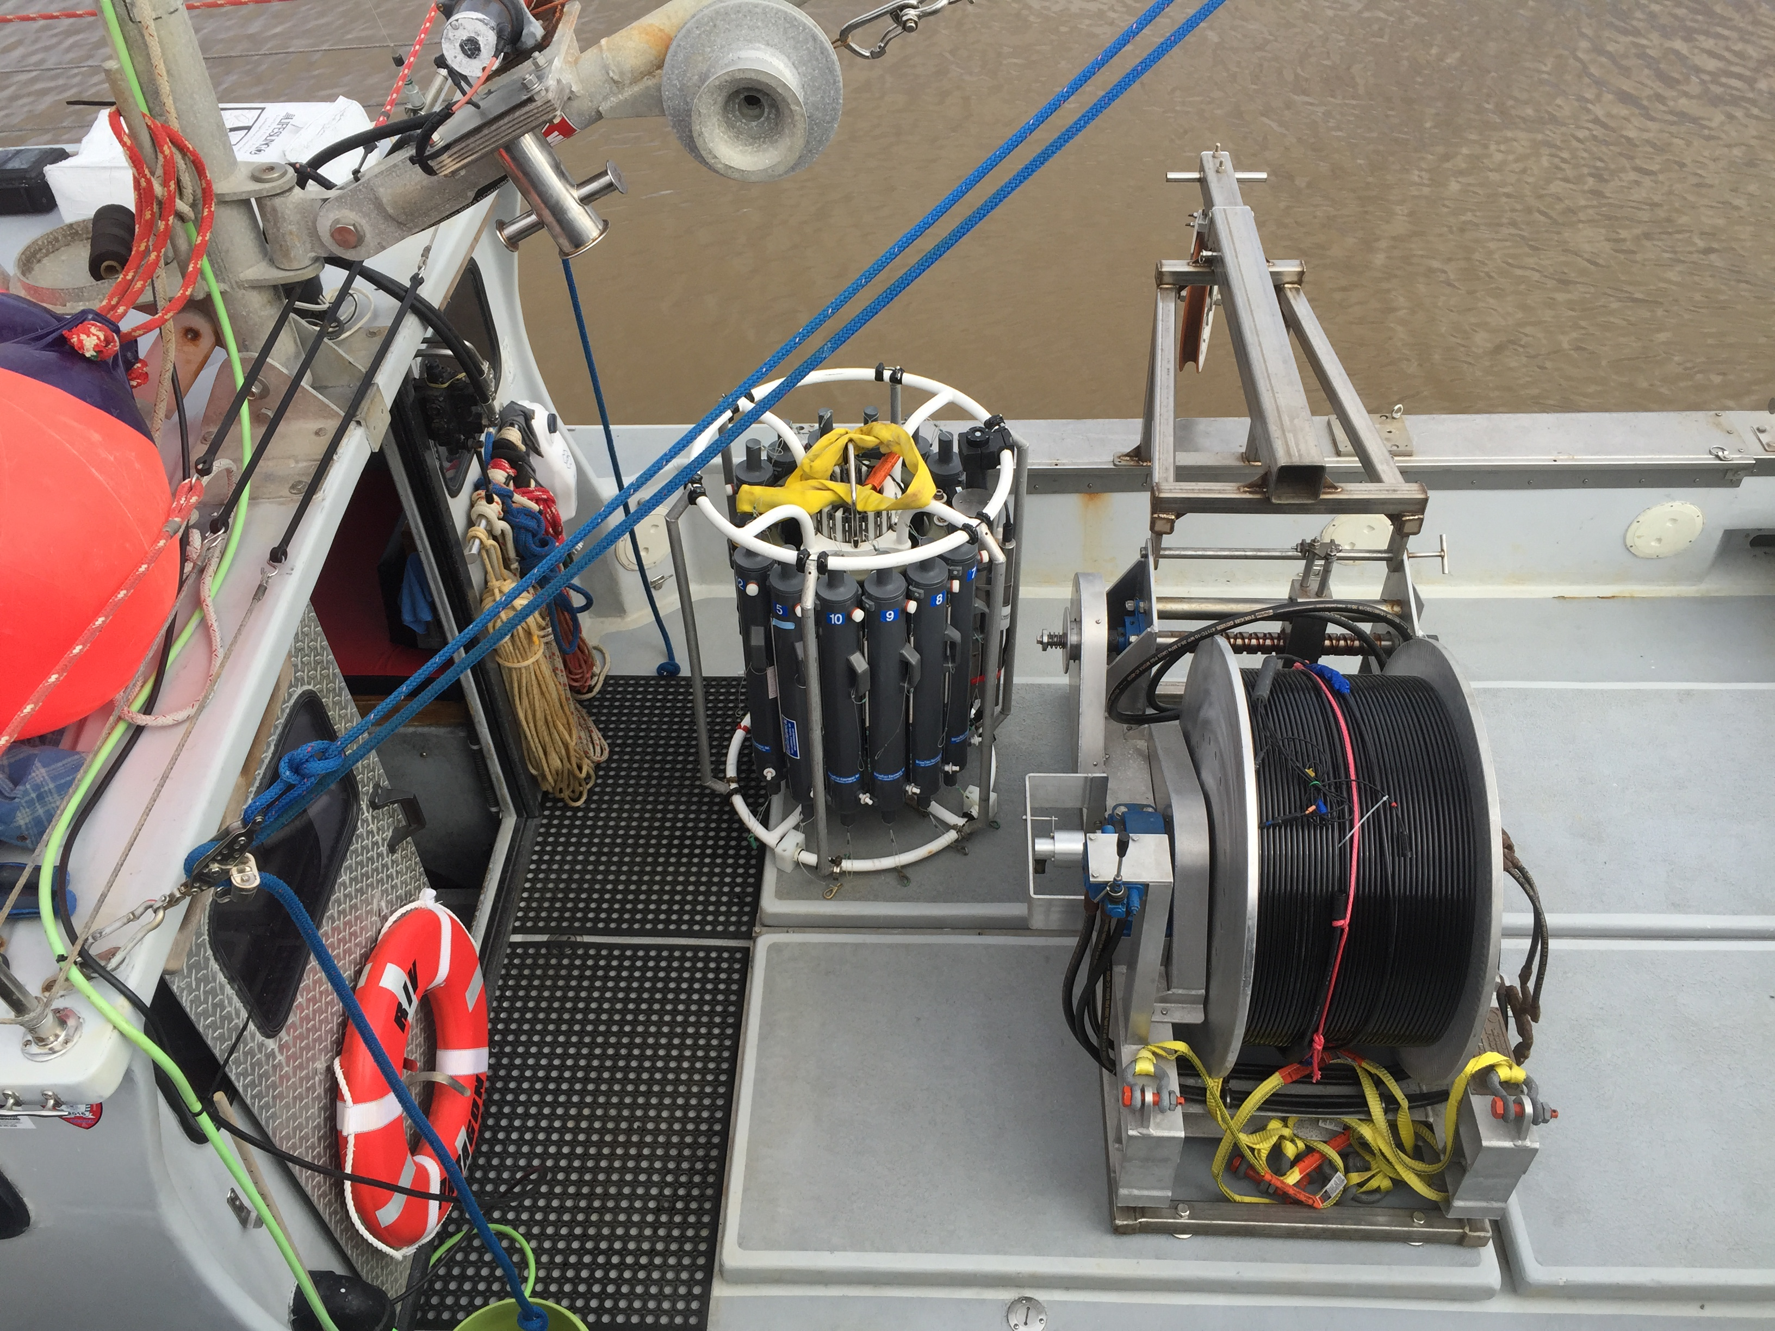
Figure 1: Preferred deck configuration while underway.

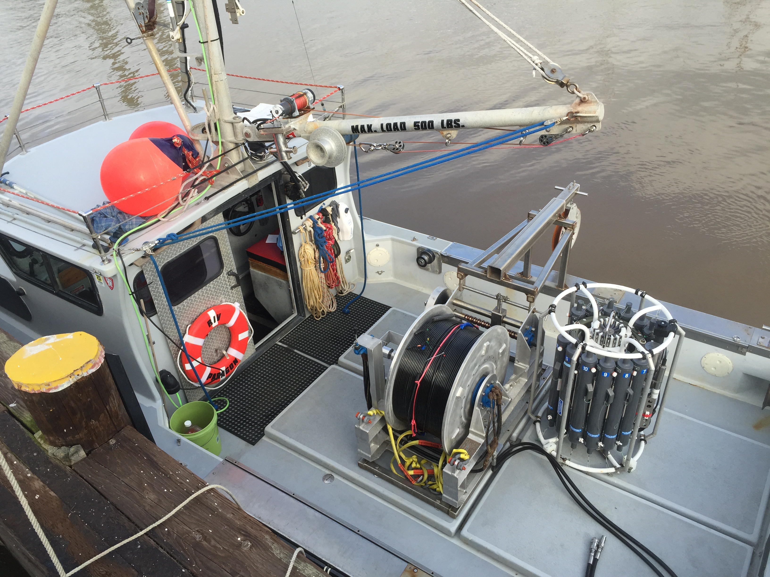
Figure 2: Carousel stored aft of winch is more difficult to deploy.

Load Weights and Incline Tests:
In a meeting with Kelly, Grech, Dawe and Figurski on Feb 9, 2017 it was agreed that an experiment should be performed to test the incline of the R/V Paragon at each step of the deployment and recovery procedure with the vessel at dock and with slack lines.

Results of Incline Experiment:
Underway position (Fig. 1): Incline 1.5° stbd
Recovery with carousel full of water, submerged, on CTD boom (Fig. 3): 1.0° stbd
Recovery with carousel full of water and suspended (Fig. 4): 2.3° stbd

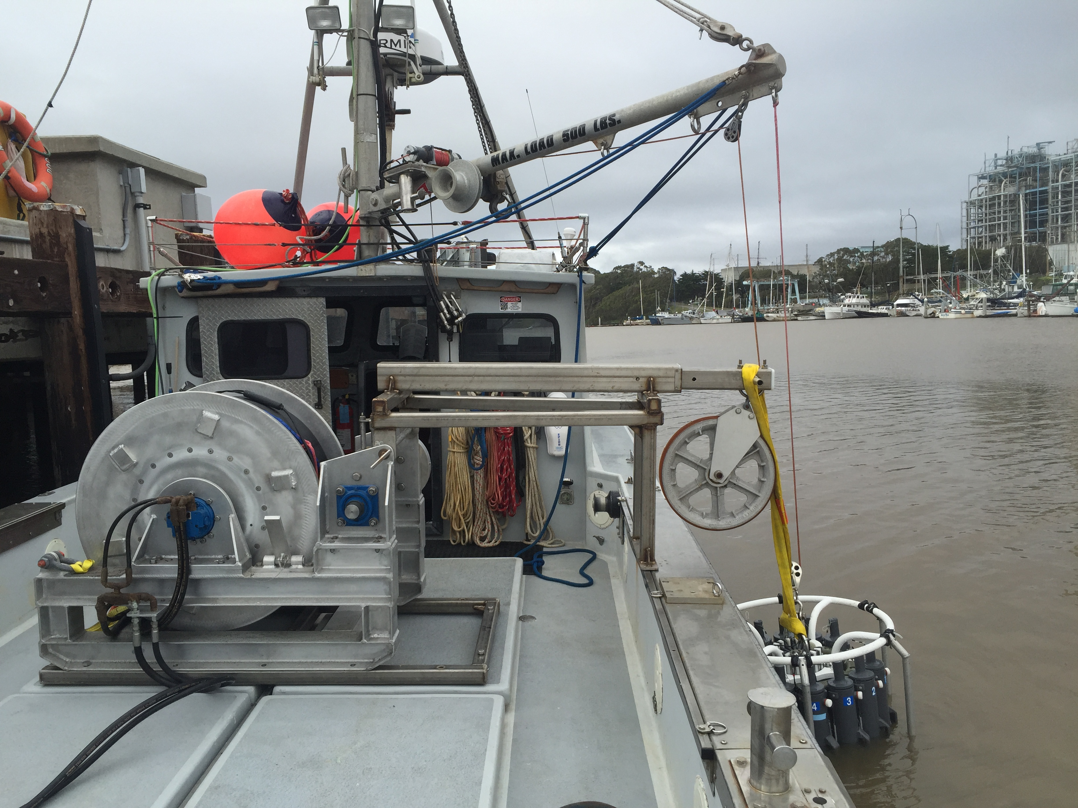
Figure 3: Simulated moment of CTD cast (results are from carousel submerged)

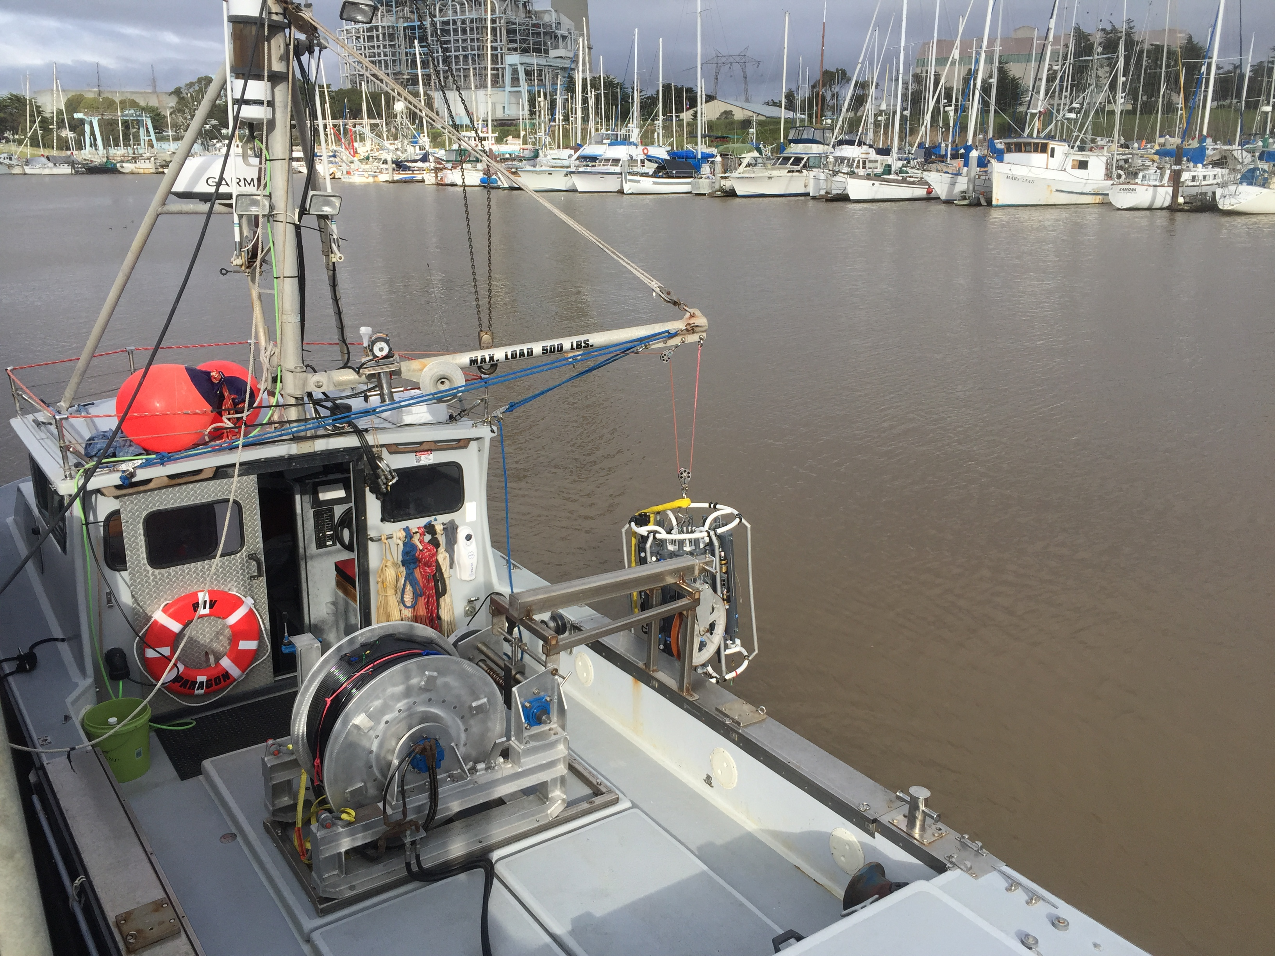
Figure 4: Simulated heeling moment during recovery of carousel with full bottles

Summary:
The results of this test indicate that the maximum incline that the vessel experienced during the deployment and recovery procedure of the CTD carousel was 2.3° to starboard when the full carousel was suspended out of water from the vessel boom. This test was completed in still water and does not necessarily reflect the incline that will be experienced at sea. For reference, this degree of heeling is comparable to or less than other regular operations conducted on the vessel.
The USCG certified marine surveyor, Rodgers and Associates, conducted a simplified stability test on December 7, 2016. By applying a total of 2460 lbs. of weight to the gunwales, they simulated the breaking strength (2400 lbs.) of the CTD electro-mechanical cable. The vessel performed favorably during the test, heeling only 8° and did not wet the decks. Rodgers and Associates concluded
On the basis of the survey and estimated light ship stability calculations, the vessel PARAGON as presently outfitted and equipped was determined to have satisfactory stability. The vessel as outfitted showed reasonable buoyancy. The vessel’s beam is wide and center of gravity is well defined. Metacenter height was found reasonably high with the vessel in a loaded condition. The values of the test indicated reasonable stability for use as outfitted on protected waters.
This MBARI study demonstrates that the heeling of the vessel during the deployment and recovery of a CTD carousel, with winch and boom aboard, falls within acceptable levels. At-sea trials will provide a better understanding of how the vessel performs in dynamic conditions. Initial trials will be conducted cautiously and incrementally.

Appendix:

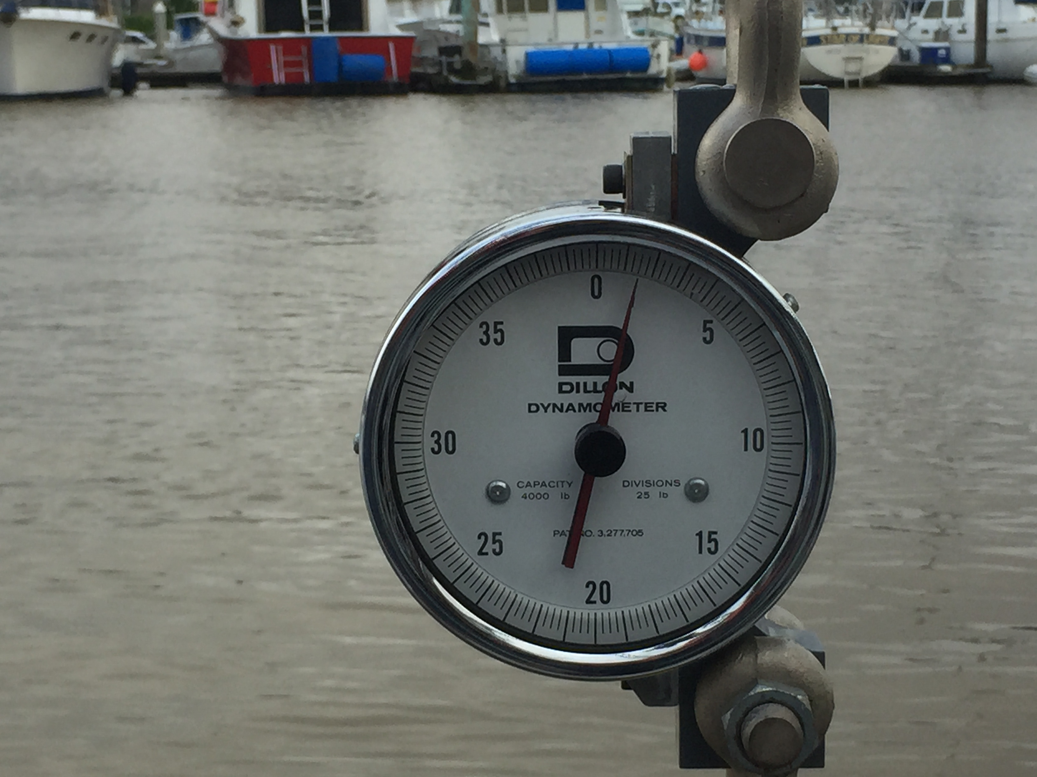
Figure 5: Weight of submerged carousel with full bottles (150 lbs).

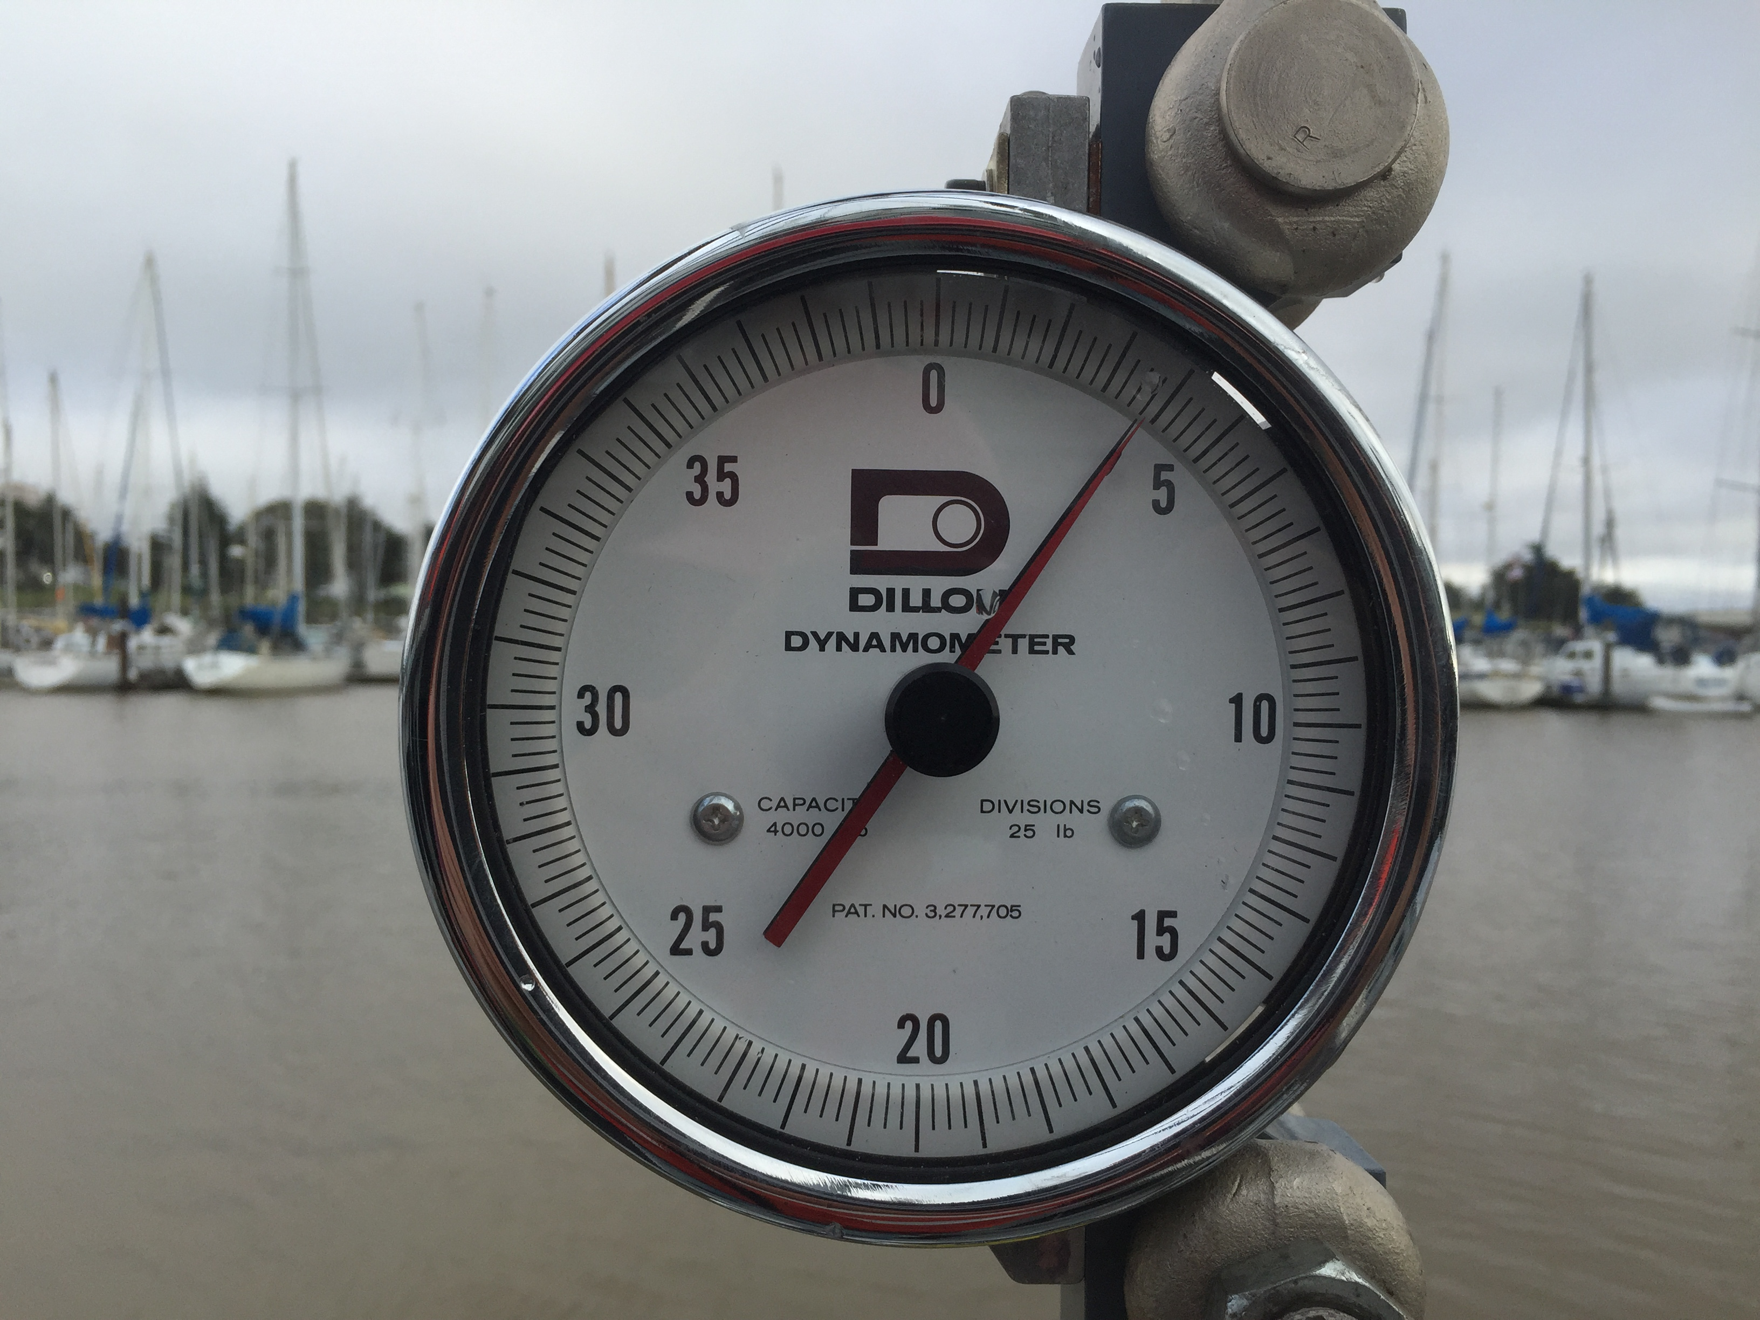

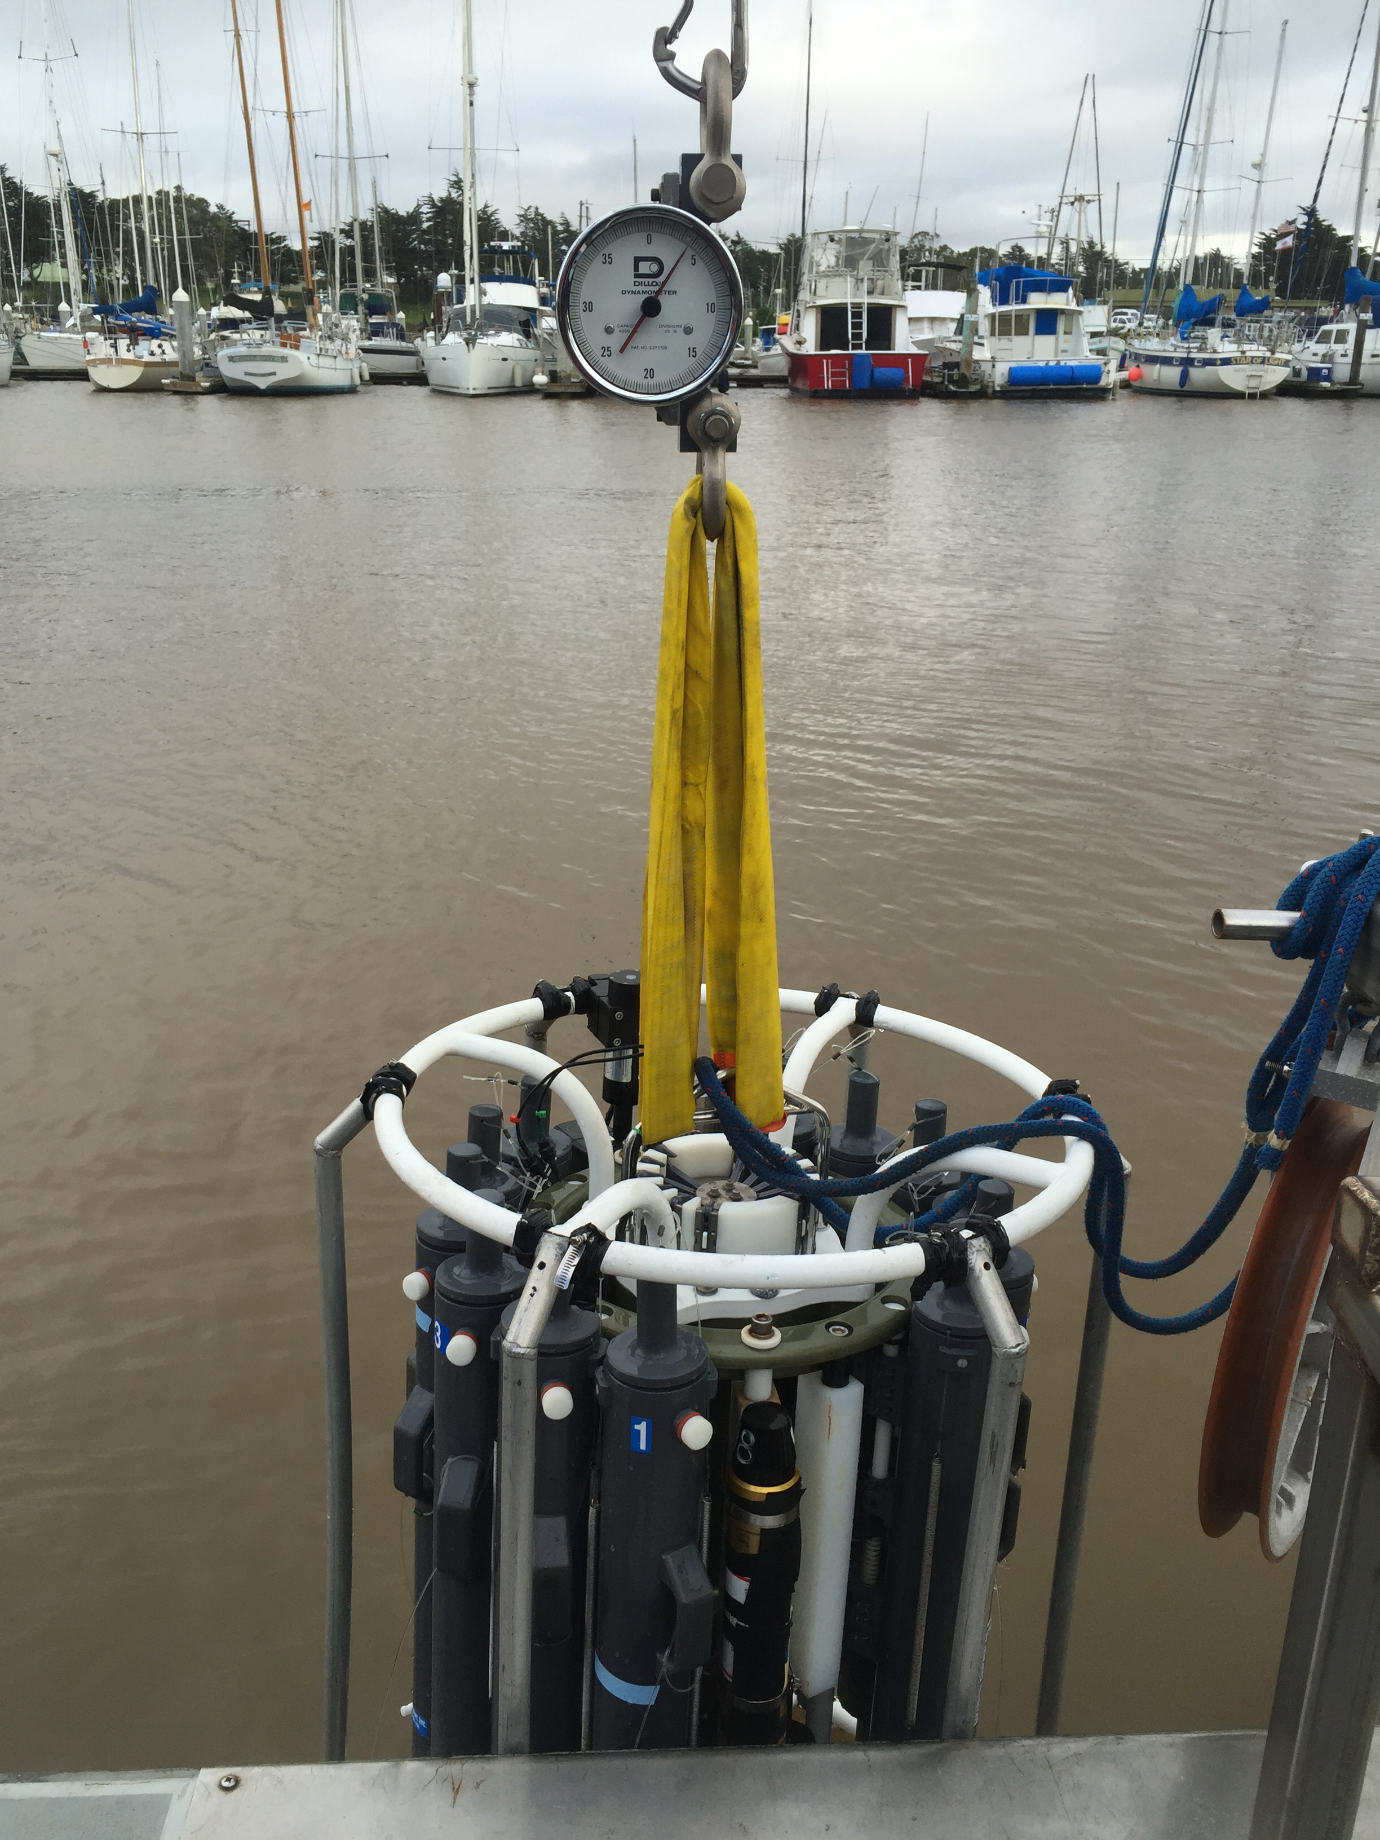

Figure 6: Weight of fully suspended carousel with full bottles (380 lbs.)

Test Schedule:

-Duration Trial for Compartment Heat
45 minutes operation
Measure temperatures incrementally and monitor

-Finalize Carousel deployment procedure

-Sea Trial with Stand in weight (150 lbs. in water)
Tests:
- Stability underway
- Winch capacity
- Winch speed
- Reliability of hydraulics
- Overall process

-Sea Trial with Carousel
Tests:
- Overall procedure with carousel
- Slip ring, deck box connectors

