10 June 2013

The increasing demand for the R/V Paragon has been a proof of concept that MBARI has need of a small multi-user vessel that is a fast and versatile research platform. During its short life with MBARI it has rescued the Power Buoy in the middle of the night and has run three to eight research operations per week. Unfortunately, it has been plagued by engine trouble in the port engine since its adoption by MBARI. The port engine is beyond repair after it broke an exhaust valve and damaged the cylinder two weeks ago.
If MBARI decides to go forward with the R/V Paragon, my concern is that replacing the F250 (3.3 L) commits us to that size engine. Twin 250 HP engines do not provide enough HP for that boat. While its performance on the water seems anything but underpowered, the boat has to run between 5000 and 6000 RPM to be on plane and that is in the full throttle range. Bigger engines would reduce the RPM required to get on plane that should, in turn, reduce strain on the engines and reduce fuel burn.
Another concern is that the long-term condition of the starboard engine is unknown, especially given the history of the port engine and some reports of stuttering on the day of the failure. Down time of the R/V Paragon is costly because researchers charter outside vessels such as the R/V John Martin that costs $3500/day ($270/hour).

Power Options:

Replace one V6 3.3 liter F250 (~$19,000+ $2000 install)
Replace two V6 4.2 liter F250 (~$52,000+ $3500 install)
Replace two V8 5.3 liter F350 (~$65,000+ $3500 install)

Install could be completed in approximately 1 week from order. Unfortunately, V6 (3.3) is on back order right now and may not be available until 7/15/13.

New engines come with a 3 year warranty.

Should MBARI want to look to other vessels to fill the niche, I looked into comparably sized new and used vessels:

New Radon: 33’ x 11’ ($255,000 base price, no extras, no engines)
Best guess, a new R/V Paragon would be around $500,000
13-14 month build time (without engines)

29’ x 9’ ($137,000 base price, no extras, no engines)
Best guess, around $300,000
16-17 month build time (without engines)

Used Radon: Radon-style Vessels are difficult to find and hold their value. Presently only 3 used Radons 29’ or larger are for sale in California.
R/V Paragon (22,000 lb)
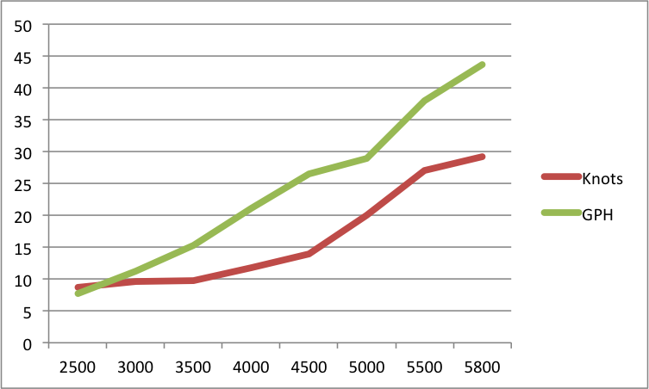
Boat with twin F350s (11,500 lb)

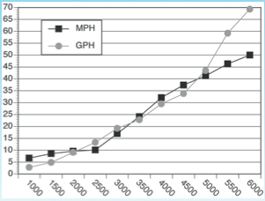
Boat with twin F250s (8,000 lb)
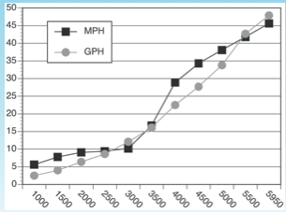

You can see how the other boats begin to plane around 2500-3000 RPM, whereas the R/V Paragon planes around 3500-4000 RPM.

