R /V Paragon
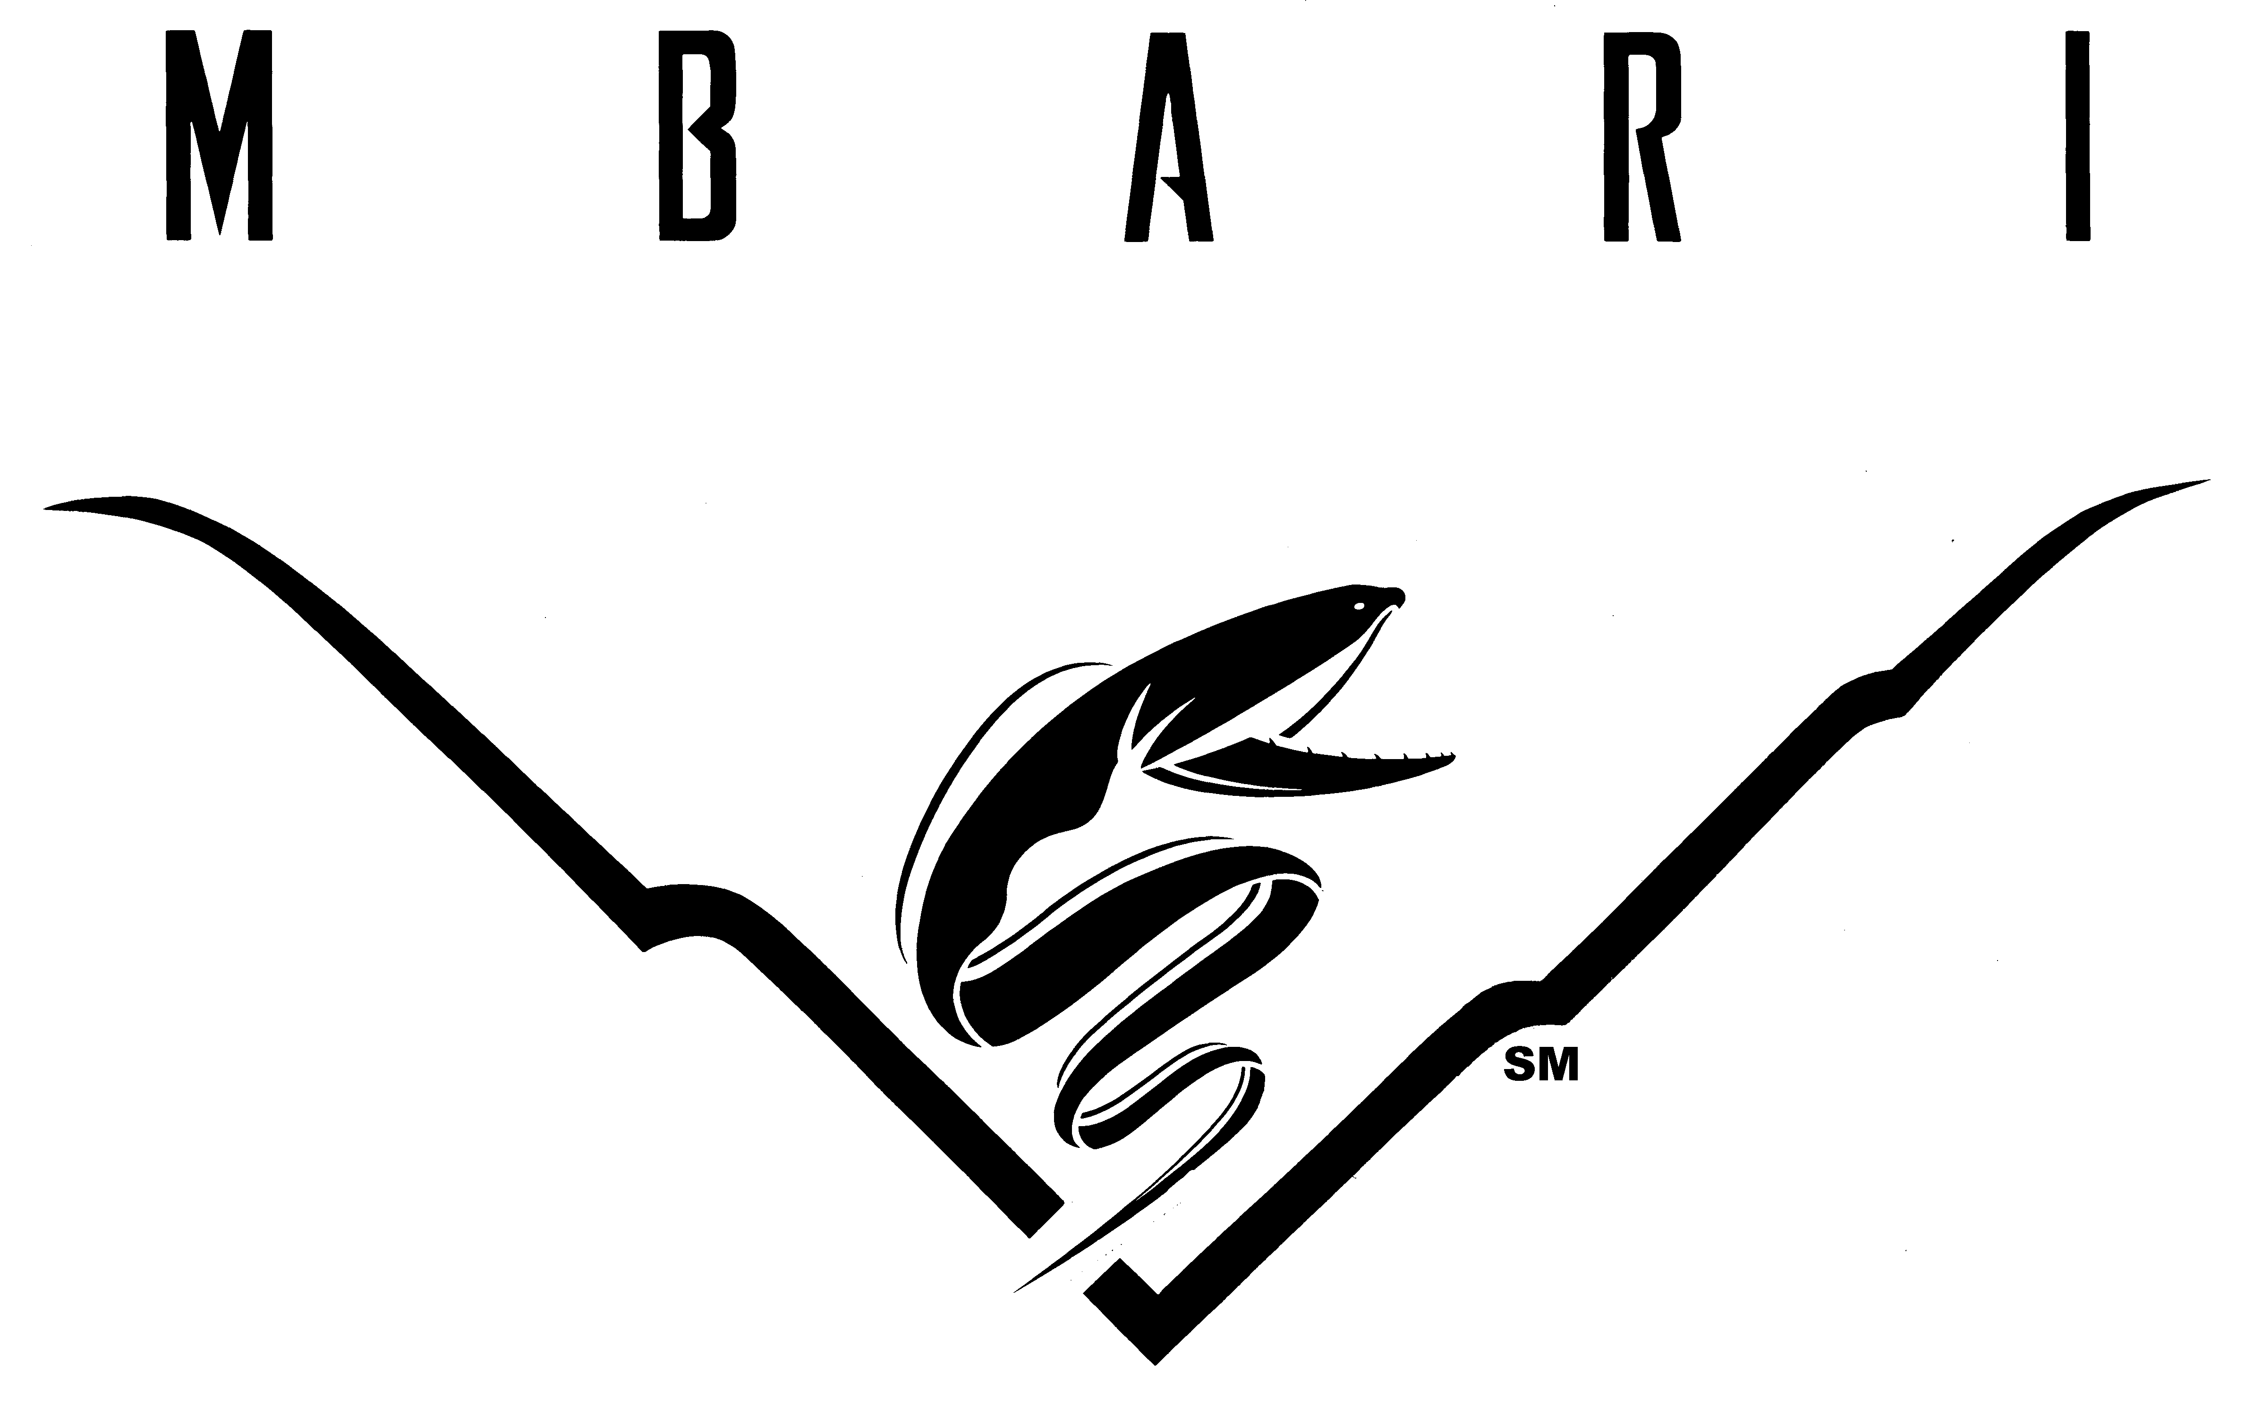

Operation Checklist

Start Up

- Verify pre-cruise has been submitted
- Identify Shore Contact, fill out Float Plan & deliver to manifest box
- Fill out visitor waivers and deposit in manifest box if required
- Fill out Cruise Log
- Determine if fuel is sufficient for trip (dip if any uncertainty of level)
- Engine Power PERKO- Switch ON
- House Power PERKO- Switch ON
- Check high water alarm
- Check fuel level in gas hydraulics motor and refill if low
- Run blowers for 3 minutes prior to starting engines
- Remove engine covers and lower engines
- Center and secure boom
- Tie down and secure loads
- Secure anchor, chain and winch
- Set one VHF Radio to channel 16
- Turn on Garmin displays
- Brief new passengers on vessel safety
  - Hazard of falling overboard
  - Man overboard procedure – ring, sling, throw bag, and cargo net
  - Whereabouts of PFDs and survival suits
  - Requirements for work vests, hardhats, and steel-toed shoes
  - Watch head on boom capstan and T-bit
  - Radar – make sure it is off before going forward
  - Emergency communication on VHF 16, Garmin DSC, SPOT, cell phones and EPIRB
  - Fire extinguishers – location and procedure
  - First Aid and AED locations
  - Location of Flares
  - Abandon ship – Mayday call, Don immersion suit, take EPIRB and ditch bag, stay with vessel as long as possible, stay together
- Confirm that everyone on deck is wearing work vests
- Cast off once crew is ready

Underway

- Confirm lines and buoys are inboard and secured
- Confirm passengers on back deck are wearing proper safety gear
- Turn on navigation lights in restricted visibility
- Turn on radar in restricted visibility
- Monitor blind spot for hazards
- Monitor engine diagnostics
- Always ask whether the crew and passengers are ready before accelerating

Shut Down

- Fuel boat if under 100 gallons on board
- Notify shore contact of your safe return
- Complete logs- Cruise, Maintenance, and Fuel logs
- Rinse Engines through cowling when vertical for 30 seconds each
- Raise Engines
- Rinse exterior of engines, bracket and tie-bar thoroughly
- Gravity flush engines 5 minutes apiece – DO NOT START ENGINE
- Replace rinse-hose fittings on engine
- Rinse boat thoroughly including windows, deck, and anchor winch
- Rinse water off windows with RO and Rain-X sprayer.
- Empty trash
- Stow work vests and hardhats NEATLY in V-berth
- Close and lock windows
- Tidy up the V-berth and cabin
- Clean Garmin monitors if smudges – ONLY use the cleaning kit stored behind the helm seat
- Replace covers on GPS and engine display
- Turn Engine Power PERKO Switch OFF
- Turn House Power PERKO Switch OFF
- Turn inverter OFF
- Confirm all tools are clean and returned
- Rinse lines and hang on the rail aft of the helm
- Rinse and bundle ratchet straps. Stow in green bin in cabin.
- Center and secure the boom. Add half hitch on a bight to both side-lines.
- Lock cabin and aft hatch with combo locks oriented right-side-up
- Stow and depressurize the dock hose - run the hose down and back on the Flyer dock
- Confirm the boat is secured to dock properly (Fenders in place and lines secure to cleats)
- Finish lines with a Flemish Flake (yes please. It is quite nice)
- Plug in sealion electric fence on Flyer dock.
- Replace the caution sign at top of ramp on exit.

Fueling

- Dip fuel tanks and note volume of each tank in cruise log
- Insert fuel nozzle and make contact with the fill port to discharge static
- Fuel with 89 Octane gas to a volume of 100 gallons in the saddle tanks
- Do NOT leave the nozzle while filling
- Add Ring Free Plus to fuel (1 oz/10 gallons)
- Fill out Cruise Log
- Fill out Fuel Log

