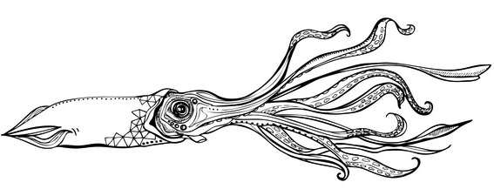 | Quote
Moss Landing Boat Works |  | Date: December 7, 2015
To  7501 Sandholdt Road  Moss Landing, CA 95039  831-633-2417 |  |  | MBARI  Jared Figurski

Boat | Job | Payment Terms | Due Date
Paragon 36’ | Deck Repairs

Qty | Description | Unit Price | Line Total
3 | Remove existing port decking over fuel tank | $80.00 | $240.00
4 | Replace and reinforce deck structure | $80.00 | $320.00
1 | 3M Filler | $63.79 | $63.79
1 | Gelcoat Qt. | $29.99 | $29.99
1 | Surfacing Agent Pt. | $19.00 | $19.00
1 | Misc Materials (tape, sandpaper, masking, etc.) | $75..00 | $75.00
 |  | Subtotal | $2409.97
 |  | Sales Tax | 0.00
 |  | Total | $2409.97

Quotation prepared by: Andrew Hippert
This is a quotation on the goods named, subject to the conditions noted below:

Thank you for your business!
Moss Landing Boat Works 7501 Sandholdt Rd, Moss Landing, CA 95039 831-633-2417

