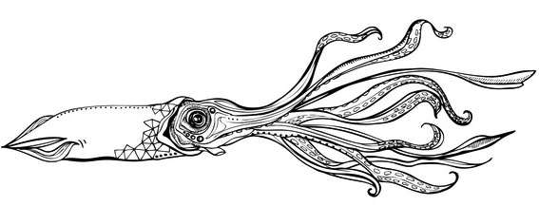 | Quote
Moss Landing Boat Works |  | Date: November 24, 2015
To  7501 Sandholdt Road  Moss Landing, CA 95039  831-633-2417 |  |  | MBARI  Jared Figurski

Boat | Job | Payment Terms | Due Date
Paragon 36’ | Deck Hatches (4)

Qty | Description | Unit Price | Line Total
10 | Grind, sand and prep for gelcoat, repair as necessary | $80.00 | $800.00
10 | Apply primer, apply gelcoat, apply non-skid | $80.00 | $800.00
1 | Gelcoat gallon | $89.99 | $89.99
1 | Acetone gallon | $327.49 | $27.49
1 | Misc materials (tape, sandpaper, rollers, etc) | $100.00 | $75.00
 |  | Subtotal | $1792.48
 |  | Sales Tax | 0.00
 |  | Total | $1792.48

Quotation prepared by: Andrew Hippert
This is a quotation on the goods named, subject to the conditions noted below:

Thank you for your business!
Moss Landing Boat Works 7501 Sandholdt Rd, Moss Landing, CA 95039 831-633-2417

